Supplementary Information

Three-dimensional bulk reduced graphene oxide coating strongly bonded to the metals realized by cold plasma and pulse current

Zbigniew Zimniak¹, Włodzimierz Tylus², Beata Borak³, Michał Pachnicz⁴, Małgorzata Rutkowska-Gorczyca⁵, Roman Wróblewski⁶, Karol Kobiela⁷ & Daniel Dusza⁸

¹ Faculty of Mechanical Engineering, Department of Metal Forming, Welding and Metrology, Wroclaw University of Science and Technology, 50-371 Wrocław, Wybrzeże Wyspiańskiego 27, Poland.

² Faculty of Chemistry, Department of Advanced Material Technologies, Wroclaw University of Science and Technology, 50-371 Wrocław, Wybrzeże Wyspiańskiego 27, Poland.

³ Faculty of Mechanical Engineering, Department of Mechanics, Materials and Biomedical Engineering, Wroclaw University of Science and Technology, 50-371 Wrocław, Wybrzeże Wyspiańskiego 27, Poland.

⁴ Faculty of Civil Engineering, Department of Geotechnics, Hydrotechnics, Underground and Hydraulic Engineering, Wroclaw University of Science and Technology, 50-371 Wrocław, Wybrzeże Wyspiańskiego 27, Poland.
⁵ Faculty of Mechanical Engineering, Department of Vehicle Engineering, Wroclaw University of Science and Technology, 50-371 Wrocław, Wybrzeże Wyspiańskiego 27, Poland.
⁶ Faculty of Mechanical Engineering, Department of Lightweight Elements Engineering, Foundry & Automation, Wrocław University of Science and Technology, 50-371 Wrocław, Wybrzeże Wyspiańskiego 27, Poland.

⁷ Faculty of Mechanical Engineering, Department of Advanced Manufacturing Techniques, Wrocław University of Science and Technology, 50-371 Wrocław, Wybrzeże Wyspiańskiego 27, Poland.

⁸ Faculty of Electrical Engineering, Department of Electrical Machines, Drives and Measurements, Wroclaw University of Science and Technology, 50-371, Wrocław, Wybrzeże Wyspiańskiego 27, Poland.

Supplementary Figure 1: A schematic representation of the experimental set up for the deposition of 3D rGO layers on a metal sheet.

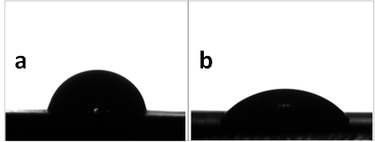
Supplementary Figure 2: Contact angle of a water droplet. a Contact angle of a water droplet on the Ti Grade 2 surface before activation. b Contact angle of a water droplet on the Ti Grade 2 surface after activation.

Supplementary Figure 3: Surface free energy.
Deionized water and diiodomethane were used as standard test liquids, with formamide and ethylene glycol were employed as additional probes. Wetting is achieved using a small test droplet with a volume of approximately 1 μL. The contact angle (θ) for flat surfaces is described by Young's equation, which states that cos(θ) = (γSV - γSL) / γLV, where γSV is the interfacial tension between the gas and the surface, γSL is the interfacial tension between the liquid and the surface, and γLV is the interfacial tension between the liquid and the gas. It is generally accepted that a surface is hydrophilic if the contact angle of water on that surface is less than 90°. On hydrophilic surfaces, a water droplet spreads out due to stronger interactions and adsorption with the substrate compared to the molecular bonds between water molecules.
Surface free energy (SFE) calculations were used to assess the efficiency of cold plasma treatment, as shown in Figure 1. Investigations were carried out in Ti Grade 2, both before and after low temperature plasma activation. For comparison purposes, studies were also carried out on other materials used in this work.
The SFE was calculated using the Owens-Wendt-Rable-Kaelble equation. Data for SFE calculations, i.e. contact angles, were measured using a Kruss DSAHT 1200 measuring device. Four measuring liquids were used and their parameters are presented in Table 1. The results represent the arithmetic mean of four drops of each liquid taken on the same specimen, with standard deviations also calculated.
As observed in Figure 1, cold plasma treatment positively impacts the polar fraction and consequently the SFE of all specimens. For Ti Grade 2 and AISI 304 stainless steel, a significant increase in the polar fraction of SFE is observed, from approximately 20 mJ/m² to 40 mJ/m² for Ti Grade 2 and from 19 mJ/m² to 38 mJ/m² for AISI 304, respectively. For WCLV steel, the polar fraction of SFE also increases by approximately 70%, from approximately 22 mJ/m² to 37 mJ/m².
The observation of standard deviation bars indicates that the surface becomes more stable after plasma activation, particularly for the titanium specimen. With the increase in the polar fraction of SFE for all specimens, a corresponding decrease in the dispersive fraction and an overall increase in the total SFE are observed.

Supplementary Table 1. Measurement liquids for contact angle determination.
 | Measuring liquids
 | di-iodomethane | deionized water | formamide | ethylene glycole
dispersive fraction | 47,4 | 19,9 | 23,5 | 30,1
polar fraction | 2,6 | 52,2 | 33,4 | 17,6

Supplementary Table 2. Chemical composition (% at.) of the Ti surface, before and after treatment with a plasma beam.
 |  | O 1s | Ti 2p | C 1s | N 1s | Ca 2p | O:Ti | C:Ti
Ti delivered |  | 28.67 | 10.9 | 57.72 | 1.92 | 0.79 | 2.63 | 5.30
Ti grinded |  | 30.72 | 11.68 | 53.92 | 2.43 | 1.26 | 2.63 | 4.62
Ti grinded+plasma |  | 57.37 | 23.79 | 16.22 | 1.02 | 1.61 | 2.41 | 0.68

Supplementary Table 3. Fitting parameters for C 1s envelope in graphene type materials [Błąd! Nie można odnaleźć źródła odwołania.].
Species | Peak ident. | Position, eV | FWHM, eV | Lineshape | Area constraint
C=C | A | 284.3 |  | LA(1.2, 2.5, 5) #
C-C, C-H | B | A+0.5 | C*1 | GL(30) ##
C-OH, C-O-C | C | A+2.0 |  | GL(30)
C=O | D | A+3.5 | C*1 | GL(30)
O-C=O | E | A+4.5 | C*1 | GL(30)
π🡪 π* sat. | F | A+6.4 |  | GK(30) | A*0.07
# - line-shape details for CasaXPS; define asymmetric peak-shape for C=C
## - 30% of Lorentzian in Gaussian/Lorentzian formula (CasaXPS)

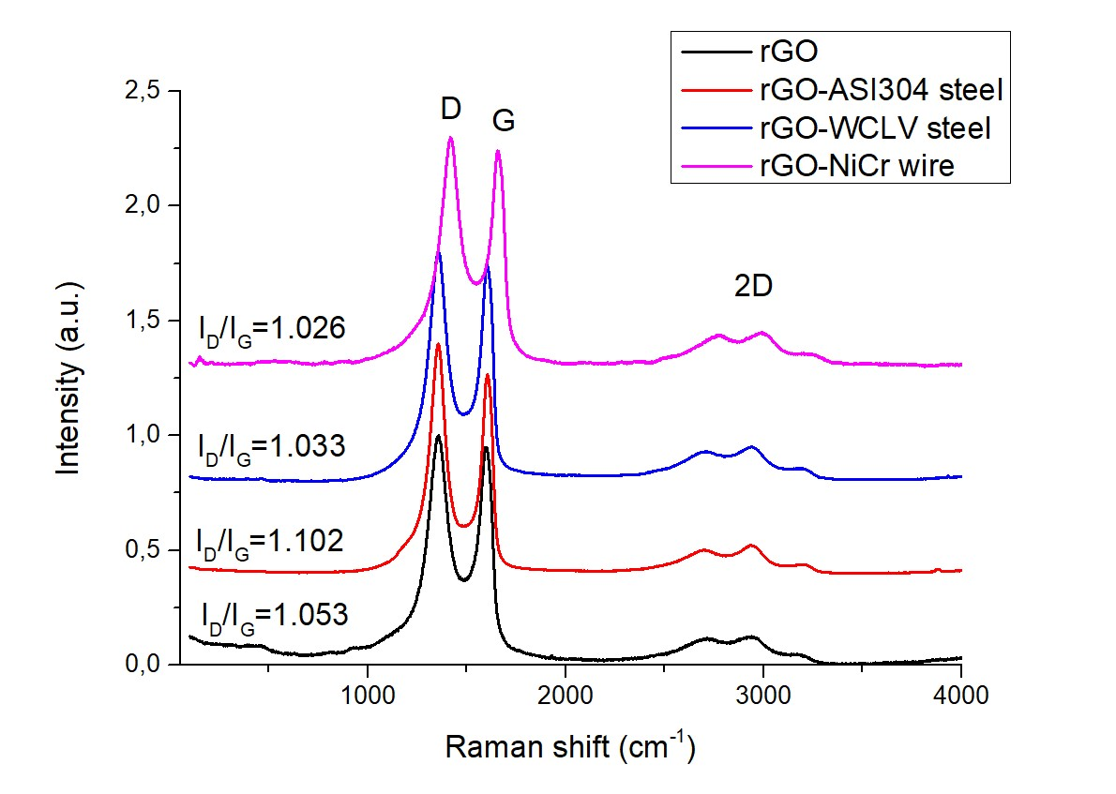
Supplementary Figure 4: Raman spectra of rGO and the same rGO deposited on ASI 304 steel, WCLV steel and NiCr wire.

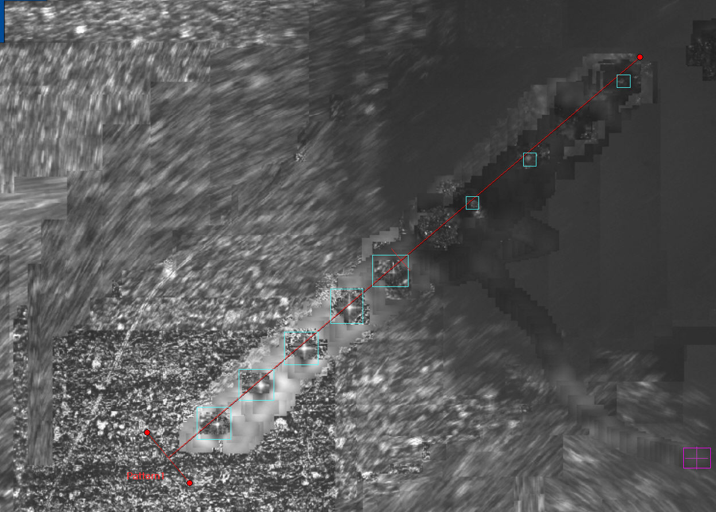
Supplementary Figure 5: Micrograph of the sample showing indentations along the designated red measurement line.
Supplementary Table 4. Vickers microhardness test results.
 | Distance (mm) | Hardness HV_{(0.1)} | Load (N)
1 | 0,206 | 144 | 1000
2 | 0,387 | 144 | 1000
3 | 0,594 | 140 | 1000
4 | 0,819 | 142 | 1000
5 | 0,982 | 137 | 1000
6 | X | X | 1000
7 | 1,36 | 1010 | 1000
8 | 1,62 | 932 | 1000
9 | X | X | 1000
10 | 2,04 | 976 | 1000

Supplementary Figure 6: Electrical parameter measurement station.
Figure 6 shows the experimental setup designed to study the mechanical deformation of the rGO-NiCr interface. This setup allows testing using two methods, assuming one NiCr wire is fixed and the other can move. The setup for measuring resistance and voltage includes the following instruments: Agilent 34420A, HP 34401A, while temperature measurements were made using an HP 34970A and a type K thermocouple. Temperature changes were achieved using a resistive heating element and an HP 3631A power supply. Data acquisition was automated using the National Instruments LabVIEW software.
Supplementary Figure 7: Four-point probe measurement of the resistance of the 3D rGO-NiCr interface for low resistance values.

