Supplementary Information
Wafer-scale black phosphorus film synthesis on arbitrary substrates enabled by van der Waals layer passivation
Cheng Chen^{1,2,7}, Yuling Yin^{4,5,7}, Dong Wang^{1,7}, JunSheng Xu¹, Yuting Du³, Xingang Hou¹, Siyuan Wang¹, Yaning Liang¹, Jing Xu¹, Shuo Zhang¹, Xiangyi Wang¹, Qiang Yu¹, Jie Li¹, Haibo Zeng⁶✉, Erjun Kan², Qinghong Yuan^{3,4}✉, Feng Ding⁴, Junyong Wang¹✉, and Kai Zhang¹✉
¹Key Laboratory of Semiconductor Display Materials and Chips & i-Lab, Suzhou Institute of Nano-Tech and Nano-Bionics (SINANO), Chinese Academy of Sciences, Suzhou 215123, China
²MIIT Key Laboratory of Semiconductor Microstructure and Quantum Sensing, School of Physics, Nanjing University of Science and Technology, Nanjing 210094, China
³State Key Laboratory of Precision Spectroscopy, School of Physics and Electronic Science, East China Normal University, Shanghai,200241, China.
⁴Suzhou Laboratory, Suzhou 215123, People’s Republic of China.
⁵Institute of Technology for Carbon Neutrality, Shenzhen Institute of Advanced Technology, Chinese Academy of Sciences, Shenzhen 518055, People’s Republic of China.
⁶MIIT Key Laboratory of Advanced Display Materials and Devices, Jiangsu Engineering Research Center for Quantum Dot Display, Institute of Optoelectronics & Nanomaterials, School of Materials Science and Engineering, Nanjing University of Science and Technology, Nanjing 210094, China.
⁷These authors contributed equally: Cheng Chen, Yuling Yin and Dong Wang.
✉Email: zeng.haibo@njust.edu.cn; qhyuan@phy.ecnu.edu.cn; jywang2022@sinano.ac.cn; and kzhang2015@sinano.ac.cn

Table of Contents
Supplementary Fig.1 Schematic illustration of BP films growth stage through van der Waals layer passivation.
Supplementary Fig.2 BP films growth stage: from isolated domains to continuous film.
Supplementary Fig.3 The configurations and corresponding formation energies of phosphorus allotropy phase on various substrate.
Supplementary Fig. 4 Atomic structures of phosphorus allotropes in vacuum and on a SnI₂ substrate.
Supplementary Fig.5 Formation energies and corresponding Gibbs free energies calculations of BP cluster on SnI₂ substrate.
Supplementary Fig.6 Full-coverage and uniformity of tin iodide passivation layer on substrate investigated by XPS characterization.
Supplementary Fig.7 Three-dimensional element distribution of as-grown BP films on tin iodide layer passivated substrate by time-of-flight secondary ion mass spectroscopy analysis.
Supplementary Fig.8 Batch yield of BP films by stacking multiple passivated substrates.
Supplementary Fig.9 Effects of tin iodide pieces on the growth of BP films.
Supplementary Fig.10 Identification of the intermediate tin iodide passivation layer between the grown BP film and the substrate.
Supplementary Fig.11 Regrowth of BP films with the tin iodide layer passivation layer.
Supplementary Fig.12 Crystalline orientation of the grown BP films and the underlying GaN substrates.
Supplementary Fig.13 Cross-section STEM image of grown BP films and corresponding element distribution by EDS mapping images.
Supplementary Fig.14 Compare of the lattice constant of the BP films grown on diverse passivated substrates.
Supplementary Fig.15 Relative rotation angle between BP films and crystal substrate identified by cross-sectional HAADF TEM image.
Supplementary Fig.16 The hetero-interfaces atoms arrangement of the grown BP films on GaN terraces surface.
Supplementary Fig.17 Interface strain of BP films grown on diverse passivated substrates analyzed by GPA mapping.
Supplementary Fig.18 The dislocation found in the red phosphorus film on substrate without tin iodide passivation layer.
Supplementary Fig. 19 Schematics of the growth of BP films on passivated substrate.
Supplementary Fig.20 Strain the BP films grown on different substrates characterized by Raman spectroscopy.
Supplementary Fig.21 Compare of the PL spectra of the BP film grown on passivated substrate and that grown on alloy substrate.
Supplementary Figure 22. The thickness uniformity of as-grown BP films through AFM characterization.
Supplementary Fig.23 Spatial uniformity of as-grown BP films on passivated substrate through Raman mapping.
Supplementary Fig.24 Photoluminescence mapping of as-grown continuous BP film.
Supplementary Fig.25 Statistical distribution of Raman shift and peak intensity of as-grown BP film.
Supplementary Fig.26 Raman characterization of the BP films grown on alloy substrate.
Supplementary Fig.27 Uniformity of continuous BP film demonstrated by morphology characterized.
Supplementary Fig.28 The excellent films flatness independent of the growth substrate type.
Supplementary Fig.29 Electrical performance of the BP FETs.
Supplementary Fig.30 Temperature-dependent FETs behavior of the BP film sample.
Supplementary Fig.31 Atoms arrangement at the film-substrate interface of the directly grown BP films and transferred BP films.
Supplementary Fig. 32 Statistical analysis of the electrical characteristics of the BP/Si heterojunction device array.
Supplementary Figure 33. Polarized electroluminescence of BP/Si heterojunction.
Supplementary Fig.34. Photoresponse of BP/Si heterojunction photodiode.
Supplementary Fig.35. Statistical analysis of the electrical characteristics of the BP/GaN heterojunction devices array.

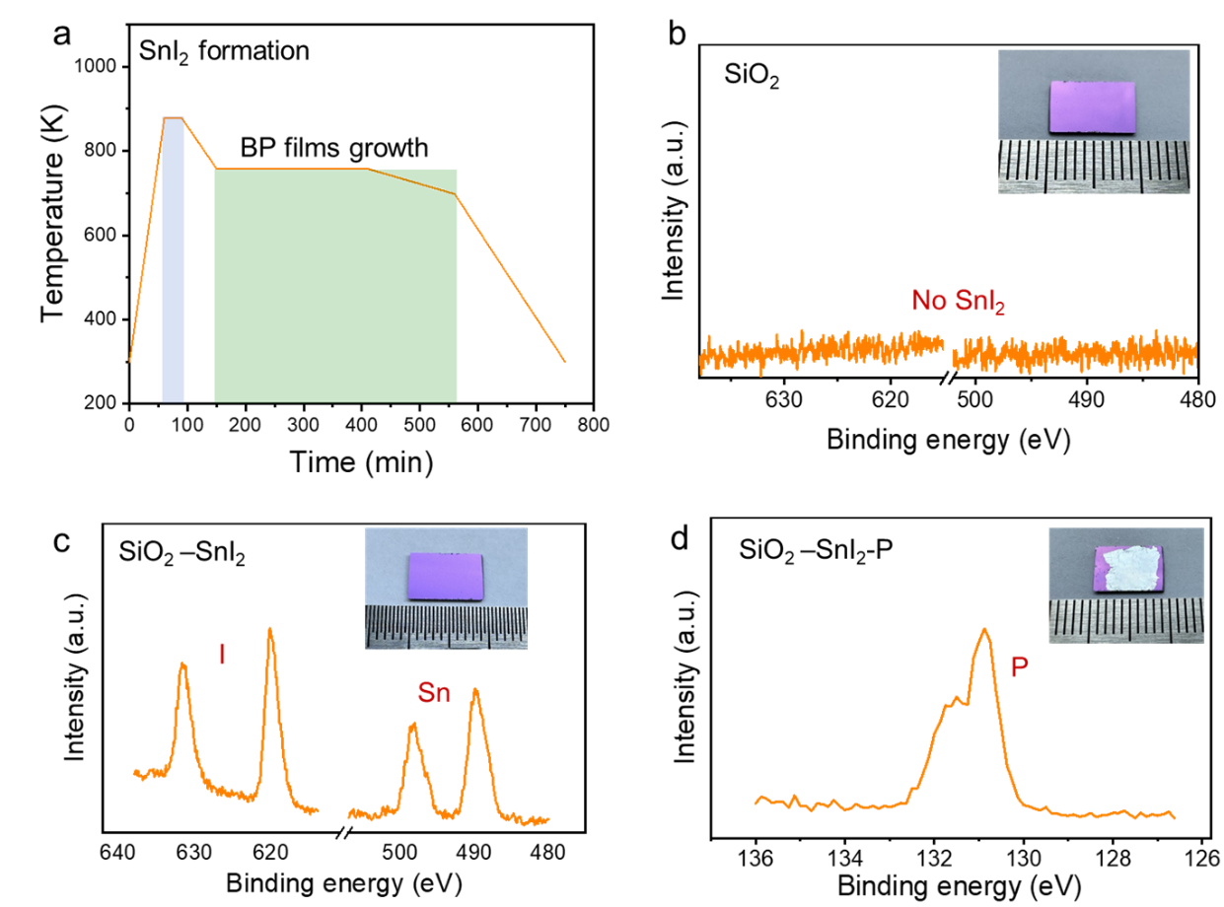
Supplementary Figure 1. Schematic illustration of BP films growth stage through vdW layer passivation. a, Temperature program of the BP films growth process, SnI₂ formation occurs at the temperature stage of 825 K. b-d, Photograph of the substrate surface and corresponding element identification by XPS. The SnI₂ compound is first formed on the substrate, followed by the formation of the BP film.

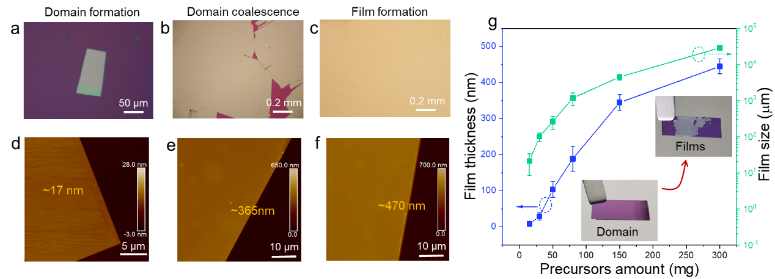
Supplementary Figure 2. Growth stages of BP films: from isolated domains to a continuous film. a-c, Optical microscopy photographs illustrating the sequential growth of a BP from isolated domains to a continuous film. As the precursor supply continues, individual BP domains grow and coalesce into a wafer-scale continuous film, with simultaneous increases in both lateral size and thickness. d-f, Representative AFM images of BP films corresponding to different growth stages shown in a–c. g, Statistical analysis of film thickness and lateral size as a function of precursor amount.

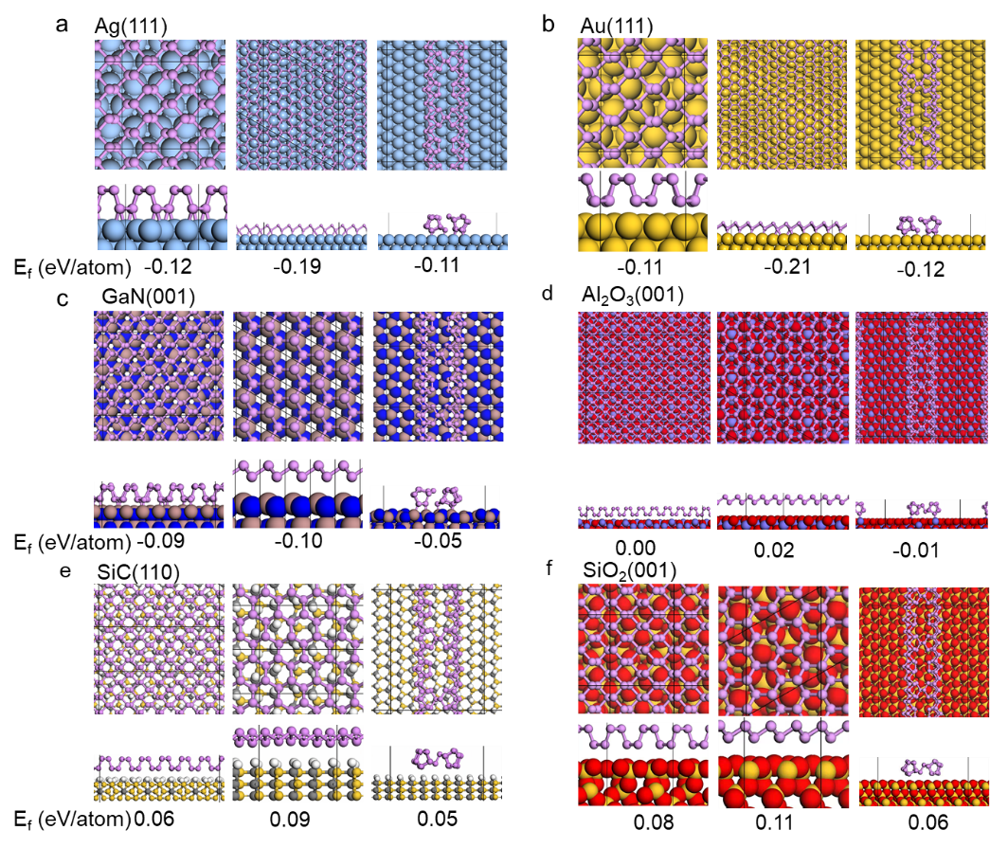
Supplementary Figure 3. Configurations and corresponding formation energies of phosphorus allotropes (black phosphorene, blue phosphorene and red phosphorene) on various substrates. In d, "Al₂O₃" denotes sapphire, while in f, "SiO₂" denotes quartz. The vdW interaction between red phosphorus chains has been used to revise the formation energy of a red phosphorus chain to be that of monolayer red phosphorene.
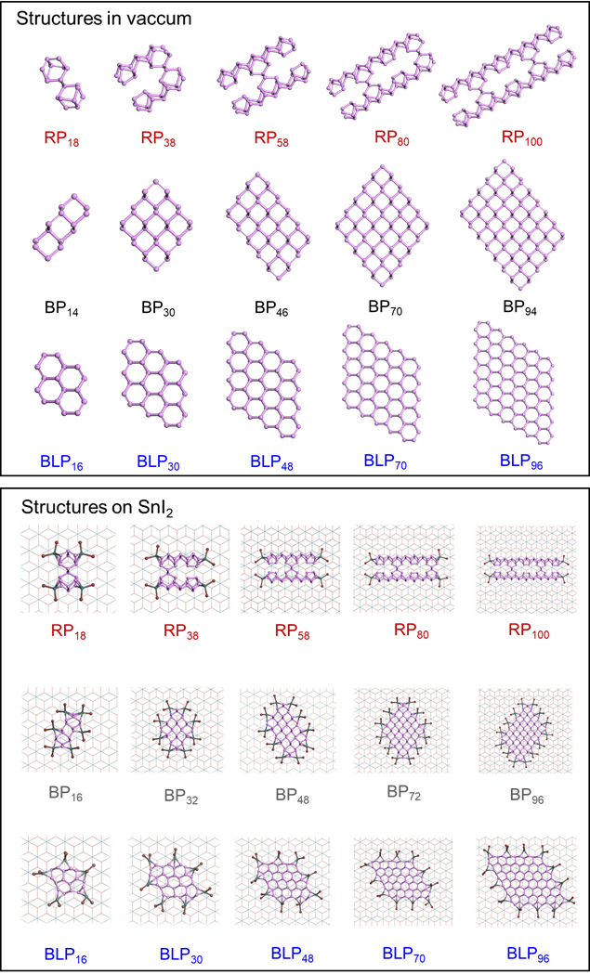
Supplementary Figure 4. Atomic structures of phosphorus allotropes (black phosphorene, red phosphorene and blue phosphorene) in vacuum and on a SnI₂ substrate.

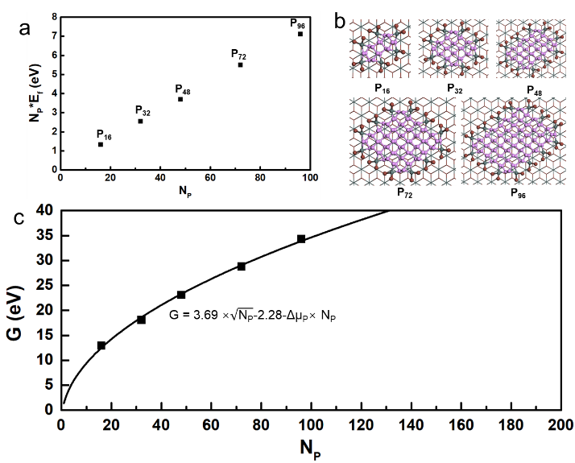
Supplementary Figure 5. Formation energies and corresponding Gibbs free energies calculations of BP cluster on SnI₂ substrate.

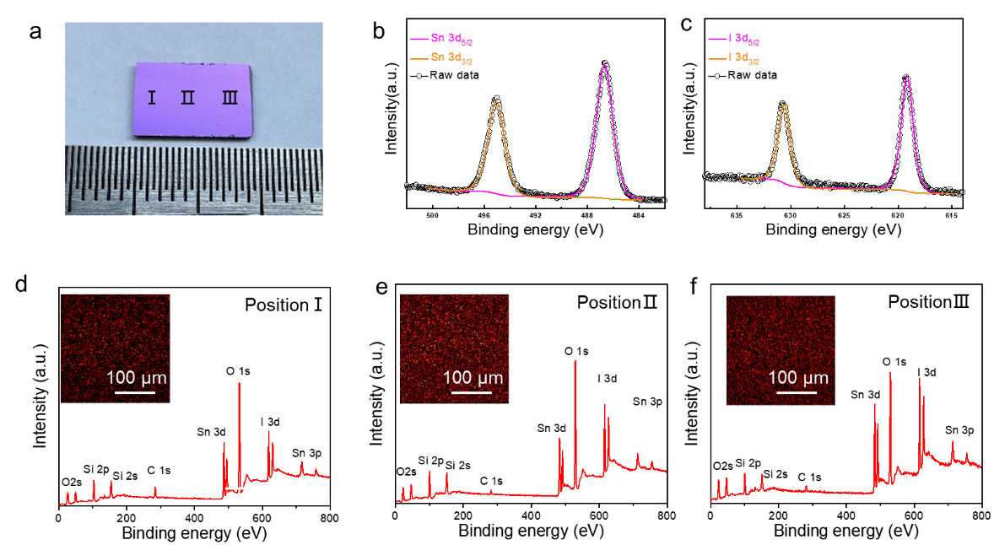
Supplementary Figure 6. Full-coverage and uniformity of tin iodide passivation layer on substrate investigated by XPS characterization. a, Photograph of a SiO₂ substrate covered with SnI₂ passivation layer. b-c, High-resolution XPS spectrum of Sn 3d and I 3d, respectively. d-f, XPS survey spectra of SnI₂ at locations marked in a, indicating the uniform distribution of SnI₂ layer over centimeter-scale.

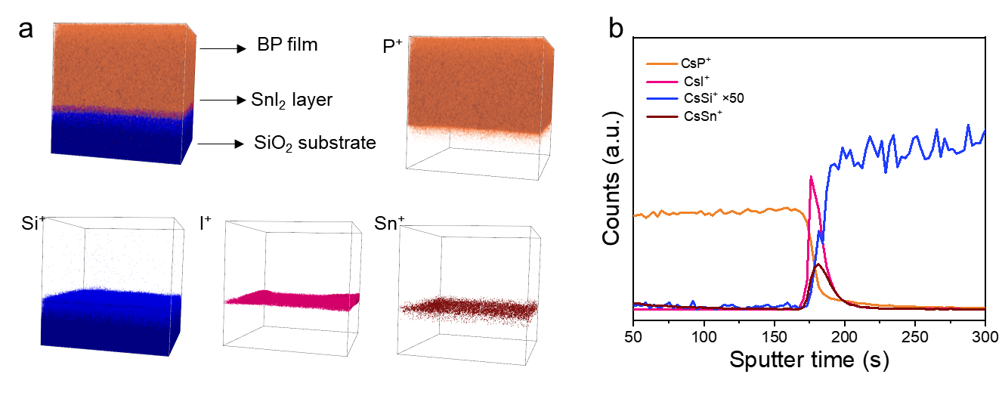
Supplementary Figure 7. Three-dimensional element distribution of as-grown BP films on SnI₂ layer passivated substrate by time-of-flight secondary ion mass spectroscopy (TOF-SIMS) analysis. a, Three-dimensional images of depth profiles of P, Si, I, Sn species. b, TOF-SIMS depth profiles of the species in a.

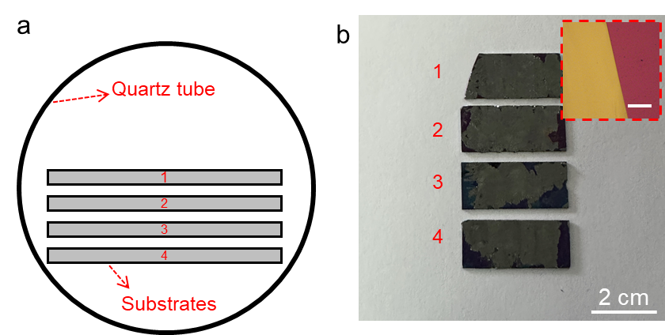
Supplementary Figure 8. Batch yield of BP films by stacking multiple passivated substrates. a, Schematic of stacking multiple substrates in the growth ampoule to grow BP crystal films simultaneously. b, Photograph of the BP films grown on multiple Si/SiO₂ substrates.

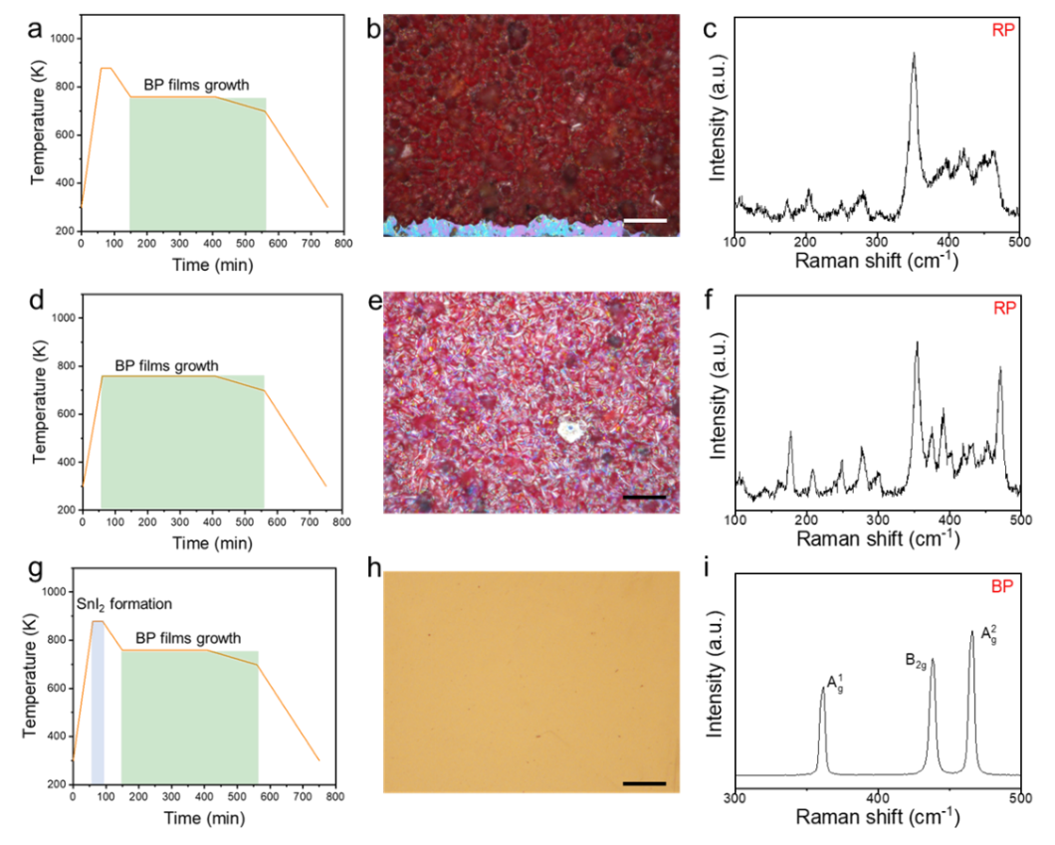
Supplementary Figure 9. Effects of SnI₂ on the growth of BP films. a, d, and g, Temperature program of the BP films growth process, tin iodide layer formation occurs in the 825 K stage. b-c, e-f, and h-i, Representative optical images and corresponding Raman spectra of the products under different growth conditions. When the tin iodide formation stage is present but its source is missing, the product is red phosphorus rather than BP films (b,c). When the tin iodide source is present but its formation stage is missing, the product is red phosphorus rather than BP films (e,f). When both the tin iodide source and its formation stage are present, the product is successfully obtained as a BP film (h,i).

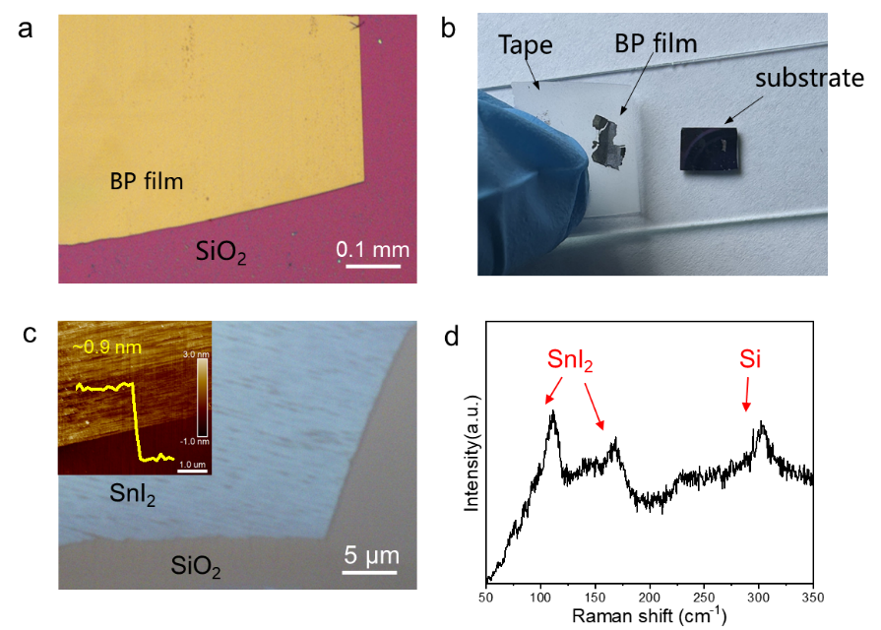
Supplementary Figure 10. Identification of the intermediate SnI₂ layer between the grown BP film and the substrate. a, A typical optical image of a grown BP film. b, Photograph of the BP film peeled off by Scotch tape. b A typical photograph of the re-grown BP film. c, Optical image of the BP film at the edge position. d, Raman spectra of the exposed SnI₂ passivation layer.

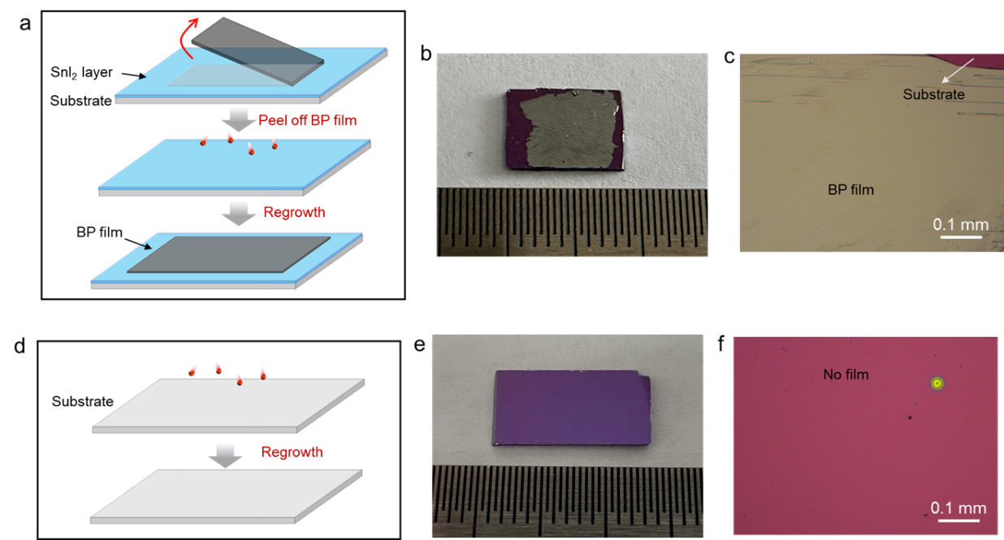

Supplementary Figure 11. Regrowth of BP films with the SnI₂ layer passivation layer. a, Schematic illustration of the removal and regrowth of BP films. The as-grown BP films are peeled off with Scotch tape, which would perfectly maintain the formed buffer layer. b, A typical photograph of the re-grown BP film. c, Optical image of the BP film at the edge position. d-f, Illustration and optical micrographs of BP growth on an unused new substrate; the optical micrographs show no BP film grown on the substrate.

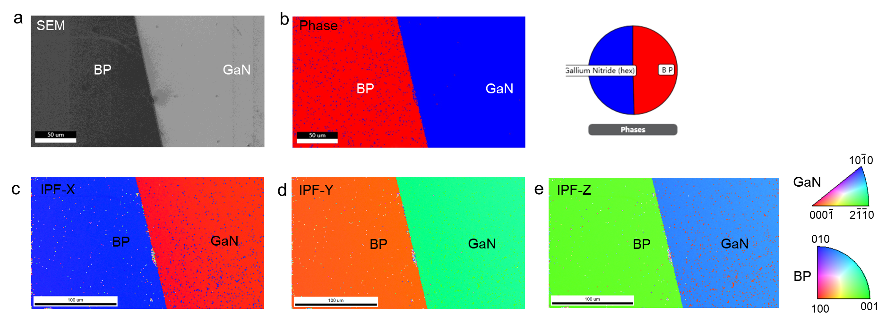
Supplementary Figure 12. Crystalline orientation of BP films and the underlying GaN substrates. a, SEM image of a BP film grown on a Si substrate, which shows the EBSD measured area. b, The phase distribution map. c-e, Inverse pole figures mappings along X, Y and Z directions, respectively.

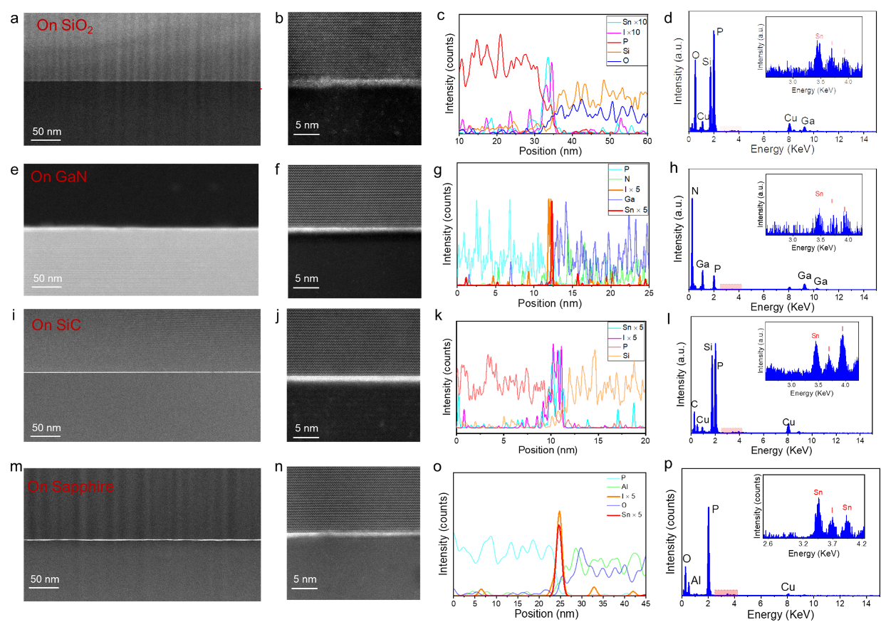
Supplementary Figure 13. Cross-section STEM image of grown BP films and corresponding element distribution by EDS mapping images, showing the existence of I and Sn elements at the interface.

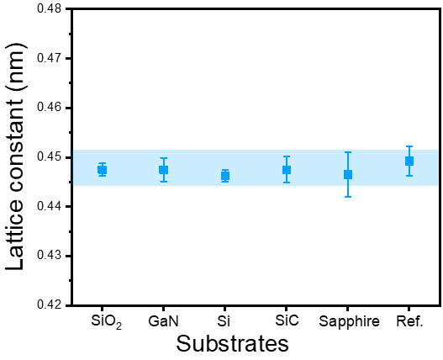
Supplementary Figure 14. Comparison of the lattice constant of the BP films grown on various substrates with the reported reference. The lattice constant [space of BP (001)] is calculated based on the atomic-resolution STEM HAADF images of the hetero-interface between the BP films and the growth substrates.

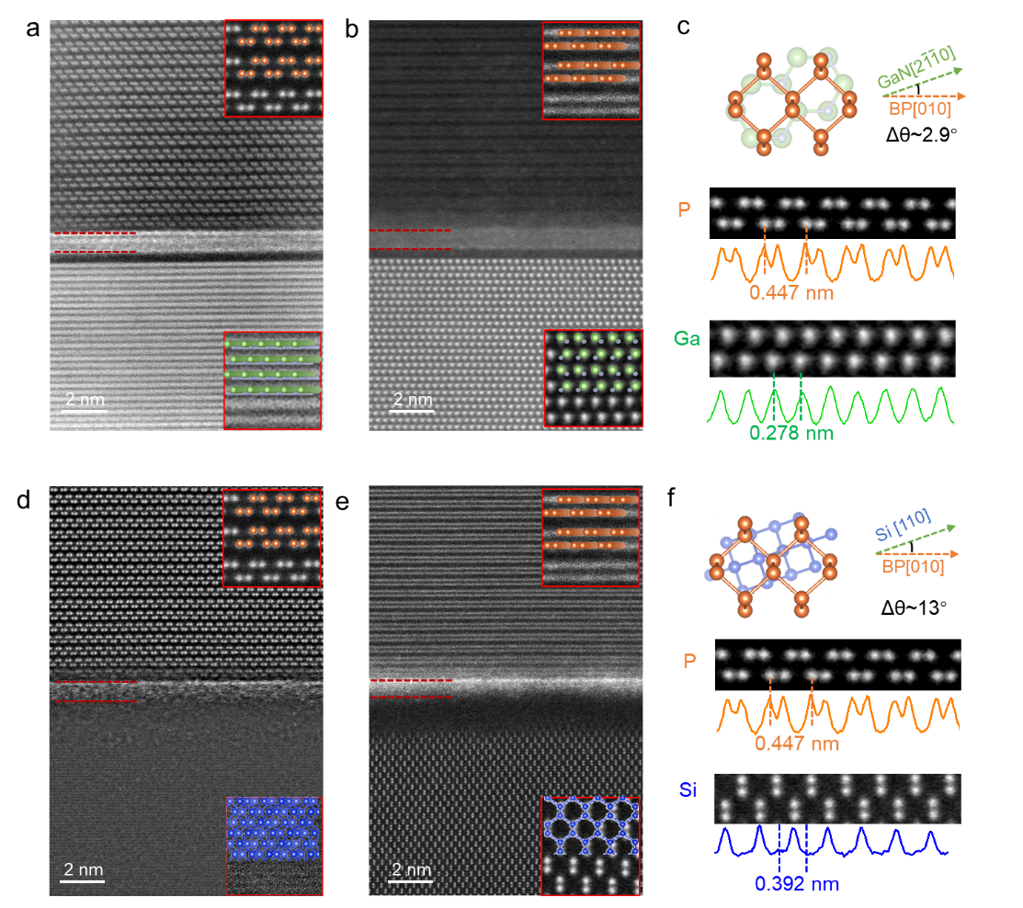

Supplementary Figure 15. Relative rotation angle between BP films and crystal substrate identified by cross-sectional HAADF TEM image. a-b, Cross-sectional HAADF-STEM images at the BP/GaN interface along BP [001] and GaN [2110], respectively. c, A schematic diagram showing that BP [001] has an in-plane rotation of 2.9° relative to GaN [2110] for the sample shown in a and b, the displayed lattice symmetries and constant between the BP films and substrate is shown mismatched. d-f, Cross-sectional HAADF-STEM images at the BP/Si interface along BP [001] and Si[110], respectively. f, A schematic diagram showing that BP [001] has an in-plane rotation of 13° relative to Si[110] for the sample shown in d and e. Both the lattice symmetries and the constants are also mismatched.
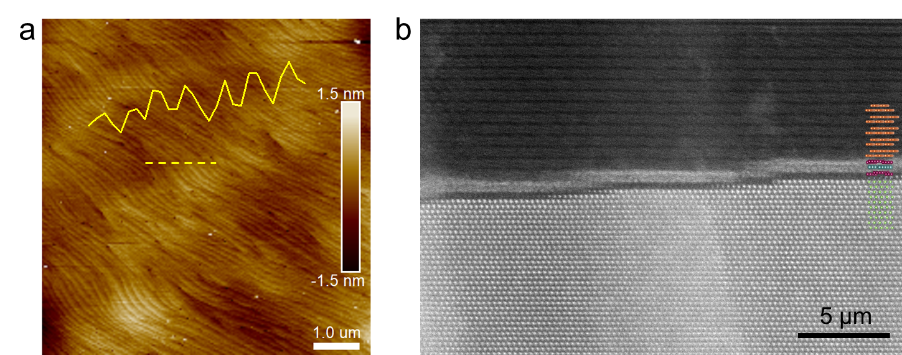
Supplementary Figure 16. Growth of BP films on GaN terraces surface. a, AFM images of the GaN, showing terrace surface morphology with dense atomic steps. b, Cross-sectional HAADF-STEM image features the BP films grown on a terrace-like GaN surface, with a continuous SnI₂ passivation layer.

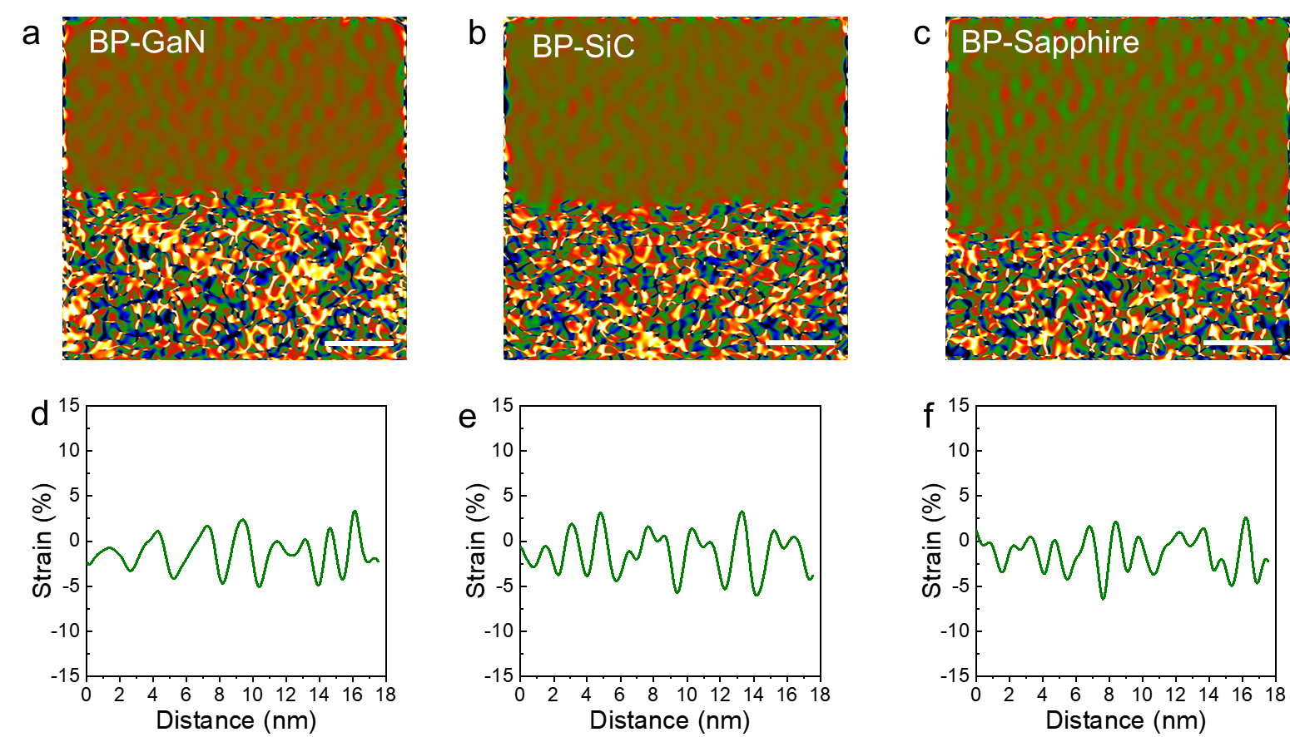
Supplementary Figure 17. a-c, GPA images in xx (ε_{xx}) of the grown BP film on GaN (a), SiC (b), and sapphire substrate (c), respectively. Scale bar, 2 nm. d-f, Corresponding line profile extracted from a-c.

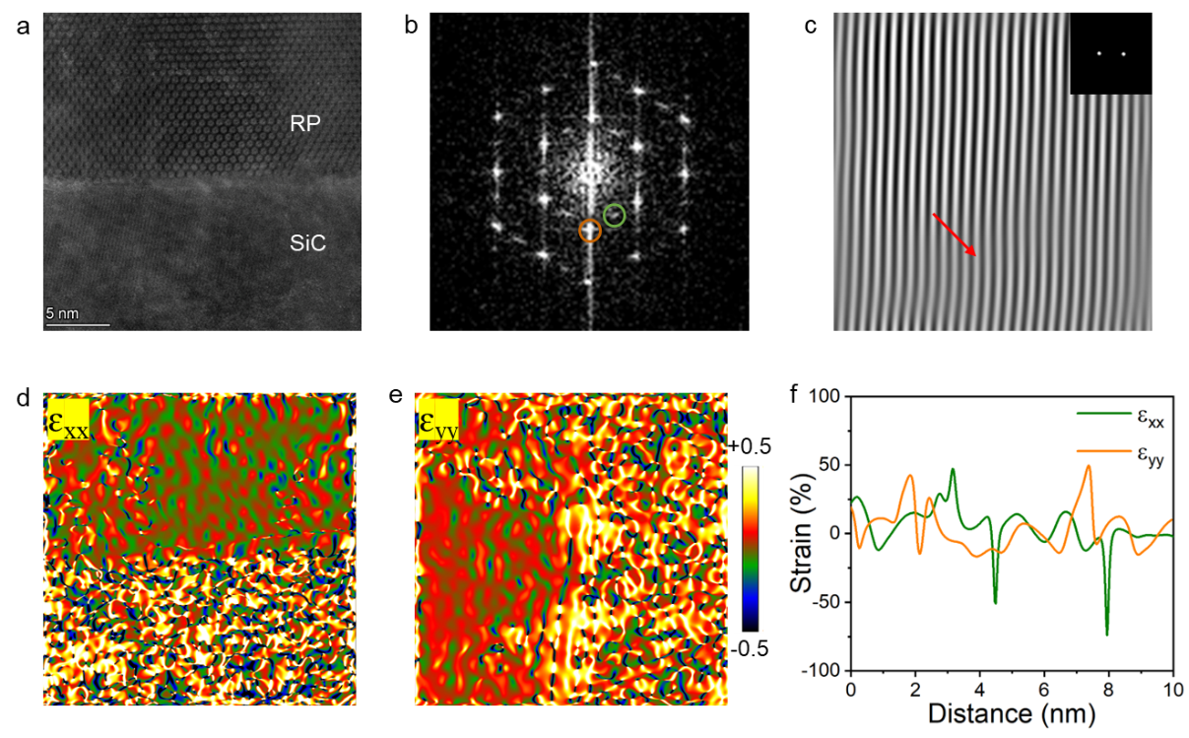
Supplementary Figure 18. The interface dislocation distributed in the interface of red phosphorus and the substrate. a, A HAADF-STEM image of the red phosphorus /4H-SiC interface. b, FFT pattern from the interface region shown in a. c, IFFT images of the red phosphorus, indicating the existence of dislocations (red arrow). d-f, GPA images of the BP films at the interfaces shown in a, and corresponding Strain distribution.

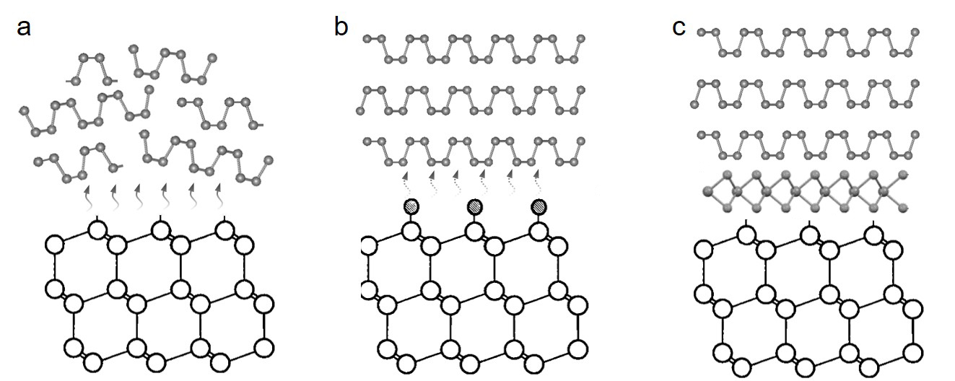
Supplementary Figure 19. Schematics of the growth of BP films on passivated substrates. a, On pristine substrate surfaces, BP nucleation is hardly formed due to the disturbance from the substrate surfaces (such as dangling bonds). b, A schematic of BP film growth on monolayer atoms-passivated substrate. There are two limitations: first, the atoms may not covalently match well with the substrate surface atoms; second, the monolayer may not completely shield the potential field effects from the substrate. c, A schematic of BP film growth on a vdW layer passivated substrate. The SnI₂ triatomic layer’s polar structure can effectively passivate the substrate without the need for covalent matching.

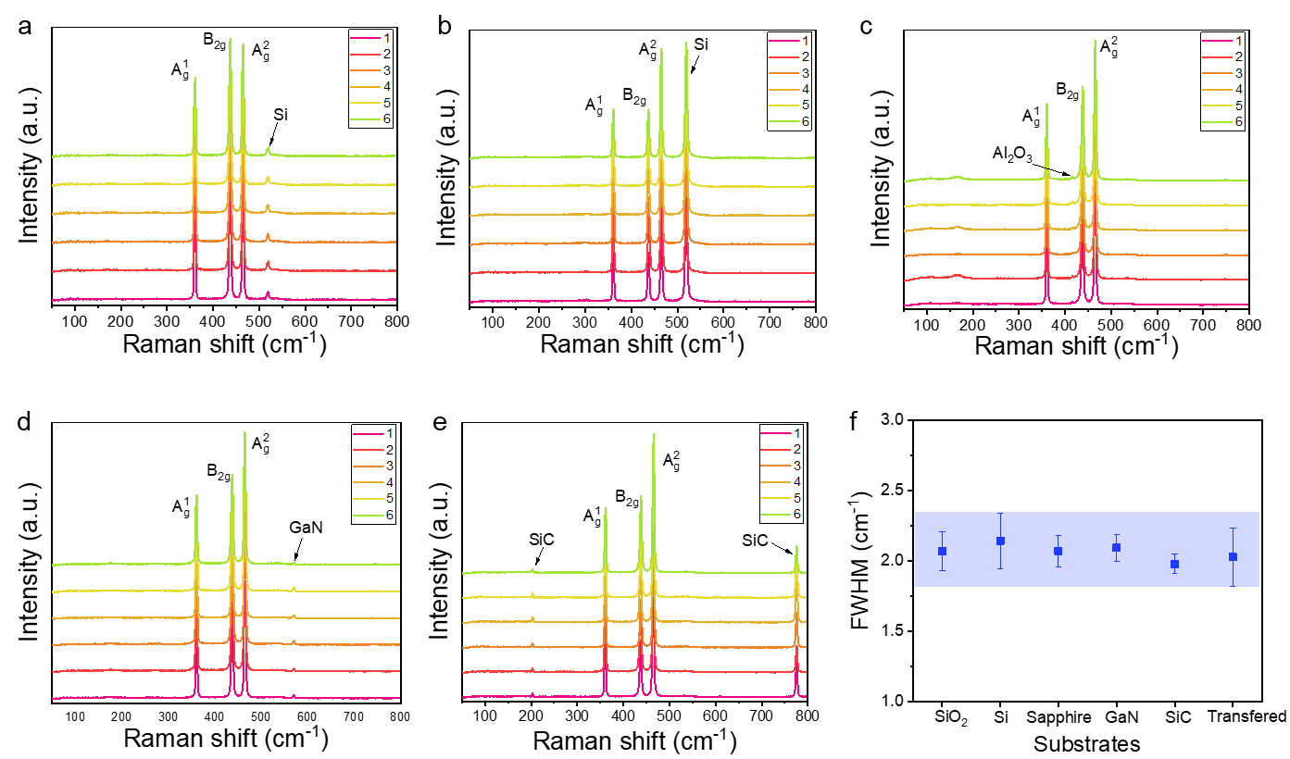 Supplementary Figure 20. Raman spectra of the BP films grown on various substrates. a-e, Raman spectra of the BP films grown SiO₂, Si, sapphire, GaN, 4H-SiC substrates. f, The FWHM comparison of B_{2g} extracted from a-e.

Supplementary Figure 21. Comparison of the PL spectra of the BP film grown on SnI₂ passivated substrate (green line) and that of BP films grown on alloy substrate (blue line). The BP film grown on SnI₂ passivated substrate (Si/SiO₂) exhibits a narrower PL peak.

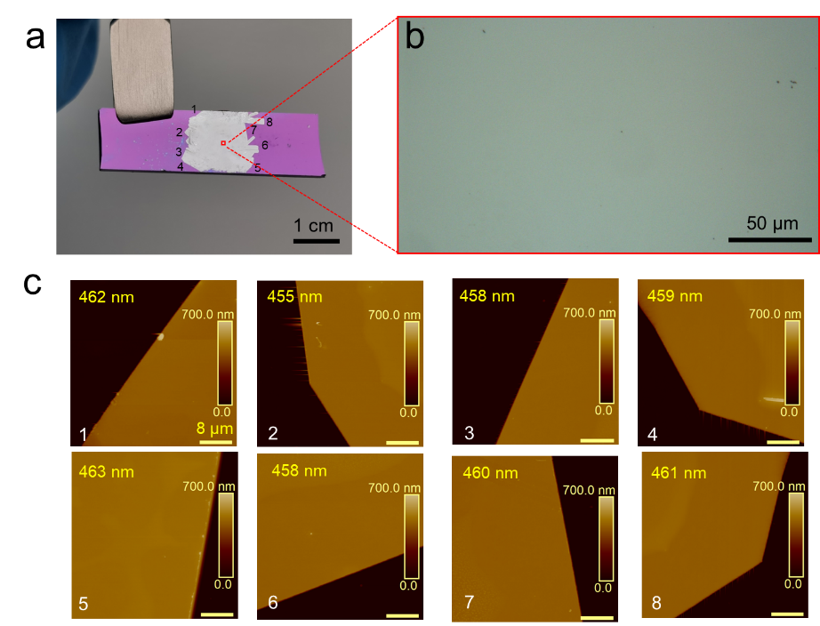
Supplementary Figure 22. The thickness uniformity of as-grown BP films through AFM characterization. a, Photograph of a BP film grown on Si/SiO₂ substrate. b, High-resolution optical image of the central region marked by the red box in a. c, AFM height images taken from the edge location in a, indicating good thickness uniformity across the centimeter-scale film. Scale bar, 8 μm.

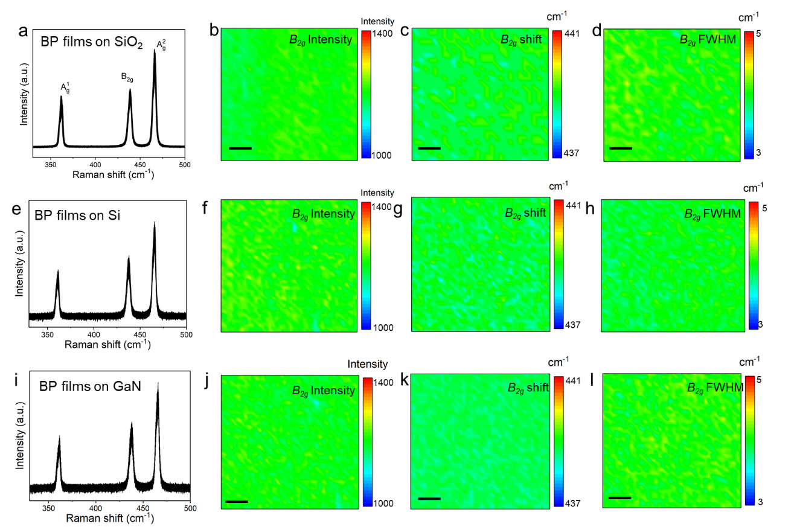
Supplementary Figure 23. Spatial uniformity of as-grown BP films on various passivated substrate through Raman mapping. Scale bar, 10 μm.

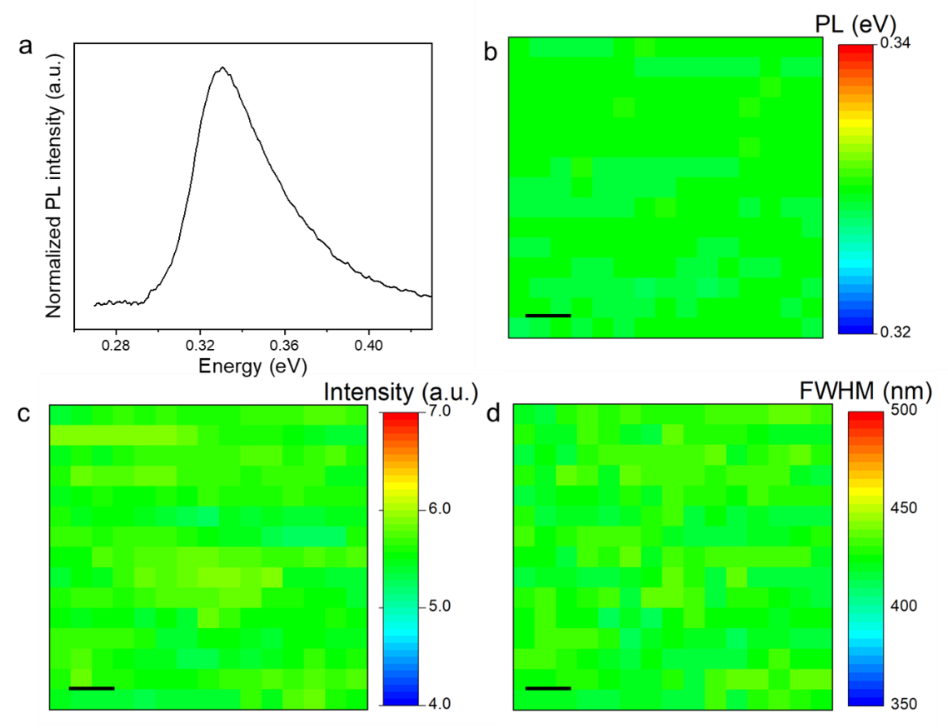
Supplementary Figure 24. Photoluminescence mapping of continuous BP film. a, Normalized PL spectra of the BP films grown on SnI₂ passivated substrate. b-d, PL mapping of the peak energy, intensity, and FWHM, Scale bar, 10 μm.

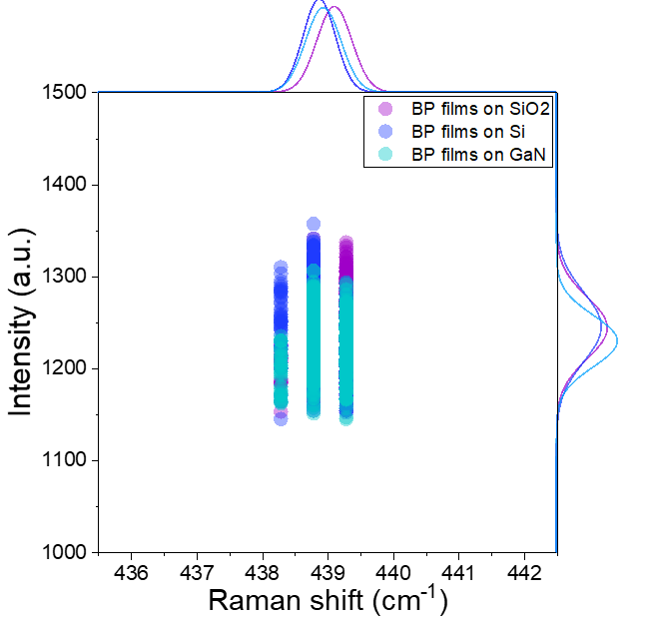
Supplementary Figure 25. Statistical distribution of Raman shift and spectral intensity from 100 Raman spectra of the grown BP films on SiO₂, Si and GaN substrate. The discontinuous intervals along the X-axis for the Raman shift arise from the grating line-density limitation of the used Raman spectroscopy system (the minimum step size is 0.498 cm⁻¹).

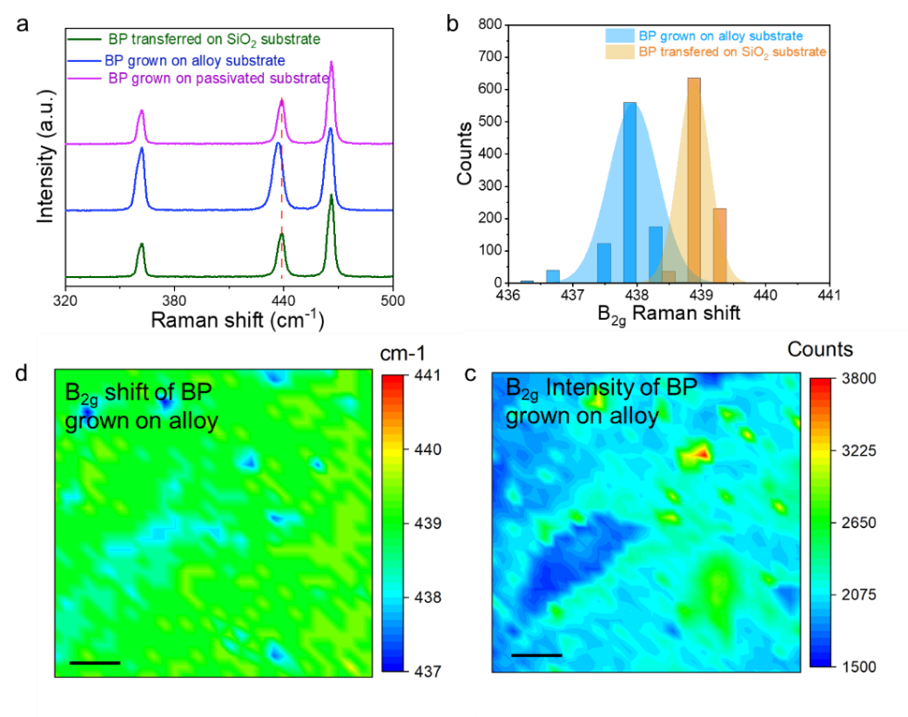
Supplementary Figure 26. Raman characterization of the films grown on the alloy substrate. a, The contrast Raman spectra of BP films transferred on the SiO₂ substrate, grown on alloy substrate, and SnI₂ passivated SiO₂ substrate. The Raman peak of BP films grown on alloy redshifts compared with the transferred BP film. b, The statistical distribution of B_{2g} peak position from 625 spectra compared with that of transferred BP. c and d, Raman mapping of the B_{2g} peak shift and intensity of the BP films grown on alloy substrate.

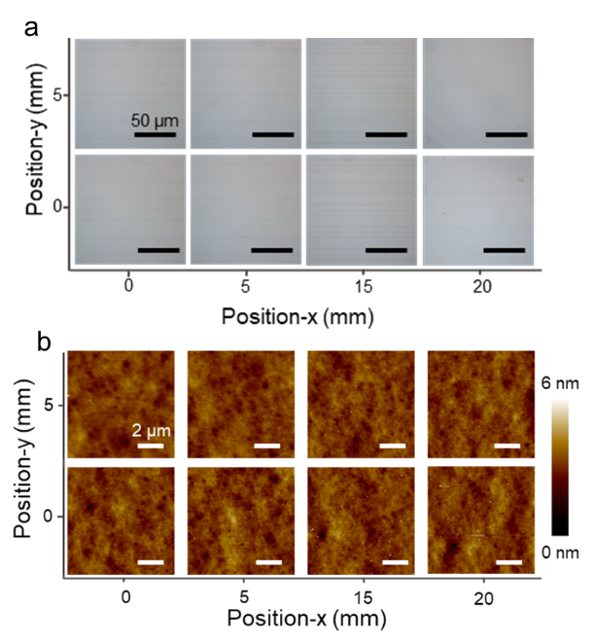
Supplementary Figure 27. Uniformity of continuous BP film demonstrated by morphological characterization. a, Optical images of BP films at 8 different positions at intervals of ~5 mm in distance. b, AFM images taken from each location in a.

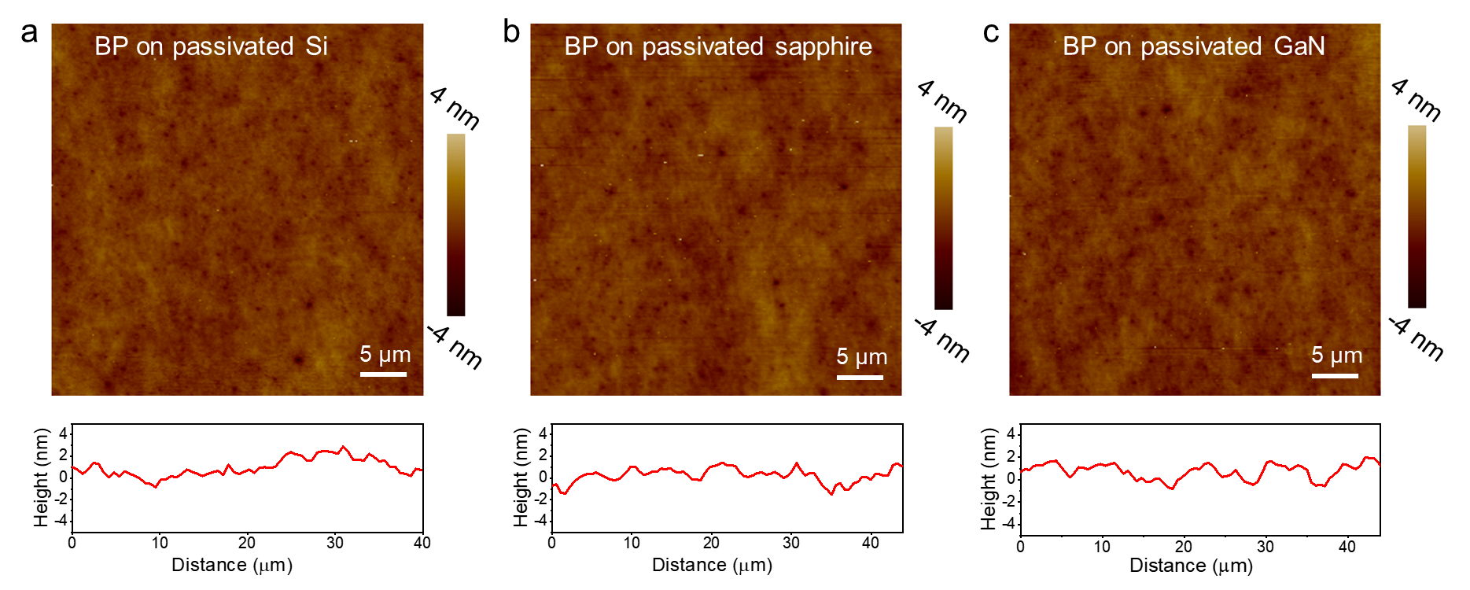
Supplementary Figure 28. The excellent films flatness independent of the growth substrate type. Large-area AFM scans conducted on the BP films grown on Si (a), sapphire (b) and GaN (c) substrates. The AFM morphology mapping and corresponding height profiles indicate that the height variation remains 0.5-1 nm, independent of the growth substrate type.

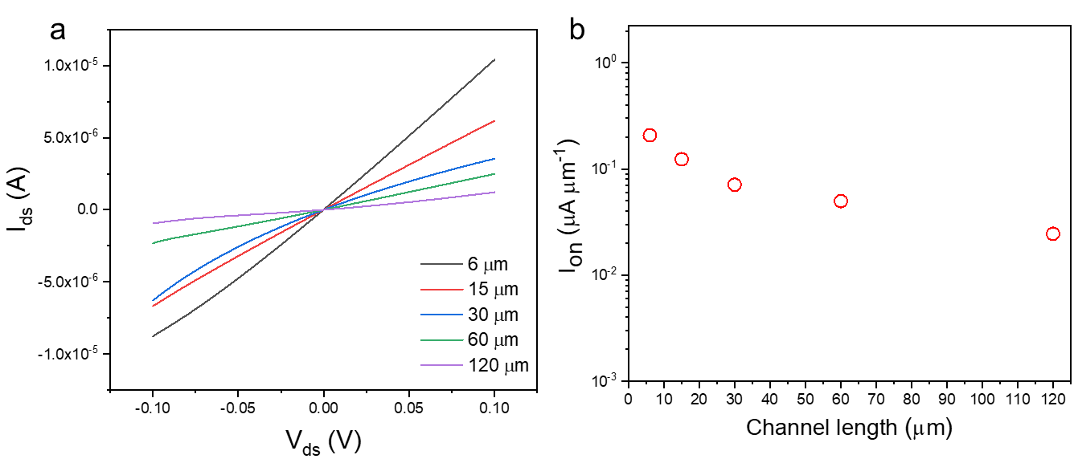
Supplementary Figure 29. Electrical performance of the BP FETs. a, I-V curves of the devices with different channel lengths. b, The measured on-current at different channel lengths.

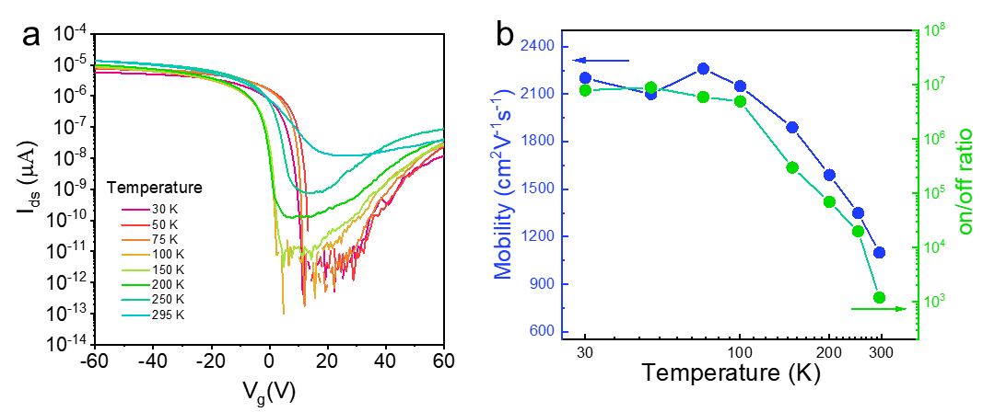
Supplementary Figure 30. Temperature-dependent FET behavior of the BP film sample. a, Transfer curves (I_{ds} versus V_{g}) of the BP device under different temperatures, exhibiting an ambipolar transport behaviour and a large on/off ratio. b, Hole carrier mobility and current on/off ratio versus the temperature of the device.

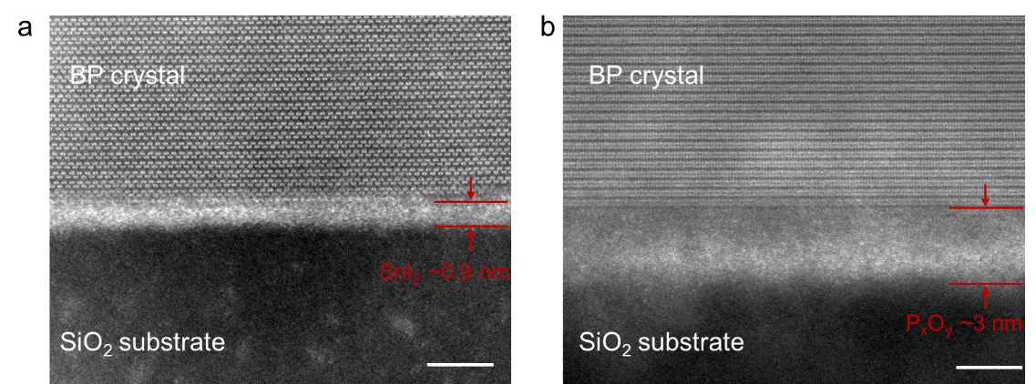
Supplementary Figure 31. STEM images comparing the atomic arrangement at the film-substrate interface of the directly grown BP films (a) and transferred BP films(b). Scale bar, 2 nm.

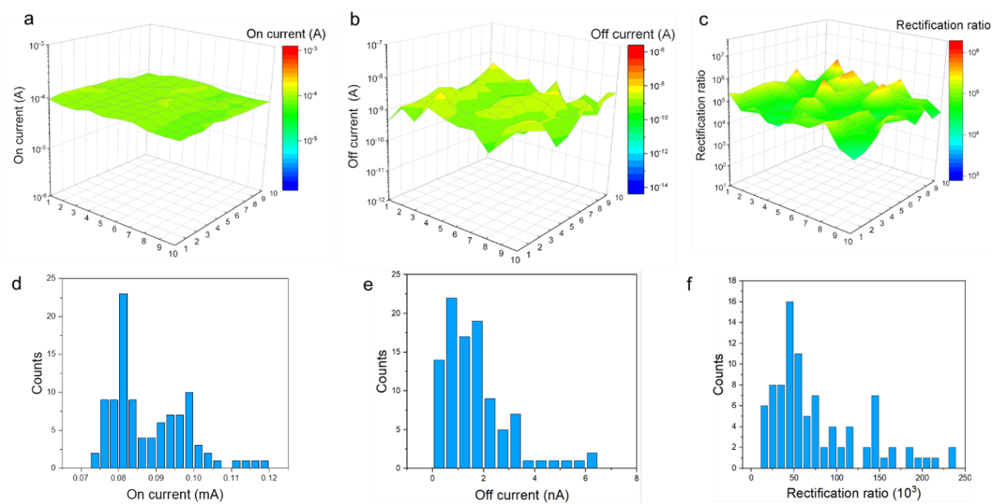
Supplementary Figure 32. Statistical analysis of the electrical characteristics of the BP/Si heterojunction device array. a-c, Spatial distribution of on-current, off-current, and rectification ratio extracted from the I-V curves of a 10×10 heterojunction device array, all exhibiting relatively narrow distribution as shown in d-f.

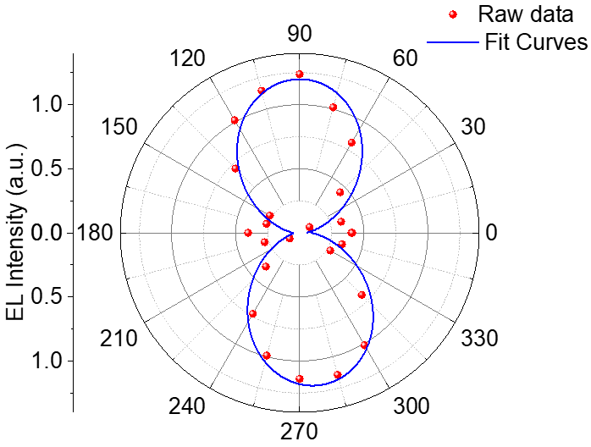
Supplementary Figure 33. Polarized electroluminescence of BP/Si heterojunction. Polar plot of EL intensity of the heterojunction as a function of rotation angle, shows a degree of polarization of 91.1% with polarization direction along with the armchair direction of BP.

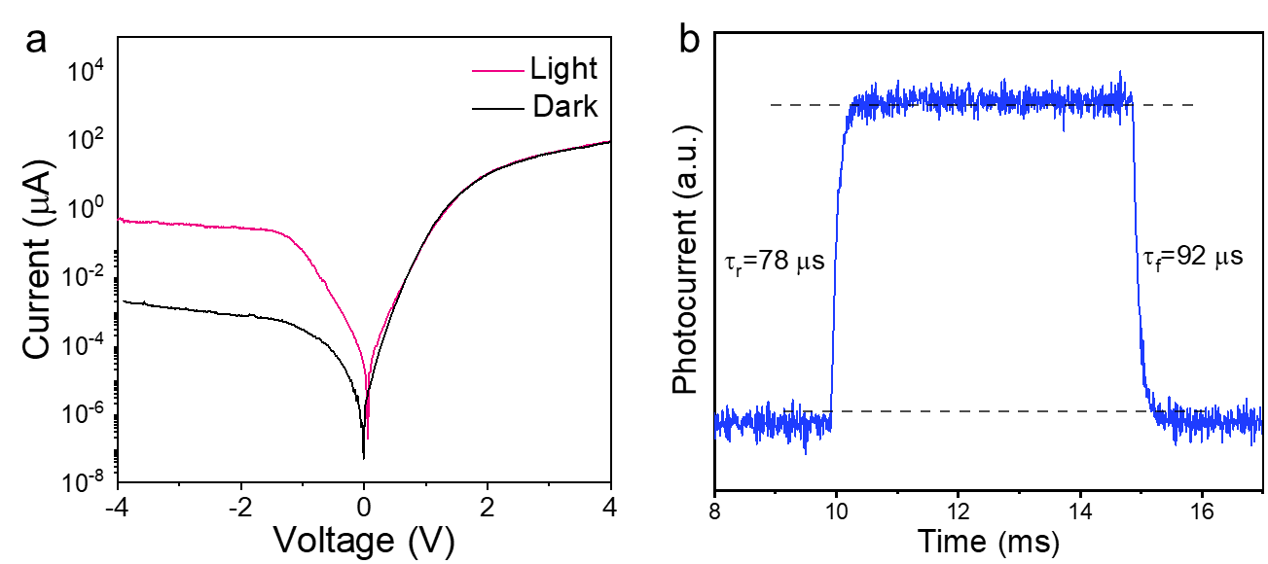
Supplementary Figure 34. Photoresponse of BP/Si heterojunction photodiode. a, The compared I–V curves of the BP/Si heterojunction photodiode in the dark and under light illumination (1550nm), indicating obvious photoresponse current. b, Rising and falling edges for estimating the rise time and the fall time.

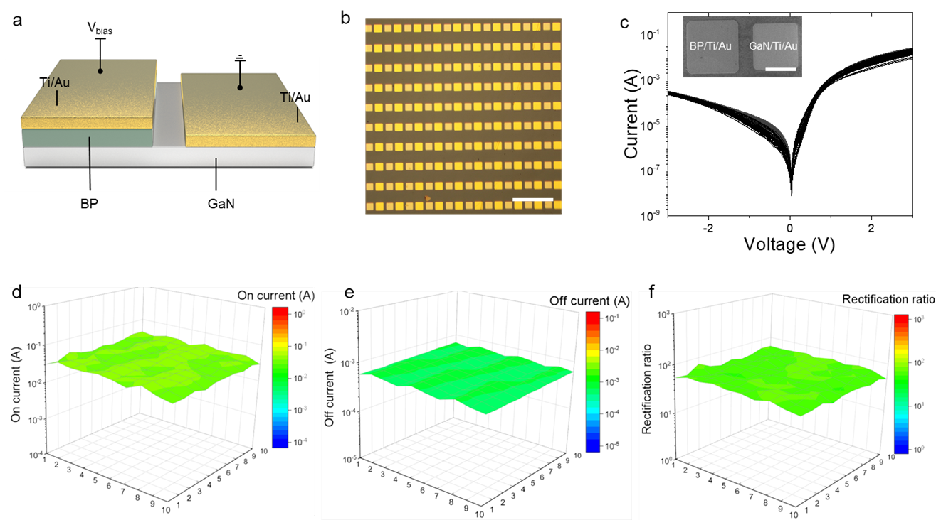
Supplementary Figure 35. Statistical analysis of the electrical characteristics of the BP/GaN heterojunction device array. a, Schematic diagram of the vertical p–n heterojunction fabricated based on the grown BP films on the GaN substrate. b, Optical image of 10×10 BP/GaN vertical heterojunction array. Scale bar, 500 μm. c, I–V curves of the 100 p–n heterojunctions. The inset shows a typical SEM image of the fabricated heterojunction. Scale bar, 50 μm. d-f, Spatial distribution of on-current, off-current, and rectification ratio extracted from the I-V curves of 10×10 heterojunction devices, all showing a relatively narrow distribution.

