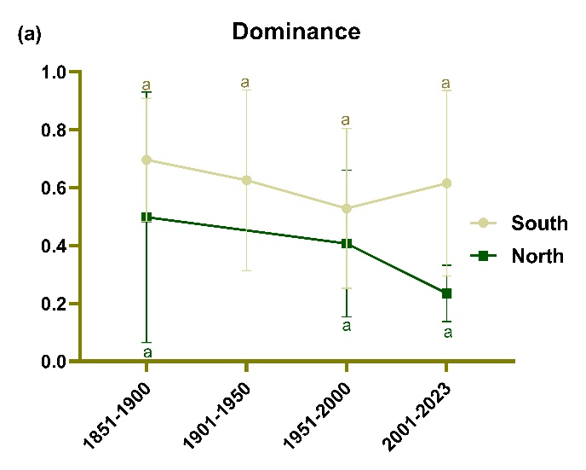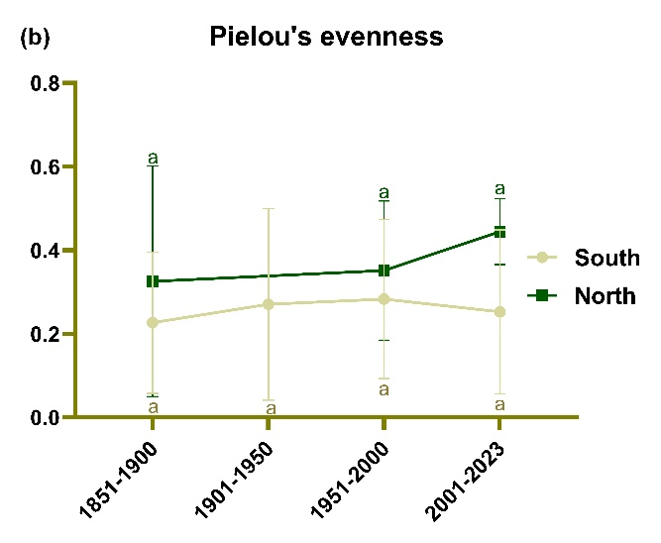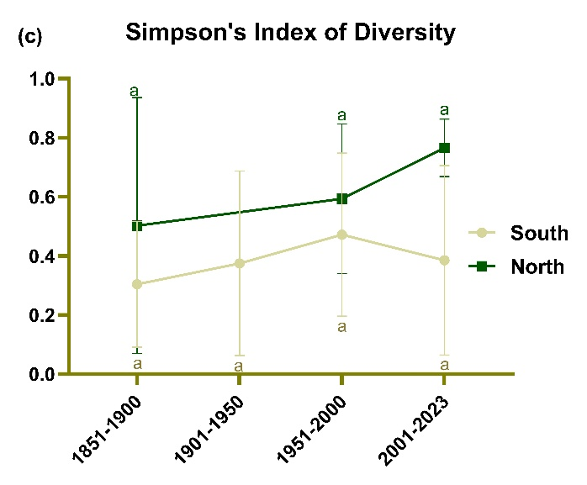
Figure S1 The alpha diversity indices of fungal community from south and north in 50-year groups. Letters above the column represent the significant difference (P < 0.05) among groups.

