Supplementary Information

Tables
Table S1 – Details of funding sources and weighting of workload measures in the LLR funding formula.
Scope of Formula | Components of Formula | Component Description | % Distribution
In scope  Global sum  CCG discretionary  Local enhanced services  Prescribing incentive Scheme  Miscellaneous | Core funding component | A fixed sum of 48% of a practice’s existing Carr-Hill Global Sum | 41.2% of in scope  (27.1% of in + out of scope)
 | Needs-based funding component | - Case mix adjusted, coding adjusted expected relative service activity, then  - Further adjustment for patient turnover, then  - Further communications adjustment | 52.9% of in scope  (34.8% of in + out of scope)
 | Deprivation component | Based on practice level Index of Multiple Deprivation derived from postal code areas of registered patients | 5.9% of in scope  (3.8% of in + out of scope)
Out of scope  QOF income  DES  Primary Care Network |  | Paid on existing arrangements | (34.3% of in + out of scope)
Outside scope discussion (by unanimous agreement)  Premises  Prescribing | Premises funding unsuitable for this process  Prescribing too destabilizing a risk at practice level | Paid on existing arrangements | N/A

Table S2- estimates of additional staffing FTEs afforded by average Health Equity Payment
Occupation | Estimated total cost to employ per annum | Estimated additional FTE based on average payment of £48,000 per year
Entry-level receptionist (Band 2) | £30,270 | 1.6
Care Navigator (Band 2) | £30,270 | 1.6
Experienced receptionist (Band 3) | £30,854-32,909 | 1.5-1.6
Staff nurse (Band 5) | £38,416-46,764 | 1-1.3
Senior practice nurse (Band 6) | £47,860-57,632 | 0.8-1
Advanced nurse practitioner (Band 7) | £59,153-67,691 | 0.7-0.8
Salaried GP | £93,718-141,41 | 0.3-0.5
GP trainee (ST1-8) | £63,973-90,271 | 0.5-0.8
N.B. These estimates are based on NHS Agenda for Change salaries as at 2024, with additional costs of National Insurance contributions and pension contributions. Other costs would be incurred by practices to employ staff such as training but these are not included as this is indicative only.

Table S3 - HEP funding bands for LLR practices
Category | Under LLR model, how much did they gain? | Under a redistributive model, how much would they gain/lose?
1 | >9.6% of core funding | Gain >9.6% of core funding
2 | 6.4-9.6% of core funding | Gain 6.4-9.6% of core funding
3 | 3.2-6.4% of core funding | Gain 3.2-6.4% of core funding
4 | 0-3.2% of core funding | Gain 0-3.2% of core funding
5 | 0 | Lose 0-3.2% of core funding
6 | 0 | Lose 3.2-6.4% of core funding
7 | 0 | Lose 6.4-9.6% of core funding
8 | 0 | Lose >9.6% of core funding

Table S4 – contextual information about comparator ICSs
Integrated care system | Why did we select this ICS? | Percentage of LSOAs that are urban | Percentage of LSOAs in the most deprived quintile
Leicester, Leicestershire and Rutland | (reference) | 75.89 | 12.27
Coventry & Warwickshire | Similar overall distribution of LSOAs classified as urban and in the most deprived quintile | 80.24 | 13.48
Derby & Derbyshire | Similar geography to LLR – a more deprived city (Derby) surrounded by less deprived, more rural areas. | 75.92 | 17.91
Humber & North Yorkshire | Similar overall distribution of LSOAs classified as urban and in the most deprived quintile | 64.71 | 18.68
Lancashire & South Cumbria | Similar overall distribution of LSOAs classified as urban, although more LSOAs in the most deprived quintile | 80.19 | 29.68
Lincolnshire | Similar overall distribution of LSOAs in the most deprived quintile, although fewer classified as urban | 53.83 | 15.48
North East & North Cumbria | Similar overall distribution of LSOAs classified as urban, although more LSOAs in the most deprived quintile | 78.37 | 32.51
Nottingham & Nottinghamshire | Similar geography to LLR – a more deprived city (Nottingham) surrounded by less deprived, more rural areas | 80.15 | 26.95
South Yorkshire | Similar geography to LLR – a more deprived city (Sheffield) surrounded by less deprived, more rural areas | 90.90 | 36.69
Staffordshire & Stoke-on-Trent | Similar overall distribution of LSOAs classified as urban and in the most deprived quintile | 83.33 | 19.07
West Yorkshire | Similar geography to LLR – a more deprived city (Leeds) surrounded by less deprived, more rural areas | 89.08 | 35.14

Table S5. Practice characteristics in LLR prior to commencement of HEP (June 2021, Q2 2021 staffing outcomes, 2022 GPPS survey, 2021/22 QOF year), stratified by deprivation quintile
 | 1 – Most deprived  (N = 11) | 2  (N = 34) | 3  (N = 9) | 4  (N = 27) | 5 – Least deprived  (N = 37)
List size | 9,263 (3,699) | 7,339 (5,004) | 10,779 (4,914) | 9,980 (6,282) | 9,417 (4,800)
% patients male | 49.98 (1.01) | 52.48 (2.61) | 50.62 (1.12) | 49.83 (0.95) | 49.32 (1.02)
% patients over 65 | 11.05 (3.07) | 10.64 (3.75) | 16.27 (5.29) | 19.32 (2.84) | 20.84 (3.18)
% local population white | 64.26 (17.39) | 35.15 (21.39) | 75.12 (17.47) | 85.97 (17.12) | 87.72 (13.85)
% local population who do not speak English | 4.56 (3.73) | 10.67 (5.75) | 2.37 (1.80) | 1.19 (1.35) | 0.56 (0.60)
% local population with English as a second language | 23.21 (12.33) | 42.31 (14.64) | 13.91 (9.13) | 7.41 (7.22) | 4.63 (4.55)
% local population living rurally | 0.27 (0.55) | 0.34 (0.52) | 2.15 (2.44) | 20.35 (31.60) | 44.36 (38.87)
Sub-ICB, n (%)
East Leicestershire & Rutland | 0 (0%) | 0 (0%) | 1 (11%) | 5 (19%) | 20 (54%)
Leicester City | 11 (100%) | 33 (97%) | 1 (11%) | 2 (7.4%) | 0 (0%)
West Leicestershire | 0 (0%) | 1 (2.9%) | 7 (78%) | 20 (74%) | 17 (46%)
% received funding in 2021/22, n (%) | 8 (73%) | 22 (65%) | 6 (67%) | 20 (74%) | 15 (41%)
FTE GPs (excluding training) per 1,000 weighted patients | 0.42 (0.16) | 0.47 (0.20) | 0.49 (0.07) | 0.47 (0.14) | 0.59 (0.33)
Missing | 0 | 0 | 1 | 0 | 0
FTE nurses per 1,000 weighted patients | 0.22 (0.09) | 0.18 (0.11) | 0.27 (0.11) | 0.27 (0.10) | 0.26 (0.11)
Missing | 0 | 7 | 0 | 1 | 0
FTE administrative staff per 1,000 weighted patients | 1.14 (0.28) | 1.19 (0.39) | 1.40 (0.36) | 1.20 (0.33) | 1.14 (0.29)
Missing | 1 | 2 | 0 | 0 | 0
Weighted % responses ‘Good’ or ‘Very Good’ on the question “Overall experience of making an appointment” | 46.98 (14.74) | 54.66 (13.88) | 49.35 (15.21) | 55.01 (14.69) | 62.74 (15.71)
Weighted % responses ‘Good’ or ‘Very Good’ on the question “Overall experience of GP practice” | 62.81 (12.56) | 68.12 (10.83) | 62.94 (14.67) | 70.45 (13.10) | 77.17 (11.85)
Weighted % responses ‘Yes, definitely’ or ‘Yes, to some extent’ on the question “Thinking about the reason for your last general practice appointment, were your needs met?” | 85.69 (5.59) | 87.13 (6.48) | 88.71 (2.18) | 90.34 (5.59) | 93.02 (4.35)
% of available QOF achievement points | 89.30 (4.93) | 89.78 (5.38) | 91.61 (4.05) | 94.43 (4.58) | 95.38 (3.80)
Mean (SD) unless otherwise specified

Table S6. Practice characteristics in LLR prior to commencement of HEP (June 2021, Q2 2021 staffing outcomes, 2022 GPPS survey, 2021/22 QOF year) stratified by Sub-ICB
 | East Leicestershire & Rutland  (N = 26) | Leicester City  (N = 47) | West Leicestershire  (N = 45)
List size | 11,644 (6,702) | 8,004 (5,136) | 8,608 (3,680)
% patients male | 49.28 (0.78) | 51.77 (2.57) | 49.90 (1.13)
% patients over 65 | 21.18 (3.02) | 10.87 (4.19) | 19.13 (2.85)
% local population white | 83.89 (15.71) | 41.94 (23.32) | 88.72 (12.18)
% local population who do not speak English | 0.86 (0.84) | 9.01 (5.84) | 0.92 (1.15)
% local population with English as a second language | 6.41 (5.59) | 37.29 (15.97) | 6.03 (6.05)
% local population living rurally | 33.94 (36.64) | 0.35 (0.64) | 29.46 (37.50)
IMD quintile
1 – Most deprived | 0 (0%) | 11 (23%) | 0 (0%)
2 | 0 (0%) | 33 (70%) | 1 (2.2%)
3 | 1 (3.8%) | 1 (2.1%) | 7 (16%)
4 | 5 (19%) | 2 (4.3%) | 20 (44%)
5 – Least deprived | 20 (77%) | 0 (0%) | 17 (38%)
% received funding | 11 (42%) | 31 (66%) | 29 (64%)
FTE GPs (excluding training) per 1,000 weighted patients | 0.63 (0.36) | 0.46 (0.19) | 0.48 (0.14)
Missing | 0 | 0 | 1
FTE nurses per 1,000 weighted patients | 0.27 (0.12) | 0.20 (0.11) | 0.26 (0.10)
Missing | 0 | 7 | 1
FTE administrative staff per 1,000 weighted patients | 1.23 (0.32) | 1.18 (0.36) | 1.18 (0.32)
Missing | 0 | 3 | 0
Weighted % responses ‘Good’ or ‘Very Good’ on the question “Overall experience of making an appointment” | 59.33 (17.38) | 53.36 (14.27) | 57.24 (15.32)
Weighted % responses ‘Good’ or ‘Very Good’ on the question “Overall experience of GP practice” | 74.12 (14.35) | 67.62 (11.59) | 71.68 (13.12)
Weighted % responses ‘Yes, definitely’ or ‘Yes, to some extent’ on the question “Thinking about the reason for your last general practice appointment, were your needs met?” | 92.22 (5.93) | 87.08 (6.24) | 90.98 (4.34)
% of available QOF achievement points | 94.32 (4.68) | 89.90 (5.29) | 94.67 (4.06)
Mean (SD) unless otherwise specified

Figures

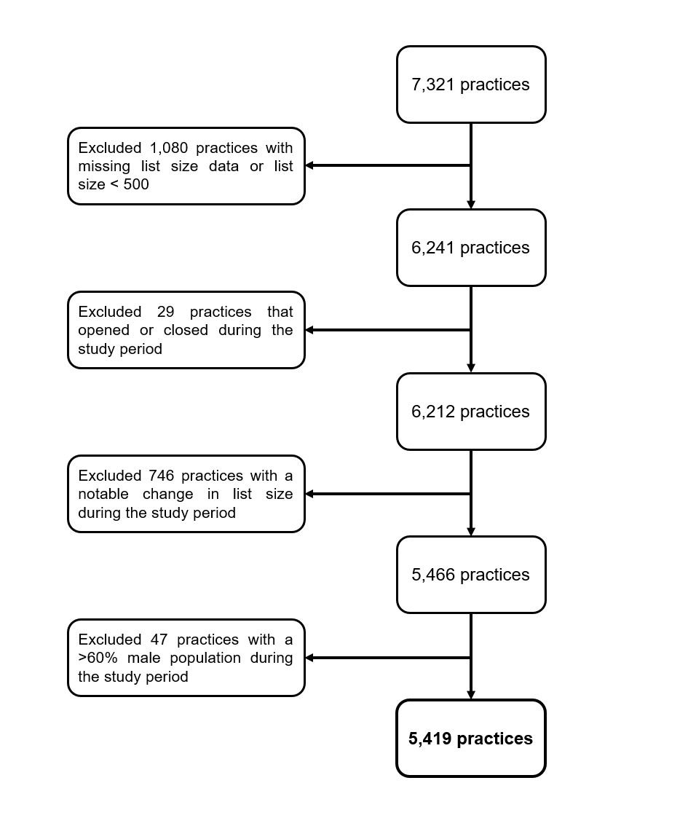

Figure S1. Flow diagram of practice exclusions
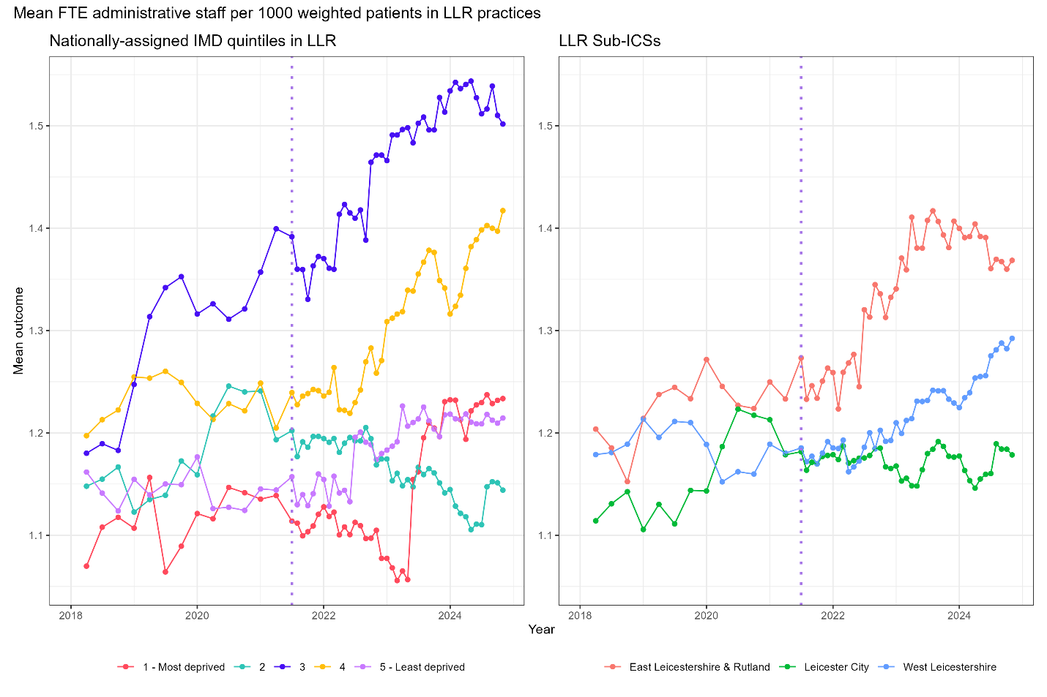
Figure S2- time series plot of mean FTE administrative staff per 1000 weighted patients in LLR practices for nationally-assigned deprivation quintiles in LLR and LLR sub-ICBs
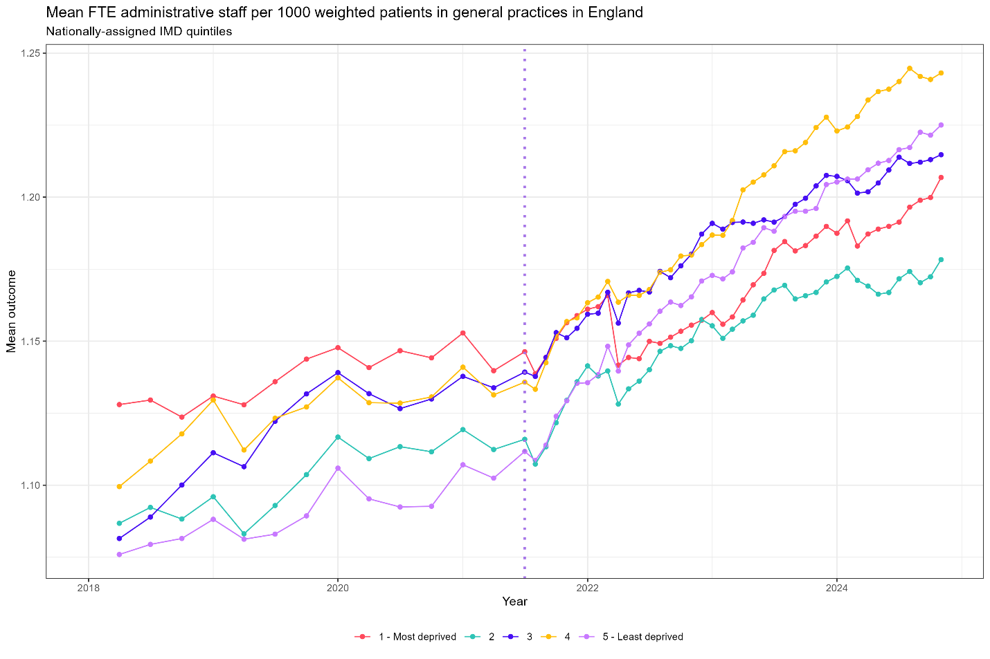
Figure S3- time series plot of mean FTE administrative staff per 1000 weighted patients for all GP practices in England using nationally-assigned deprivation quintiles

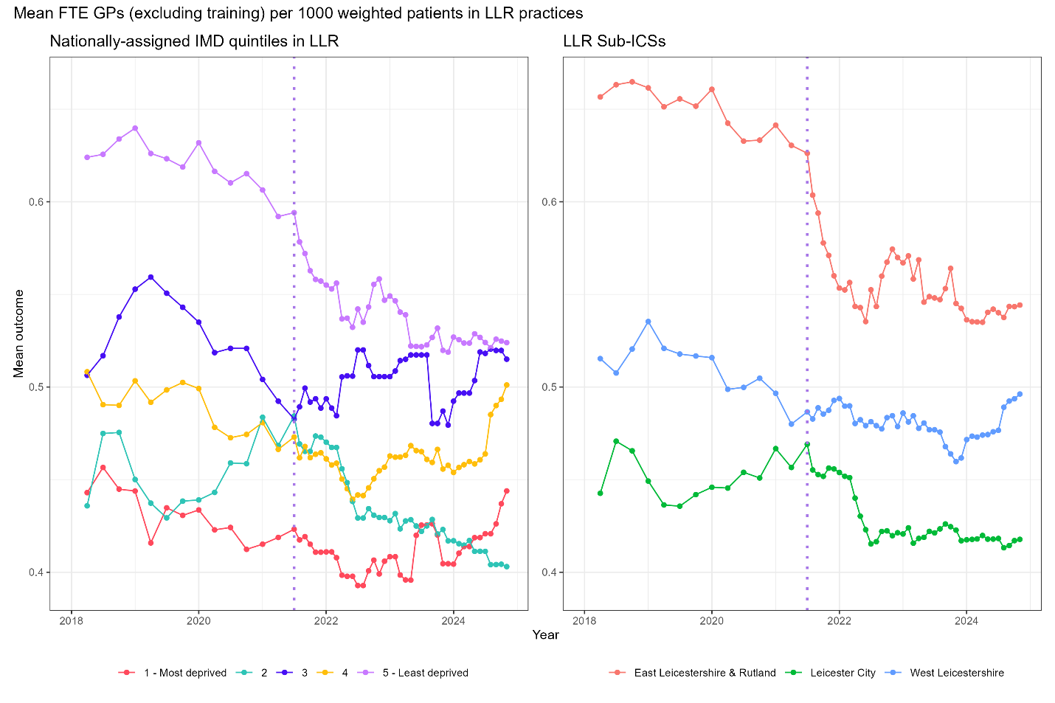
Figure S4- time series plot of mean FTE GPs (excluding training) per 1000 weighted patients in LLR practices for nationally-assigned deprivation quintiles in LLR and LLR sub-ICBs

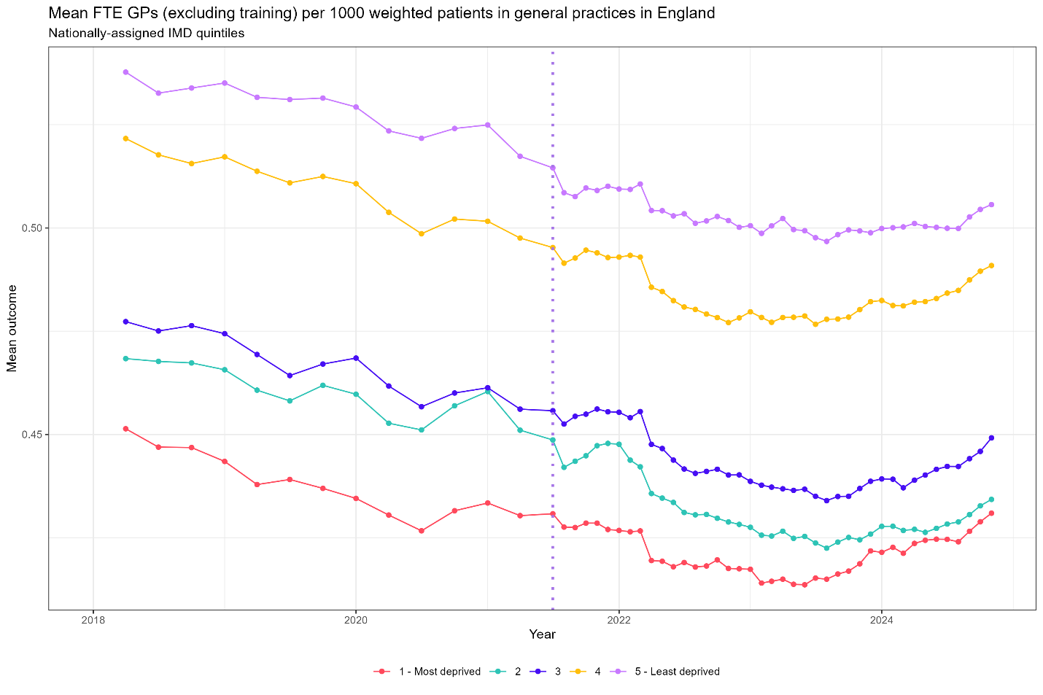
Figure S5- time series plot of mean FTE GPs (excluding training) per 1000 weighted patients for all GP practices in England using nationally-assigned deprivation quintiles

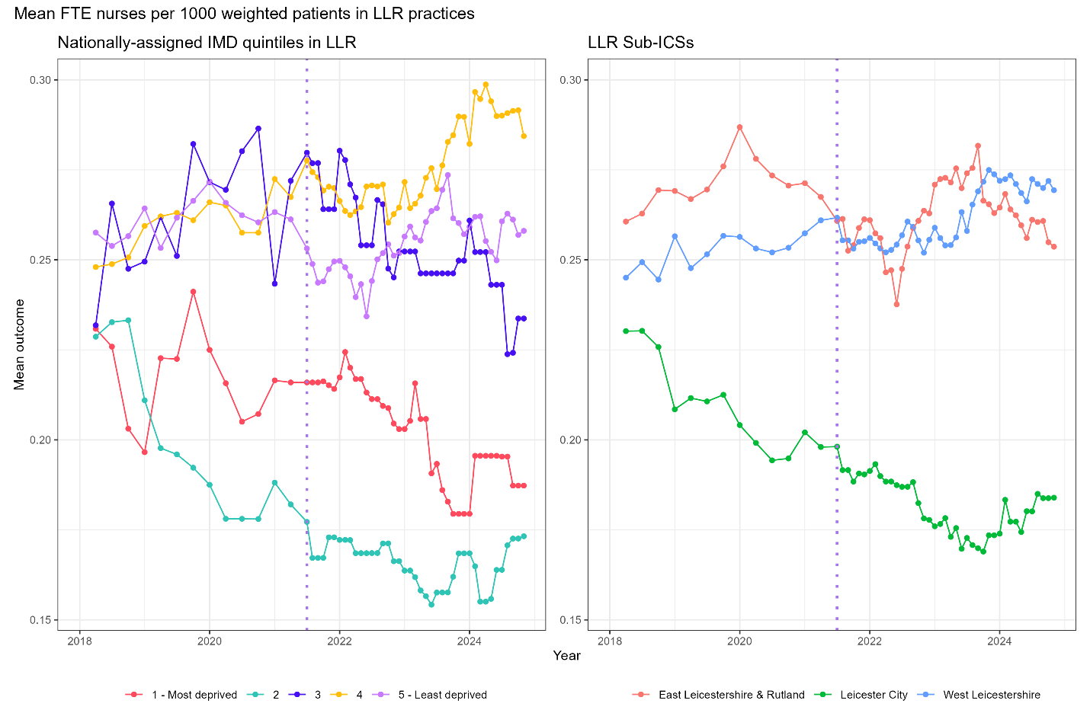
Figure S6- time series plot of mean FTE nurses per 1000 weighted patients in LLR practices for nationally-assigned deprivation quintiles in LLR and LLR sub-ICBs

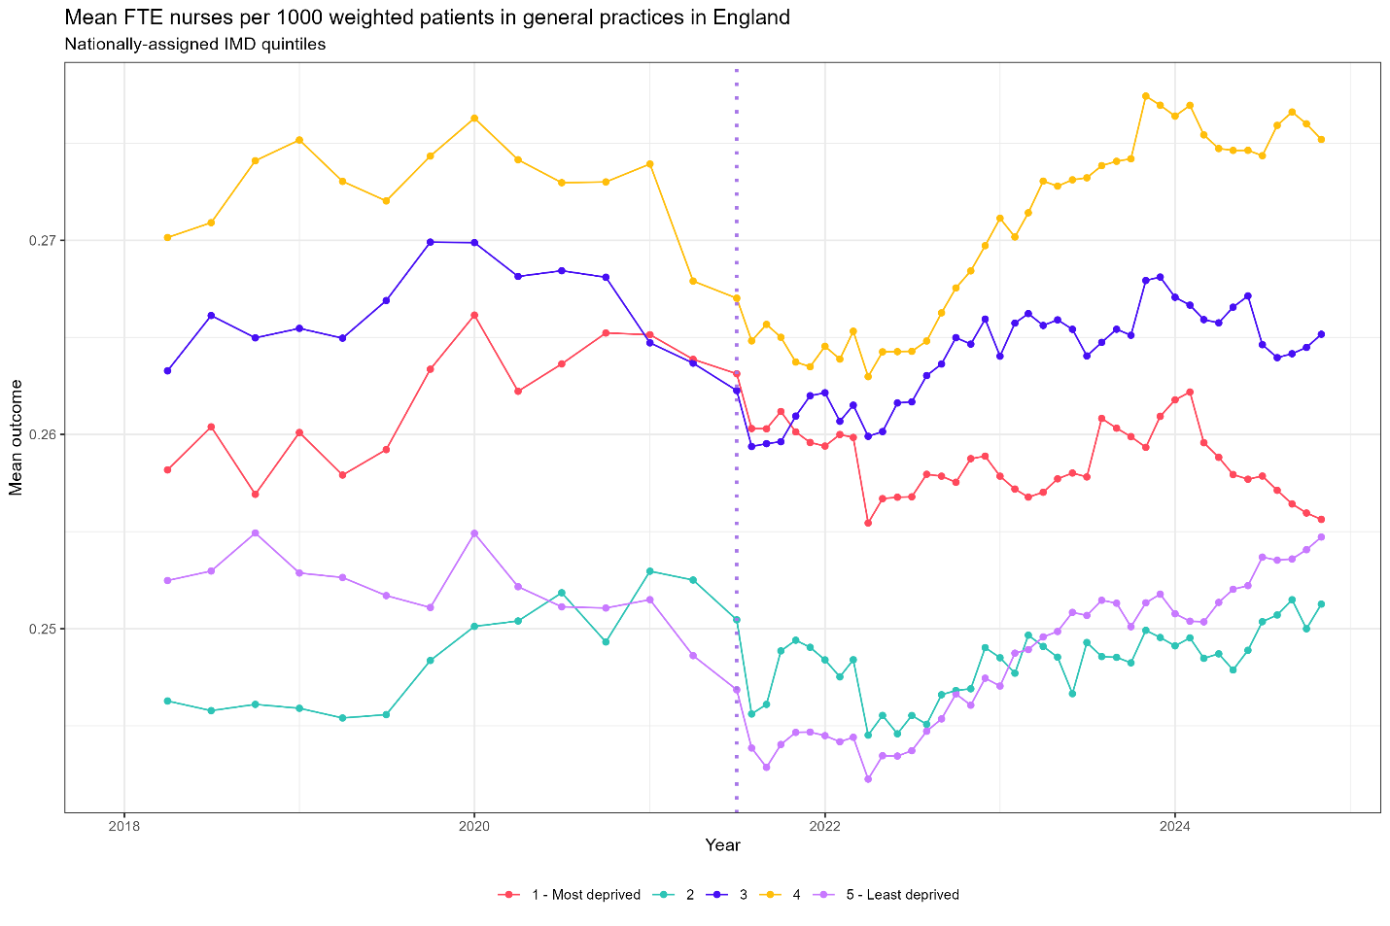
Figure S7- time series plot of mean FTE nurses per 1000 weighted patients for all GP practices in England using nationally-assigned deprivation quintiles

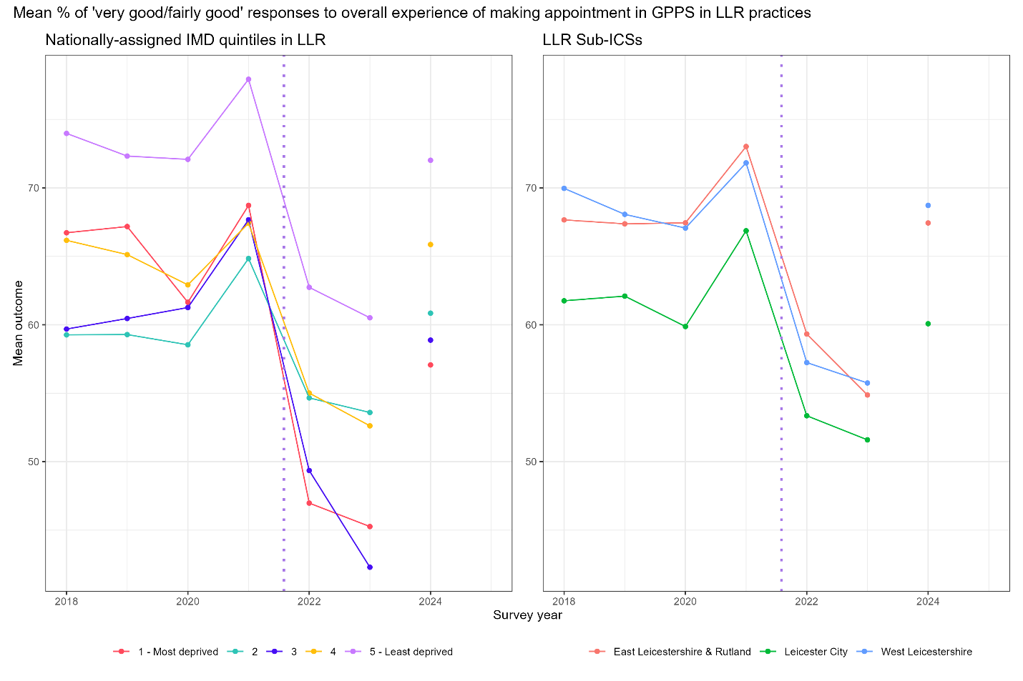
Figure S8- time series plot of mean percentage of ‘very good/ fairly good’ responses to overall experience of making an appointment in LLR practices for nationally-assigned deprivation quintiles in LLR and LLR sub-ICBs

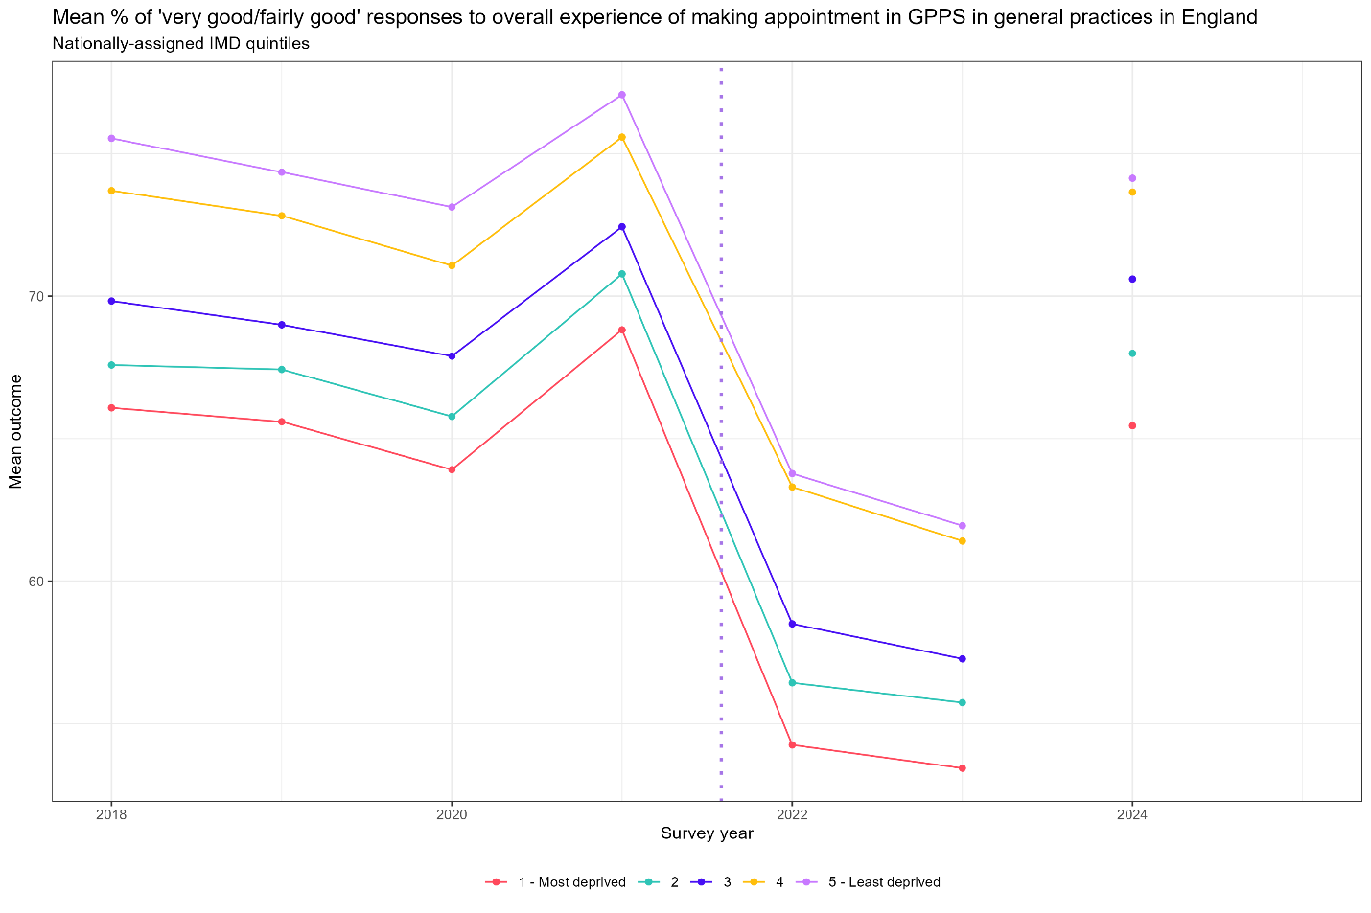
Figure S9- time series plot of mean percentage of ‘very good/ fairly good’ responses to overall experience of making an appointment for all GP practices in England using nationally-assigned deprivation quintiles

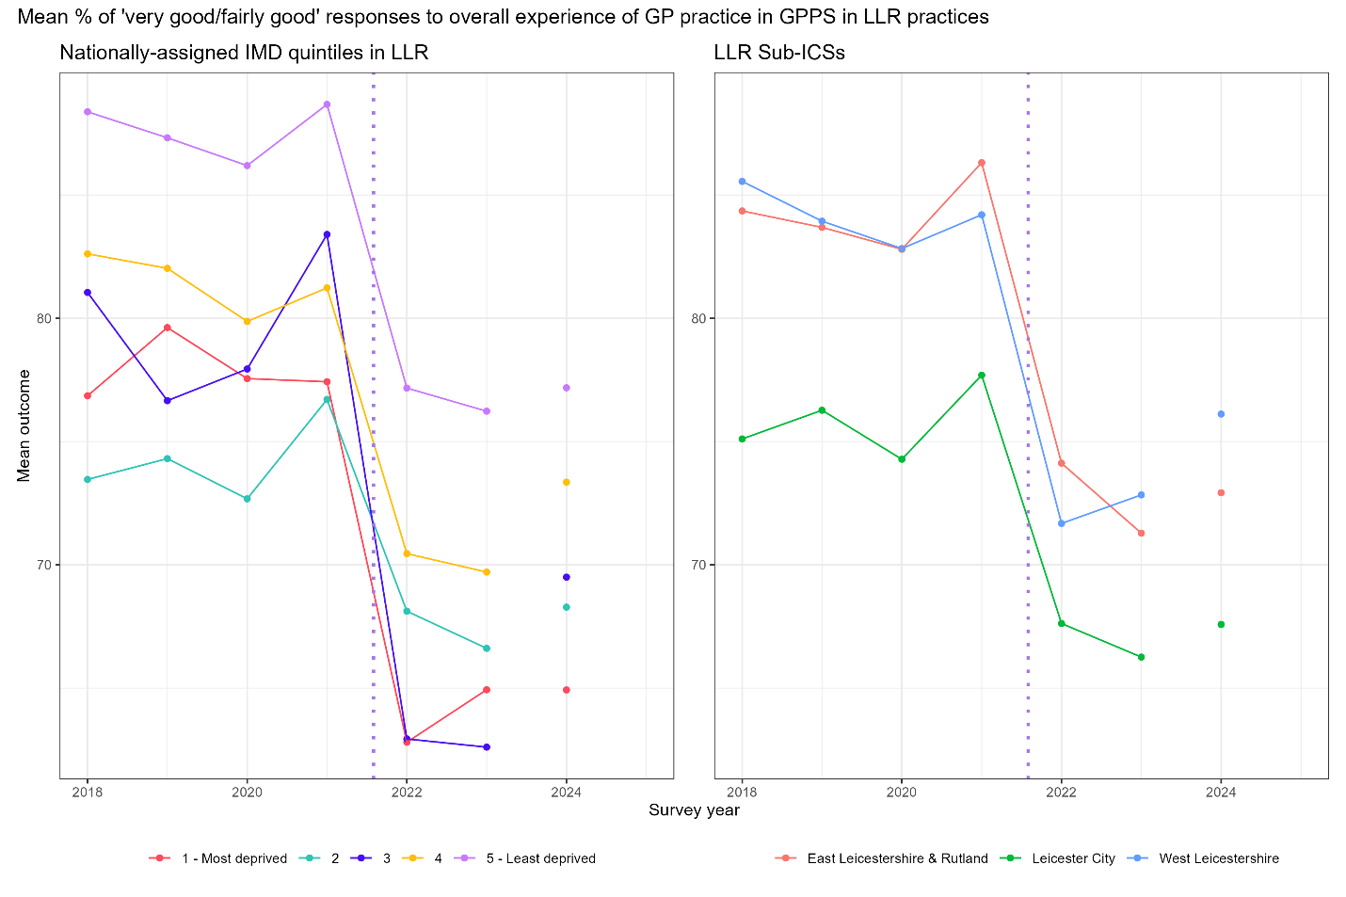
Figure S10- time series plot of mean percentage of ‘very good/ fairly good’ responses to overall experience of GP practice in LLR practices for nationally-assigned deprivation quintiles in LLR and LLR sub-ICBs

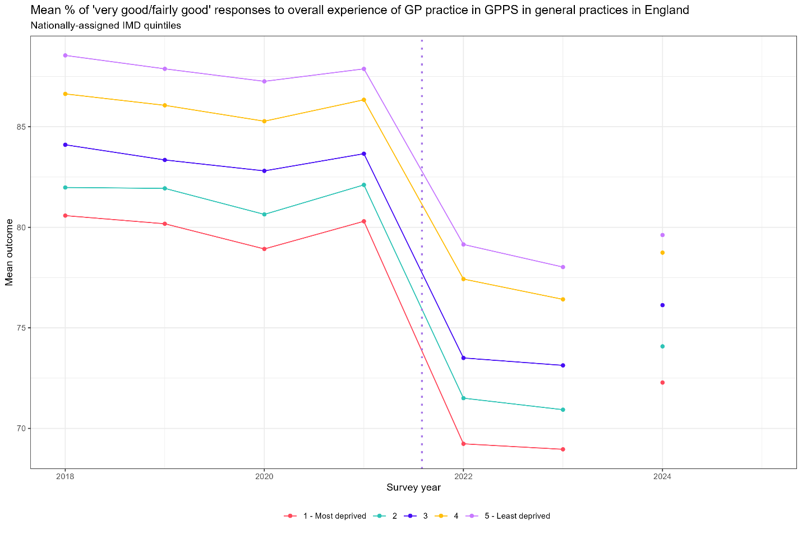
Figure S11- time series plot of mean percentage of ‘very good/ fairly good’ responses to overall experience of GP practice for all GP practices in England using nationally-assigned deprivation quintiles

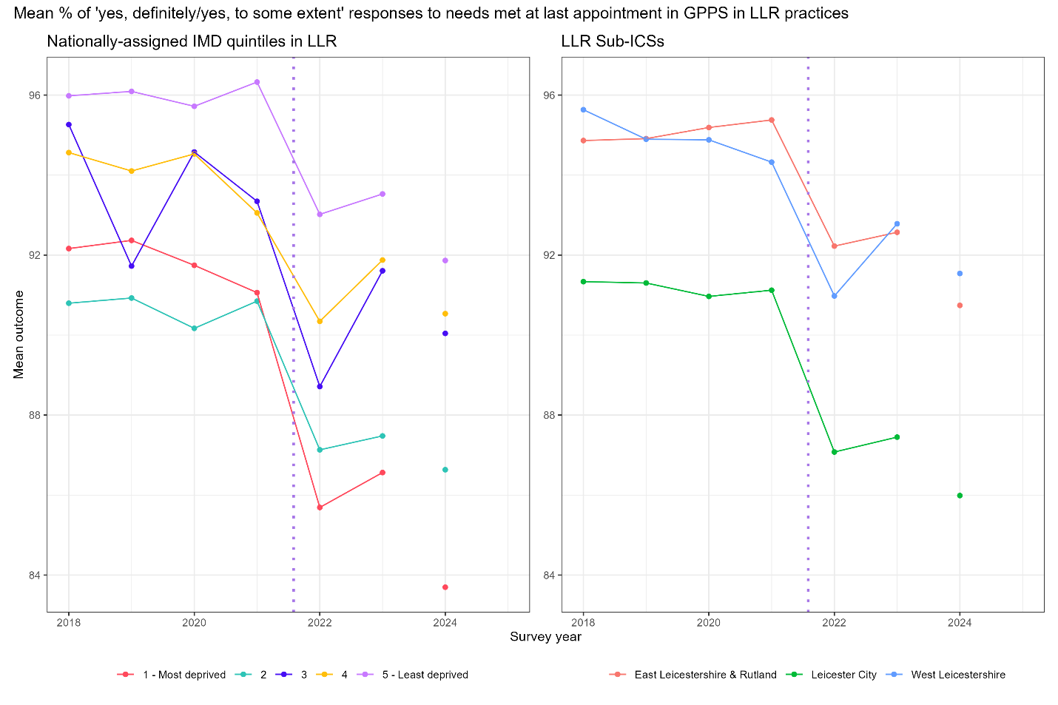
Figure S12- time series plot of mean percentage of ‘yes, definitely/ yes, to some extent’ responses to needs met at last appointment in LLR practices for nationally-assigned deprivation quintiles in LLR and LLR sub-ICBs

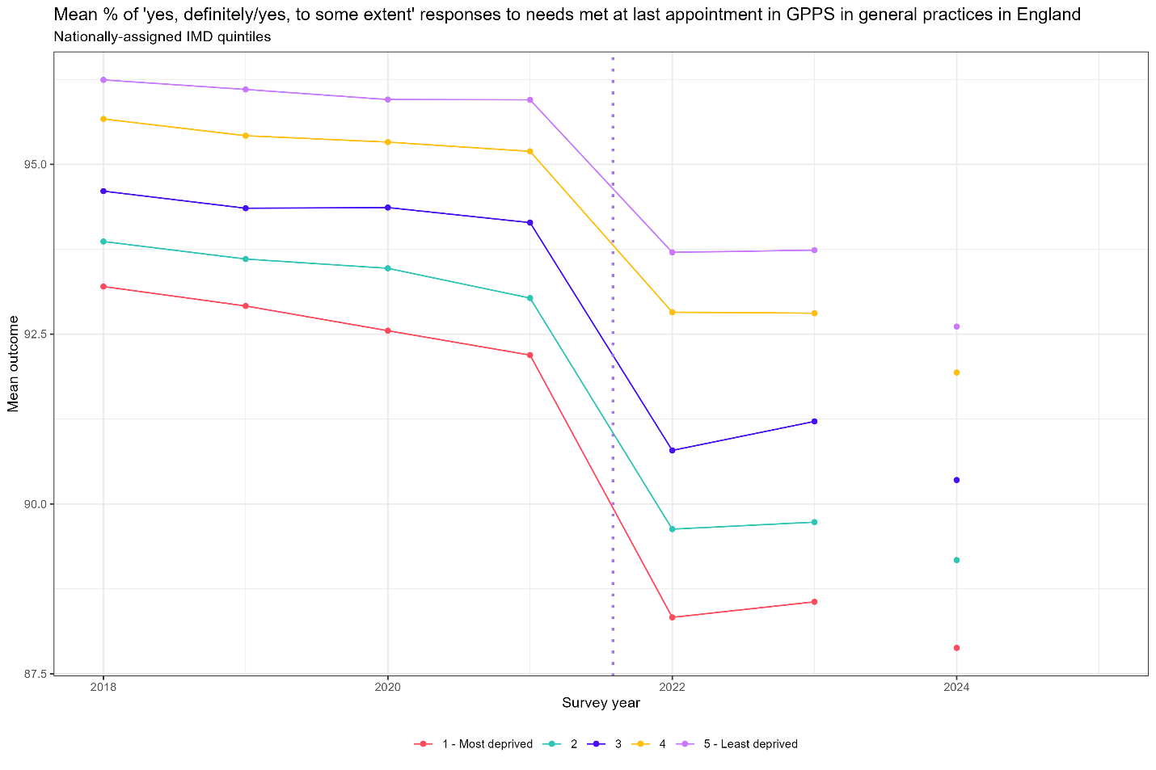
Figure S13- time series plot of mean percentage of ‘yes, definitely/ yes, to some extent’ responses to needs met at last appointment for all GP practices in England using nationally-assigned deprivation quintiles

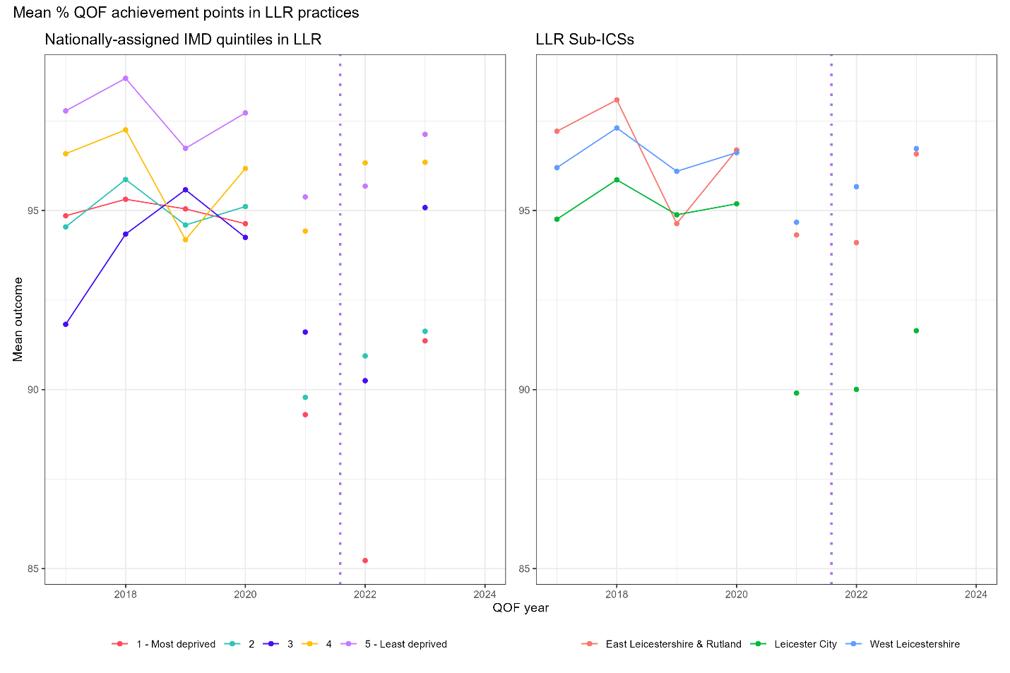
Figure S14- time series plot of mean percentage of QOF achievement in LLR practices for nationally-assigned deprivation quintiles in LLR and LLR sub-ICBs

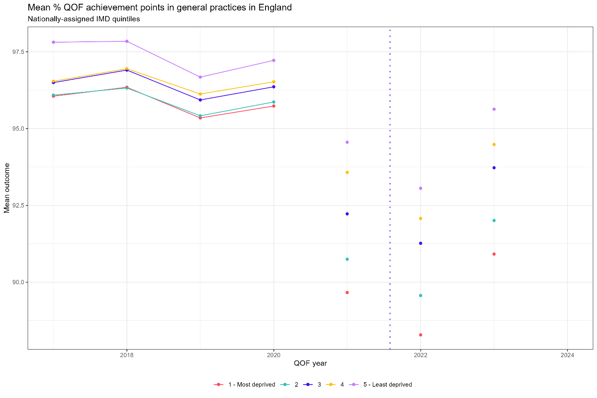
Figure S15- time series plot of mean percentage of QOF achievement for all GP practices in England using nationally-assigned deprivation quintiles
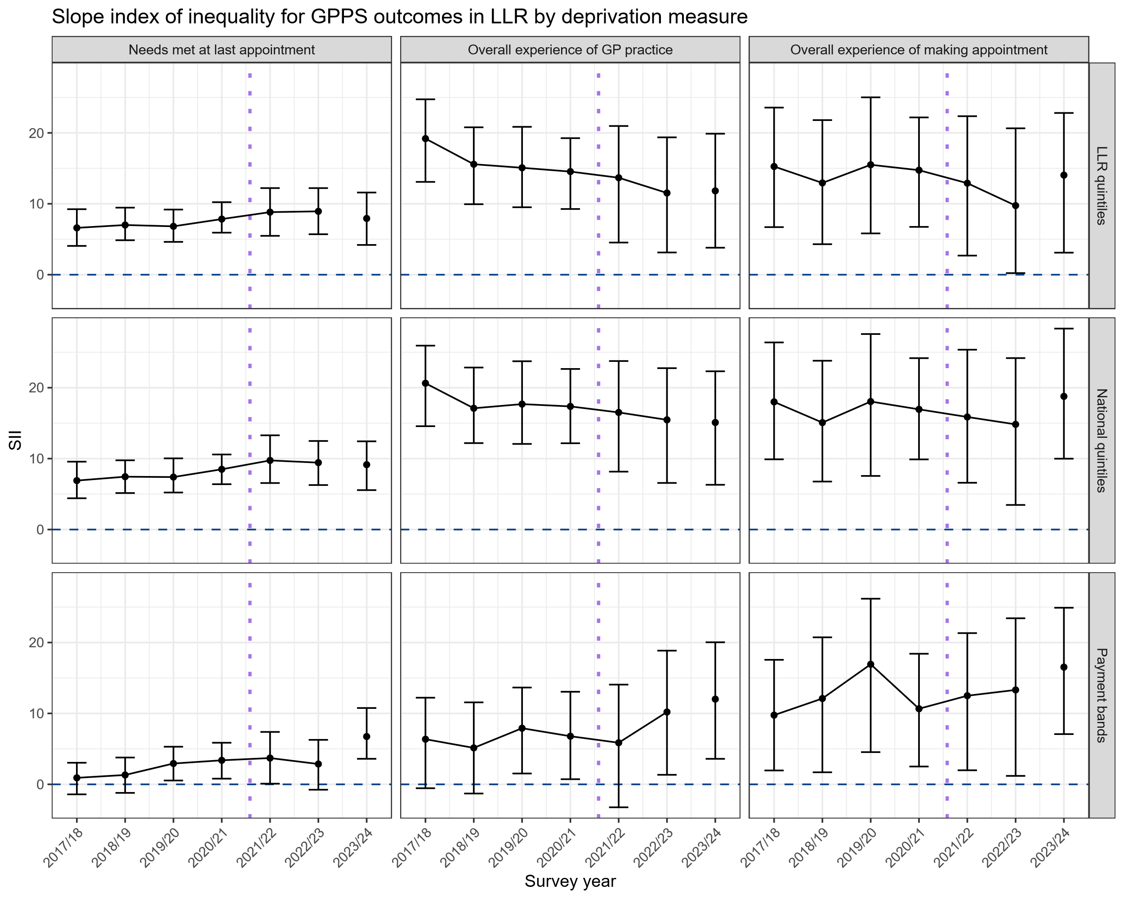
Figure S16- comparison of SIIs relating to patient satisfaction for LLR ICB using different ways to construct need groups (LLR-assigned quintiles of deprivation, nationally-assigned quintiles of deprivation, HEP payment bands)

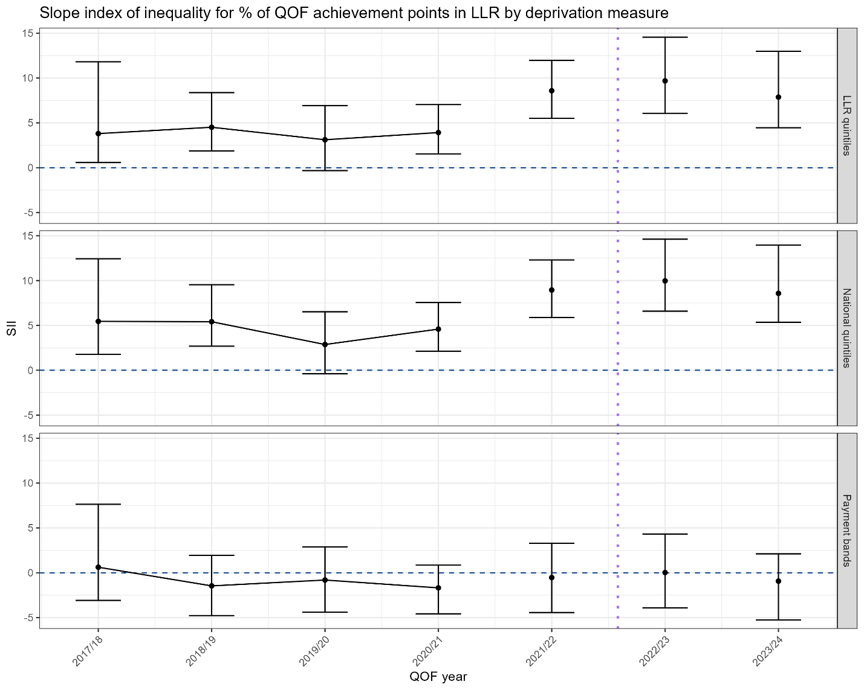
Figure S17- comparison of SII relating to QOF achievement for LLR ICB using different ways to construct need groups (LLR-assigned quintiles of deprivation, nationally-assigned quintiles of deprivation, HEP payment bands)

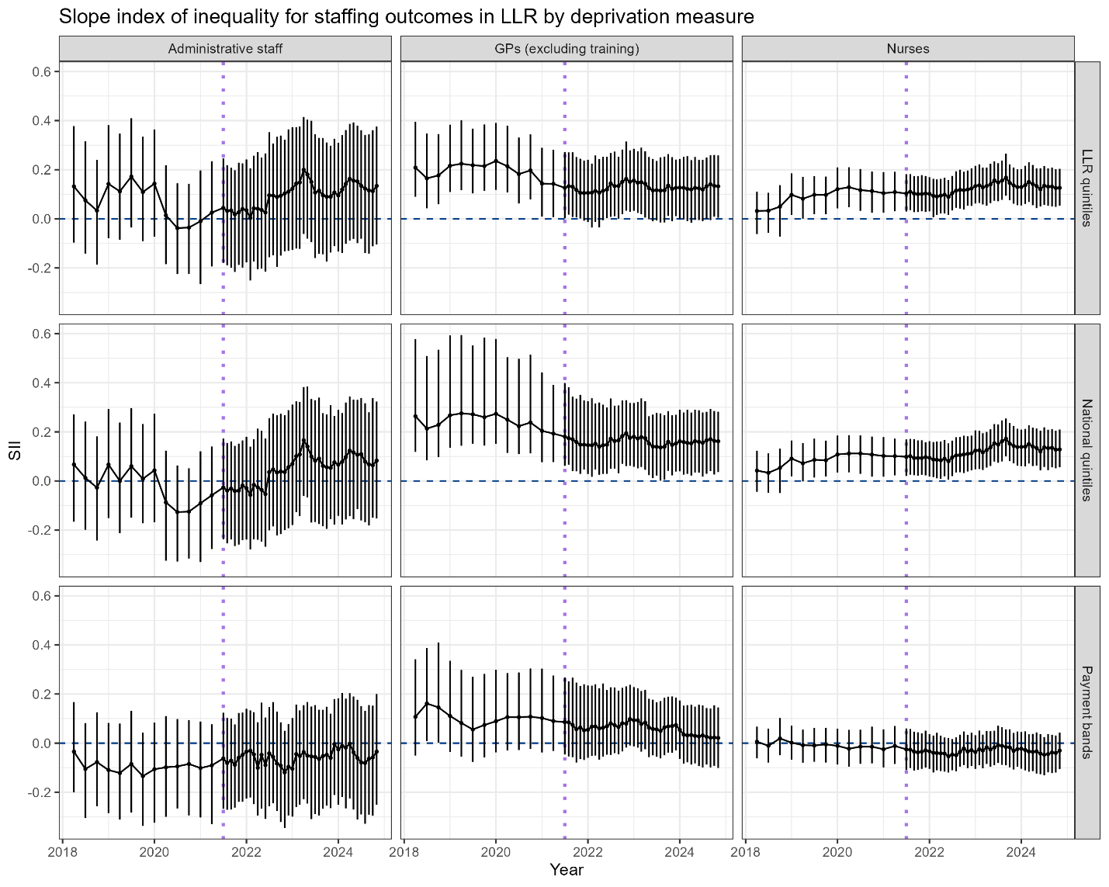
Figure S18- comparison of SII relating to staffing for LLR ICB using different ways to construct need groups (LLR-assigned quintiles of deprivation, nationally-assigned quintiles of deprivation, HEP payment bands)

Supplementary methods
Practices who did not report list size data or with a list size below 500 patients whilst open during the study period were excluded. Practice open date was determined as the latest of the recorded opening date and the earliest date at which the practice had a recorded list size of at least 500 patients. Similarly, practice closure date was determined as the earliest of the recorded closure date – when applicable – and the latest date at which the practice reported a list size of at least 500 patients. Any practices that opened after April 2018 or closed before June 2024 were excluded from the analysis.
We excluded practices with a notable change in list size during the study period – such as resulting from a merger with other practices – as these may have impacted the running of the practice and consequently caused sudden shifts in our outcome variables. To identify these practices, we flagged any month-on-month change in list size of at least 100 patients making up at least 10% of the practice list size. We excluded any practice flagged after being open for at least one year (per the recorded opening date), preventing the exclusion of any practice with an increase in list size that could be attributed to its own opening. Supplementary Information Figure 1 shows exclusions at each stage.
Finally, any practice with more than 60% of their practice population registered as male at any point during the study period was excluded as these are often specialist prison or army services.

