Supplementary Information
Buoyancy–Latent Heat Reconstruction Energy Gain: Challenge to Thermodynamic Conservation Boundaries
Introduction:
This supplementary information provides the technical details, data, and charts from the main paper, where experiments under insulated conditions demonstrate reproducible buoyancy-latent heat reconstruction energy gains.
The inspiration for this study came from the author's simulation of energy reproduction in the atmospheric circulation rainfall process. Over a 20-year period, experiments were conducted with water and various refrigerants, with the apparatus height increasing from the initial 1.5m to 4.5m. The energy gain progressed from 1.1 to 2.4 in this paper. By creating various insulated isolation conditions, performing multiple measurements, and comparing analyses, the study ultimately revealed that the mechanism behind the gain stemmed from the confusion between latent heat and buoyancy in traditional theory. The significance of this discovery lies not in the gain multiplier but in the fact that, for the first time, an experiment in an isolated system confirmed the continuous phenomenon where output energy exceeds input energy.
Replication experiments only require obtaining the result "output energy > input energy" under strictly insulated and controllable conditions to confirm that the confusion between buoyancy and latent heat in energy path definitions has been resolved. This validates the breakthrough discovery of boundary conditions to the first law of thermodynamics in this study.
At 10°C, R134a refrigerant with 60J heat input results in a bubble volume of 15.6mL; at 20°C, the bubble volume decreases to 9.8mL. Therefore, with input water temperatures between 7°C and 14°C, the evaporation bubble yield is higher, producing more buoyant work, and the system's cycle is more stable.
General Conclusion of Experimental Results:
The author obtained the Earth’s annual rainfall data of 5.77×10²³ kg from the United Nations' "World Water Day" reports and subsequently derived the latent heat of vaporization: 5.77×10²³ kg / 2463 kJ/kg = 1.4×10²⁷ kJ. At the end of this paper, the author estimated the buoyant work of water vapor and the gravitational work of rainfall, both of which are greater than the solar heat input. The reasoning analysis can be extended to gaseous planetary atmospheric circulation heat gain.
1.System Fabrication Data
1）Buoyancy Power Tube:
Material: Transparent PTFE
Inner Diameter: 10 mm, Wall Thickness: 2 mm
Length: 4.00 ± 0.05 m
Location: Left vertical tube in Figure 3
2）Evaporator with Heating Module:
Material: Copper, 12mm diameter
Power: 60W constant power heater
It is configured as a coiled copper tube evaporator inside a stainless steel or plastic barrel.
3）Condenser (Coaxial Heat Exchanger):
Inner Tube: Copper, 12 mm diameter
Outer Tube: Stainless steel corrugated tube or transparent PTFE
Location: Top of stainless steel corrugated tube or transparent PTFE tube
4）Gravity Return Line with Subcooling Exchanger:
Material: Transparent PTFE
Length: 4.20 ± 0.05 m
Location: Right vertical transparent tube
5）Throttling Device:
Material: Copper Capillary Tube
Length: 1.0–1.2 ± 0.05 m
2.Operating Conditions:
Ambient Temperature: 18–22°C
Cooling Medium: Ice water or tap water (5–14°C)
System Height: 4.5 m
Heat Source: Electric heater (60 W constant power)
Water Flow Rate: 23 ± 1 L/h
Test Duration: 60–90 minutes
3.Experimental Methodology
Control Experiment:
Cold water of the same volume and initial temperature was placed in an electric heater to measure the heating rate and confirm the heater’s efficiency.
System Test:
The system was operated with 60W heat input and 23 L/h cold water, recording temperature and flow rate. Observed buoyancy power tube showed high-speed two-phase flow.
Data Acquisition:
Temperature sensors with ±0.1°C accuracy, flow meters with ±0.2 L/h accuracy, and power meters with ±0.5 W accuracy were used. Data was recorded electronically.
4.Experimental Results
Energy Balance Ratio:
Input: 216 kJ heat input
Output: 523 kJ heat output
Energy Gain: Output/Input ≈ 2.42
Reproducibility and Variability:
Energy gain varied between 1.1 to 2.4 times across different experiments, influenced by factors like pipe roughness, welding errors, and water temperature.
5.Conclusion:
The study confirms a breakthrough in thermodynamic boundaries, where "output energy > input energy" validates the discovery of boundary conditions to the first law of thermodynamics.
Table 1: Energy Balance Data
Time | Indoor Temp (°C) | Inlet Temp (°C) | Outlet Temp (°C) | Input Heat (kJ) | Output Heat (kJ)
09:45 | 20.3 | 20.3 | 20.3 | 0 | 0
10:00 | 20.3 | 15.2 | 20.7 | 25.2 | 60.5
10:20 | 20.3 | 14.8 | 20.2 | 72 | 174
10:25 | 20.2 | 14.8 | 20.2 | 90 | 216
10:30 | 20.3 | 14.2 | 20.2 | 108 | 261
10:35 | 20.3 | 14.1 | 19.5 | 126 | 305
10:40 | 20.3 | 14.1 | 19.4 | 144 | 347
10:45 | 20.4 | 14.1 | 19.4 | 162 | 392
10:50 | 20.4 | 14.3 | 19.8 | 180 | 430
10:55 | 20.4 | 14.3 | 19.7 | 198 | 479
11:00 | 20.4 | 14.2 | 19.6 | 216 | 523
11:05 | 20.4 | 14.3 | 19.5 | 234 | 565
11:10 | 20.4 | 14.0 | 19.4 | 252 | 609
11:15 | 20.4 | 13.8 | 19.3 | 270 | 659
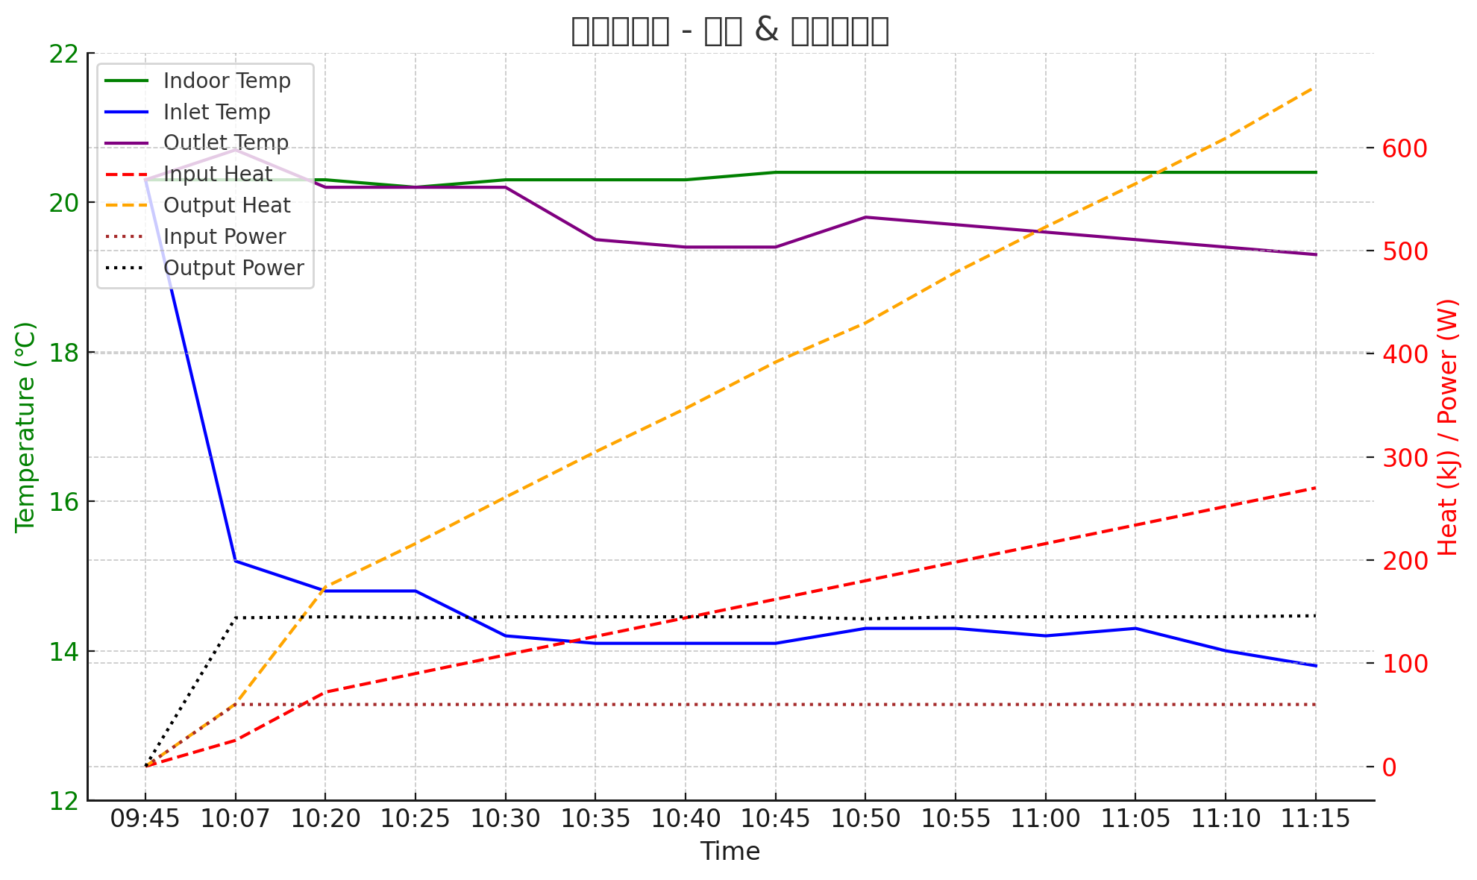

Experimental Data (Figure 5):
Time Indoor Temp (℃) Inlet Temp (℃) Heating Module (℃) Buoyancy Pipe (℃) Gravity Pipe (℃) Outlet Temp (℃) Input Energy (KJ) Water Meter (L) Output Energy (KJ)
09:50 20.3 20.3 20.3 20.3 20.2 20.3 0 0.0 0
09:55 20.3 15.5 21.5 21.1 19.2 20.7 18 – –
10:00 20.3 15.3 22.1 21.3 18.6 20.7 0 0.0 0
10:05 20.3 15.3 22.4 21.4 18.6 20.7 18 1.91 43.1
10:10 20.3 15.3 22.3 21.4 18.5 20.7 36 3.83 86.4
10:15 20.3 15.3 22.1 21.3 18.5 20.7 54 5.74 129.5
10:20 20.3 15.2 22.7 21.2 18.2 20.7 72 7.66 172.9
10:25 20.3 15.2 22.8 21.2 18.4 20.6 90 9.58 216.2
10:30 20.3 15.3 22.8 21.1 18.3 20.6 108 11.4 257.3
10:35 20.3 15.3 22.7 21.1 18.3 20.7 126 13.4 302
10:40 20.3 15.3 22.7 21.1 18.2 20.7 144 15.3 345
10:45 20.2 15.3 22.7 21.1 18.2 20.7 162 17.2 388.2
10:50 20.3 15.4 22.6 20.9 18.2 20.7 180 19.2 433.3
10:55 20.3 15.4 22.6 21.1 18.2 20.7 198 21.09 476
11:00 20.3 15.4 22.5 21.2 18.3 20.7 216 23.11 521.6
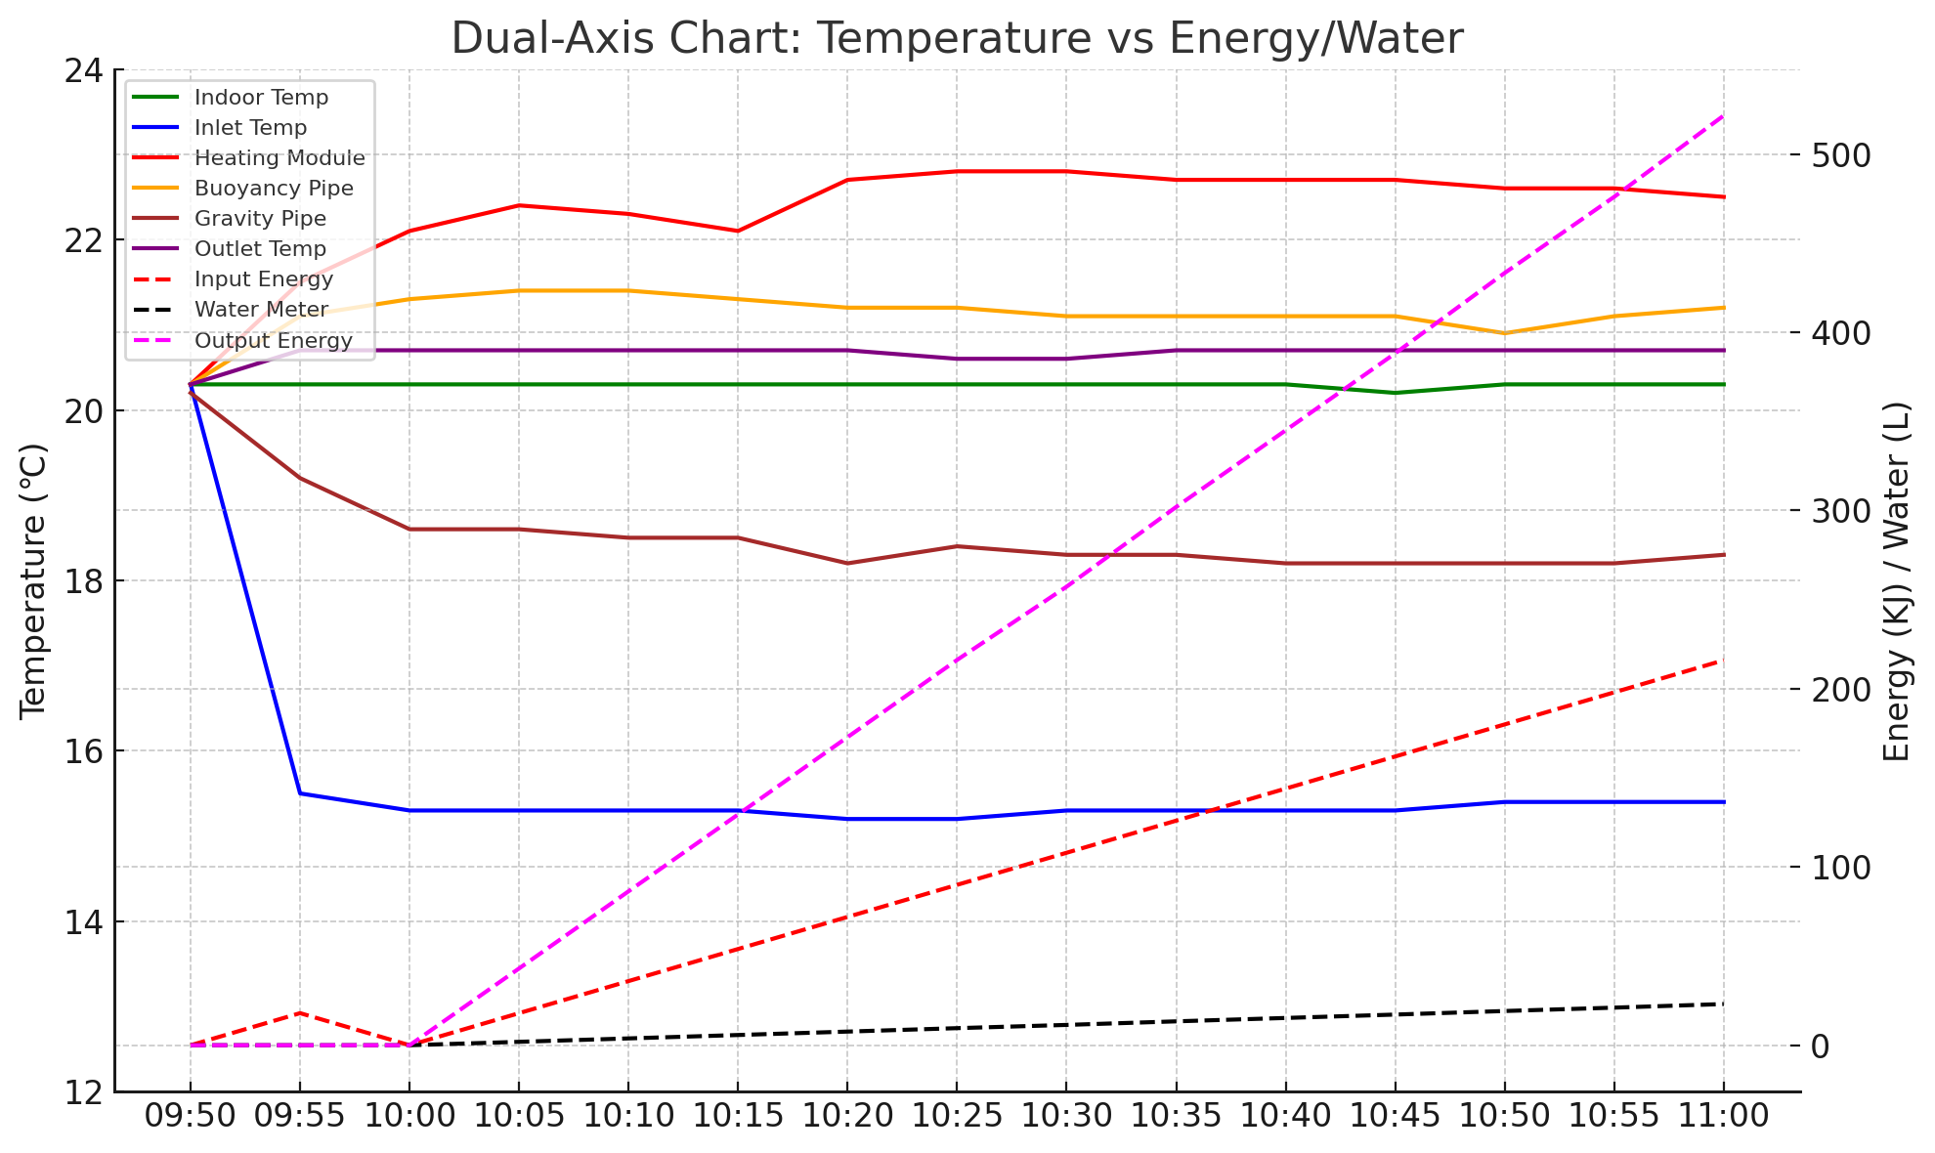
Chart Interpretation:
• Temperature Stability: Most temperature parameters remain between 19–21°C, with slight fluctuations, indicating that the system is operating stably.
• Water and Heat Accumulation: Both water output and output heat show stepwise increases, verifying the gradual accumulation of measurements during the experiment.
• Correlation: As water output increases, output heat rises simultaneously, indicating that hydraulic output and heat transfer efficiency are consistent.

6.Supplementary Figures and Legends
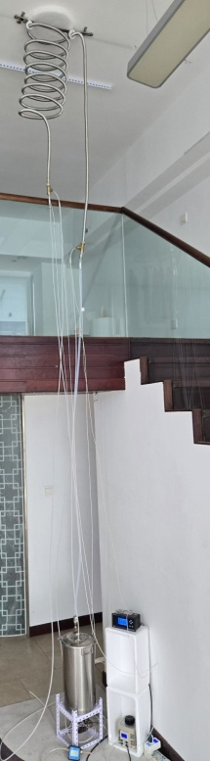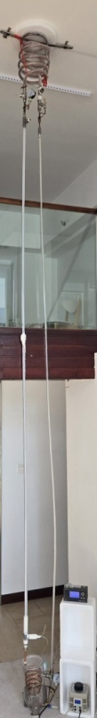
Figure S1a Figure S1b
Figure S1. Overview photo of the experimental system, including the evaporator water tank, coaxial heat exchanger, buoyancy power tube, gravity return pipe, and measurement system. Used to verify the comparison between input and output power under different operating conditions.
Figure S1a and Figure S1b Experimental Setup
Two sets of experimental apparatus were constructed, with condensers and evaporator water tanks made of stainless steel and plastic materials, respectively. Both configurations yielded the same experimental conclusion: the output energy exceeded the input energy.
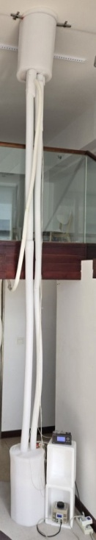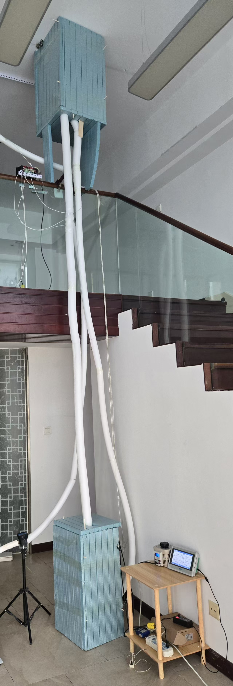
Figure S2. Photo of the experimental system after adding an insulating layer. All components are wrapped with foam material for insulation.
Figure S2a and Figure S2b Experimental Setup
The apparatus was insulated successively with 30 mm EPE material and reinforced with an additional layer of XPE material, totaling 60 mm of insulation. The same experimental conclusion was obtained under both conditions: the output energy exceeded the input energy.
- Generalized Conclusions from Experimental Results
Based on the experimental phenomena and data analysis, the following broader conclusions can be drawn:
The system demonstrates reproducible buoyancy-driven energy amplification under strictly controlled insulated conditions, achieving an output-to-input energy ratio of approximately 2.42. This confirms that the energy gain mechanism stems from the reconstruction of buoyancy and latent heat pathways rather than external energy input.
These findings challenge the traditional boundaries of thermodynamic conservation laws, suggesting that atmospheric circulation on Earth may similarly amplify energy through phase change and buoyancy effects. The results imply that planetary heat dynamics are influenced not only by solar radiation but also by intrinsic amplification mechanisms within fluid systems.
The study provides a new perspective for understanding climate energy cycles and the role of greenhouse gases, highlighting the potential for reinterpreting energy transfer processes in both engineered and natural systems.

The author obtained data on Earth's annual rainfall of 5.77×10²³ kg from United Nations "World Water Day" reports and subsequently reverse-calculated the latent heat of vaporization:
5.77×10²³ kg / 2463 kJ/kg = 1.4×10²⁷ kJ.
This includes the total heat after becoming superheated steam, approximately 2.8×10²⁷ kJ, which, according to conventional theory, originates from solar radiation input.
The minimum vapor volume is:
V = 5.77×10²³ kg × 73 m³/kg = 4.2×10²⁵ m³.
The buoyancy work energy of condensing rain clouds floating at 2000–6000 m (average 4000 m) is:
Q = ρvgh = [(1.2 kg/m³ + 0.3 kg/m³) / 2] × 4.2×10²⁵ m³ × 9.8 N/kg × 4000 m
= 1.2×10³⁰ kJ,
which far exceeds the solar input heat.
The gravitational work of rainfall is:
Q = mgh = 5.77×10²³ kg × 4000 m × 9.8 m/s² = 2.2×10²⁸ kJ,
which is also higher than the solar radiation heat of 1.4×10²⁷ kJ.
Thus, it is inferred that while part of Earth's heat comes from the sun, a larger portion originates from heat amplification through atmospheric circulation. This aligns with the experimental conclusions of this paper.
Evidence from the High Temperature of Earth's Thermosphere
The three modes of heat transfer are conduction, convection, and radiation.
Atmospheric circulation heat, when conducted to the edge of the atmosphere (30–50 km), encounters a vacuum environment where conduction and convection capabilities are lost. This results in significant heat blockage, causing temperatures to rise to 1000°C and radiate heat into outer space. The experiments in this paper provide the most plausible explanation for this phenomenon.
Earth acts as a solar energy amplifier. Water vapor volume: v = E<sub>in</sub> × q, where q is the latent heat of vaporization and E<sub>in</sub> is the solar radiation heat. This determines ρvgh = the magnitude of amplified energy. The intensity of solar heat determines the temperature of Earth's thermosphere.
Jupiter, Saturn, Uranus, and Neptune, which are farther from the sun, receive very little solar heat. However, their thicker atmospheric circulations similarly amplify energy. This discovery may unravel the mystery of planetary material amplification.
In Earth's atmosphere, the density of nitrogen is ρ = 1.25 g/dm³, oxygen ρ = 1.43 g/dm³, and gaseous carbon dioxide ρ = 1.98 g/dm³. According to E<sub>out</sub> = E<sub>in</sub> + ρvgh + ρmgh, buoyancy work heat will significantly increase. This may reveal the true secret behind how carbon dioxide in the atmosphere leads to temperature rise.

