Supplementary information

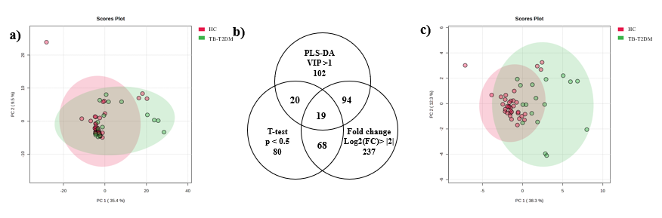
S1 Figure 1: (a) PCA plot illustrates no natural differentiation between TB-T2DM group and HC metabolic profiles, using all samples and metabolites. (b) A Venn diagram, illustrating the number of metabolites meeting each criterium and their overlaps of common metabolites forming the noise-reduced data set. (c) PCA plot of noise-reduced dataset illustrates separation between the TB-T2DM and the HC group.

