SUPPLEMENTAL MATERIAL

Longitudinal association of dietary spermidine with hepatic function indexes and cardiometabolic traits in older adults with metabolic syndrome

Supplemental table 1. Mixed-effects models of hepatic and cardiometabolic indexes, anthropometric measurements and blood pressure normalized to baseline visit 2
Supplemental table 2. Estimated effects of a 20-unit increase in spermidine levels 5
Supplemental table 3. Estimated effects of a 20-unit increase in spermine levels 8
Supplemental table 4. Estimated effects of a 20-unit increase in putrescine levels 11
For treatment stratified analysis (Supplemental Figure 1 to 7): 14
Supplemental figure 1. Stratified analysis effects of dietary SPD on FLI according to pharmacological treatment 15
Supplemental figure 2. Stratified analysis effects of dietary SPD on HSI according to pharmacological treatment 16
Supplemental figure 3. Stratified analysis effects of dietary SPD on AST according to pharmacological treatment 17
Supplemental figure 4. Stratified analysis effects of dietary SPD on ALT according to pharmacological treatment 18
Supplemental figure 5. Stratified analysis effects of dietary SPD on alkaline phosphatase according to pharmacological treatment 19
Supplemental figure 6. Stratified analysis effects of dietary SPD on gamma glutamyl transferase according to pharmacological treatment 20
Supplemental figure 7. Stratified analysis effects of dietary SPD on calcium according to pharmacological treatment 21

Supplemental table 1. Mixed-effects models of hepatic and cardiometabolic indexes, anthropometric measurements and blood pressure normalized to baseline visit

Spermidine | beta (95% CI) | p-value |  | P-int. vis x cluster = <0.001
∆ vis 6-0 |  |  |  | P-int within vis0 = <0.001
Cluster 1 | 1.395 (0.186 to 2.604) | 0.024 |  | P-int within vis6 = <0.001
Cluster 2 | 3.415 (2.214 to 4.616) | 0.000 |  | P-int within vis12 = <0.001
Cluster 3 | 5.372 (3.692 to 7.052) | 0.000
∆ vis 12-0
Cluster 1 | 1.049 (-0.182 to 2.279) | 0.095
Cluster 2 | 2.465 (1.249 to 3.682) | 0.000
Cluster 3 | 6.213 (4.519 to 7.907) | 0.000
Waist-to-Hip Ratio | beta (95% CI) | p-value |  | P-int. vis x cluster = 0.174
∆ vis 6-0 |  |  |  | P-int within vis0 = 0.066
Cluster 1 | -0.005 (-0.008 to -0.002) | 0.000 |  | P-int within vis6 = 0.075
Cluster 2 | -0.005 (-0.008 to -0.002) | 0.000 |  | P-int within vis12 = 0.662
Cluster 3 | -0.005 (-0.009 to -0.001) | 0.008
∆ vis 12-0
Cluster 1 | -0.003 (-0.006 to 0) | 0.031
Cluster 2 | -0.004 (-0.007 to -0.002) | 0.002
Cluster 3 | -0.007 (-0.011 to -0.003) | 0.000
Waist-to-Height Ratio | beta (95% CI) | p-value |  | P-int. vis x cluster = <0.001
∆ vis 6-0 |  |  |  | P-int within vis0 = <0.001
Cluster 1 | -0.004 (-0.006 to -0.003) | 0.000 |  | P-int within vis6 = 0.013
Cluster 2 | -0.007 (-0.009 to -0.005) | 0.000 |  | P-int within vis12 = 0.328
Cluster 3 | -0.008 (-0.011 to -0.006) | 0.000
∆ vis 12-0
Cluster 1 | -0.004 (-0.006 to -0.003) | 0.000
Cluster 2 | -0.008 (-0.01 to -0.006) | 0.000
Cluster 3 | -0.012 (-0.014 to -0.009) | 0.000
Urine Albumin-Creatinine Ratio (UACR) | beta (95% CI) | p-value |  | P-int. vis x cluster = 0.746
∆ vis 6-0 |  |  |  | P-int within vis0 = 0.987
Cluster 1 | 5.673 (1.075 to 10.27) | 0.016 |  | P-int within vis6 = 0.385
Cluster 2 | 6.928 (2.369 to 11.488) | 0.003 |  | P-int within vis12 = 0.410
Cluster 3 | 2.551 (-3.843 to 8.945) | 0.434
∆ vis 12-0
Cluster 1 | 2.868 (-1.806 to 7.543) | 0.229
Cluster 2 | 4.257 (-0.356 to 8.871) | 0.070
Cluster 3 | 0.032 (-6.409 to 6.474) | 0.992
Triglyceride-Glucose Index (TyG) | beta (95% CI) | p-value |  | P-int. vis x cluster = 0.598
∆ vis 6-0 |  |  |  | P-int within vis0 = 0.193
Cluster 1 | -0.025 (-0.049 to -0.001) | 0.039 |  | P-int within vis6 = 0.806
Cluster 2 | -0.053 (-0.077 to -0.029) | 0.000 |  | P-int within vis12 = 0.848
Cluster 3 | -0.05 (-0.083 to -0.017) | 0.003
∆ vis 12-0
Cluster 1 | -0.028 (-0.052 to -0.003) | 0.026
Cluster 2 | -0.041 (-0.065 to -0.017) | 0.001
Cluster 3 | -0.047 (-0.08 to -0.013) | 0.006
Triglycerides/HDL Ratio | beta (95% CI) | p-value |  | P-int. vis x cluster = 0.919
∆ vis 6-0 |  |  |  | P-int within vis0 = 0.437
Cluster 1 | -0.002 (-0.022 to 0.019) | 0.860 |  | P-int within vis6 = 0.844
Cluster 2 | -0.013 (-0.033 to 0.007) | 0.215 |  | P-int within vis12 = 0.751
Cluster 3 | -0.01 (-0.039 to 0.018) | 0.486
∆ vis 12-0
Cluster 1 | 0.003 (-0.017 to 0.024) | 0.754
Cluster 2 | -0.001 (-0.021 to 0.02) | 0.931
Cluster 3 | -0.004 (-0.033 to 0.024) | 0.767
Each model represents the results of a mixed-effects model analysing the change in markers related to anthropometry and blood pressure across time, normalized to baseline visit values. The model includes three hierarchical levels with random intercepts for node, cluster, and individual patients, accounting for intra-cluster correlation and individual variability. Models was adjusted for age (years), sex, baseline markers (continuous), intervention group, education level (higher degree, university, secondary school, primary school, illiterate), baseline physical activity (METs-min/week), smoking status (non-smoker, ex-smoker, smoker, other), total physical Mediterranean Diet adherence score-17p (continuous), total protein intake (g/d), carbohydrates (g/d), and total energy intake (kcal/d).

Supplemental table 1. Continuation.

Fibrosis-4 Index (FIB-4) | beta (95% CI) | p-value |  | P-int. vis x cluster = 0.955
∆ vis 6-0 |  |  |  | P-int within vis0 = 0.735
Cluster 1 | 0.012 (-0.018 to 0.041) | 0.433 |  | P-int within vis6 = 0.562
Cluster 2 | 0.02 (-0.009 to 0.05) | 0.175 |  | P-int within vis12 = 0.815
Cluster 3 | 0.011 (-0.03 to 0.052) | 0.596
∆ vis 12-0
Cluster 1 | 0.025 (-0.005 to 0.055) | 0.107
Cluster 2 | 0.021 (-0.009 to 0.051) | 0.166
Cluster 3 | 0.022 (-0.019 to 0.064) | 0.292
Fibrosis-5 Index (FIB-5) | beta (95% CI) | p-value |  | P-int. vis x cluster = 0.340
∆ vis 6-0 |  |  |  | P-int within vis0 = 0.403
Cluster 1 | 0.14 (-0.038 to 0.318) | 0.122 |  | P-int within vis6 = 0.317
Cluster 2 | 0.197 (0.021 to 0.374) | 0.028 |  | P-int within vis12 = 0.373
Cluster 3 | -0.074 (-0.321 to 0.173) | 0.556
∆ vis 12-0
Cluster 1 | 0.239 (0.058 to 0.42) | 0.010
Cluster 2 | 0.257 (0.078 to 0.435) | 0.005
Cluster 3 | -0.019 (-0.268 to 0.23) | 0.879
APRI (AST to Platelet Ratio Index) | beta (95% CI) | p-value |  | P-int. vis x cluster = 0.523
∆ vis 6-0 |  |  |  | P-int within vis0 = 0.415
Cluster 1 | -0.001 (-0.008 to 0.005) | 0.660 |  | P-int within vis6 = 0.629
Cluster 2 | -0.008 (-0.015 to -0.002) | 0.014 |  | P-int within vis12 = 0.357
Cluster 3 | -0.007 (-0.016 to 0.002) | 0.137
∆ vis 12-0
Cluster 1 | -0.002 (-0.009 to 0.004) | 0.509
Cluster 2 | -0.01 (-0.016 to -0.003) | 0.003
Cluster 3 | -0.006 (-0.016 to 0.003) | 0.166
Fatty Liver Index (FLI) | beta (95% CI) | p-value |  | P-int. vis x cluster = <0.001
∆ vis 6-0 |  |  |  | P-int within vis0 = <0.001
Cluster 1 | -1.529 (-2.269 to -0.789) | 0.000 |  | P-int within vis6 = 0.318
Cluster 2 | -3.217 (-3.954 to -2.48) | 0.000 |  | P-int within vis12 = 0.540
Cluster 3 | -3.585 (-4.613 to -2.557) | 0.000
∆ vis 12-0
Cluster 1 | -1.845 (-2.6 to -1.09) | 0.000
Cluster 2 | -3.399 (-4.147 to -2.651) | 0.000
Cluster 3 | -4.501 (-5.539 to -3.464) | 0.000
Hepatic Steatosis Index (HSI) | beta (95% CI) | p-value |  | P-int. vis x cluster = <0.001
∆ vis 6-0 |  |  |  | P-int within vis0 = 0.001
Cluster 1 | -0.411 (-0.6 to -0.221) | 0.000 |  | P-int within vis6 = 0.798
Cluster 2 | -0.69 (-0.878 to -0.501) | 0.000 |  | P-int within vis12 = 0.143
Cluster 3 | -0.799 (-1.062 to -0.536) | 0.000
∆ vis 12-0
Cluster 1 | -0.381 (-0.574 to -0.188) | 0.000
Cluster 2 | -0.858 (-1.049 to -0.667) | 0.000
Cluster 3 | -1.073 (-1.339 to -0.808) | 0.000
EPI Creatinine Clearance Index | beta (95% CI) | p-value |  | P-int. vis x cluster = 0.591
∆ vis 6-0 |  |  |  | P-int within vis0 = 0.407
Cluster 1 | -0.088 (-0.775 to 0.599) | 0.801 |  | P-int within vis6 = 0.585
Cluster 2 | -0.01 (-0.693 to 0.672) | 0.977 |  | P-int within vis12 = 0.652
Cluster 3 | -0.327 (-1.281 to 0.628) | 0.503
∆ vis 12-0
Cluster 1 | -0.136 (-0.835 to 0.564) | 0.704
Cluster 2 | -0.764 (-1.455 to -0.072) | 0.030
Cluster 3 | -1 (-1.963 to -0.038) | 0.042
Each model represents the results of a mixed-effects model analysing the change in markers related to anthropometry and blood pressure across time, normalized to baseline visit values. The model includes three hierarchical levels with random intercepts for node, cluster, and individual patients, accounting for intra-cluster correlation and individual variability. Models was adjusted for age (years), sex, baseline markers (continuous), intervention group, education level (higher degree, university, secondary school, primary school, illiterate), baseline physical activity (METs-min/week), smoking status (non-smoker, ex-smoker, smoker, other), total physical Mediterranean Diet adherence score-17p (continuous), total protein intake (g/d), carbohydrates (g/d), and total energy intake (kcal/d).

Supplemental table 1. Continuation.

BMI (kg/m²) | beta (95% CI) | p-value |  | P-int. vis x cluster = <0.001
∆ vis 6-0 |  |  |  | P-int within vis0 = <0.001
Cluster 1 | -0.173 (-0.254 to -0.092) | 0.000 |  | P-int within vis6 = 0.137
Cluster 2 | -0.389 (-0.47 to -0.308) | 0.000 |  | P-int within vis12 = 0.337
Cluster 3 | -0.53 (-0.643 to -0.418) | 0.000
∆ vis 12-0
Cluster 1 | -0.187 (-0.269 to -0.104) | 0.000
Cluster 2 | -0.472 (-0.554 to -0.39) | 0.000
Cluster 3 | -0.665 (-0.778 to -0.551) | 0.000
Waist (cm) | beta (95% CI) | p-value |  | P-int. vis x cluster = <0.001
∆ vis 6-0 |  |  |  | P-int within vis0 = <0.001
Cluster 1 | -0.728 (-1.021 to -0.435) | 0.000 |  | P-int within vis6 = 0.024
Cluster 2 | -1.154 (-1.446 to -0.863) | 0.000 |  | P-int within vis12 = 0.313
Cluster 3 | -1.37 (-1.777 to -0.963) | 0.000
∆ vis 12-0
Cluster 1 | -0.758 (-1.056 to -0.459) | 0.000
Cluster 2 | -1.314 (-1.61 to -1.018) | 0.000
Cluster 3 | -1.929 (-2.339 to -1.518) | 0.000
Hip (cm) | beta (95% CI) | p-value |  | P-int. vis x cluster = 0.001
∆ vis 6-0 |  |  |  | P-int within vis0 = 0.001
Cluster 1 | -0.186 (-0.445 to 0.072) | 0.157 |  | P-int within vis6 = 0.981
Cluster 2 | -0.662 (-0.919 to -0.405) | 0.000 |  | P-int within vis12 = 0.529
Cluster 3 | -0.874 (-1.233 to -0.515) | 0.000
∆ vis 12-0
Cluster 1 | -0.465 (-0.728 to -0.202) | 0.001
Cluster 2 | -0.912 (-1.173 to -0.652) | 0.000
Cluster 3 | -1.292 (-1.654 to -0.93) | 0.000
DBP (mmHg) | beta (95% CI) | p-value |  | P-int. vis x cluster = 0.478
∆ vis 6-0 |  |  |  | P-int within vis0 = 0.492
Cluster 1 | -1.036 (-1.545 to -0.526) | 0.000 |  | P-int within vis6 = 0.133
Cluster 2 | -0.868 (-1.374 to -0.362) | 0.001 |  | P-int within vis12 = 0.456
Cluster 3 | -1.273 (-1.981 to -0.565) | 0.000
∆ vis 12-0
Cluster 1 | -1.507 (-2.026 to -0.989) | 0.000
Cluster 2 | -1.502 (-2.014 to -0.989) | 0.000
Cluster 3 | -1.438 (-2.151 to -0.724) | 0.000
SBP (mmHg) | beta (95% CI) | p-value |  | P-int. vis x cluster = 0.327
∆ vis 6-0 |  |  |  | P-int within vis0 = 0.196
Cluster 1 | -1.214 (-2.151 to -0.276) | 0.011 |  | P-int within vis6 = 0.093
Cluster 2 | -0.913 (-1.844 to 0.018) | 0.055 |  | P-int within vis12 = 0.699
Cluster 3 | -1.703 (-3.006 to -0.4) | 0.010
∆ vis 12-0
Cluster 1 | -1.728 (-2.682 to -0.774) | 0.000
Cluster 2 | -2.242 (-3.185 to -1.3) | 0.000
Cluster 3 | -2.185 (-3.498 to -0.871) | 0.001
Each model represents the results of a mixed-effects model analysing the change in markers related to anthropometry and blood pressure across time, normalized to baseline visit values. The model includes three hierarchical levels with random intercepts for node, cluster, and individual patients, accounting for intra-cluster correlation and individual variability. Models was adjusted for age (years), sex, baseline markers (continuous), intervention group, education level (higher degree, university, secondary school, primary school, illiterate), baseline physical activity (METs-min/week), smoking status (non-smoker, ex-smoker, smoker, other), total physical Mediterranean Diet adherence score-17p (continuous), total protein intake (g/d), carbohydrates (g/d), and total energy intake (kcal/d).

Supplemental table 2. Estimated effects of a 20-unit increase in spermidine levels

 | Spermidine
 | v66 |  | v12
 | beta (95% CI)¹ | p | beta (95% CI)¹ | p
Waist-to-Hip Ratio
crude | -0.0011 (-0.0023 to 0.0000) | 0.049 | -0.0016 (-0.0027 to -0.0004) | 0.007
Mod 1 | -0.0014 (-0.0024 to -0.0003) | 0.014 | -0.0016 (-0.0027 to -0.0005) | 0.004
Mod 2 | -0.0012 (-0.0023 to -0.0001) | 0.033 | -0.0014 (-0.0025 to -0.0003) | 0.010
Mod 3 | -0.0012 (-0.0023 to -0.0001) | 0.030 | -0.0015 (-0.0026 to -0.0004) | 0.009
Waist-to-Height Ratio
crude | -0.0011 (-0.0019 to -0.0004) | 0.004 | -0.0016 (-0.0024 to -0.0008) | <0.001
Mod 1 | -0.0013 (-0.0020 to -0.0005) | 0.001 | -0.0017 (-0.0024 to -0.0009) | <0.001
Mod 2 | -0.0010 (-0.0017 to -0.0003) | 0.007 | -0.0014 (-0.0021 to -0.0007) | <0.001
Mod 3 | -0.0009 (-0.0016 to -0.0002) | 0.009 | -0.0014 (-0.0021 to -0.0007) | <0.001
Urine Albumin-Creatinine Ratio (UACR)
crude | -0.54 (-2.38 to 1.30) | 0.563 | -0.34 (-2.20 to 1.52) | 0.717
Mod 1 | -0.35 (-2.10 to 1.40) | 0.693 | 0.13 (-1.64 to 1.90) | 0.883
Mod 2 | -0.377 (-2.131 to 1.377) | 0.673 | 0.093 (-1.680 to 1.866) | 0.918
Mod 3 | -0.447 (-2.208 to 1.314) | 0.619 | 0.043 (-1.738 to 1.823) | 0.963
Triglyceride-Glucose Index (TyG)
crude | -0.0063 (-0.0159 to 0.0033) | 0.200 | -0.0031 (-0.0128 to 0.0066) | 0.530
Mod 1 | -0.0091 (-0.0183 to 0.0001) | 0.053 | -0.0050 (-0.0143 to 0.0043) | 0.289
Mod 2 | -0.0067 (-0.0158 to 0.0025) | 0.152 | -0.0030 (-0.0123 to 0.0062) | 0.517
Mod 3 | -0.0064 (-0.0156 to 0.0027) | 0.168 | -0.0028 (-0.0121 to 0.0064) | 0.550
Triglycerides/HDL Ratio
crude | -0.0052 (-0.0134 to 0.0030) | 0.217 | -0.0020 (-0.0103 to 0.0064) | 0.644
Mod 1 | -0.0052 (-0.0131 to 0.0026) | 0.192 | -0.0020 (-0.0099 to 0.0059) | 0.622
Mod 2 | -0.0040 (-0.0118 to 0.0038) | 0.312 | -0.0010 (-0.0089 to 0.0069) | 0.809
Mod 3 | -0.0040 (-0.0118 to 0.0039) | 0.320 | -0.0007 (-0.0086 to 0.0073) | 0.869
Fibrosis-4 Index (FIB-4)
crude | 0.0035 (-0.0084 to 0.0153) | 0.566 | 0.0017 (-0.0102 to 0.0137) | 0.776
Mod 1 | 0.0034 (-0.0079 to 0.0147) | 0.556 | 0.0041 (-0.0074 to 0.0155) | 0.487
Mod 2 | 0.0023 (-0.0090 to 0.0136) | 0.690 | 0.0033 (-0.0082 to 0.0147) | 0.574
Mod 3 | 0.0014 (-0.0099 to 0.0128) | 0.805 | 0.0027 (-0.0088 to 0.0142) | 0.644
Fibrosis-5 Index (FIB-5)
crude | -0.038 (-0.109 to 0.033) | 0.299 | -0.106 (-0.178 to -0.034) | 0.004
Mod 1 | -0.0235 (-0.0910 to 0.0441) | 0.495 | -0.0733 (-0.1416 to -0.0049) | 0.036
Mod 2 | -0.0270 (-0.0946 to 0.0407) | 0.435 | -0.0761 (-0.1446 to -0.0076) | 0.029
Mod 3 | -0.0203 (-0.0881 to 0.0476) | 0.558 | -0.0679 (-0.1365 to 0.0008) | 0.053
APRI (AST to Platelet Ratio Index)
crude | -0.0001 (-0.0028 to 0.0025) | 0.910 | -0.0006 (-0.0032 to 0.0020) | 0.654
Mod 1 | -0.0005 (-0.0030 to 0.0019) | 0.666 | -0.0005 (-0.0031 to 0.0020) | 0.674
Mod 2 | -0.0005 (-0.0030 to 0.0020) | 0.672 | -0.0005 (-0.0030 to 0.0020) | 0.693
Mod 3 | -0.0008 (-0.0034 to 0.0017) | 0.505 | -0.0008 (-0.0033 to 0.0017) | 0.544
Fatty Liver Index (FLI)
crude | -0.370 (-0.677 to -0.062) | 0.018 | -0.453 (-0.764 to -0.142) | 0.004
Mod 1 | -0.496 (-0.792 to -0.200) | 0.001 | -0.577 (-0.876 to -0.278) | <0.001
Mod 2 | -0.357 (-0.643 to -0.071) | 0.014 | -0.459 (-0.749 to -0.170) | 0.002
Mod 3 | -0.345 (-0.632 to -0.058) | 0.018 | -0.466 (-0.756 to -0.176) | 0.002
Hepatic Steatosis Index (HSI)
crude | -0.057 (-0.135 to 0.021) | 0.151 | -0.118 (-0.196 to -0.039) | 0.003
Mod 1 | -0.0681 (-0.1423 to 0.0061) | 0.072 | -0.1323 (-0.2074 to -0.0572) | 0.001
Mod 2 | -0.040 (-0.113 to 0.033) | 0.280 | -0.108 (-0.181 to -0.034) | 0.004
Mod 3 | -0.039 (-0.112 to 0.034) | 0.291 | -0.111 (-0.185 to -0.038) | 0.003
EPI Creatinine Clearance Index
crude | -0.143 (-0.419 to 0.133) | 0.309 | -0.328 (-0.607 to -0.050) | 0.021
Mod 1 | -0.036 (-0.299 to 0.226) | 0.787 | -0.143 (-0.408 to 0.123) | 0.292
Mod 2 | -0.051 (-0.314 to 0.211) | 0.701 | -0.149 (-0.415 to 0.117) | 0.271
Mod 3 | -0.023 (-0.287 to 0.240) | 0.862 | -0.133 (-0.399 to 0.134) | 0.329
¹ Symbols in beta and 95% CI: * p<0.05, ** p<0.01, ***p<0.001
Model 1 adjusted for baseline age (years), sex, baseline value, and intervention group
Model 2 additional adjusted for education level (higher degree, university, secondary school, primary school, illiterate), baseline physical activity (METs-min/week), smoking status (non-smoker, ex-smoker, smoker, other), Mediterranean Diet adherence score-17p (continuous), total protein intake (g/d), carbohydrates (g/d), and total energy intake (kcal/d)
Model 3 additional adjusted for total vegetable intake (g/d), fruit intake (g/d), legume intake (g/d), fish intake (g/d), and nut intake (g/d)

Supplemental table 2. Continuation.

 | Spermidine
 | v66 |  | v12
 | beta (95% CI)¹ | p | beta (95% CI)¹ | p
BMI (kg/m²)
crude | -0.050 (-0.085 to -0.015) | 0.005 | -0.067 (-0.102 to -0.032) | <0.001
Mod 1 | -0.064 (-0.097 to -0.031) | <0.001 | -0.076 (-0.110 to -0.043) | <0.001
Mod 2 | -0.045 (-0.076 to -0.013) | 0.005 | -0.061 (-0.092 to -0.029) | <0.001
Mod 3 | -0.0408 (-0.0723 to -0.0093) | 0.011 | -0.0600 (-0.0919 to -0.0282) | <0.001
Waist (cm)
crude | -0.194 (-0.316 to -0.071) | 0.002 | -0.267 (-0.391 to -0.143) | <0.001
Mod 1 | -0.221 (-0.338 to -0.103) | <0.001 | -0.281 (-0.400 to -0.162) | <0.001
Mod 2 | -0.169 (-0.282 to -0.056) | 0.003 | -0.239 (-0.353 to -0.124) | <0.001
Mod 3 | -0.166 (-0.279 to -0.052) | 0.004 | -0.243 (-0.358 to -0.129) | <0.001
Hip (cm)
crude | -0.0733 (-0.1786 to 0.0320) | 0.173 | -0.1008 (-0.2073 to 0.0057) | 0.064
Mod 1 | -0.079 (-0.180 to 0.022) | 0.125 | -0.116 (-0.218 to -0.014) | 0.026
Mod 2 | -0.0482 (-0.1477 to 0.0514) | 0.343 | -0.0927 (-0.1934 to 0.0080) | 0.071
Mod 3 | -0.0418 (-0.1416 to 0.0580) | 0.411 | -0.0943 (-0.1953 to 0.0067) | 0.067
DBP - Diastolic Blood Pressure (mmHg)
crude | -0.094 (-0.297 to 0.110) | 0.367 | 0.030 (-0.176 to 0.235) | 0.779
Mod 1 | -0.117 (-0.312 to 0.077) | 0.238 | 0.012 (-0.185 to 0.209) | 0.904
Mod 2 | -0.097 (-0.291 to 0.098) | 0.329 | 0.030 (-0.167 to 0.226) | 0.768
Mod 3 | -0.073 (-0.268 to 0.122) | 0.463 | 0.045 (-0.152 to 0.243) | 0.652
SBP - Systolic Blood Pressure (mmHg)
crude | -0.089 (-0.464 to 0.285) | 0.640 | -0.084 (-0.463 to 0.295) | 0.664
Mod 1 | -0.122 (-0.480 to 0.236) | 0.504 | -0.178 (-0.540 to 0.184) | 0.335
Mod 2 | -0.087 (-0.445 to 0.271) | 0.634 | -0.148 (-0.510 to 0.214) | 0.423
Mod 3 | -0.034 (-0.393 to 0.324) | 0.851 | -0.105 (-0.468 to 0.258) | 0.570
Glucose (mg/dL)
crude | -0.29 (-0.78 to 0.20) | 0.241 | -0.25 (-0.74 to 0.25) | 0.331
Mod 1 | -0.397 (-0.862 to 0.068) | 0.094 | -0.352 (-0.823 to 0.119) | 0.143
Mod 2 | -0.34 (-0.80 to 0.13) | 0.153 | -0.31 (-0.78 to 0.16) | 0.199
Mod 3 | -0.33 (-0.80 to 0.13) | 0.161 | -0.32 (-0.79 to 0.15) | 0.188
AST - Aspartate Aminotransferase (U/L)
crude | -0.060 (-0.260 to 0.140) | 0.557 | -0.091 (-0.293 to 0.111) | 0.380
Mod 1 | -0.112 (-0.302 to 0.078) | 0.248 | -0.101 (-0.293 to 0.091) | 0.303
Mod 2 | -0.102 (-0.292 to 0.087) | 0.290 | -0.091 (-0.283 to 0.101) | 0.353
Mod 3 | -0.119 (-0.310 to 0.071) | 0.220 | -0.106 (-0.299 to 0.087) | 0.281
ALT - Alanine Aminotransferase (U/L)
crude | -0.1532 (-0.4301 to 0.1237) | 0.278 | -0.1730 (-0.4531 to 0.1072) | 0.226
Mod 1 | -0.232 (-0.494 to 0.031) | 0.083 | -0.246 (-0.511 to 0.020) | 0.070
Mod 2 | -0.1853 (-0.4472 to 0.0767) | 0.166 | -0.2034 (-0.4684 to 0.0616) | 0.133
Mod 3 | -0.213 (-0.476 to 0.050) | 0.112 | -0.234 (-0.500 to 0.032) | 0.085
Alkaline Phosphatase (U/L)
crude | 0.76 (0.18 to 1.34) | 0.010 | 2.04 (1.46 to 2.63) | <0.001
Mod 1 | 0.74 (0.20 to 1.28) | 0.007 | 1.82 (1.27 to 2.37) | <0.001
Mod 2 | 0.77 (0.23 to 1.31) | 0.006 | 1.84 (1.29 to 2.39) | <0.001
Mod 3 | 0.77 (0.23 to 1.31) | 0.006 | 1.81 (1.26 to 2.36) | <0.001
Gamma GT (U/L)
crude | 0.228 (-0.409 to 0.864) | 0.483 | 0.100 (-0.544 to 0.743) | 0.762
Mod 1 | 0.153 (-0.452 to 0.757) | 0.620 | 0.028 (-0.583 to 0.639) | 0.929
Mod 2 | 0.185 (-0.419 to 0.789) | 0.549 | 0.060 (-0.551 to 0.671) | 0.847
Mod 3 | 0.184 (-0.422 to 0.791) | 0.551 | 0.041 (-0.573 to 0.654) | 0.897
Calcium (mg/dL)
crude | -0.0096 (-0.0206 to 0.0015) | 0.090 | -0.0106 (-0.0217 to 0.0006) | 0.063
Mod 1 | -0.0060 (-0.0166 to 0.0045) | 0.263 | -0.0106 (-0.0213 to 0.0001) | 0.052
Mod 2 | -0.0071 (-0.0177 to 0.0035) | 0.189 | -0.0115 (-0.0222 to -0.0008) | 0.036
Mod 3 | -0.0076 (-0.0183 to 0.0030) | 0.158 | -0.0118 (-0.0225 to -0.0010) | 0.032
¹ Symbols in beta and 95% CI: * p<0.05, ** p<0.01, ***p<0.001
Model 1 adjusted for baseline age (years), sex, baseline value, and intervention group
Model 2 additional adjusted for education level (higher degree, university, secondary school, primary school, illiterate), baseline physical activity (METs-min/week), smoking status (non-smoker, ex-smoker, smoker, other), Mediterranean Diet adherence score-17p (continuous), total protein intake (g/d), carbohydrates (g/d), and total energy intake (kcal/d)
Model 3 additional adjusted for total vegetable intake (g/d), fruit intake (g/d), legume intake (g/d), fish intake (g/d), and nut intake (g/d)

Supplemental table 2. Continuation.

 | Spermidine
 | v66 |  | v12
 | beta (95% CI)¹ | p | beta (95% CI)¹ | p
Albumin (g/dL)
crude | 0.0028 (-0.0055 to 0.0110) | 0.511 | -0.0041 (-0.0125 to 0.0042) | 0.330
Mod 1 | 0.0014 (-0.0064 to 0.0093) | 0.724 | -0.0058 (-0.0137 to 0.0022) | 0.156
Mod 2 | 0.0006 (-0.0072 to 0.0085) | 0.875 | -0.0065 (-0.0145 to 0.0015) | 0.109
Mod 3 | 0.0011 (-0.0068 to 0.0090) | 0.782 | -0.0059 (-0.0139 to 0.0021) | 0.150
Total Cholesterol (mg/dL)
crude | 0.33 (-0.44 to 1.10) | 0.395 | 1.36 (0.59 to 2.14) | 0.001
Mod 1 | 0.28 (-0.45 to 1.01) | 0.452 | 1.30 (0.56 to 2.04) | 0.001
Mod 2 | 0.32 (-0.42 to 1.05) | 0.397 | 1.34 (0.60 to 2.08) | <0.001
Mod 3 | 0.33 (-0.41 to 1.06) | 0.379 | 1.36 (0.62 to 2.11) | <0.001
HDL Cholesterol (mg/dL)
crude | -0.0093 (-0.2072 to 0.1886) | 0.927 | -0.0131 (-0.2132 to 0.1871) | 0.898
Mod 1 | 0.055 (-0.134 to 0.243) | 0.569 | 0.016 (-0.175 to 0.206) | 0.872
Mod 2 | 0.0275 (-0.1612 to 0.2161) | 0.775 | -0.0051 (-0.1959 to 0.1857) | 0.959
Mod 3 | 0.0266 (-0.1627 to 0.2158) | 0.783 | 0.0005 (-0.1909 to 0.1920) | 0.996
LDL (calculated if triglycerides ≤300) (mg/dL)
crude | 0.39 (-0.29 to 1.07) | 0.259 | 1.33 (0.64 to 2.02) | <0.001
Mod 1 | 0.34 (-0.31 to 0.99) | 0.310 | 1.27 (0.62 to 1.93) | <0.001
Mod 2 | 0.36 (-0.29 to 1.01) | 0.283 | 1.30 (0.64 to 1.96) | <0.001
Mod 3 | 0.37 (-0.29 to 1.02) | 0.271 | 1.30 (0.64 to 1.96) | <0.001
Triglycerides (mg/dL)
crude | -0.18 (-1.35 to 0.98) | 0.761 | 0.31 (-0.87 to 1.48) | 0.612
Mod 1 | -0.51 (-1.62 to 0.60) | 0.366 | 0.10 (-1.02 to 1.23) | 0.856
Mod 2 | -0.242 (-1.347 to 0.863) | 0.668 | 0.327 (-0.790 to 1.445) | 0.566
Mod 3 | -0.230 (-1.339 to 0.879) | 0.684 | 0.358 (-0.763 to 1.479) | 0.531
HbA1c (%)
crude | -0.0132 (-0.0260 to -0.0004) | 0.043 | -0.0108 (-0.0237 to 0.0021) | 0.101
Mod 1 | -0.0199 (-0.0320 to -0.0077) | 0.001 | -0.0147 (-0.0270 to -0.0025) | 0.019
Mod 2 | -0.0175 (-0.0296 to -0.0054) | 0.005 | -0.0128 (-0.0251 to -0.0006) | 0.040
Mod 3 | -0.0176 (-0.0298 to -0.0055) | 0.004 | -0.0135 (-0.0258 to -0.0013) | 0.031
IFCC (mmol/mol)
crude | -0.057 (-0.182 to 0.068) | 0.373 | -0.088 (-0.214 to 0.038) | 0.172
Mod 1 | -0.1373 (-0.2564 to -0.0183) | 0.024 | -0.1475 (-0.2680 to -0.0270) | 0.016
Mod 2 | -0.1128 (-0.2314 to 0.0058) | 0.062 | -0.1268 (-0.2467 to -0.0068) | 0.038
Mod 3 | -0.1169 (-0.2359 to 0.0020) | 0.054 | -0.1359 (-0.2562 to -0.0155) | 0.027
¹ Symbols in beta and 95% CI: * p<0.05, ** p<0.01, ***p<0.001
Model 1 adjusted for baseline age (years), sex, baseline value, and intervention group
Model 2 additional adjusted for education level (higher degree, university, secondary school, primary school, illiterate), baseline physical activity (METs-min/week), smoking status (non-smoker, ex-smoker, smoker, other), Mediterranean Diet adherence score-17p (continuous), total protein intake (g/d), carbohydrates (g/d), and total energy intake (kcal/d)
Model 3 additional adjusted for total vegetable intake (g/d), fruit intake (g/d), legume intake (g/d), fish intake (g/d), and nut intake (g/d)

Supplemental table 3. Estimated effects of a 20-unit increase in spermine levels
 | Spermine
 | v66 |  | v12
 | beta (95% CI)¹ | p | beta (95% CI)¹ | p
Waist-to-Hip Ratio
crude | -0.0005 (-0.0028 to 0.0017) | 0.635 | -0.0018 (-0.0041 to 0.0005) | 0.120
Mod 1 | -0.0009 (-0.0030 to 0.0012) | 0.410 | -0.0021 (-0.0043 to 0.0000) | 0.054
Mod 2 | -0.0003 (-0.0025 to 0.0018) | 0.753 | -0.0017 (-0.0039 to 0.0004) | 0.114
Mod 3 | -0.0002 (-0.0023 to 0.0019) | 0.849 | -0.0016 (-0.0038 to 0.0005) | 0.142
Waist-to-Height Ratio
crude | -0.0018 (-0.0032 to -0.0003) | 0.020 | -0.0025 (-0.0040 to -0.0010) | 0.001
Mod 1 | -0.0018 (-0.0032 to -0.0003) | 0.015 | -0.0023 (-0.0038 to -0.0009) | 0.001
Mod 2 | -0.0010 (-0.0023 to 0.0004) | 0.168 | -0.0018 (-0.0031 to -0.0004) | 0.013
Mod 3 | -0.0007 (-0.0021 to 0.0006) | 0.298 | -0.0016 (-0.0030 to -0.0002) | 0.026
Urine Albumin-Creatinine Ratio (UACR)
crude | -0.21 (-3.82 to 3.40) | 0.909 | -1.51 (-5.16 to 2.15) | 0.419
Mod 1 | 0.64 (-2.81 to 4.08) | 0.716 | -1.00 (-4.48 to 2.48) | 0.572
Mod 2 | 0.577 (-2.872 to 4.026) | 0.743 | -1.049 (-4.531 to 2.433) | 0.555
Mod 3 | 0.437 (-3.026 to 3.899) | 0.805 | -1.075 (-4.566 to 2.417) | 0.546
Triglyceride-Glucose Index (TyG)
crude | -0.0135 (-0.0323 to 0.0054) | 0.161 | -0.0150 (-0.0341 to 0.0041) | 0.123
Mod 1 | -0.0143 (-0.0324 to 0.0038) | 0.122 | -0.0115 (-0.0298 to 0.0068) | 0.219
Mod 2 | -0.0089 (-0.0268 to 0.0090) | 0.331 | -0.0074 (-0.0255 to 0.0107) | 0.423
Mod 3 | -0.0079 (-0.0259 to 0.0100) | 0.387 | -0.0066 (-0.0247 to 0.0115) | 0.475
Triglycerides/HDL Ratio
crude | -0.0102 (-0.0263 to 0.0059) | 0.216 | -0.0134 (-0.0298 to 0.0029) | 0.108
Mod 1 | -0.0074 (-0.0228 to 0.0080) | 0.346 | -0.0096 (-0.0252 to 0.0060) | 0.226
Mod 2 | -0.0046 (-0.0199 to 0.0108) | 0.560 | -0.0072 (-0.0227 to 0.0083) | 0.361
Mod 3 | -0.0046 (-0.0200 to 0.0108) | 0.558 | -0.0070 (-0.0225 to 0.0086) | 0.379
Fibrosis-4 Index (FIB-4)
crude | 0.0061 (-0.0171 to 0.0293) | 0.606 | 0.0003 (-0.0232 to 0.0238) | 0.981
Mod 1 | 0.0037 (-0.0185 to 0.0260) | 0.743 | 0.0021 (-0.0204 to 0.0246) | 0.853
Mod 2 | 0.0004 (-0.0218 to 0.0227) | 0.969 | 0.0002 (-0.0223 to 0.0226) | 0.988
Mod 3 | -0.0015 (-0.0238 to 0.0209) | 0.898 | -0.0011 (-0.0236 to 0.0214) | 0.925
Fibrosis-5 Index (FIB-5)
crude | -0.035 (-0.175 to 0.105) | 0.624 | -0.169 (-0.311 to -0.027) | 0.019
Mod 1 | -0.0229 (-0.1557 to 0.1100) | 0.736 | -0.1056 (-0.2398 to 0.0287) | 0.123
Mod 2 | -0.0262 (-0.1592 to 0.1068) | 0.699 | -0.1081 (-0.2425 to 0.0262) | 0.115
Mod 3 | -0.0137 (-0.1471 to 0.1197) | 0.841 | -0.0950 (-0.2296 to 0.0395) | 0.166
APRI (AST to Platelet Ratio Index)
crude | 0.0007 (-0.0044 to 0.0058) | 0.778 | -0.0014 (-0.0065 to 0.0038) | 0.606
Mod 1 | 0.0004 (-0.0045 to 0.0053) | 0.877 | -0.0012 (-0.0061 to 0.0038) | 0.647
Mod 2 | 0.0002 (-0.0047 to 0.0051) | 0.939 | -0.0012 (-0.0062 to 0.0037) | 0.624
Mod 3 | -0.0001 (-0.0050 to 0.0048) | 0.961 | -0.0015 (-0.0064 to 0.0035) | 0.561
Fatty Liver Index (FLI)
crude | -0.672 (-1.277 to -0.067) | 0.029 | -0.643 (-1.256 to -0.029) | 0.040
Mod 1 | -0.798 (-1.382 to -0.215) | 0.007 | -0.679 (-1.269 to -0.089) | 0.024
Mod 2 | -0.463 (-1.026 to 0.099) | 0.106 | -0.428 (-0.997 to 0.140) | 0.140
Mod 3 | -0.354 (-0.917 to 0.209) | 0.217 | -0.352 (-0.921 to 0.217) | 0.225
Hepatic Steatosis Index (HSI)
crude | -0.117 (-0.270 to 0.036) | 0.133 | -0.123 (-0.278 to 0.032) | 0.119
Mod 1 | -0.1014 (-0.2475 to 0.0446) | 0.174 | -0.1141 (-0.2619 to 0.0336) | 0.130
Mod 2 | -0.039 (-0.182 to 0.105) | 0.598 | -0.066 (-0.211 to 0.078) | 0.368
Mod 3 | -0.020 (-0.163 to 0.124) | 0.788 | -0.055 (-0.200 to 0.090) | 0.457
EPI Creatinine Clearance Index
crude | -0.390 (-0.931 to 0.151) | 0.157 | -0.611 (-1.159 to -0.063) | 0.029
Mod 1 | -0.245 (-0.761 to 0.270) | 0.351 | -0.267 (-0.788 to 0.255) | 0.316
Mod 2 | -0.282 (-0.798 to 0.235) | 0.285 | -0.287 (-0.808 to 0.235) | 0.281
Mod 3 | -0.220 (-0.738 to 0.297) | 0.404 | -0.240 (-0.762 to 0.283) | 0.369
¹ Symbols in beta and 95% CI: * p<0.05, ** p<0.01, ***p<0.001
Model 1 adjusted for baseline age (years), sex, baseline value, and intervention group
Model 2 additional adjusted for education level (higher degree, university, secondary school, primary school, illiterate), baseline physical activity (METs-min/week), smoking status (non-smoker, ex-smoker, smoker, other), Mediterranean Diet adherence score-17p (continuous), total protein intake (g/d), carbohydrates (g/d), and total energy intake (kcal/d)
Model 3 additional adjusted for total vegetable intake (g/d), fruit intake (g/d), legume intake (g/d), fish intake (g/d), and nut intake (g/d)

Supplemental table 3. Continuation.

 | Spermine
 | v66 |  | v12
 | beta (95% CI)¹ | p | beta (95% CI)¹ | p
BMI (kg/m²)
crude | -0.117 (-0.186 to -0.049) | 0.001 | -0.146 (-0.215 to -0.076) | <0.001
Mod 1 | -0.118 (-0.183 to -0.052) | <0.001 | -0.134 (-0.200 to -0.068) | <0.001
Mod 2 | -0.076 (-0.138 to -0.014) | 0.016 | -0.103 (-0.166 to -0.040) | 0.001
Mod 3 | -0.0571 (-0.1189 to 0.0046) | 0.070 | -0.0897 (-0.1521 to -0.0273) | 0.005
Waist (cm)
crude | -0.307 (-0.547 to -0.066) | 0.012 | -0.402 (-0.646 to -0.159) | 0.001
Mod 1 | -0.316 (-0.547 to -0.085) | 0.007 | -0.397 (-0.630 to -0.163) | 0.001
Mod 2 | -0.184 (-0.406 to 0.039) | 0.105 | -0.299 (-0.524 to -0.074) | 0.009
Mod 3 | -0.143 (-0.366 to 0.079) | 0.207 | -0.270 (-0.495 to -0.045) | 0.019
Hip (cm)
crude | -0.2476 (-0.4542 to -0.0411) | 0.019 | -0.2235 (-0.4330 to -0.0140) | 0.037
Mod 1 | -0.235 (-0.433 to -0.036) | 0.020 | -0.190 (-0.391 to 0.011) | 0.064
Mod 2 | -0.1570 (-0.3525 to 0.0385) | 0.116 | -0.1347 (-0.3323 to 0.0630) | 0.182
Mod 3 | -0.1285 (-0.3245 to 0.0675) | 0.199 | -0.1145 (-0.3125 to 0.0834) | 0.257
DBP - Diastolic Blood Pressure (mmHg)
crude | -0.268 (-0.667 to 0.131) | 0.188 | 0.034 (-0.371 to 0.438) | 0.871
Mod 1 | -0.273 (-0.655 to 0.110) | 0.162 | 0.025 (-0.362 to 0.411) | 0.901
Mod 2 | -0.240 (-0.622 to 0.143) | 0.219 | 0.053 (-0.333 to 0.439) | 0.786
Mod 3 | -0.177 (-0.560 to 0.206) | 0.366 | 0.107 (-0.280 to 0.493) | 0.589
SBP - Systolic Blood Pressure (mmHg)
crude | -0.267 (-1.002 to 0.468) | 0.477 | -0.034 (-0.779 to 0.710) | 0.928
Mod 1 | -0.276 (-0.979 to 0.428) | 0.443 | -0.098 (-0.810 to 0.613) | 0.786
Mod 2 | -0.201 (-0.904 to 0.502) | 0.575 | -0.044 (-0.754 to 0.666) | 0.903
Mod 3 | -0.084 (-0.789 to 0.621) | 0.815 | 0.060 (-0.651 to 0.772) | 0.868
Glucose (mg/dL)
crude | -0.32 (-1.28 to 0.64) | 0.515 | -0.74 (-1.71 to 0.23) | 0.136
Mod 1 | -0.364 (-1.280 to 0.551) | 0.435 | -0.692 (-1.618 to 0.233) | 0.143
Mod 2 | -0.22 (-1.14 to 0.69) | 0.633 | -0.59 (-1.51 to 0.34) | 0.213
Mod 3 | -0.13 (-1.05 to 0.79) | 0.780 | -0.52 (-1.44 to 0.41) | 0.274
AST - Aspartate Aminotransferase (U/L)
crude | 0.099 (-0.293 to 0.491) | 0.621 | -0.127 (-0.524 to 0.270) | 0.532
Mod 1 | 0.043 (-0.331 to 0.416) | 0.823 | -0.125 (-0.502 to 0.253) | 0.517
Mod 2 | 0.048 (-0.326 to 0.421) | 0.802 | -0.115 (-0.492 to 0.262) | 0.551
Mod 3 | 0.048 (-0.326 to 0.423) | 0.800 | -0.113 (-0.491 to 0.265) | 0.558
ALT - Alanine Aminotransferase (U/L)
crude | -0.0023 (-0.5459 to 0.5413) | 0.993 | -0.0469 (-0.5979 to 0.5040) | 0.867
Mod 1 | -0.081 (-0.597 to 0.436) | 0.759 | -0.144 (-0.666 to 0.378) | 0.588
Mod 2 | 0.0045 (-0.5110 to 0.5199) | 0.986 | -0.0768 (-0.5973 to 0.4437) | 0.772
Mod 3 | 0.010 (-0.506 to 0.527) | 0.968 | -0.077 (-0.598 to 0.444) | 0.772
Alkaline Phosphatase (U/L)
crude | 1.56 (0.42 to 2.70) | 0.007 | 3.76 (2.60 to 4.91) | <0.001
Mod 1 | 1.58 (0.51 to 2.65) | 0.004 | 3.27 (2.20 to 4.35) | <0.001
Mod 2 | 1.65 (0.58 to 2.71) | 0.002 | 3.31 (2.23 to 4.39) | <0.001
Mod 3 | 1.68 (0.61 to 2.75) | 0.002 | 3.32 (2.24 to 4.40) | <0.001
Gamma GT (U/L)
crude | 0.920 (-0.328 to 2.167) | 0.149 | 1.080 (-0.185 to 2.345) | 0.094
Mod 1 | 0.648 (-0.540 to 1.836) | 0.285 | 0.722 (-0.479 to 1.924) | 0.239
Mod 2 | 0.742 (-0.445 to 1.929) | 0.221 | 0.813 (-0.386 to 2.013) | 0.184
Mod 3 | 0.799 (-0.393 to 1.991) | 0.189 | 0.856 (-0.346 to 2.059) | 0.163
Calcium (mg/dL)
crude | -0.0057 (-0.0274 to 0.0160) | 0.606 | -0.0302 (-0.0522 to -0.0083) | 0.007
Mod 1 | -0.0016 (-0.0224 to 0.0192) | 0.879 | -0.0278 (-0.0487 to -0.0068) | 0.010
Mod 2 | -0.0029 (-0.0237 to 0.0178) | 0.782 | -0.0290 (-0.0500 to -0.0080) | 0.007
Mod 3 | -0.0040 (-0.0249 to 0.0169) | 0.707 | -0.0296 (-0.0506 to -0.0086) | 0.006
¹ Symbols in beta and 95% CI: * p<0.05, ** p<0.01, ***p<0.001
Model 1 adjusted for baseline age (years), sex, baseline value, and intervention group
Model 2 additional adjusted for education level (higher degree, university, secondary school, primary school, illiterate), baseline physical activity (METs-min/week), smoking status (non-smoker, ex-smoker, smoker, other), Mediterranean Diet adherence score-17p (continuous), total protein intake (g/d), carbohydrates (g/d), and total energy intake (kcal/d)
Model 3 additional adjusted for total vegetable intake (g/d), fruit intake (g/d), legume intake (g/d), fish intake (g/d), and nut intake (g/d)

Supplemental table 3. Continuation.

 | Spermine
 | v66 |  | v12
 | beta (95% CI)¹ | p | beta (95% CI)¹ | p
Albumin (g/dL)
crude | 0.0056 (-0.0106 to 0.0218) | 0.500 | -0.0188 (-0.0351 to -0.0024) | 0.025
Mod 1 | 0.0038 (-0.0116 to 0.0193) | 0.629 | -0.0213 (-0.0369 to -0.0057) | 0.007
Mod 2 | 0.0026 (-0.0129 to 0.0181) | 0.741 | -0.0222 (-0.0378 to -0.0066) | 0.005
Mod 3 | 0.0022 (-0.0134 to 0.0177) | 0.785 | -0.0225 (-0.0381 to -0.0068) | 0.005
Total Cholesterol (mg/dL)
crude | -0.11 (-1.62 to 1.40) | 0.883 | 1.25 (-0.28 to 2.78) | 0.111
Mod 1 | 0.15 (-1.29 to 1.59) | 0.842 | 1.25 (-0.21 to 2.70) | 0.093
Mod 2 | 0.17 (-1.27 to 1.61) | 0.814 | 1.31 (-0.14 to 2.77) | 0.077
Mod 3 | 0.14 (-1.30 to 1.59) | 0.848 | 1.29 (-0.16 to 2.75) | 0.082
HDL Cholesterol (mg/dL)
crude | 0.0307 (-0.3574 to 0.4187) | 0.877 | -0.2542 (-0.6477 to 0.1393) | 0.205
Mod 1 | 0.152 (-0.218 to 0.522) | 0.421 | -0.261 (-0.635 to 0.113) | 0.172
Mod 2 | 0.0961 (-0.2744 to 0.4666) | 0.611 | -0.2959 (-0.6702 to 0.0784) | 0.121
Mod 3 | 0.0883 (-0.2835 to 0.4600) | 0.642 | -0.2913 (-0.6664 to 0.0838) | 0.128
LDL (calculated if triglycerides ≤300) (mg/dL)
crude | 0.12 (-1.22 to 1.46) | 0.860 | 1.67 (0.31 to 3.02) | 0.016
Mod 1 | 0.27 (-1.01 to 1.55) | 0.681 | 1.57 (0.28 to 2.86) | 0.017
Mod 2 | 0.26 (-1.02 to 1.54) | 0.693 | 1.59 (0.30 to 2.88) | 0.016
Mod 3 | 0.23 (-1.06 to 1.51) | 0.730 | 1.56 (0.26 to 2.85) | 0.018
Triglycerides (mg/dL)
crude | -1.21 (-3.50 to 1.08) | 0.299 | -0.80 (-3.11 to 1.52) | 0.501
Mod 1 | -1.31 (-3.50 to 0.88) | 0.240 | -0.39 (-2.60 to 1.82) | 0.728
Mod 2 | -0.742 (-2.914 to 1.431) | 0.503 | 0.034 (-2.159 to 2.228) | 0.976
Mod 3 | -0.735 (-2.914 to 1.445) | 0.509 | 0.053 (-2.146 to 2.251) | 0.962
HbA1c (%)
crude | -0.0211 (-0.0462 to 0.0040) | 0.099 | -0.0239 (-0.0494 to 0.0015) | 0.065
Mod 1 | -0.0289 (-0.0528 to -0.0050) | 0.018 | -0.0280 (-0.0521 to -0.0039) | 0.023
Mod 2 | -0.0240 (-0.0478 to -0.0002) | 0.048 | -0.0242 (-0.0483 to -0.0002) | 0.048
Mod 3 | -0.0214 (-0.0452 to 0.0024) | 0.078 | -0.0225 (-0.0466 to 0.0015) | 0.066
IFCC (mmol/mol)
crude | -0.140 (-0.385 to 0.105) | 0.263 | -0.218 (-0.466 to 0.031) | 0.086
Mod 1 | -0.2396 (-0.4738 to -0.0054) | 0.045 | -0.2753 (-0.5122 to -0.0385) | 0.023
Mod 2 | -0.1889 (-0.4221 to 0.0442) | 0.112 | -0.2362 (-0.4718 to -0.0005) | 0.049
Mod 3 | -0.1677 (-0.4014 to 0.0659) | 0.159 | -0.2243 (-0.4602 to 0.0116) | 0.062
¹ Symbols in beta and 95% CI: * p<0.05, ** p<0.01, ***p<0.001
Model 1 adjusted for baseline age (years), sex, baseline value, and intervention group
Model 2 additional adjusted for education level (higher degree, university, secondary school, primary school, illiterate), baseline physical activity (METs-min/week), smoking status (non-smoker, ex-smoker, smoker, other), Mediterranean Diet adherence score-17p (continuous), total protein intake (g/d), carbohydrates (g/d), and total energy intake (kcal/d)
Model 3 additional adjusted for total vegetable intake (g/d), fruit intake (g/d), legume intake (g/d), fish intake (g/d), and nut intake (g/d)

Supplemental table 4. Estimated effects of a 20-unit increase in putrescine levels
 | Putrescine
 | v66 |  | v12
 | beta (95% CI)¹ | p | beta (95% CI)¹ | p
Waist-to-Hip Ratio
crude | -0.0002 (-0.0005 to 0.0001) | 0.189 | 0.0000 (-0.0003 to 0.0003) | 0.921
Mod 1 | -0.0002 (-0.0004 to 0.0001) | 0.186 | 0.0000 (-0.0002 to 0.0003) | 0.836
Mod 2 | -0.0002 (-0.0005 to 0.0000) | 0.105 | 0.0000 (-0.0003 to 0.0002) | 0.952
Mod 3 | -0.0002 (-0.0005 to 0.0000) | 0.071 | 0.0000 (-0.0003 to 0.0002) | 0.823
Waist-to-Height Ratio
crude | 0.0000 (-0.0002 to 0.0001) | 0.725 | 0.0000 (-0.0001 to 0.0002) | 0.607
Mod 1 | 0.0000 (-0.0002 to 0.0002) | 0.988 | 0.0001 (-0.0001 to 0.0003) | 0.331
Mod 2 | -0.0001 (-0.0002 to 0.0001) | 0.546 | 0.0000 (-0.0001 to 0.0002) | 0.678
Mod 3 | -0.0001 (-0.0002 to 0.0001) | 0.380 | 0.0000 (-0.0002 to 0.0002) | 0.873
Urine Albumin-Creatinine Ratio (UACR)
crude | -0.15 (-0.59 to 0.29) | 0.496 | -0.05 (-0.49 to 0.39) | 0.817
Mod 1 | -0.15 (-0.56 to 0.26) | 0.471 | 0.00 (-0.41 to 0.42) | 0.987
Mod 2 | -0.154 (-0.563 to 0.256) | 0.463 | 0.000 (-0.415 to 0.416) | 1.000
Mod 3 | -0.155 (-0.566 to 0.256) | 0.461 | 0.012 (-0.404 to 0.429) | 0.954
Triglyceride-Glucose Index (TyG)
crude | 0.0015 (-0.0008 to 0.0038) | 0.198 | 0.0011 (-0.0012 to 0.0034) | 0.370
Mod 1 | 0.0004 (-0.0018 to 0.0025) | 0.747 | 0.0008 (-0.0014 to 0.0029) | 0.501
Mod 2 | 0.0001 (-0.0020 to 0.0023) | 0.896 | 0.0006 (-0.0016 to 0.0027) | 0.603
Mod 3 | 0.0000 (-0.0021 to 0.0022) | 0.964 | 0.0005 (-0.0017 to 0.0027) | 0.648
Triglycerides/HDL Ratio
crude | 0.0010 (-0.0009 to 0.0030) | 0.302 | 0.0001 (-0.0018 to 0.0021) | 0.900
Mod 1 | 0.0004 (-0.0014 to 0.0022) | 0.680 | 0.0003 (-0.0016 to 0.0021) | 0.760
Mod 2 | 0.0003 (-0.0016 to 0.0021) | 0.774 | 0.0002 (-0.0017 to 0.0020) | 0.839
Mod 3 | 0.0002 (-0.0016 to 0.0020) | 0.816 | 0.0002 (-0.0017 to 0.0020) | 0.861
Fibrosis-4 Index (FIB-4)
crude | 0.0015 (-0.0013 to 0.0043) | 0.295 | 0.0003 (-0.0025 to 0.0032) | 0.810
Mod 1 | 0.0007 (-0.0019 to 0.0034) | 0.585 | 0.0001 (-0.0026 to 0.0028) | 0.959
Mod 2 | 0.0010 (-0.0017 to 0.0036) | 0.464 | 0.0003 (-0.0024 to 0.0029) | 0.847
Mod 3 | 0.0010 (-0.0017 to 0.0036) | 0.467 | 0.0003 (-0.0024 to 0.0030) | 0.838
Fibrosis-5 Index (FIB-5)
crude | 0.013 (-0.004 to 0.030) | 0.147 | -0.004 (-0.021 to 0.013) | 0.658
Mod 1 | 0.0098 (-0.0060 to 0.0256) | 0.222 | -0.0038 (-0.0198 to 0.0122) | 0.645
Mod 2 | 0.0093 (-0.0065 to 0.0251) | 0.248 | -0.0039 (-0.0199 to 0.0121) | 0.631
Mod 3 | 0.0095 (-0.0063 to 0.0254) | 0.237 | -0.0035 (-0.0196 to 0.0125) | 0.667
APRI (AST to Platelet Ratio Index)
crude | -0.0002 (-0.0008 to 0.0004) | 0.581 | 0.0000 (-0.0006 to 0.0006) | 0.986
Mod 1 | -0.0004 (-0.0009 to 0.0002) | 0.239 | -0.0001 (-0.0006 to 0.0005) | 0.865
Mod 2 | -0.0003 (-0.0009 to 0.0003) | 0.288 | 0.0000 (-0.0006 to 0.0006) | 0.930
Mod 3 | -0.0004 (-0.0010 to 0.0002) | 0.218 | -0.0001 (-0.0007 to 0.0005) | 0.815
Fatty Liver Index (FLI)
crude | 0.021 (-0.053 to 0.096) | 0.573 | 0.032 (-0.043 to 0.106) | 0.403
Mod 1 | -0.003 (-0.073 to 0.067) | 0.939 | 0.031 (-0.040 to 0.102) | 0.392
Mod 2 | -0.022 (-0.089 to 0.046) | 0.530 | 0.014 (-0.055 to 0.082) | 0.696
Mod 3 | -0.030 (-0.098 to 0.038) | 0.384 | 0.005 (-0.063 to 0.073) | 0.888
Hepatic Steatosis Index (HSI)
crude | 0.008 (-0.010 to 0.027) | 0.380 | 0.016 (-0.003 to 0.034) | 0.100
Mod 1 | 0.0054 (-0.0120 to 0.0229) | 0.541 | 0.0123 (-0.0054 to 0.0300) | 0.173
Mod 2 | 0.003 (-0.014 to 0.020) | 0.753 | 0.010 (-0.008 to 0.027) | 0.281
Mod 3 | 0.001 (-0.016 to 0.018) | 0.932 | 0.007 (-0.010 to 0.025) | 0.398
EPI Creatinine Clearance Index
crude | -0.030 (-0.097 to 0.036) | 0.367 | -0.033 (-0.099 to 0.033) | 0.326
Mod 1 | 0.007 (-0.055 to 0.068) | 0.832 | -0.018 (-0.080 to 0.044) | 0.568
Mod 2 | 0.008 (-0.054 to 0.069) | 0.806 | -0.017 (-0.080 to 0.045) | 0.583
Mod 3 | 0.009 (-0.053 to 0.071) | 0.772 | -0.016 (-0.079 to 0.046) | 0.610
¹ Symbols in beta and 95% CI: * p<0.05, ** p<0.01, ***p<0.001
Model 1 adjusted for baseline age (years), sex, baseline value, and intervention group
Model 2 additional adjusted for education level (higher degree, university, secondary school, primary school, illiterate), baseline physical activity (METs-min/week), smoking status (non-smoker, ex-smoker, smoker, other), Mediterranean Diet adherence score-17p (continuous), total protein intake (g/d), carbohydrates (g/d), and total energy intake (kcal/d)
Model 3 additional adjusted for total vegetable intake (g/d), fruit intake (g/d), legume intake (g/d), fish intake (g/d), and nut intake (g/d)

Supplemental table 4. Continuation.

 | Putrescine
 | v66 |  |  |  | v12
 | beta (95% CI)¹ |  | p |  | beta (95% CI)¹ |  | p
BMI (kg/m²)
crude |  | 0.012 (0.003 to 0.020) |  | 0.007 |  | 0.010 (0.001 to 0.018) |  | 0.022
Mod 1 |  | 0.011 (0.003 to 0.019) |  | 0.005 |  | 0.008 (0.000 to 0.016) |  | 0.041
Mod 2 |  | 0.009 (0.001 to 0.016) |  | 0.021 |  | 0.006 (-0.001 to 0.014) |  | 0.116
Mod 3 |  | 0.0076 (0.0002 to 0.0150) |  | 0.045 |  | 0.0048 (-0.0027 to 0.0122) |  | 0.212
Waist (cm)
crude |  | -0.007 (-0.037 to 0.022) |  | 0.620 |  | 0.004 (-0.025 to 0.034) |  | 0.789
Mod 1 |  | -0.002 (-0.030 to 0.025) |  | 0.864 |  | 0.010 (-0.018 to 0.038) |  | 0.466
Mod 2 |  | -0.011 (-0.038 to 0.016) |  | 0.425 |  | 0.002 (-0.025 to 0.029) |  | 0.873
Mod 3 |  | -0.015 (-0.042 to 0.012) |  | 0.276 |  | -0.002 (-0.029 to 0.025) |  | 0.904
Hip (cm)
crude |  | 0.0137 (-0.0117 to 0.0390) |  | 0.291 |  | 0.0065 (-0.0188 to 0.0319) |  | 0.613
Mod 1 |  | 0.019 (-0.005 to 0.043) |  | 0.118 |  | 0.009 (-0.015 to 0.034) |  | 0.440
Mod 2 |  | 0.0141 (-0.0094 to 0.0375) |  | 0.239 |  | 0.0048 (-0.0189 to 0.0285) |  | 0.690
Mod 3 |  | 0.0127 (-0.0108 to 0.0362) |  | 0.290 |  | 0.0033 (-0.0204 to 0.0270) |  | 0.785
DBP - Diastolic Blood Pressure (mmHg)
crude |  | -0.009 (-0.057 to 0.040) |  | 0.730 |  | -0.020 (-0.068 to 0.029) |  | 0.433
Mod 1 |  | -0.005 (-0.051 to 0.040) |  | 0.814 |  | -0.018 (-0.064 to 0.029) |  | 0.456
Mod 2 |  | -0.006 (-0.051 to 0.040) |  | 0.804 |  | -0.019 (-0.065 to 0.027) |  | 0.423
Mod 3 |  | -0.006 (-0.052 to 0.039) |  | 0.787 |  | -0.018 (-0.065 to 0.028) |  | 0.433
SBP - Systolic Blood Pressure (mmHg)
crude |  | 0.073 (-0.017 to 0.162) |  | 0.110 |  | 0.061 (-0.029 to 0.150) |  | 0.186
Mod 1 |  | 0.063 (-0.021 to 0.146) |  | 0.142 |  | 0.048 (-0.036 to 0.133) |  | 0.264
Mod 2 |  | 0.057 (-0.027 to 0.140) |  | 0.184 |  | 0.042 (-0.043 to 0.127) |  | 0.329
Mod 3 |  | 0.055 (-0.029 to 0.138) |  | 0.201 |  | 0.042 (-0.043 to 0.127) |  | 0.333
Glucose (mg/dL)
crude |  | 0.07 (-0.05 to 0.18) |  | 0.259 |  | 0.01 (-0.10 to 0.13) |  | 0.811
Mod 1 |  | 0.041 (-0.068 to 0.150) |  | 0.461 |  | -0.026 (-0.136 to 0.085) |  | 0.648
Mod 2 |  | 0.03 (-0.08 to 0.14) |  | 0.547 |  | -0.03 (-0.14 to 0.08) |  | 0.563
Mod 3 |  | 0.03 (-0.08 to 0.14) |  | 0.636 |  | -0.04 (-0.15 to 0.07) |  | 0.490
AST - Aspartate Aminotransferase (U/L)
crude |  | -0.020 (-0.068 to 0.028) |  | 0.414 |  | -0.007 (-0.055 to 0.041) |  | 0.781
Mod 1 |  | -0.036 (-0.080 to 0.008) |  | 0.111 |  | -0.010 (-0.055 to 0.035) |  | 0.668
Mod 2 |  | -0.035 (-0.079 to 0.010) |  | 0.125 |  | -0.009 (-0.054 to 0.036) |  | 0.702
Mod 3 |  | -0.040 (-0.084 to 0.005) |  | 0.081 |  | -0.013 (-0.058 to 0.032) |  | 0.571
ALT - Alanine Aminotransferase (U/L)
crude |  | -0.0451 (-0.1113 to 0.0211) |  | 0.182 |  | 0.0001 (-0.0663 to 0.0665) |  | 0.997
Mod 1 |  | -0.067 (-0.128 to -0.005) |  | 0.033 |  | -0.008 (-0.071 to 0.054) |  | 0.790
Mod 2 |  | -0.0662 (-0.1273 to -0.0051) |  | 0.034 |  | -0.0086 (-0.0705 to 0.0534) |  | 0.787
Mod 3 |  | -0.075 (-0.136 to -0.013) |  | 0.017 |  | -0.017 (-0.079 to 0.045) |  | 0.599
Alkaline Phosphatase (U/L)
crude |  | 0.07 (-0.07 to 0.21) |  | 0.307 |  | 0.09 (-0.05 to 0.23) |  | 0.197
Mod 1 |  | 0.07 (-0.05 to 0.20) |  | 0.246 |  | 0.09 (-0.04 to 0.21) |  | 0.185
Mod 2 |  | 0.07 (-0.06 to 0.19) |  | 0.294 |  | 0.08 (-0.04 to 0.21) |  | 0.201
Mod 3 |  | 0.07 (-0.06 to 0.19) |  | 0.289 |  | 0.08 (-0.04 to 0.21) |  | 0.200
Gamma GT (U/L)
crude |  | 0.013 (-0.139 to 0.166) |  | 0.863 |  | 0.033 (-0.120 to 0.186) |  | 0.673
Mod 1 |  | -0.030 (-0.172 to 0.112) |  | 0.680 |  | 0.049 (-0.095 to 0.193) |  | 0.503
Mod 2 |  | -0.037 (-0.179 to 0.105) |  | 0.609 |  | 0.045 (-0.098 to 0.188) |  | 0.538
Mod 3 |  | -0.039 (-0.181 to 0.103) |  | 0.591 |  | 0.044 (-0.100 to 0.188) |  | 0.547
Calcium (mg/dL)
crude |  | -0.0010 (-0.0036 to 0.0016) |  | 0.457 |  | -0.0019 (-0.0046 to 0.0007) |  | 0.150
Mod 1 |  | -0.0011 (-0.0035 to 0.0014) |  | 0.397 |  | -0.0021 (-0.0046 to 0.0004) |  | 0.097
Mod 2 |  | -0.0011 (-0.0035 to 0.0014) |  | 0.402 |  | -0.0021 (-0.0045 to 0.0004) |  | 0.108
Mod 3 |  | -0.0011 (-0.0035 to 0.0014) |  | 0.390 |  | -0.0021 (-0.0046 to 0.0004) |  | 0.105
¹ Symbols in beta and 95% CI: * p<0.05, ** p<0.01, ***p<0.001
Model 1 adjusted for baseline age (years), sex, baseline value, and intervention group
Model 2 additional adjusted for education level (higher degree, university, secondary school, primary school, illiterate), baseline physical activity (METs-min/week), smoking status (non-smoker, ex-smoker, smoker, other), Mediterranean Diet adherence score-17p (continuous), total protein intake (g/d), carbohydrates (g/d), and total energy intake (kcal/d)
Model 3 additional adjusted for total vegetable intake (g/d), fruit intake (g/d), legume intake (g/d), fish intake (g/d), and nut intake (g/d)

Supplemental table 4. Continuation.

 | Putrescine
 | v66 |  |  |  | v12
 | beta (95% CI)¹ |  | p |  | beta (95% CI)¹ |  | p
Albumin (g/dL)
crude |  | 0.0030 (0.0011 to 0.0050) |  | 0.002 |  | 0.0008 (-0.0012 to 0.0028) |  | 0.425
Mod 1 |  | 0.0024 (0.0006 to 0.0042) |  | 0.009 |  | 0.0005 (-0.0014 to 0.0023) |  | 0.617
Mod 2 |  | 0.0024 (0.0006 to 0.0042) |  | 0.010 |  | 0.0004 (-0.0014 to 0.0023) |  | 0.638
Mod 3 |  | 0.0026 (0.0007 to 0.0044) |  | 0.006 |  | 0.0006 (-0.0013 to 0.0024) |  | 0.534
Total Cholesterol (mg/dL)
crude |  | 0.21 (0.03 to 0.39) |  | 0.025 |  | 0.16 (-0.03 to 0.34) |  | 0.094
Mod 1 |  | 0.17 (0.00 to 0.34) |  | 0.053 |  | 0.16 (-0.01 to 0.34) |  | 0.063
Mod 2 |  | 0.17 (0.00 to 0.34) |  | 0.050 |  | 0.17 (-0.01 to 0.34) |  | 0.058
Mod 3 |  | 0.18 (0.01 to 0.35) |  | 0.039 |  | 0.18 (0.00 to 0.35) |  | 0.046
HDL Cholesterol (mg/dL)
crude |  | 0.0189 (-0.0285 to 0.0664) |  | 0.435 |  | -0.0297 (-0.0772 to 0.0179) |  | 0.221
Mod 1 |  | 0.033 (-0.012 to 0.077) |  | 0.148 |  | -0.021 (-0.066 to 0.023) |  | 0.347
Mod 2 |  | 0.0342 (-0.0100 to 0.0784) |  | 0.129 |  | -0.0203 (-0.0650 to 0.0244) |  | 0.373
Mod 3 |  | 0.0338 (-0.0105 to 0.0781) |  | 0.135 |  | -0.0204 (-0.0652 to 0.0244) |  | 0.372
LDL (calculated if triglycerides ≤300) (mg/dL)
crude |  | 0.16 (-0.01 to 0.32) |  | 0.059 |  | 0.16 (0.00 to 0.32) |  | 0.057
Mod 1 |  | 0.13 (-0.02 to 0.28) |  | 0.089 |  | 0.16 (0.01 to 0.32) |  | 0.037
Mod 2 |  | 0.14 (-0.02 to 0.29) |  | 0.079 |  | 0.17 (0.01 to 0.32) |  | 0.032
Mod 3 |  | 0.15 (-0.01 to 0.30) |  | 0.059 |  | 0.18 (0.02 to 0.33) |  | 0.024
Triglycerides (mg/dL)
crude |  | 0.20 (-0.08 to 0.48) |  | 0.160 |  | 0.16 (-0.11 to 0.44) |  | 0.248
Mod 1 |  | 0.05 (-0.21 to 0.31) |  | 0.686 |  | 0.14 (-0.13 to 0.40) |  | 0.304
Mod 2 |  | 0.040 (-0.219 to 0.298) |  | 0.764 |  | 0.126 (-0.135 to 0.388) |  | 0.344
Mod 3 |  | 0.039 (-0.220 to 0.297) |  | 0.771 |  | 0.128 (-0.134 to 0.390) |  | 0.339
HbA1c (%)
crude |  | 0.0003 (-0.0028 to 0.0034) |  | 0.842 |  | 0.0005 (-0.0026 to 0.0036) |  | 0.743
Mod 1 |  | 0.0005 (-0.0023 to 0.0034) |  | 0.727 |  | 0.0001 (-0.0028 to 0.0030) |  | 0.930
Mod 2 |  | 0.0002 (-0.0026 to 0.0031) |  | 0.866 |  | -0.0001 (-0.0030 to 0.0028) |  | 0.940
Mod 3 |  | -0.0001 (-0.0030 to 0.0027) |  | 0.936 |  | -0.0005 (-0.0033 to 0.0024) |  | 0.749
IFCC (mmol/mol)
crude |  | -0.006 (-0.036 to 0.024) |  | 0.712 |  | -0.004 (-0.034 to 0.026) |  | 0.796
Mod 1 |  | -0.0024 (-0.0304 to 0.0256) |  | 0.867 |  | -0.0109 (-0.0392 to 0.0175) |  | 0.452
Mod 2 |  | -0.0053 (-0.0331 to 0.0226) |  | 0.711 |  | -0.0130 (-0.0412 to 0.0151) |  | 0.365
Mod 3 |  | -0.0091 (-0.0369 to 0.0188) |  | 0.524 |  | -0.0170 (-0.0452 to 0.0112) |  | 0.237
¹ Symbols in beta and 95% CI: * p<0.05, ** p<0.01, ***p<0.001
Model 1 adjusted for baseline age (years), sex, baseline value, and intervention group
Model 2 additional adjusted for education level (higher degree, university, secondary school, primary school, illiterate), baseline physical activity (METs-min/week), smoking status (non-smoker, ex-smoker, smoker, other), Mediterranean Diet adherence score-17p (continuous), total protein intake (g/d), carbohydrates (g/d), and total energy intake (kcal/d)
Model 3 additional adjusted for total vegetable intake (g/d), fruit intake (g/d), legume intake (g/d), fish intake (g/d), and nut intake (g/d)

For treatment stratified analysis (Supplemental Figure 1 to 7):

Two complementary approaches were applied to analyze the use of hormonal, thyroid, and osteoporosis treatments throughout the study period:

1. Cross-sectional distribution at each time point: The first approach focused on the number of participants receiving each specific treatment at baseline, 6 months, and 12 months, independently. At baseline, 60 participants were undergoing hormonal treatment, decreasing slightly to 56 participants at visit 6 and 54 at visit 12. Regarding thyroid treatment, 254 participants were receiving it at baseline, with a slight increase to 258 at visit 6 and 259 at visit 12. As for osteoporosis treatment, 293 participants were on treatment at baseline, which increased to 358 at visit 6 and further to 410 at visit 12. These numbers reflect the distribution of participants receiving each specific treatment (hormonal, thyroid, or osteoporosis-related) at the three different time points (0, 6, and 12 months), regardless of continuity over time

2. Longitudinal consistency in treatment use across all time points: The second approach aimed to identify participants with sustained treatment use across all three visits. A total of 25 participants consistently received hormonal treatment at baseline, visit 6, and visit 12 (i.e., uninterrupted treatment across all visits). The same was observed for thyroid treatment, with 254 participants maintaining continuous use at all three time points. In the case of osteoporosis treatment, 189 participants were on treatment across baseline, visit 6, and visit 12 without interruption. These values represent participants with sustained pharmacological treatment over the full 12-month follow-up

Supplemental figure 1. Stratified analysis effects of dietary SPD on FLI according to pharmacological treatment

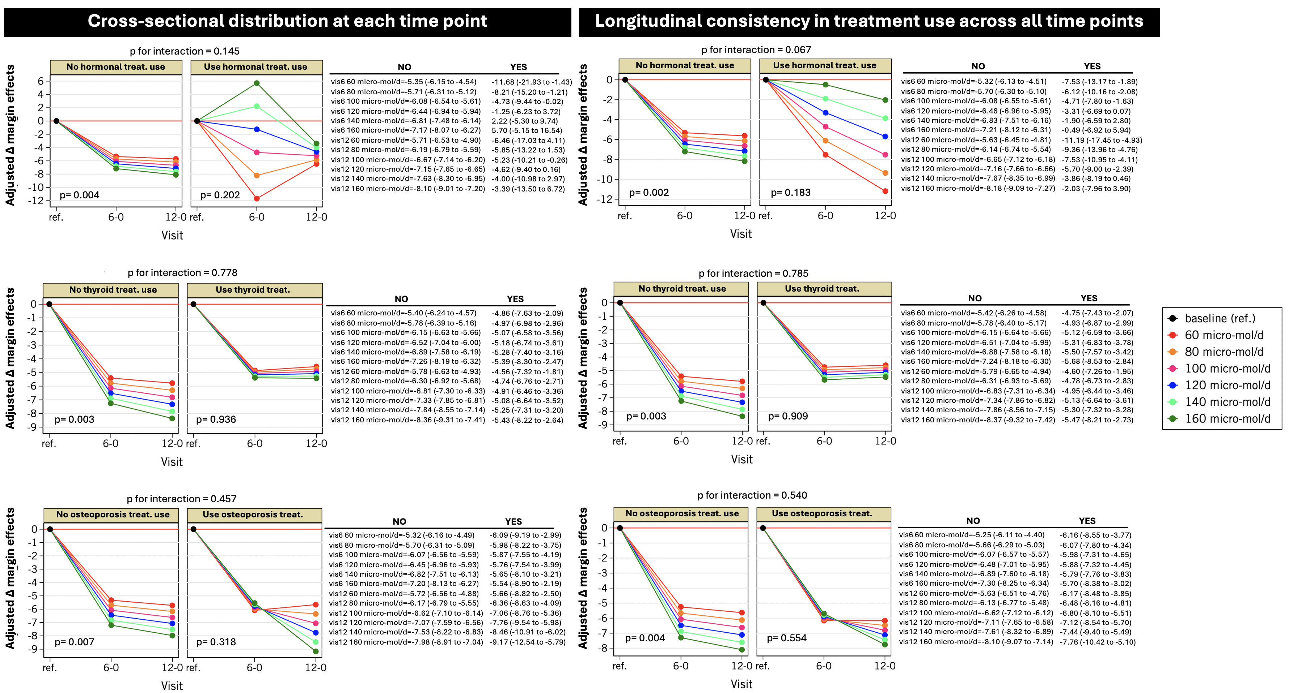

Supplemental figure 2. Stratified analysis effects of dietary SPD on HSI according to pharmacological treatment
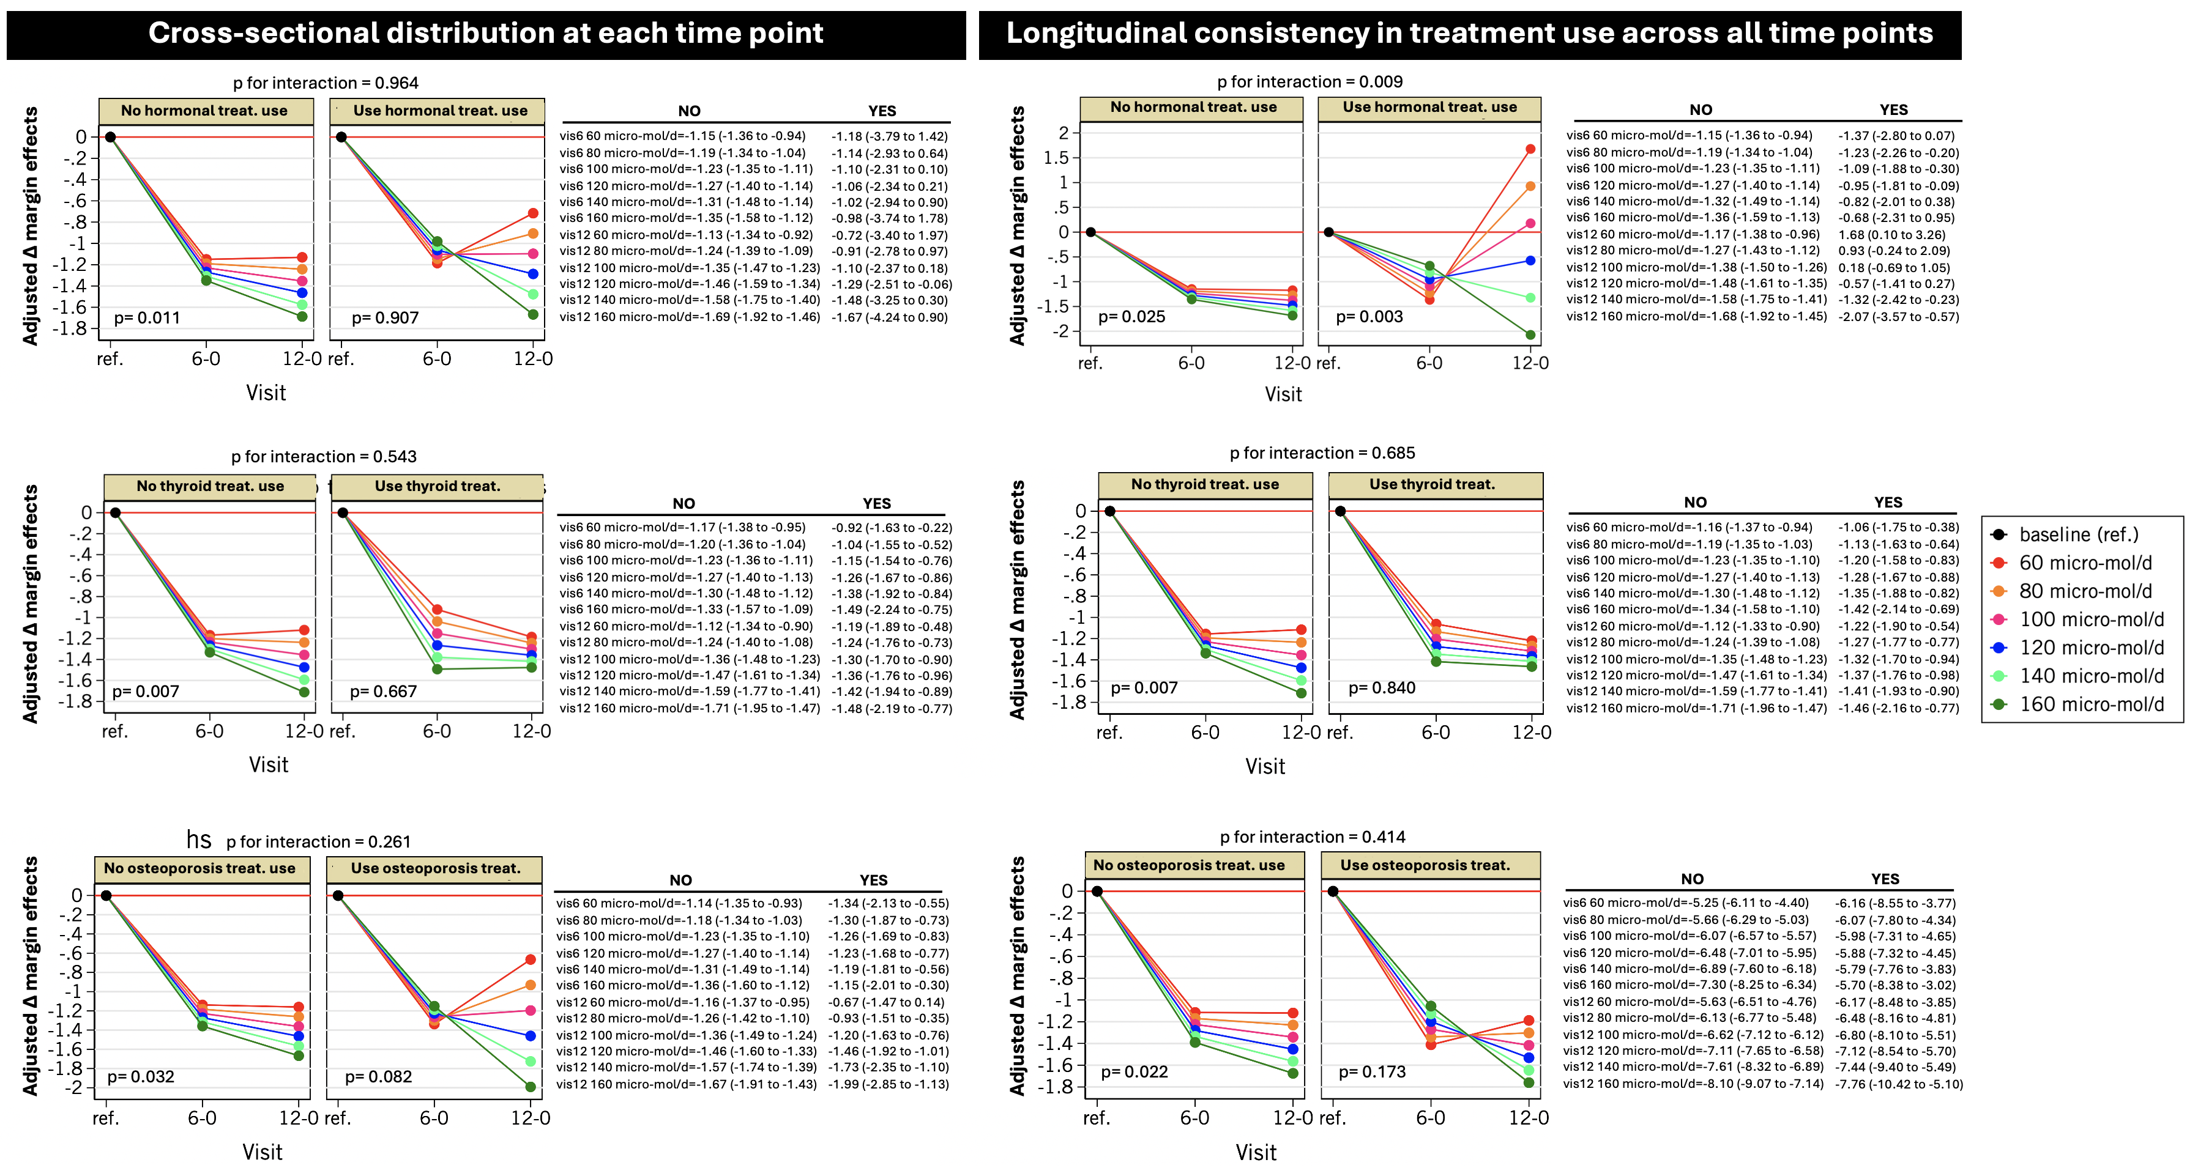

Supplemental figure 3. Stratified analysis effects of dietary SPD on AST according to pharmacological treatment
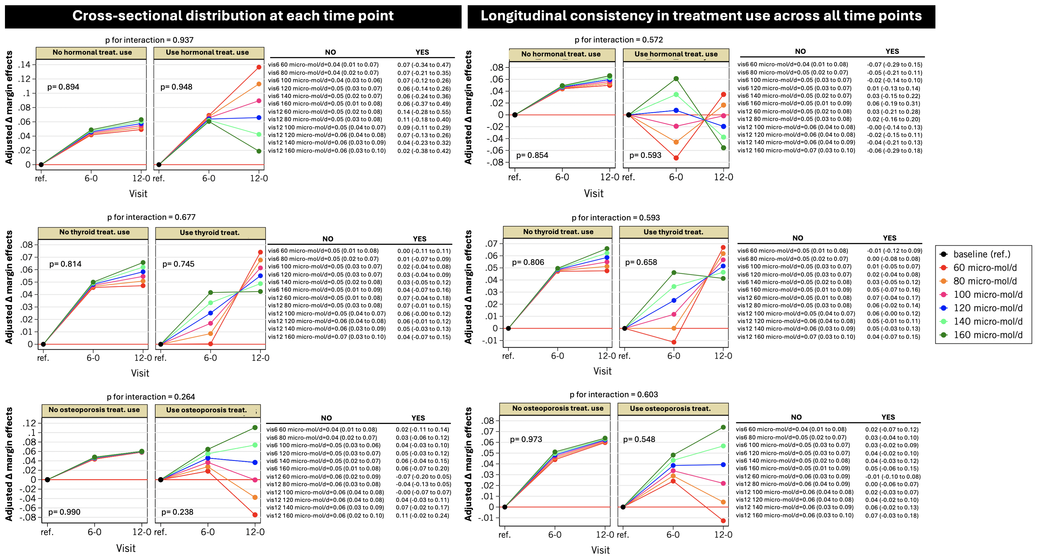

Supplemental figure 4. Stratified analysis effects of dietary SPD on ALT according to pharmacological treatment
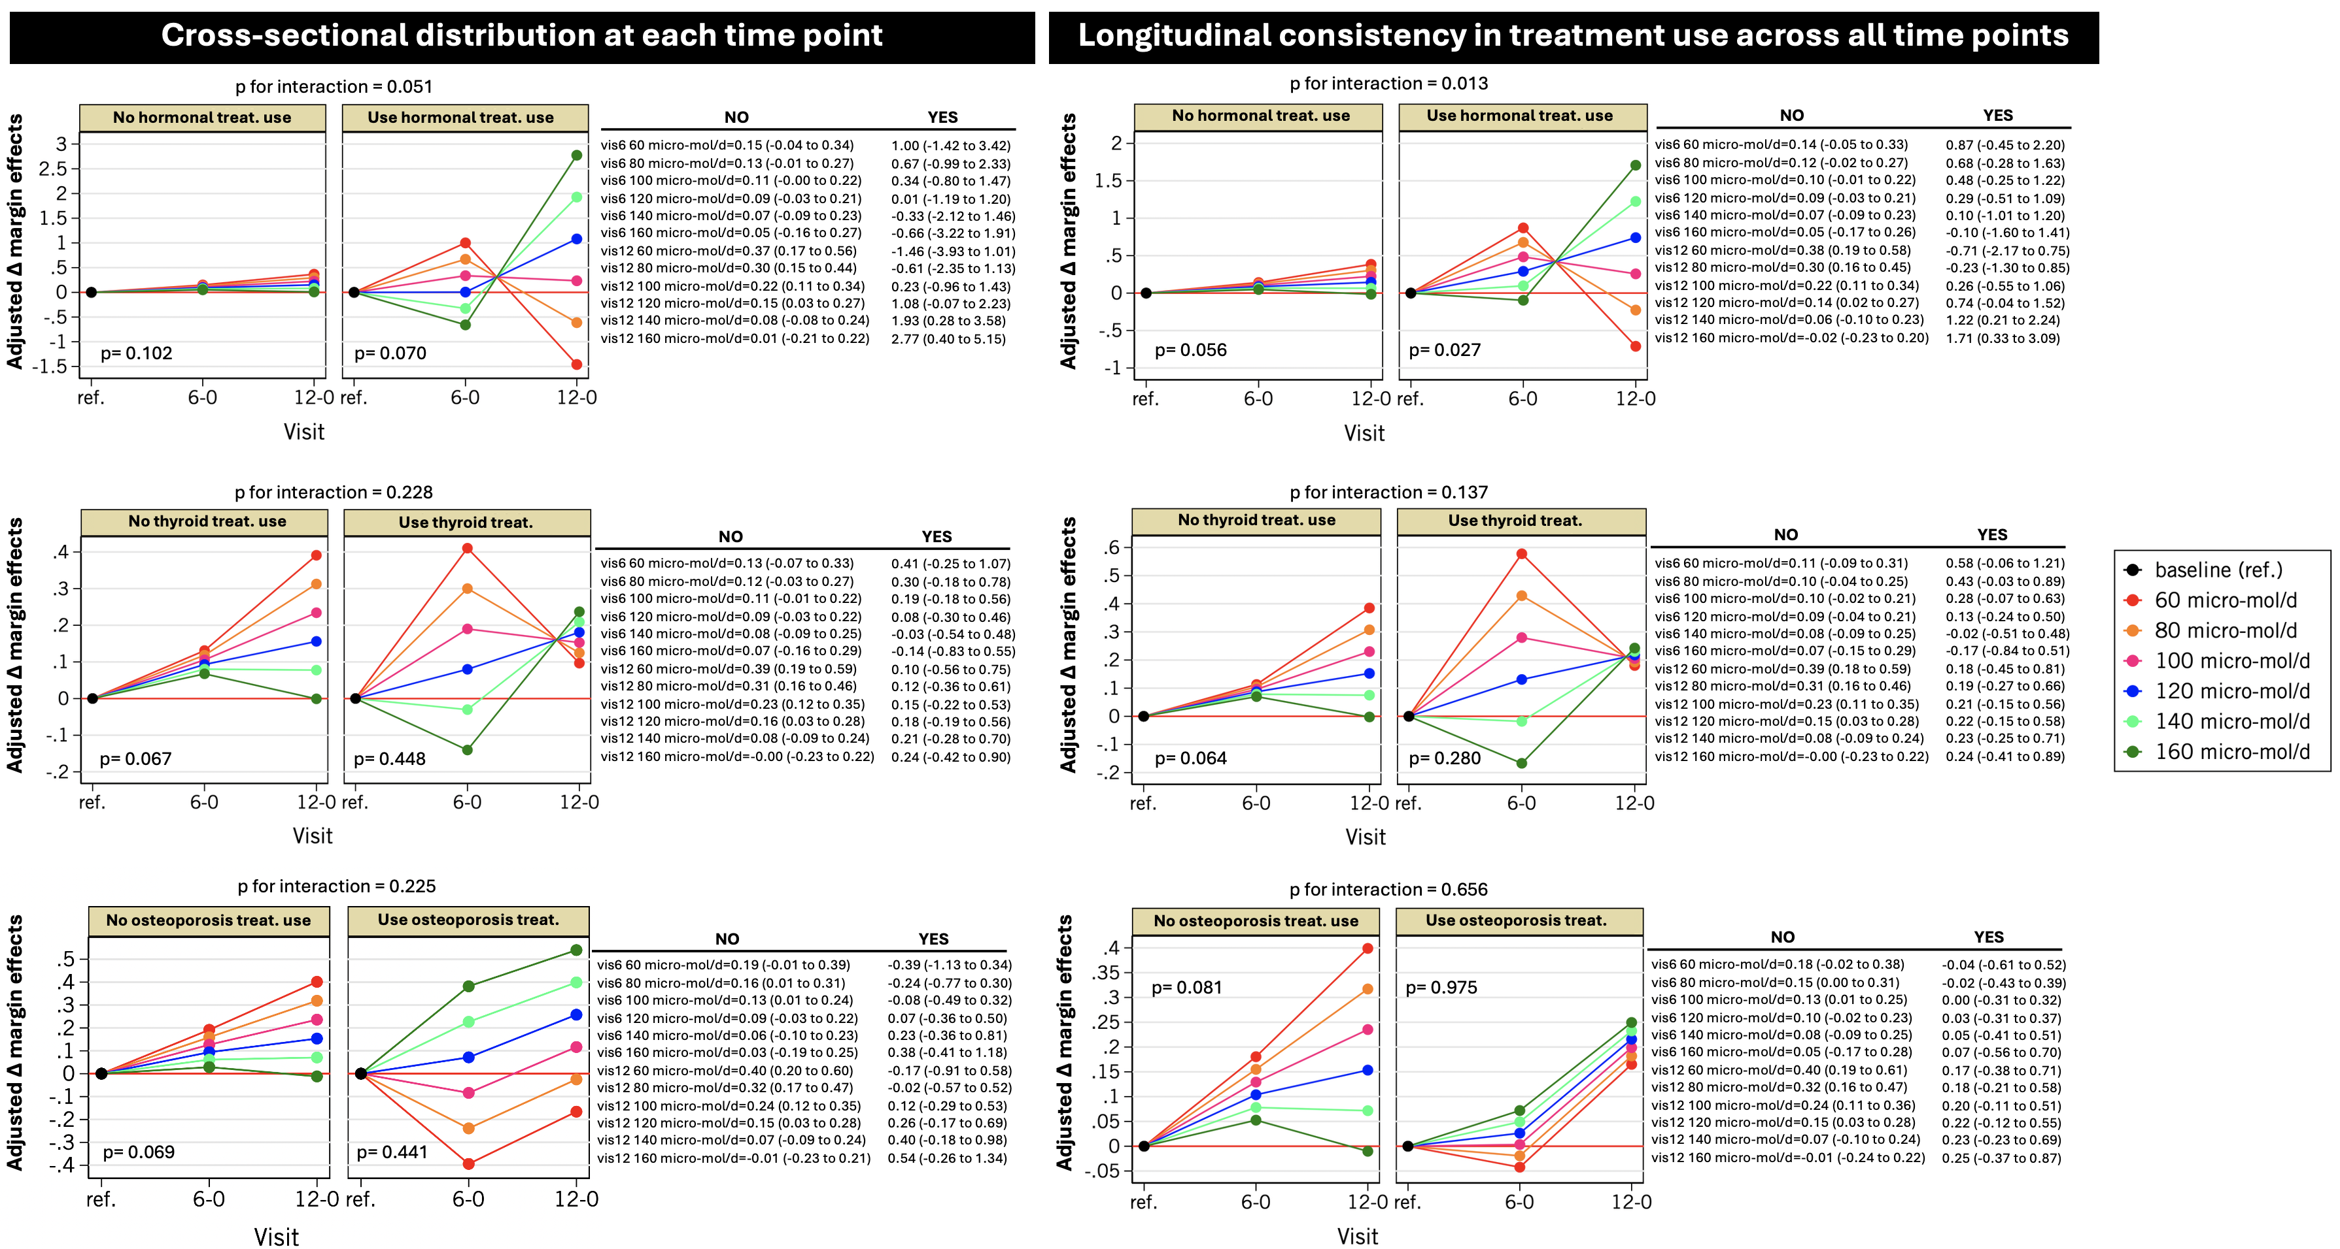

Supplemental figure 5. Stratified analysis effects of dietary SPD on alkaline phosphatase according to pharmacological treatment
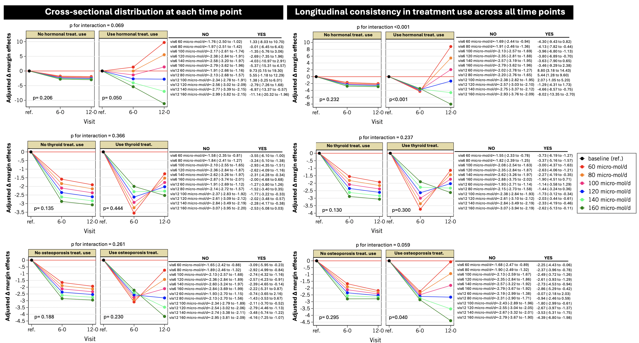

Supplemental figure 6. Stratified analysis effects of dietary SPD on gamma glutamyl transferase according to pharmacological treatment
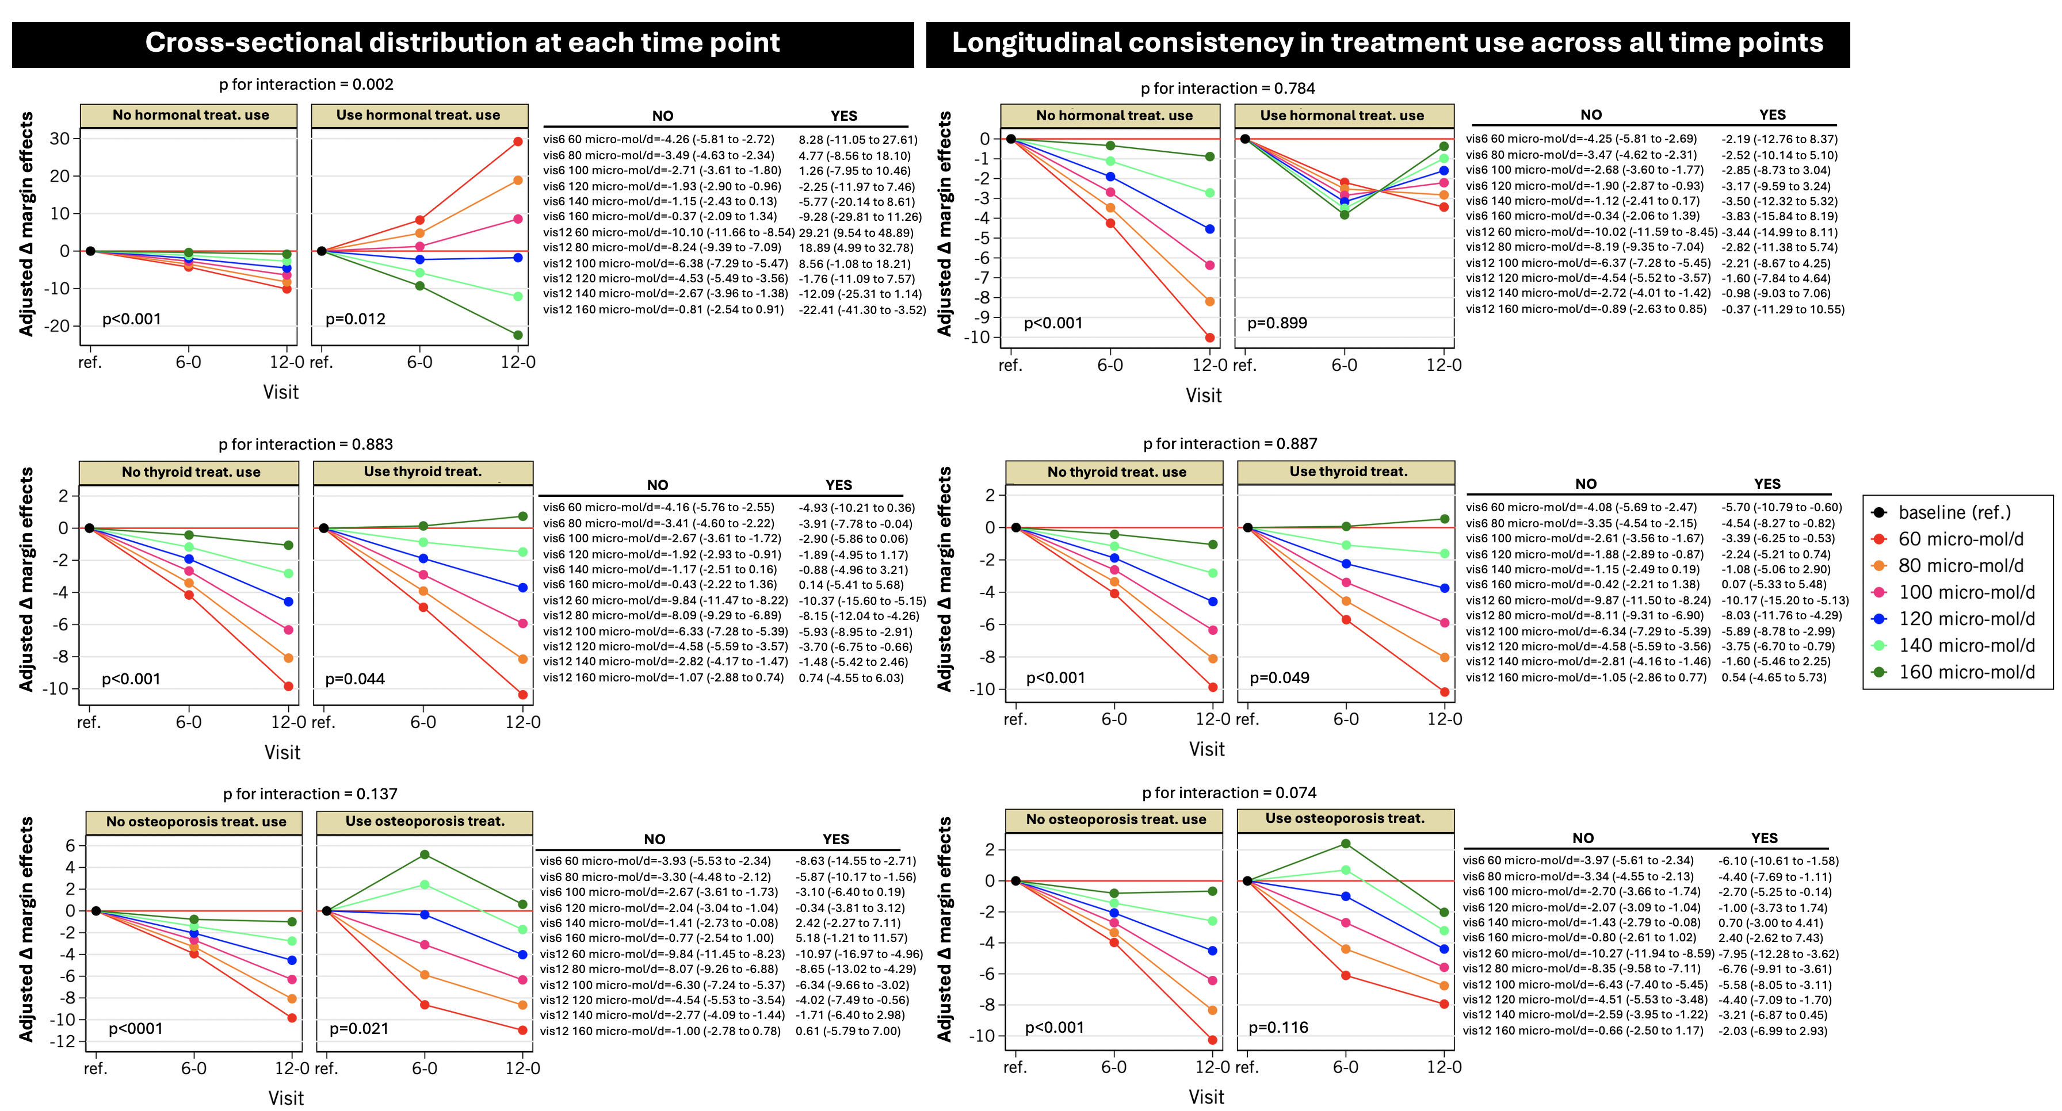

Supplemental figure 7. Stratified analysis effects of dietary SPD on calcium according to pharmacological treatment
