Supplementary information

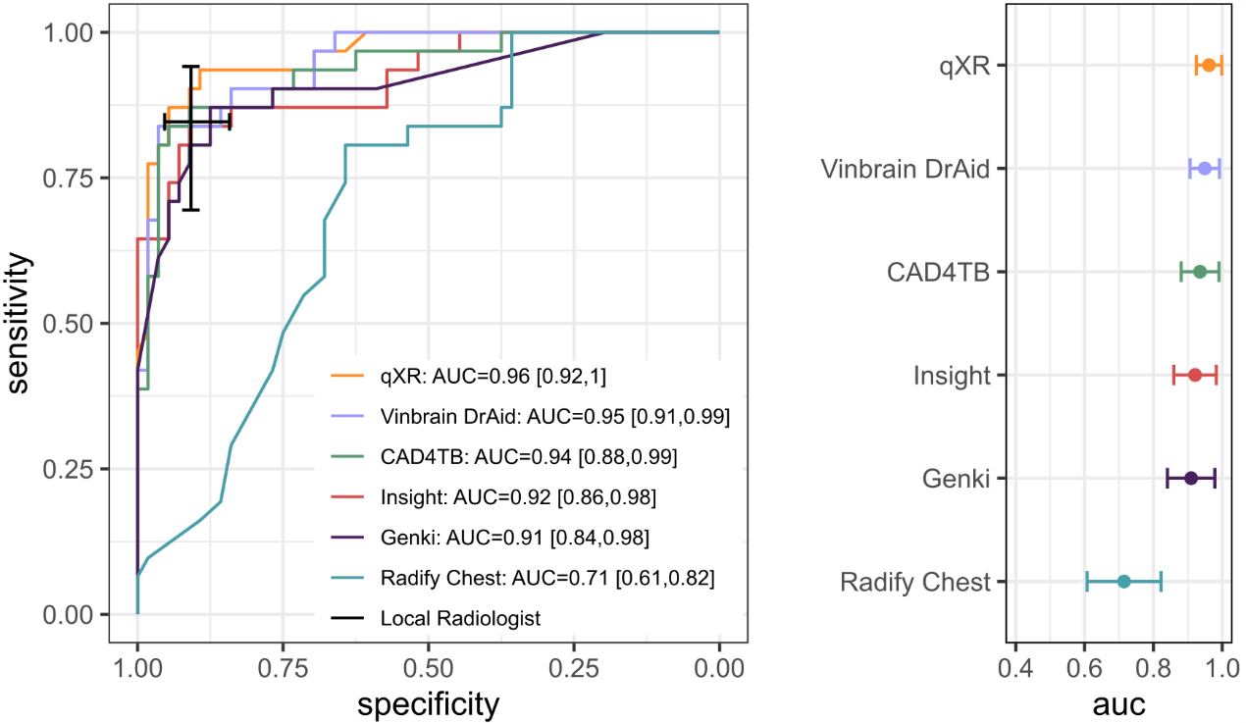
Figure S1. Receiver operating characteristic curves of 7 CAD products (left), assessed in children aged between 13 and 16 years, against a microbiological reference standard and the AUCs with corresponding confidence intervals (right)
Results in this figure are based for all products on the subgroup of children between 13 and 16 years, which were 87 observations, including 31 children with microbiologically confirmed TB and 56 children without TB.
AUC=area under the receiver operating characteristic curve, CAD=computer-aided detection, CXR=chest X-ray, ROC=receiver operating characteristic, TB=tuberculosis.

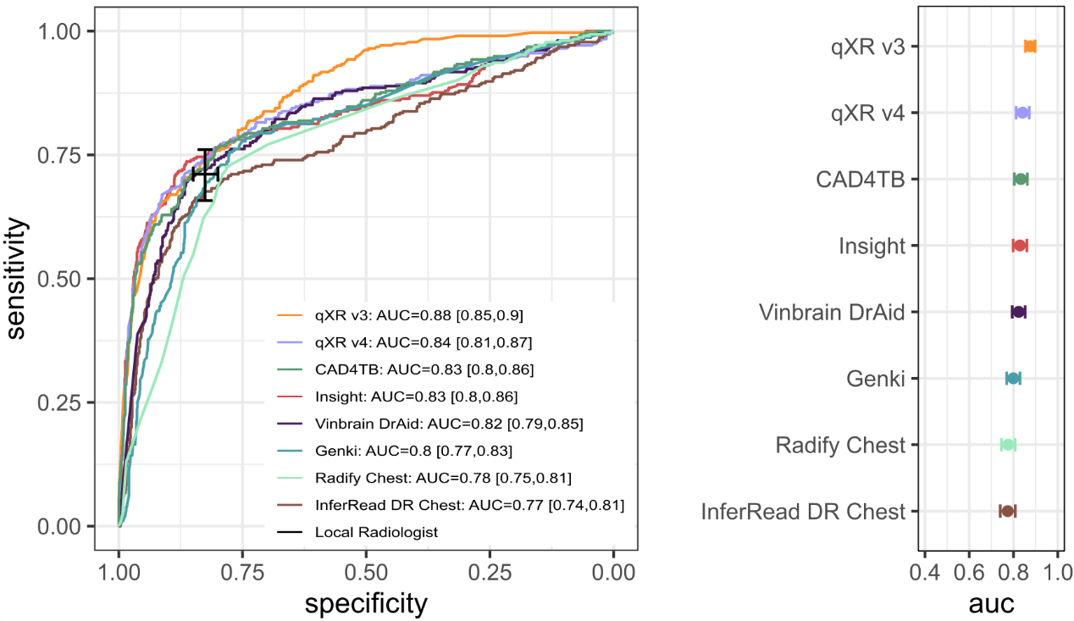

Figure S2. Receiver operating characteristic curves of 8 CAD products including two versions of qXR (v3 and v4) (left), assessed in adults, against a microbiological reference standard and the AUCs with corresponding confidence intervals (right)

A new product version of qXR (v4) was released after the completion of the implementation study and evaluated on the same dataset. Results in this figure are based on 1245 observations, including 315 individuals with confirmed TB and 930 individuals without TB, all 16 years and above and with a digital CXR images that was processed by all assessed CAD products.
AUC=area under the receiver operating characteristic curve, CAD=computer-aided detection, CXR=chest X-ray, ROC=receiver operating characteristic, TB=tuberculosis.

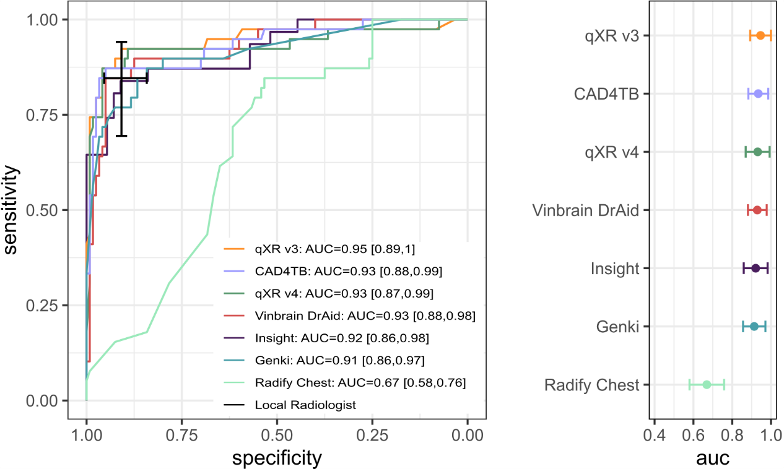

Figure S3. Receiver operating characteristic curves (left) of 8 CAD products including two versions of qXR (v3 and v4), assessed in children, against a microbiological reference standard and the AUCs with corresponding confidence intervals (right)
A new product version of qXR (v4) was released after the completion of the implementation study and evaluated on the same dataset. Results in this figure are based for all products, except Insight CXR, on 159 observations, including 39 children with microbiologically confirmed TB and 120 children without TB, all between 6 and16 years and with a digital CXR images that was processed by all assessed CAD products. Results for Insight CXR are based on the subgroup of children between 13 and 16 years, which were 87 observations, including 31 children with microbiologically confirmed TB and 56 children without TB.

AUC=area under the receiver operating characteristic curve, CAD=computer-aided detection, CXR=chest X-ray, ROC=receiver operating characteristic, TB=tuberculosis.

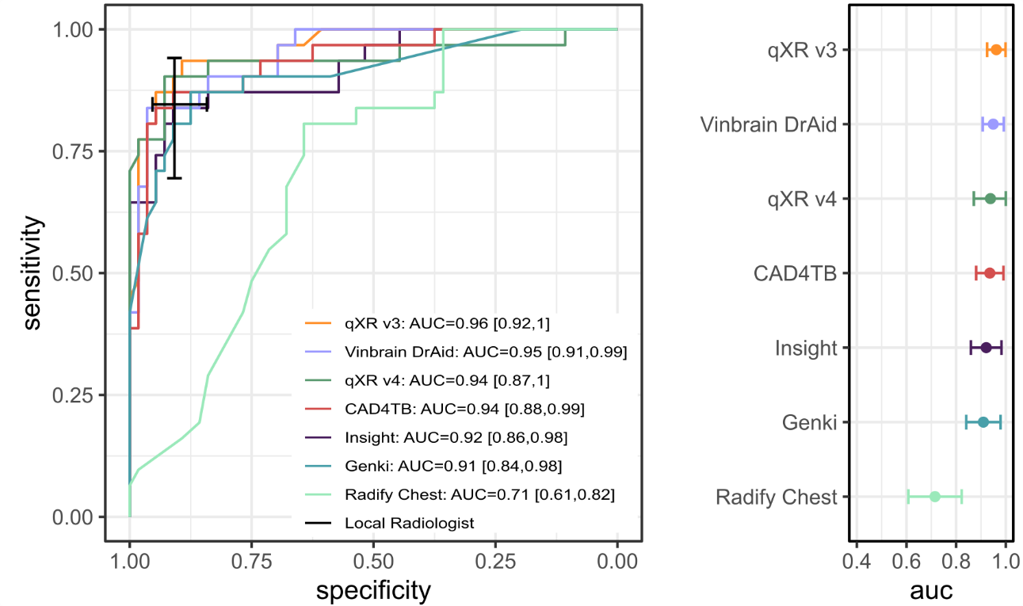

Figure S4. Receiver operating characteristic curves of 8 CAD products including two versions of qXR (v3 and v4), assessed in children aged between 13 and 16 years, against a microbiological reference standard and their AUCs with corresponding confidence intervals (right)
A new product version of qXR (v4) was released after the completion of the implementation study and evaluated on the same dataset. Results in this figure are based for all products on the subgroup of children between 13 and 16 years, which were 87 observations, including 31 children with microbiologically confirmed TB and 56 children without TB.

AUC=area under the receiver operating characteristic curve, CAD=computer-aided detection, CXR=chest X-ray, ROC=receiver operating characteristic, TB=tuberculosis.

