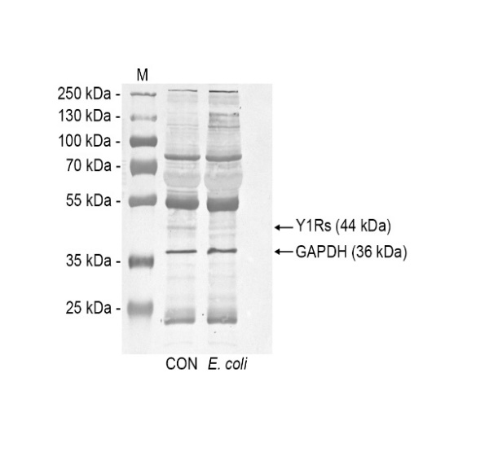
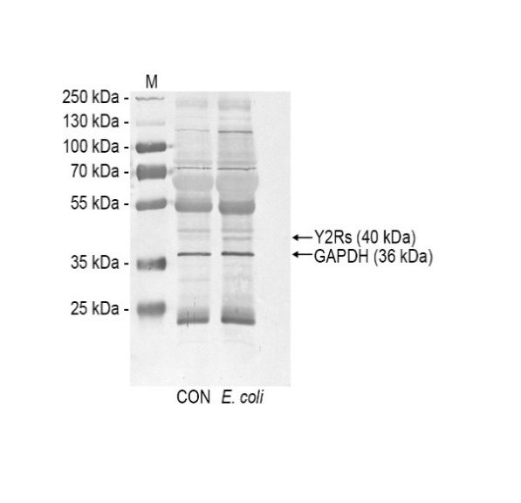
A
B
Figure 1. Representative blots for neuropeptide Y (NPY) receptor subtype 1 (Y1R, A) and NPY receptor subtype 2 (Y2R, B) protein abundances in the endometrium of gilts from the control (CON) and E. coli (E. coli) groups, determined by Western blotting. The density of bands was normalized against glyceraldehyde-3-phosphate dehydrogenase (GAPDH) protein used as loading control. Protein bands corresponded to the molecular weight of Y1Rs, Y2Rs and GAPDH - 44, 40 and 36 kDa, respectively. marker: M.

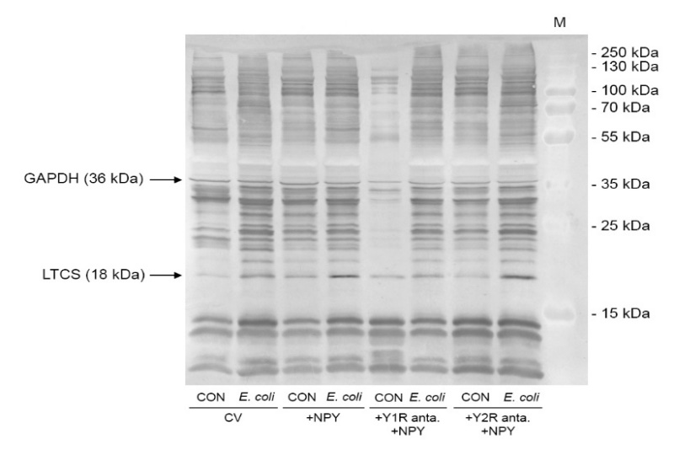
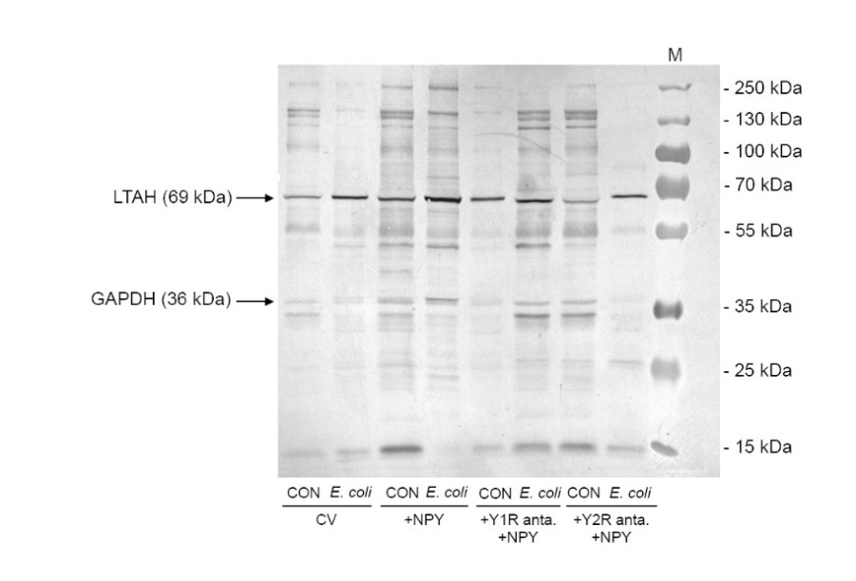
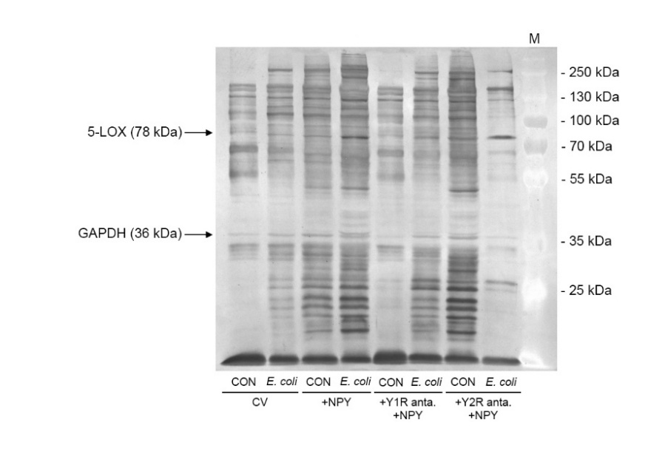
C
B
A
`
Figure 2. Representative blots for 5-lipoxygenase (5-LOX, A), leukotriene A4 hydrolase (LTAH, B) and leukotriene C4 synthase (LTCS, C) protein abundances in the endometrium of gilts from the control (CON) and E. coli (E. coli) groups, after using neuropeptide Y (NPY) alone or with antagonists of NPY receptor subtype 1 (Y1R) and NPY receptor subtype 2 (Y2R), determined by Western blotting. The density of bands was normalized against glyceraldehyde-3-phosphate dehydrogenase (GAPDH) protein used as loading control. Protein bands corresponded to the molecular weight of 5-LOX, LTAH, LTCS and GAPDH - – 78, 69, 18 and 36 kDa, respectively. marker: M; control value: CV (gained for an endometrial stripes from the CON or E. coli groups that had not undergone any treatment in vitro conditions); anta.: antagonist.

