Improvement effects of calcium silicate hydrate and humic acid-encapsulated Alcaligenes faecalis on acidic farmland soil and alterations in microbial community structure
Luhua Jiang ¹ ² ³, Manjun Miao ¹ ², Ziwen Guo ¹ ², Jiejie Yang ¹ ², Yulong Peng ¹ ², Junzhao Wu ¹ ², Bo Miao ¹ ², Xueduan Liu ^{1 2 3, *}
¹ School of Minerals Processing and Bioengineering, Central South University, Changsha 410083, China
² Key Laboratory of Biometallurgy of Ministry of Education, Central South University, Changsha 410083, China
³ Yuelushan Laboratory, Changsha 410128, China
* Correspondence: xueduanliu@csu.edu.cn (X.D. Liu)

Contents:
Fig. S1 Pearson correlation between soil environmental factors in S1 (a), S2 (b), S3 (c) and S4 (d). Note: orange indicates positive correlation and blue indicates negative correlation; * P＜0.05; ** P＜0.01; *** P＜0.001
Fig. S2 Venn diagram (a) and alpha diversity (b) of soil microbial community under different treatments
Fig. S3 The RDA plot between microbial community structures (genus level) and environmental factors in different treatment groups. Note: blue arrows represent taxa; red arrows represent environmental factors; the angle between the arrows represents correlation (acute angle: positive correlation; obtuse angle: negative correlation; right angle: no correlation)

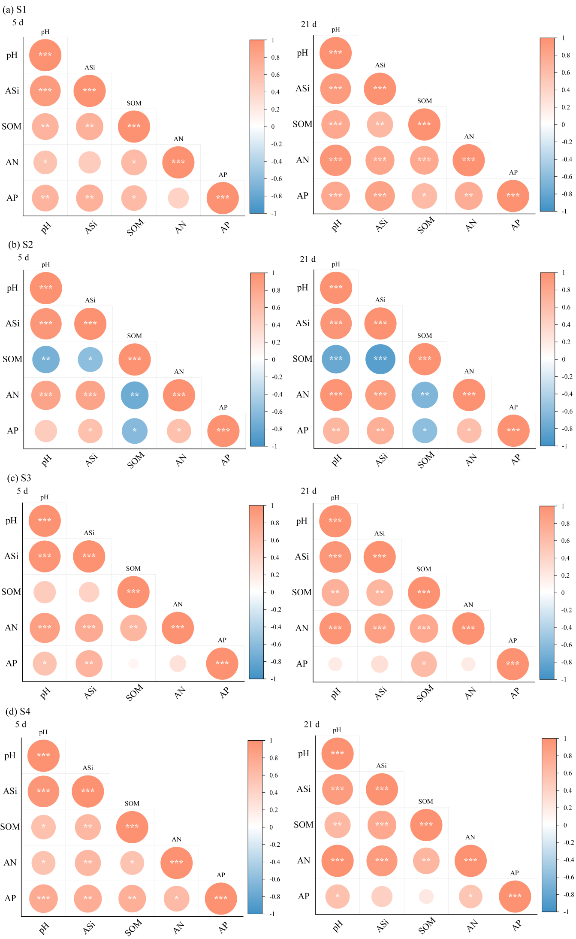

Fig. S1 Pearson correlation between soil environmental factors in S1 (a), S2 (b), S3 (c) and S4 (d). Note: orange indicates positive correlation and blue indicates negative correlation; * P＜0.05; ** P＜0.01; *** P＜0.001
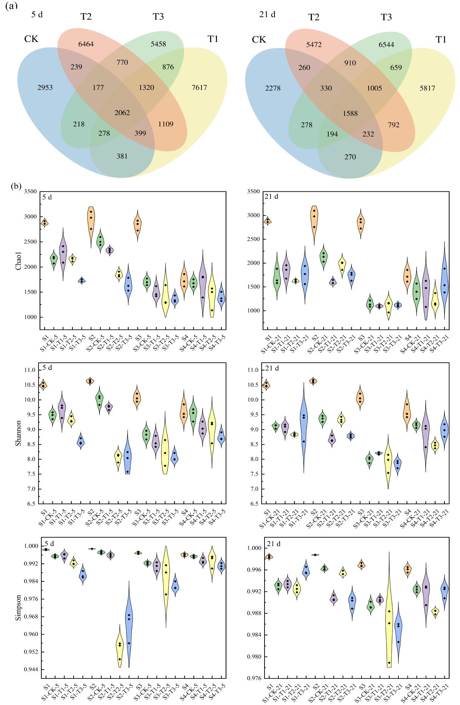

Fig. S2 Venn diagram (a) and alpha diversity (b) of soil microbial community under different treatments

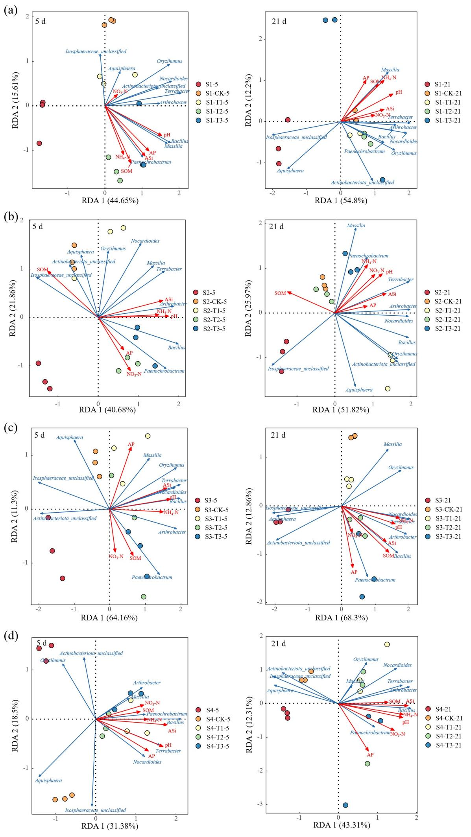

Fig. S3 The RDA plot between microbial community structures (genus level) and environmental factors in different treatment groups. Note: blue arrows represent taxa; red arrows represent environmental factors; the angle between the arrows represents correlation (acute angle: positive correlation; obtuse angle: negative correlation; right angle: no correlation)

