Figure S1 The effects of soil phosphorus availability on plant height and stem diameter of soybean
Note: Lowercase letters indicate significant differences in the same variety under different phosphorus treatments (P < 0.05), and "*, **" represent significance at the 0.05 and 0.01 levels, respectively. This convention applies to all supplementary figures unless otherwise stated.
Figure S2 KEGG enrichment analysis of DAMs in soybean roots
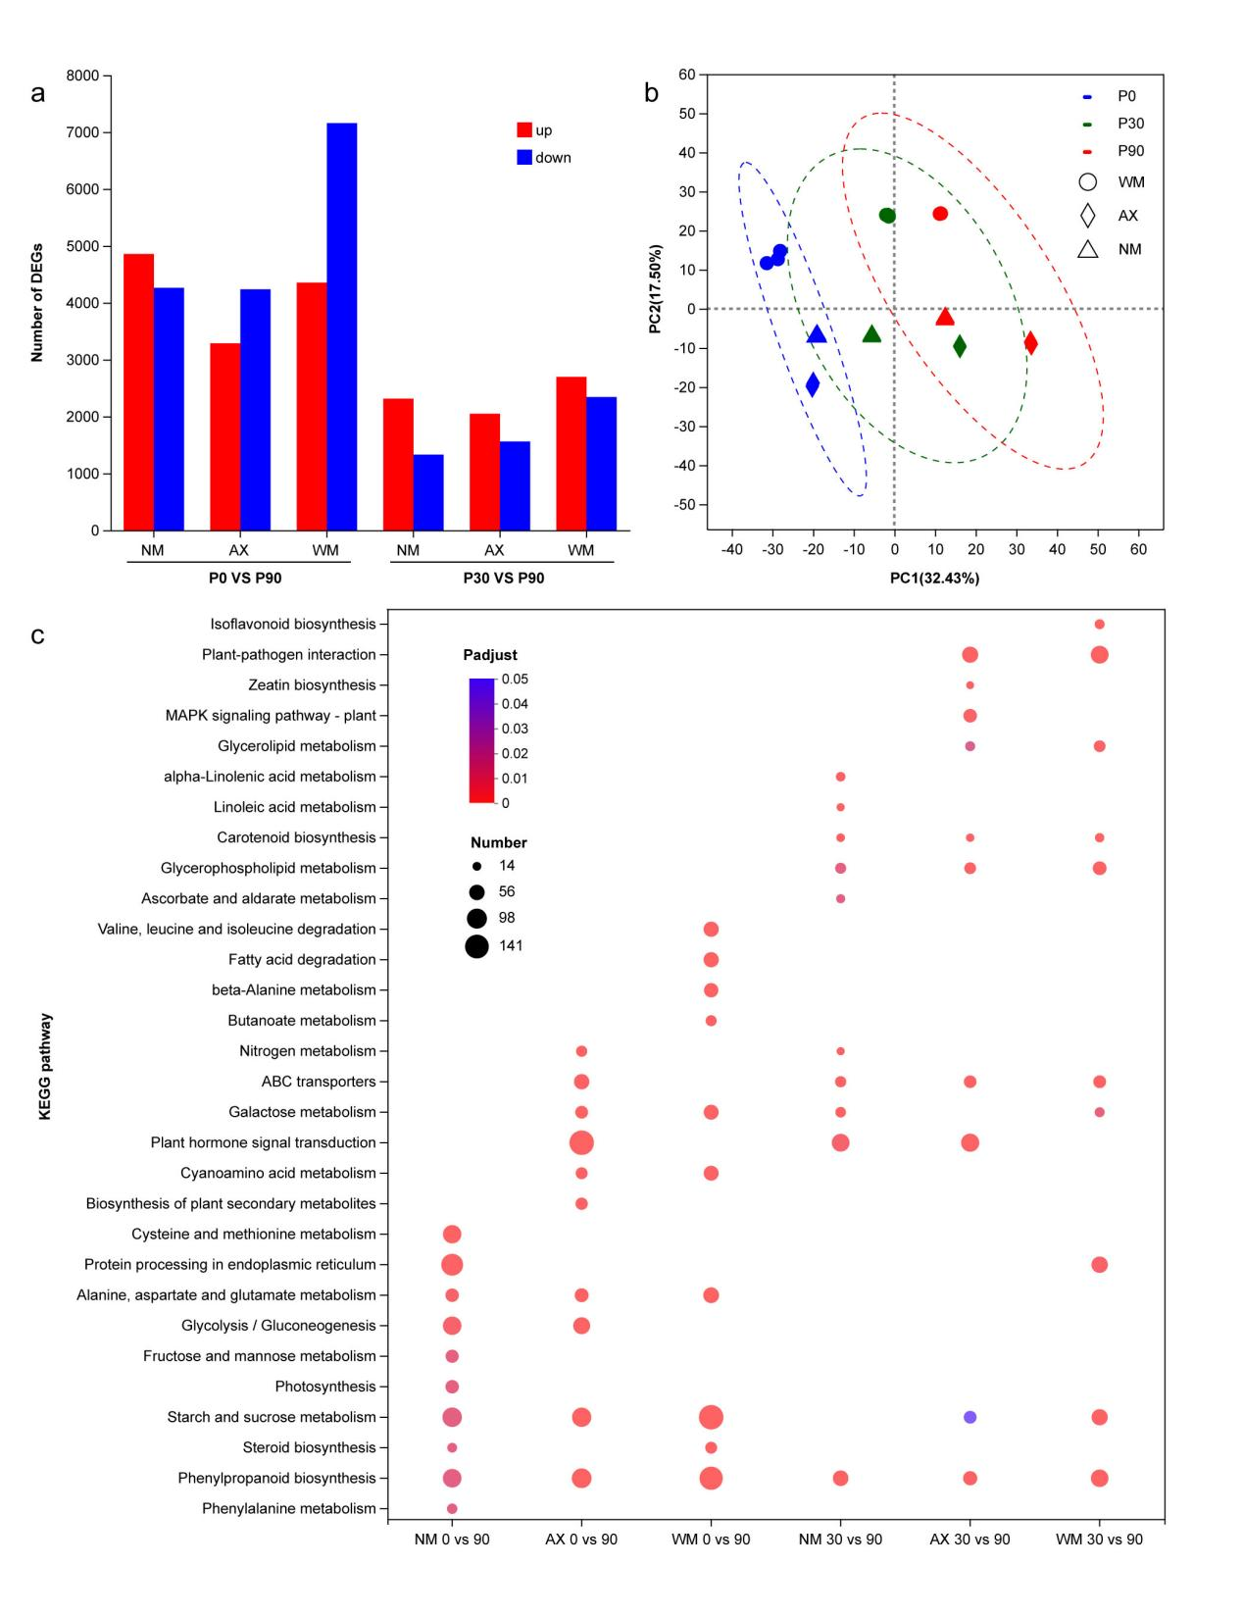
Figure S3 KEGG enrichment analysis of differentially expressed genes in soybean root system
Note: A, represents the expression of root DEGs under different phosphorus treatments;
B, PCA analysis of gene expression in three soybean varieties under different phosphorus treatments;
C, KEGG enrichment analysis of differentially expressed genes in soybean root system.

