Supplementary Material
1 Descriptive and Correlation Analysis of EV71 and CoxA16 Infection Cases with Meteorological Factors in Various Prefecture-Level Cities of Fujian Province
(1)Fuzhou City
From 2017 to 2020, the mean values of Tmax, Tmin, MT, PRE, PRS, RHU, and MWS in Fuzhou City were 25.5℃, 17.9℃, 21.1℃, 3.7mm, 1005.1hPa, 72.9%, and 5.1m/s, respectively (Supplementary Material Table 1). Tmax, Tmin, MT, PRE, PRS, and RHU were identified as influencing factors for EV71 and CoxA16 infections (P < 0.01), with Tmax, Tmin, MT, PRE, and RHU showing a positive correlation (r > 0) and PRS showing a negative correlation (r < 0); MWS did not show a significant correlation (P > 0.05) (Supplementary Material Table 2).
Table 1 Descriptive statistics of meteorological factors in Fuzhou city, 2017-2020
 | Mean ± Standard Deviation | Percentile
 |  | P₀ | P₁₀ | P₂₅ | P₅₀ | P₇₅ | P₉₀ | P₁₀₀
Tmax（℃） | 25.5 ± 7.7 | 5.9 | 14.2 | 19.4 | 25.7 | 32.2 | 35.5 | 40.4
Tmin（℃） | 17.9 ± 6.8 | -0.2 | 8.9 | 12.2 | 18.3 | 24.4 | 26.7 | 29.1
MT（℃） | 21.1 ±6.8 | 3.9 | 11.5 | 15.4 | 21.5 | 27.4 | 30.1 | 33.5
PRE（mm） | 3.7 ± 10.5 | 0.0 | 0.0 | 0.0 | 0.0 | 1.3 | 12.2 | 127.3
PRS（hPa） | 1005.1 ± 7.5 | 979.8 | 995.5 | 999.1 | 1005.5 | 1010.9 | 1014.7 | 1022.6
RHU（%） | 72.9 ± 12.3 | 35.0 | 56.9 | 64.9 | 72.3 | 81.5 | 90.2 | 99.0
MWS（m/s） | 5.1 ± 1.6 | 1.7 | 3.4 | 4.1 | 5.0 | 6.0 | 6.9 | 20.3
Table 2 Spearman correlation analysis of EV71 and CoxA16 infection and meteorological factors in Fuzhou city, 2017-2020
 | Cases | Tmax（℃） | Tmin（℃） | MT（℃） | PRE（mm） | PRS（hPa） | RHU（hPa）
Tmax（℃） | 0.080**
Tmin（℃） | 0.097** | 0.918**
MT（℃） | 0.093** | 0.973** | 0.978**
PRE（mm） | 0.054* | -0.103** | -0.012 | -0.070**
PRS（hPa） | -0.107** | -0.843** | -0.867** | -0.873** | -0.188**
RHU（hPa） | 0.087** | -0.124** | 0.042 | -0.052* | 0.674** | -0.204**
MWS（m/s） | 0.027 | 0.534** | 0.388** | 0.452** | -0.030 | -0.407** | -0.242**
Note ** P < 0.01, * P < 0.05
(2)Longyan City
From 2017 to 2020, the mean values of Tmax, Tmin, MT, PRE, PRS, RHU, and MWS in Longyan City were 26.6℃, 17.0℃, 21.2℃, 4.6mm, 971.0hPa, 73.5%, and 4.5m/s, respectively (Supplementary Material Table 3). Tmax, Tmin, MT, PRE, PRS, and RHU were identified as influencing factors for EV71 and CoxA16 infections (P < 0.01), with Tmax, Tmin, MT, PRE, and RHU showing a positive correlation (r > 0) and PRS showing a negative correlation (r < 0); MWS did not show a significant correlation (P > 0.05) (Supplementary Material Table 4).
Table 3 Descriptive statistics of meteorological factors in Longyan city, 2017-2020
 | Mean ± Standard  Deviation | Percentile
 | Mean ± Standard  Deviation | P₀ | P₁₀ | P₂₅ | P₅₀ | P₇₅ | P₉₀ | P₁₀₀
Tmax（℃） | 26.6 ± 6.5 | 6.7 | 17.2 | 22.2 | 27.3 | 32.1 | 34.6 | 38.2
Tmin（℃） | 17.0 ± 6.2 | -1.1 | 8.4 | 12.5 | 17.7 | 22.7 | 24.1 | 27.3
MT（℃） | 21.2 ± 5.8 | 4.7 | 12.9 | 16.8 | 21.8 | 26.4 | 28.3 | 31.8
PRE（mm） | 4.6 ± 13.4 | 0.0 | 0.0 | 0.0 | 0.0 | 2.3 | 14.3 | 161.3
PRS（hPa） | 971.0 ± 5.9 | 952.2 | 963.3 | 966.5 | 971.3 | 975.4 | 978.4 | 985.1
RHU（%） | 73.5 ± 11.0 | 22.3 | 60.0 | 66.3 | 73.6 | 81.3 | 87.6 | 97.1
MWS（m/s） | 4.5 ± 1.5 | 1.7 | 2.8 | 3.6 | 4.4 | 5.2 | 6.4 | 11.4
Table 4 Spearman correlation analysis of EV71 and CoxA16 infection and meteorological factors in Longyan city, 2017-2020
 | Cases | Tmax（℃） | Tmin（℃） | MT（℃） | PRE（mm） | PRS（hPa） | RHU（%）
Tmax（℃） | 0.068**
Tmin（℃） | 0.122** | 0.843**
MT（℃） | 0.097** | 0.952** | 0.951**
PRE（mm） | 0.176** | -0.059* | 0.188** | 0.032
PRS（hPa） | -0.166** | -0.782** | -0.870** | -0.858** | -0.269**
RHU（%） | 0.170** | -0.128** | 0.221** | 0.013 | 0.712** | -0.236**
MWS（m/s） | -0.016 | 0.293** | 0.220** | 0.254** | 0.051 | -0.218** | -0.215**
Note ** P < 0.01, * P < 0.05
(3)Nanping City
From 2017 to 2020, the mean values of Tmax, Tmin, MT, PRE, PRS, RHU, and MWS in Nanping City were 24.7℃, 15.4℃, 19.5℃, 4.8mm, 992.0hPa, 78.8%, and 2.7m/s, respectively (Supplementary Material Table 5). Tmin, PRE, PRS, and RHU (P < 0.05) were identified as influencing factors for EV71 and CoxA16 infections, with Tmin, PRE, and RHU showing a positive correlation (r > 0) and PRS showing a negative correlation (r < 0); Tmax, MT, and MWS did not show significant correlations (P > 0.05) (Supplementary Material Table 6).
Table 5 Descriptive statistics of meteorological factors in Nanping city, 2017-2020
 | Mean±Standard  Deviation | Percentile
 | Mean±Standard  Deviation | P₀ | P₁₀ | P₂₅ | P₅₀ | P₇₅ | P₉₀ | P₁₀₀
Tmax（℃） | 24.7 ± 8.4 | 2.9 | 12.6 | 17.6 | 25.4 | 32.5 | 35.3 | 39.0
Tmin（℃） | 15.4 ± 7.6 | -4.0 | 5.2 | 9.5 | 15.9 | 22.7 | 24.6 | 27.7
MT（℃） | 19.5 ± 7.5 | 1.1 | 9.4 | 13.3 | 20.2 | 26.3 | 29.1 | 31.9
PRE（mm） | 4.8 ± 12.0 | 0.0 | 0.0 | 0.0 | 0.0 | 3.6 | 15.7 | 116.4
PRS（hPa） | 992.0 ± 7.4 | 970.4 | 982.4 | 986.1 | 992.3 | 997.6 | 1001.4 | 1010.2
RHU（%） | 78.8 ± 10.6 | 47.0 | 65.1 | 70.7 | 78.7 | 87.0 | 93.6 | 99.0
MWS（m/s） | 2.7 ± 1.1 | 1.0 | 1.6 | 1.9 | 2.4 | 3.2 | 4.3 | 8.2
Table 6 Spearman correlation analysis of EV71 and CoxA16 infection and meteorological factors in Nanping city, 2017-2020
 | Cases | Tmax（℃） | Tmin（℃） | MT（℃） | PRE（mm） | PRS（hPa） | RHU（%）
Tmax（℃） | 0.034
Tmin（℃） | 0.058* | 0.883**
MT（℃） | 0.040 | 0.965** | 0.966**
PRE（mm） | 0.051* | -0.176** | 0.068** | -0.066*
PRS（hPa） | -0.071** | -0.824** | -0.891** | -0.883** | -0.152**
RHU（%） | 0.080** | -0.388** | -0.052* | -0.243** | 0.705** | 0.009
MWS（m/s） | 0.002 | 0.453** | 0.423** | 0.439** | 0.186** | -0.462** | -0.130**
Note ** P < 0.01, * P < 0.05
(4)Ningde City
From 2017 to 2020, the mean values of Tmax, Tmin, MT, PRE, PRS, RHU, and MWS in Ningde City were 24.4℃, 17.8℃, 20.8℃, 5.1mm, 1011.6hPa, 76.6%, and 3.0m/s, respectively (Supplementary Material Table 7). Tmax, Tmin, MT, PRE, PRS, and RHU were identified as influencing factors for EV71 and CoxA16 infections (P < 0.05), with Tmax, Tmin, MT, PRE, and RHU showing a positive correlation (r > 0) and PRS showing a negative correlation (r < 0); MWS did not show a significant correlation (P > 0.05) (Supplementary Material Table 8).
Table 7 Descriptive statistics of meteorological factors in Ningde city, 2017-2020
 | Mean±Standard  Deviation | Percentile
 | Mean±Standard  Deviation | P₀ | P₁₀ | P₂₅ | P₅₀ | P₇₅ | P₉₀ | P₁₀₀
Tmax（℃） | 24.4 ± 7.7 | 6.0 | 13.8 | 18.1 | 24.8 | 31.1 | 34.5 | 39.8
Tmin（℃） | 17.8 ± 7.0 | 0.2 | 8.7 | 11.9 | 18.1 | 24.5 | 26.8 | 29.8
MT（℃） | 20.8 ± 7.0 | 4.4 | 11.1 | 14.9 | 21.0 | 27.2 | 30.0 | 34.1
PRE（mm） | 5.1 ± 13.9 | 0.0 | 0.0 | 0.0 | 0.0 | 3.7 | 15.6 | 187.9
PRS（hPa） | 1011.6 ± 7.9 | 983.3 | 1001.2 | 1005.2 | 1011.9 | 1017.7 | 1021.8 | 1030.1
RHU（%） | 76.6 ± 12.3 | 35.0 | 59.8 | 67.9 | 76.7 | 86.5 | 93.5 | 100.0
MWS（m/s） | 3.0 ± 0.9 | 0.7 | 1.8 | 2.4 | 3.0 | 3.5 | 4.0 | 11.5
Table 8 Spearman correlation analysis of EV71 and CoxA16 infection and meteorological factors in Ningde city, 2017-2020
 | Cases | Tmax（℃） | Tmin（℃） | MT（℃） | PRE（mm） | PRS（hPa） | RHU（%）
Tmax（℃） | 0.154**
Tmin（℃） | 0.166** | 0.935**
MT（℃） | 0.166** | 0.979** | 0.982**
PRE（mm） | 0.058* | -0.114** | 0.013 | -0.063*
PRS（hPa） | -0.210** | -0.850** | -0.877** | -0.877** | -0.152**
RHU（%） | 0.092** | -0.186** | 0.025 | -0.087** | 0.700** | -0.143**
MWS（m/s） | -0.021 | 0.502** | 0.353** | 0.417** | -0.066* | -0.325** | -0.344**
Note ** P < 0.01, * P < 0.05
(5)Putian City
From 2017 to 2020, the mean values of Tmax, Tmin, MT, PRE, PRS, RHU, and MWS in Putian City were 25.6℃, 19.1℃, 21.8℃, 4.1mm, 1005.2hPa, 72.2%, and 4.8m/s, respectively (Supplementary Material Table 9). Tmax, Tmin, MT, and PRS (P < 0.01) were identified as influencing factors for EV71 and CoxA16 infections, with Tmax, Tmin, and MT showing a positive correlation (r > 0) and PRS showing a negative correlation (r < 0); PRE, RHU, and MWS did not show significant correlations (P > 0.05) (Supplementary Material Table 10).
Table 9 Descriptive statistics of meteorological factors in Putian city, 2017-2020
 | Mean±Standard  Deviation | Percentile
 | Mean±Standard  Deviation | P₀ | P₁₀ | P₂₅ | P₅₀ | P₇₅ | P₉₀ | P₁₀₀
Tmax（℃） | 25.6 ± 6.9 | 6.7 | 16.0 | 20.3 | 26.0 | 31.9 | 34.4 | 38.1
Tmin（℃） | 19.1 ± 6.2 | 2.9 | 10.6 | 13.6 | 19.9 | 25.0 | 26.9 | 31.1
MT（℃） | 21.8 ± 6.3 | 4.7 | 13.1 | 16.6 | 22.3 | 27.6 | 29.9 | 33.6
PRE（mm） | 4.1 ± 13.8 | 0.0 | 0.0 | 0.0 | 0.0 | 0.7 | 11.2 | 196.2
PRS（hPa） | 1005.2 ± 7.0 | 981.2 | 996.1 | 999.6 | 1005.6 | 1010.6 | 1014.1 | 1021.4
RHU（%） | 72.2 ± 13.6 | 25.0 | 54.1 | 63.4 | 72.8 | 82.0 | 90.3 | 99.0
MWS（m/s） | 4.8 ± 1.4 | 1.8 | 3.2 | 3.9 | 4.7 | 5.7 | 6.5 | 15.1
Table 10 Spearman correlation analysis of EV71 and CoxA16 infection and meteorological factors in Putian city, 2017-2020
 | Cases | Tmax（℃） | Tmin（℃） | MT（℃） | PRE（mm） | PRS（hPa） | RHU（%）
Tmax（℃） | 0.094**
Tmin（℃） | 0.086** | 0.933**
MT（℃） | 0.097** | 0.977** | 0.982**
PRE（mm） | 0.024 | -0.075** | -0.025 | -0.058*
PRS（hPa） | -0.112** | -0.843** | -0.861** | -0.867** | -0.196**
RHU（%） | 0.046 | 0.097** | 0.184** | 0.133** | 0.617** | -0.387**
MWS（m/s） | 0.040 | 0.391** | 0.320** | 0.351** | -0.088** | -0.218** | -0.346**
Note ** P < 0.01, * P < 0.05
(6)Quanzhou City
From 2017 to 2020, the mean values of Tmax, Tmin, MT, PRE, PRS, RHU, and MWS in Quanzhou City were 27.3℃, 19.4℃, 22.8℃, 3.4mm, 1009.9hPa, 73.1%, and 4.6m/s, respectively (Supplementary Material Table 11). Tmax, Tmin, MT, PRE, PRS, and RHU were identified as influencing factors for EV71 and CoxA16 infections (P < 0.01), with Tmax, Tmin, MT, PRE, and RHU showing a positive correlation (r > 0) and PRS showing a negative correlation (r < 0); MWS did not show a significant correlation (P > 0.05) (Supplementary Material Table 12).

Table 11 Descriptive statistics of meteorological factors in Quanzhou city, 2017-2020
 | Mean±Standard  Deviation | Percentile
 | Mean±Standard  Deviation | P₀ | P₁₀ | P₂₅ | P₅₀ | P₇₅ | P₉₀ | P₁₀₀
Tmax（℃） | 27.3 ± 6.2 | 10.1 | 18.7 | 22.3 | 27.9 | 32.7 | 35.1 | 39.5
Tmin（℃） | 19.4 ± 6.0 | 2.3 | 11.4 | 14.7 | 20.2 | 25.1 | 26.5 | 31.0
MT（℃） | 22.8 ± 5.8 | 6.5 | 14.9 | 18.1 | 23.4 | 28.1 | 30.0 | 34.9
PRE（mm） | 3.4 ± 9.8 | 0.0 | 0.0 | 0.0 | 0.0 | 0.7 | 11.8 | 113.0
PRS（hPa） | 1009.9 ± 6.8 | 988.2 | 1001.0 | 1004.6 | 1010.3 | 1015.0 | 1018.4 | 1026.4
RHU（%） | 73.1 ± 13.1 | 20.5 | 54.5 | 64.6 | 74.7 | 82.4 | 89.1 | 99.0
MWS（m/s） | 4.6 ± 1.2 | 1.6 | 3.0 | 3.7 | 4.5 | 5.2 | 6.1 | 10.4
Table 12 Spearman correlation analysis of EV71 and CoxA16 infection and meteorological factors in Quanzhou city, 2017-2020
 | Cases | Tmax（℃） | Tmin（℃） | MT（℃） | PRE（mm） | PRS（hPa） | RHU（%）
Tmax（℃） | 0.133**
Tmin（℃） | 0.196** | 0.910**
MT（℃） | 0.167** | 0.971** | 0.974**
PRE（mm） | 0.074** | -0.061* | 0.053* | -0.016
PRS（hPa） | -0.169** | -0.826** | -0.862** | -0.862** | -0.215**
RHU（%） | 0.152** | 0.044 | 0.195** | 0.110** | 0.590** | -0.354**
MWS（m/s） | -0.026 | 0.206** | 0.110** | 0.146** | -0.045 | -0.084** | -0.278**
Note ** P < 0.01, * P < 0.05
(7)Sanming City
From 2017 to 2020, the mean values of Tmax, Tmin, MT, PRE, PRS, RHU, and MWS in Sanming City were 26.0℃, 16.8℃, 20.9℃, 4.2mm, 990.0hPa, 73.8%, and 4.5m/s, respectively (Supplementary Material Table 13). Tmax, Tmin, MT, PRE, PRS, and RHU were identified as influencing factors for EV71 and CoxA16 infections (P < 0.05), with Tmax, Tmin, MT, PRE, and RHU showing a positive correlation (r > 0) and PRS showing a negative correlation (r < 0); MWS did not show a significant correlation (P > 0.05) (Supplementary Material Table 14).
Table 13 Descriptive statistics of meteorological factors in Sanming city, 2017-2020
 | Mean±Standard  Deviation | Percentile
 | Mean±Standard  Deviation | P₀ | P₁₀ | P₂₅ | P₅₀ | P₇₅ | P₉₀ | P₁₀₀
Tmax（℃） | 26.0 ± 8.1 | 4.9 | 14.3 | 19.5 | 26.7 | 33.2 | 36.2 | 39.6
Tmin（℃） | 16.8 ± 6.9 | -1.7 | 7.5 | 11.4 | 17.2 | 23.6 | 25. | 27.5
MT（℃） | 20.9 ± 7.0 | 2.9 | 11.3 | 15.4 | 21.4 | 27.2 | 29.7 | 32.5
PRE（mm） | 4.2 ± 11.0 | 0.0 | 0.0 | 0.0 | 0.0 | 2.4 | 14.5 | 136.0
PRS（hPa） | 990.0 ± 7.1 | 970.0 | 981.0 | 984.3 | 990.2 | 995.3 | 999.1 | 1007.6
RHU（%） | 73.8 ± 11.9 | 34.3 | 58.5 | 64.6 | 73.3 | 83.2 | 90.3 | 98.5
MWS（m/s） | 4.5 ± 1.2 | 2.0 | 3.1 | 3.6 | 4.3 | 5.2 | 5.9 | 11.2
Table 14 Spearman correlation analysis of EV71 and CoxA16 infection and meteorological factors in Sanming city, 2017-2020
 | Cases | Tmax（℃） | Tmin（℃） | MT（℃） | PRE（mm） | PRS（hPa） | RHU（%）
Tmax（℃） | 0.084**
Tmin（℃） | 0.085** | 0.888**
MT（℃） | 0.086** | 0.969** | 0.965**
PRE（mm） | 0.068** | -0.152** | 0.028 | -0.088**
PRS（hPa） | -0.102** | -0.826** | -0.885** | -0.878** | -0.149**
RHU（%） | 0.065* | -0.326** | -0.024 | -0.206** | 0.702** | -0.044
MWS（m/s） | -0.046 | 0.007 | 0.074** | 0.031 | 0.154** | 0.001 | -0.013
Note ** P < 0.01, * P < 0.05
(8)Xiamen City
From 2017 to 2020, the mean values of Tmax, Tmin, MT, PRE, PRS, RHU, and MWS in Xiamen City were 26.0°C, 19.2°C, 21.9°C, 2.6mm, 997.9hPa, 75.2%, and 5.5m/s, respectively (Supplementary Material Table 15). As shown in Table 16, Tmax, Tmin, MT, PRE, PRS, and RHU were identified as influencing factors for EV71 and CoxA16 infections (P < 0.01), with Tmax, Tmin, MT, PRE, and RHU showing a positive correlation (r > 0) and PRS showing a negative correlation (r < 0); MWS did not show a significant correlation (P > 0.05) (Supplementary Material Table 16).
Table 15 Descriptive statistics of meteorological factors in Xiamen city, 2017-2020
 | Mean±Standard  Deviation | Percentile
 | Mean±Standard  Deviation | P₀ | P₁₀ | P₂₅ | P₅₀ | P₇₅ | P₉₀ | P₁₀₀
Tmax（℃） | 26.0 ± 6.3 | 8.7 | 17.3 | 21.0 | 26.7 | 31.5 | 33.8 | 39.6
Tmin（℃） | 19.2 ± 5.9 | 3.9 | 11.2 | 14.1 | 19.9 | 24.9 | 26.4 | 28.3
MT（℃） | 21.9 ± 5.8 | 5.8 | 13.8 | 17.0 | 22.5 | 27.5 | 29.0 | 33.5
PRE（mm） | 2.6 ± 8.8 | 0.0 | 0.0 | 0.0 | 0.0 | 0.2 | 6.9 | 136.5
PRS（hPa） | 997.9 ± 6.4 | 976.9 | 989.5 | 992.9 | 998.4 | 1002.8 | 1006.0 | 1013.3
RHU（%） | 75.2 ± 12.9 | 26.6 | 57.3 | 67.0 | 76.5 | 84.1 | 91.7 | 99.9
MWS（m/s） | 5.5 ± 1.56 | 2.1 | 3.8 | 4.5 | 5.2 | 6.2 | 7.4 | 18.6
Table 16 Spearman correlation analysis of EV71 and CoxA16 infection and meteorological factors in Xiamen city, 2017-2020
 | Cases | Tmax（℃） | Tmin（℃） | MT（℃） | PRE（mm） | PRS（hPa） | RHU（%）
Tmax（℃） | 0.152**
Tmin（℃） | 0.162** | 0.934**
MT（℃） | 0.165** | 0.974** | 0.984**
PRE（mm） | 0.076** | -0.109** | -0.046 | -0.070**
PRS（hPa） | -0.235** | -0.831** | -0.862** | -0.864** | -0.170**
RHU（%） | 0.167** | 0.095** | 0.181** | 0.138** | 0.578** | -0.380**
MWS（m/s） | -0.011 | 0.065* | 0.033 | 0.041 | 0.013 | 0.029 | -0.362**
Note ** P < 0.01, * P < 0.05
(9)Zhangzhou City
From 2017 to 2020, the mean values of Tmax, Tmin, MT, PRE, PRS, RHU, and MWS in Zhangzhou City were 27.7°C, 19.8°C, 23.3°C, 3.8mm, 1010.6hPa, 72.0%, and 3.7m/s, respectively (Supplementary Material Table 17). As shown in Table 18, Tmax, Tmin, MT, PRE, PRS, RHU, and MWS were all identified as influencing factors for EV71 and CoxA16 infections (P < 0.01), with Tmax, Tmin, MT, PRE, RHU, and MWS showing a positive correlation (r > 0) and PRS showing a negative correlation (r < 0) (Supplementary Material Table 18).
Table 17 Descriptive statistics of meteorological factors in Zhangzhou city, 2017-2020
 | Mean±Standard  Deviation | Percentile
 | Mean±Standard  Deviation | P₀ | P₁₀ | P₂₅ | P₅₀ | P₇₅ | P₉₀ | P₁₀₀
Tmax（℃） | 27.7 ± 6.6 | 9.8 | 18.7 | 22.5 | 28.2 | 33.7 | 36.1 | 39.7
Tmin（℃） | 19.8 ± 6.0 | 1.6 | 11.8 | 15.0 | 20.3 | 25.4 | 26.9 | 29.3
MT（℃） | 23.3 ± 5.9 | 7.3 | 15.2 | 18.4 | 23.8 | 28.8 | 30.6 | 34.4
PRE（mm） | 3.8 ± 10.7 | 0.0 | 0.0 | 0.0 | 0.0 | 1.0 | 12.7 | 90.7
PRS（hPa） | 1010.6 ± 6.8 | 989.5 | 1001.6 | 1005.3 | 1011.2 | 1015.9 | 1019.2 | 1026.8
RHU（%） | 72.0 ± 11.8 | 27.7 | 57.4 | 64.3 | 72.0 | 80.0 | 88.1 | 100.0
MWS（m/s） | 3.7 ± 1.0 | 1.2 | 2.5 | 3.0 | 3.7 | 4.2 | 4.8 | 12.1
Table 18 Spearman correlation analysis of EV71 and CoxA16 infection and meteorological factors in Zhangzhou city, 2017-2020
 | Cases | Tmax（℃） | Tmin（℃） | MT（℃） | PRE（mm） | PRS（hPa） | RHU（%）
Tmax（℃） | 0.146**
Tmin（℃） | 0.179** | 0.908**
MT（℃） | 0.161** | 0.971** | 0.972**
PRE（mm） | 0.120** | -0.065* | 0.048 | -0.033
PRS（hPa） | -0.244** | -0.836** | -0.884** | -0.875** | -0.196**
RHU（%） | 0.117** | -0.045 | 0.152** | 0.029 | 0.635** | -0.257**
MWS（m/s） | 0.078** | 0.478** | 0.350** | 0.393** | 0.038 | -0.369** | -0.159**
Note ** P < 0.01, * P < 0.05
2 Sensitivity analysis
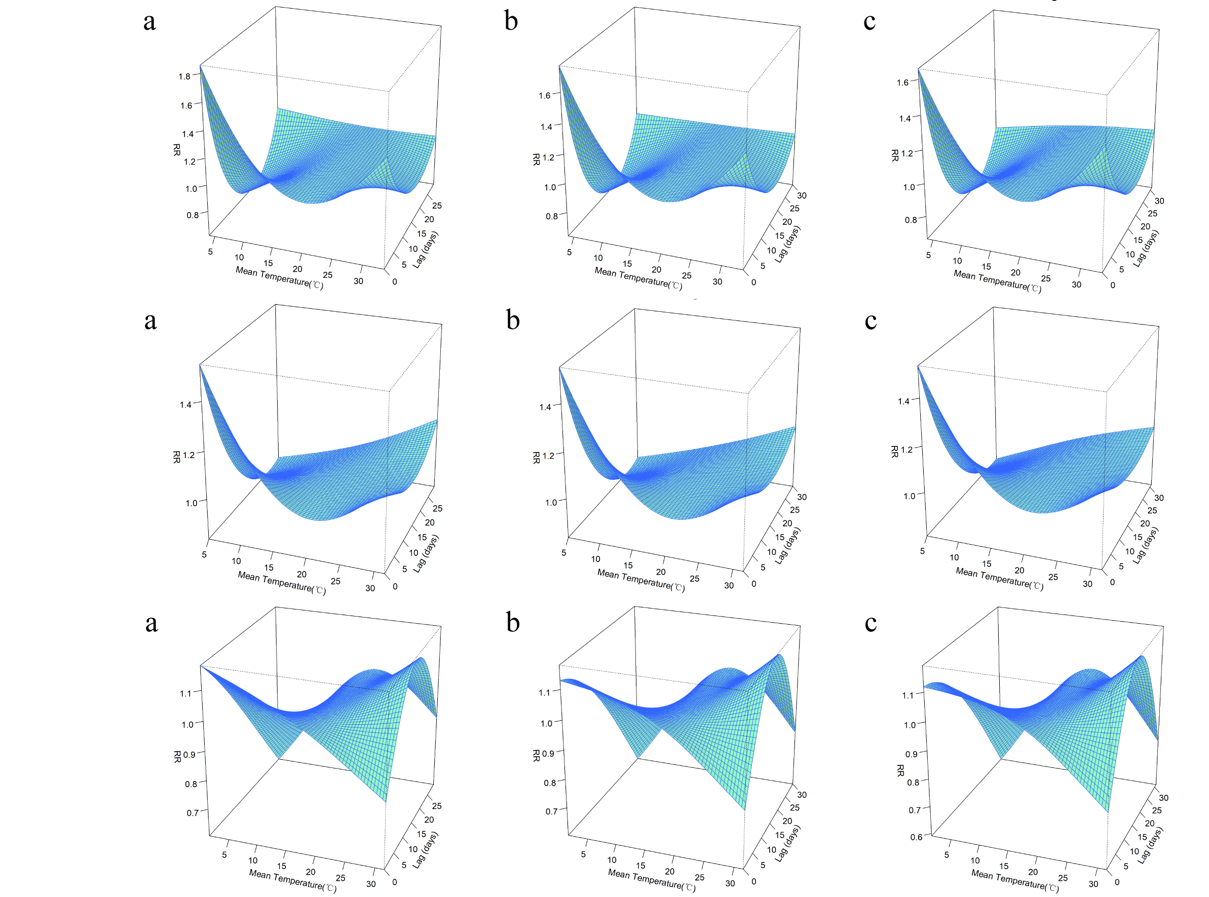
Figure 1-1 The results of the sensitivity analysis in mean temperature model for Fuzhou city. a represents the 29-day lag, b represents the 30-day lag, and c represents the 31-day lag.
Figure 1-2 The results of the sensitivity analysis in mean temperature model for Longyan city. a represents the 29-day lag, b represents the 30-day lag, and c represents the 31-day lag.
Figure 1-3 The results of the sensitivity analysis in mean temperature model for Nanping city. a represents the 29-day lag, b represents the 30-day lag, and c represents the 31-day lag.
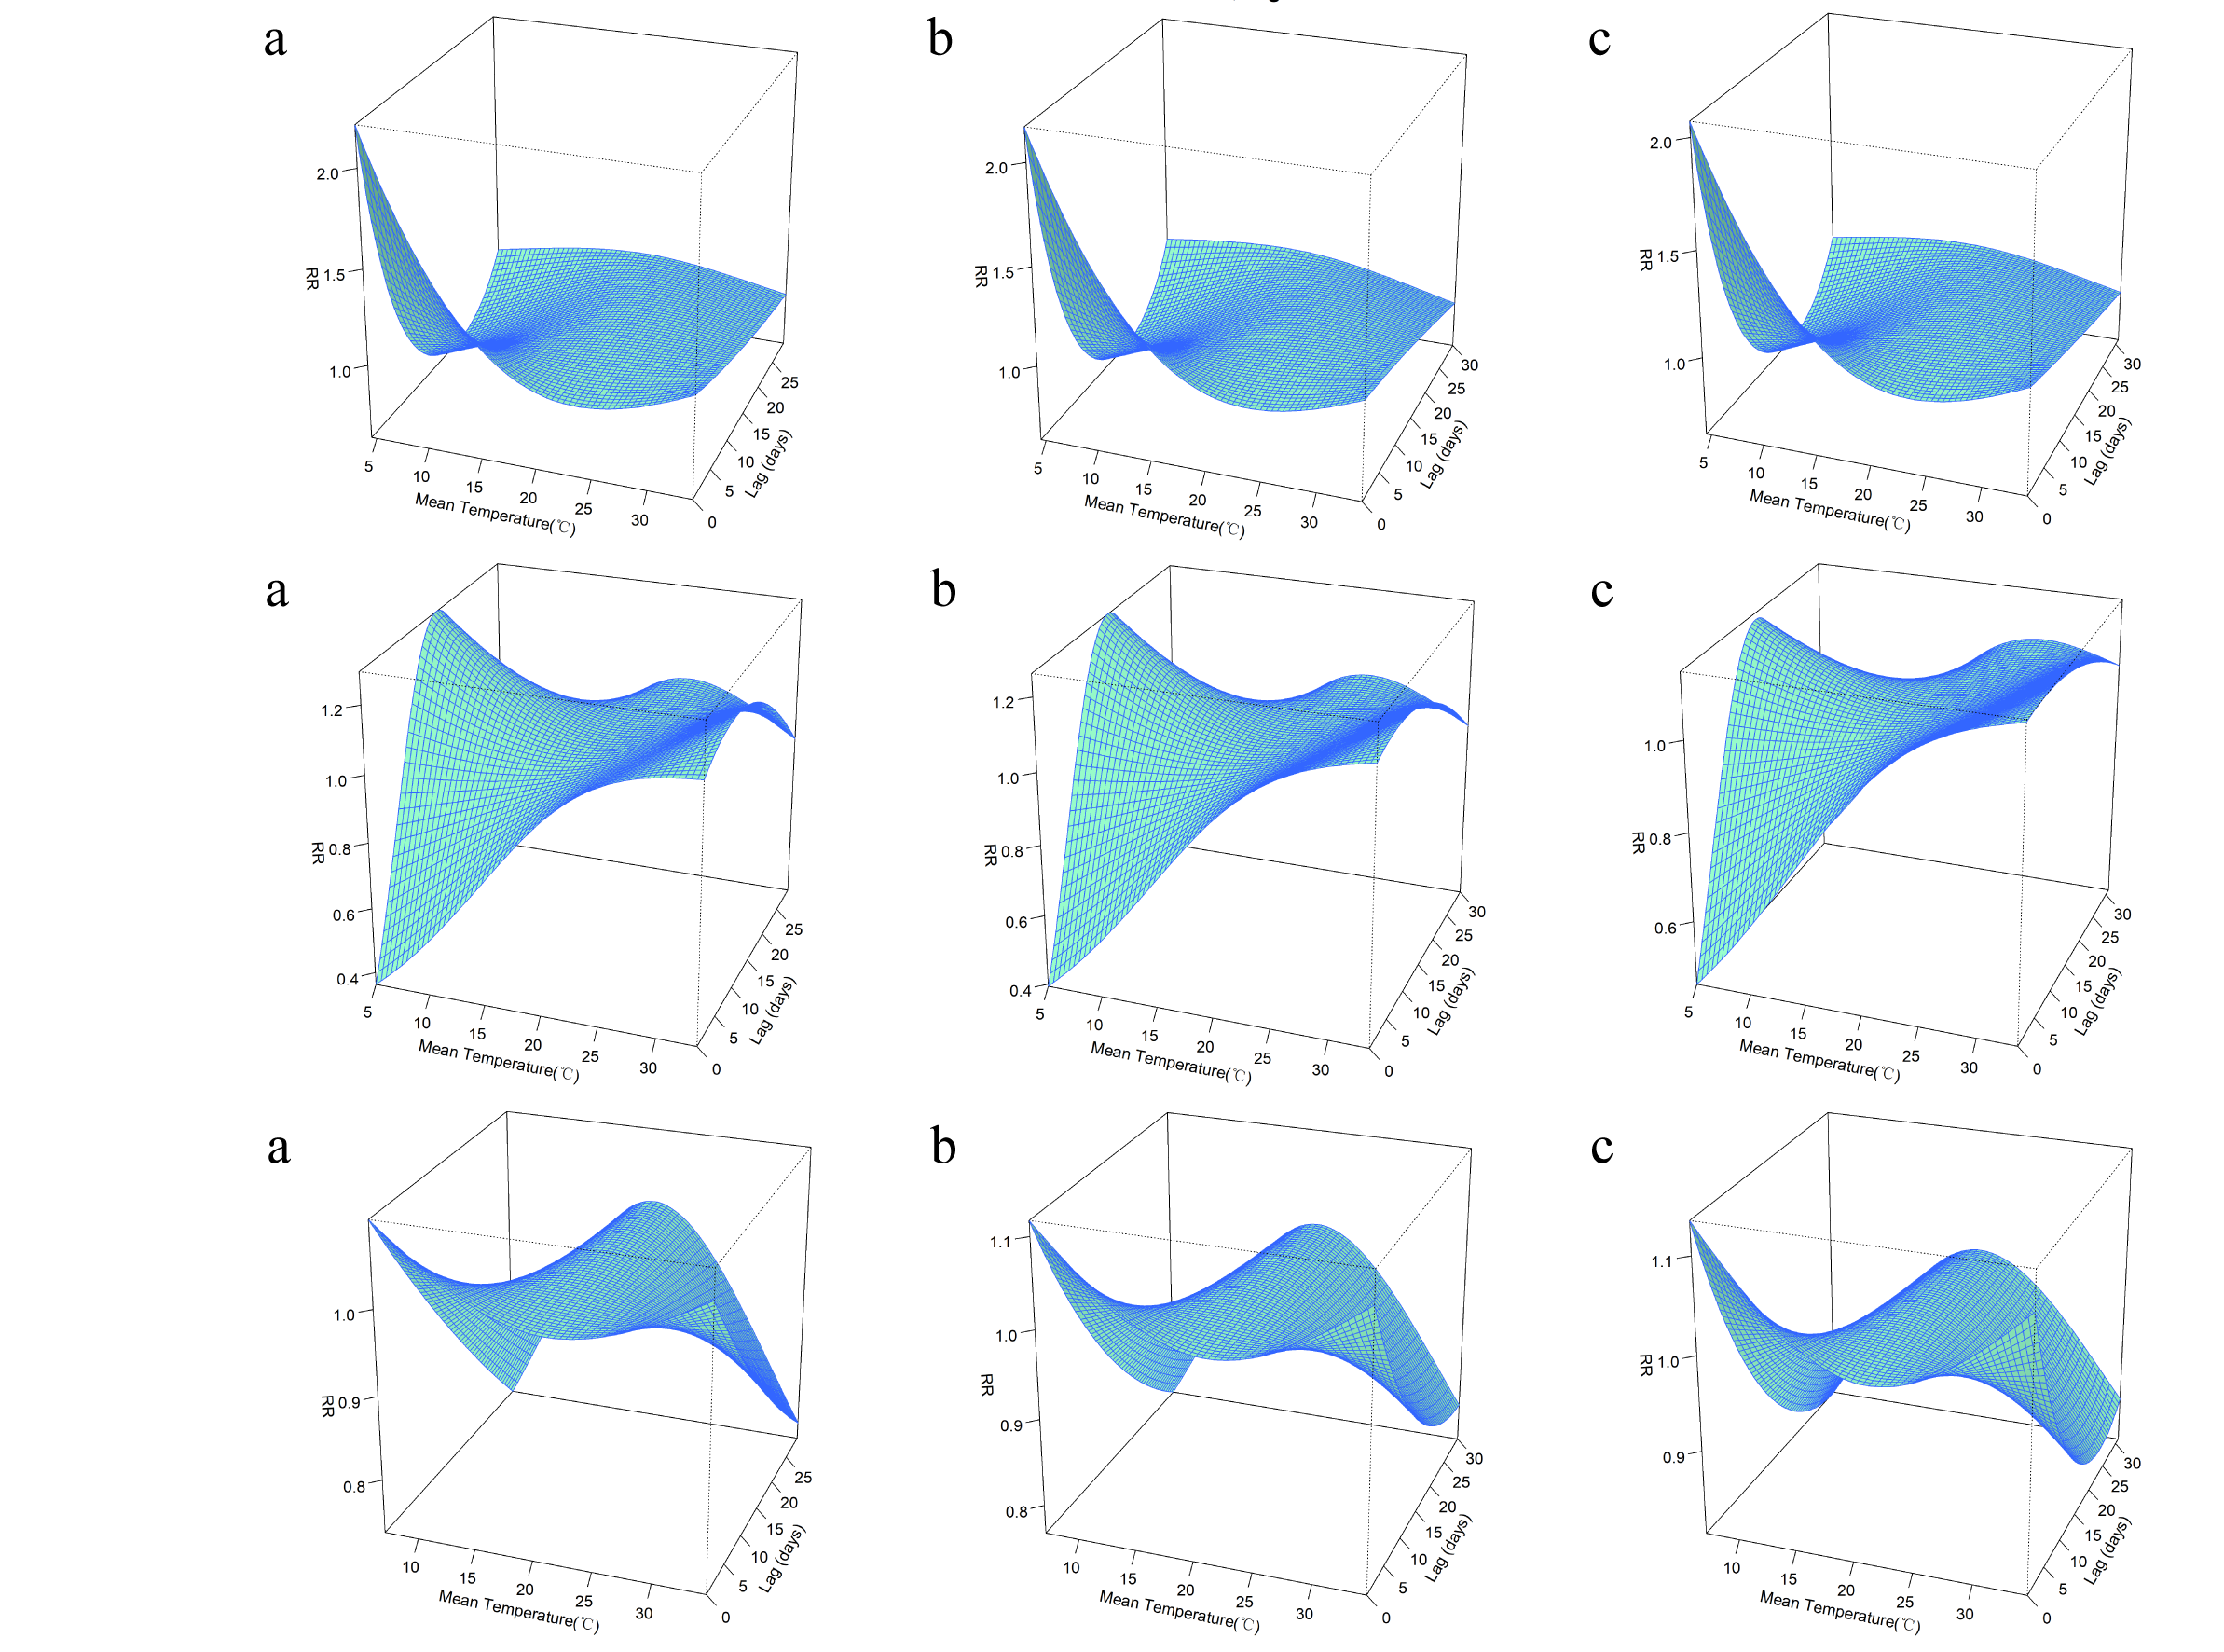
Figure 1-4 The results of the sensitivity analysis in mean temperature model for Ningde city. a represents the 29-day lag, b represents the 30-day lag, and c represents the 31-day lag.
Figure 1-5 The results of the sensitivity analysis in mean temperature model for Putian city. a represents the 29-day lag, b represents the 30-day lag, and c represents the 31-day lag.
Figure 1-6 The results of the sensitivity analysis in mean temperature model for Quanzhou city. a represents the 29-day lag, b represents the 30-day lag, and c represents the 31-day lag.
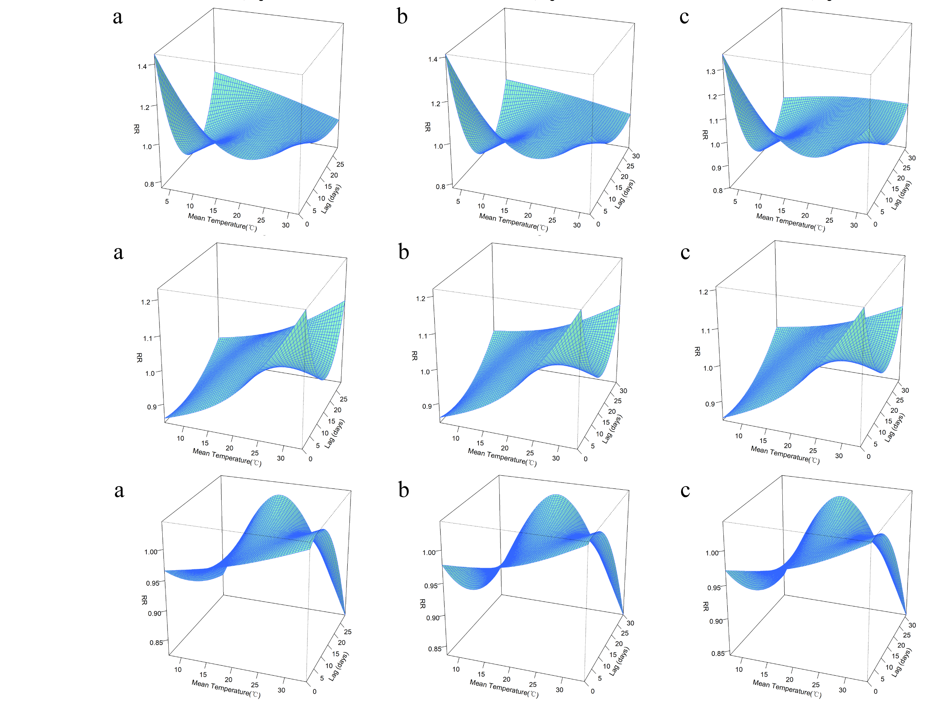
Figure 1-7 The results of the sensitivity analysis in mean temperature model for Sanming city. a represents the 29-day lag, b represents the 30-day lag, and c represents the 31-day lag.

Figure 1-8 The results of the sensitivity analysis in mean temperature model for Xiamen city. a represents the 29-day lag, b represents the 30-day lag, and c represents the 31-day lag.
Figure 1-9 The results of the sensitivity analysis in mean temperature model for Zhangzhou city. a represents the 29-day lag, b represents the 30-day lag, and c represents the 31-day lag.
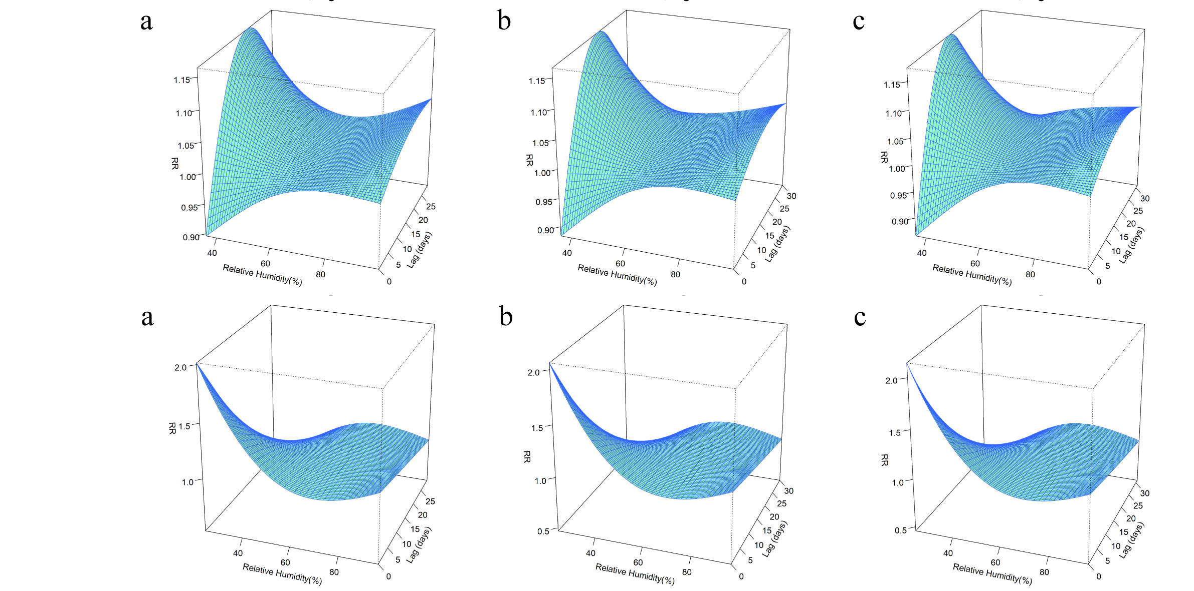
Figure 2-1 The results of the sensitivity analysis in relative humidity model for Fuzhou city. a represents the 29-day lag, b represents the 30-day lag, and c represents the 31-day lag.
Figure 2-2 The results of the sensitivity analysis in relative humidity model for Longyan city. a represents the 29-day lag, b represents the 30-day lag, and c represents the 31-day lag.
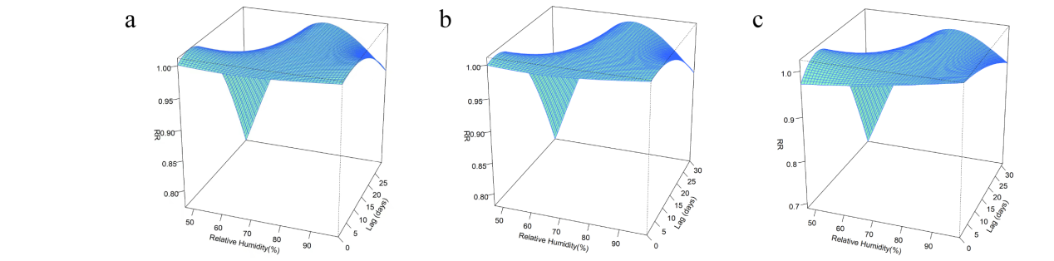
Figure 2-3 The results of the sensitivity analysis in relative humidity model for Nanping city. a represents the 29-day lag, b represents the 30-day lag, and c represents the 31-day lag.
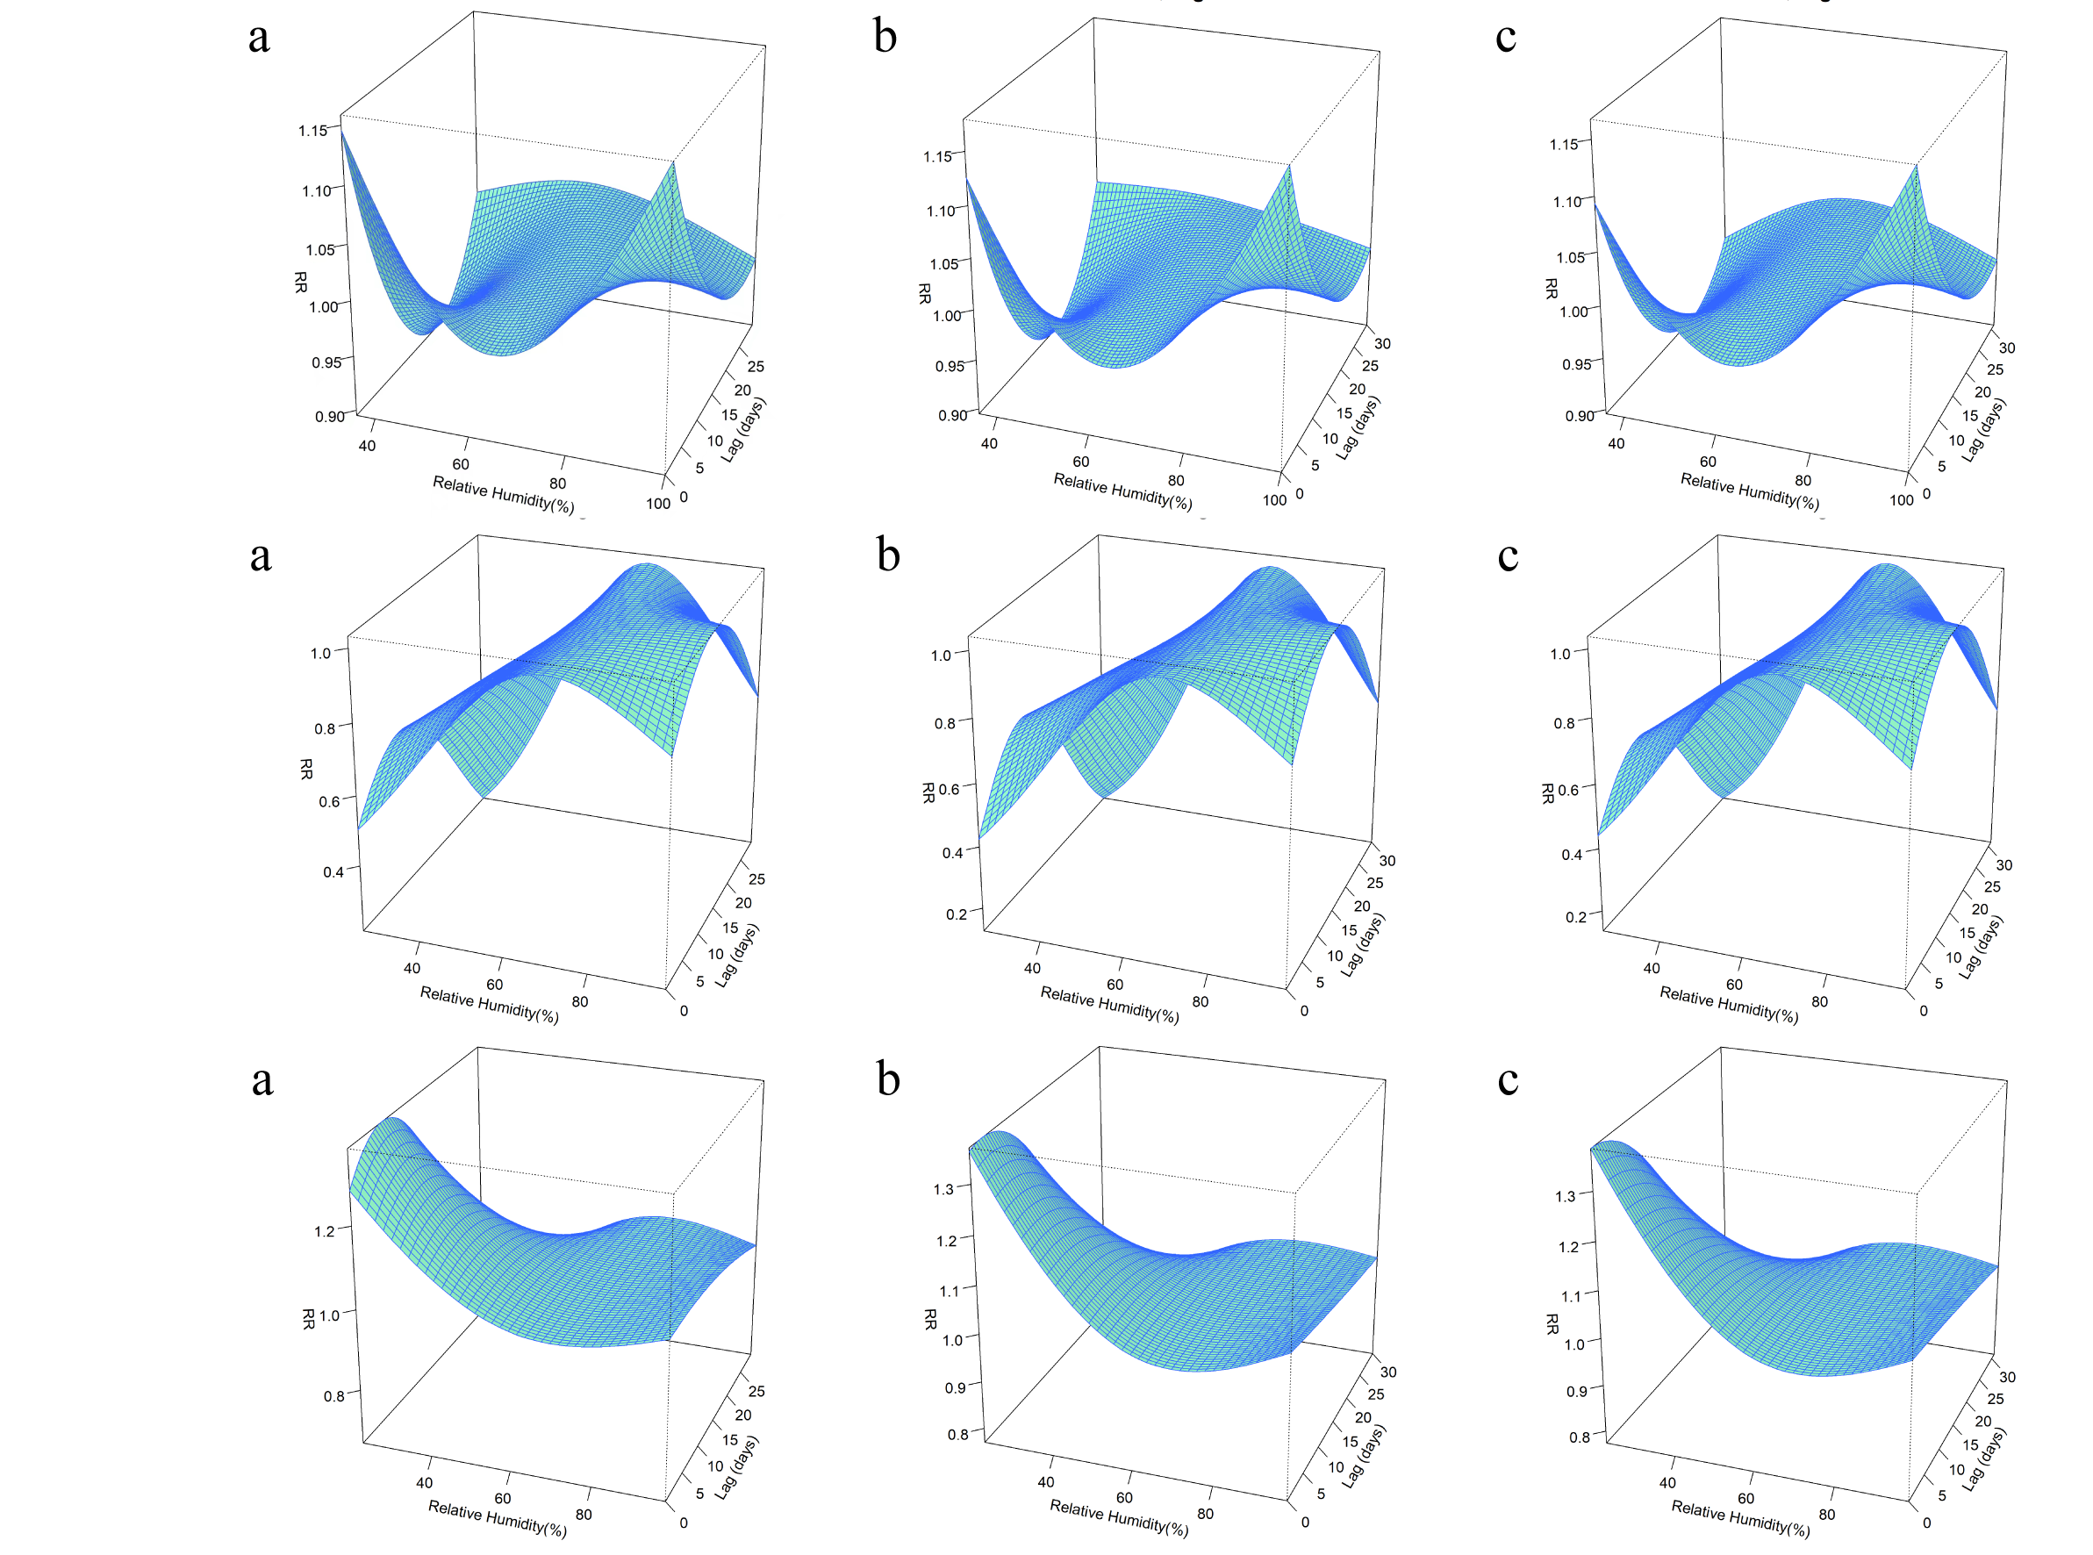
Figure 2-4 The results of the sensitivity analysis in relative humidity model for Ningde city. a represents the 29-day lag, b represents the 30-day lag, and c represents the 31-day lag.
Figure 2-5 The results of the sensitivity analysis in relative humidity model for Putian city. a represents the 29-day lag, b represents the 30-day lag, and c represents the 31-day lag.
Figure 2-6 The results of the sensitivity analysis in relative humidity model for Quanzhou city. a represents the 29-day lag, b represents the 30-day lag, and c represents the 31-day lag.
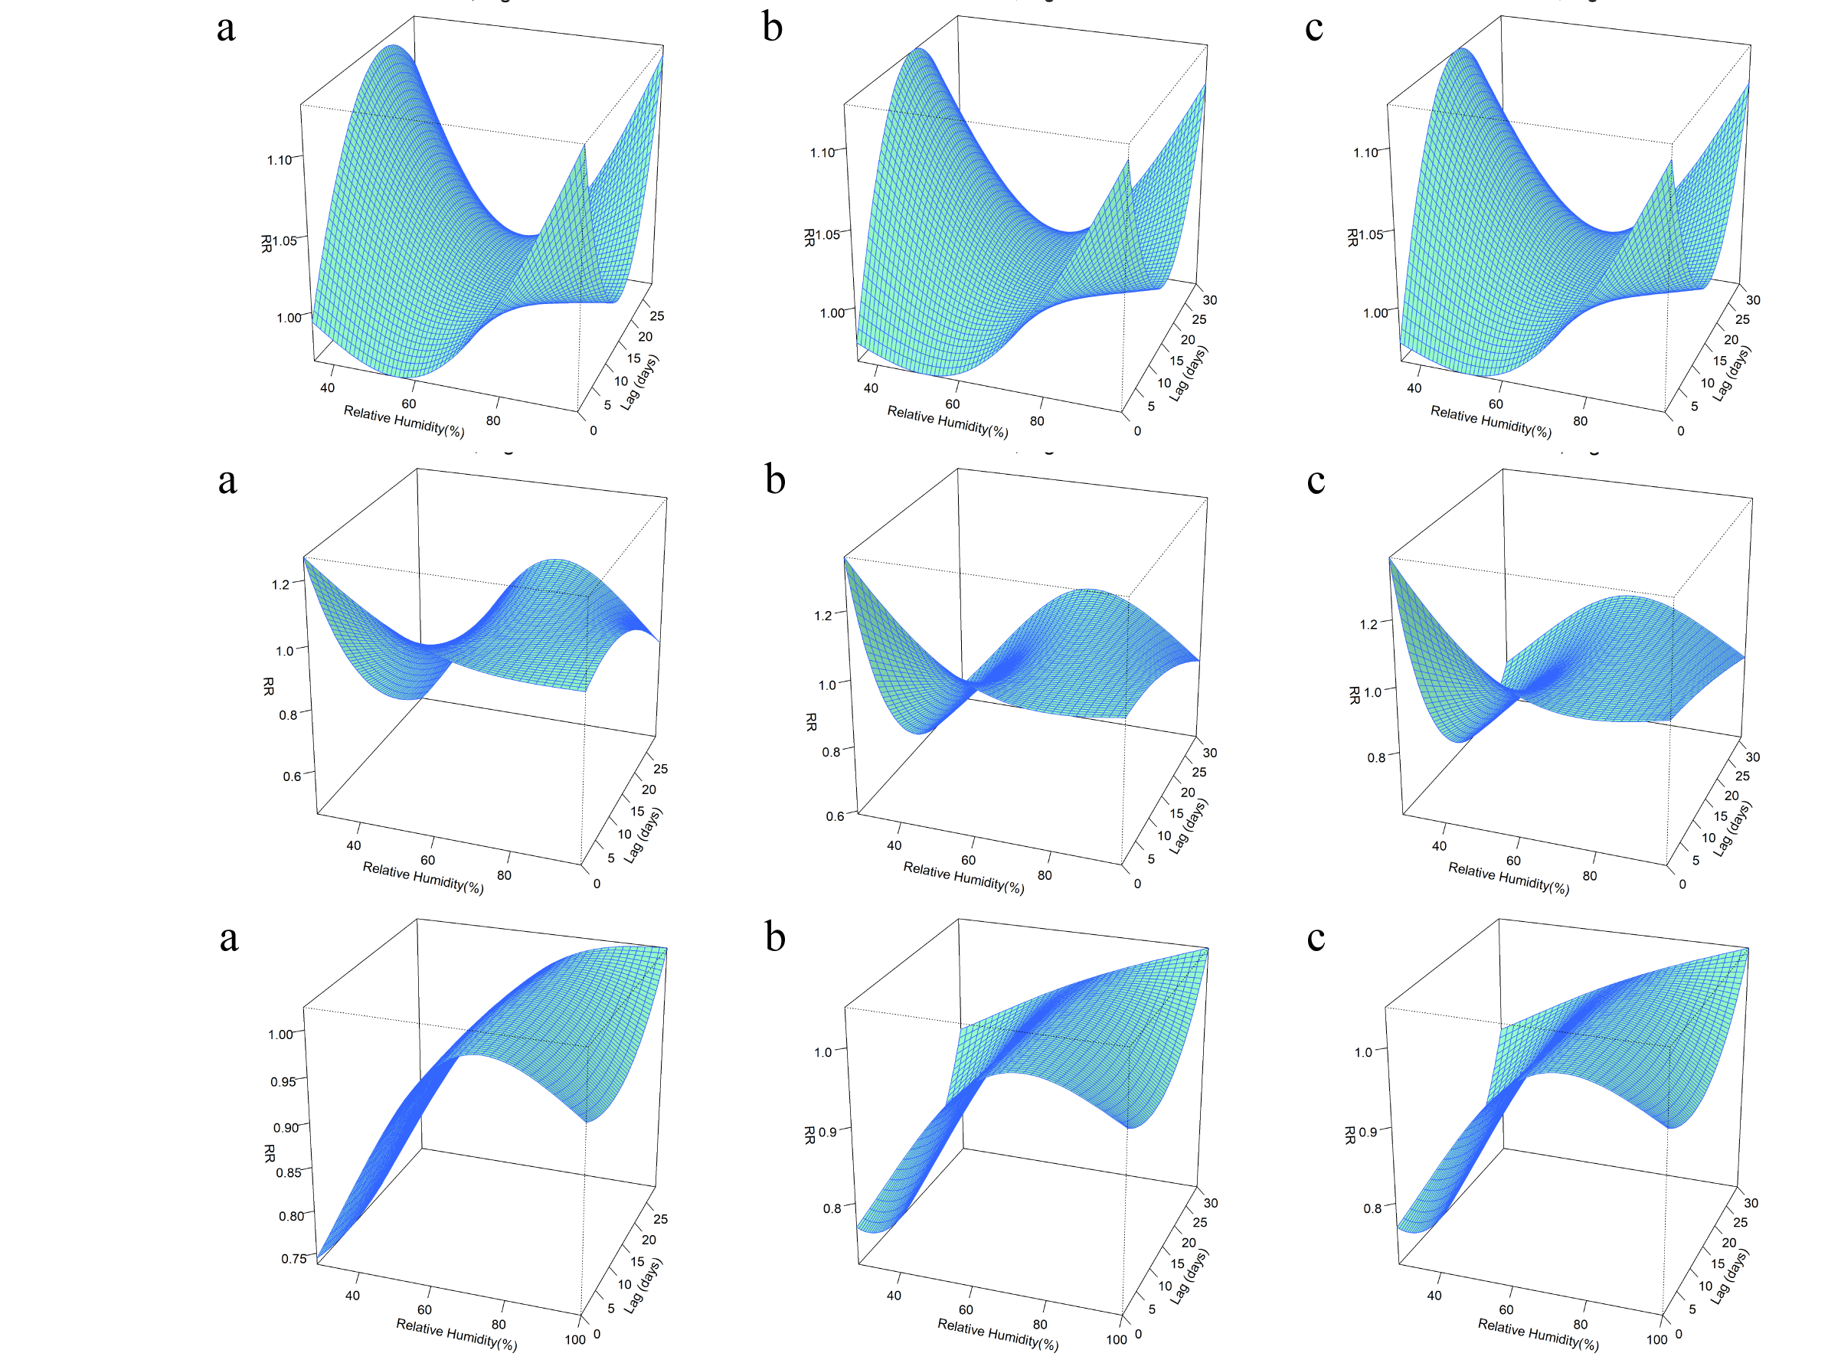
Figure 2-7 The results of the sensitivity analysis in relative humidity model for Sanming city. a represents the 29-day lag, b represents the 30-day lag, and c represents the 31-day lag.
Figure 2-8 The results of the sensitivity analysis in relative humidity model for Xiamen city. The lag days for a, b and c are 29, 30 and 31 days, respectively.
Figure 2-9 The results of the sensitivity analysis in relative humidity model for Zhangzhou city. a represents the 29-day lag, b represents the 30-day lag, and c represents the 31-day lag.
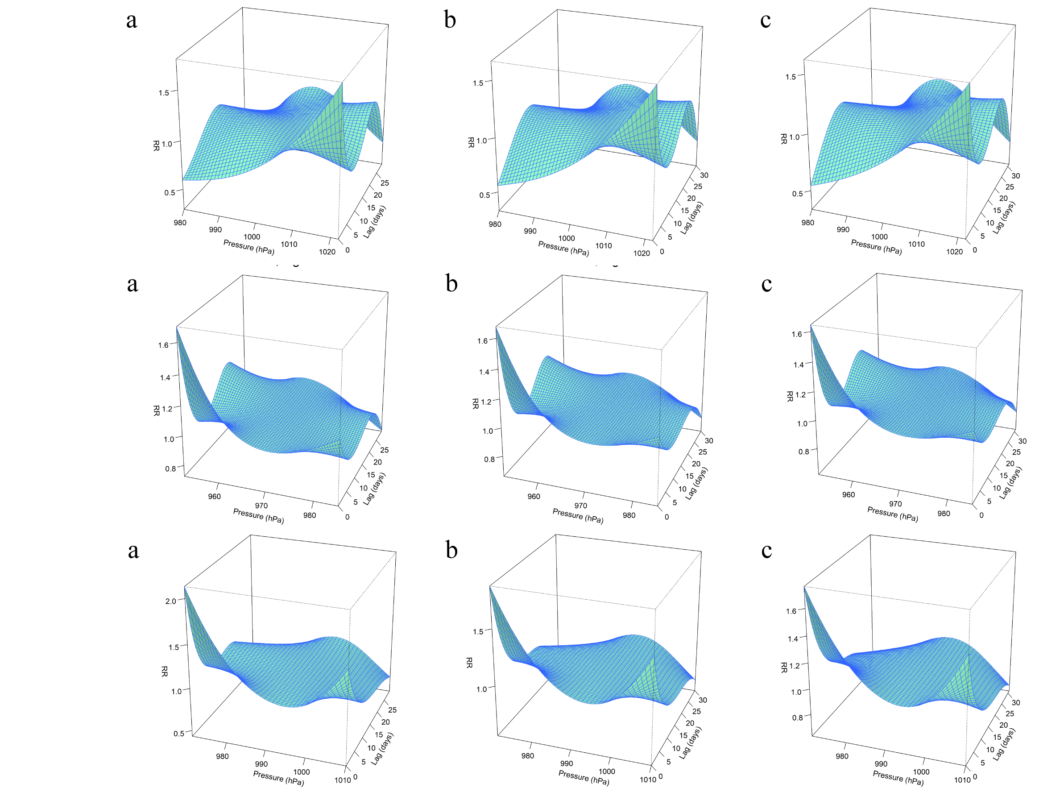
Figure 3-1 The results of the sensitivity analysis in air pressure model for Fuzhou city. a represents the 29-day lag, b represents the 30-day lag, and c represents the 31-day lag.
Figure 3-2 The results of the sensitivity analysis in air pressure model for Longyan city. a represents the 29-day lag, b represents the 30-day lag, and c represents the 31-day lag.
Figure 3-3 The results of the sensitivity analysis in air pressure model for Nanping city. a represents the 29-day lag, b represents the 30-day lag, and c represents the 31-day lag.
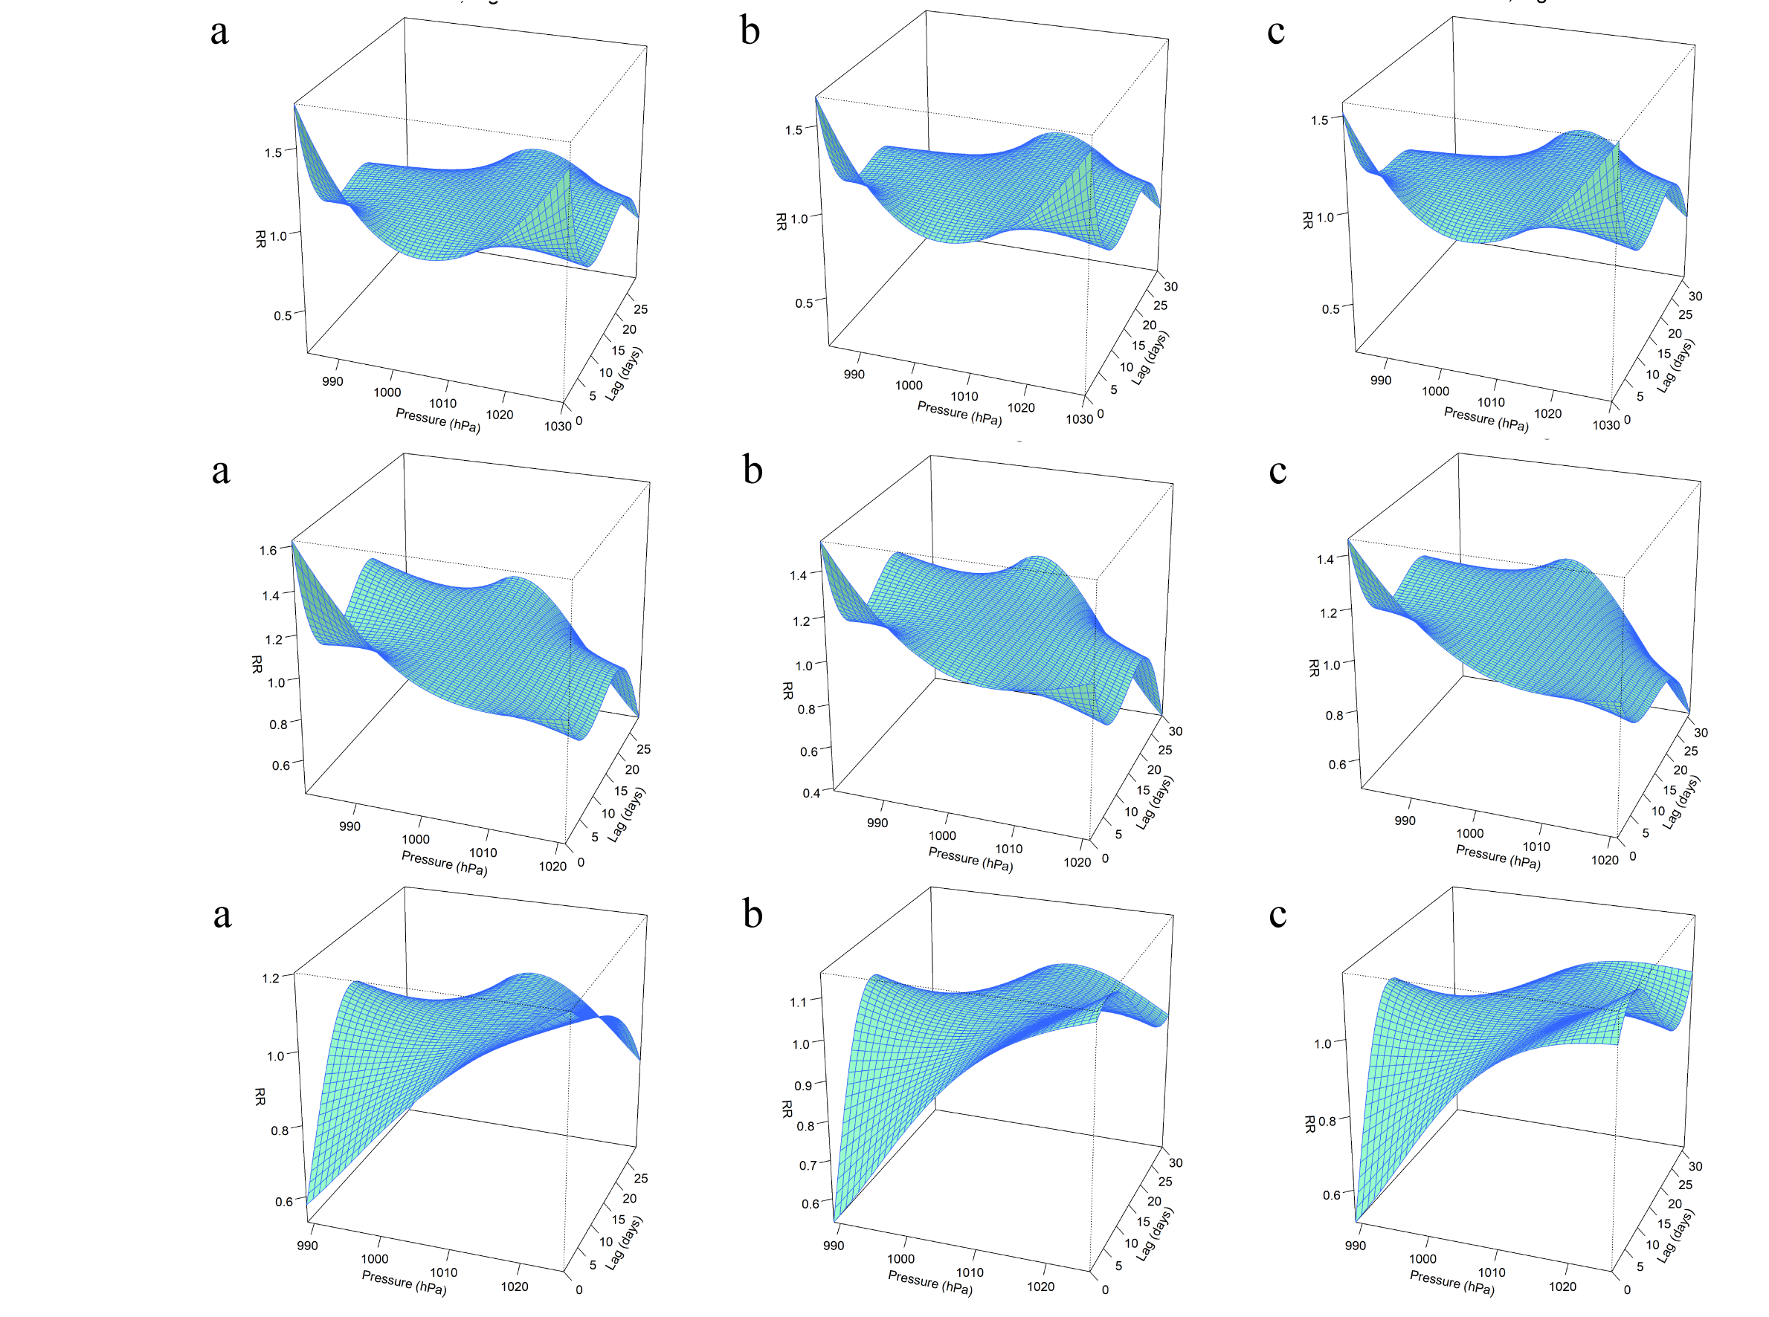
Figure 3-4 The results of the sensitivity analysis in air pressure model for Ningde city. a represents the 29-day lag, b represents the 30-day lag, and c represents the 31-day lag.
Figure 3-5 The results of the sensitivity analysis in air pressure model for Putian city. a represents the 29-day lag, b represents the 30-day lag, and c represents the 31-day lag.
Figure 3-6 The results of the sensitivity analysis in air pressure model for Quanzhou city. a represents the 29-day lag, b represents the 30-day lag, and c represents the 31-day lag.
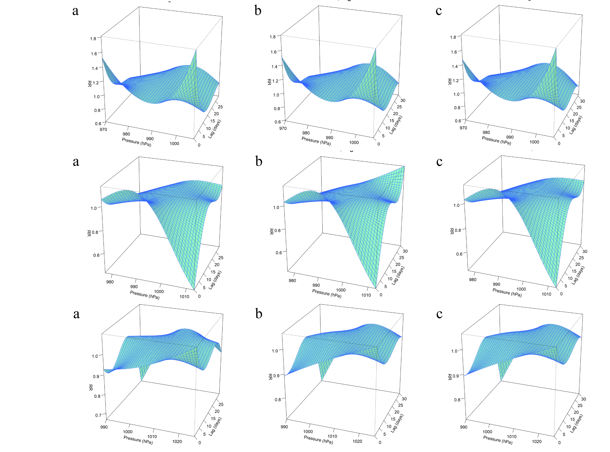
Figure 3-7 The results of the sensitivity analysis in air pressure model for Sanming city. a represents the 29-day lag, b represents the 30-day lag, and c represents the 31-day lag.
Figure 3-8 The results of the sensitivity analysis in air pressure model for Xiamen city. a represents the 29-day lag, b represents the 30-day lag, and c represents the 31-day lag.
Figure 3-9 The results of the sensitivity analysis in air pressure model for Zhanghou city. a represents the 29-day lag, b represents the 30-day lag, and c represents the 31-day lag.

