SUPPLEMENTARY RESULTS
Optimizing Soybean Breeding: High-Throughput Phenotyping for Stink Bug Resistance and High Yields
Maiara de Oliveira¹; Alexandre Hild Aono²; Patricia Braga¹; Adriano Abreu Moreira¹; Fernanda Smaniotto Campion¹; Felipe Augusto Krause¹; Fernando Henrique Iost Filho³; Juliano de Bastos Pazini³; Pedro Takao Yamamoto³; and José Baldin Pinheiro^{1*}

Supplementary Table 1. Predictive abilities (PA) of three different ML models, AdaBoost, MLP, and SVM, for the five manually measured traits in two growing seasons, 2019/2020 and 2020/2021, at each flight time. PAs were evaluated using Pearson correlation for regression models on the traits GY, NDM, HSW, and TOL. For classification models, used for the LR trait, accuracy was the metric used.
 |  | GY |  |  | HSW |  |  | NDM |  |  | TOL |  |  | LR
Year | DAP | AdB. | MLP | SVM | AdB. | MLP | SVM | AdB. | MLP | SVM | AdB. | MLP | SVM | AdB. | MLP | SVM
2019/  2020 | 90 | 0.46 | 0.12 | 0.21 | 0.18 | 0.12 | 0.1 | 0.29 | 0 | 0.2 | 0.11 | 0.01 | 0.11 | 0.22 | 0.22 | 0.20
2019/  2020 | 97 | 0.44 | 0.25 | 0.26 | 0.12 | 0.15 | 0.12 | 0.3 | -0.1 | 0.23 | 0.14 | -0.03 | 0.06 | 0.20 | 0.23 | 0.20
2019/  2020 | 106 | 0.51 | 0.4 | 0.32 | 0.43 | 0.32 | 0.25 | 0.6 | 0.09 | 0.38 | 0.41 | 0 | 0.3 | 0.29 | 0.23 | 0.20
2019/  2020 | 113 | 0.6 | 0.42 | 0.37 | 0.51 | 0.47 | 0.39 | 0.67 | 0.03 | 0.53 | 0.47 | 0.08 | 0.39 | 0.27 | 0.22 | 0.20
2019/  2020 | 120 | 0.7 | 0.58 | 0.56 | 0.59 | 0.56 | 0.47 | 0.71 | 0.05 | 0.6 | 0.44 | 0.12 | 0.44 | 0.34 | 0.33 | 0.21
2019/  2020 | 127 | 0.64 | 0.56 | 0.55 | 0.55 | 0.54 | 0.49 | 0.62 | 0.05 | 0.54 | 0.45 | -0.06 | 0.4 | 0.36 | 0.37 | 0.22
2020/  2021 | 57 | 0.76 | 0.64 | 0.68 | 0.69 | 0.57 | 0.6 | 0.37 | 0.06 | 0.27 | 0.23 | 0 | 0.21 | 0.29 | 0.29 | 0.28
2020/  2021 | 65 | 0.81 | 0.64 | 0.69 | 0.72 | 0.59 | 0.61 | 0.34 | 0 | 0.26 | 0.21 | -0.03 | 0.24 | 0.29 | 0.29 | 0.28
2020/  2021 | 71 | 0.82 | 0.64 | 0.68 | 0.71 | 0.57 | 0.58 | 0.31 | 0.01 | 0.21 | 0.17 | 0.05 | 0.16 | 0.31 | 0.31 | 0.28
2020/  2021 | 78 | 0.84 | 0.63 | 0.67 | 0.73 | 0.59 | 0.57 | 0.24 | -0.1 | 0.13 | 0.25 | -0.01 | 0.16 | 0.31 | 0.30 | 0.28
2020/  2021 | 85 | 0.78 | 0.44 | 0.34 | 0.69 | 0.42 | 0.3 | 0.31 | -0.1 | 0.26 | 0.14 | 0 | 0.1 | 0.32 | 0.29 | 0.28
2020/  2021 | 92 | 0.74 | 0.43 | 0.34 | 0.66 | 0.43 | 0.34 | 0.44 | -0.2 | 0.35 | 0.24 | 0.01 | 0.23 | 0.30 | 0.29 | 0.28
2020/  2021 | 99 | 0.72 | 0.24 | 0.21 | 0.61 | 0.28 | 0.24 | 0.51 | -0.1 | 0.42 | 0.24 | 0.04 | 0.25 | 0.29 | 0.29 | 0.28
2020/  2021 | 107 | 0.68 | 0.41 | 0.33 | 0.63 | 0.43 | 0.37 | 0.64 | 0.12 | 0.54 | 0.36 | -0.03 | 0.3 | 0.32 | 0.30 | 0.28
2020/  2021 | 114 | 0.63 | 0.42 | 0.42 | 0.58 | 0.47 | 0.47 | 0.56 | -0.2 | 0.51 | 0.36 | -0.03 | 0.32 | 0.35 | 0.33 | 0.28
2020/  2021 | 122 | 0.65 | 0.51 | 0.49 | 0.61 | 0.5 | 0.43 | 0.61 | 0.18 | 0.48 | 0.44 | 0.01 | 0.43 | 0.39 | 0.36 | 0.28

Supplementary Table 2. Predictive abilities (PA) of three different ML models, AdaBoost, MLP, and SVM, for the five manually measured traits in two growing seasons, 2019/2020 and 2020/2021, at each flight time. PAs were evaluated using mean squared error for regression models on the traits GY, NDM, HSW, and TOL. For classification models, used for the LR trait, precision was the metric used.
 |  | GY |  |  | HSW |  |  | NDM |  |  | TOL |  |  | LR
Year | DAP | AdB. | MLP | SVM | AdB. | MLP | SVM | AdB. | MLP | SVM | AdB. | MLP | SVM | AdB. | MLP | SVM
2019/  2020 | 90 | 270181 | 307498 | 360460 | 28776 | 24578 | 29388 | 10.1 | 80.4 | 13.2 | 0.0054 | 4.8 | 0.0061 | 0.21 | 0.19 | 0.08
2019/  2020 | 97 | 236327 | 305725 | 358940 | 27563 | 22077 | 28270 | 8.3 | 122.3 | 11.5 | 0.0054 | 48.1 | 0.0059 | 0.19 | 0.23 | 0.09
2019/  2020 | 106 | 189110 | 243736 | 355585 | 22829 | 18643 | 28192 | 7.4 | 204.2 | 10.5 | 0.0057 | 54.2 | 0.0059 | 0.26 | 0.24 | 0.09
2019/  2020 | 113 | 217567 | 250363 | 360064 | 24405 | 19658 | 28818 | 9.6 | 98.5 | 11.4 | 0.0054 | 8.5 | 0.0060 | 0.27 | 0.23 | 0.09
2019/  2020 | 120 | 290920 | 442840 | 364307 | 40760 | 26454 | 29818 | 14.6 | 138.5 | 14.4 | 0.0071 | 3.9 | 0.0065 | 0.30 | 0.29 | 0.16
2019/  2020 | 127 | 296165 | 358319 | 363776 | 34329 | 26219 | 29701 | 14.6 | 85.5 | 14.2 | 0.0068 | 7.3 | 0.0065 | 0.34 | 0.32 | 0.18
2020/  2021 | 57 | 475925 | 722001 | 867394 | 386777 | 498260 | 611058 | 7.6 | 86.3 | 11.7 | 0.0149 | 2.5 | 0.0153 | 0.28 | 0.29 | 0.18
2020/  2021 | 65 | 530779 | 727973 | 865350 | 406265 | 483693 | 608497 | 9.5 | 2184 | 11.0 | 0.0148 | 3518 | 0.0152 | 0.28 | 0.28 | 0.18
2020/  2021 | 71 | 508380 | 654901 | 855257 | 391632 | 467282 | 607178 | 8.6 | 285 | 12.1 | 0.0137 | 25.0 | 0.0138 | 0.30 | 0.24 | 0.18
2020/  2021 | 78 | 364475 | 529435 | 858763 | 330987 | 424552 | 608339 | 12.0 | 1029 | 12.8 | 0.0162 | 74.0 | 0.0162 | 0.30 | 0.24 | 0.18
2020/  2021 | 85 | 296048 | 543537 | 848846 | 298452 | 415293 | 600972 | 12.2 | 259 | 12.9 | 0.0164 | 24.5 | 0.0160 | 0.34 | 0.28 | 0.18
2020/  2021 | 92 | 279382 | 563397 | 860841 | 314961 | 439028 | 609376 | 12.4 | 274 | 13.1 | 0.0166 | 61.1 | 0.0166 | 0.30 | 0.29 | 0.18
2020/  2021 | 99 | 261983 | 564648 | 862498 | 294017 | 419245 | 610626 | 13.6 | 332 | 13.2 | 0.0160 | 21.1 | 0.0164 | 0.29 | 0.28 | 0.18
2020/  2021 | 107 | 351000 | 702333 | 868343 | 324166 | 507863 | 614002 | 12.4 | 173 | 13.1 | 0.0167 | 2.9 | 0.0167 | 0.32 | 0.25 | 0.18
2020/  2021 | 114 | 405513 | 713408 | 866994 | 359308 | 502075 | 612688 | 10.8 | 144 | 13.0 | 0.0159 | 2.0 | 0.0160 | 0.34 | 0.31 | 0.18
2020/  2021 | 122 | 433084 | 885817 | 870498 | 399652 | 597425 | 614897 | 9.8 | 1099 | 12.8 | 0.0161 | 68.1 | 0.0158 | 0.40 | 0.33 | 0.18

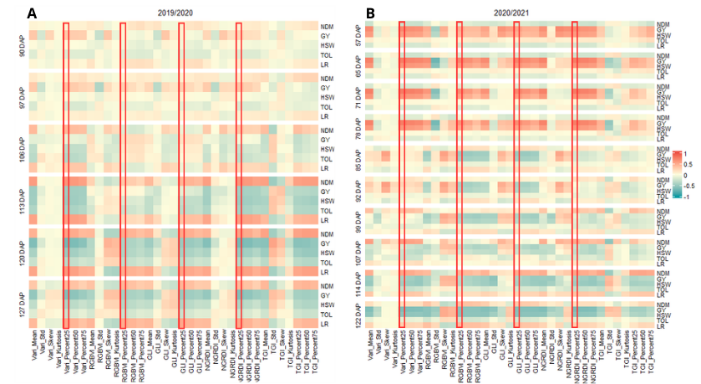
Supplementary Fig. 1. Heatmap displaying the correlation between manually measured traits and vegetation indices across different phenological stages for two consecutive growing seasons, 2019/2020 (A) and 2020/2021 (B). Traits assessed include NDM (Number of Days to Maturity), GY (Grain Yield), HSW (Healthy Seed Weight), TOL (Tolerance), and LR (Leaf Retention). The red rectangles highlight vegetation indices selected based on the 25th percentile (Percent25), marking the most relevant indices for further analysis.

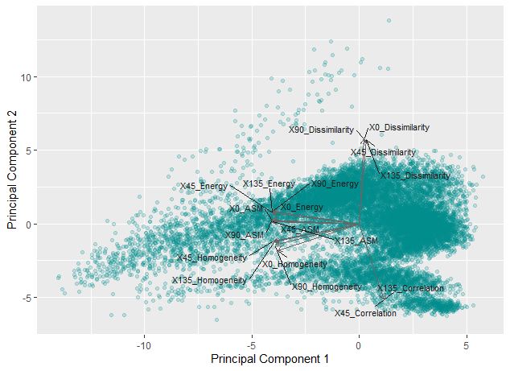
Supplementary Fig. 2. Principal Component Analysis (PCA) biplot illustrating the distribution of texture indices based on the first two principal components. The vectors represent different texture indices, including Dissimilarity, Energy, Homogeneity, ASM (Angular Second Moment), and Correlation, calculated at four angles (0°, 45°, 90°, and 135°). The scatter points represent individual observations, with each point corresponding to a plot in the field, recorded at different flight times and across multiple growing seasons.

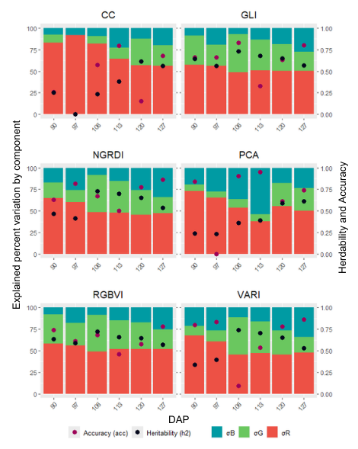
Supplementary Fig. 3. Percentage of variation explained by variance components, heritability, and accuracy for image-derived traits during the 2019/2020 growing season for each flight.
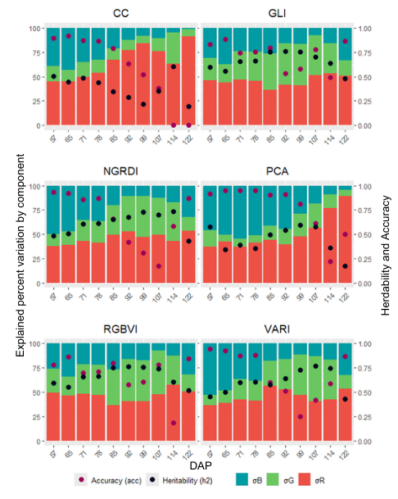
Supplementary Fig. 4. Percentage of variation explained by variance components, heritability, and accuracy for image-derived traits during the 2020/2021 growing season for each flight.
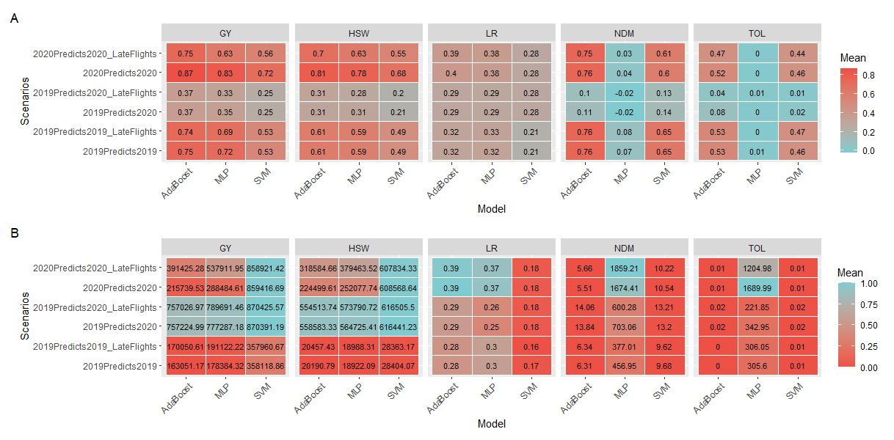
Supplementary Fig. 5. Predictive abilities (PA) of three different ML models—AdaBoost, MLP, and SVM—evaluated for the five manually measured traits across different tested scenarios. The evaluations were performed using 10-fold cross-validation repeated 50 times. A. PAs were assessed using Pearson correlation for the regression models on traits GY (Grain Yield), NDM (Number of Days to Maturity), HSW (Healthy Seed Weight), and TOL (Tolerance). For the classification model applied to the LR (Leaf Retention) trait, accuracy was used as the evaluation metric. B. PAs were assessed using mean squared error (MSE) for the regression models on traits GY, NDM, WHS, and TOL. For the classification model applied to LR, precision was used as the evaluation metric.

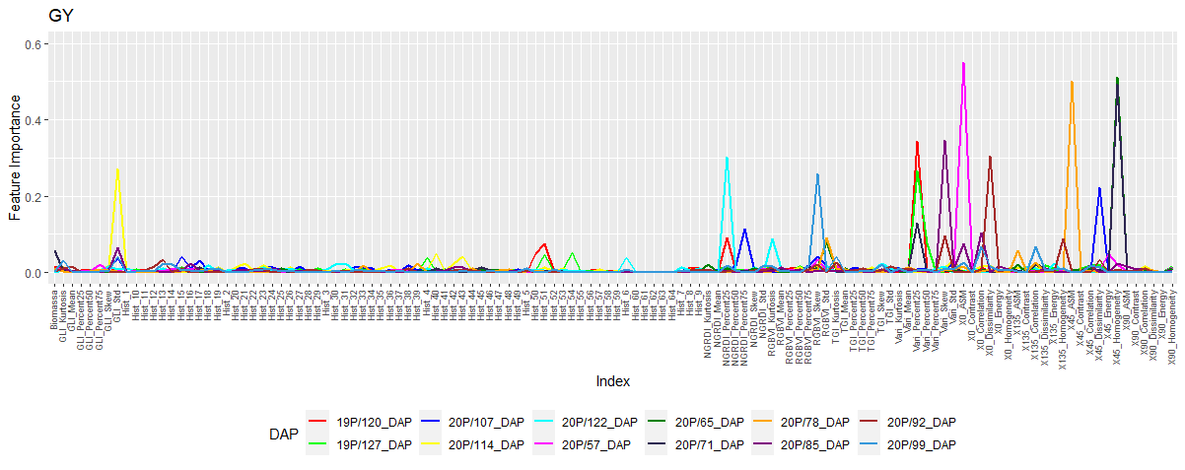Supplementary Fig. 6. Importance of each predictor variable for predicting GY in each flight where the predictive ability was greater than 0.60. The importance was calculated based on decision tree analysis, estimating the importance of each image-derived feature using the Gini index.
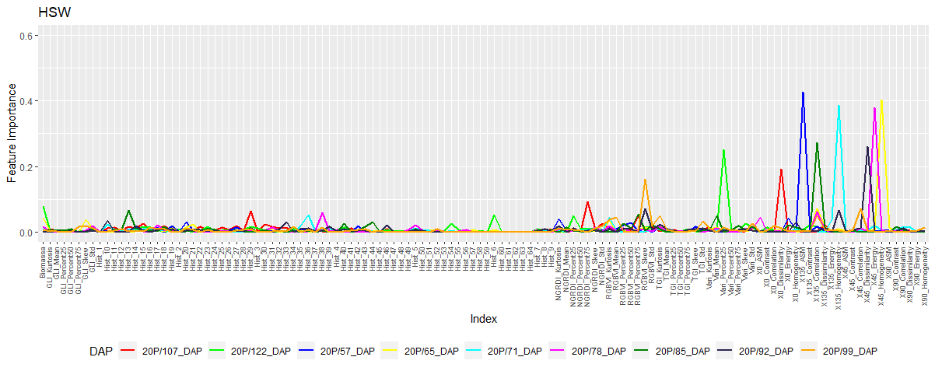Supplementary Fig. 7. Importance of each predictor variable for predicting HSW in each flight where the predictive ability was greater than 0.60. The importance was calculated based on decision tree analysis, estimating the importance of each image-derived feature using the Gini index.
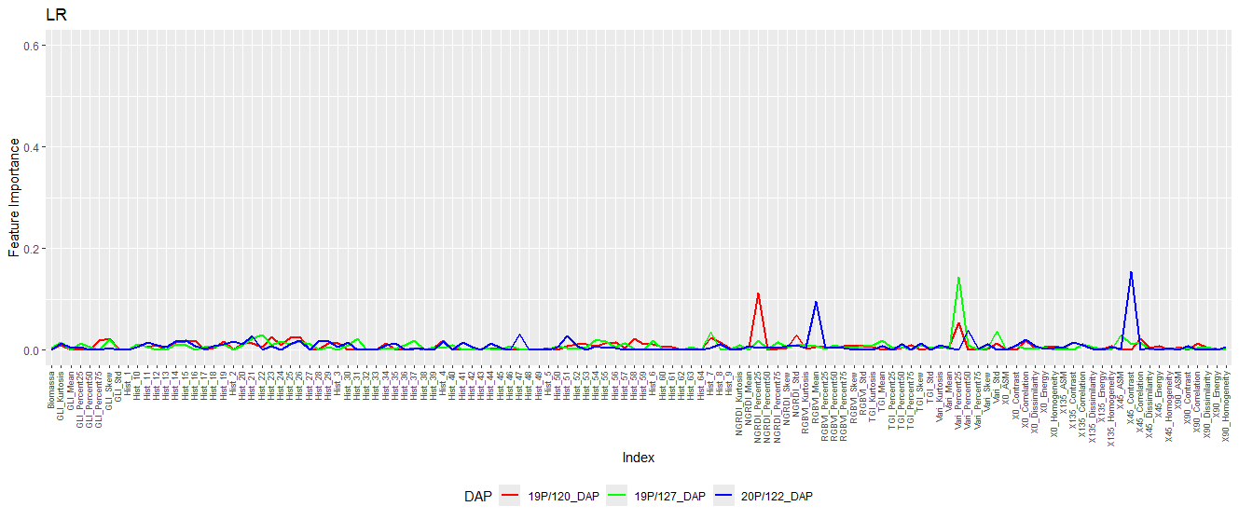
Supplementary Fig. 8. Importance of each predictor variable for predicting LR on flights in which the predictive ability was better. The importance was calculated based on decision tree analysis, estimating the importance of each image-derived feature using the Gini index.
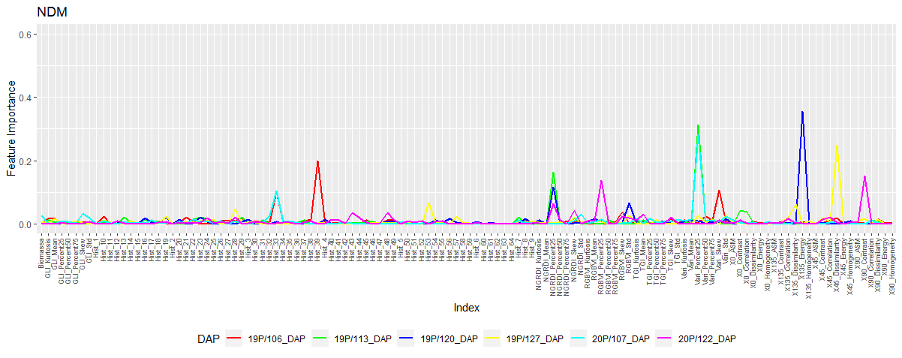
Supplementary Fig. 9. Importance of each predictor variable for predicting NDM in each flight where the predictive ability was greater than 0.60. The importance was calculated based on decision tree analysis, estimating the importance of each image-derived feature using the Gini index.

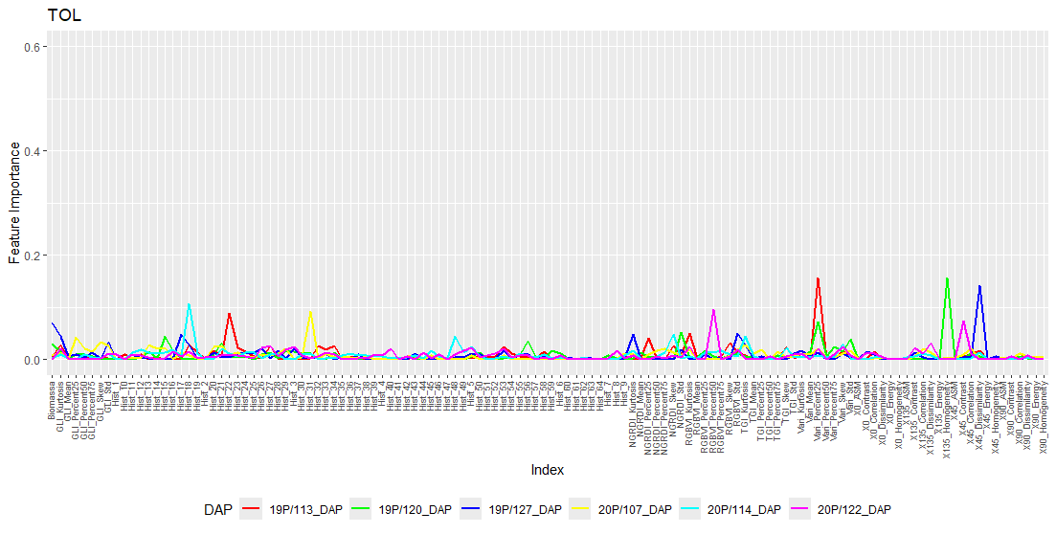Supplementary Fig. 10. Importance of each predictor variable for predicting NDM on flights in which the predictive ability was better. The importance was calculated based on decision tree analysis, estimating the importance of each image-derived feature using the Gini index.

