Supplemental Table 1. Analysis Details for Each Dependent Measure Examined

Measure Dependent Variable Analysis

Neurotoxicity Measures Maternal Weight Gain (g) Independent samples t-test
Gestational Weight Gain (g) Independent samples t-test
Litter Size Independent samples t-test
Percent Live Births Independent samples t-test
Percent Male Independent samples t-test
Implantation Sites Independent samples t-test
Dam Brain: Body Weight (g) Independent samples t-test
Dam Liver: Body Weight (g) Independent samples t-test
Pup Brain: Body Weight (g) 2 (Exposure) x 2 (Sex) ANOVA
Pup Liver: Body Weight (g) 2 (Exposure) x 2 (Sex) ANOVA
Post-natal weight gain (g) 2 (Exposure) x 2 (Sex) x 4 (Day) ANOVA

Maternal Behavior Pup retrieval (sec) 2 (Exposure) x 4 (Day) ANOVA

DRH Lever Presses 2 (Exposure) x 2 (Sex) x 3 (Phase) ANOVA
Reinforcers 2 (Exposure) x 2 (Sex) x 3 (Phase) ANOVA

DRL 15
Molar Measures Rein:Nonreinf Responses 2 (Exposure) x 2 (Sex) x 6 (Block) ANOVA
Reinforcers Earned 2 (Exposure) x 2 (Sex) x 6 (Block) ANOVA
Total Trials 2 (Exposure) x 2 (Sex) x 6 (Block) ANOVA
Peak Deviation Analysis Burst Ratio 2 (Exposure) x 2 (Sex) x 6 (Block) ANOVA
Peak Area 2 (Exposure) x 2 (Sex) x 6 (Block) ANOVA
Peak Location 2 (Exposure) x 2 (Sex) x 6 (Block) ANOVA

FPA mPFC Baseline Release 2 (Exposure) x 2 (Sex) ANOVA
Baseline Synaptic Half-life 2 (Exposure) x 2 (Sex) ANOVA

FPA NAc Baseline Release 2 (Exposure) x 2 (Sex) ANOVA
Baseline Synaptic Half-life 2 (Exposure) x 2 (Sex) ANOVA
Available Supply 2 (Exposure) x 2 (Sex) ANOVA
Autoreceptor Sensitivity 2 (Exposure) x 2 (Sex) x 7 (Prepulse) ANOVA
Release Post-cocaine 2 (Exposure) x 2 (Sex) x 7 (Time) ANOVA
Synaptic Half-life Post-cocaine 2 (Exposure) x 2 (Sex) x 7 (Time) ANOVA

Note. Italics denotes repeated-measures factor. g=grams, sec=seconds; DRH = Differential Reinforcement of High Rates; DRL = Differential Reinforcement of Low Rates; FPA = Fixed Potential Amperometry; Medial prefrontal cortex = mPFC; Nucleus accumbens = NAc
Supplemental Table 2. Neurotoxiology and Maternal Behavior Outcomes

0 mg/kg THC (vehicle) 5.0 mg/kg THC
n = 7 litters n = 10 litters
______________________________________________________________________________

Dams (PND 0- Parturition)
Gestational Weight Gain (g) 146.71 ± 10.48 141.80 ± 5.39
Litter Size 14.00 ± .69 13.60 ± .50
Percent Live Births 100.00 97.70 ± 1.17
Percent Male 48.43 ± 4.33 42.30 ± 4.58

Dams (Parturition – Weaning)
Lactational Weight Gain (g) 59.00 ± 5.99 41.70 ± 4.62^{C}
Implanation Sites 15.43 ± .20 14.80 ± .53
Brain:Body Weight (g) .0062 ± .0001 .0065 ± .0001^{D}
Liver: Body Weight (g) .0489 ± .0009 .0500 ± .0010

Pups (Body Weight: Birth – Weaning, g)
PND 0 6.15 ± .21 5.69 ± .18
PND 7 14.40 ± .53 13.85 ± .45
PND 14 30.42 ± .81 27.23 ± .68^{A}
PND 21 50.90 ± 1.64 45.28 ± 1.37^{B}

Pups (Organ Weights at Weaning; g)
Male Brain:Body Weight .0293 ± .0012 .0320 ± .0008
Female Brain:Body Weight .0301 ± .0013 .0327 ± .0009
Male Liver:Body Weight .0387 ± .0011 .0403 ± .0006
Female Liver:Body Weight .0423 ± .0011 .0409 ± .0006

Dam Pup Retrieval (sec)
PND 2 178.55 ± 42.60 233.31 ± 60.85
PND 4 148.58 ± 47.45 235.31 ± 55.39
PND 6 87.31 ± 32.04 229.42 ± 62. 84
PND 8 162.83 ± 45.44 179.96 ± 64. 20
______________________________________________________________________________Note. Values represent means ± standard error of the mean (SEM), THC = delta-9-tetrahydrocannabinol, PND = postnatal day, g=grams, sec = seconds, ^{A}p=.009, ^{B}p=.019, ^{C}p=.035, ^{D}p=.036, η_{p}²=.210

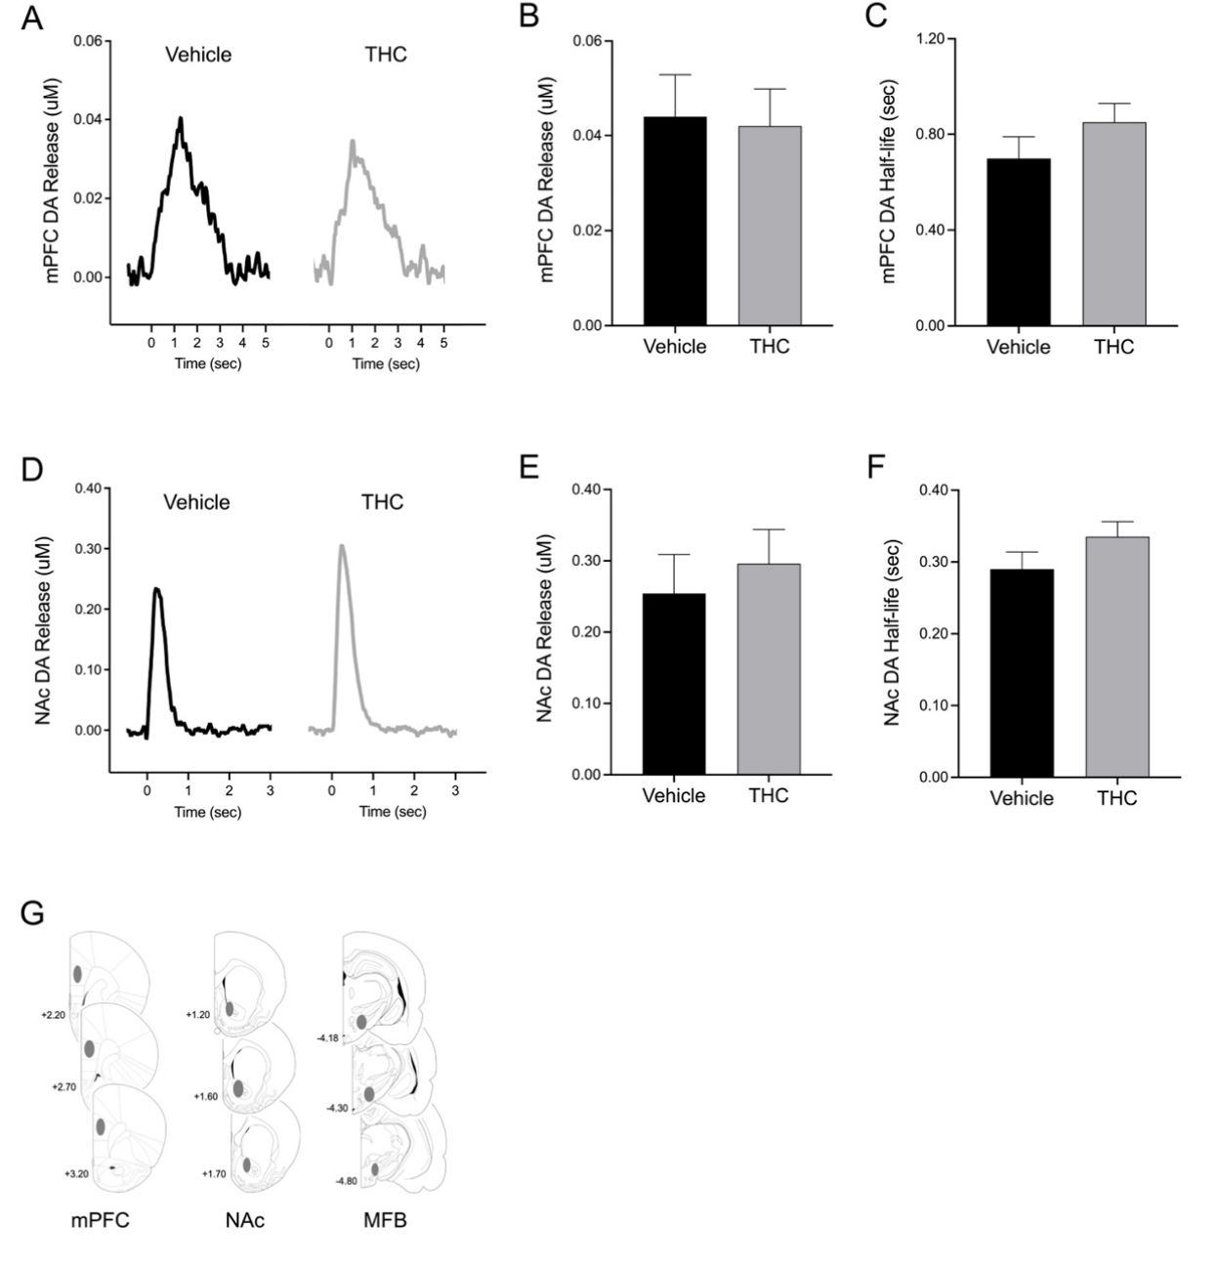
Supp. Fig. 1 Perinatal Δ9-THC exposure did not affect baseline stimulation-evoked DA release (A, B) or half-life (C) in the mPFC. In the NAc, stimulation-evoked DA release (D, E) and half-life (F) were also not affected by perinatal Δ9-THC exposure. Histology figure (G) showing location of stimulating electrode placed in the MFB and recording electrodes in the mPFC and NAc. Error bars represent standard error of the mean. DA = dopamine, mPFC=medial prefrontal cortex, NAc=nucleus accumbens, MFB=medial forebrain bundle, THC= delta-9-tetrahydrocannabinol

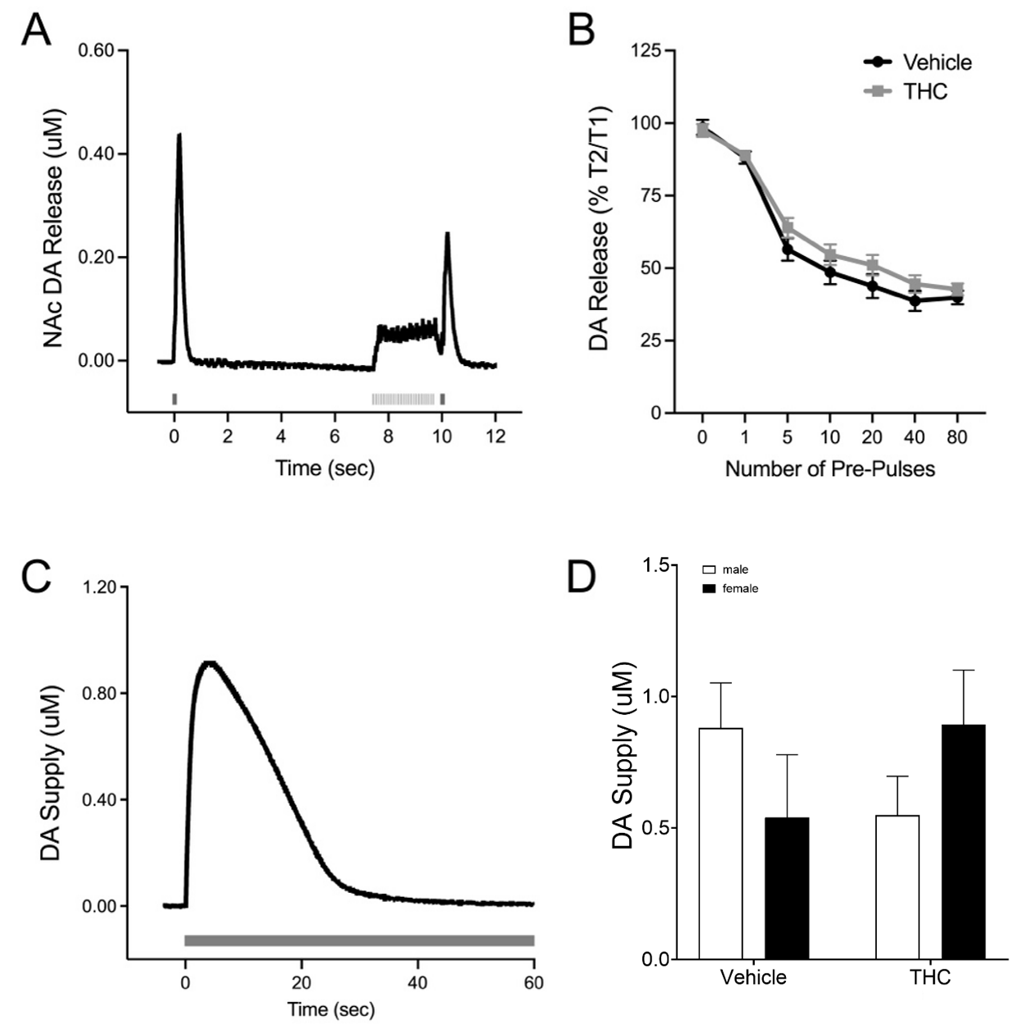
Supp. Fig. 2 Perinatal THC exposure did not affect autoreceptor sensitivity (A, B). While the effect of exposure on DA supply (C) appeared to differ based on sex (D), post hoc simple effects analysis did not reveal an effect of exposure in either sex analyzed separately, or an effect of sex in the rats perinatally exposed to vehicle or to THC. Error bars represent standard error of the mean. DA = dopamine, NAc=nucleus accumbens, THC= delta-9-tetrahydrocannabinol

