Supplementary Information for:
Success Score: A Deep Learning Framework for Predicting Football Match Outcomes and Evaluating Team Performance
Authors: Farzam Manafzadeh, Changiz Eslahchi, Hadi Nobari
Supplementary Figure S1. Distribution of home vs away Success Scores.
Density (or histogram) plots of Success Scores for home and away teams over 2020–2021 to 2022–2023 across four leagues. Home distributions are consistently right-shifted relative to away, indicating a measurable home advantage (paired one-sided t-test comparing home vs away scores: t = 13.24, p = 3.18×10⁻³⁹). SS, Success Score.
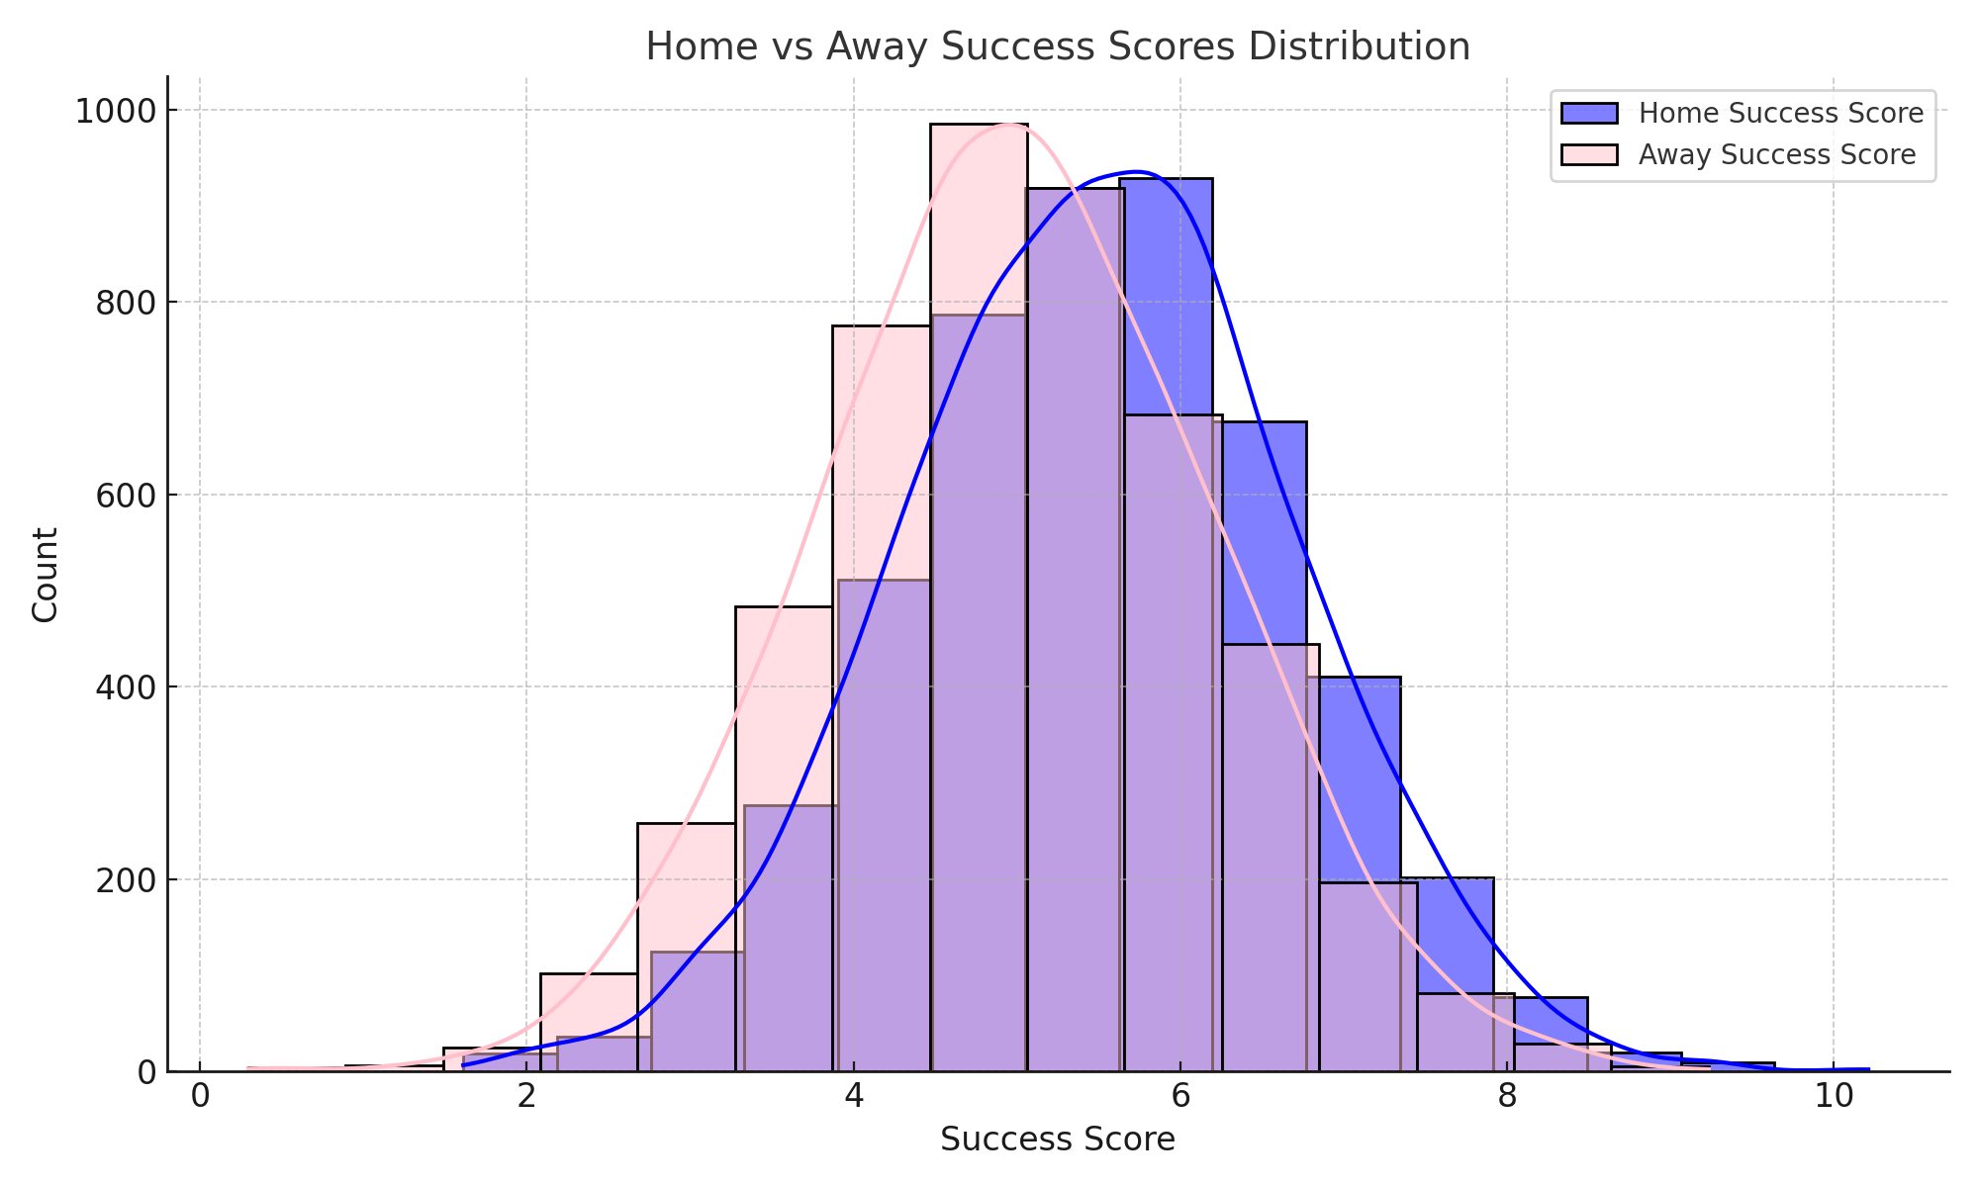
Supplementary Figure S2. Training and validation loss across cross-validation folds.
MAE per epoch for five folds of training the DNN. Training loss decreases steadily; validation loss remains low and stable, indicating effective learning and limited overfitting. MAE, mean absolute error; DNN, deep neural network.
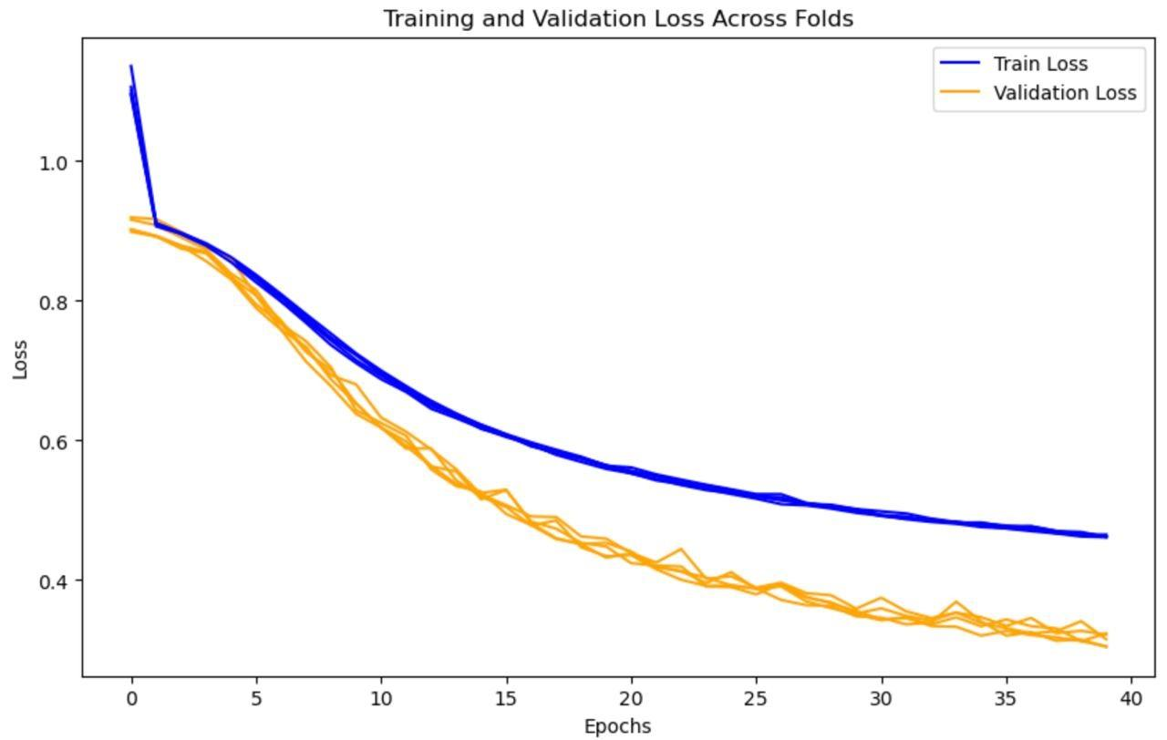
Supplementary Table S1. Per-match case study breakdowns for Manchester United and FC Barcelona (2024–2025, weeks 2–11).
For each match: week, home/away teams and scores, Actual SS, Predicted SS, outcome and performance label (Solid vs Poor). “Solid” indicates meeting/exceeding predicted potential; “Poor” indicates under-performance relative to a predicted advantage.
Week | Home Team | Away Team | Home Score | Away Score | Actual  Success Score | Predicted  Success Score | Outcome | Performance
2 | Brighton | Manchester United | 2 | 1 | 4.33 | 5.8 | home win | poor
3 | Manchester United | Liverpool | 0 | 3 | 3.36 | 5.37 | away win | poor
4 | Southampton | Manchester United | 0 | 3 | 6.95 | 4.60 | away win | solid
5 | Crystal Palace | Manchester United | 0 | 0 | 5.72 | 5.18 | draw | solid
6 | Manchester United | Tottenham Hotspur | 0 | 3 | 2.84 | 5.38 | away win | poor
7 | Aston Villa | Manchester United | 0 | 0 | 5.08 | 4.72 | draw | solid
8 | Manchester United | Brentford | 2 | 1 | 5.87 | 5.47 | home win | solid
9 | West Ham United | Manchester United | 2 | 1 | 4.63 | 5.11 | home win | poor
Week | Home Team | Away Team | Home Score | Away Score | Actual  Success Score | Predicted  Success Score | Outcome | Performance
2 | Barcelona | Athletic Club | 2 | 1 | 6.08 | 5.89 | home win | solid
3 | Rayo Vallecano | Barcelona | 1 | 2 | 5.36 | 4.98 | away win | solid
4 | Barcelona | Real Valladolid | 7 | 0 | 7.61 | 6.87 | home win | solid
5 | Girona | Barcelona | 1 | 4 | 5.98 | 5.04 | away win | solid
6 | Villarreal | Barcelona | 1 | 5 | 5.57 | 5.16 | away win | solid
7 | Barcelona | Getafe | 1 | 0 | 6.88 | 5.80 | home win | solid
8 | Osasuna | Barcelona | 4 | 2 | 4.32 | 6.07 | home win | poor
9 | Deportivo Alaves | Barcelona | 0 | 3 | 7.33 | 5.69 | away win | solid
10 | Barcelona | Sevilla | 5 | 1 | 6.31 | 6.22 | home win | solid
11 | Real Madrid | Barcelona | 0 | 4 | 6.65 | 4.50 | away win | solid

