Supplementary File 3 - Table S4 - S7 & Figure S1 - S2
Participant Demographics (KIIs and FGDs)
Table S4. Parent Participant Demographics - KIIs
Participant ID | Qualification | Employment | Age (years) | Gender
Parent 1 | Postgraduate | Driver | 51 | Male
Parent 2 | Matric | Driver | 52 | Male
Parent 3 | Graduate | Nurse | 42 | Female
Parent 4 | Postgraduate | Health Technologist | 51 | Female

Table S5. School Administrator Participant Demographics - KIIs
Participant ID | Age (years) | Designation | Gender
Administrator 1 | 59 | Senior Headmistress | Female
Administrator 2 | 55 | Deputy Director | Male
Administrator 3 | 53 | Senior Headmistress | Female
Administrator 4 | 48 | District Education Officer | Male
Administrator 5 | 52 | Principal | Male
Administrator 6 | 59 | Principal | Male
Administrator 7 | 47 | Deputy Director | Female

Table S6. Student Participant Demographics - FGDs
Group | Gender | No. of Participants | Mean Age (years)
FGD-S1 | Male | 10 | 14.9
FGD-S2 | Female | 10 | 14.5

Table S7. Teacher Participant Demographics – FGDs
Group | Gender | No. of Participants | Mean Age (years) | Mean Teaching Experience (years)
FGD-T1 | Male | 8 | 43.5 | 21.75
FGD-T2 | Female | 8 | 41.5 | 14.81

Figure S1: Distribution of Stakeholder Engagement Across Major Themes
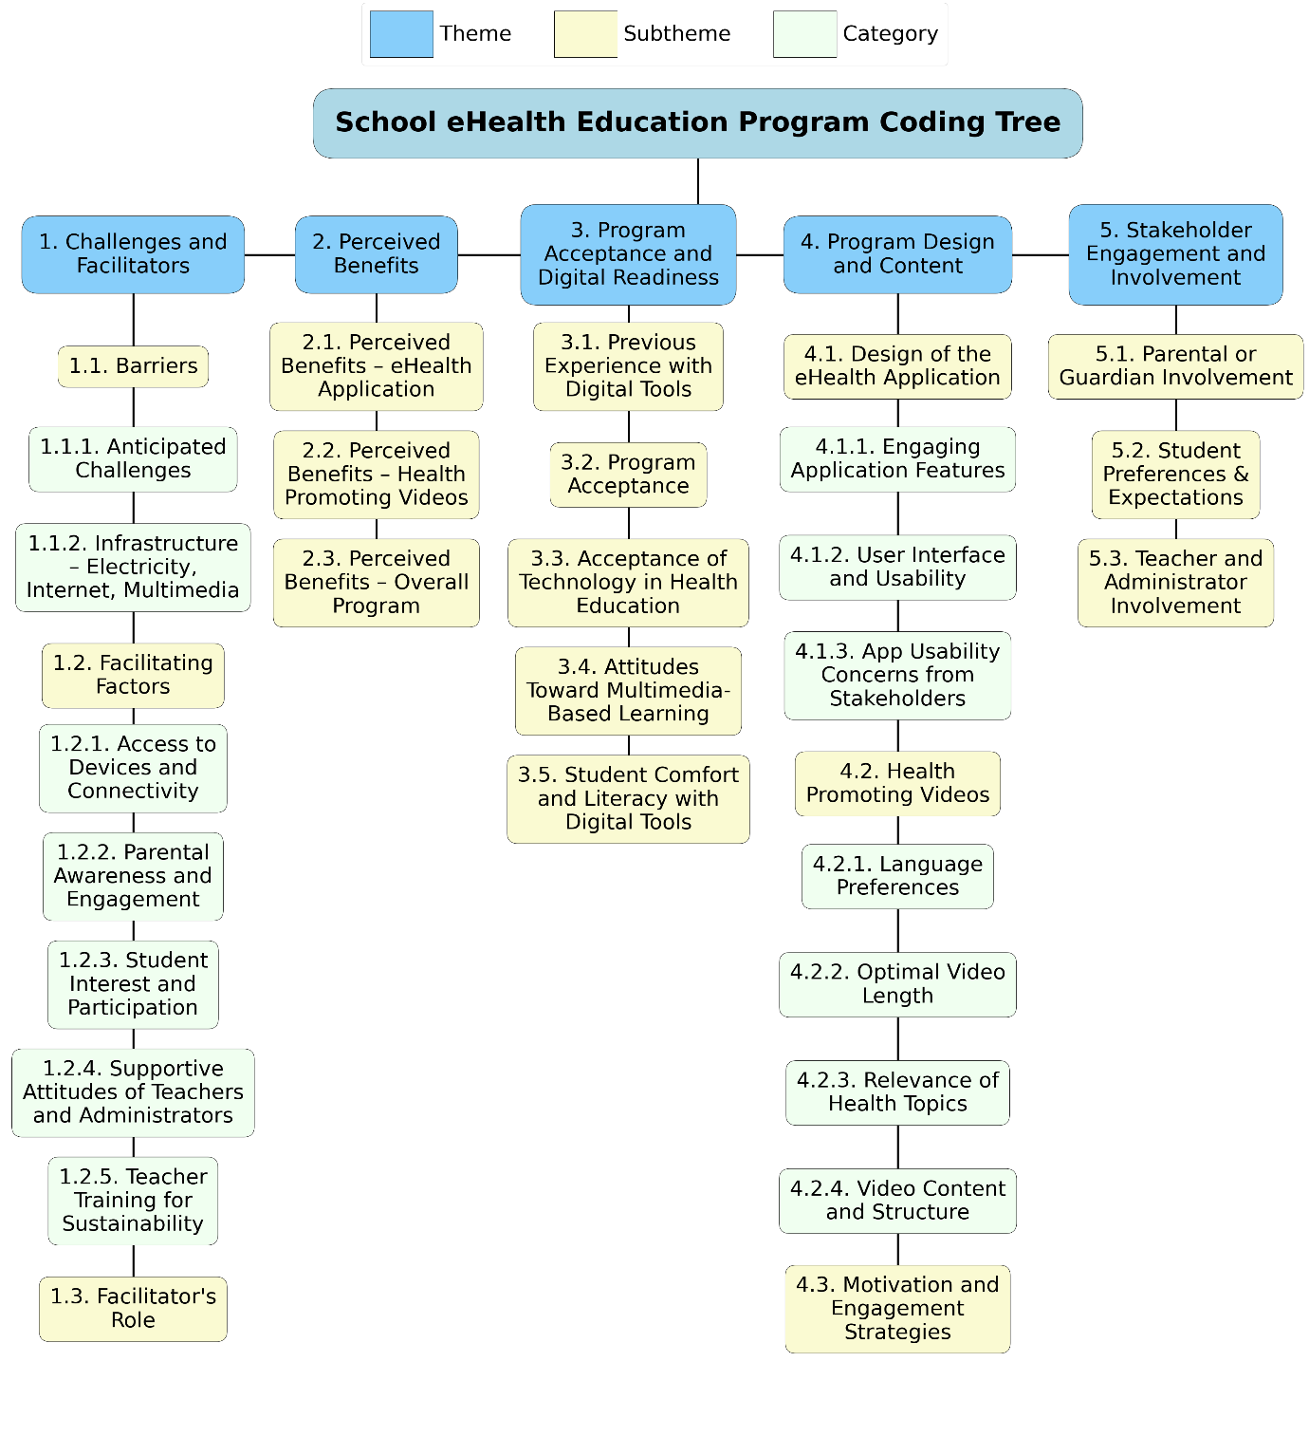
Figure S2: eSHEPP Coding tree of themes, subthemes, and categories

