Supplementary Materials
Reduced YTHDF2 inhibits PD-L1 expression by stabilizing m⁶A-containing SPOP mRNA in colorectal cancer

Xian Xu^{1,2,†}, Hao Chen^{1,†}, Rongjie Zhao^{1,†}, Jiansheng Xie¹, Hao Liu¹, Binbin Xie¹, Jun Lou¹, Haidong Wang¹, Xinkai Wu¹, Weidong Han^{3,*}, Hongming Pan^{1,*}, Jiaying Shen^{1,*}

¹Department of Medical Oncology, Sir Run Run Shaw Hospital, Zhejiang University School of Medicine, Hangzhou, Zhejiang, P. R. China.
²Department of Pulmonary and Critical Care Medicine, Sir Run Run Shaw Hospital, Zhejiang University School of Medicine, Hangzhou, Zhejiang, P. R. China.
³Department of Colorectal Medical Oncology, Zhejiang Cancer Hospital, Hangzhou, Zhejiang, P. R. China.

†These authors contributed equally to this work.
*Correspondence authors:
Dr. Jiaying Shen; Department of Medical Oncology; Sir Run Run Shaw Hospital; Zhejiang University School of Medicine; No. 3 East Qingchun Road; Hangzhou; Zhejiang; P.R. China; 310016; Email: 11318167@zju.edu.cn.
Dr. Hongming Pan; Department of Medical Oncology; Sir Run Run Shaw Hospital; Zhejiang University School of Medicine; No. 3 East Qingchun Road; Hangzhou; Zhejiang; P.R. China; 310016; Email: panhongming@zju.edu.cn.
Dr. Weidong Han; Department of Colorectal Medical Oncology, Zhejiang Cancer Hospital; No. 1, East Banshan Road; Hangzhou; Zhejiang; P.R. China; 310022; Email: hanwd@zju.edu.cn.
Email addresses for all authors:
Xian Xu, xxian@zju.edu.cn.
Hao Chen, 22218189@zju.edu.cn.
Rongjie Zhao, rogerzhao@zju.edu.cn.
Jiansheng Xie, xiejiansheng@zju.edu.cn.
Hao Liu, liuhao431@163.com.
Binbin Xie, xiebb@zju.edu.cn.
Jun Lou, loujundz@163.com
Haidong Wang, haidongwang@zju.edu.cn.
Xinkai Wu, wuxinkai@zju.edu.cn
Weidong Han, hanwd@zju.edu.cn.
Hongming Pan, panhongming@zju.edu.cn.
Jiaying Shen, 11318167@zju.edu.cn.

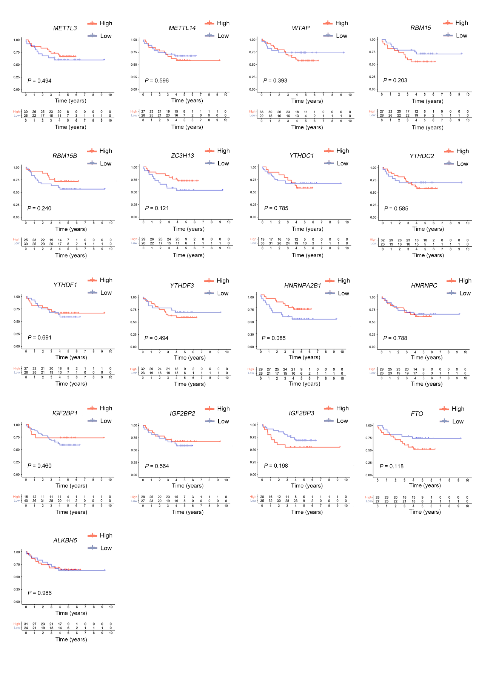
Supplementary Figure S1. Part of m⁶A regulators did not play important roles in affecting the prognosis of CRC, related to Figure 1.
OS analysis for patients with high or low m⁶A RNA regulators expression levels from GSE17537 (n = 55). The top half of figure showed the overall survival curves and the bottom half of figure represented the number of patients at different points of time. Red represented high expression level whereas blue represented low expression level.

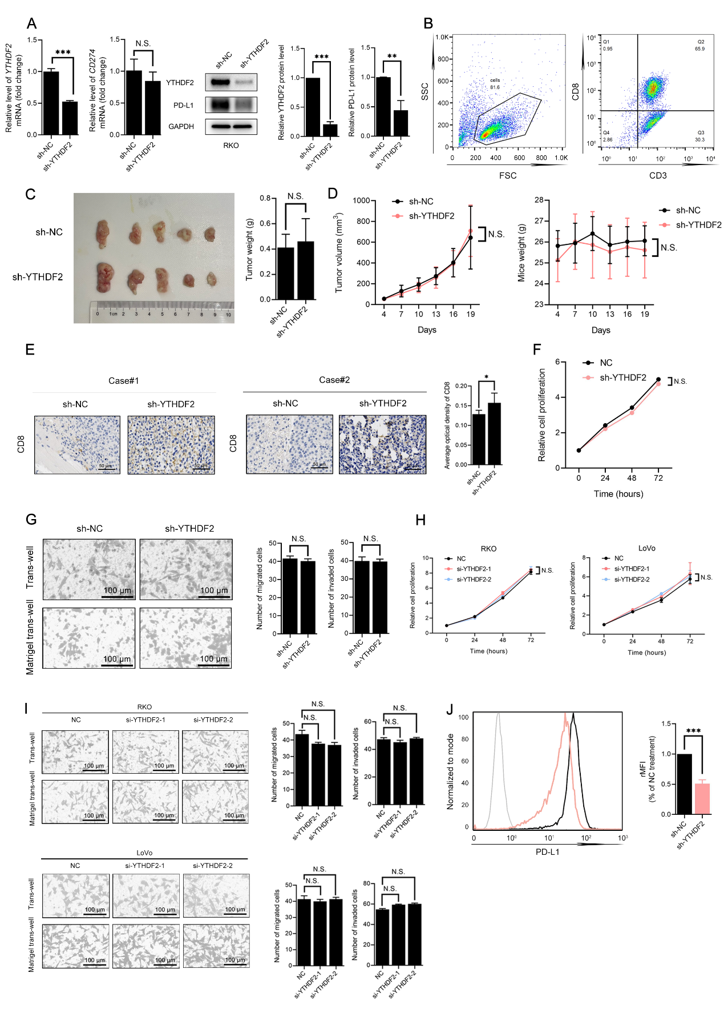
Supplementary Figure S2. YTHDF2 was not related to cell proliferation, migration or invasion, related to Figure 2.
A. qRT-PCR and western blots analysis of YTHDF2 and CD274/PD-L1 expression levels post lentivirus-mediated transfection of sh-NC or sh-YTHDF2 in RKO cells. The quantification was shown.
B. Flow cytometric analysis of PBMCs before injected to the caudal vein of NSG mice.
C-D. Representative images of subcutaneous tumors formed by sh-NC or sh-YTHDF2 RKO cells without PBMCs injection. The tumor volumes and mice weights were monitored after cell implanting every 3 days (n = 5). Tumor masses were weighed after harvesting.
E. Representative image (left) and quantification (right) of CD8 staining in subcutaneous tumors. Scale bars, 50 μm.
F. CCK-8 proliferation assay in sh-NC or sh-YTHDF2 RKO cells.
G. Representative images of trans-well migration and invasion assays in sh-NC or sh-YTHDF2 RKO cells (left). The quantification was shown (right).
H. CCK-8 proliferation assay in siRNAs (NC or si-YTHDF2) transfected CRC cell lines (RKO and LoVo).
I. Representative images of trans-well migration and invasion assays in RKO (upper) and LoVo cells (lower) after YTHDF2 knockdown (left). The quantification was shown (right).
J. PD-L1 was visualized by flow cytometry in sh-NC or sh-YTHDF2 RKO cells. The quantification was shown (right).
The hypothesis test for significance between two groups utilized Student’s t test. Results were analyzed with ANOVA for three or more groups. N.S., no statistical significance, *P < 0.050, **P < 0.010, and ***P < 0.001. Values are mean ± SEM.
Abbreviations: CCK-8: cell counting kit-8; CRC: colorectal cancer; MFI: mean fluorescence intensity; NC: negative control; PBMCs: peripheral blood mononuclear cells.

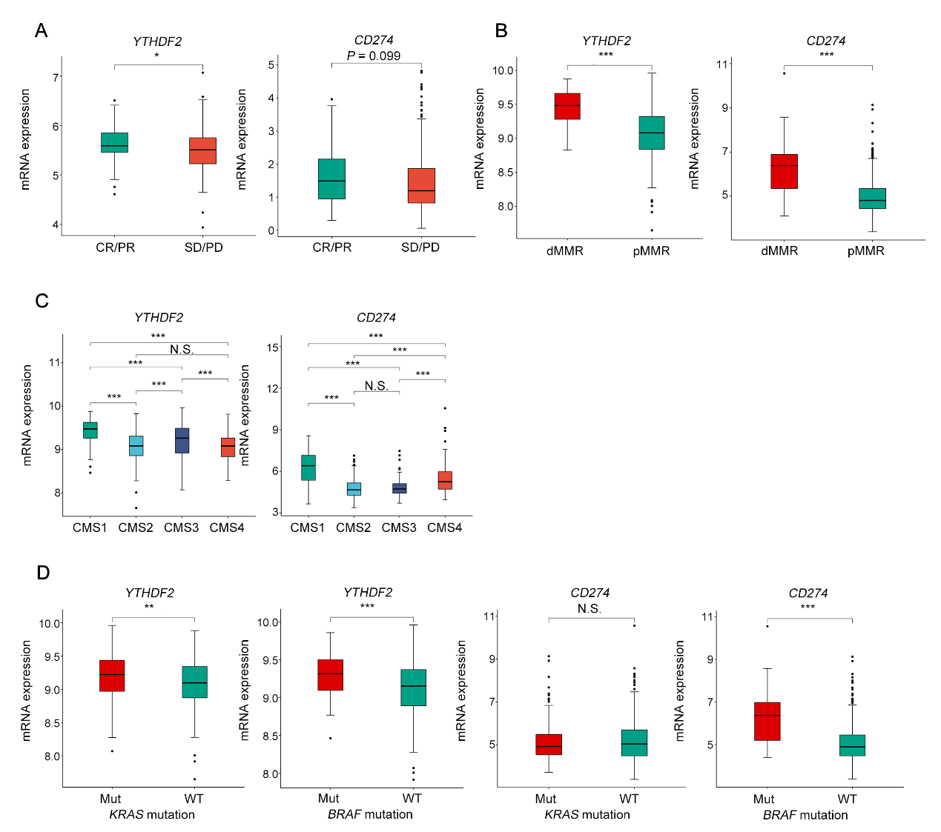
Supplementary Figure S3. Expression patterns of YTHDF2 in CRC with different pathological and molecular characteristics, related to Figure 2.
A. The transcription profile according to PD-L1 blockade atezolizumab treatment response in the IMvigor210 cohort (n = 348). CR and PR were defined as treatment-sensitive, while SD and PD were treatment-resistant.
B-C. The expression of YTHDF2 and CD274 in (B) dMMR/pMMR (75 dMMR and 444 pMMR) and (C) CMS (76 CMS1, 182 CMS2, 90 CMS3, and 128 CMS4) classification in GSE39582.
D. The relationship between YTHDF2, CD274 expression and conditions of KRAS mutation (217 KRAS-mutant and 328 KRAS-wild type), BRAF mutation (51 BRAF-mutant and 461 BRAF-wild type).
Wilcox test was adopted. N.S., no statistical significance, *P < 0.050, ** P < 0.010, and *** P < 0.001.
Abbreviations: CMS: consensus molecular subtypes; CR: complete response; CRC: colorectal cancer; dMMR: deficient mismatch repair; Mut: mutated-type; PD: progressive disease; pMMR: mismatch repair-proficient; PR: partial response; SD: stable disease; WT: wild-type.

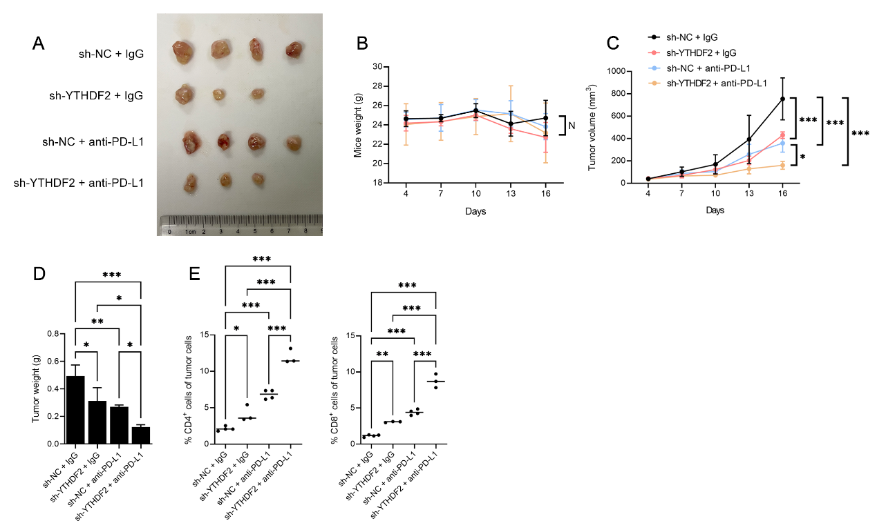
Supplementary Figure S4. Anti-PD-L1 treatment with YTHDF2 knockdown inhibited tumor growth, related to Figure 2.
A. Representative images of subcutaneous tumors formed by sh-NC or sh-YTHDF2 RKO cells treated with IgG or anti-PD-L1 antibody (n = 3~4).
B-C. The mice weights (B) and tumor volumes (C) were monitored after cell implanting every 3 days (n = 3~4).
D. Tumor masses were weighed after harvesting.
E. Flow cytometric analysis of the percentage of CD4⁺ or CD8⁺ tumor infiltrating-lymphocytes.
The hypothesis test for significance between two groups utilized Student’s t test. Results were analyzed with ANOVA for three or more groups. N.S., no statistical significance, *P < 0.050, **P < 0.010, and ***P < 0.001. Values are mean ± SEM.
Abbreviations: IgG: immune globulin G; NC: negative control.

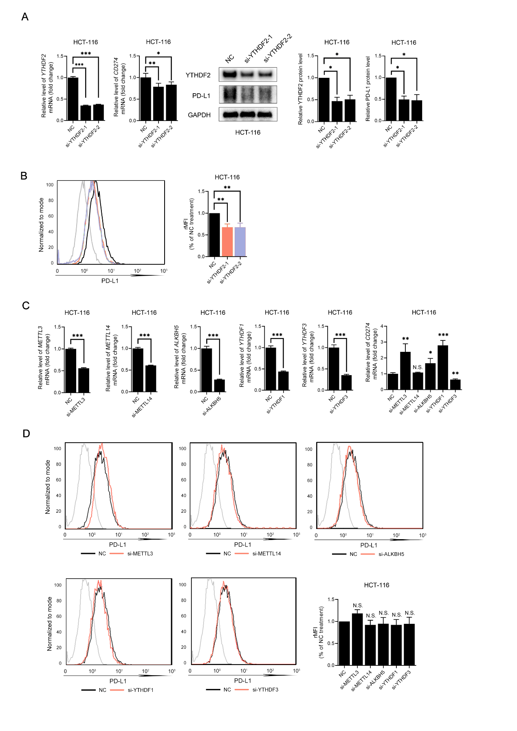
Supplementary Figure S5. Reduced YTHDF2 decreased PD-L1 expression, related to Figure 3.
A. qRT-PCR and western blots analysis of YTHDF2 and CD274/PD-L1 expression levels post siRNAs (NC or si-YTHDF2) transfection in CRC cell line (HCT-116). The quantification of western blots was shown (right).
B. PD-L1 was visualized by flow cytometry in HCT-116 cells treated with siRNAs (NC or si-YTHDF2). The quantification was shown (right).
C. qRT-PCR analysis of m⁶A RNA regulators and CD274 expression levels post siRNAs transfection in CRC cell line (HCT-116).
D. PD-L1 was visualized by flow cytometry in HCT-116 cells treated with m⁶A RNA regulators siRNAs. The quantification was shown.
The hypothesis test for significance between two groups utilized Student’s t test. Results were analyzed with ANOVA for three or more groups. GAPDH was included as loading control in western blots. HPRT1 served as the internal control in qRT-PCR. N.S., no statistical significance, *P < 0.050, **P < 0.010, and ***P < 0.001. Values are mean ± SEM.
Abbreviations: CRC: colorectal cancer; MFI: mean fluorescence intensity; NC: negative control.

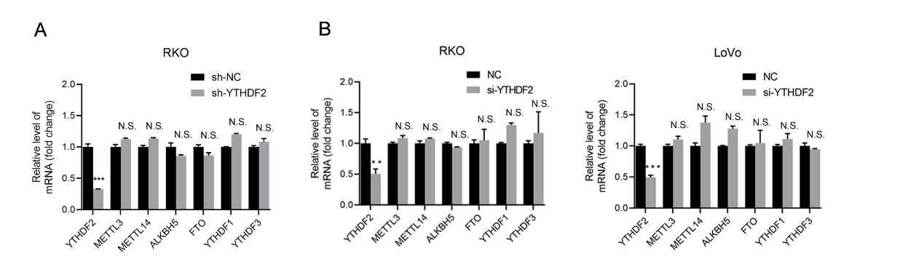
Supplementary Figure S6. Knockdown of YTHDF2 did not impact the expression levels of other m⁶A regulators, related to Figure 3.
A. qRT-PCR analysis m⁶A RNA regulators expression in sh-NC or sh-YTHDF2 RKO cells.
B. qRT-PCR analysis m⁶A RNA regulators expression in siRNAs (NC or si-YTHDF2) transfected CRC cell lines (RKO and LoVo).
The hypothesis test for significance between two groups utilized Student’s t test. HPRT1 served as the internal control in qRT-PCR. N.S., no statistical significance, *P < 0.050, **P < 0.010, and ***P < 0.001. Values are mean ± SEM.
Abbreviations: CRC: colorectal cancer; m⁶A: N⁶-methyladenosine; NC: negative control.

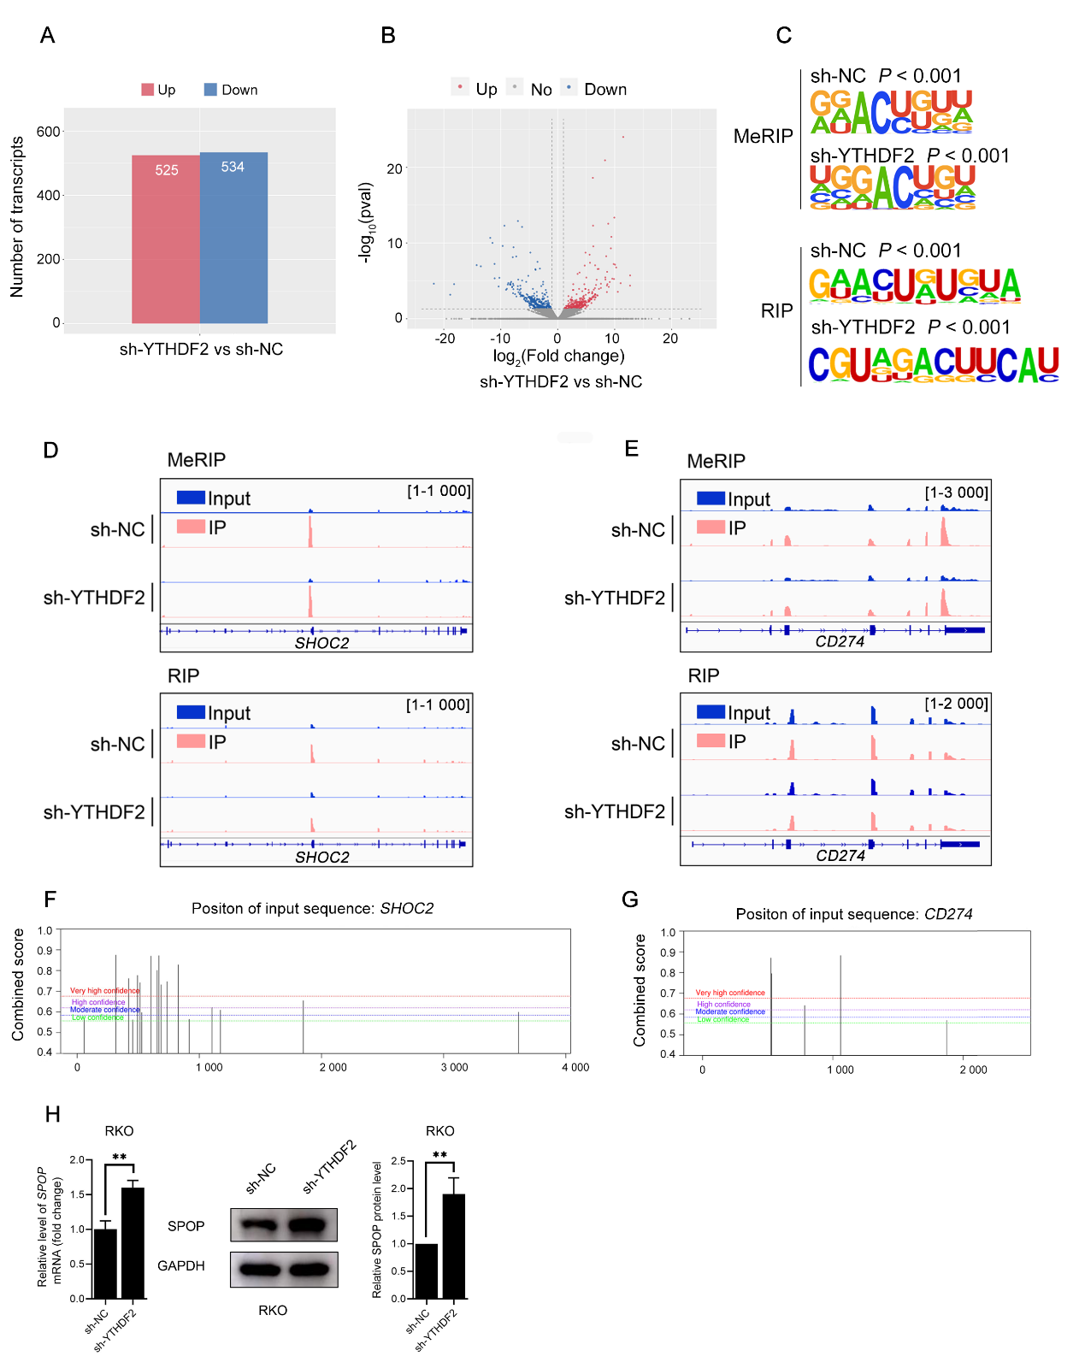
Supplementary Figure S7. Identification of potential target mRNAs of YTHDF2, related to Figure 4.
A. Differentially expressed transcripts were shown by analysis of RNA-seq data in sh-NC and sh-YTHDF2 RKO cells. Red represented up-regulated transcripts whereas blue represented down-regulated transcripts.
B. Volcano plot of differentially expressed transcripts. Significantly up-regulated or down-regulated transcripts were plotted in red and blue points respectively.
C. Motif analysis by the HOMER motif discovery tool revealed a “DRACH” consensus (where D represents A, G, or U, R represents A or G, H represents A, C, or U) for m⁶A modification sites and YTHDF2-binding sites.
D-E. IGV tracks displayed the distribution of m⁶A peaks and YTHDF2-binding sites along SHOC2 (D) and CD274 (E) mRNAs according to MeRIP-seq and RIP-seq data. The abscissa represented transcripts, and the ordinate represented peaks signals. Red represented IP group whereas blue represented Input group.
F-G. The potential m⁶A sites of SHOC2 (F) and CD274 (G) mRNA were predicted by SRAMP. The abscissa represented transcripts, and the ordinate represented combined scores Different color lines indicated different confidences (red, purple, blue and green respectively represented very high, high, moderate and low confidence).
H. qRT-PCR and western blots analysis of SPOP expression levels in sh-NC or sh-YTHDF2 RKO cells. The quantification was shown.
The hypothesis test for significance between two groups utilized Student’s t test. GAPDH was included as loading control in western blots. HPRT1 served as the internal control in qRT-PCR. N.S., no statistical significance, *P < 0.050, ** P < 0.010, and *** P < 0.001. Values are mean ± SEM.
Abbreviations: IGV: integrative genomics viewer; IP: immune-precipitation; m⁶A: N⁶-methyladenosine; MeRIP: methylated RNA immunoprecipitation; NC: negative control; RIP: RNA binding protein immunoprecipitation.

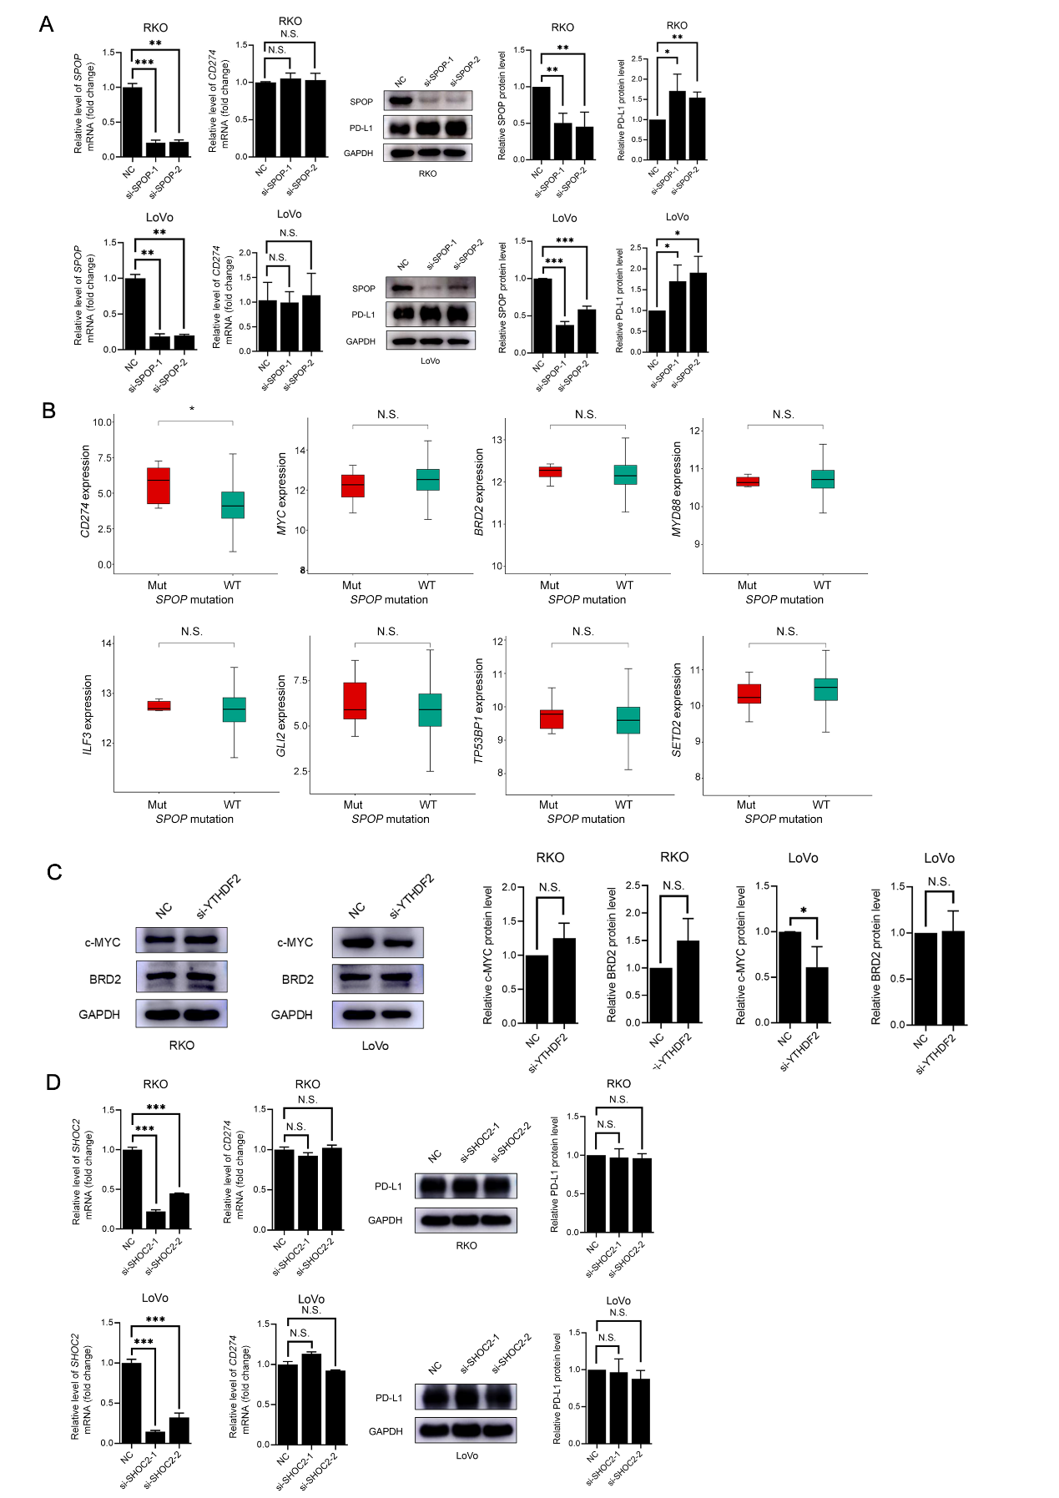
Supplementary Figure S8. YTHDF2-mediated SPOP mRNA decay did not affect the stability of other substrates in CRC, related to Figure 5.
A. qRT-PCR and western blots analysis of SPOP and CD274/PD-L1 in siRNAs (NC or si-SPOP) transfected CRC cell lines (RKO and LoVo). The quantification was shown (right).
B. CD274 expression levels were compared in 7 SPOP-mutant and 585 SPOP-wild type CRC tissues. Wilcox test was adopted.
C. Western blots analysis of c-MYC and BRD2 in siRNAs (NC or si-YTHDF2) transfected CRC cell lines (RKO and LoVo). GAPDH was included as loading control in western blots. The quantification of western blots was shown (right).
D. qRT-PCR and western blots analysis of SHOC2 and CD274/PD-L1 in siRNAs (NC or si-SHOC2) transfected CRC cell lines (RKO and LoVo). The quantification of western blots was shown (right).
The hypothesis test for significance between two groups utilized Student’s t test. Results were analyzed with ANOVA for three or more groups. GAPDH was included as loading control in western blots. HPRT1 served as the internal control in qRT-PCR. N.S., no statistical significance, *P < 0.050, **P < 0.010, and ***P < 0.001. Values are mean ± SEM.
Abbreviations: CRC: colorectal cancer; Mut: mutated-type; NC: negative control; WT: wild-type.

Table S1. siRNAs and sh-RNAs used for silencing genes.
 | Sequence
 | Sense 5’→3’ | Antisense 5’→3’
si-NC | UUCUCCGAACGUGUCACGUTT | ACGUGACACGUUCGGAGAATT
si-YTHDF2-1 | GCCCAAUAAUGCAUAUACUTT | AGUAUAUGCAUUAUUGGGCTT
si-YTHDF2-1 | GCUCUGGAUAUAGUAGCAATT | UUGCUACUAUAUCCAGAGCTT
si-METTL3 | GCAAGUAUGUUCACUAUGATT | UCAUAGUGAACAUACUUGCTT
si-METTL14 | GGCUAAAGGAUGAGUUAAUTT | AUUAACUCAUCCUUUAGCCTT
si-YTHDF1 | CCGCGUCUAGUUGUUCAUGAATT | UUCAUGAACAACUAGACGCGGTT
si-YTHDF3 | AUGGAUUAAAUCAGUAUCUAATT | UUAGAUACUGAUUUAAUCCAUTT
si-ALKBH5 | ACAAGUACUUCUUCGGCGATT | UCGCCGAAGAAGUACUUGUTT
si-SPOP-1 | CAACUAUCAUGCUUCGGAUTT | AUCCGAAGCAUGAUAGUUGTT
si-SPOP-2 | GGUAAAGGUUCCUGAGUGCTT | GCACUCAGGAACCUUUACCTT
si-SHOC2-1 | AAGCUGCGGAUGCUUGAUUTT | AAUCAAGCAUCCGCAGCUUTT
si-SHOC2-2 | UACCUUCGCUUUAAUCGUAUATT | UAUACGAUUAAAGCGAAGGUATT
sh-NC | TTCTCCGAACGTGTCACGT
sh-YTHDF2 | TTCCTACCAGATGCAATGTTT

Table S2. Primers for qPCR analysis.
Gene | Sequence
Gene | Forward 5’→3’ | Reverse 5’→3’
METTL3 | AAGCTGCACTTCAGACGAAT | GGAATCACCTCCGACACTC
METTL14 | AGAAACTTGCAGGGCTTCCT | TCTTCTTCATATGGCAAATTTTCTT
YTHDF1 | ATGTCGGCCACCAGCGTGGACA | TCATTGTTTGTTTCGACTCTGC
YTHDF2 | GGCAGCACTGAAGTTGGG | CTATTGGAAGCCACGATGTTA
YTHDF3 | TGACAACAAACCGGTTACCA | TGTTTCTATTTCTCTCCCTACGC
ALKBH5 | CCCGAGGGCTTCGTCAACA | CGACACCCGAATAGGCTTGA
FTO | TGGGTTCATCCTACAACGG | CCTCTTCAGGGCCTTCAC
CD274 | CTGTCACGGTTCCCAAGGAC | GACAATTAGTGCAGCCAGGTC
HPRT1 | TGACACTGGCAAAACAATGCA | GGTCCTTTTCACCAGCAAGCT
SPOP | GCCGCTCTCAGAGATTTCCT | AGCACCAACTCTCAGCTACG
SHOC2 | GGGGCTCCTGACGGAACT | TGGATCTAAAAGCACTATGCCC
SPOP-m⁶A | TGTTGTGAGGGGAAGAGACTGC | CCCCCGTTTCCCCCAAGTTATT

Table S3. Wild-type and mutant-type m⁶A sequences in SPOP 3’UTR.
SPOP 3’UTR | Sequence 5’→3’
Wild-type  (1 571-1 660 bp) | ACTGTTGCTGCCACTGACCACCAGGTAGACAGCGCAATCTGTGGAGCTTTTACTCTGTT  GTGAGGGGAAGAGACTGCATTGTGGCCCCAGACTTTTAAAACAGCACTAAATAACTTG  GGGGAAACGGGGGGAGGGAAAATGAAATGAAAACCCTGTTGCTGCGTCACTGTGTTCC  CTTTGGCCTGGCTGAGTTTGATACTGTGGGGATTC
Mutant-type  (1 571-1 660 bp) | ACTGTTGCTGCCACTGACCACCAGGTAGACAGCGCAATCTGTGGAGCTTTTACTCTGTT  GTGAGGGGAAGAGTCTGCATTGTGGCCCCAGTCTTTTAAAACAGCACTAAATATCTTGG  GGGAAACGGGGGGAGGGAAAATGAAATGAAAACCCTGTTGCTGCGTCACTGTGTTCCC  TTTGGCCTGGCTGAGTTTGATACTGTGGGGATTC

Table S4. Primers for PCR and vector construction.
Primer |  | Sequence 5’→3’
SPOP 3’UTR | Forward | AACGAGCTCGCTAGCCTCGAGACTGTTGCTGCCACTGACCAC
SPOP 3’UTR | Reverse | CAGGTCGACTCTAGACTCGAGGAATCCCCACAGTATCAAACTCAGC
SPOP mutant 3’UTR | Forward | GGCCCCAGTCTTTTAAAACAGCACTAAATATCTTGGGGGAAACGGGGGG
SPOP mutant 3’UTR | Reverse | TTTAAAAGACTGGGGCCACAATGCAGACTCTTCCCCTCACAACAGAGTAAAA

