Supplementary Information

Silicon fertilisation affects morphological and immune defences of an insect pest and enhances plant compensatory growth
Tarikul Islam^{1,2}, Ben D. Moore¹ & Scott N. Johnson¹
¹ Hawkesbury Institute for the Environment, Western Sydney University, Locked Bag 1797, Penrith, NSW 2751, Australia
² Department of Entomology, Faculty of Agriculture, Bangladesh Agricultural University, Mymensingh 2202, Bangladesh

Corresponding author:
Tarikul Islam
Email: tarikul.islam@westernsydney.edu.au
tarikul.entom@bau.edu.bd
ORCID ID: https://orcid.org/0000-0003-1128-6713

Postal address:
Hawkesbury Institute for the Environment
Western Sydney University
Locked Bag 1797
Penrith 2751 NSW Australia

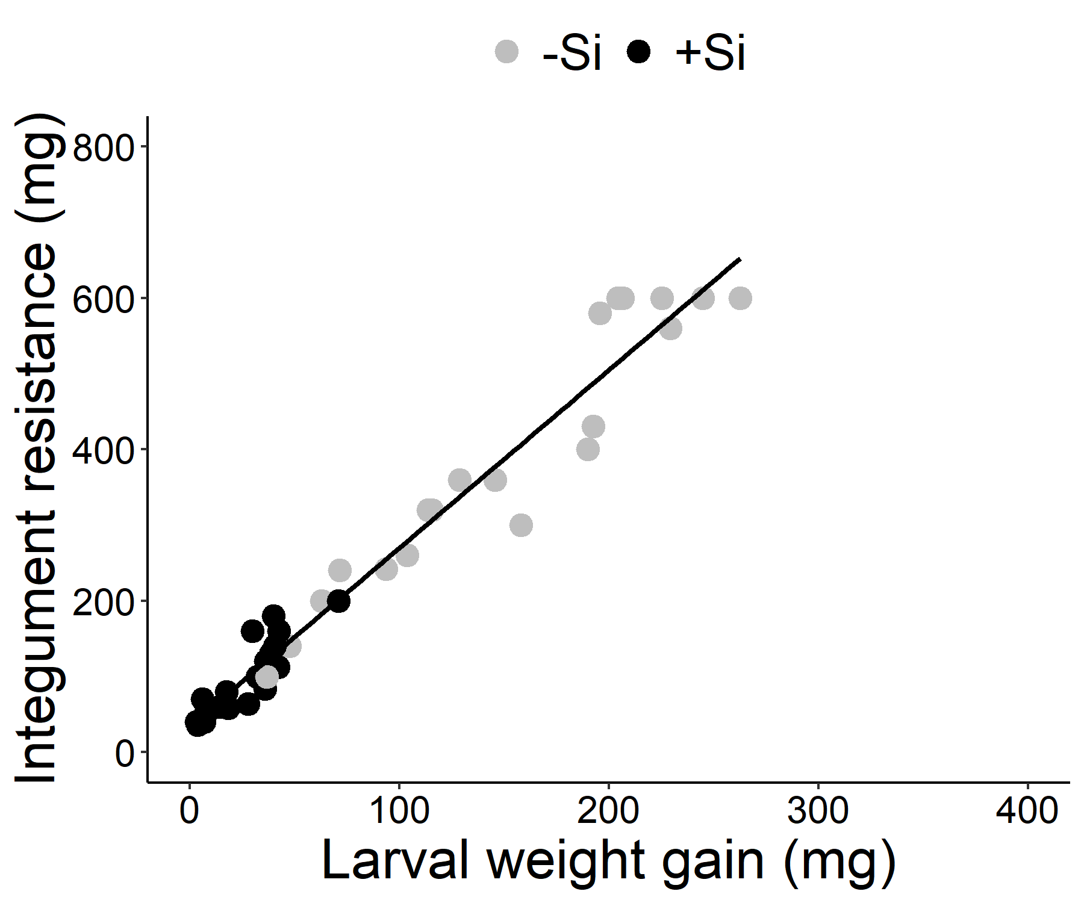
(a)

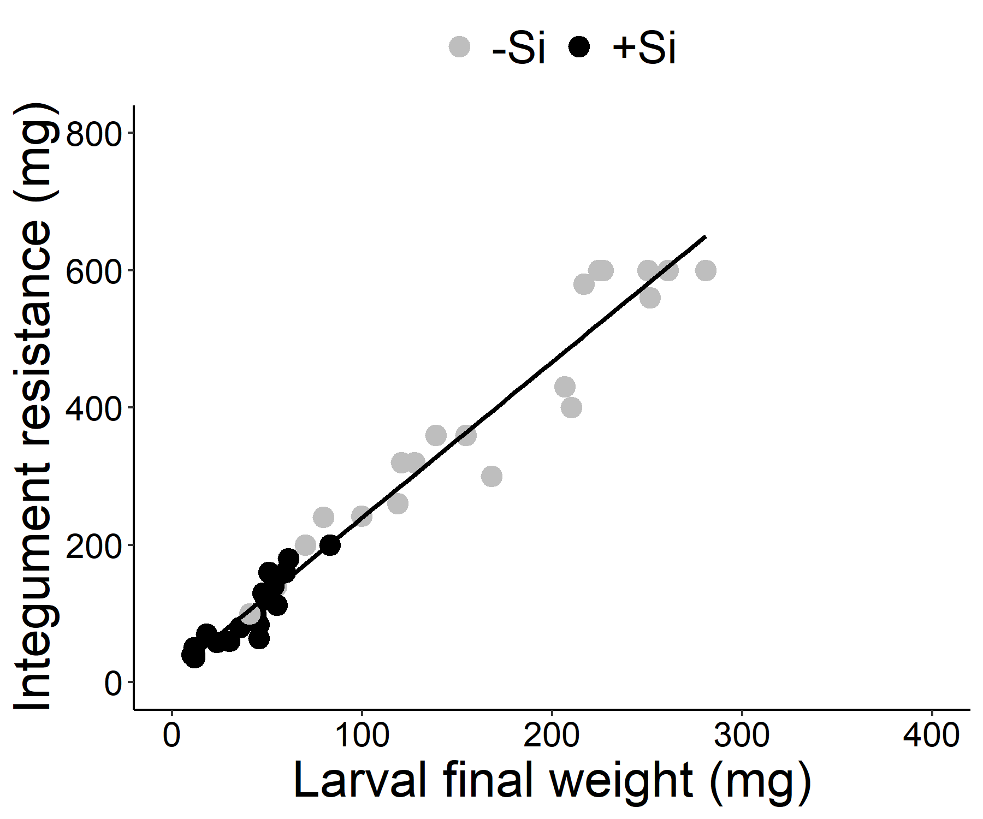
(b)

Fig. S1 The positive correlations between (a) larval weight gain and integument resistance and (b) larval final weight and integument resistance. Larvae were allowed to feed on –Si or +Si host plants for seven days before measurements.

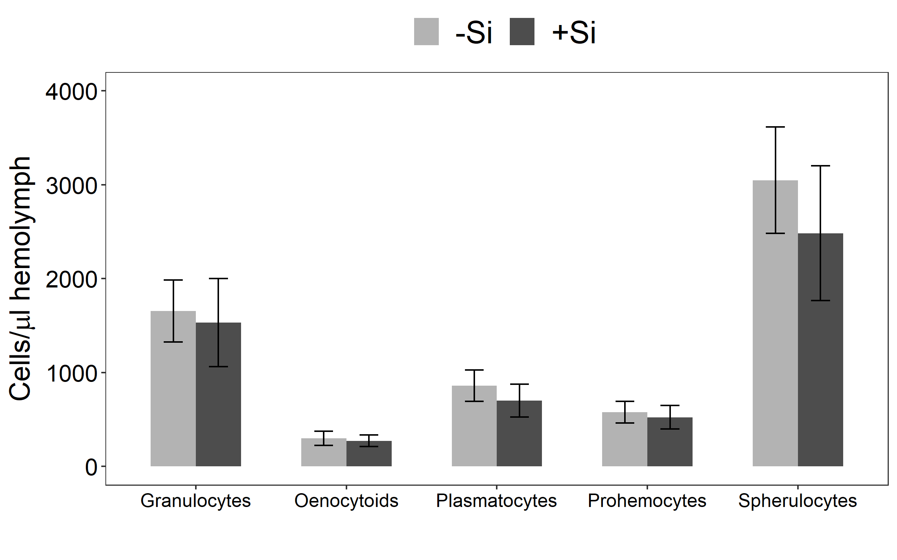
(a)

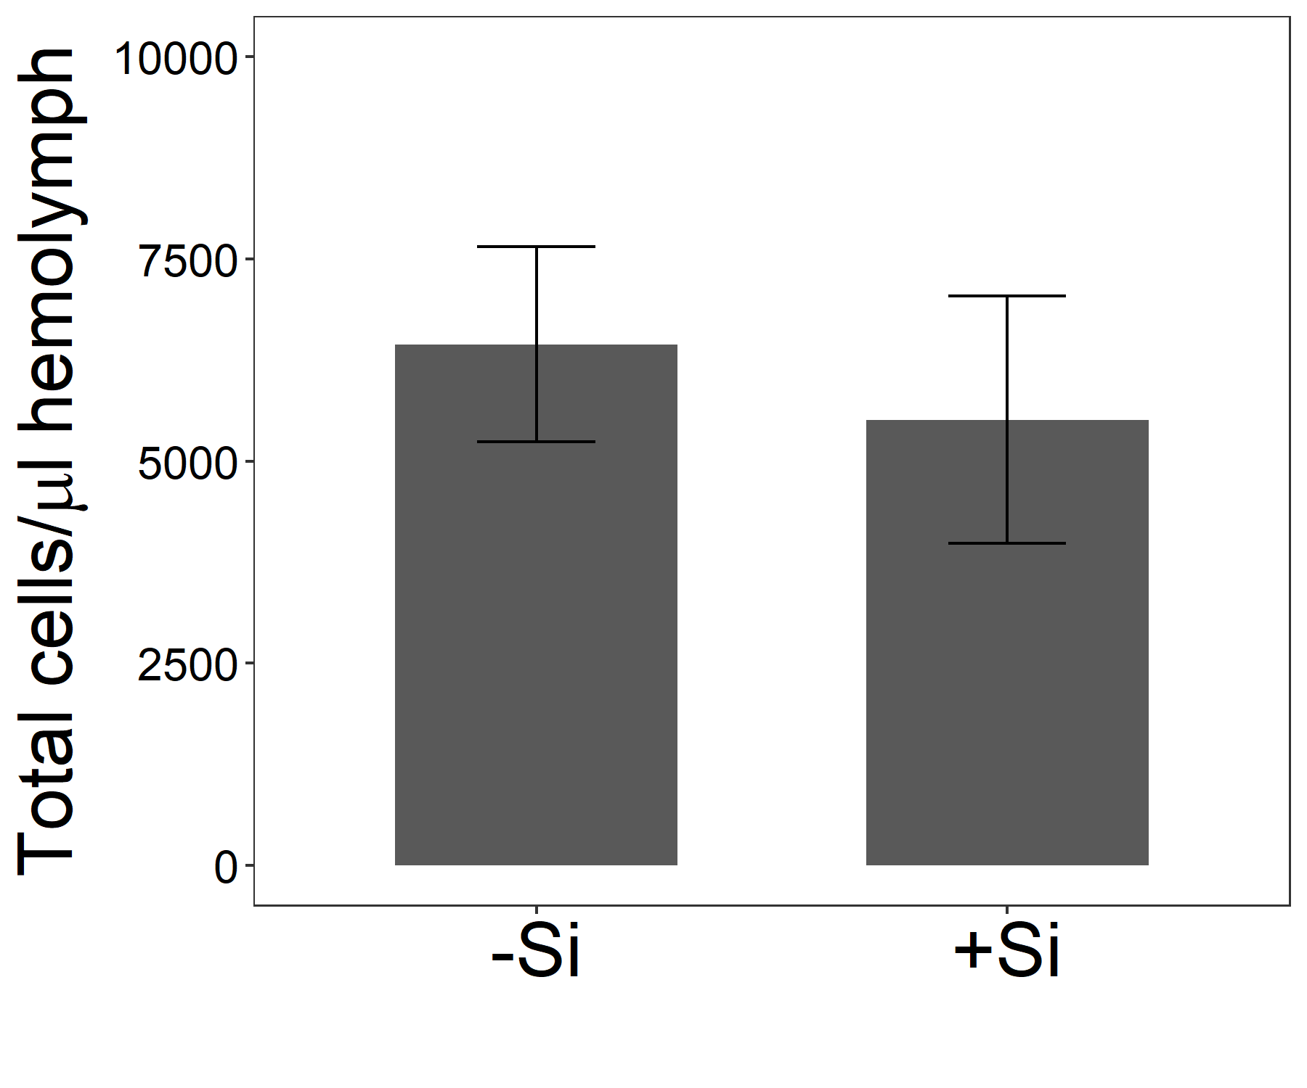
(b)
Fig. S2 The density of hemocytes per microliter of hemolymph in larvae fed on –Si or +Si plants: (a) individual hemocyte density and (b) total hemocyte density. Mean ± SE shown (N = 10). Group means were compared using Student’s t-tests

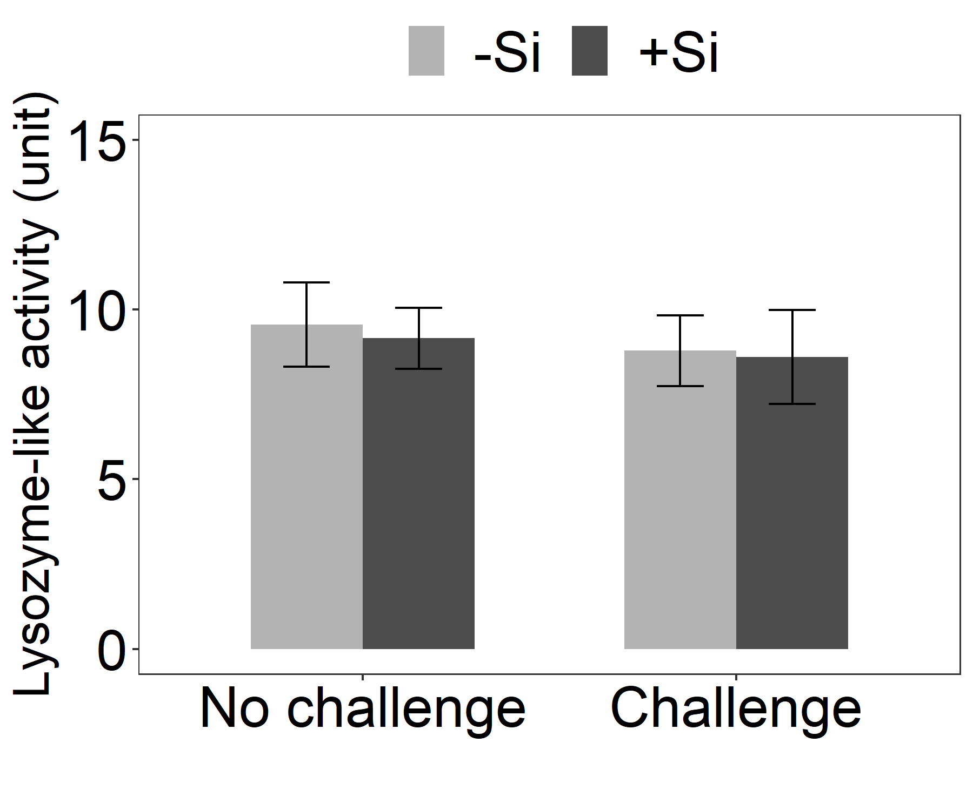
Fig. S3 Lysozyme-like activity in the hemolymph of immunologically naïve (no challenge) and challenged larvae following feeding on –Si or +Si plants. Mean ± SE shown (N = 10). Group means were compared using Student’s t-tests

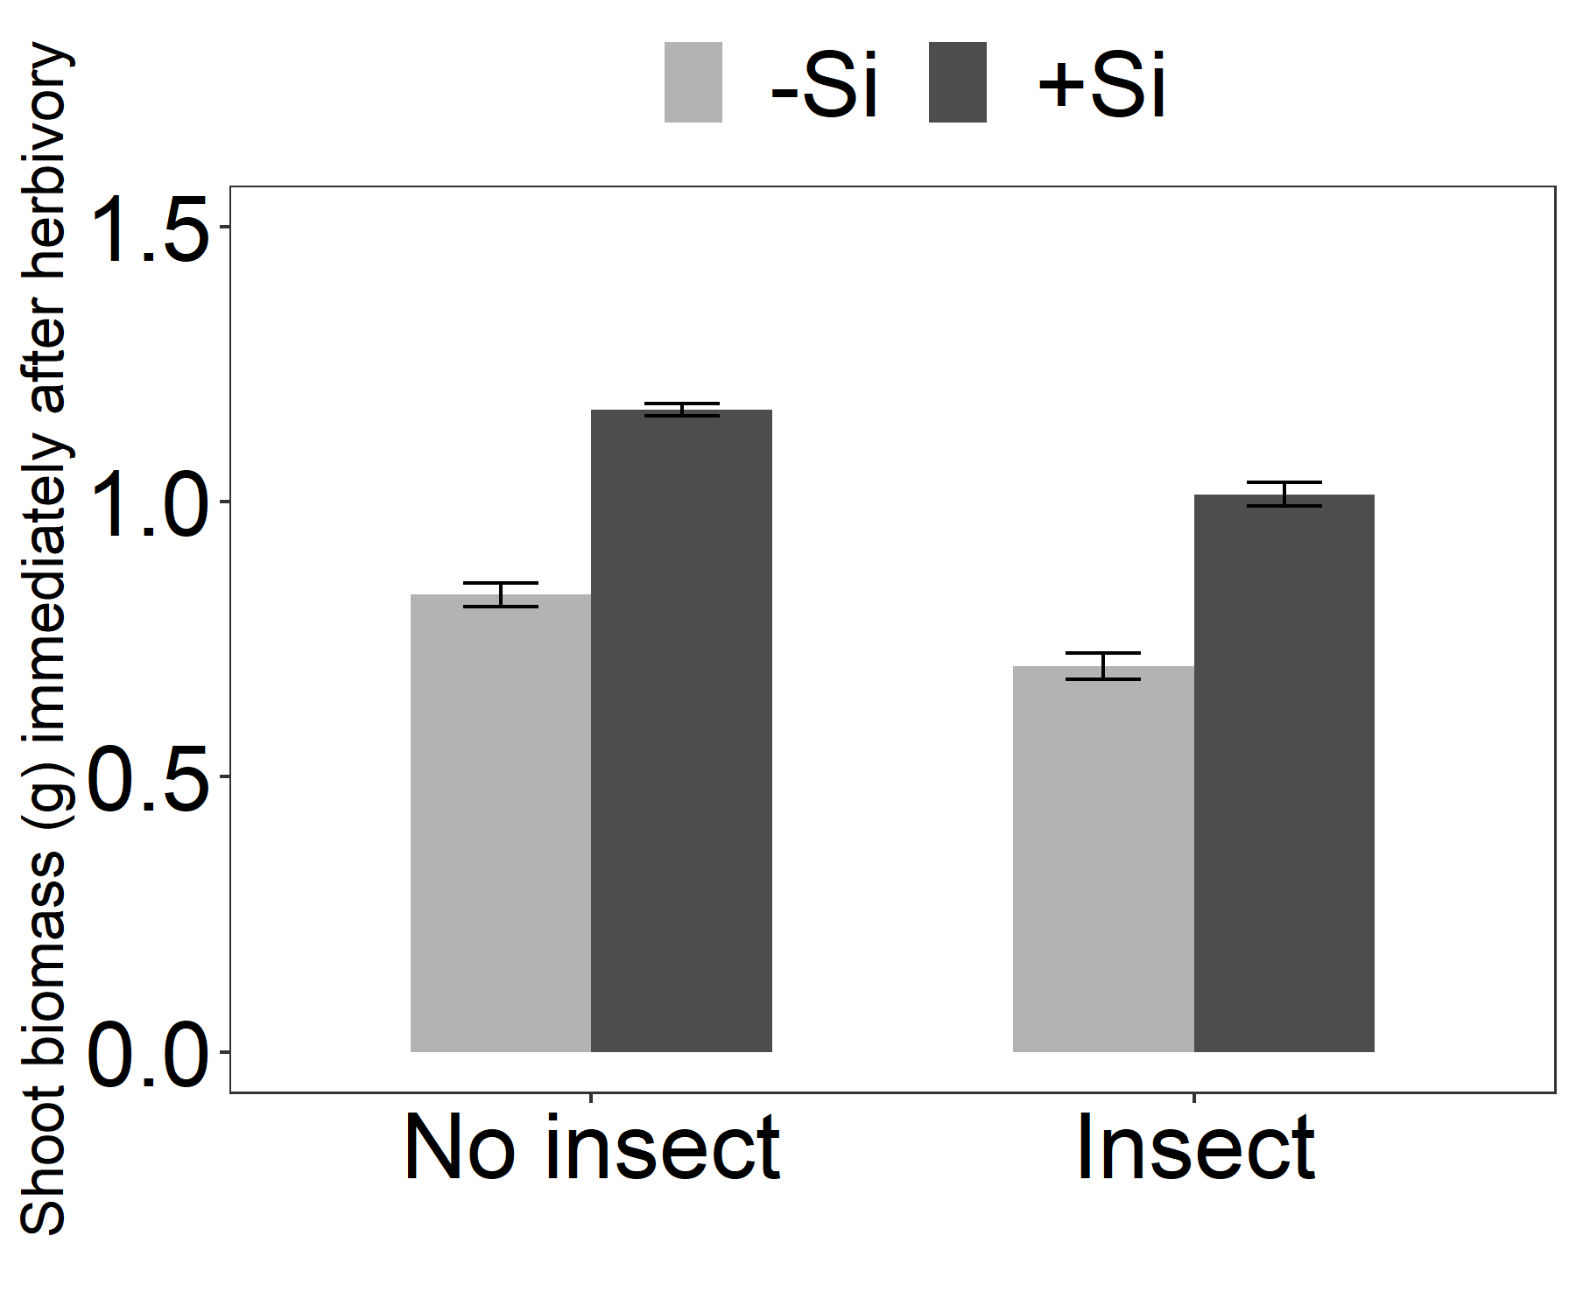
Si ***, Herbivore ***
b
a
B
A
Fig. S4 Shoot biomass of plants harvested immediately after herbivory along with insect-free control plants. Mean ± SE shown (N = 15). Data were primarily analysed using a two-way ANOVA test and the levels of statistical significance at 95% confidence intervals are presented by asterisks (*** p < 0.001). A Tukey’s HSD test was further used to compare the group means. Different uppercase letters indicate a significant difference between insect-free –Si plants and insect-fed –Si plants whereas different lowercase letters indicate a significant difference between insect-free +Si plants and insect-fed +Si plants.

Table S1 Defensive behaviours of larvae fed on –Si and +Si plants. Mean ± SE shown (N = 20). Each defensive behaviour was compared using a Wilcoxon’s rank-sum test at a 95% confidence interval
Behavioural defence | Larvae fed on −Si plants | Larvae fed on +Si plants | Statistical analysis
Behavioural defence | Larvae fed on −Si plants | Larvae fed on +Si plants | Test statistic (W) | p value
Number of headrears | 3.00 ± 0.00 | 2.85 ± 0.08 | 230 | 0.080
Number of thrashes | 0.95 ± 0.35 | 1.00 ± 0.32 | 192.5 | 0.818
Number of regurgitations | 0.50 ± 0.20 | 0.50 ± 0.17 | 193 | 0.832
Flee (no. of squares crossed) | 34.38 ± 3.53 | 31.08 ± 2.11 | 111.5 | 0.758

Table S2 Summary output of Student’s t-tests for comparing the differences in hemocyte density and lysozyme-like activity in the hemolymph of larvae fed on –Si or +Si plants
Response variable | Fig. | Statistical analysis
Response variable | Fig. | df | Test statistic (t) | p value
Individual hemocytes
Prohemocytes | S1 (a) | 18 | 0.32 | 0.752
Granulocytes | S1 (a) | 18 | 0.22 | 0.830
Plasmatocytes | S1 (a) | 18 | 0.66 | 0.520
Spherulocytes | S1 (a) | 18 | 0.62 | 0.544
Oenocytoids | S1 (a) | 18 | 0.29 | 0.777
Total hemocyte density | S1 (b) | 18 | 0.48 | 0.638
Lysozyme-like activity (No challenge) | S2 | 18 | 0.27 | 0.791
Lysozyme-like activity (Challenge) | S2 | 18 | 0.11 | 0.914

Table S3 Summary output of a two-way ANOVA test for the effects of silicon and insect herbivory on shoot biomass of plants harvested immediately after herbivory. Statistically significant effects (p < 0.05) are indicated in bold
Response variable | Fig. | df | Si |  | Herbivore |  | Si × Herbivore
Response variable | Fig. | df | F | p value | F | p value | F | p value
Shoot biomass (g) | S3 | 1,56 | 263.85 | <0.001 | 50.34 | <0.001 | 0.38 | 0.539

