Supplementary Material 2

2.1 Questionnaire

2.2 Coding guide

2.1 Questionnaire

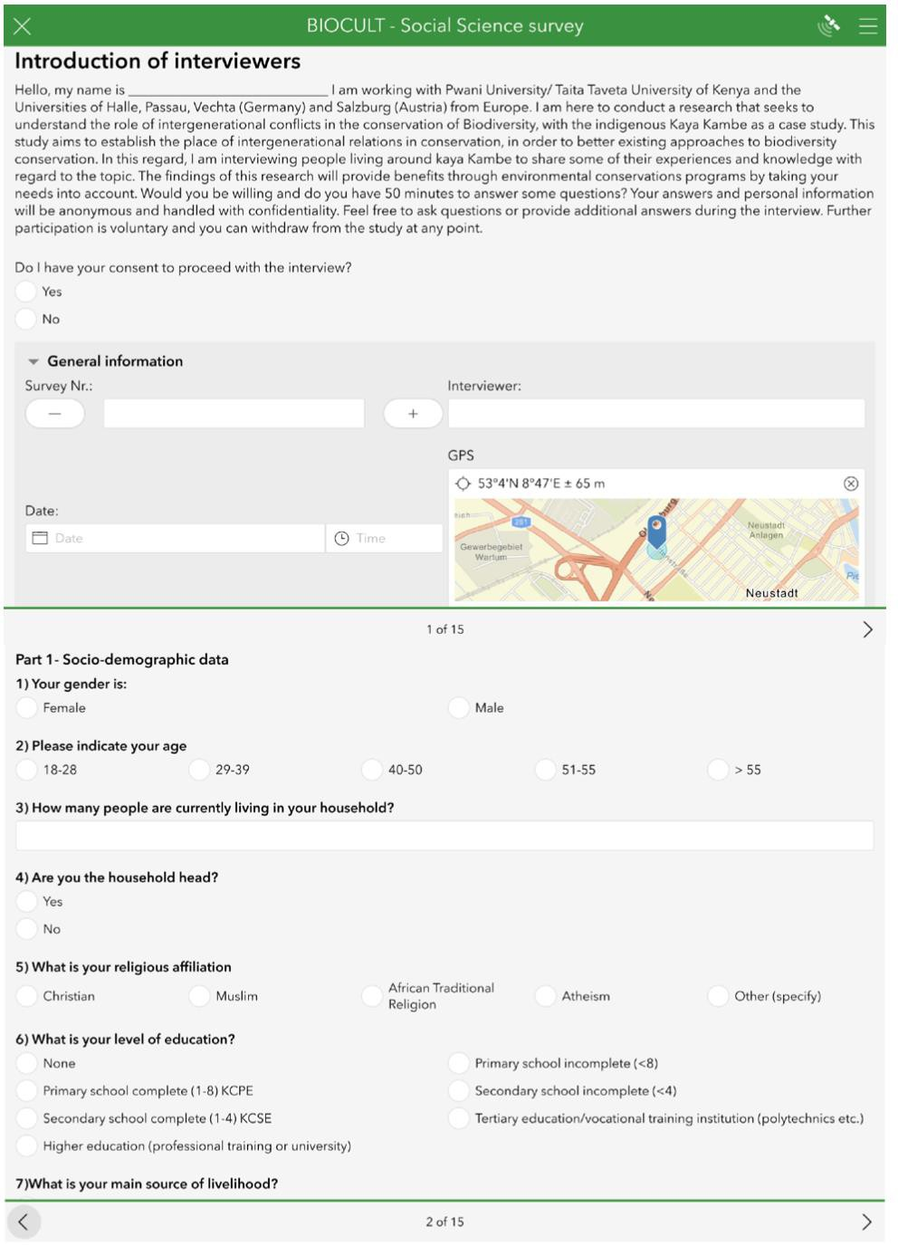

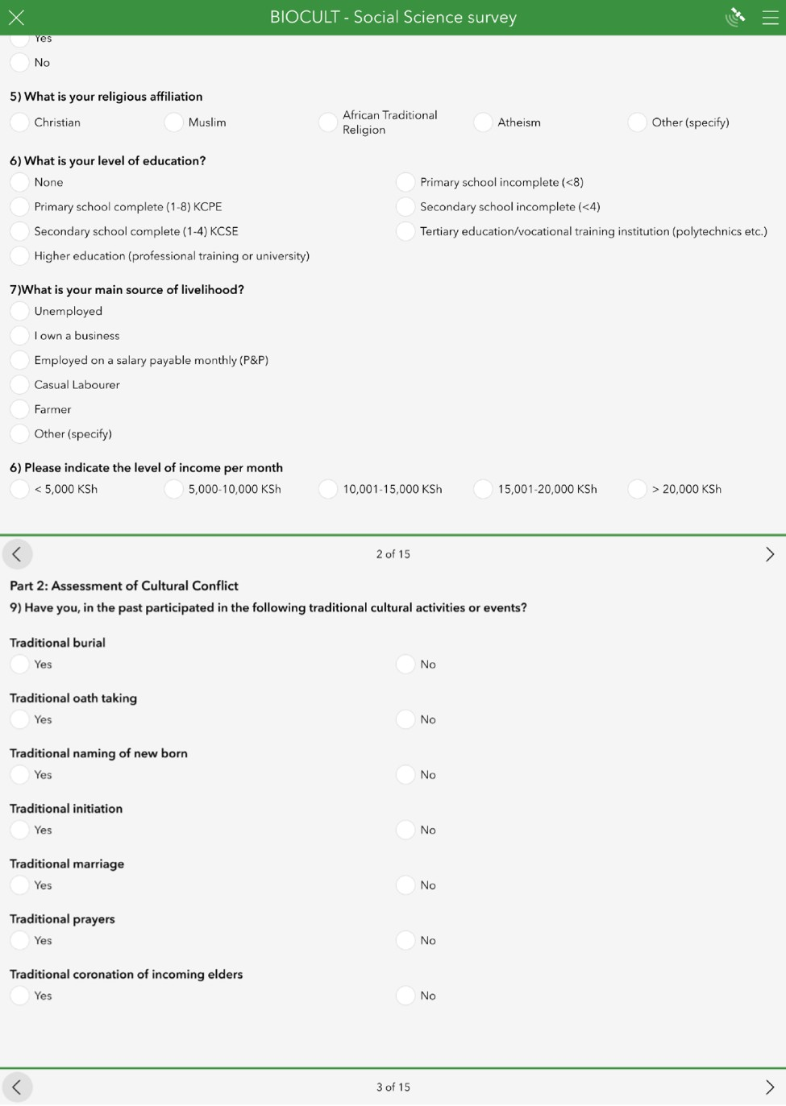

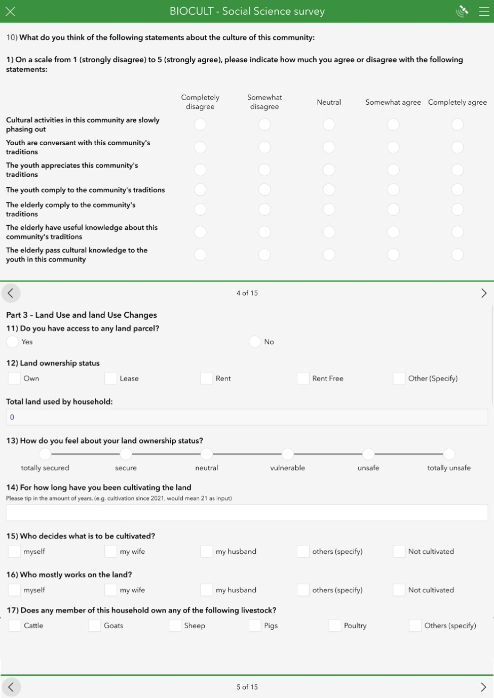

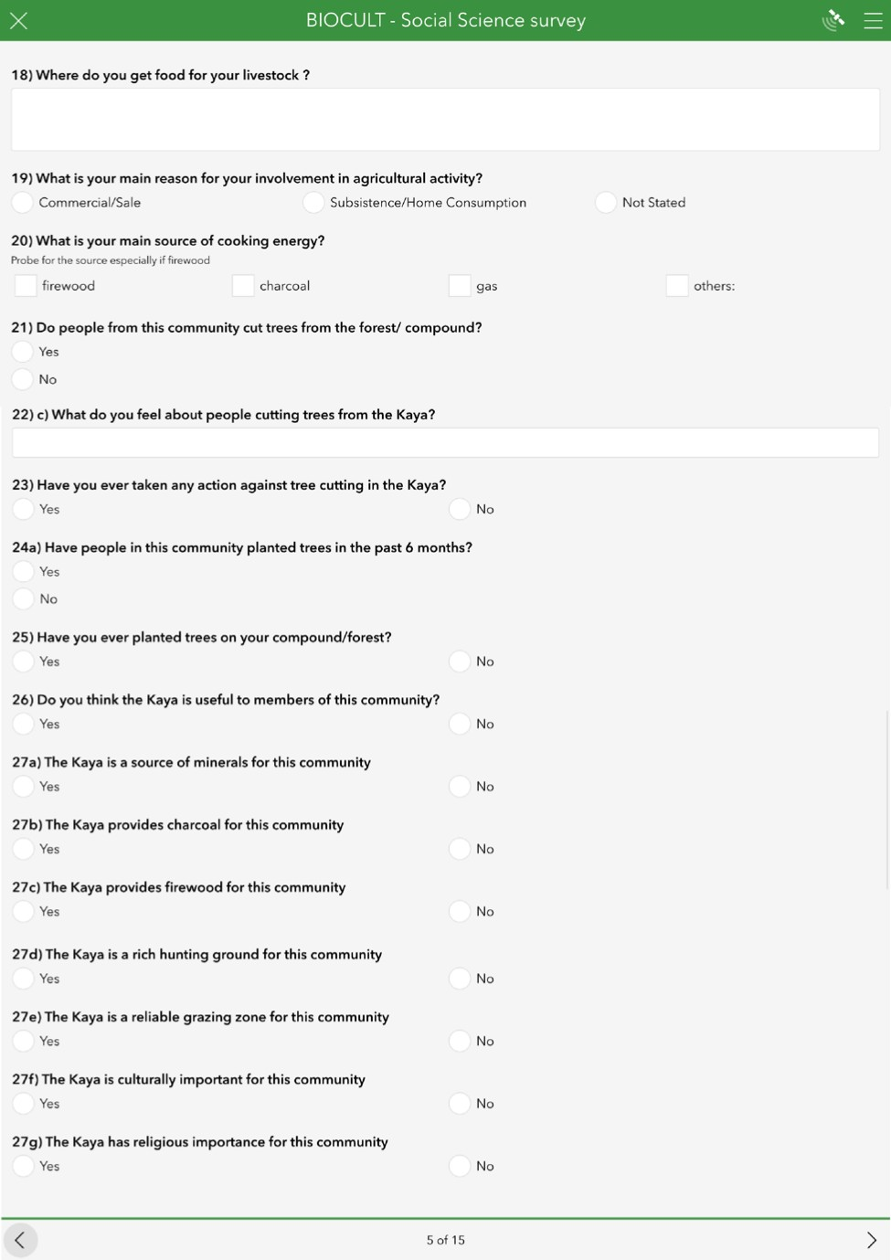

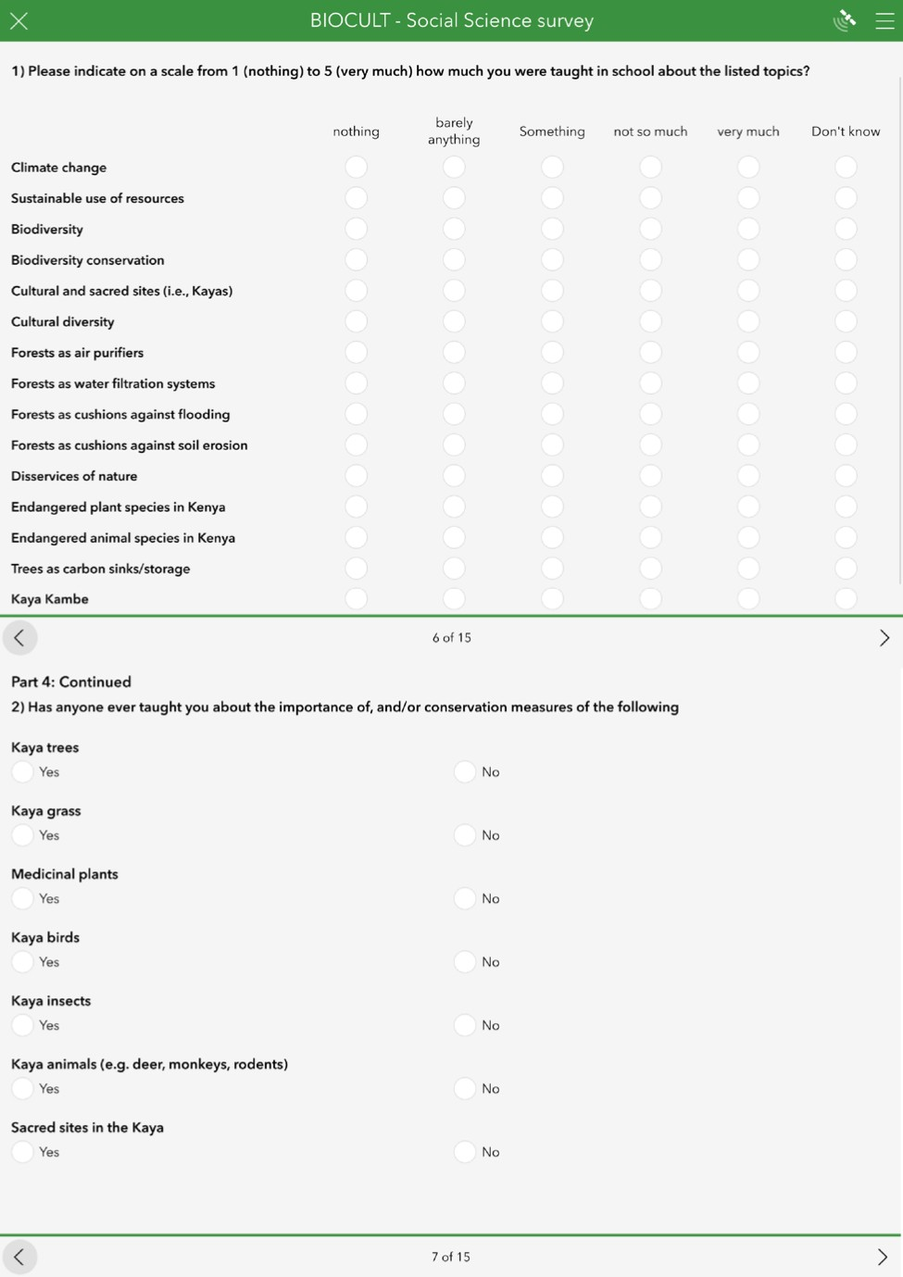

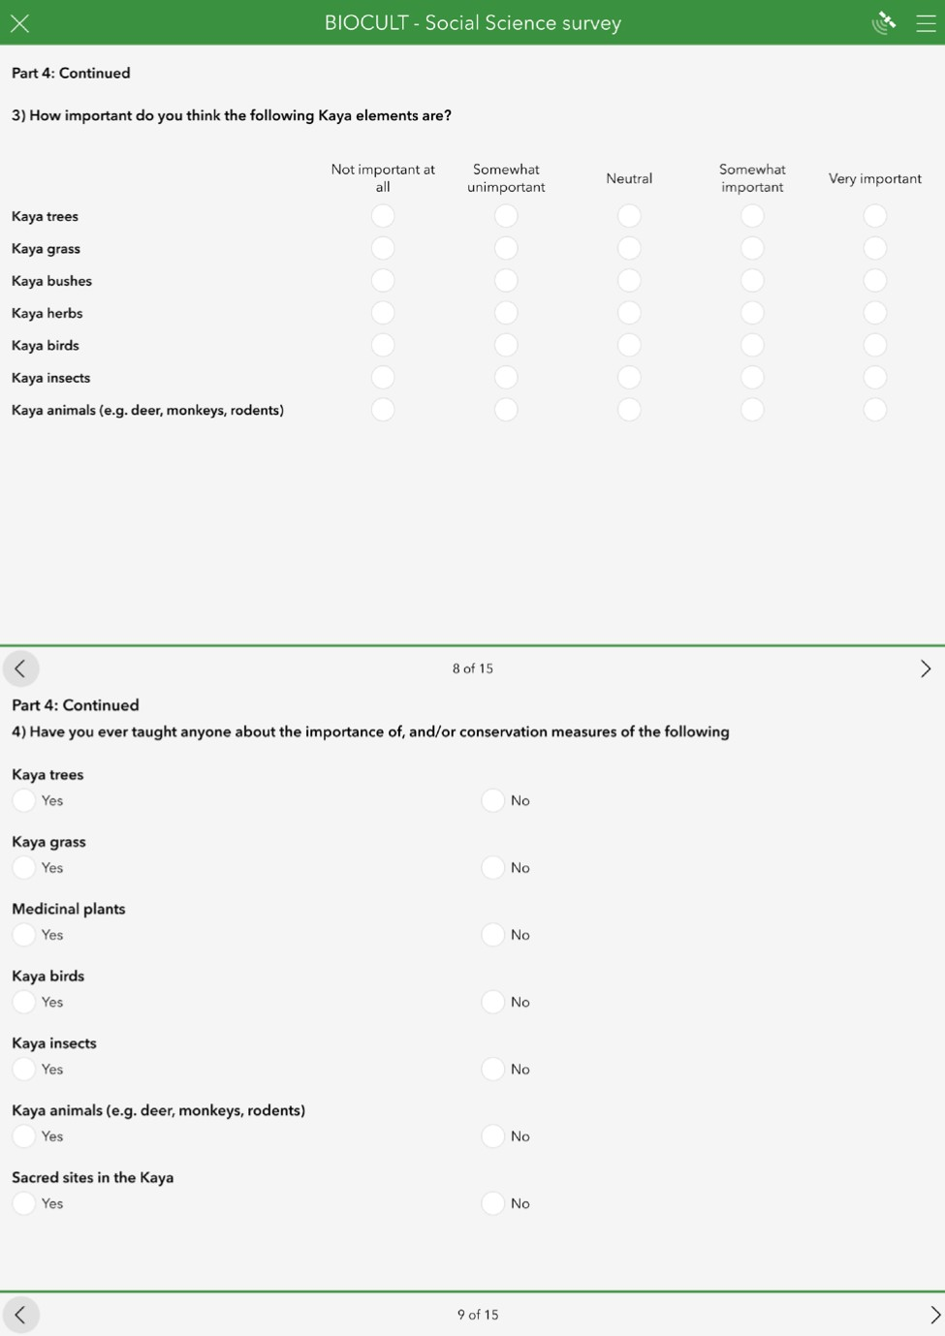

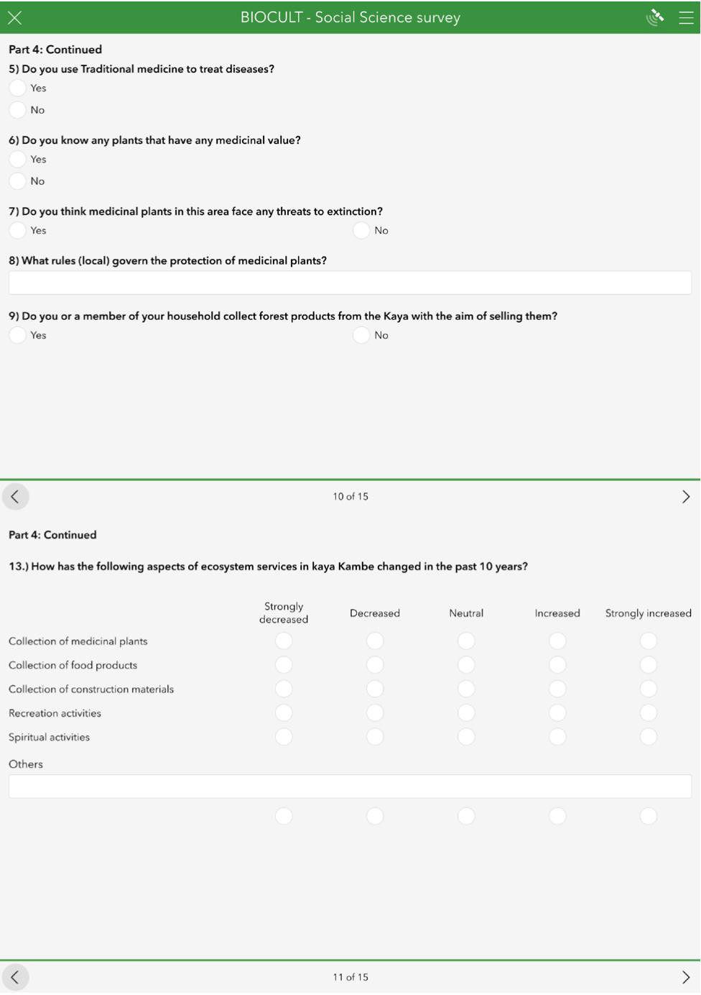

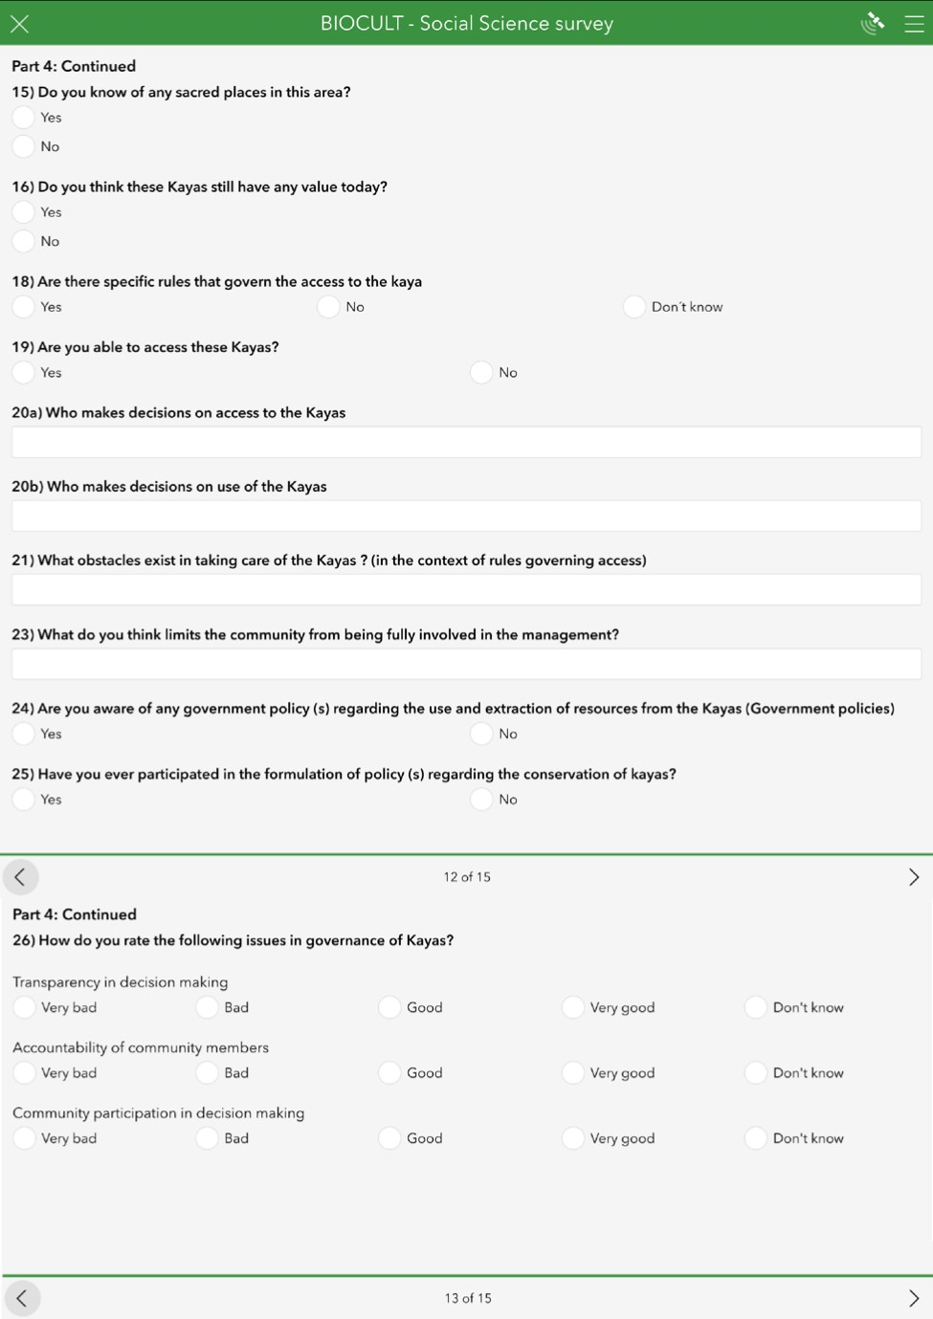



2.2 Coding guide

Table S15. Coding guide for categorising the variables of hypothesis 1

Categorisation of the reasons for the importance of kaya trees
Category | Definition of | Explanation | Coding rule
K 1 Providing EsS | The providing EsS are the products (raw materials) that result from natural processes such as wood (HAASE 2016, p. 130 f.; ZERBE 2019, p. 23 f.) | Respondents´ name supplying products.
K 1.1 Building material |  |  | Timber, build houses/furniture, for building, for construction
K 1.2 Food |  |  | Fruits
K 1.3 Energy sources |  |  | Firewood, charcoal
K 1.4 Commercial benefit |  |  | Sell products, sale, sell to pay school fees, livelihood
K 1.5 Medicine |  |  | Medicine, treat diseases
K 2 Cultural EsS | The cultural OSLs represent the relationship between people and their environment, such as an ecosystem as a recreational space (HAASE 2016, p. 130 f.; ZERBE 2019, p. 23 f.) | Interviewees name cultural values.
K 2.1 Aesthetic value |  |  | Aesthetic value
K 2.2 Cultural value |  |  | For traditional prayers, cultural heritage for Mijikenda, village of elders, important for rituals, used for worship, for rain prayer artefacts, trees are  shrines, preserve culture, prayer sites
K 3 Regulating EsS | The regulating EsS represent services that have a regulating effect on natural processes such as water filtration (HAASE 2016, p. 130 f.; ZERBE 2019, p. 23 f.) | Interviewees mention regulatory services.
K 3.1 Wind breaker |  |  | Windbreaker
K 3.2 Air pollution control |  |  | Cleans air, good air, free flow of air
K 3.3 Ecosystem regulation |  |  | Good ecosystem, preserves environment, for better environment, conserve environment, build Kaya, protects environment of community, protect forest, protect area, protect community from calamities and diseases
K 3.4 Water balance |  |  | Rain, brings rain, attract rain, water catchment
K 3.5 Soil erosion |  |  | Prevent soil erosion
K 3.6 Climate regulation |  |  | Shadow, cool breeze, cool surrounding, prevent droughts
K 4 Supporting EsS | The supporting EsS represent fundamental ecological processes and functions such as nutrient cycles or | Interviewees name supporting services.
 | Ecosystems as habitats (HAASE 2016, p. 130 f.; ZERBE 2019, p. 23 f.)
K 4.1 Habitat |  |  | Home for animals
K 4.2 Preservation of genetic diversity |  |  | Only remaining forest, there are indigenous trees

Categorisation of the reasons for the importance of kaya grass
Category | Definition of | Explanation | Coding rule
K 1 Providing EsS | The providing EsS are the products (raw materials) that result from natural processes such as wood (HAASE 2016, p. 130 f.; ZERBE 2019, p. 23 f.) | Respondents name supplying products.
K 1.1 Building material |  |  | Construction, build houses, building, straw Mnazi, used for basketry
K 1.2 Food |  |  | Pasture for animals, some used for food, food, food  for cows and animals, grazing, livestock, cattle
K 1.5 Medicine |  |  | Medicine
K 2 Cultural EsS | The cultural OSLs represent the relationship between people and their environment, such as an ecosystem as a | Interviewees name cultural values.
 | Recreational space (HAASE 2016, p. 130 f.; ZERBE 2019, p. 23 f.)
K 2.1 Aesthetic value |  |  | Aesthetic value, beautification, green environment,
K 2.2 Cultural value |  |  | Preserve culture, rooftops for prayer houses, building houses of pr
K 3 Regulating EsS | The regulating EsS represent services that have a regulating effect on natural processes such as water filtration (HAASE 2016, p. 130 f.; ZERBE 2019, p. 23 f.) | Interviewees mention regulatory services.
K 3.1 Ecosystem regulation |  |  | Forest coverage
K 3.2 Water balance |  |  | Hold rain water, attract dew, protects soil water, maintain humidity
K 3.3 Soil erosion |  |  | Prevent soil erosion, soil cover
K 4 Supporting EsS | The supporting EsS represent basic ecological processes and functions such as nutrient cycles or ecosystems as habitats (HAASE 2016, p.130 f.; ZERBE 2019, p. 23 f.) | Interviewees name supporting services.
K 4.1 Habitat |  |  | Home of insects, home for animals, hiding areas for animals
K 4.2 Preservation of genetic diversity |  |  | Indigenous plants, preserves forest vegetation, part of kaya vegetation, part of environment, support conservation
K 4.3 Nutrient cycle |  |  | Manure, fertile area, manuring in farms

Categorisation of the reasons for the importance of kaya bushes
Category | Definition of | Explanation | Coding rule
K 1 Providing EsS | The providing EsS are the products (raw materials) that result from natural processes such as wood (HAASE 2016, p. 130 f.; ZERBE 2019, p. 23 f.) | Respondents name supplying products.
K 1.1 Food |  |  | Food for animals, food, vegetables for cooking
K 1.2 Energy sources |  |  | Firewood
K 2 Cultural EsS | The cultural OSLs represent the relationship between people and their environment, such as an ecosystem as a recreational space (HAASE 2016, p. 130 f.; ZERBE 2019, p. 23 f.) | Interviewees name cultural values.
K 2.1 Aesthetic value |  |  | Aesthetic value, beautify environment
K 2.2 Cultural value |  |  | For those who believe in them, preserve culture, for houses of elders, hold community traditions, for the elders
K 3 Regulating EsS | The regulating EsS represent services that have a regulating effect on natural processes such as water filtration (HAASE 2016, p. 130 f.; ZERBE 2019, p. 23 f.) | Interviewees mention regulatory services.
K 3.1 Ecosystem regulation |  |  | Buffer zone, protects kaya, ecosystem regulation, they expand the forest coverage, provides cover for forest trees, protect inner Kaya, protecting kaya from people going inside, preserve trees, forest cover
K 3.2 Air pollution control |  |  | For fresh air, air purifier
K 3.3 Soil erosion |  |  | Prevent soil erosion
K 3.4 Climate regulation |  |  | Shade
K. 3.5 Wind breaker |  |  | Windbreaker
K 4 Supporting EsS | The supporting EsS represent basic ecological processes and functions such as nutrient cycles or ecosystems as habitats (HAASE 2016, p. 130 f.; ZERBE 2019, p. 23 f.) | Interviewees name supporting services.
K 4.1 Habitat |  |  | Habitat for animals, shelter for animals
K 4.2 Preservation of genetic diversity |  |  | Grow into trees, not to lose indigenous plants, species, environmental purposes, improves environment, protects biodiversity, conservation of environment, biodiversity
K 4.3 Nutrient cycle |  |  | Manure for soil

Categorisation of the reasons for the importance of kaya herbs
Category | Definition of | Explanation | Coding rule
K 1 Providing EsS | The providing EsS are the products (raw materials) that result from natural processes such as wood (HAASE 2016, p. 130 f.; ZERBE 2019, p. 23 f.) | Respondents name supplying products.
K 1.1 Food |  |  | Food for forest pigs
K 1.2 Medicine |  |  | Treat diseases, provide heal, useful for medicine /  drugs, herbal medicine, medication, medicinal value, to use them, alternative medicine
K 2 Cultural EsS | The cultural OSLs represent the relationship between people and their environment, such as an ecosystem as a recreational space (HAASE 2016, p. 130f.; ZERBE 2019, p. 23 f.) | Interviewees name cultural values.
K 2.1 Cultural value |  |  | For herbalist, prayer rituals, cultural knowledge, important for herbalist
K 3 Regulating EsS | The regulating EsS represent services that have a regulating effect on natural processes such as water filtration (HAASE 2016, p. 130 f.; ZERBE 2019, p. 23 f.) | Interviewees mention regulatory services.
K 3.1 Air pollution control |  |  | Air purifier

Categorisation of the reasons for the importance of kaya birds
Category | Definition of | Explanation | Coding rule
K 1 Providing EsS | The providing EsS are the products (raw materials) that result from natural processes such as wood (HAASE 2016, p. 130 f.; ZERBE 2019, p. 23 f.) | Respondents name supplying products.
K 1.1 Food |  |  | Source of food
K 2 Cultural EsS | The cultural OSLs represent the relationship between people and their environment, e.g. an ecosystem as a recreational space (HAASE 2016, p. 130 f.; ZERBE 2019, p. 23 f.)
K 2.1 Aesthetic value |  |  | Aesthetic value, beautification of forest, wealth of forest
K 2.2 Cultural value |  | Interviewees name cultural values. | Preserve culture, welcome a day in the morning, they make sounds when something bad is about to happen, religious beliefs, symbols, making Ornaments
K 2.3 Tourism |  |  | Preserve tourism, tourist attraction
K 3 Regulating EsS | The regulating EsS represent services that have a regulating effect on natural processes such as water filtration (HAASE 2016, p. 130 f.; ZERBE 2019, p. 23 f.) | Interviewees mention regulatory services.
K 3.1 Ecosystem regulation |  |  | Conservation of environment
K 4 Supporting EsS | The supporting EsS represent basic ecological processes and functions such as nutrient cycles or ecosystems as habitats (HAASE 2016, p. 130 f.; ZERBE 2019, p. 23 f.) | Interviewees name supporting services.
K 4.1 Preservation of genetic diversity |  |  | Part of ecosystem, biodiversity. Part of biodiversity
K 5 Other |  | Interviewees cite reasons that cannot be assigned to any of the EsS categories. | Detections of climate change, alarm, inform when it is about to rain, sign of rain, for time keeping, security of forest, alarm in their voice

Categorisation of the reasons for the importance of Kaya insects
Category | Definition of | Explanation | Coding rule
K 1 Providing EsS | The providing EsS are the products (raw materials) that result from natural processes such as wood (HAASE 2016, p. 130 f.; ZERBE 2019, p. 23 f.) | Respondents name supplying products.
K 1.1 Food |  |  | Food for animals, food for people, food source, honey of bees
K 2 Cultural EsS | The cultural OSLs represent the relationship between people and their environment, such as an ecosystem as a recreational space (HAASE 2016, p. 130 f.; ZERBE 2019, p. 23 f.) | Interviewees name cultural values.
K 2.1 Aesthetic value |  |  | Beauty of forest, beauty
K 2.2 Cultural value |  |  | Symbols, wealth of Kaya
K 2.3 Tourism |  |  | Attract tourists
K 3 Regulating EsS | The regulating EsS represent services that have a regulating effect on natural processes, such as the filtration of water (HAASE 2016, p. 130 f.; ZERBE  2019, p. 23 f.) | Interviewees mention regulatory services.
K 3.1 Ecosystem regulation |  |  | Preservation, forest soldiers, conservation of environment
K 4 Supporting EsS | The supporting EsS represent basic ecological processes and functions such as nutrient cycles or ecosystems as habitats (HAASE 2016, p. 130 f.; ZERBE 2019, p. 23 f.) | Interviewees name supporting services.
K 4.1 Preservation of genetic diversity |  |  | Pollination, biodiversity
K 5 Other |  | Interviewees cite reasons that cannot be assigned to any of the EsS categories. | Inform when its about to rain (butterflies), climate detection, some destroy crops, local use to pretend weather

Categorisation of the reasons for the importance of the Kaya animals
Category | Definition of | Explanation | Coding rule
K 1 Providing EsS | The providing EsS are the products (raw materials) that result from natural processes such as wood (HAASE 2016, p. 130 f.; ZERBE 2019, p. 23 f.) | Respondents name supplying products.
K 1.1 Food |  |  | Good as food, provide meat, source for food
K 2 Cultural EsS | The cultural OSLs represent the relationship between people
 | and its environment, such as an ecosystem as a recreational area (HAASE 2016, p. 130 f.; ZERBE 2019, p. 23 f.)
K 2.1 Aesthetic value |  |  | Aesthetic value, pleasant to watch
K 2.2 Cultural value |  | Interviewees name cultural values. | Symbols, wealth of Kaya, take care of the place, act like guards for the forest, use for sacrifice, wealth of kaya, protect the kaya
K 2.3 Tourism |  |  | Tourists are interested in them, tourist attraction
K 3 Regulating EsS | The regulating EsS represent services that have a regulating effect on natural processes such as water filtration (HAASE 2016, p. 130f.; ZERBE 2019, p. 23 f.) | Interviewees mention regulatory services.
K 3.1 Ecosystem regulation |  |  | Preserve kaya, movements in trees
K 4 Supporting EsS | The supporting EsS represent basic ecological processes and functions such as nutrient cycles or ecosystems as habitats (HAASE 2016, p. 130 f.; ZERBE 2019, p. 23 f.) | Interviewees name supporting services.
K 4.1 Preservation of genetic diversity |  |  | Ecosystem, all species depend on each other, without animals no plants, all animals are important, biodiversity, conservation of environment
K 5 Other |  | Interviewees cite reasons that cannot be assigned to any of the EsS categories. | For future studying, future generations will see them
Table S16. Coding guide for categorising the variables of hypothesis 4

Categorisation of the logging location
Category | Explanation | Coding rule
K 1 Own property | Interviewees named a place where timber was felled in relation to their own property. | Own property, compound, home
K 2 Agricultural land | Interviewees name a logging site related to agricultural land. | Own property, compound, home
K 3 Kaya | Interviewees name a logging site related to the kaya. | Forest, forest bushes, near forest
K 4 Other | Interviewees named other logging locations. | Anywhere, sea shore

Categorisation of the benefits achieved from logging
Category | Explanation | Coding rule
K 1 Timber | Interviewees cite a benefit achieved for logging with regard to use as construction timber. | Timber, building, construction, wood, furniture, roofing, tables
K 2 Firewood | Interviewees mention a benefit achieved for logging with regard to use as firewood. | Firewood, to cook, charcoal
K 3 Sale | Interviewees cite a benefit achieved for logging in relation to the sale of timber. | Commercial use, sell it, for sale, mango trees are sold, selling as timber, selling, sell timber, sell charcoal
K 4 Food/medicine | Interviewees cite a benefit achieved for logging in terms of use as food or medicine. | Fruits, mango, medicinal use, treats stomach pains
K 5 Miscellaneous | Interviewees cite several benefits achieved for logging.

