Supplementary information for
A wide-range topological thermometer with Ta₂Pd₃Te₅: From power-law response to application prospects

Yupeng Li,^{1, 2, *} Anqi Wang,^{2, 3, *} Senyang Pan,⁴ Dayu Yan,² Guang Yang,² Xingchen Guo,^{2, 3} Yu Hong,^{2, 3} Zhiyuan Zhang,^{2, 3} Ziwei Dou,² Guangtong Liu,^{2, 5} Fanming
Qu,^{2, 3, 5} Zhijun Wang,^{2, 3} Tian Qian,^{2, 5} Jinglei Zhang,^{4,} † Youguo Shi,^{2, 5,} ‡ Li Lu,^{2, 3, 5, §} and Jie Shen^{2, 5,} ¶

¹ Hangzhou Key Laboratory of Quantum Matter, School of Physics,
Hangzhou Normal University, Hangzhou 311121, China
² Beijing National Laboratory for Condensed Matter Physics,
Institute of Physics, Chinese Academy of Sciences, Beijing 100190, China
³ School of Physical Sciences, University of Chinese
Academy of Sciences, Beijing 100049, China
⁴ Anhui Province Key Laboratory of Condensed Matter Physics at Extreme Conditions, High Magnetic Field Laboratory of the Chinese
Academy of Sciences, Hefei 230031, Anhui, China
⁵ Songshan Lake Materials Laboratory, Dongguan 523808, China

——
* Equal contributions
† zhangjinglei@hmfl.ac.cn
‡ ygshi@iphy.ac.cn
§ lilu@iphy.ac.cn
¶ shenjie@iphy.ac.cn
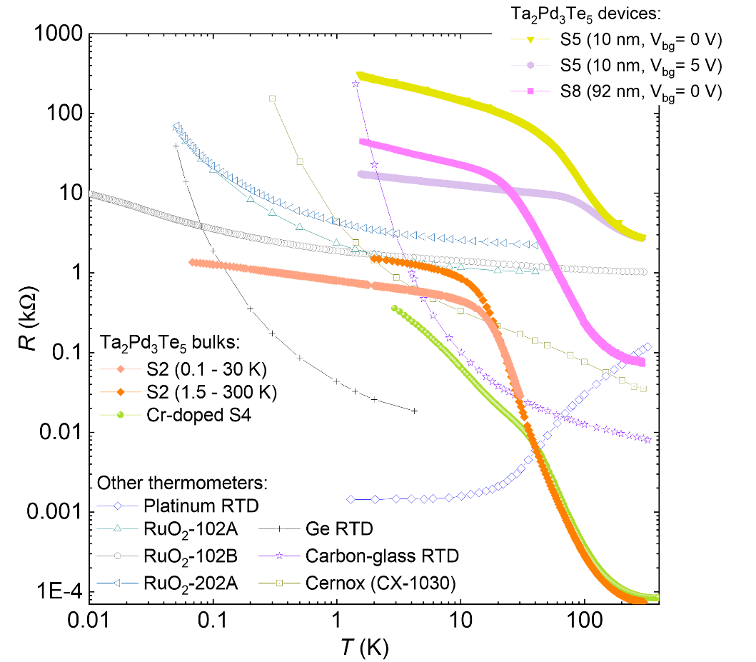
Figure S1. Summary of Ta₂Pd₃Te₅ and other thermometers. Temperature-dependent resistance in Ta₂Pd₃Te₅ thermometers, RuO₂ and other thermometers (open scatters)^{1,2} is shown. Significantly, the rate of increase in resistance with decreasing temperature in Ta₂Pd₃Te₅ thermometers is much lower than that in conventional semiconductor thermometers, indicating their great potential for lower temperature detection. The resistance of Ta₂Pd₃Te₅ sample S2 exhibits slight variations between high (1.5 - 300 K) and low (0.1 - 30 K) temperature regimes, primarily due to differences in sample dimensions caused by varying electrode preparation conditions.

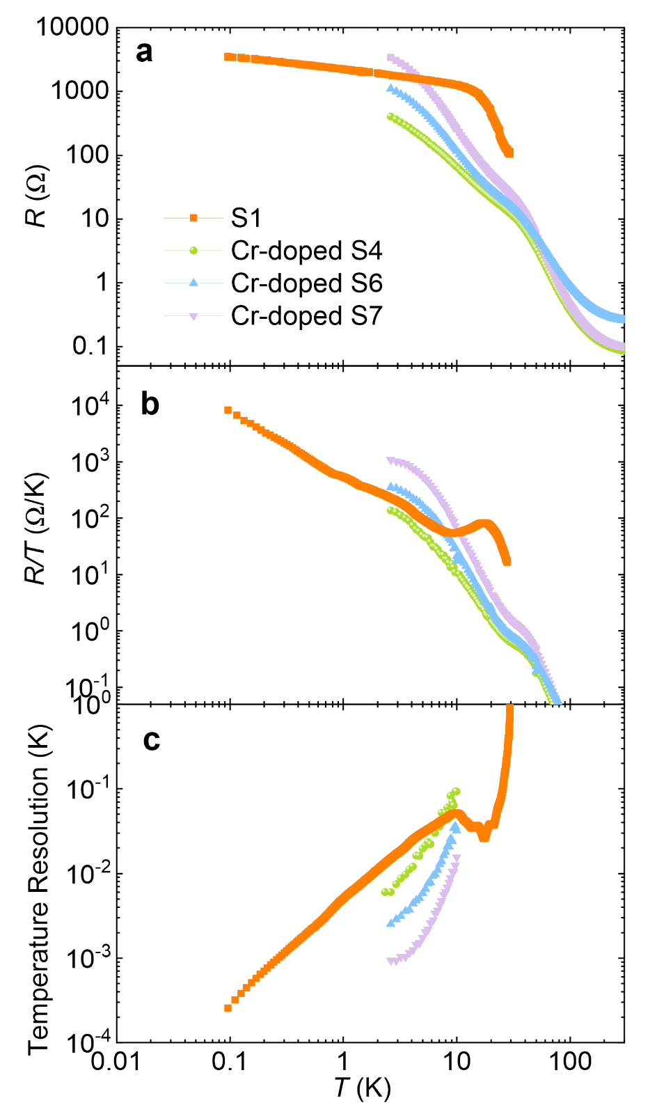
Figure S2. Properties of Cr-doped Ta₂Pd₃Te₅. R - T curves (a), temperature sensitivity (b) and resolution (c) of three Cr-doped Ta₂Pd₃Te₅ samples and an undoped sample S2 are shown. The approximate power law behavior at low temperatures displays α = 1.93 (2.35) with an error bar of ±0.05 for sample S6 (S7). The chemical composition of the three Cr-doped Ta₂Pd₃Te₅ samples is also similar. The only low-temperature resolution of Cr-doped samples are shown, because discontinuous excitation current is applied at high temperatures, resulting in the discrete behavior.

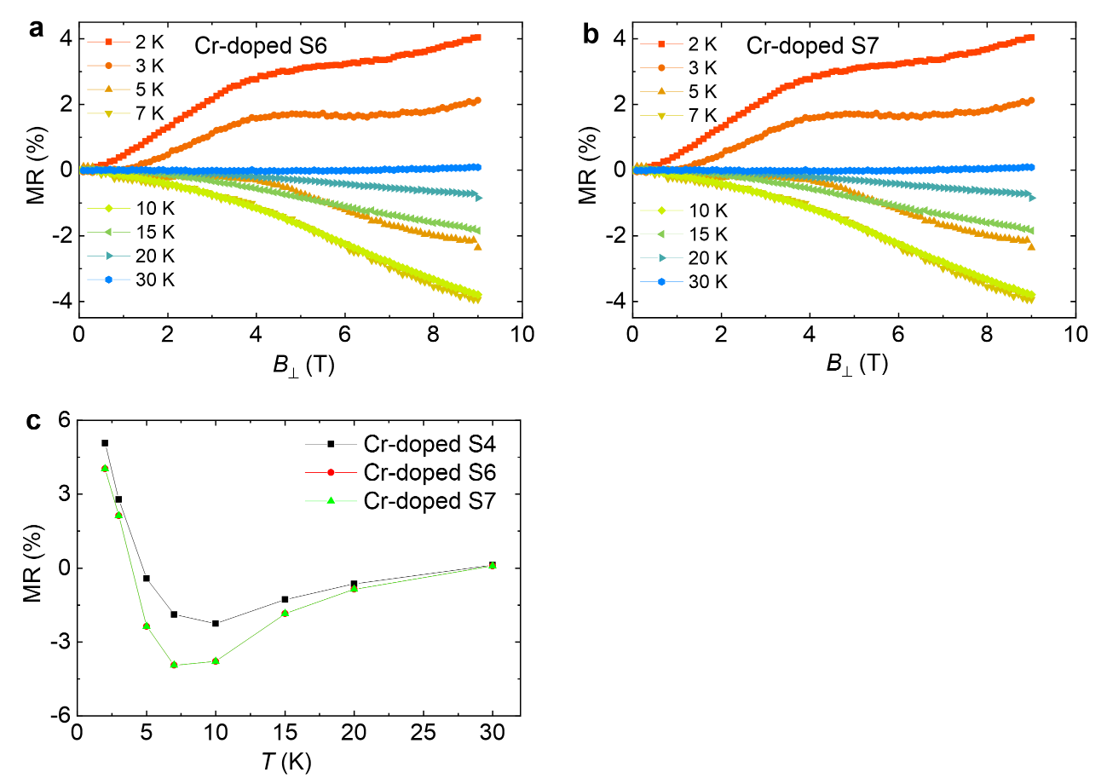
Figure S3. Magnetoresistance of Cr-doped Ta₂Pd₃Te₅. Magnetoresistance of Cr-doped Ta₂Pd₃Te₅ samples S6 (a) and S7 (b) at different temperatures. c, Magnetoresistance of three Cr-doped samples at 9 T.

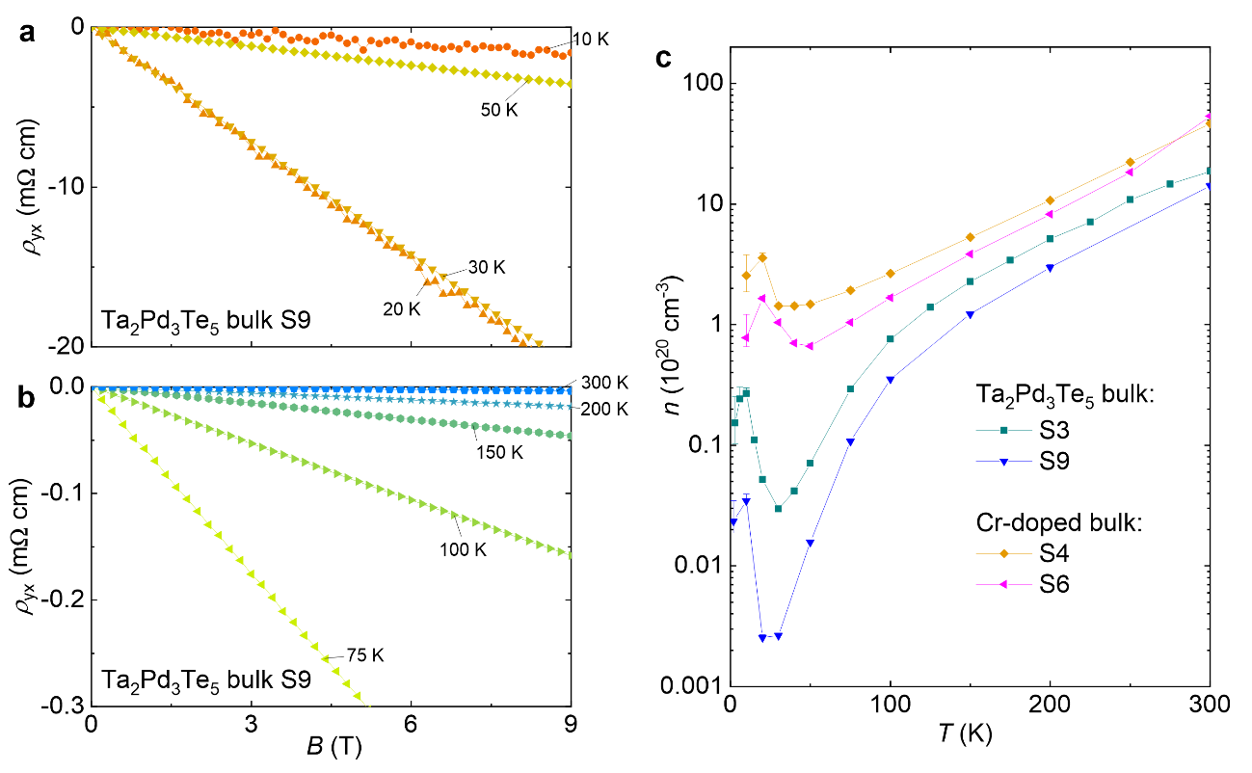
Figure S4. Carrier density. a, b, Typical Hall resistivity of Ta₂Pd₃Te₅. The sample S9 shows the typical election-type Hall resistivity. c, Temperature-dependent carrier density for pristine undoped and Cr-doped Ta₂Pd₃Te₅. Cr-doped Ta₂Pd₃Te₅ samples display the higher carrier density than Ta₂Pd₃Te₅.

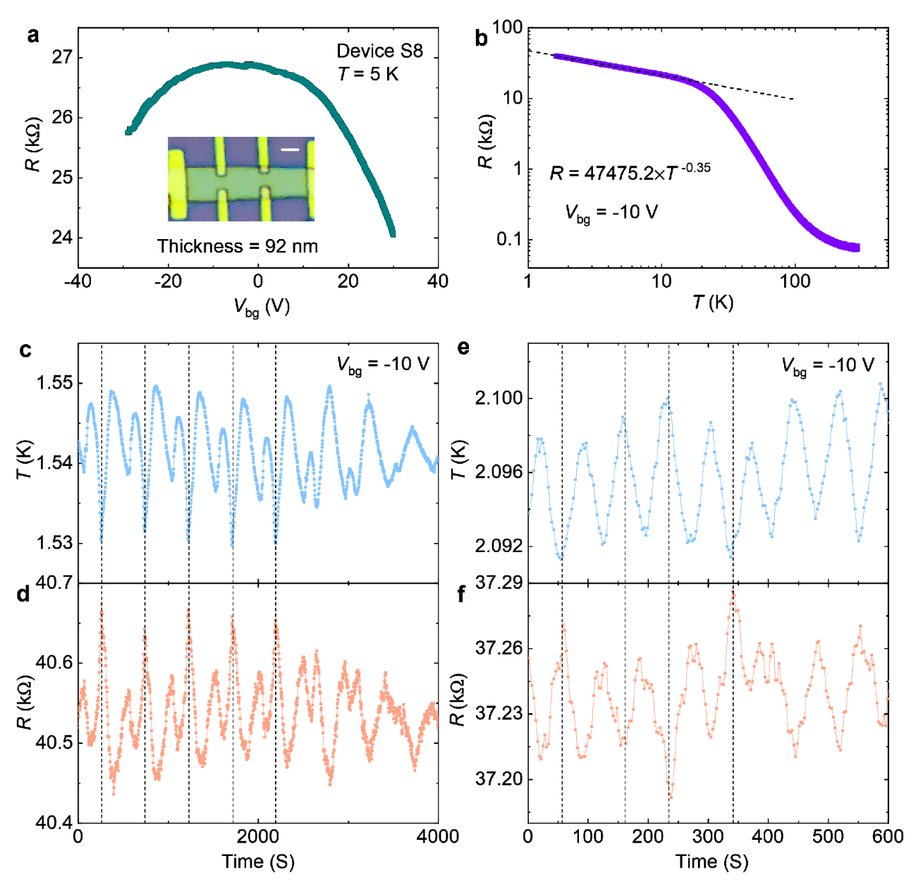
Figure S5. Temperature sensitivity of Ta₂Pd₃Te₅ device S8 as a function of time. a, V_{bg}-dependent resistance of device S8 at 5 K. The inset displays the photomicrograph of device S8 with a thickness of 92 nm and SiO₂/Si+ as bottom gate, and the white scale bar corresponds to 2 μm. b, R - T curve at V_{bg} = -10 V with α = -0.35. c, e, System temperature as a function of time at V_{bg} = -10 V. d, f, Corresponding resistance as a function of time and temperature. The oscillation behavior of temperature and resistance is consistent (see the typical dashed black lines), indicating high temperature sensitivity of Ta₂Pd₃Te₅ thermometers at low temperatures.

Table SI. Summary of ultra-low temperature thermometers. It is important to note that values in italics in the temperature columns are the estimated resistance based on the power law or exponential behavior of the R - T curves, and the unit of resistance in the temperature columns is kΩ. The ΔT/T columns indicate the magnetic effect of the thermometers, and the thermometer precision is a ratio of temperature resolution to temperature.
Sample | α | ΔT/T (2K, B⊥=9T) | Precision (0.1 K) | 0.1 K | 10 mK | 1 mK | 0.1 mK
Bulk S1 | 0.21 | 40% | 0.30% | 3.4 | 5.8 | 9.5 | 15.4
S2 | 0.21 | 41% (54%, B||) | 0.60% | 1.3 | 2.1 | 3.3 | 5.4
S3 | 0.31 | -- | 0.30% | 3.9 | 8.4 | 17 | 34.4
Cr-doped S4 | 1.55 | 3.10% | ~0.3% (2 K) | 82 | 3000 | -- | --
S5(V_{bg}=3V) | 0.49 | 10% (1.5 K, 6T) | 4 ×10⁻⁴ (2 K) | 320 | 988 | > 10³ | --
S5(V_{bg}=4V) | 0.28 | -- | 0.2% (2 K) | 69.3 | 130.7 | 246.1 | 464.3
S5(V_{bg}=5V) | 0.17 | -- | 0.6% (2 K) | 27 | 39.5 | 57.8 | 84.5
RuO₂-102B^{2,3} | 0.46 | 15% | 4 ×10⁻⁴ | 3.6 | 9.9 | 28 | 83
RuO₂-102B^{2,4} | 0.38 | -- | -- | 1.9 | 4.6 | 11.3 | 27.2
RuO₂-102A^{1,2} | -- | 9% | 4 ×10⁻⁵ | 193.8 | > 10³ | -- | --
RuO₂-202A^{1,2} | -- | 2.50% | -- | 23.9 | > 10³ | -- | --
Ge RTD² | -- | 60% (8T) | 2 ×10⁻⁵ | 1.9 | > 10³ | -- | --

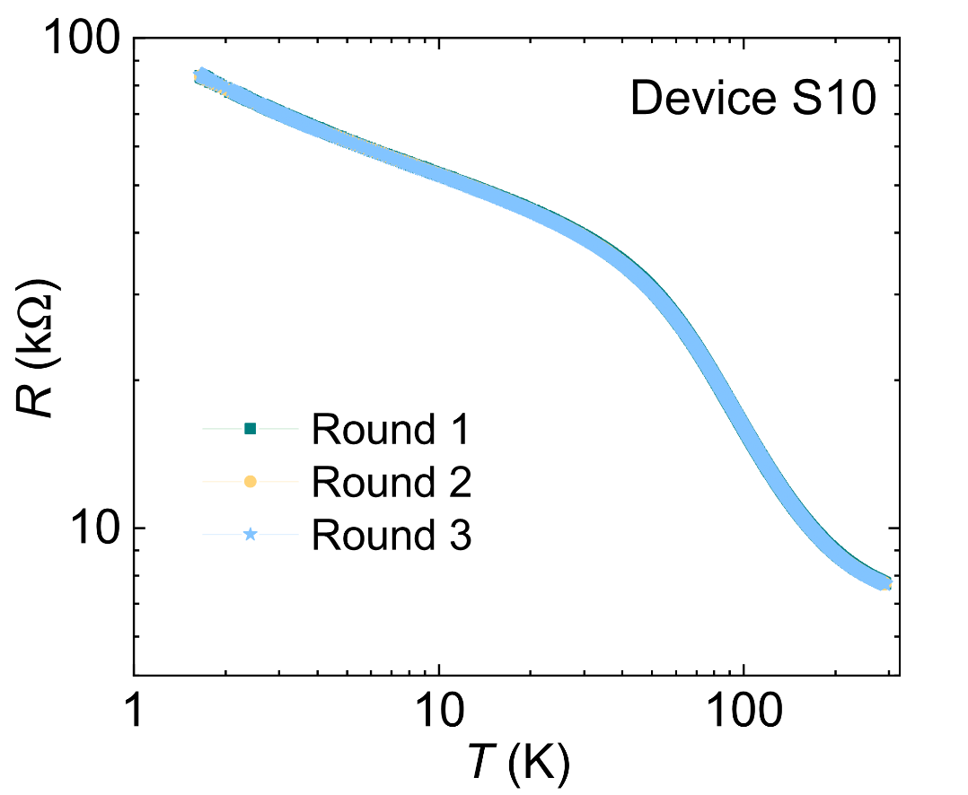
Figure S6. Repeatability of the R - T characteristics in Ta₂Pd₃Te₅ device S10 at V_{bg} = 6 V.

Reference:
[1] Yeager, C. J. & Courts, S. S. A review of cryogenic thermometry and common temperature sensors. IEEE
Sens. J. 1, 352-360 (2001).
[2] Lake Shore Cryotronics, U., Inc. OH.
[3] Courts, S. S. & Krause, J. K. a Commercial Ruthenium Oxide Thermometer for Use to 20 Millikelvin. AIP Conf. Proc. 985, 947–954 (2008).
[4] Myers, S. A., Li, H. & Csáthy, G. A. A ruthenium oxide thermometer for dilution refrigerators operating
down to 5 mK. Cryogenics 119, 103367 (2021).

