Supporting Information

Memristive Crossbar Array-based Hardware Framework for Compressed Sensing and Event-Driven Neuromorphic Processing

Mingxin Deng^{1,2}, Yinan Wang¹, Hui Xu¹, Likang Sun¹, Lun Lu¹, Ao Xu¹, Nuo Xu², Zhiwei Li¹, Qingjiang Li^{1,}* and Kyung Min Kim^{2,}*.

¹College of Electronic Science and Technology, National University of Defense Technology (NUDT), Changsha 410073, China.

²College of Computer Science and Technology & National Demonstration Center for Experimental Computer Education, National University of Defense Technology (NUDT), Changsha 410073, China.
³Department of Materials Science and Engineering, Korea Advanced Institute of Science and Technology (KAIST), Daejeon 34141, Republic of Korea.

*Correspondence and requests for materials should be addressed to Q.Li and K.M.Kim.
(Email: Q.Li qingjiangli@nudt.edu.cn, K.M.Kim km.kim@kaist.ac.kr)

Contents
Note 1. Detailed description of the proposed CGD algorithm
Note 2. Convergence analysis of the CGD Algorithm
Note 3. Principle and Transfer Characteristics of AMC Circuits
Note 4. Dominant Poles Analysis and Mentor Carlo Simulation of AMC Circuits
Note 5. Nonidealities Considered in Large-Scale Simulation
Figure S1. Extended AMC circuits for real-valued matrices.
Figure S2. Detailed structure of MCA.
Figure S3. More measurement results for different matrices and input voltages.
Figure S4. Circuits setup for CS recovery.
Figure S5. The measured output voltage of MRI and RSP in the circuits experiment.
Figure S6. Sweeping of the dominant pole position $\log_{10}(|Re\left(s_{d}|\right))$ for AMC circuits with different matrix sizes, bandwidth of OA, and feedback constant $c$.
Figure S7. The Monte-Carlo simulation of AMC circuits with different matrix sizes, bandwidth of OA, and feedback constant $c$.
Figure S8. The employed OA model for the simulation.
Figure S9. Matrices for ECG recovery.
Figure S10. An MCA model with parasitic capacitors.
Figure S11. Investigation of performance influence introduced by nonidealities.
Figure S12. Two examples of SPICE simulation output of MRI and RSP over time in the ECG signal and image recovery.
Figure S13. DCT sparse basis ($Ψ$) used for natural images.
Figure S14. More experimental results for different natural images.
Figure S15. The power consumption fractions of the overall recovery circuits.

Note 1. Detailed description of the proposed CGD algorithm
To resolve the CS recovery problem as shown in Figure 1a of the main text, it involves finding the sparsest $s^{*}$ (minimal $L_{0}$ norm) among the infinite number of solutions in an underdetermined equation $As=y$. While the $L_{0}$-norm directly counts the number of non-zero elements, it leads to a non-convex, NP-hard optimization problem that is computationally intractable for practical applications. In contrast, the $L_{1}$-norm is convex and can be efficiently minimized using well-established optimization algorithms, while still encouraging sparsity. Therefore, we choose the $L_{1}$ norm minimization model in Equation (1) in the main text for CS recovery.¹ The lower figure geometrically demonstrates the $L_{1}$ norm minimization problem.
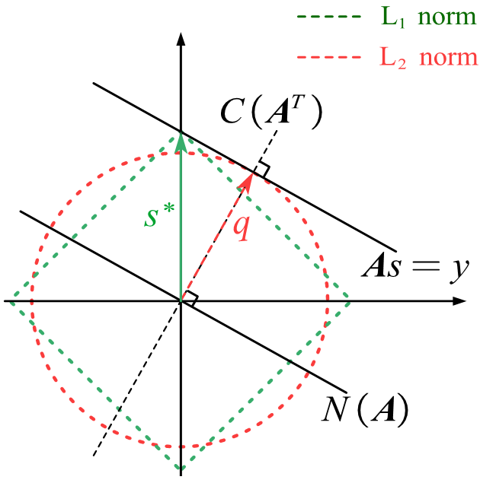
$N\left(A\right)$ and $C\left(A^{T}\right)$ represents the zero space and row space of matrix $A$, respectively. Another black solid line parallel to $N\left(A\right)$ indicates the affine space, which contains an infinite number of feasible solutions for $s$ defined by the equality constraint $As=y$. The red circle and green square represent the contour line of $L_{2}$ and $L_{1}$ norm, respectively.So, the green vector $s^{*}$ and red vector $q$ are the solution which have minimal $L_{1}$ and $L_{2}$ norm minimization, respectively, among all possible solutions. In other words, $s^{*}$ is the perfect CS recovery result, and $q$ is the solution with the minimal Euclidean norm.
$q=A^{T}{\left(AA^{T}\right)}^{-1}y$ (MRI)
To find $s^{*}$, we proposed an iterative method, constraint gradient descent (CGD) algorithm.
$s^{\left(t+1\right)}=z^{\left(t+1\right)}+q-Pz^{\left(t+1\right)}$ $z^{\left(t+1\right)}=s^{\left(t\right)}-ε×sgn\left(s^{\left(t\right)}\right)$
, where the superscript $t$ denotes the iteration number, $sgn\left(⋅\right)$ indicates the sign function for each element of a vector, which is also the subgradient of the function $L_{1}$ norm ${∥⋅∥}_{1}$.
$sgn_{i}\left(s\right)=\left\{\begin{matrix}1, & s_{i}>0 \\ 0, & s_{i}=0 \\ -1, & s_{i}<0\end{matrix}\right.$
The projection matrix $P$ projects the vector $z^{\left(t+1\right)}$ to subspace $C\left(A^{T}\right)$
$Pz^{\left(t+1\right)}=A^{T}{\left(AA^{T}\right)}^{-1}Az^{\left(t+1\right)}$ (RSP)
thus Equation project $z^{\left(t+1\right)}$ into the affine subspace $As=y$. The convergence procedure of CGD can be geometrically demonstrated in following figure.
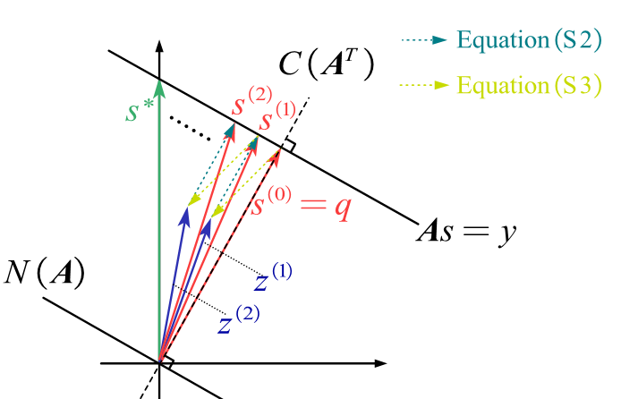
Obviously, $s^{\left(0\right)}=q$ is the initial point of iteration. Then Equation reduces all coordinate values of all dimensions in $s^{(t)}$ by the small step size $ε$ and get $z^{\left(t+1\right)}$, the $L_{1}$ norm of result $z^{\left(t+1\right)}$ will be smaller, but it does not satisfy equality constraint $As=y$. Then equation . projects $z^{\left(t+1\right)}$ to the feasible domain of equality constraint and gets the new iteration result $s^{\left(t+1\right)}$, which is closer to the optimal solution $s^{*}$ than $s^{\left(t\right)}$. Similar to other greedy methods, the step size $ε$ controls the trade-off between convergence speed and solution accuracy. More detailed proof of algorithm convergence and the criterion of $ε$ are given in the Supplementary Note 2.

Note 2. Convergence analysis of the CGD Algorithm
Some necessary lemmas are given below before the deviation:
Lemma 1: (Parallelogram law) Euclidean distance expansion identity of vector $u$ and $v$:
${∥u-v∥}_{2}^{2}= {∥u∥}_{2}^{2}+{∥v∥}_{2}^{2}-2 u^{T}v$
Lemma 2 ²: (Gradient inequality) For any convex function $f(⋅)$ and any gradient $g∈∂f(x)$ at point $x$, we have:
$f\left(y\right)≥f\left(x\right)+ g^{T}\left(y - x\right)$
Lemma 3 ³: (Non-Expansive Property of Orthogonal Projection) For any closed convex set $D$, let $Π_{D}\left(x\right)$ represent the projection of vector $x$ onto $D$. Then, we have:
$Π_{D}\left(x\right)-Π_{D}\left(y\right)≤x-y$
The distance between the current vector and the optimal solution $s^{*}$ is
${∥z^{(t+1)}-s^{*}∥}_{2}^{2}$=${∥s^{(t)}-s^{*}-ε×sgn\left(s^{\left(t\right)}\right)∥}_{2}^{2}$
Replace $u=s^{(t)}-s^{*}$ and $v=ε×sgn\left(s^{\left(t\right)}\right)$ in Lemma 1, we have
${∥z^{(t+1)}-s^{*}∥}_{2}^{2}= {∥s^{(t)}-s^{*}∥}_{2}^{2}+{∥ε×sgn\left(s^{\left(t\right)}\right)∥}_{2}^{2}-2 {(s^{(t)}-s^{*})}^{T}×ε×sgn\left(s^{\left(t\right)}\right)$
Where ${∥sgn\left(s^{\left(t\right)}\right)∥}_{2}^{2}$ represent the number of non-zero elements in $s^{\left(t\right)}$, we use $n$ to denote it. According to the Gradient inequality Lemma 2, we have
$${∥z^{\left(t+1\right)}-s^{*}∥}_{2}^{2}= {∥s^{\left(t\right)}-s^{*}∥}_{2}^{2}+εn-2 {\left(s^{\left(t\right)}-s^{*}\right)}^{T}×ε×sgn\left(s^{\left(t\right)}\right)$$
$$≤{∥s^{\left(t\right)}-s^{*}∥}_{2}^{2}+εn-\left({∥s^{t}∥}_{1}-{∥s^{*}∥}_{1}\right)$$
In terms of Euclidean distance, $z^{\left(t+1\right)}$ is closer to the optimal solution $s^{*}$ than $s^{\left(t\right)}$, as long as the step size satisfies
$εn≤{∥s^{t}∥}_{1}-{∥s^{*}∥}_{1}$
Then, Equation fixes $z^{\left(t+1\right)}$ into the affine subspace $As=y$ and get the new iteration result $s^{\left(t+1\right)}$which satisfy the equation constraint. The Euclidean distance between the new solution and optimal solution is
${∥s^{\left(t+1\right)}-s^{*}∥}_{2}^{2}={∥\left(I-P\right)z^{\left(t+1\right)}+q-s^{*}∥}_{2}^{2}$
As $P$ is the projection matrix to the row space of matrix $A$, $\left(I-P\right)$ is a projection matrix to the null space of matrix $A$. For the projection matrix, we always have $Ps^{*}=q$ and $P^{2}=P$, so we can rewrite Equation as
${∥s^{\left(t+1\right)}-s^{*}∥}_{2}^{2}={∥\left(I-P\right)\left(z^{\left(t+1\right)}-s^{*}\right)∥}_{2}^{2}$
According to Lemma 3, we have the following inequality;
${∥s^{\left(t+1\right)}-s^{*}∥}_{2}^{2}≤{∥z^{\left(t+1\right)}-s^{*}∥}_{2}^{2}$
Combined with Equation and under the condition of a small step size in Equation , it means the result of the new iteration is always getting closer to the optimal solution.
${∥s^{\left(t+1\right)}-s^{*}∥}_{2}^{2}≤{∥z^{\left(t+1\right)}-s^{*}∥}_{2}^{2}≤{∥s^{\left(t\right)}-s^{*}∥}_{2}^{2}$
The degree of closeness, i.e., the upper bound on the algorithm’s accuracy, is controlled by the step size $ε$. Similar to other greedy algorithms, a smaller step size can yield more accurate results, but at the cost of slower convergence. To balance convergence speed and accuracy, a variable step size strategy can be employed: using a larger $ε$ in the early stages of the iteration to accelerate convergence, and gradually decreasing $ε$ in later iterations to improve accuracy.

Note 3. Principle and Transfer Characteristics of AMC Circuits
To calculate the MRI and RSP with a real-valued matrix, an extended structure in Figure S1 can be adopted. The basic principle is the same as the circuits in Figure 1c, but uses the difference of two MCAs to represent the real-valued matrix. Thus, it has the same structure and number of operational amplifiers (OAs) as the circuits for positive matrices, except that the sizes of the three MCAs are doubled, as noted in MCAs 1, 2, and 3. MCA 1 corresponds to the row-split form of the matrix $A^{T}$, while MCAs 2 and 3 are in column-split form. In addition to the matrix-mapped devices, there is also an additional compensation row (or column) for each of the three MCAs to ensure the proper functioning of the circuit, marked as g, g', and g″.
To map the real-value matrix to device conductance, $A^{T}$ is split into two matrices $G_{1}$, $G_{2}∈R^{N×M}$and then mapped into MCA with the unit conductance $g_{0}$ without the use of analog inverters
$\left(G_{1}-G_{2}\right)/g_{0}=A^{T}$
In MCA 1, $G_{1}$ and $G_{2}$ are connected to the inverting and non-inverting input ports of the OAs, respectively, while the reverse is true for MCA 2, which establishes the negative feedback for the overall circuit. When calculating MRI, $M$ inputs noted in blue are connected to the non-inverting input ports of OA 2, and the inverting input ports are floating. According to Kirchhoff’s current law, the voltage of the non-inverting and inverting input of the $i$-th OA of OA1 are
$Z_{i}^{1+}=\frac{\sum_{j=1}^{M}{G_{1,ij}}V_{r,j}}{\sum_{j=1}^{M}{G_{1,ij}}+g_{1i}}$
$Z_{i}^{1-}=\frac{\sum_{j=1}^{M}{G_{2,ij}}V_{r,j}+V_{o,j}cg_{0}}{\sum_{j=1}^{M}{G_{2,ij}}+g_{2i}+cg_{0}}$
, where $G_{1,ij}$ represents the conductance of the element in the $i$-th row and $j$-th column of matrix $G_{1}$. The virtual short of OA set 1 result in $Z_{i}^{1+}=Z_{i}^{1-}$. Considering all $i=1,2,…,N$, we can rewrite Equation in matrix form.
$U_{L+}^{-1}G_{1}V_{r}=U_{L-}^{-1}\left(G_{2}V_{r}+cV_{o}g_{0}\right)$
where $U_{L+}$ and $U_{L-}$ are diagonal matrices represent the denominators of Equation for different $i$, $U_{L+}=diag\left(\sum_{j=1}^{M}{G_{1,ij}}+g_{1i},i=1,2,...,N\right),$ $U_{L-}=diag\left(\sum_{j=1}^{M}{G_{2,ij}}+g_{2i}+cg_{0},i=1,2,...,N\right)$, When we set the appropriate value for $g_{2i}$ and $g_{1i}$ to make $U_{L+}=U_{L-}$
$g_{2i}-g_{1i}=\sum_{j=1}^{M}{G_{1,ij}}-\sum_{j=1}^{M}{G_{2,ij}}-cg_{0}=\left(\sum_{j=1}^{M}{A_{ij}^{T}}-c\right)g_{0}$
Substituting Equation , the relationship of voltages can be represented by the matrix $A$
$A^{T}V_{r}=cV_{o}$
Similarly, the virtual short of OA set 2 can be represented as
$U_{R+}^{-1}\left(G_{2}^{T}V_{o}+V_{y}g_{0}\right)=U_{R-}^{-1}G_{1}^{T}V_{o}$
where $U_{R+}=diag(\sum_{j=1}^{N}{G_{2,ij}^{T}}+g'_{2i}+g_{0},i=1,2,...,M$) and $U_{R-}=diag\left(\sum_{j=1}^{N}{G_{1,ij}^{T}}+g'_{1i},i=1,2,...,M\right)$. When we set the compensation conductance to make $U_{R+}^{-1}=U_{R-}^{-1}$,
$g'_{2i}-g'_{1i}=\left(\sum_{j=1}^{N}{A_{ij}}-1\right)g_{0}$
The voltage relationship is governed by the matrix $A$
$AV_{o}=V_{y}$
Combining and , the relationship of input and output voltage is,
$V_{o}=A^{T}{\left(AA^{T}\right)}^{-1}V_{y}$
Thus, the MRI can be calculated with appropriate voltage mapping. The constant $c$ does not affect the static results but influences the dynamic behavior, which will be discussed later.
For the calculation of RSP, the green input signal path ($V_{z}$) is selected. In this case, the two compensation conductance rows of MCA 2 and 3 are in parallel, allowing them to be merged into a single row for a more concise derivation: $g^{a}=g'+g″$. The voltage relationship between $V_{r}$ and $V_{o}$ in MCA 1 remains the same as in . Due to the pre-processing of input voltages $V_{y}$ by MCA 3, the virtual short condition of OA 2 leads to
$U_{P+}^{-1}\left(G_{2}^{T}V_{o}+G_{2}^{T}V_{z}\right)=U_{P-}^{-1}\left(G_{1}^{T}V_{o}+G_{1}^{T}V_{z}\right)$
where $U_{P+}=diag\left(2\sum_{j=1}^{N}{G_{2,ij}^{T}}+g_{2i}^{a},i=1,2,...,M\right)$ and $U_{P-}=diag\left(2\sum_{j=1}^{N}{G_{1,ij}^{T}}+g_{1i}^{a},i=1,2,...,M\right)$. We need to select the compensation conductance to make $U_{P+}=U_{P-}$,
$g_{2i}^{a}-g_{1i}^{a}=2\left(\sum_{j=1}^{N}{G_{1,ij}^{T}}-\sum_{j=1}^{N}{G_{2,ij}^{T}}\right)=2\sum_{j=1}^{N}{A_{ij}}g_{0}$
it means the compensation conductance of MCA 3 is
$\begin{matrix}g″_{2i}-g″_{1i}=\left(g_{2i}^{a}-g_{1i}^{a}\right)-\left(g'_{2i}-g'_{1i}\right)=\left(\sum_{j=1}^{N}{A_{ij}}+1\right)g_{0}\end{matrix}$
The voltage relationship can be obtained from ,
$AV_{o}=-AV_{z}$
It should be noted that Equation does not imply $V_{o}=-V_{z}$, as $A$ is a broad matrix with more columns than rows, making it non-invertible. By combining and , the relationship between the input and output voltages becomes clear.
$V_{o}=-A^{T}\left(AA^{T}\right)AV_{z}$
Thus, the RSP can be computed in the same manner.
The steady-state analysis above has verified the function of the RRAM-based AMC circuits in which the relationship of input and output voltage satisfies the target equations. To verify its stability and convergence time, the transfer function of the circuits needs to be investigated. First, for MRI, according to the input voltages of OAs described in and , the input-output equations of two sets of OAs can be written in matrix form
$\left(U_{N}GV_{r}\left(s\right)-U_{N}V_{0}\left(s\right)cg_{0}\right)H\left(s\right)=V_{o}\left(s\right)$
$\left(U_{M}V_{y}\left(s\right)g_{0}-U_{M}G^{T}V_{o}\left(s\right)\right)H\left(s\right)=V_{r}\left(s\right)$
where $U_{N}=U_{L+}^{-1}=U_{L-}^{-1}$, $U_{M}=U_{R+}^{-1}=U_{R-}^{-1}$, $G=G_{1}-G_{2}=g_{0}A^{T}$, and the open-loop transfer function of OA is represented by $H\left(s\right)$. Considering the single-pole model for OA $H\left(s\right)=\frac{L}{1+s/ω}$, where $L$ is the open-loop gain and $ω$ is the 3-dB bandwidth. By defining the gain bandwidth product (GBWP) of OA $p=Lω$, the input-output relationship of the overall right inverse calculation circuits in the Laplace domain is
$V_{o}\left(s\right)=T_{r}\left(s\right)V_{y}\left(s\right)$
where $T_{r}\left(s\right)$ is the transfer function of MRI calculation
$T_{r}\left(s\right)≈\frac{p^{2}U_{N}GU_{M}g_{0}}{{I_{N}s}^{2}+pcg_{0}U_{N}s+p^{2}U_{N}GU_{M}G^{T}}$
The poles are defined by values of $s$, making the determinant of the denominator in zero (make the denominator irreversible)
$\text{det}\left(I_{N}s^{2}+pcg_{0}U_{N}s+p^{2}U_{N}GU_{M}G^{T}\right)=0$
It is a common form of the Quadratic Eigenvalue Problem (QEP), which is used in the analysis of second-order differential systems, such as single mass-spring systems or RLC cascaded circuits. $U_{N}$ and $U_{M}$ are diagonal matrices with all positive values, so three coefficient matrices $U_{N}GU_{M}G^{T}$ is positive-semidefinite and $cg_{0}U_{N}$ and $I_{n}$ are all positive-definite, especially the positive-definite damping matrix ${cg_{0}U}_{N}$ ensures the system’s total energy decreases over time. It makes sure that the real part of all $λ$ are non-positive, thus the calculation of MRI is stable.⁴
Similarly, the transfer function of the projection calculation circuits is
$\begin{matrix}T_{p}\left(s\right)≈\frac{p^{2}U_{N}GU_{M}^{'}g_{0}}{{I_{N}s}^{2}+pcg_{0}U_{N}s+p^{2}U_{N}GU_{M}^{'}G^{T}}\end{matrix}$
Similar to Equation , the poles of projection circuits are defined as
$\begin{matrix}\text{det}\left(I_{N}s^{2}+pcg_{0}U_{N}s+p^{2}U_{N}GU_{M}^{'}G^{T}\right)=0\end{matrix}$
The denominators of two transfer functions are in the same form except $U'_{M}=U_{P+}^{-1}=U_{P-}^{-1}$, because the feedback loop is equal in two cases. The matrix $U_{N}GU'_{M}G^{T}$ is also positive-semidefinite, thus the projection circuit is also stable.

Note 4. Dominant Poles Analysis and Mentor Carlo Simulation of AMC Circuits
As the PCB experiment conceptually demonstrates the capability of solving CS recovery, we further analyzed the transfer characteristics of the AMC circuits and performed additional Monte Carlo circuit simulations to explore their full potential. The position of the system poles forms the theoretical foundation for evaluating circuit convergence speed. Specifically, circuits with larger values of $\left|Re\left(s_{d}\right)\right|$ exhibit faster convergence, where $s_{d}$ denotes the non-zero pole closest to the imaginary axis in the Laplace domain, and $\left|Re\left(s_{d}\right)\right|$ quantifies its distance from the axis. According to the pole expressions defined in Equation and in Supplementary Note 3, the convergence behavior is mainly influenced by three parameters: matrix $A$, feedback constant $c$ and bandwidth $p$ of OA .
We perform parameter sweeps over $c$ from 0.1 to 1 and $p$ from 10 to ${10}^{9}$ for three different matrix sizes, 16×32, 32×64, and 64×128. For each parameter combination, 30 randomly generated matrices were tested, and the averaged results are shown in Figure S6. The results indicate that a higher OA bandwidth significantly improves convergence speed. Notably, matrix size does not significantly affect the convergence rate, implying that larger matrices are preferable, as they lead to faster overall computation speed.
Based on these findings, for a matrix size of M=64 and $N$=128, the optimal value of $c$ is approximately 2, which aligns with the ratio $N/M$. To further validate these observations, we conducted Monte Carlo circuit simulations in Simulation Program with Integrated Circuits Emphasis (SPICE). In these simulations, the matrix elements are mapped to a conductance range of 2–30 $μ$S, compatible with relatively mature RRAM technology.⁵ The single-pole behavioral model of OA was used.⁶ Again, 30 random matrices were generated for each parameter setting, and the output voltage trajectories were recorded. As shown in Figure S7, the outputs for both MRI and RSP circuits converge within several tens of nanoseconds when using a high-bandwidth OA model, a feedback constant $c$=2 and a large matrix size 64×128.

Note 5. Nonidealities Considered in Large-Scale Simulation
To simulate the large-scale hardware, we consider nonidealities in SPICE simulations, including parasitic capacitors, resistor variation, and quantization of ADC/DAC. First, we consider the MCA model with parasitic capacitors (Figure S10), as the RC delay introduced by these capacitors will increase the convergence time of the output voltage. The column and row parasitic capacitance is assumed to be $C_{wc}=30fF$ and $C_{wr}=7.5fF$, the cell parasitic capacitance is assumed to be $C_{c}=0.1fF$.^{7,8} Additionally, we further consider the device conductance variation from target values. Here, we present this variation by the ratio of error conductance and target conductance ($ΔG/G$). It has a Gaussian distribution,⁹ and the degree of error is measured by the standard deviation $δ_{G}$. Taking the ECG signal as an example, we generate 30 instances for different degrees of standard deviation, and the distribution of corresponding RSNR results is shown in Figure S11a. Considering a program verification window of 5%, it only causes a slight decrease in the overall recovery accuracy. Finally, the quantization effect of ADC and DAC is also considered for the input and output of AMC circuits. The results indicate that an 8-bit resolution is sufficient for our hardware (Figure S11b).

References
1. Donoho, D. L. For most large underdetermined systems of linear equations the minimal L1-norm solution is also the sparsest solution. Commun. Pure Appl. Math. 59, 797–829 (2006).
2. Bauschke, H. H., Wang, C., Wang, X. & Xu, J. On the Finite Convergence of a Projected Cutter Method. J. Optim. Theory Appl. 165, 901–916 (2015).
3. Kell, M. Symmetric orthogonality and non-expansive projections in metric spaces. Manuscripta Math. 161, 141–159 (2020).
4. Wang, S. et al. Optimization Schemes for In-Memory Linear Regression Circuit with Memristor Arrays. IEEE Trans. Circuits Syst. I Regul. Pap. 68, 4900–4909 (2021).
5. Wan, W. et al. A compute-in-memory chip based on resistive random-access memory. Nature 608, 504–512 (2022).
6. Wang, Y., Wang, Y. & Lenian, H. E. Behavioral modeling for operational amplifier in sigma-delta modulators with Verilog-A. IEEE Asia-Pacific Conf. Circuits Syst. Proceedings, APCCAS 1612–1615 (2008).
7. Feng, Y. et al. A Self-Terminated Operation Scheme for High-Parallel and Energy-Efficient Forming of RRAM Array. Adv. Electron. Mater. 6, 1–6 (2020).
8. Fouda, M. E., Eltawil, A. M. & Kurdahi, F. Modeling and Analysis of Passive Switching Crossbar Arrays. IEEE Trans. Circuits Syst. I Regul. Pap. 65, 270–282 (2018).
9. Tong, P. et al. Lightweight and highly robust memristor-based hybrid neural networks for electroencephalogram signal processing. Chinese Phys. B 32, (2023).

Supplementary Figures
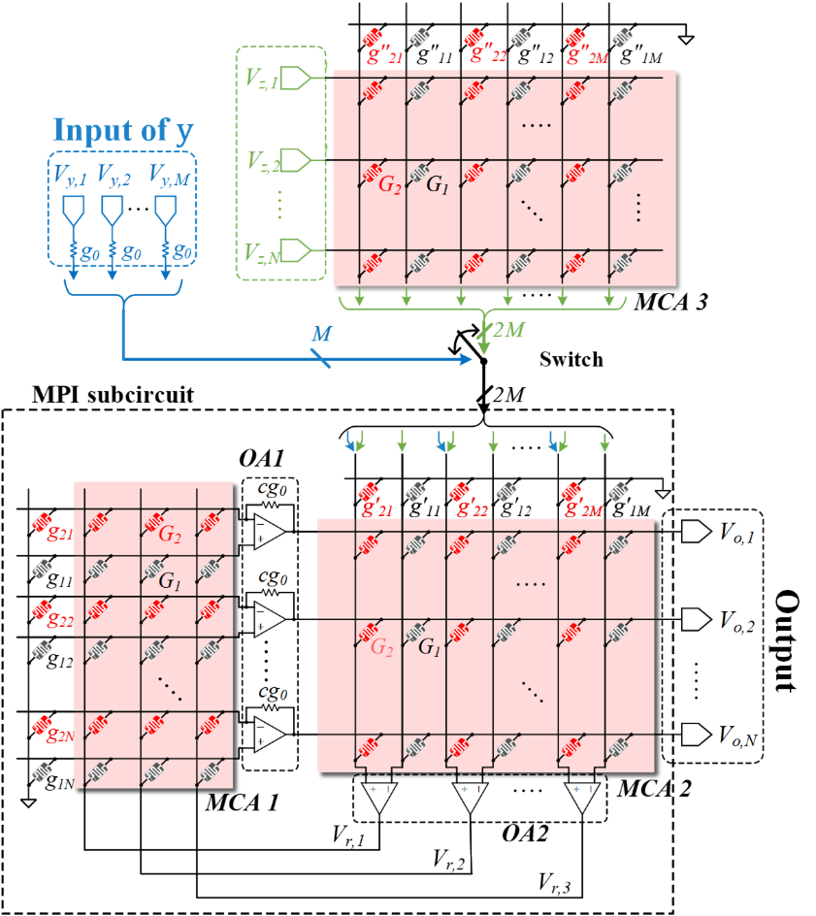
Figure S1. Extended AMC circuits for real-valued matrices. This circuit has the same principle as the circuit in Figure 2c, but maps real-value elements in matrices by the difference of two matrices $G_{1}$ and $G_{2}$. Detailed analysis is given in Supplementary Note 3.
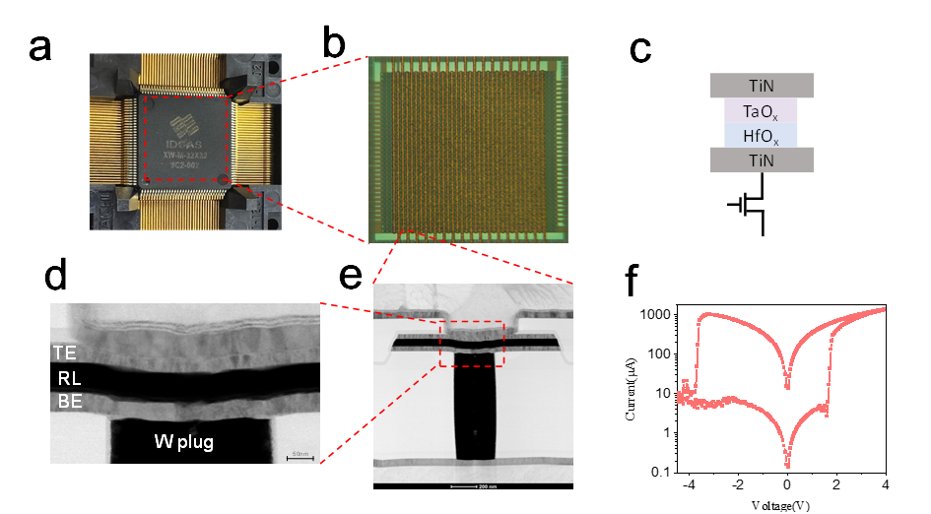
Figure S2. Detailed structure of MCA. (a) 32×32 1T1R MCA chip. (b) Optical image of MCA. (c) The structure of an MCA cell utilizes the transistor as a selector to prevent current sneak path issues. (d-e) Cross-sectional transmission electron microscope image of a memristor fabricated on a W plug, TE, top electrode; BE, bottom electrode; RL, resistive switching layer. (f) Resistive switch behavior of memristor.

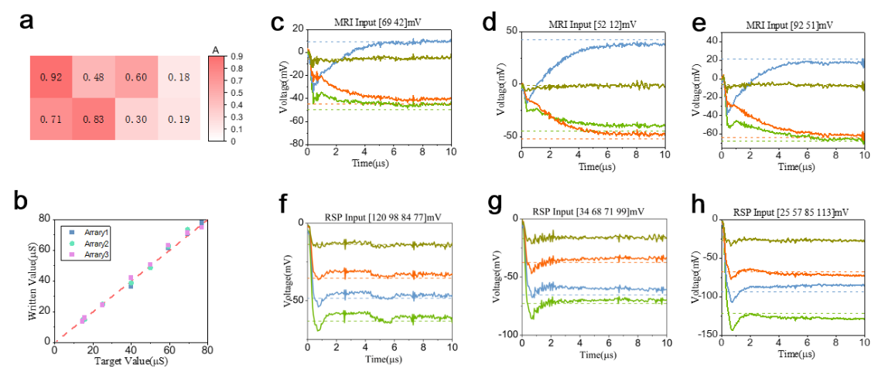
Figure S3. More measurement results for different matrices and input voltages. (a) Matrix $A$. (b) Conductance mapping result. (c-e) Measured examples of the MRI operation for various inputs. (f-h) Measured examples of RSP for various inputs. The dashed lines represent the corresponding ideal input voltage.
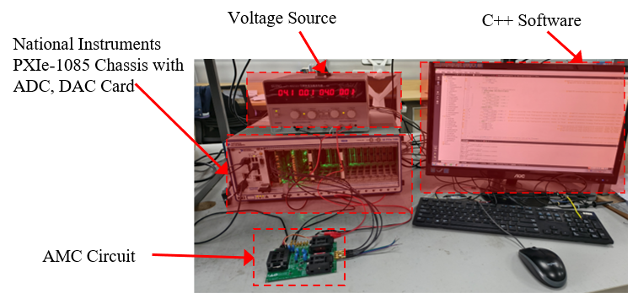
Figure S4. Circuits setup for CS recovery. The software in NI chassis controls the ADC and DAC cards to generate a voltage pulse as the input of AMC circuits, read out the output voltage, and generate a new input voltage for the next iteration.

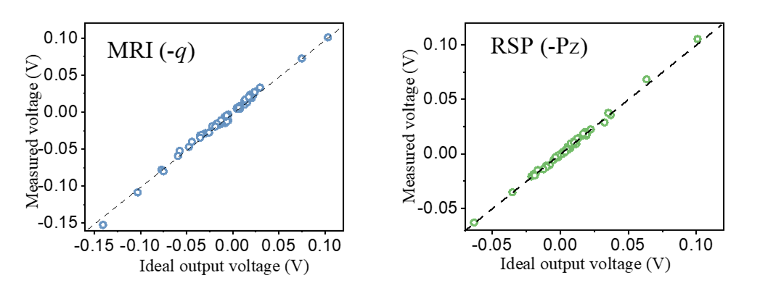
Figure S5. The measured output voltage of MRI and RSP in the circuits experiment for a sparse signal. We take the average voltage of 5 μs after the output voltage stabilization as the result to reduce the influence of small oscillations and noise.
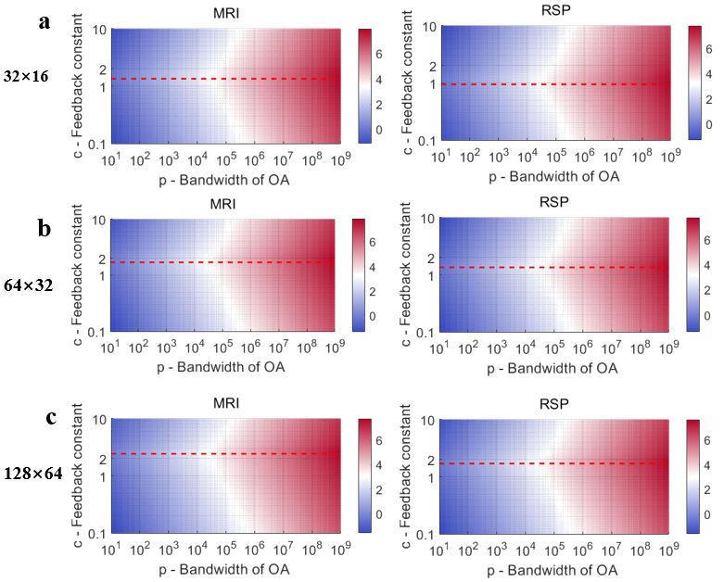
Figure S6. Sweeping of the dominant pole position $\log_{10}(|Re\left(s_{d}|\right))$ for AMC circuits with different matrix sizes, bandwidth of OA, and feedback constant $c$. Every subfigure is the result of an average of 30 random matrices, and the red dashed line represents the optimal value of $c$.
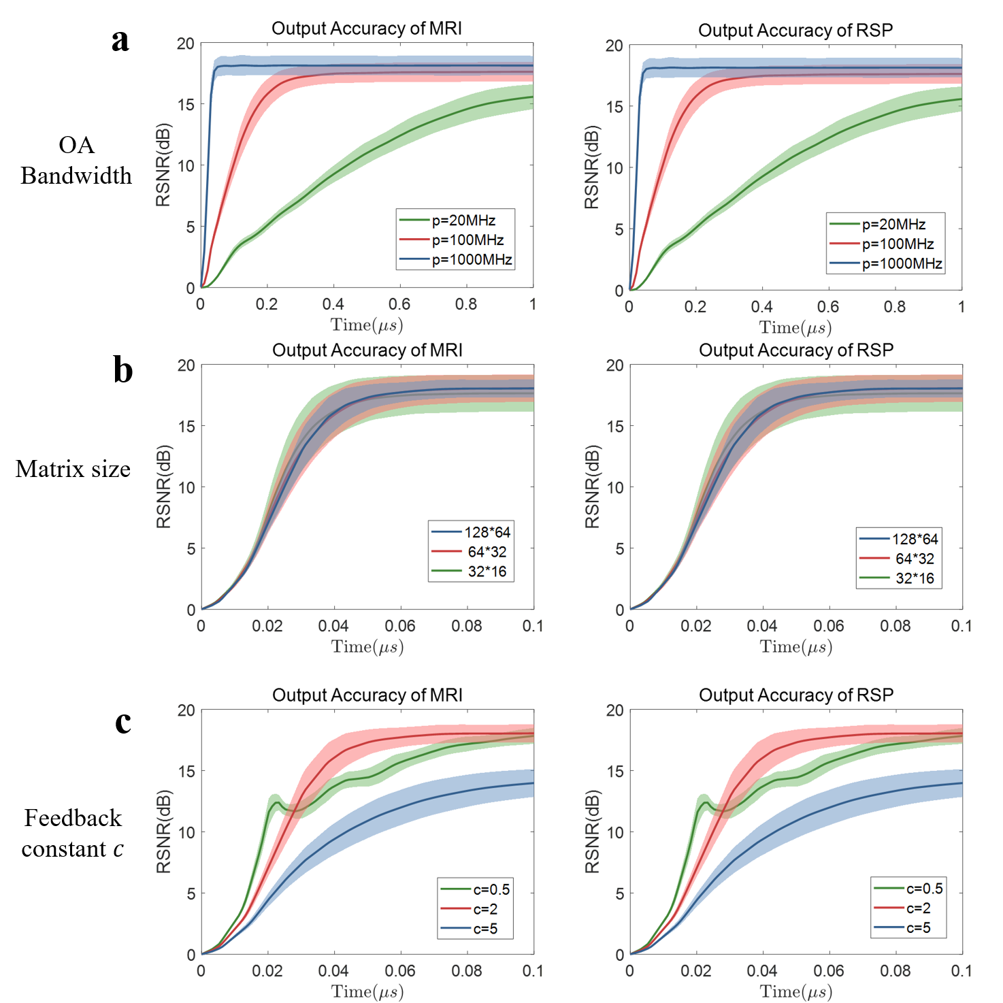
Figure S7. The Monte-Carlo simulation of AMC circuits with different matrix sizes, bandwidth of OA, and feedback constant $c$. (a) Different OA bandwidth $p$ with $c=2$ and 64×128 size matrix. (b) Different matrix size, with $p=$ 1000 MHz and $c=2$. (c) Different $c$, with $p=$ 1000 MHz and 64×128 size matrix.
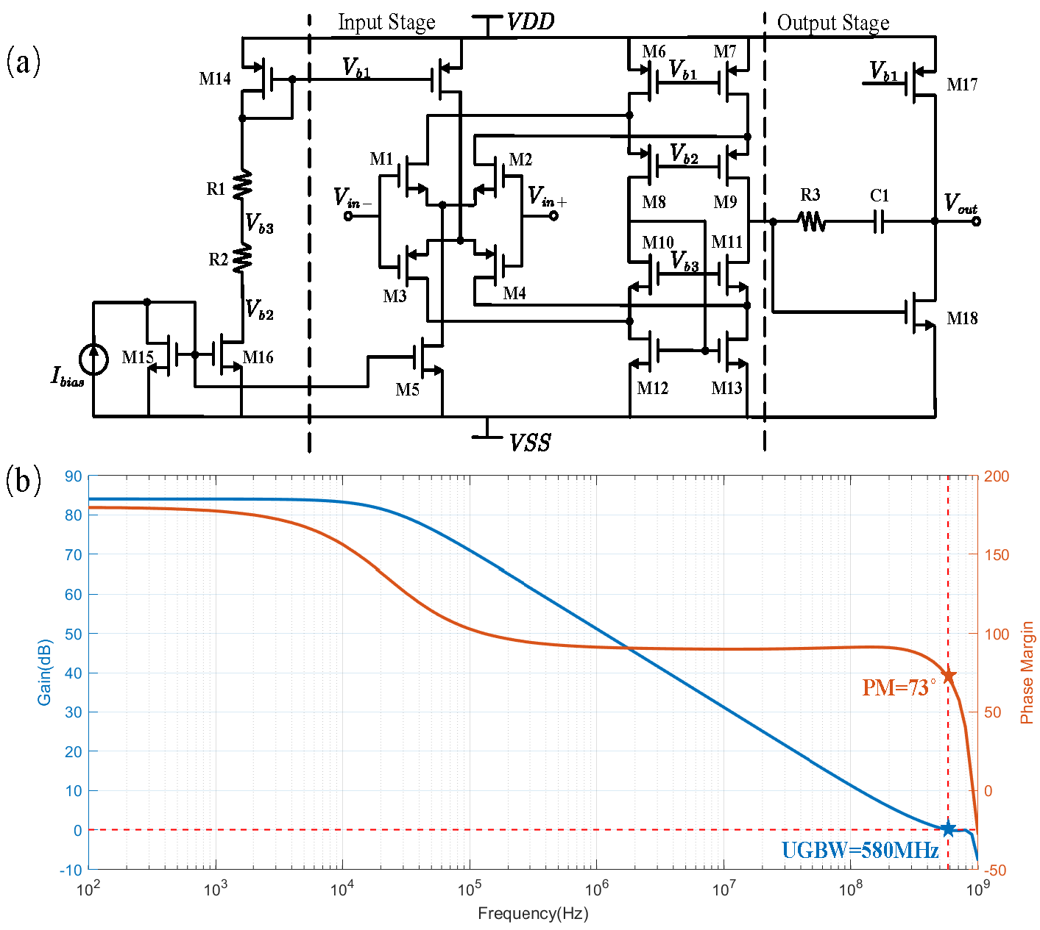
Figure S8. The employed OA model for the simulation. (a) The schematic of OA and (b) the Bode plot of OA, which is designed in SMIC 130 nm PDK, with a unity gain bandwidth of 580 MHz and a DC gain of 84 dB.
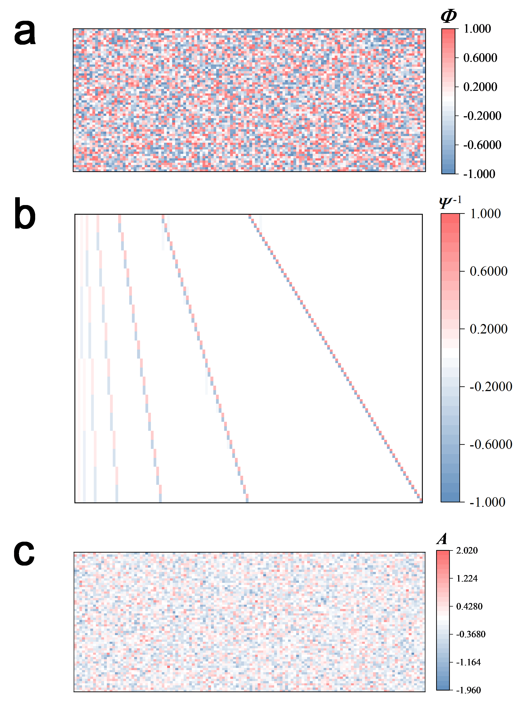
Figure S9. Matrices for ECG recovery. (a) Random matrix $Φ$, (b) Inversion of DWT basis $Ψ^{-1}$, (c) Matrix for recovery $A=ΦΨ^{-1}$.
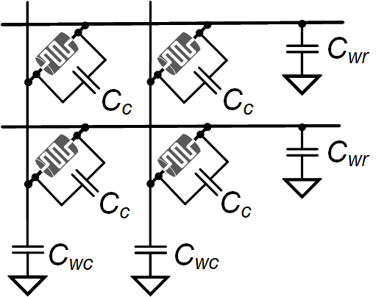
Figure S10. An MCA model with parasitic capacitors. Every device has a parasitic capacitor $C_{c}$ between two terminal. There are also parasitic capacitors $C_{wr}$ and $C_{cc}$ between lines and ground.
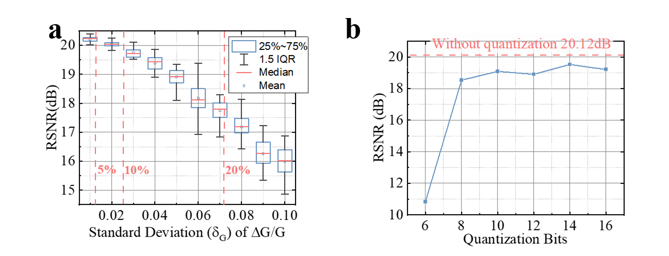
Figure S11. Investigation of performance influence introduced by nonidealities. (a) Performance degradation with different levels of conductance variation in RRAM devices. (b) Quantization effects on recovery performance.

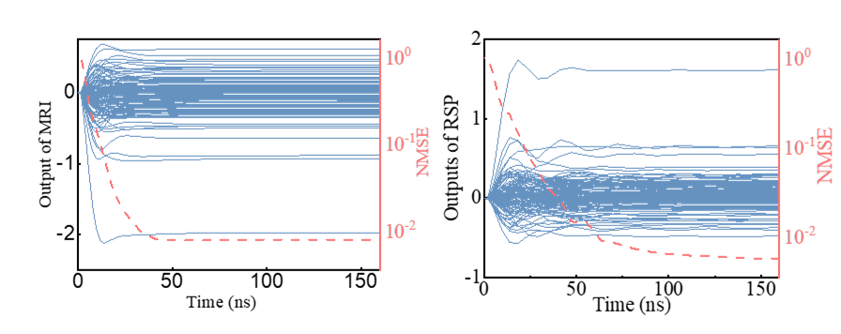
Figure S12. Two examples of SPICE simulation output of MRI and RSP over time in the ECG signal and image recovery.
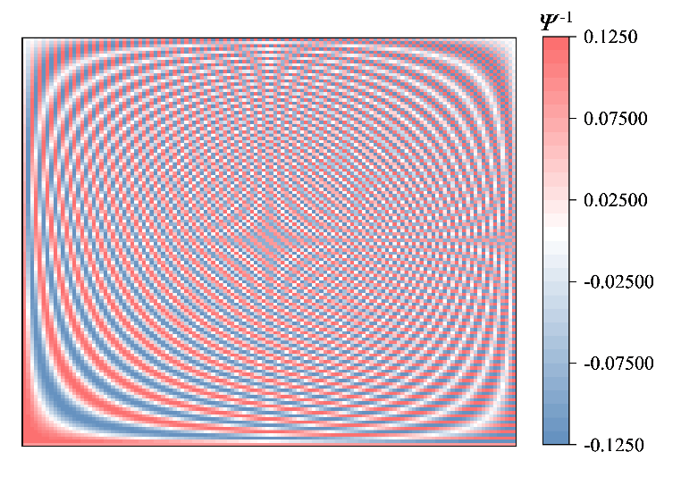
Figure S13. DCT sparse basis ($Ψ$) used for natural images.

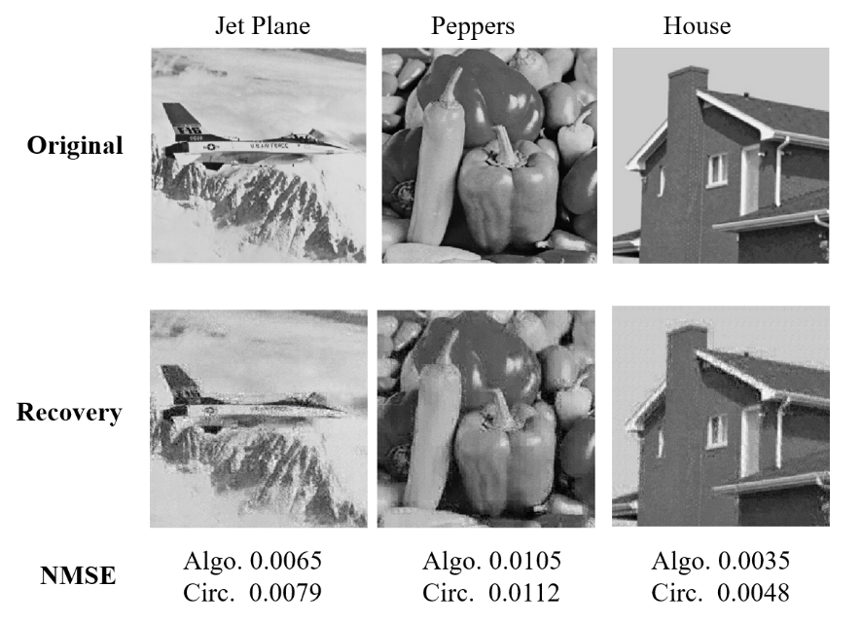
Figure S14. More experimental results for different natural images.

Figure S15. The power consumption fractions of the overall recovery circuits.

