Fig 2E Bax of A549

Fig 2E Bal of A549

Fig 2E Caspase-3 of A549

Fig 2E Caspase-7 of A549

Fig 2E GAPDH of A549

Fig 2E Bax of H1975

Fig 2E Bcl of H1975

Fig 2E Caspase-3 of H1975

Fig 2E Caspase-7 of H1975

Fig 2E GAPDH of H1975

Fig 3A E-cadherin of A549

Fig 3A GAPDH-1 of A549

Fig 3A GAPDH-2 of A549

Fig 3A MMP-2 of A549

Fig 3A MMP-9 of A549

Fig 3A N-cadherin of A549

Fig 3A E-cadherin of H1975

Fig 3A GAPDH-1 of H1975

Fig 3A GAPDH-2 of H1975

Fig 3A MMP-2 of H1975

Fig 3A MMP-9 of H1975

Fig 3A N-cadherin of H1975

Fig 4D AXIN2

Fig 4D GAPDH

Fig 4E Axin2 of A549

Fig 4E GAPDH of A549

Fig 4E Axin2 of H1975

Fig 4E GAPDH of H1975

Fig 4E Axin2

Fig 4E GAPDH

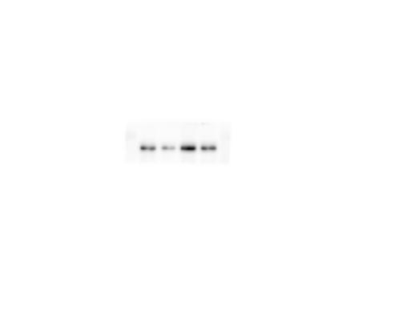
Fig 5A Axin2

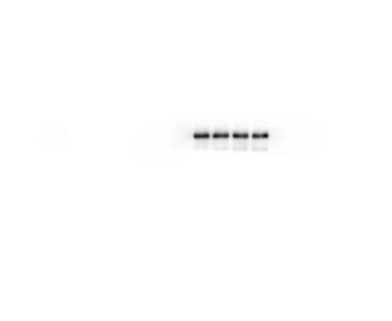
Fig 5A GAPDH

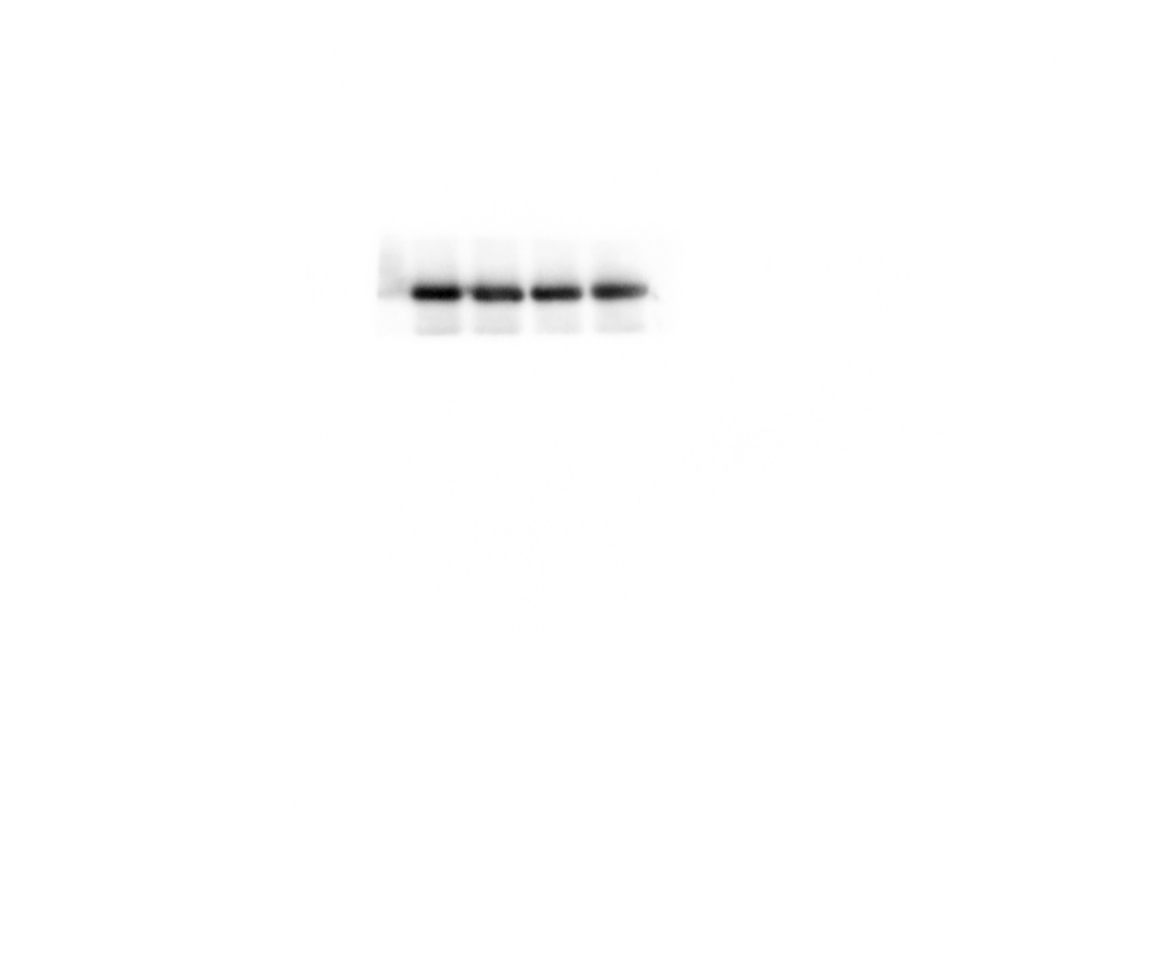
Fig 5B GAPDH

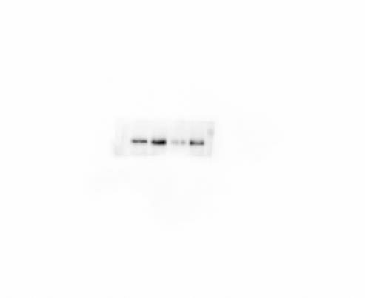
Fig 5B β-catenin

Fig 5D CD44v6

Fig 5D GAPDH

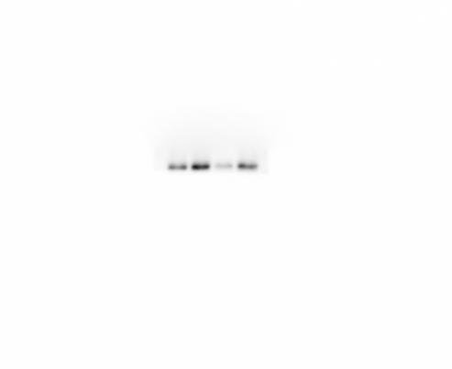
Fig 5D MMP-7

Fig 6A Axin2 of A549 and H1975

Fig 6A GAPDH of A549 and H1975

Fig 6D Bax of A549

Fig 6D Bcl of A549

Fig 6D Caspase-3 of A549

Fig 6D Caspase-7 of A549

Fig 6D GAPDH-1 of A549

Fig 6D GAPDH-2 of A549

Fig 6D Bax of H1975

Fig 6D Bcl of H1975

Fig 6D Caspase-3 of H1975

Fig 6D Caspase-7 of H1975

Fig 6D GAPDH-1 of H1975

Fig 6D GAPDH-2 of H1975

Fig 7C E-cadherin of A549

Fig 7C GAPDH-1 of A549

Fig 7C GAPDH-2 of A549

Fig 7C MMP-2 of A549

Fig 7C MMP-9 of A549

Fig 7C N-cadherin of A549

Fig 7C E-cadherin of H1975

Fig 7C GAPDH-1 of H1975

Fig 7C GAPDH-2 of H1975

Fig 7C MMP-2 of H1975

Fig 7C MMP-9 of H1975

Fig 7C N-cadherin of H1975

