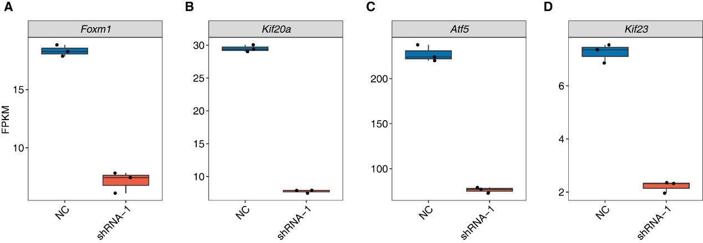
Figure S1. Expression levels of selected genes in HuR knockdown and control groups (A) Box plots showing the expression levels of four genes (Foxm1, Kif20a, Atf5, and Kif23) in negative control (NC) and HuR knockdown (shRNA-1) groups.
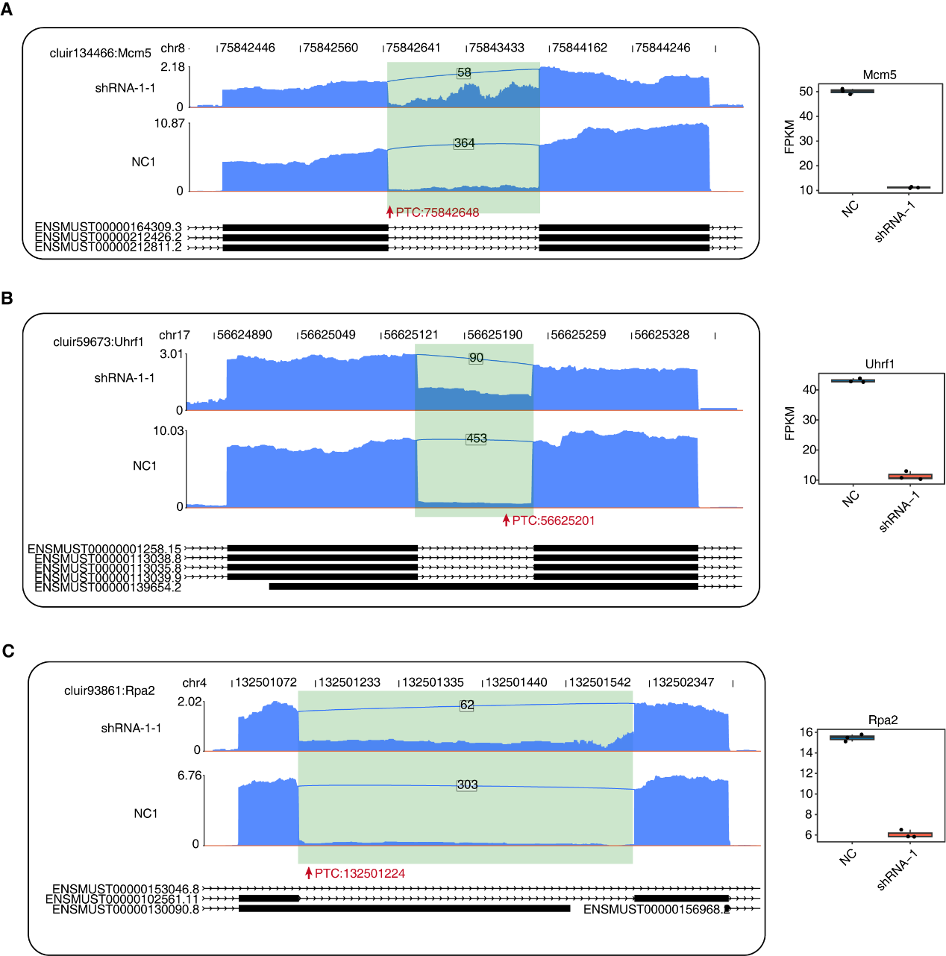
Figure S2. Representative IR events in cell cycle-related genes with PTC inclusion and decreased expression upon HuR knockdown (A-C) Genome browser views and FPKM expression plots of cell cycle-related Mcm5 (A), Uhrf1 (B), and Rpa2 (C) genes illustrated characteristic intron retention (IR) events following HuR knockdown. In every figure, retained introns were highlighted in green and premature termination codons (PTCs) were indicated by red arrows.
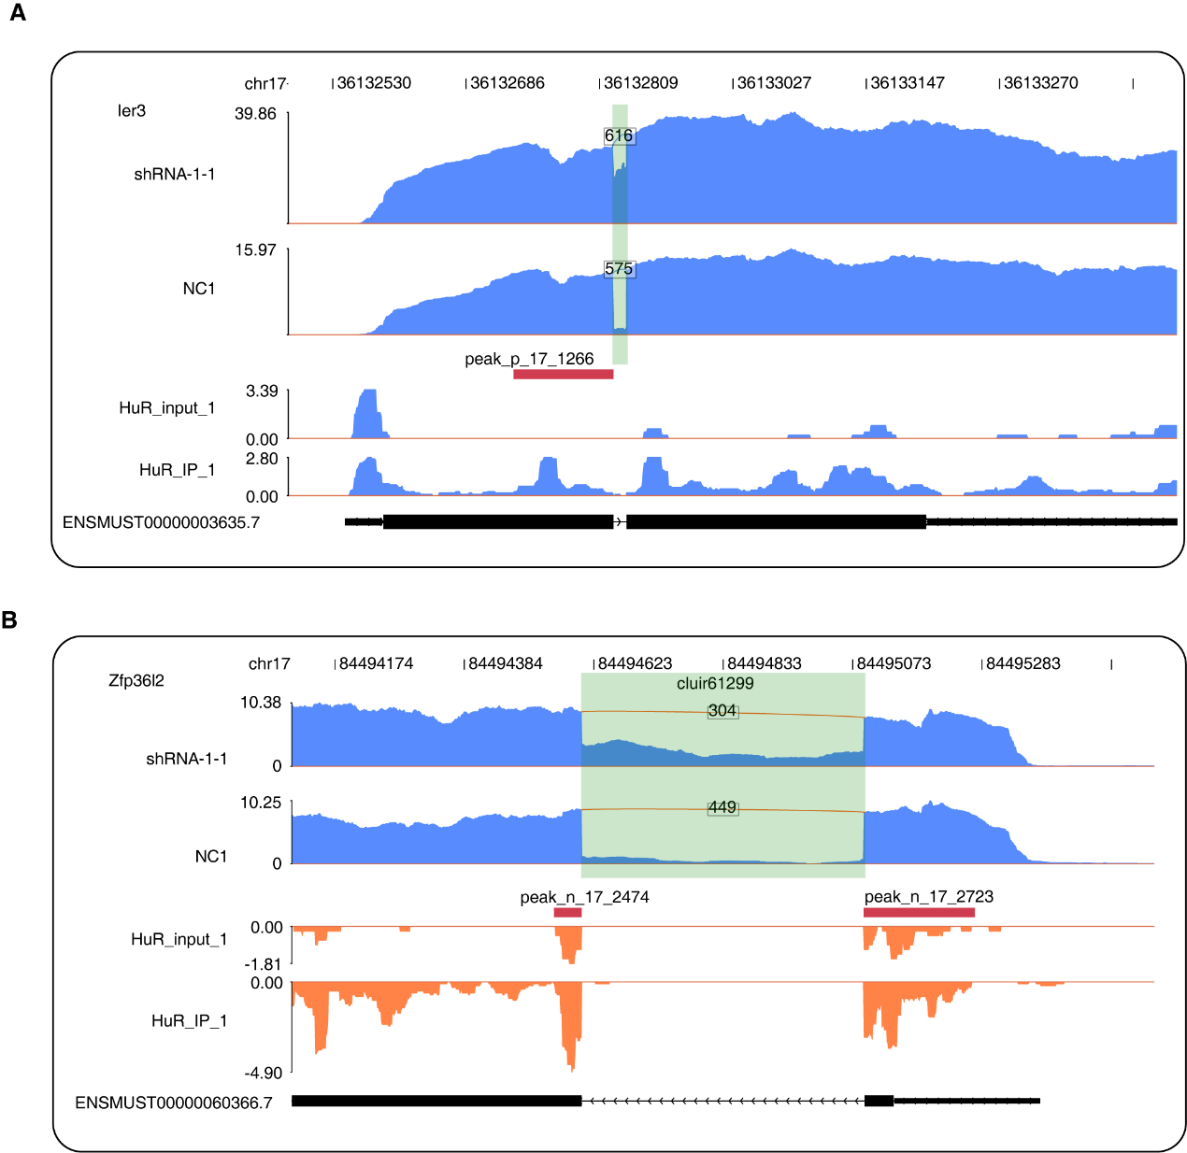
Figure S3. HuR bond near the splice sites of retained introns in cell-cycle related genes (A-B) Genome browser view of the Ier3 (A) and Zfp36l2 (B) gene showing increased intron retention in the HuR knockdown group (shRNA-1-1) compared to the control (NC1) and associated HuR peaks in eCLIP-seq. In every figure, retained introns were highlighted in green and premature termination codons (PTCs) were indicated by red arrows.

