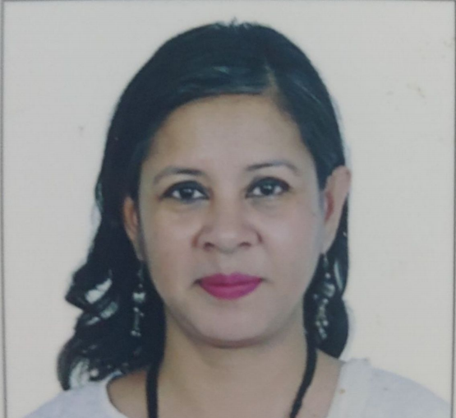

Piu Jain is a research scholar in the Department of Mechanical Engineering, Delhi Technical University, New Delhi. Her areas of research include manufacturing issues in industry and mass customisation. She has ten years of industrial experience in Indian manufacturing industries. She is also working as an Assistant Professor in the Department of Mechanical and Automation Engineering, Maharaja Agrasen Institute of Technology, Delhi.
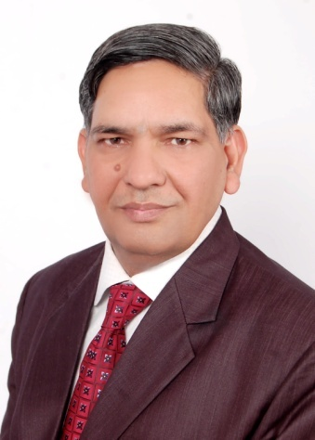

Prof. Suresh Kumar Garg is Professor of Mechanical Engineering in Delhi Technological University (Formerly Delhi College of Engineering). He has more than 25 years of experience in industry, teaching and research. His areas of interest include competitive strategies, JIT manufacturing system, quality management, technology management and supply chain management. He has published 175 papers including 75 in International Journals. He has authored course material on Production and Operations Management, Maintenance Management for IGNOU. He is a member of the Editorial Boards of several International and National journals. He is reviewer of research papers of International Journals, Conferences and also Examiner to Ph.D and M.Tech. thesis of different universities.
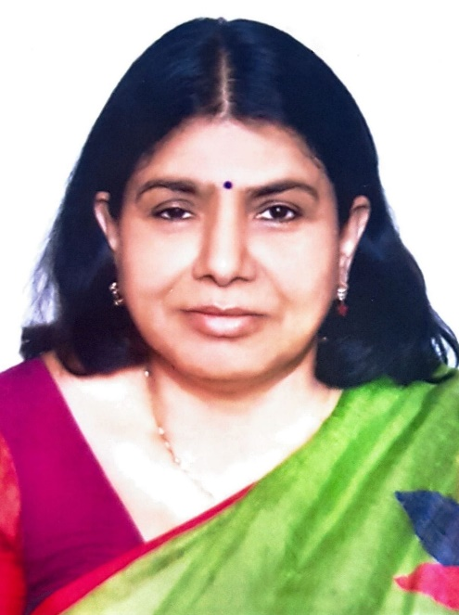

Prof. Gayatri Kansal was a professor of Mechanical Engineering in School of Engineering and Technology, IGNOU. She had been Director of School of Engineering and Technology. She was also Director Inter University Consortium. She has not only worked as a teacher but also as educationist. She designed and developed a very unique program i.e. B.Sc. (Nautical Science), with Directorate General of Shipping, and also contributed in design of many other programs. There are number of papers to her credit in national and international journals. Her area of interest includes Automation, Process control and quality management.

