Supplementary Information

pH-Responsive Delivery of Hydrophobic Anticancer Drugs Using Boron and Nitrogen Co-Doped Carbon Dots as Fluorescent Nanocarriers
Seyed Mostafa Jafariª, Saeed Masoum ^{a, *}, Elahe Seyed Hosseini ^{b, *}
ª Department of Analytical Chemistry, Faculty of Chemistry, University of Kashan, Kashan, Iran
^{b} Gametogenesis Research Center, Kashan University of Medical Sciences, Kashan, Iran

*Corresponding Author
Phone: +983155912338. Fax: +983155912397
E-mail: masoum@kashanu.ac.ir (Saeed Masoum)
Materials and Instruments
Quinine sulfate was purchased from Aladdin industry company. Curcumin and paclitaxel were purchased from Sigma-Aldrich company. All of the substances and reagents were purchased from Merck company. Deionized water was used over the experiments. The UV-Vis absorption was measured on a double-beam Ultraviolet-visible spectrophotometer (OPTIZEN 3220UV, South Korea). Purification and separation of mixtures were performed using a dialysis bag (MWCO 3.5 kDa) and centrifuge device (PIT UNIVERSAL 320, Iran). The Fourier transform infrared (FT-IR) spectra of NBCDs and conjugated to drugs, were obtained using KBr compact disc method containing powder carbon dots on a FT-IR spectrometer (Magna 550 Nicolt, USA). Photoluminescence spectra were recorded using a luminescence spectrophotometer (Perkin-Elmer LS-55). The proton nuclear magnetic resonance spectra (¹H-NMR) of samples were recorded on a Bruker Avance 400 MHz spectrometer. Zeta potential of NBCDs and conjugated to drugs and dynamic light scattering (DLS) of samples were obtained by a nanoparticle analyzer apparatus (SZ-100, HORBIA). Also, KinetDS3.0 software was employed to identify the mathematical model of drug release and the best fit of the experimental data was selected among these models.

Quantum yield (QY) measurement of NBCDs and NBCDs-drug conjugation by gradient method
QY was measured against quinine sulfate in 0.1 M H₂SO₄ (φ_{st} = 0.54), as a standard using the following equation:
φ_{x} = φ_{st} (K_{x}/K_{st}) (η_{x}/η_{st})²
where φ is the QY; K is the slope of curve; η is the refractive index (for both case is 1.33); the subscript "st" refers to standard and "x" refers to the NBCDs or NBCDs-drug. QY were measured at λ_{ex},_{max} = 360 nm, according to A and B diagrams
.
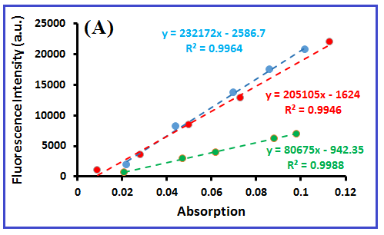
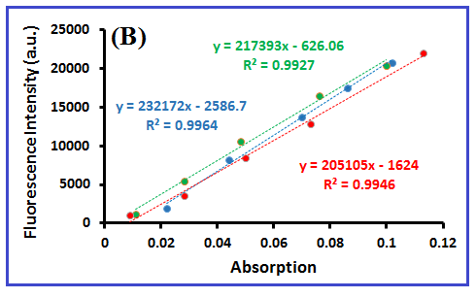
Figure S1. Quantum yield curves for (A) three curves including: quinine sulfate (red-line NBCDs (blue-line) and NBCDs-CUR (green-line) (B) three curves including: quinine sulfate (red-line), NBCDs (blue-line) and NBCDs-PTX (green-line)

Quenching mechanism of NBCDs in the presence of CUR or PTX
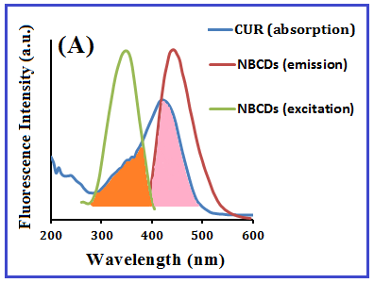
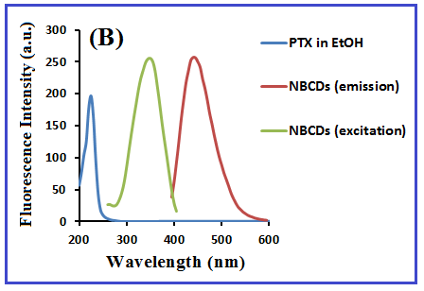
Figure S2. Spectral overlap between the absorption spectrum of the CUR (A) and PTX (B), and the excitation and emission spectra of NBCDs
In general, fluorescence quenching of carbon dots can be a result of two mechanisms including static or dynamic quenching [1]. When the absorption spectrum of the quencher overlaps to the fluorescence excitation or emission spectra of the fluorophore, thus, fluorescence of fluorophore will be turned off. This phenomenon is known as inner filter effect (IFE) [2]. According to Figure S2A, the absorption spectrum of CUR as quencher is overlapped with fluorescence excitation or emission spectra of NBCDs as fluorophore. Therefore, the possible quenching mechanism between CUR and NBCDs is IFE and this effect proves an interaction between CUR and NBCDs. According to Figure S2B, there is slightly overlap between fluorescence emission of NBCDs as fluorophore and absorption spectrum of PTX as quencher. Therefore, it can also be a reason for slight quenching of the NBCDs.

Table S1. FT-IR results for NBCDs, CUR and NBCDs-CUR
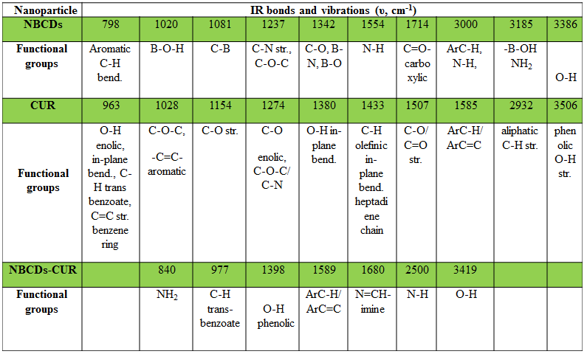

Table S2. FT-IR results for NBCDs, PTX and NBCDs-PTX
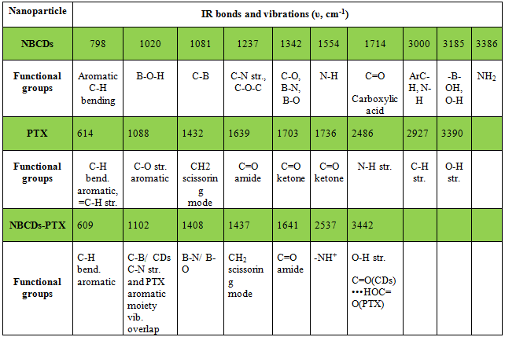

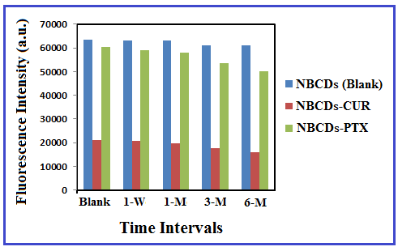
Figure S3. Fluorescence stability of NBCDs (as blank), NBCDs-CUR and NBCDs-PTX after at different time intervals (1-weak, 1-month, 3-months and 6-months, respectively)

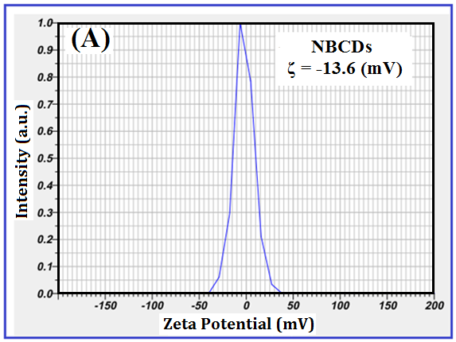
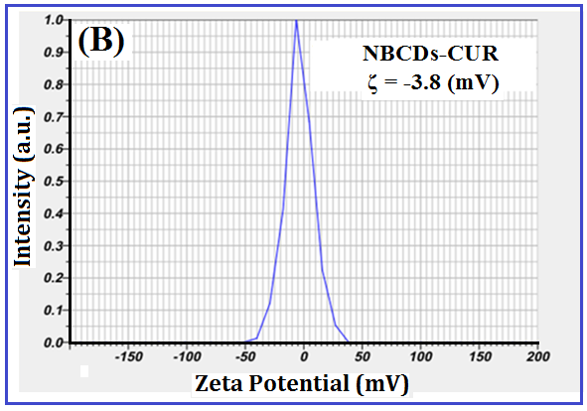
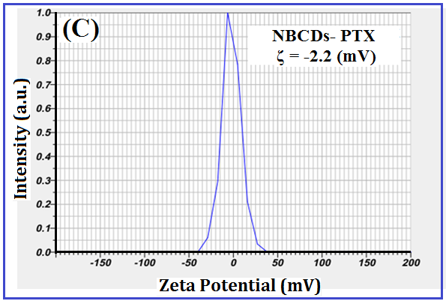
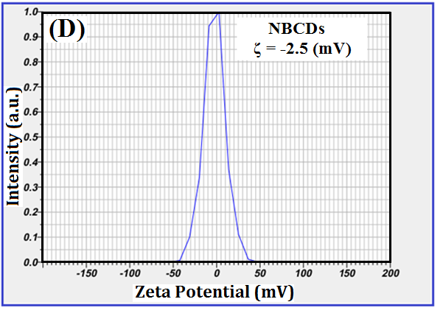
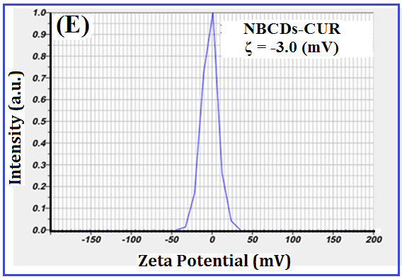
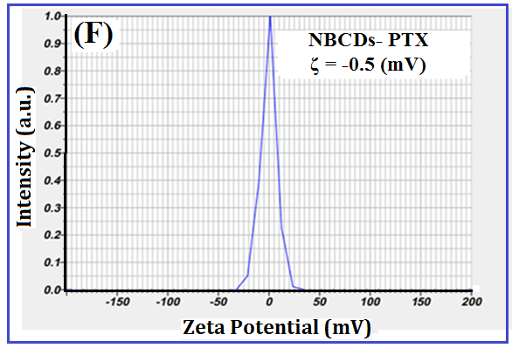
Figure S4. Zeta potential of NBCDs and drug-loaded NBCDs solution in water (A, B, C) and PBS 0.1 M (D, E, F).

Table S3. Zeta-Potential results of NBCDs before and after conjugation with drug in water and PBS (pH 7.4)
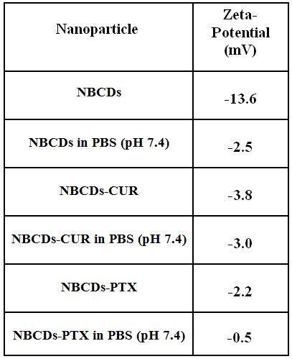

Based on results, all of the samples exhibited a negative zeta potential in water (A, B, and C) and PBS (D, E, and F), in the following order: -13.6 mV (A, NBCDs), -3.8 mV (B, NBCDs-CUR), -2.2 mV (C, NBCDs-PTX), -2.5 mV (D, NBCDs), -3.0 mV (E, NBCDs-CUR) and -0.5 mV (F, NBCDs-PTX). The negative zeta potential values of samples (especially for NBCDs and NBCDs-PTX) in PBS were drastically increased, in compared to water. Interestingly, the charge variables (ζ-potential) of NBCDs after conjugation with drug (CUR or PTX) show that the interactions between the carbon dots and the drug molecules have occurred. Also, the negative charge (for NBCDs, especially) was attributed to abundance of carboxylic, boron hydroxyl and hydroxyl groups onto the carbon dots surface, so that confirming their colloidal stability in the aqueous medium. Under physiological conditions, the stability of samples was investigated in PBS, too. A change in zeta potential of samples was observed in PBS, in compared to water. The buffer effect on the zeta potential of samples can be related to existence of strong cations (Na⁺ and K⁺) as well as strong anions (Cl‾ and PO₄³⁻) in PBS solution, due to high ionic strength and the interaction between buffer ions and carbon dots surface groups. After solving of NBCDs in the PBS solution, the salt bridges are formed between cations and oxo-groups with negative charge (such as ‗COOH and ‗OH) on the NBCDs surface. Similarly, the salt bridges are formed between anions and positively charged amine functionalities (such as ‗NH₂ groups). Thus, the formation of salt bridges can be masked the surface charges present on NBCDs and as a result, effectively neutralizing the overall zeta potential [3,4]. With respect to Figure S4, by comparing the zeta potential diagrams between B with E and C with F, it can be understood that the effect of salt bridge formation has decreased significantly after the drug is attached to the carbon dots, probably due to the involvement of functional groups on the surface of carbon dots with drug. But, this effect is significant in the case of free carbon dots (see A and D plots in Figure S4). Also, reducing the negative zeta potential makes it possible for drug systems to pass through the cell membrane and improve cellular uptake. As a result, changes in the zeta potential of carbon dots after conjugation to the drug can prove the loading of the drug on the surface of the carbon dots. As shown in Figure S4, zeta potential plot of NBCDs showed one peak at -13.6 mV in water and in the negative region. Upon functionalization of NBCDs with CUR (Figure S4B), the ζ value was changed to -3.8 mV, which is other reason for CUR interaction with functional groups onto the carbon dots surface. For NBCDs-PTX, the ζ value (-2.2 mV) was obtained in water.

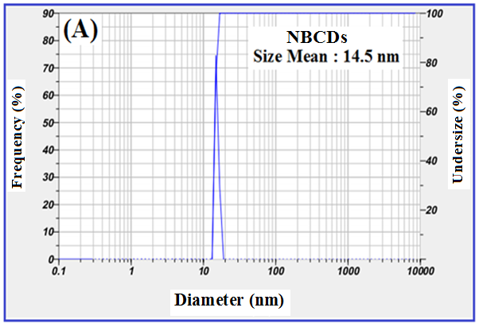

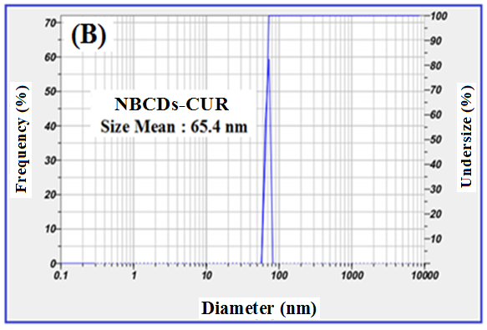

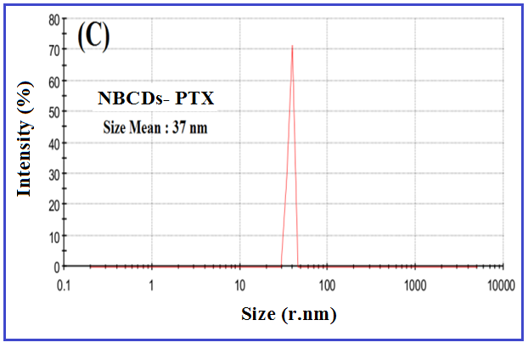

Figure S5. DLS analysis of NBCDs (A), NBCDs-CUR (B), and NBCDs-PTX (C) with the related average size

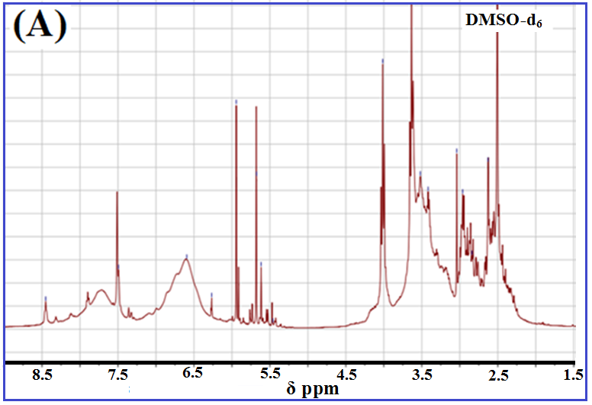

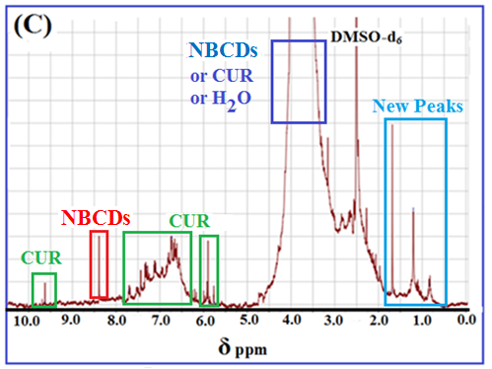
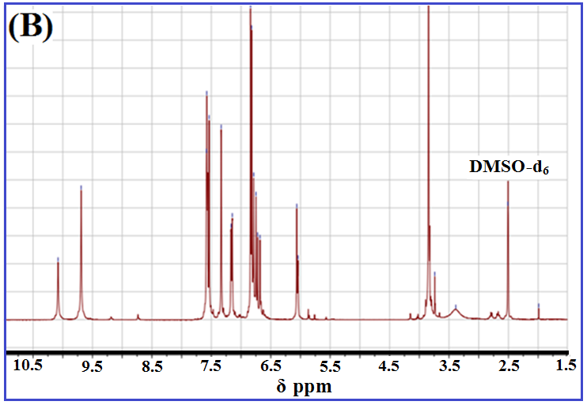
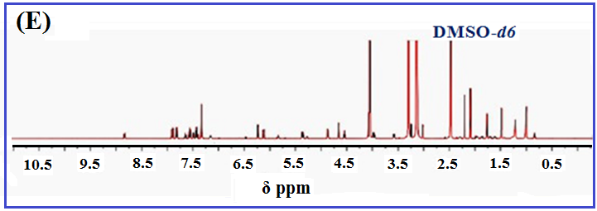
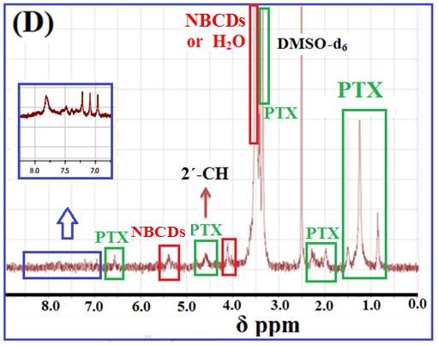

Figure S6. ¹H-NMR spectra of NBCDs (A), CUR (B), NBCDs-CUR (C), NBCDs-PTX (D), and PTX (E).

Table S4. ¹H-NMR analyses for NBCDs, drugs and NBCDs-drug in d₆-DMSO solvent
¹H-NMR (δ ppm)
 | 8.5 | 7.5 | 6.5-7.0 | 5.7-6.0 | 4.0 | 2.75-3.0 | 2.5 | NBCDs
 | Amide | Amide (RCONH) | Aromatic | Vinylic | R-NH₂ /CHOH | Benzylic | DMSO-d₆ | H-type
 | - | 10.1 | 9.7 | 6.5-7.5 | 6.1 | 3.8 | 2.5 | CUR
 | - | OH•••OMe | -OH (Phenolic) | Aromatic/ Vinylic | (H-1) | -OCH₃ | DMSO-d₆ | H-type
 | 9.7 | 8.3 | 6.2-8.0 | 6.0 | 0.8-1.7 |  | 2.5 | NBCDs-CUR
 | OH•••OMe | Amide/ Imine | Aromatic /Amide | Vinylic | Allylic (new peaks) |  | DMSO-d₆ | H-type
 | 7.5-8.0 | 6.2 | 4.5-5.0 | 4.1 | 2.1-2.2 | 0.5-1.5 | 2.5 | PTX
 | Aromatic | OH-CH-COO | R₂-CH-OH | Oxetane | CH₃CO-OR | -CH₃ | DMSO-d₆ | H-type
 | 6.6 | 5.8 | 4.8 | 4.1 | 2.0-2.2 | 0.8-1.5 | 2.5 | NBCDs-PTX
 | R₂CHCOO | OH-CH-COOPh | R₂-CH-OH | Oxetane | CH₃CO-OR | -CH₃ | DMSO-d₆ | H-type

According to the ¹H-NMR spectra (Figure S6), several sharp peaks were overally observed at ~8-10, ~6.5-8, ~1-2 ppm regions, that are attributed to the protons of the carboxylic acid or amine, aromatic groups, and aliphatic chains, respectively. In this study, ¹H-NMR spectrum of drug-loaded NBCDs showed both the expected signals for NBCDs and drug. In detail, a singlet peak corresponding to the six protons in two methoxy groups (-OCH₃) was observed in CUR structure at δ 3.8 ppm (Figure S6B). This singlet peak is also observed in the ¹H-NMR spectrum of NBCDs-CUR at δ 3.8 ppm (Figure S6C). The presence this peak at δ 3.8 ppm can be as a sign for CUR assembling onto the carbon dots. Notably, the presence of peak at δ ~6.0 ppm in both NBCDs and CUR-NBCDs ¹H-NMR spectra is attributed to the presence of –NH₂ groups in the carbon dots structure and/ or vinylic protons of CUR structure. Furthermore, a singlet peak at δ 10.1 ppm for CUR spectrum (corresponding to phenolic OH) is observed, so that the similar peak is also observed at δ 9.7 ppm (for NBCDs-CUR) after CUR assembling onto the carbon dots. By comparing the ¹H-NMR spectra of NBCDs, PTX, and NBCDs-PTX, several sharp peaks can be observed at δ 0.8-2 ppm region, which are related to the protons of the aliphatic methyl (–CH₃) in PTX structure. Indeed, the ¹H-NMR spectra of NBCDs (Figure S6A) has no peak in this region (0.8-2 ppm). As a result, the successful incorporation of PTX drug onto the carbon dots in the NBCDs-PTX (according to Figure S6D) is clearly confirmed. Due to the formation of covalent and non-covalent bonds between the drug molecules and carbon dots, the rotational mobility is reduced and thus, all of the ¹H-NMR signals of the conjugated compounds are broader than the free drug signals [5].

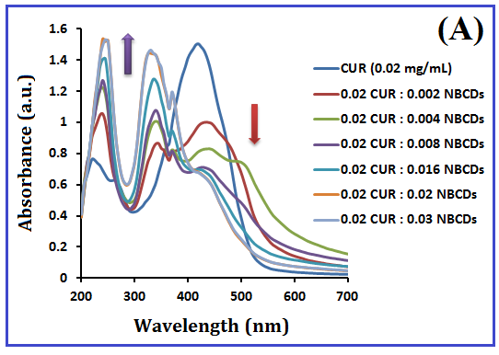
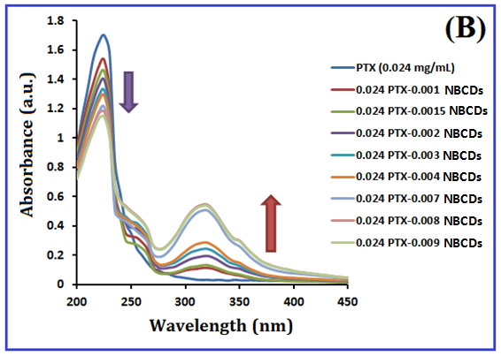

Figure S7. Absorption spectrum changes with gradual increase of carbon dots. (A) CUR drug and (B) PTX drug

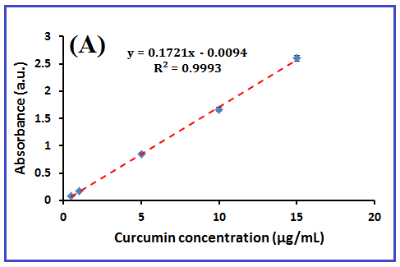

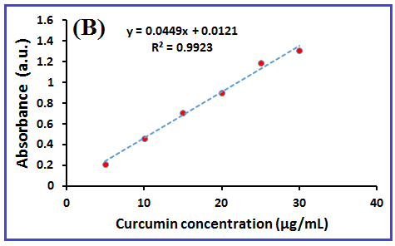
Figure S8. (A) Standard curve of CUR in methanol solvent and (B) Standard curve of CUR in PBS (0.1M, pH 7.4) and tween 80 (0.5%)

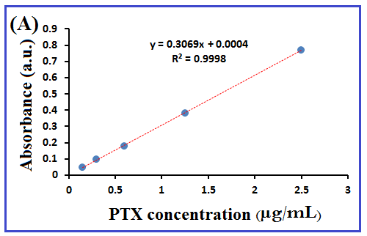
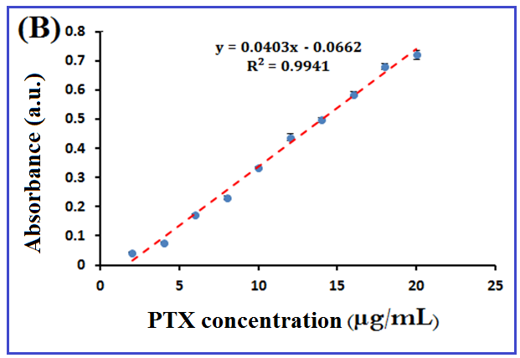
Figure S9. (A) Standard curve of PTX in methanol solvent and (B) Standard curve of PTX in PBS (0.1M, pH 7.4) and tween 80 (0.5%)

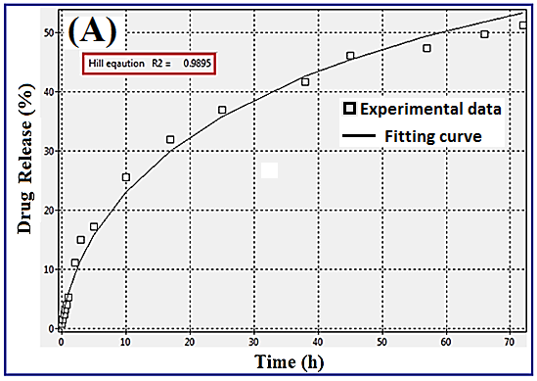
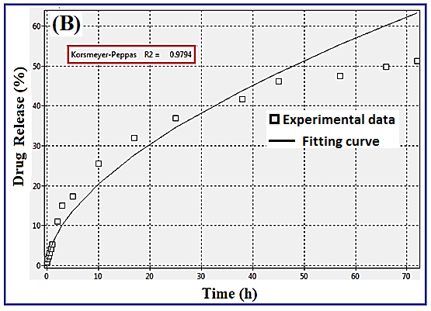

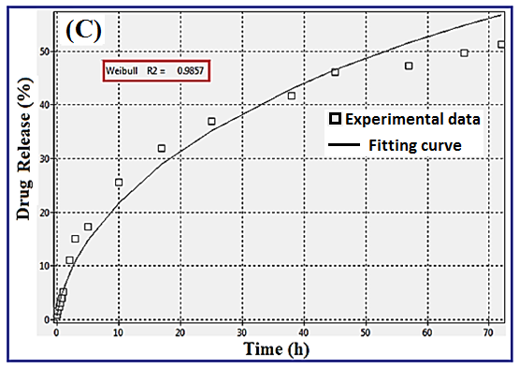
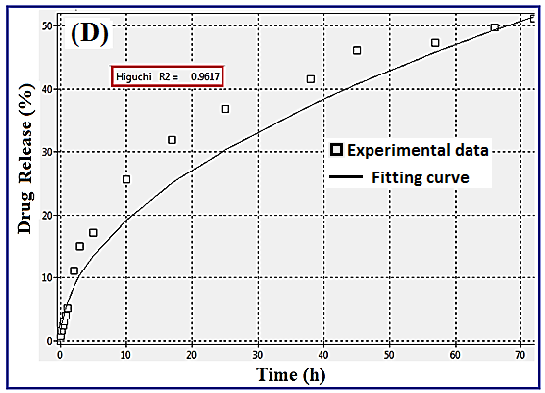
Figure S10. The proposal drug release models (fitting curve) by using software related to CUR release (as an example) of nanocarrier at pH = 5.0 against time (h) (A) Hill model (B) Korsmeyer-Peppas model (C) Weibull model (D) Higuchi model. Experimental data are as the input data to software and fitting curve are as the output of it.
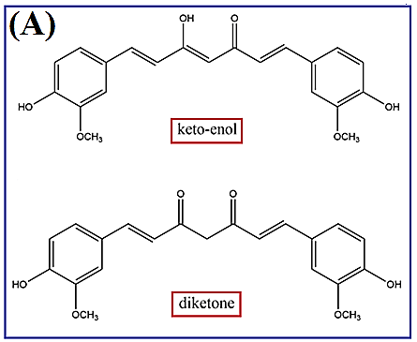

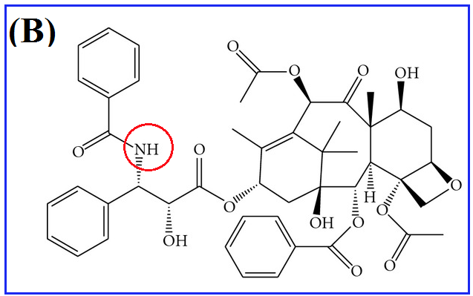

Figure S11. The structure of drugs (A) CUR tautomerism , up: keto-enol form and bottom: di-ketone form, and (B) PTX

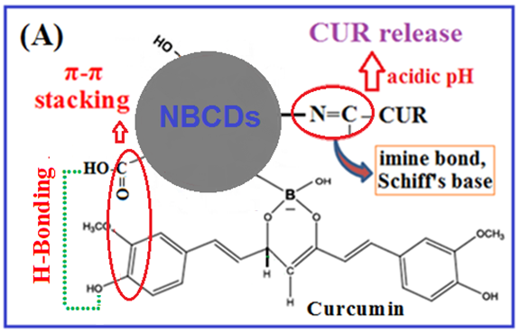
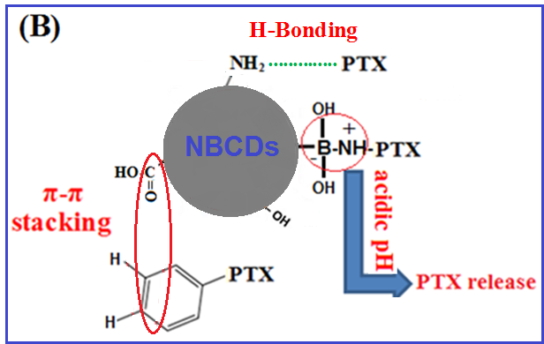
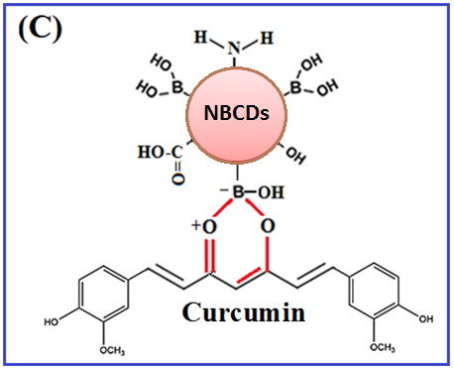

Scheme S1. Schematic illustrate different kinds of interactions between (A) CUR and (B) PTX, with NBCDs and drug release under acidic conditions.(C) six-membered ring between the keto-enol groups of CUR and the boron hydroxyl (–B(OH)₂) groups on the surface of NBCDs.
References
[1] J. Tang, Y. Zhang, Y. Liu, D. Liu, H. Qin, N. Lian, Carbon quantum dots as a fluorophore for “inner filter effect” detection of metronidazole in pharmaceutical preparations, RSC Adv. 9 (2019) 38174–38182. https://doi.org/10.1039/c9ra08477k.
[2] F. Zu, F. Yan, Z. Bai, J. Xu, Y. Wang, Y. Huang, X. Zhou, The quenching of the fluorescence of carbon dots: A review on mechanisms and applications, Microchim. Acta 184 (2017) 1899–1914. https://doi.org/10.1007/s00604-017-2318-9.
[3] S.A. Rub Pakkath, S.S. Chetty, P. Selvarasu, A. Vadivel Murugan, Y. Kumar, L. Periyasamy, M. Santhakumar, S.R. Sadras, K. Santhakumar, Transition Metal Ion (Mn²⁺, Fe²⁺, Co²⁺, and Ni²⁺)-Doped Carbon Dots Synthesized via Microwave-Assisted Pyrolysis: A Potential Nanoprobe for Magneto-fluorescent Dual-Modality Bioimaging, ACS Biomater. Sci. Eng. 4 (2018) 2581–2596. https://doi.org/10.1021/acsbiomaterials.7b00943.
[4] S. Laurent, C. Burtea, C. Thirifays, F. Rezaee, M. Mahmoudi, Significance of cell “observer” and protein source in nanobiosciences, J. Colloid Interface Sci. 392 (2013) 431–445. https://doi.org/10.1016/j.jcis.2012.10.005.
[5] I.J. Gomez, B. Arnaiz, M. Cacioppo, F. Arcudi, M. Prato, Nitrogen-doped carbon nanodots for bioimaging and delivery of paclitaxel, J. Mater. Chem. B 6 (2018) 5540–5548. https://doi.org/10.1039/c8tb01796d.

