Supplementary

Table S1: The results are achieved for ML methods. RMSE is the root mean squared error on the validation set. The metrics of R-squared (R2) indicates how well the predicted results explain the target of training. MAE is the Mean absolute error. The MAE is always positive and similar to the RMSE, but less sensitive to outliers. MSE represents mean squared error. The list is sorted in ascending order of RMSE and descending order of R-squared values.
Methods Type | Subtype | RMSE (Validation) | MSE (Validation) | RSquared (Validation) | MAE (Validation)
Ensemble | Bagged Trees | 0.03125 | 0.00100 | 0.97620 | 0.01809
Gaussian Process Regression | Matem 5/2 GPR | 0.03272 | 0.00107 | 0.97245 | 0.01818
Gaussian Process Regression | Rational Quadratic GPR | 0.03286 | 0.00108 | 0.97221 | 0.01821
Gaussian Process Regression | Squared Exponential | 0.03337 | 0.00111 | 0.97133 | 0.01850
Neural Network | Bi-layered NN | 0.03637 | 0.00132 | 0.96595 | 0.02410
Neural Network | Tri-layered NN | 0.03979 | 0.00158 | 0.95924 | 0.02600
Gaussian Process Regression | Exponential | 0.04054 | 0.00164 | 0.95770 | 0.02379
Neural Network | Medium NN | 0.04410 | 0.00194 | 0.94995 | 0.02773
SVM | Cubic | 0.04447 | 0.00198 | 0.94909 | 0.02742
Kernel | SVM | 0.04651 | 0.00216 | 0.94432 | 0.02977
Neural Network | Wide NN | 0.04832 | 0.00234 | 0.93989 | 0.02886
SVM | Quadratic | 0.04948 | 0.00245 | 0.93699 | 0.03293
Neural Network | Narrow | 0.05437 | 0.00296 | 0.92391 | 0.03477
SVM | Medium Gaussian | 0.05508 | 0.00303 | 0.92190 | 0.03575
Tree | Fine Tree | 0.05723 | 0.00328 | 0.91569 | 0.03054
Kernel | Least Squares Regression kernel | 0.05964 | 0.00356 | 0.90843 | 0.04204
Tree | Medium | 0.06426 | 0.00413 | 0.89369 | 0.03781
Ensemble | Boosted Trees | 0.06535 | 0.00427 | 0.89008 | 0.05057
Tree | Coarse Tree | 0.08223 | 0.00676 | 0.82594 | 0.05707
SVM | Fine Gaussian | 0.09723 | 0.00945 | 0.75665 | 0.05928
Linear Regression | Linear | 0.11999 | 0.01440 | 0.62938 | 0.09175
SVM | Linear | 0.15443 | 0.02385 | 0.38612 | 0.09373
SVM | Coarse | 0.17181 | 0.02952 | 0.24011 | 0.10043
Linear Regression | Robust | 0.17434 | 0.03039 | 0.21760 | 0.09108

.

Table S2: Summary of ML Model Hyperparameters and Tuning Ranges
Model Type | Subtype | Key Hyperparameters | Tuning Ranges / Notes
Ensemble (Bagged Trees) | Bagged Trees | NumLearningCycles, MinLeafSize | NumLearningCycles: 30; MinLeafSize: 8
Gaussian Process | Matern 5/2 Kernel | KernelScale, Sigma, BaiscFunction, | KernelScale: auto (fitrgp default), Sigma: auto, BasicFunction: constant
Neural Network | Tri-layered Feedforward | NumHiddenLayers, NeuronsPerLayer, LearningRate | Layers: 3 (fixed); Neurons: 10–100 per layer; LearningRate: 0.001–0.05
SVM | Cubic | BoxConstraint, KernelScale | BoxConstraint: 0.1–100; KernelScale: 0.01–10
Kernel Regression | SVM Kernel | KernelFunction, Regularization, andIterationLimit | KernelFunction: 'gaussian'; Regularization: 0.001–1; IterationLimit: 1000
Decision Tree | Fine Tree | Surrogate decision splits, MinLeafSize | Surrogate decision splits: off; MinLeafSize : 1–5 (optimized at 4)
Linear Regression | Linear | None (least-squares solution) | Robust option: on
Note: All the models were trained using MATLAB R2023b functions with custom tuning via grid search. The final parameters were selected using 5-fold cross-validation for minimizing RMSE.

Table S3: Summary of Data Flow
Dataset | Size | Purpose | Used For
Training Dataset | 2037 | Model learning | Regression modeling
Validation (Cross validation folding) | 5 subsets of training data | Hyperparameter tuning & model selection | RMSE/R² evaluation
Independent Test Set | 70 | External model validation | Final qualitatively asses of the trained model
Gridded dataset | 377200 | Apply the trained model on the nodes of the grid | Prediction map across the study area with a 2 km × 2 km.

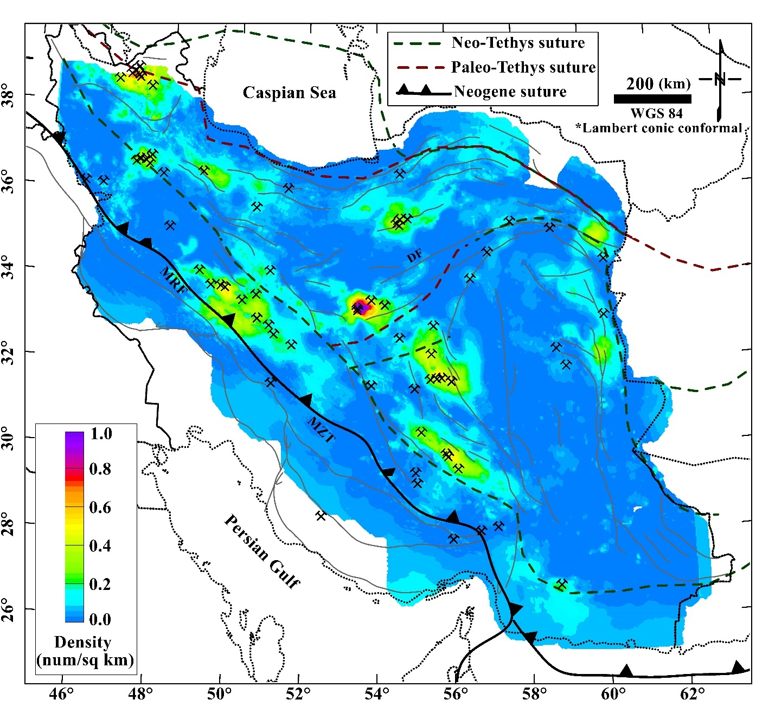
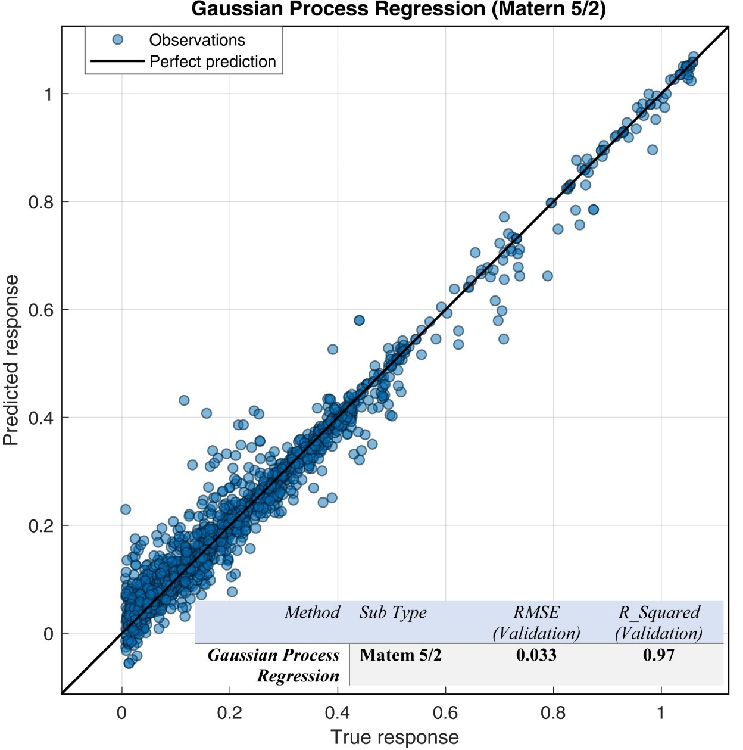
Figure S1: (top) The predicted spatial density of the ore deposits across the Iranian plateau, achieved by the Gaussian Process Regression (Matem) method.
(bottom) The scatter plot represents the predicted spatial density of mineral deposits versus the observation (Figure 2b), achieved by the Gaussian Process Regression (Matem) method.

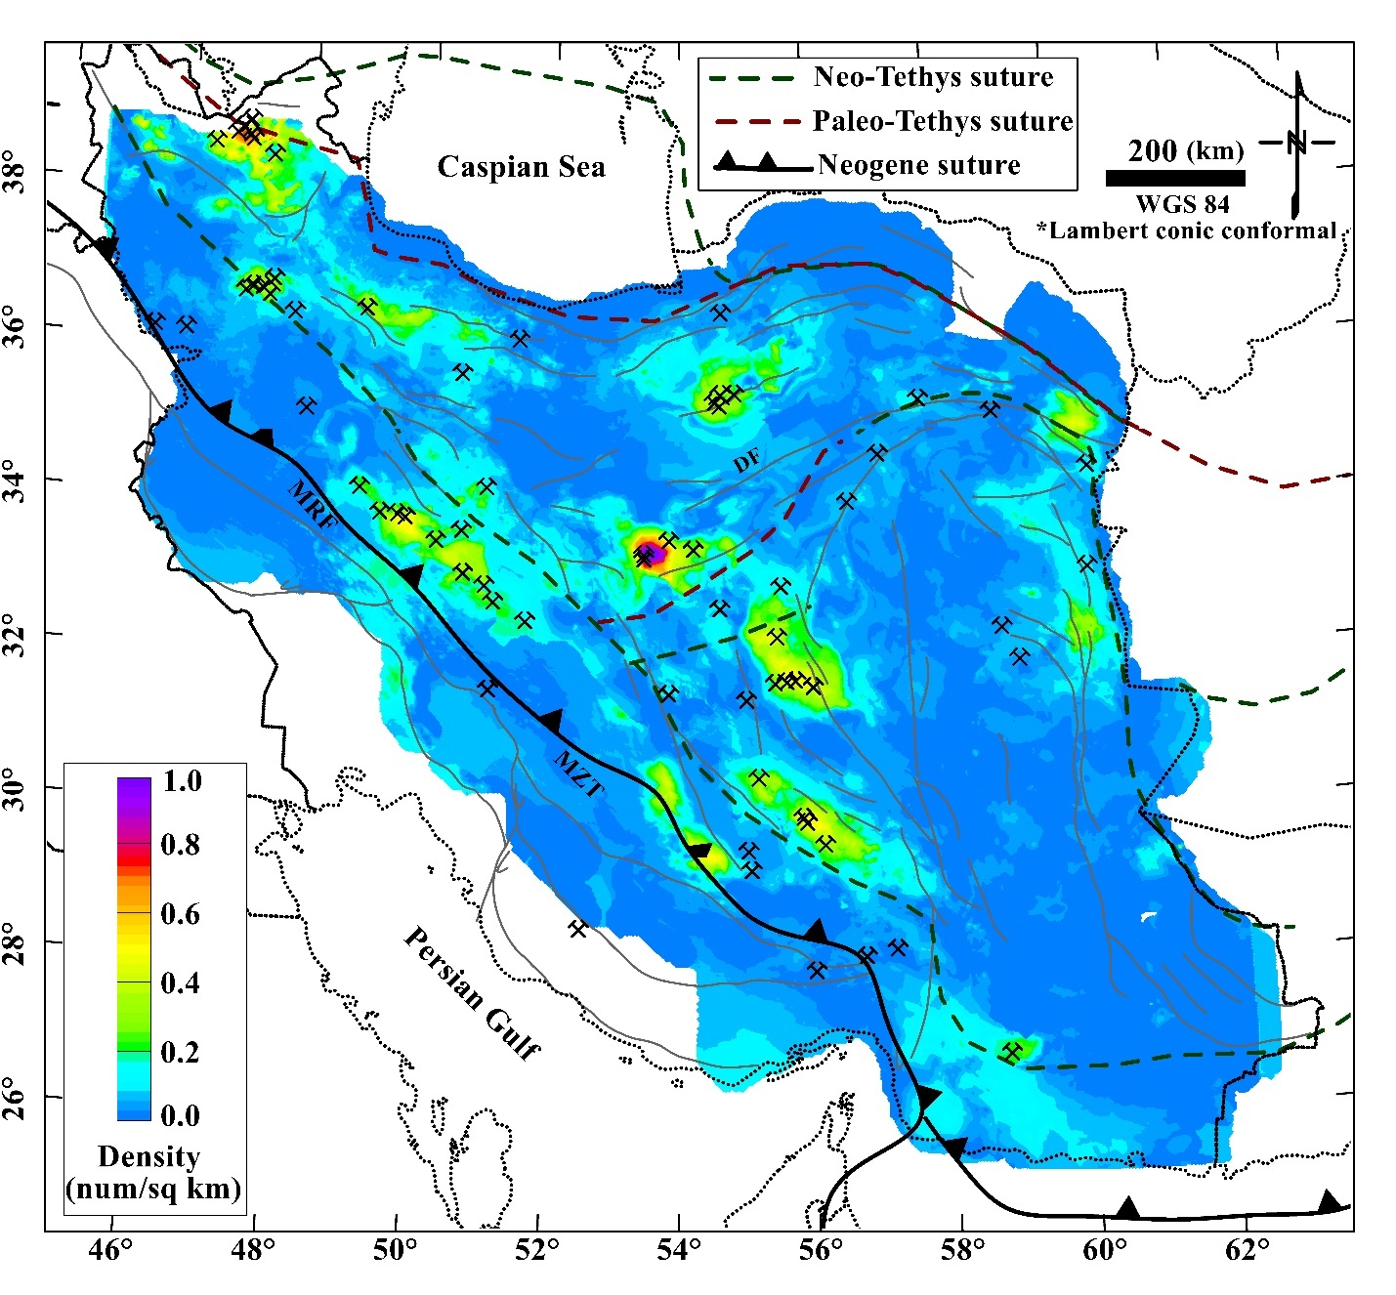
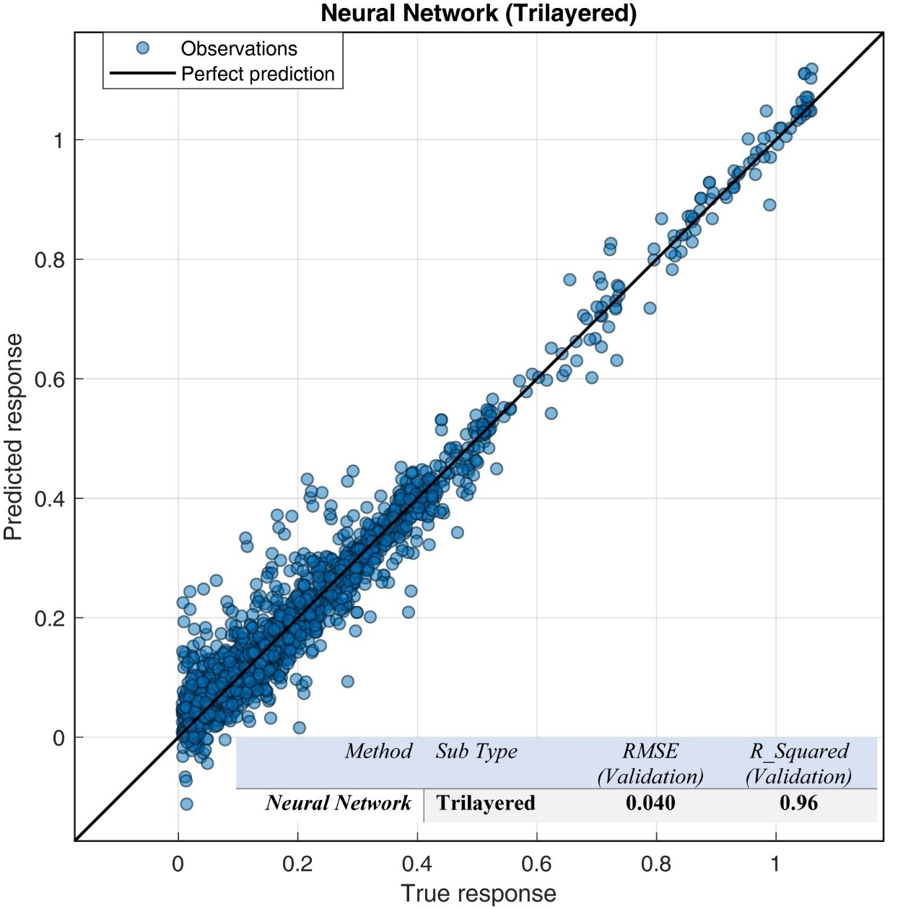
Figure S2: (top) The predicted spatial density of the ore occurrences across the Iranian plateau, achieved by the Neural Network (Trilayered) method.
(bottom) The scatter plot represents the predicted spatial density of the ore deposits versus the observation (Figure 2b), achieved by the Neural Network (Tri-layered) method.

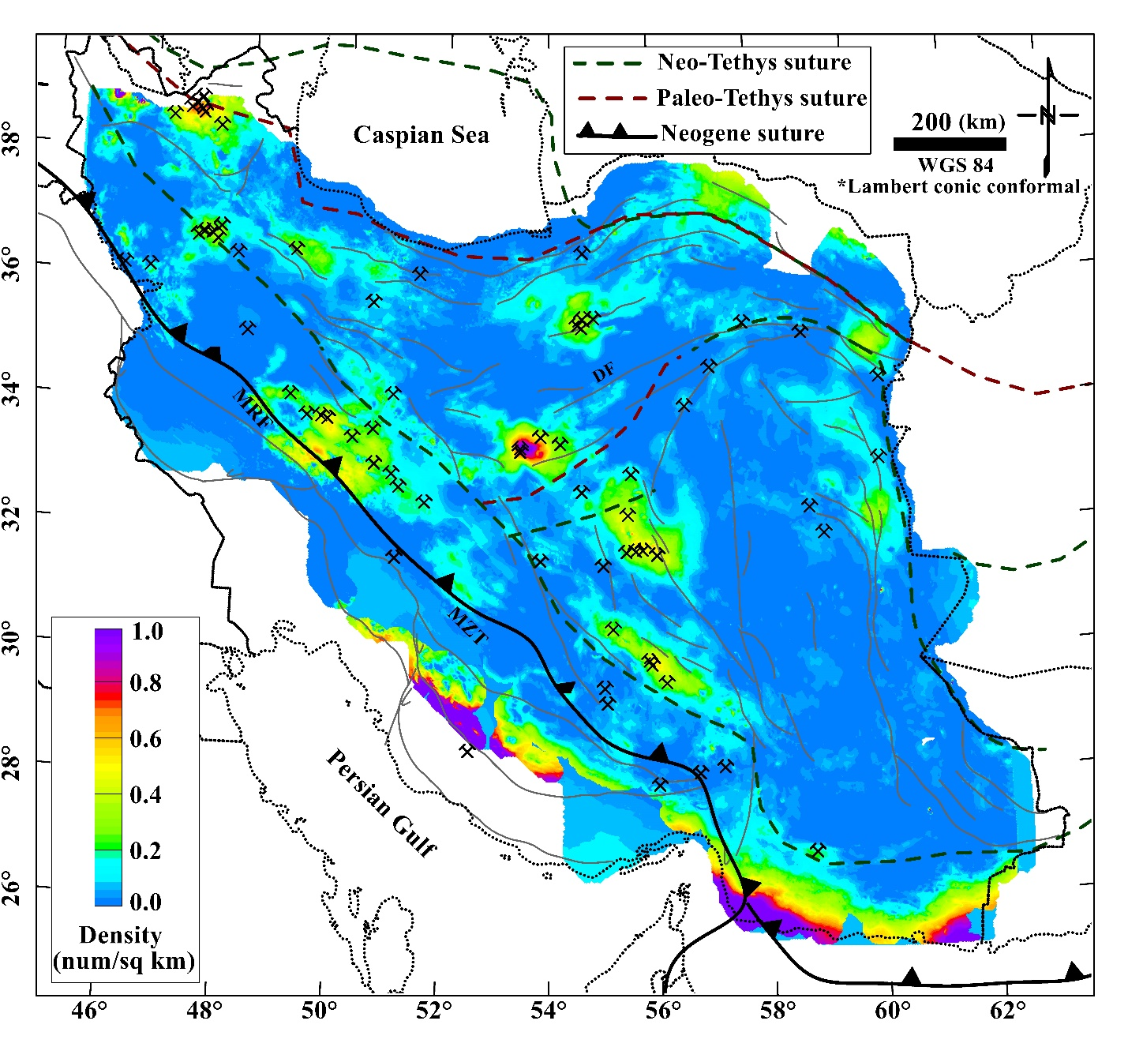
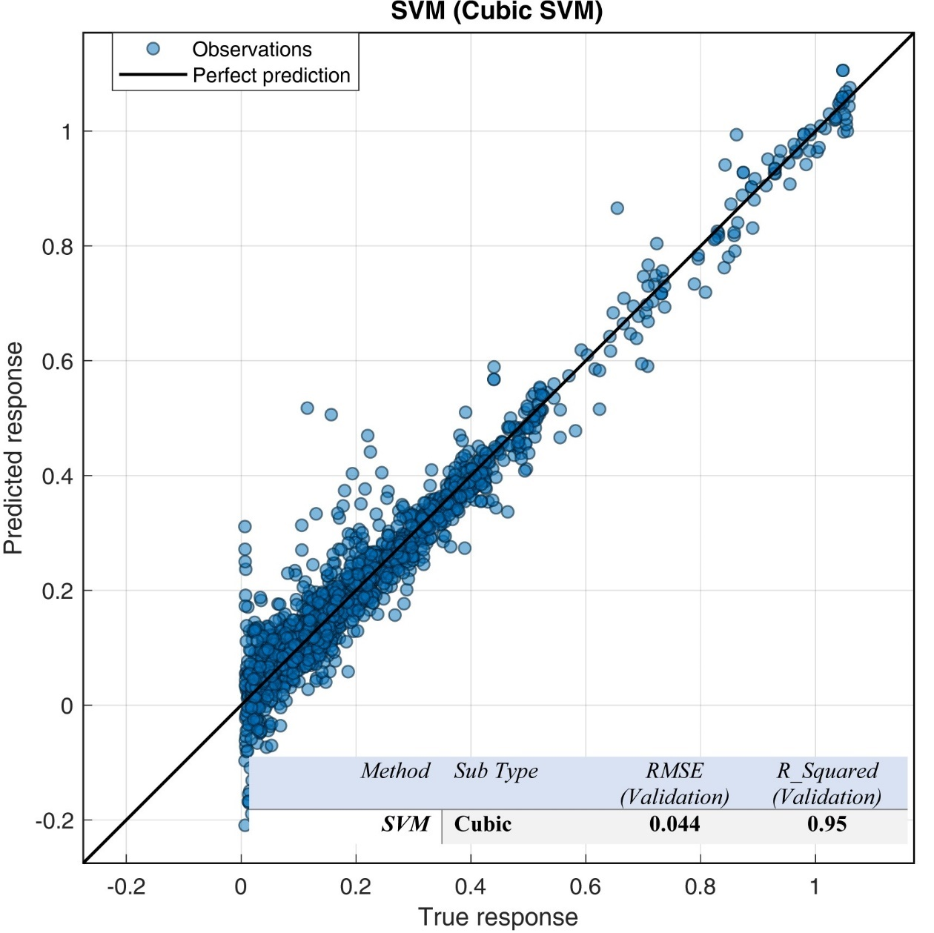
Figure S3: (top) The predicted spatial density of the ore deposits across the Iranian plateau, achieved by the SVM (Cubic) method.
(bottom) The scatter plot represents the predicted spatial density of ore deposits versus the observation (Figure 2b), achieved by the SVM (Cubic) method.

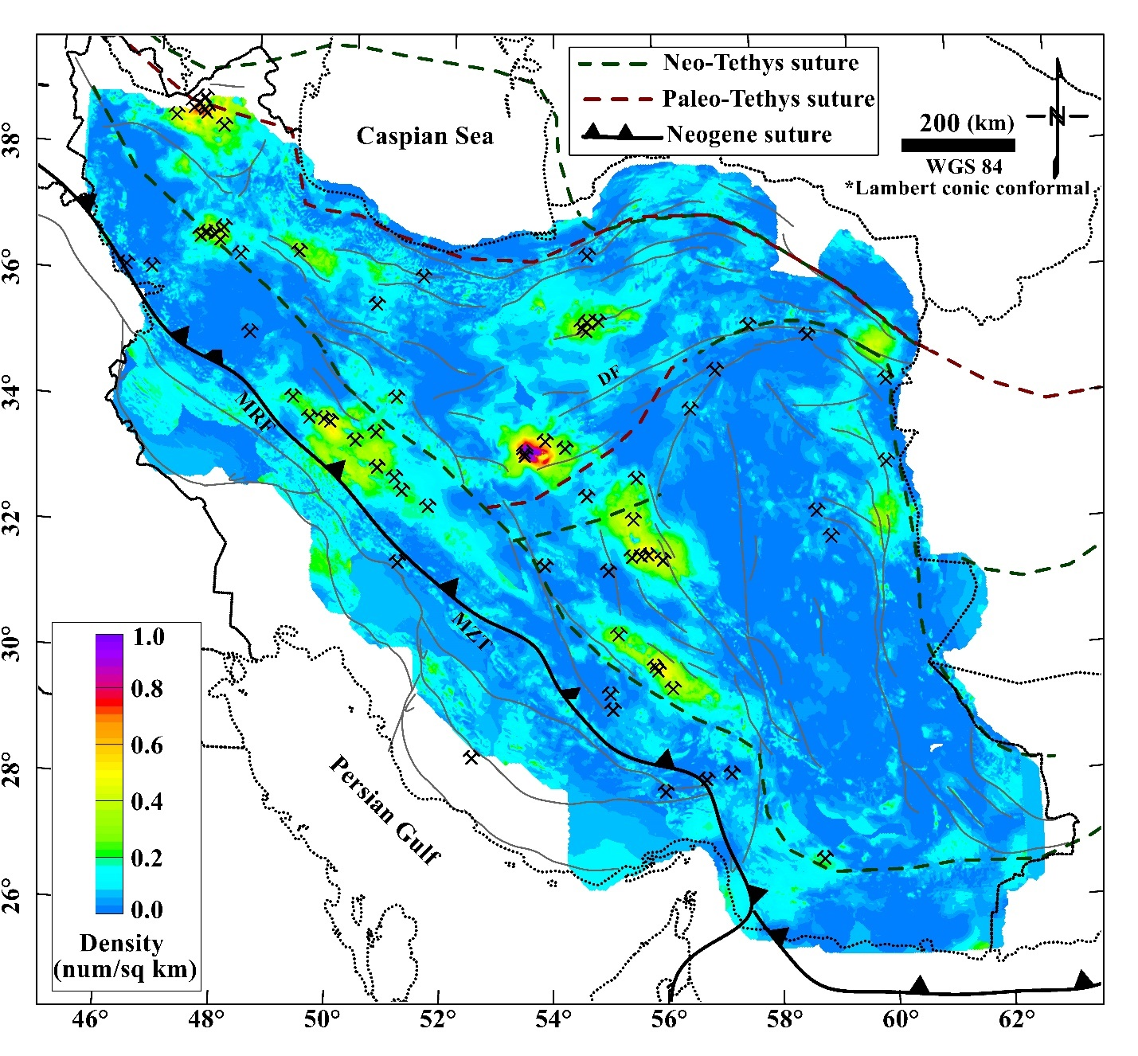
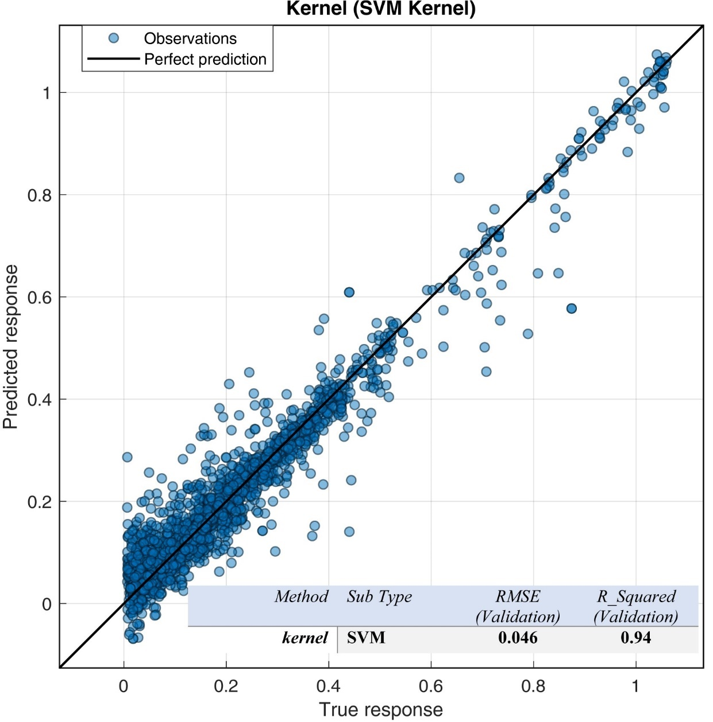
Figure S4: (top) The predicted spatial density of the ore deposits across the Iranian plateau, achieved by the Kernel (SVM) method.
(bottom) The scatter plot represents the predicted spatial density of ore deposits versus the observation (Figure 2b), achieved by the Kernel (SVM) method.

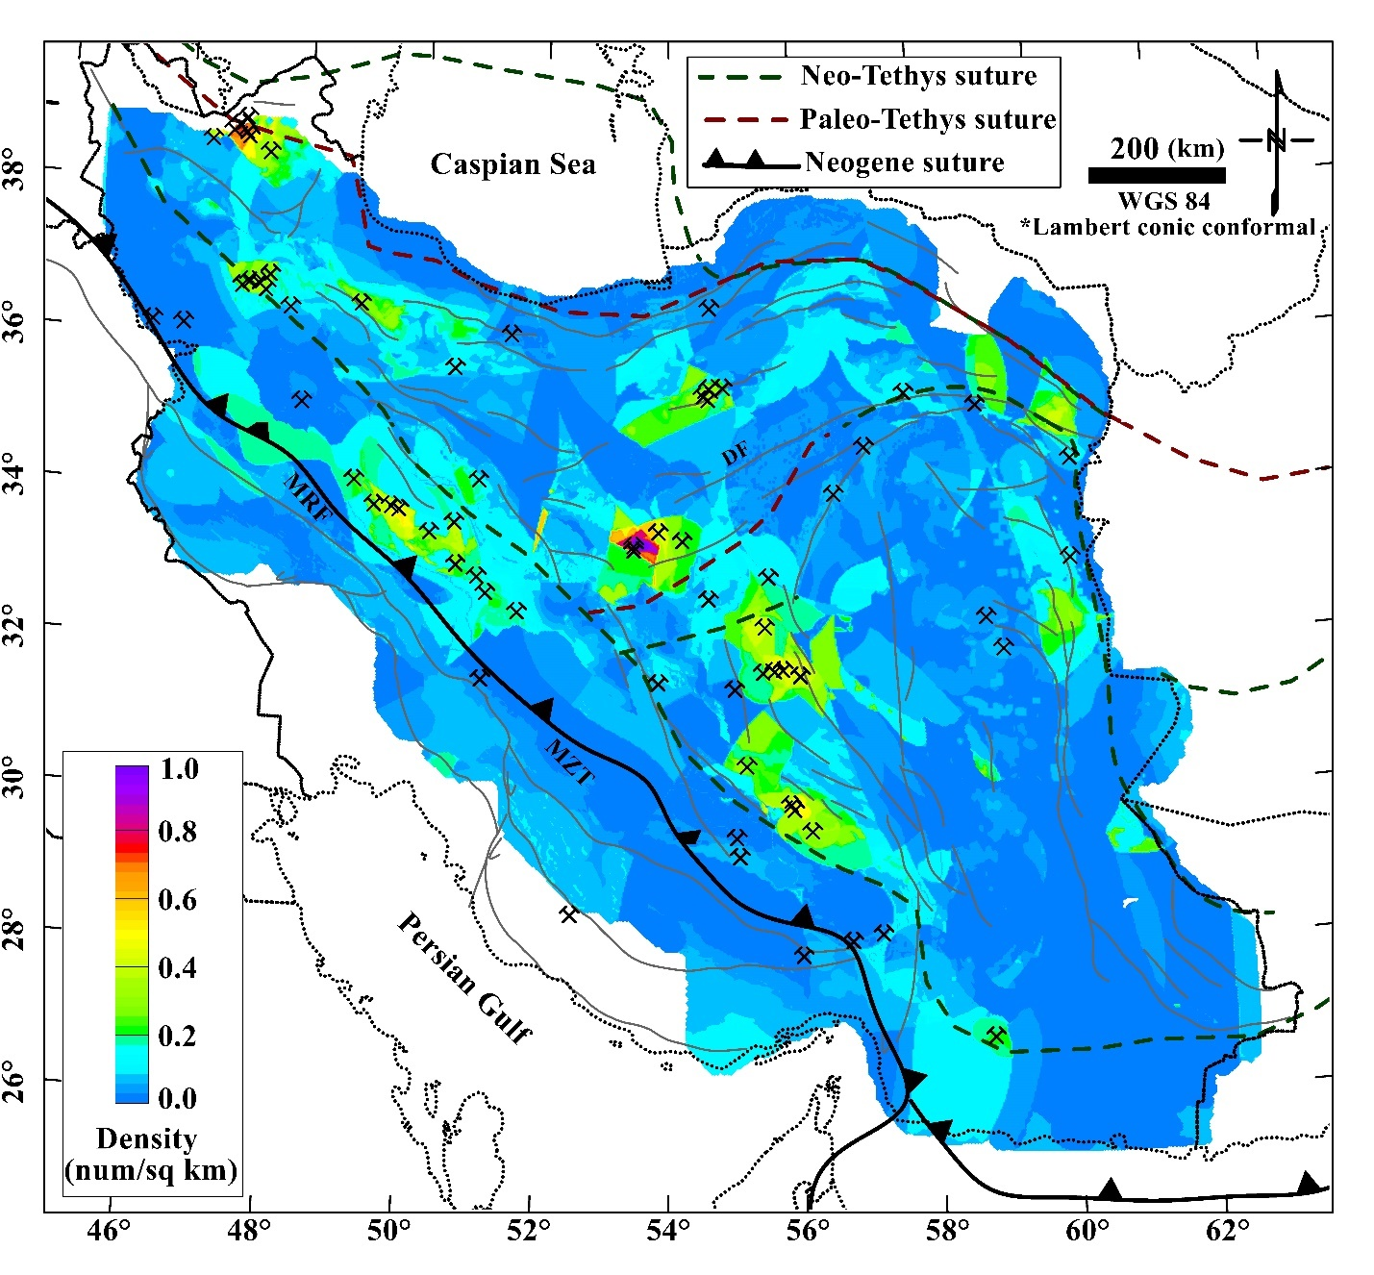
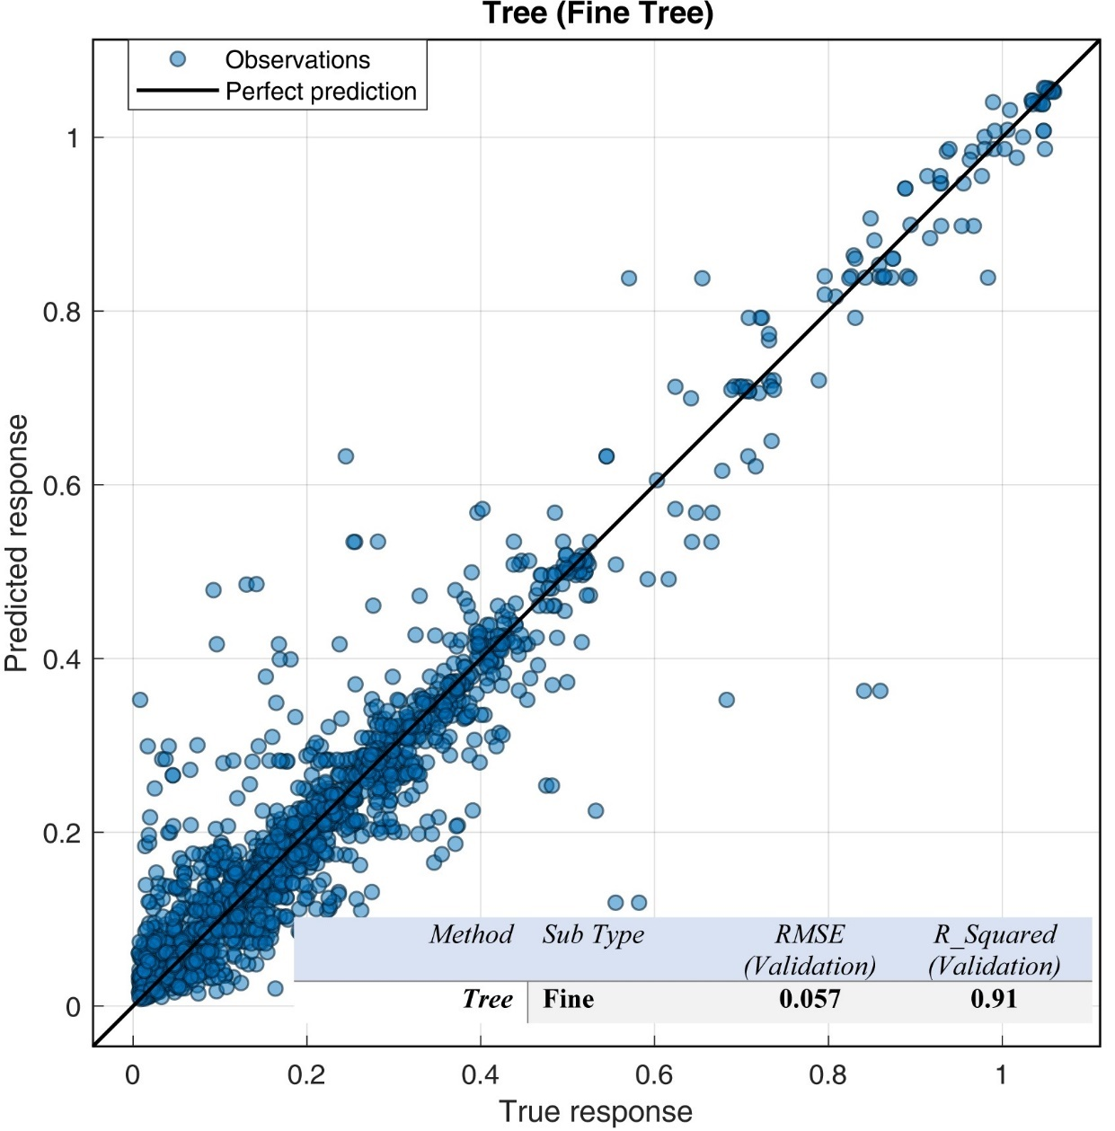
Figure S5: (top) The predicted spatial density of the ore deposits across the Iranian plateau, achieved by the Tree (Fine) method.
(bottom) The scatter plot represents the predicted spatial density of ore deposits versus the observation (Figure 2b), achieved by the Tree (Fine) method.
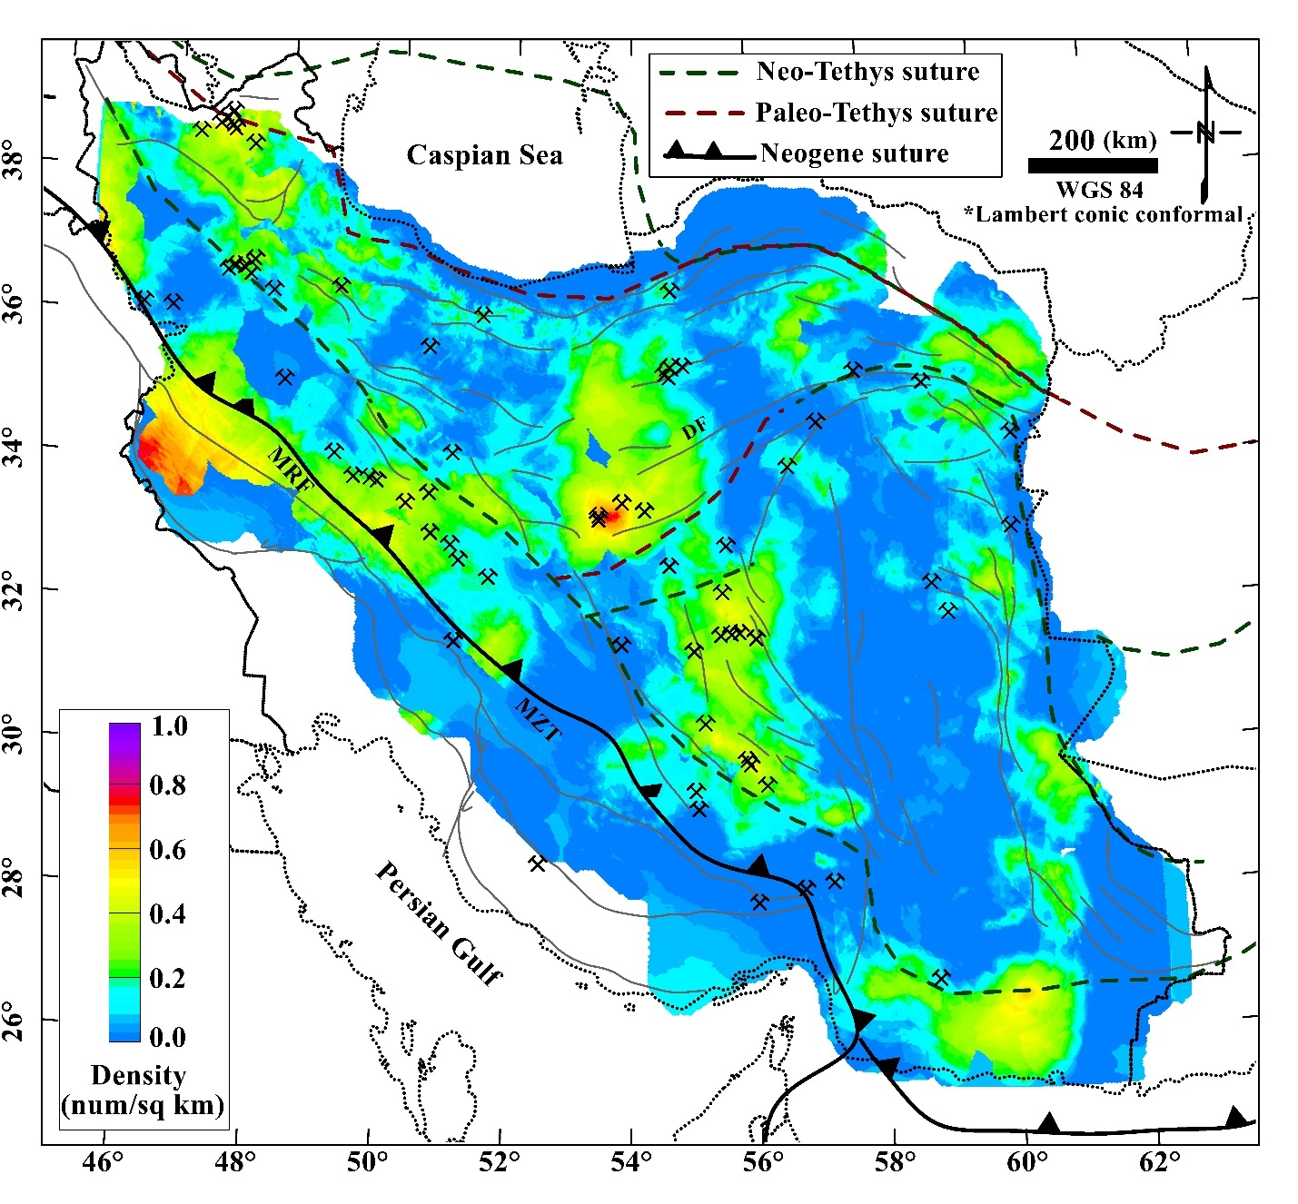
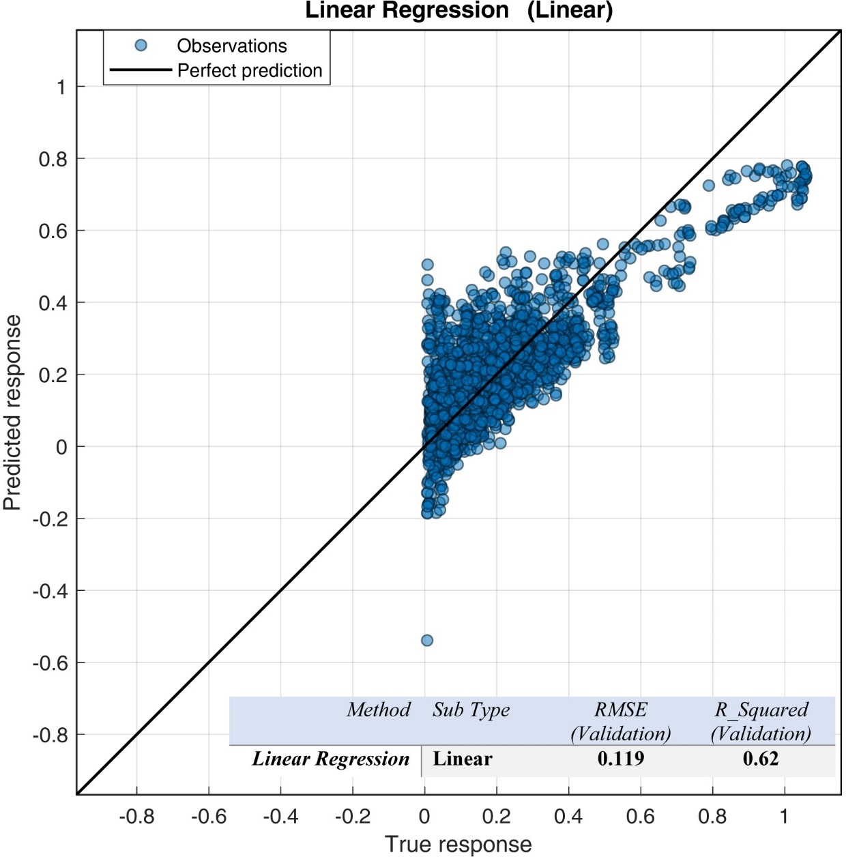
Figure S6: (top) The predicted spatial density of the ore deposits across the Iranian plateau, achieved by the Linear Regression (Linear) method.
(bottom) The scatter plot represents the predicted spatial density of ore deposits versus the observation (Figure 2b), achieved by the Linear Regression (Linear) method.
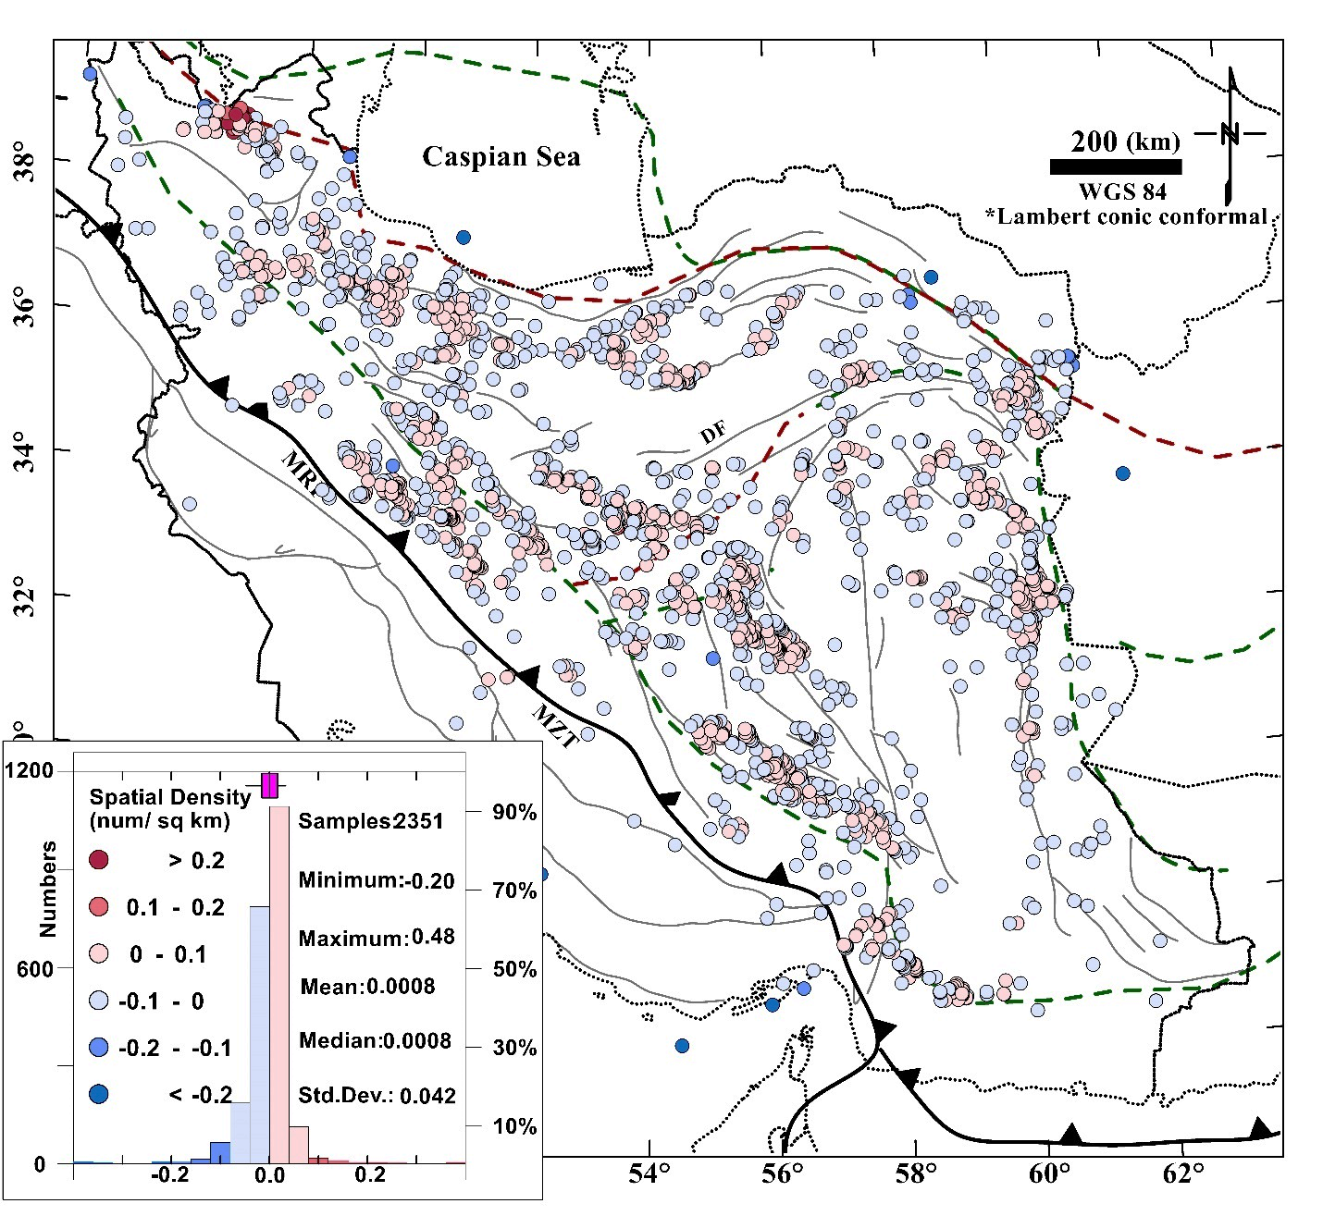
Figure S7: The residual of predicted spatial density of the ore occurrences reduced from the true spatial density at the location of ore deposits (residual = true -predicted). The trained model by the Ensemble Bagged Trees algorithm is used for prediction of the density value at the location of the ore deposits and then reduced from the true density values. The results indicate that for most of the ore deposits, the residual is < |±0.1|. Anomalous residuals (> |±0.1|) indicate the locations where the prediction of the trained model is less certain, relatively. For instance, ore deposits located far away from metallogenic clusters indicate higher values of residual, which indicate less certain prediction for less sampled areas. For highly sampled areas, only the KaraDagh metallogenic zone, in the NW of the Iranian plateau, show a cluster of ore deposits with high residuals.

