Typical Student Reflective Reports with Practice Images
1. Reflective Report: The "Silent Agreement" in Outpatient Guidance
Author: Student 07Course Module Alignment: Hospital Visit & Outpatient Practice
Key Insight: Translating "patient-centered care" into micro-actions
During the outpatient guidance practice at the General Internal Medicine Clinic, I was assigned to assist elderly patients with self-service registration machines. One 78-year-old grandma with presbyopia stood in front of the screen for 5 minutes, trembling hands hovering over the touchpad. I initially reached for the machine to operate it directly, but my instructor stopped me with a gesture—"Let her lead, you support."
I knelt down to align with her line of sight, pointing to each icon slowly: "Grandma, this blue button is 'elderly registration,' just like the green sign at the clinic entrance." When she fumbled to take out her ID card, I noticed her fingers had arthritis; instead of taking the card, I steadied her wrist gently to guide it into the reader. After registration, she held my hand and said, "Young man, you didn’t rush me—thank you."
This experience made me realize: Empathy isn’t just words. The instructor later explained, "Elderly patients fear losing autonomy; your patience preserves their dignity."
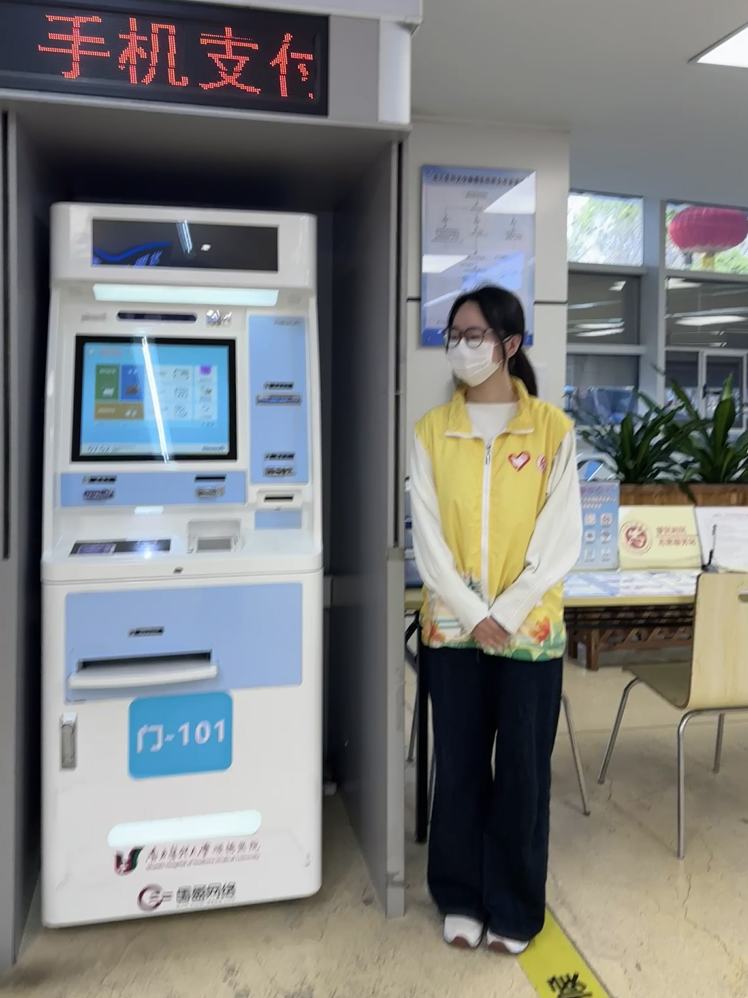

2. Reflective Report: When a "Routine" Consult Becomes a Lesson in Communication
Author: Student 23Course Module Alignment: Narrative Medicine & Clinical CommunicationKey Insight: Recognizing emotional needs behind medical questions
I shadowed Dr. Li in the Cardiology Clinic and observed a consultation with a 45-year-old hypertension patient who kept repeating, "Is my medicine really safe?" Dr. Li didn’t just list side effects—she first asked, "Did you hear something worrying from other patients?" The patient then admitted his father had suffered drug-induced kidney damage, and he feared the same fate.
Dr. Li pulled out a simplified drug manual with color-coded safety profiles and said, "Your kidney function is normal, and this drug’s safety rate for patients like you is 98%. Let’s check your creatinine monthly—we’ll adjust immediately if there’s any change." The patient’s shoulders relaxed visibly.
Afterward, Dr. Li told me: "Patients ask 'about medicine' but often mean 'about fear.' Narrative medicine teaches us to listen to the story behind the question." I later incorporated this into my reflection: Communication starts with decoding unspoken concerns.
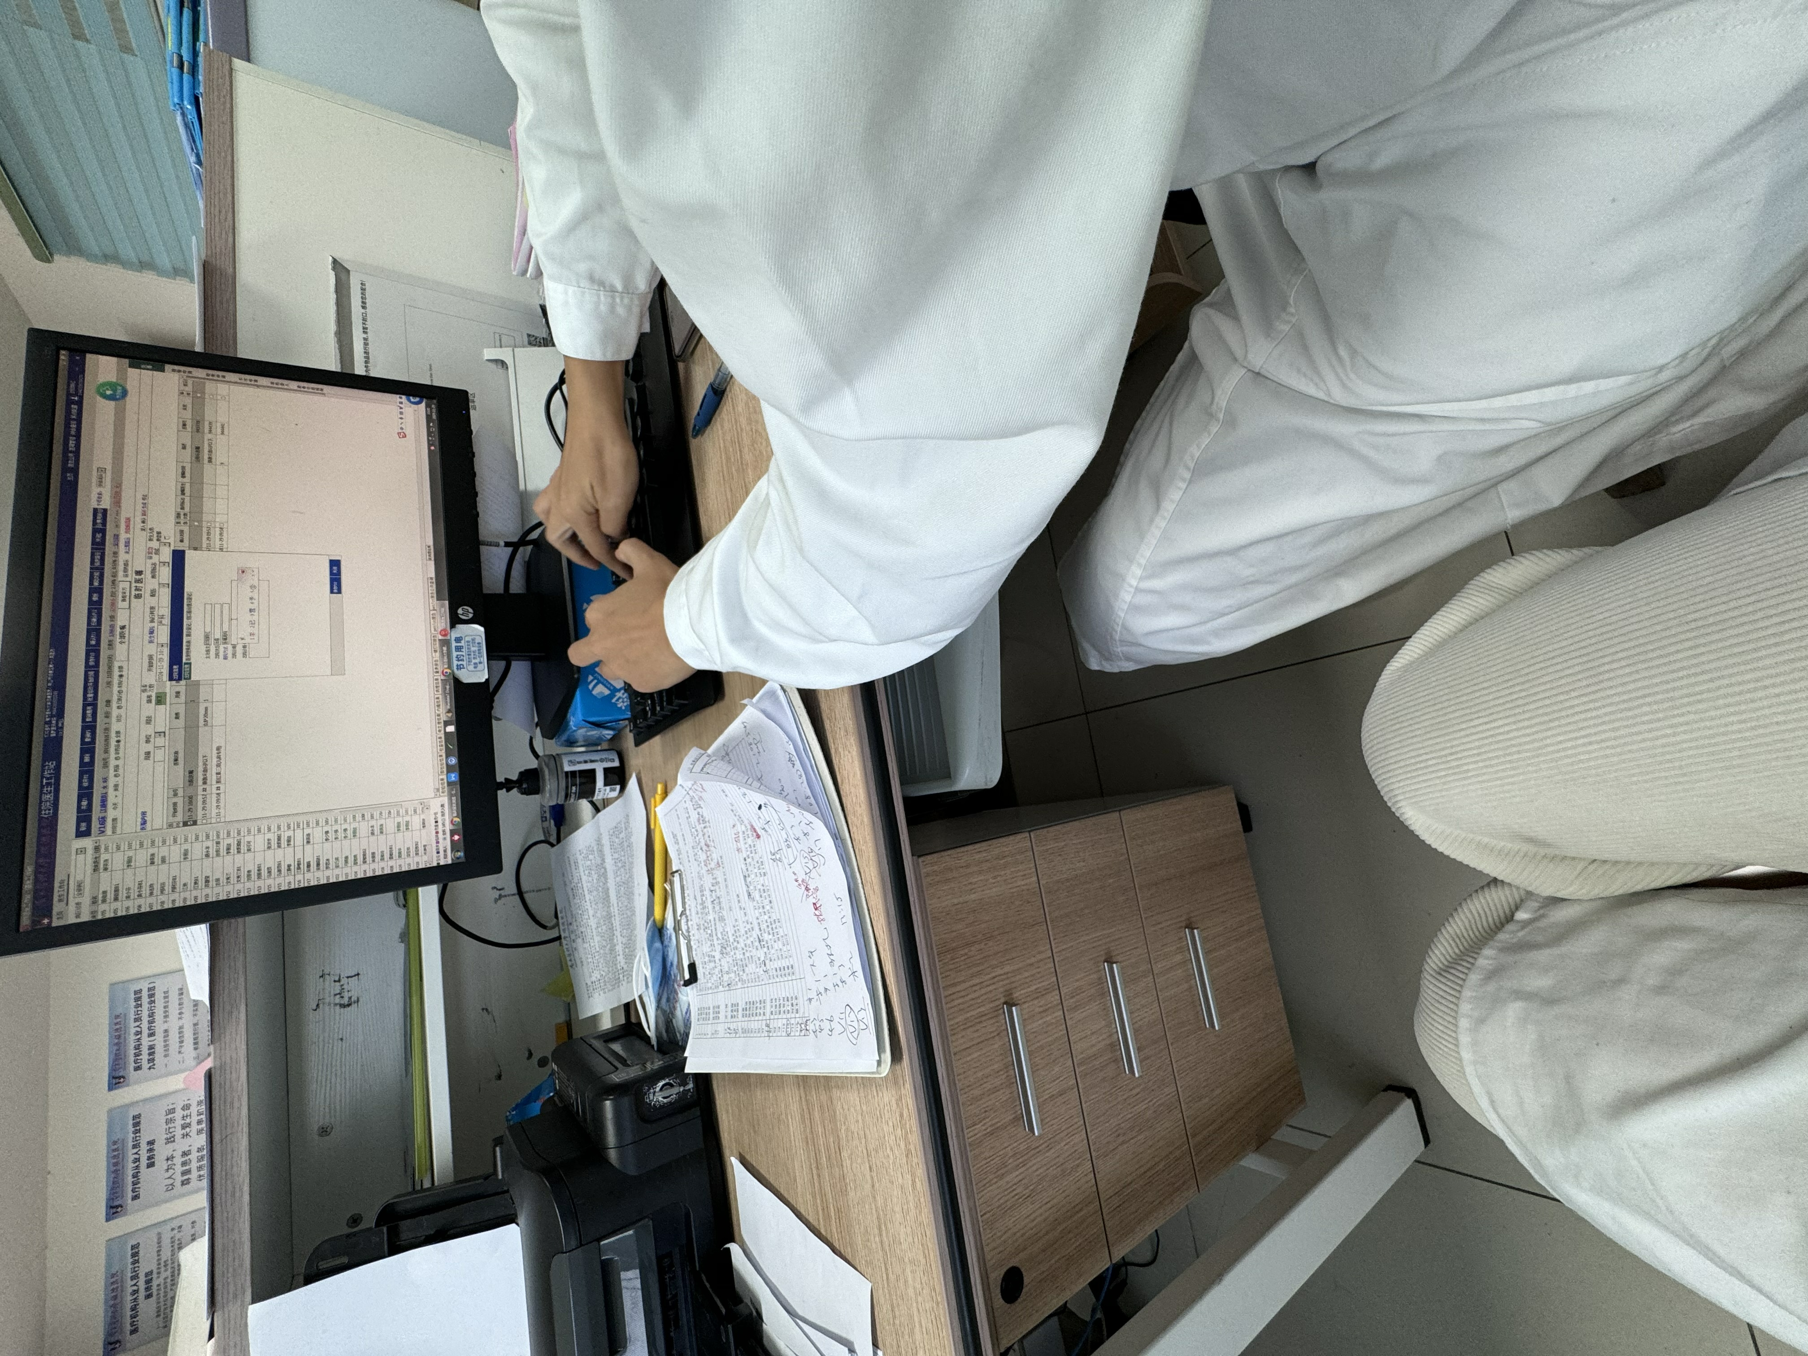

3. Reflective Report: The Weight of a "Thank You" in Emergency Observation
Author: Student 19Course Module Alignment: Emergency Department Practice & Professional IdentityKey Insight: Understanding the emotional cost of clinical work
My first emergency rotation coincided with a night shift. At 2 a.m., a traffic accident patient was wheeled in—bleeding from the forehead, screaming in pain. The nurse taught me to hold the patient’s hand while the doctor sutured: "Steady pressure helps, but so does a warm palm." I followed suit, murmuring, "It’ll be over soon—you’re doing great."
When the patient calmed down, he said, "I thought no one would care how scared I was." Later, the nurse showed me her palm—calloused from years of holding patients. "This job isn’t just skills," she said. "It’s carrying their fear for a while."
That night, I wrote in my journal: Professionalism isn’t about being "tough"—it’s about being present. The 2-hour shift felt longer than any lecture, but the patient’s hoarse "thank you" made me grasp why we need "early clinical exposure."
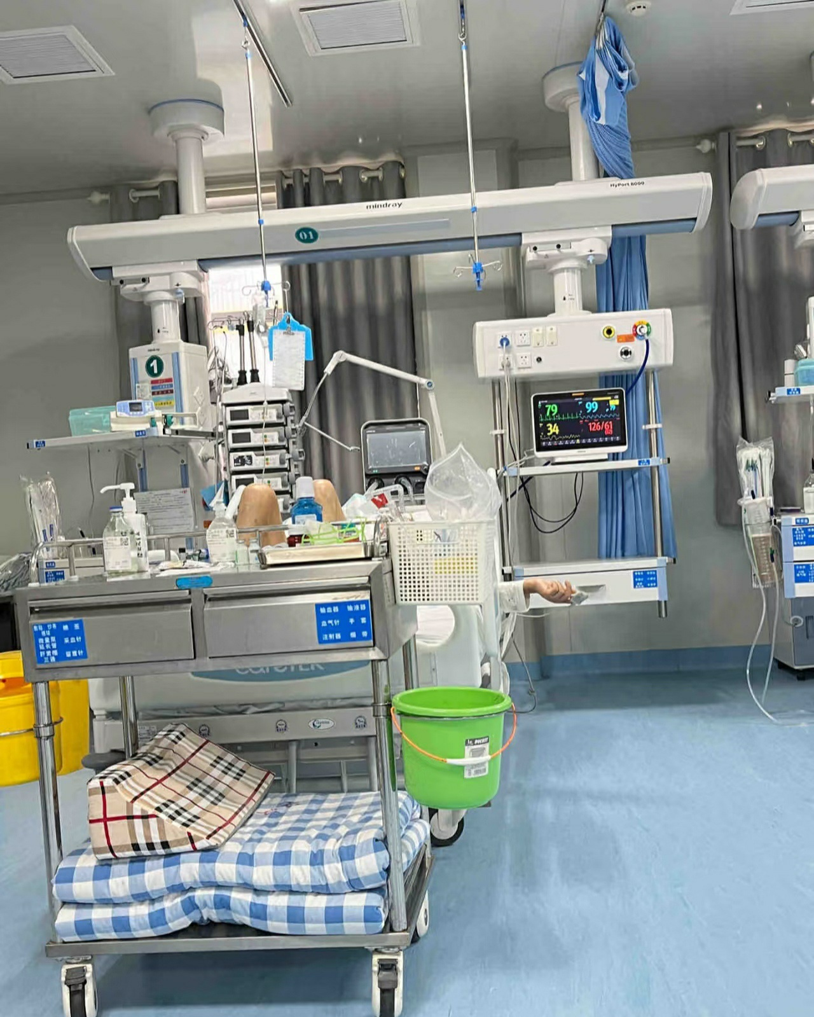

4. Reflective Report: From "Observer" to "Participant" in Community Health
Author: Student 31Course Module Alignment: Community Health Practice & Social ResponsibilityKey Insight: Connecting classroom knowledge to population health needs
In the community health outreach activity, our team was tasked with measuring blood pressure for residents. A middle-aged man refused: "I’m healthy—no need." My teammate started chatting about his garden instead: "Uncle, your roses are blooming! My grandma grows them too, but she had a stroke last year because she ignored high blood pressure."
He softened and let us measure—160/100 mmHg. We explained the risk with a leaflet: "This is like a water pipe—too much pressure hurts the pipes." We helped him set a follow-up appointment. The community doctor said, "Health education works when it’s personal, not preachy."
I realized: Clinical work isn’t limited to hospitals. Our course’s community module teaches us to meet people where they are. Holding the blood pressure cuff, I stopped feeling like a "student" and started feeling like part of the health team.
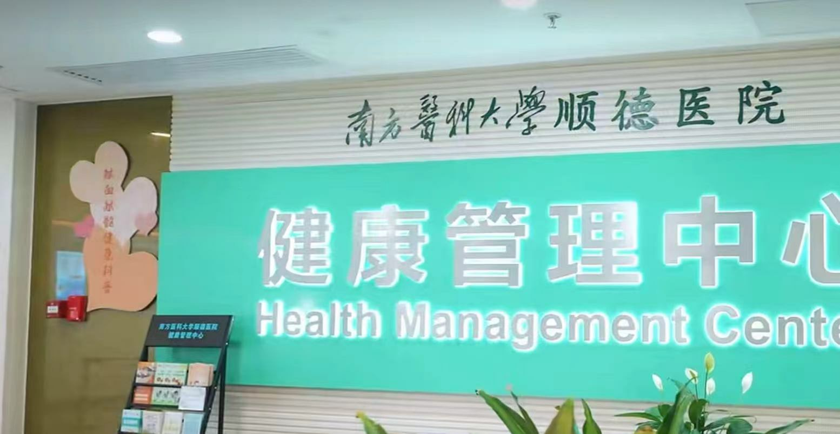

5. Reflective Report: The "Invisible" Details of Patient Dignity
Author: Student 04Course Module Alignment: Ward Rounds & Patient Care EthicsKey Insight: Recognizing dignity in routine care processes
During ward rounds, I noticed Nurse Wang always closed the curtain before helping a bedridden patient change clothes—even though the patient was comatose. I asked why, and she said: "Dignity doesn’t depend on whether someone is awake." Later, we assisted with oral care for the patient. Nurse Wang demonstrated holding the patient’s jaw gently, "Like you’re helping a family member."
When the patient’s daughter arrived, she said, "I was worried about her here, but seeing how you treat her, I trust you." Our instructor emphasized in the debrief: "Professional quality isn’t in grand gestures—it’s in closing the curtain, holding the jaw, the things that respect humanity."
This changed my understanding of "care": It’s not just treating illness, but honoring the person. I added this to my reflective report: Early clinical exposure lets us see the "ethics in details" that textbooks can’t teach.
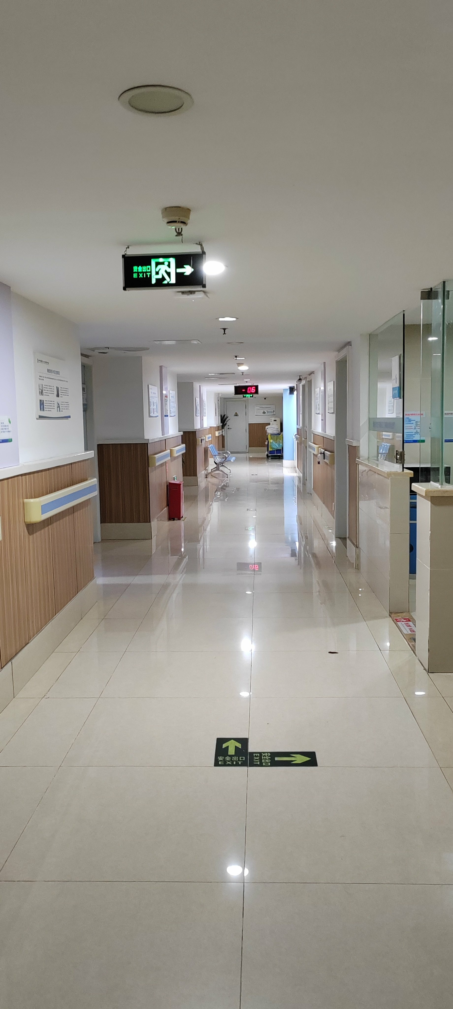

6. Reflective Report: Decoding "Confusion" in Medication Guidance
Author: Student 15Course Module Alignment: Pharmacy Practice & Health LiteracyKey Insight: Translating professional language to patient understanding
In the hospital pharmacy, I helped distribute medications and explain usage. A diabetic patient stared at his insulin pen and said, "I can’t do this—I’ll hurt myself." I repeated the instructor’s words: "Rotate injection sites, 90-degree angle." He still shook his head.
The pharmacist took over, grabbing an orange: "Pretend this is your thigh—pinch the skin like this, inject slowly." She let him practice on the orange, then said, "Your granddaughter is 5, right? This is easier than tying her shoelace." He laughed and succeeded on the first try.
Afterward, the pharmacist told me: "Patients don’t 'not understand'—we 'don’t explain well.' Narrative medicine is about using their life experience as a bridge." This made me rewrite my practice reflection: Effective communication is translating "medical terms" into "patient language."

