Supporting Information for
DAMV: A Symbiotic Fingerprint of AMV Unveiled from the Deep Atlantic
Jiajun Yang¹, Jianping Li^{1,2}, Qirong An^{1,2}, and Leon Hermanson³
¹ Frontiers Science Center for Deep Ocean Multi-spheres and Earth System (DOMES)/ Key Laboratory of Physical Oceanography/ Academy of the Future Ocean/ College of Oceanic and Atmospheric Sciences, Ocean University of China, Qingdao 266100, China.
² Laoshan Laboratory, Qingdao 266237, China.
³ Met Office Hadley Centre, Exeter, UK.

Corresponding author: Jianping Li (ljp@ouc.edu.cn)

Contents of this file
Figures S1 to S8
Tables S1 to S3
Introduction
This Supporting Information contains figures and tables supporting the results discussed in the manuscript. In this section, the SVD1 results derived from the observation is shown in Figure S1. And we discuss the robust SVD1 representing AMV-DAMV coupling at adjacent depths spanning from 2,500 m to 3,500 m in deep sea potential temperature field in Figures S2-3 and their detailed statistical similarities in Table S1. Figure S4 points out that the above-mentioned AMV-DAMV coupling still exists after a quadratic fit removal, indicating that their coupling is robust across different detrend methods. To draw a more robust and reliable conclusion, we introduce the AMV sub-ensemble, as Table S2 indicates, to reproduce the SVD analysis and improve the robustness of AMV-DAMV coupling in a multi-model ensemble way (Figure S5). Then, Table S3 demonstrates the robust time delay features between AMV and DAMV in reanalysis and multi-model simulations in details, pointing to form a robust asymmetric temporal loop. And Figure S6 shows the lead-lag correlation maps when DAMV leading (lagging) SST 7 (30) years, verifying that the DAMV could be served as a deep-ocean symbiotic fingerprint of the AMV in spatial pattern. Figure S7 identifies their strong coupling and time delay characteristics between AMV and DAMV in the Atlantic zonal-mean sea potential temperature profile, further proving both are mutually compatible. As for the Figure S8, it shows the ocean heat transport and its decomposition result in the MRI-ESM2-0, enhancing the robustness of conclusion that temperature-induced component of ocean heat transport plays a dominant role in the lead- lag correlation between the AMV and DAMV.

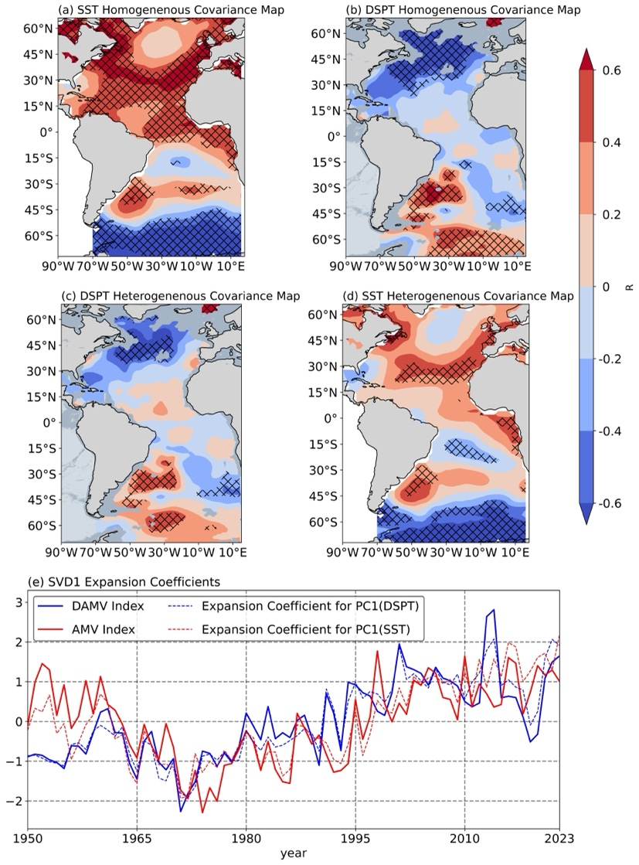
Figure S1. The leading SVD1 mode of the covariance between the SST and DSPT in the Atlantic Ocean derived from observation. The homogeneous covariance maps for (a) SST and (b) DSPT, along with the heterogeneous covariance maps for (c) SST and (d) DSPT. Crosses indicate regions significant at the 95% confidence level based on the effective number of degrees of freedom. Continents are masked in taupe, submarine topography shallower than 3,000 m is shaded in gray, and that deeper than 3,000 m deep is shaded in dark gray. (e) The annual mean time series of normalized expansion coefficients for principal component of SVD1 (PC1) of SST (dashed red line), PC1 of DSPT (dashed blue line), the AMV index (solid red line), and the DAMV index (solid blue line). The SVD1 mode accounts for 27.37% of the squared covariance fraction (SCF).

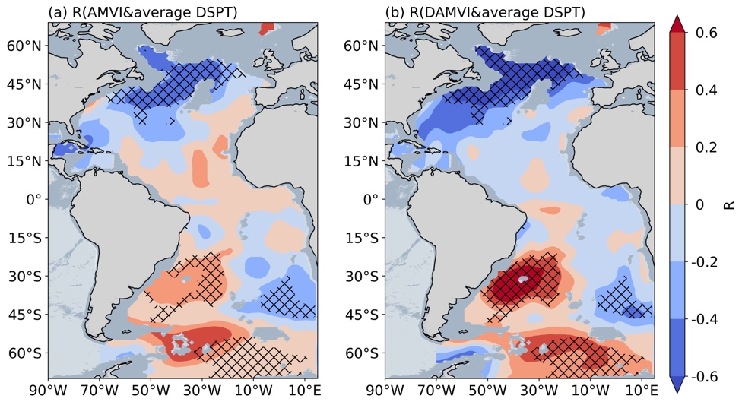
Figure S2. The coupling between AMV and DAMV in an average depth range from 2,500 m to 3,500 m. The correlation maps for (a) AMV index and average DSPT, (b) DAMV index and average DSPT. Crosses indicate regions significant at the 95% confidence level based on the effective number of degrees of freedom. Continents are masked in taupe, submarine topography shallower than 3,000 m is shaded in gray, and that deeper than 3,000 m deep is shaded in dark gray.

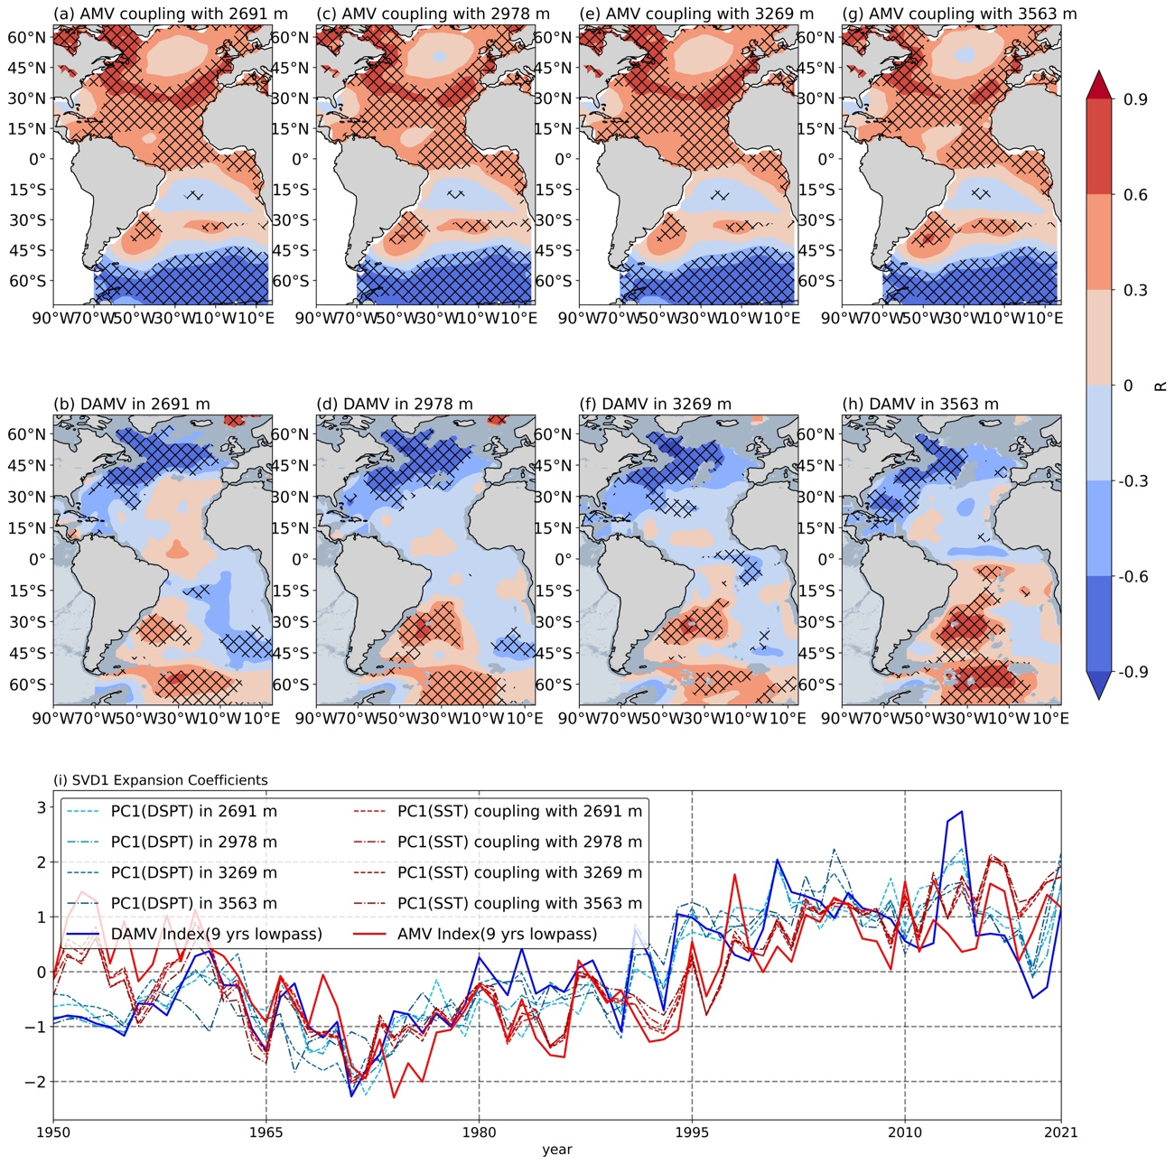

Figure S3. The leading SVD1 mode between SST and DSPT in close layers at the depths spanning from 2,500 m to 3,500 m in observation. The homogeneous covariance maps for SST coupling with (a) 2691 m, (c) 2978 m, (e) 3269 m, and (g) 3563 m. And (b), (d), (f), and (h) are the same, but for DSPT in close layer around 3,000 m. Crosses indicate regions significant at the 95% confidence level based on the effective number of degrees of freedom. Continents are masked in taupe, submarine topography shallower than 3,000 m is shaded in gray, and that deeper than 3,000 m deep is shaded in dark gray. (i) The 9-year lowpass filtered time series of normalized expansion coefficients for PC1 of SST (red lines), PC1 of DSPT (blue lines), the AMV index (dashed red line), and the DAMV index (dashed blue line). The average of SVD1 mode accounts for 24.66% of the squared covariance fraction.

Table S1. The similarities of SVD1 results derived from the different DSPT field spanning from 2,500 m to 3,500 m. Asterisk (*) represents the correlation coefficients are significant at the 95% confidence level based on the effective number of degrees of freedom (in the third column) and the large-lag standard error (in the last column).
Depths | Spatial Pattern | $$R\left(PC1,Index\right)$$ | SCF | R
2691 m | AMV-like | $0.87$* | 23.92% | 0.78*
2691 m | DAMV-like | $0.87$* | 23.92% | 0.78*
2978 m | AMV-like | $0.85$* | 26.58% | 0.78*
2978 m | DAMV-like | $0.94$* | 26.58% | 0.78*
3269 m | AMV-like | $0.89$* | 26.65% | 0.76*
3269 m | DAMV-like | $0.86$* | 26.65% | 0.76*
3563 m | AMV-like | $0.82$* | 21.48% | 0.73*
3563 m | DAMV-like | $0.82$* | 21.48% | 0.73*

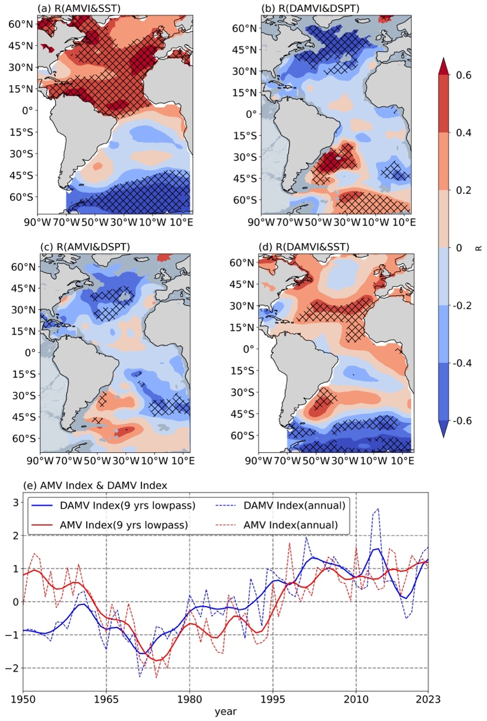
Figure S4. The coupling between AMV and DAMV based on their own indices after a quadratic fit removal for both SST and DSPT. The correlation maps for (a) AMV index and SST, (b) DAMV index and DSPT, (c) AMV index and DSPT, (d) DAMV index and SST. Crosses indicate regions significant at the 95% confidence level based on the effective number of degrees of freedom. Continents are masked in taupe, submarine topography shallower than 3,000 m is shaded in gray, and that deeper than 3,000 m deep is shaded in dark gray. (e) The 9-year lowpass filtered time series of AMV index (solid red line) and DAMV index (solid blue line). The annual mean time series of AMV index (dashed red line) and DAMV index (dashed blue line).

Table S2. The introduction of the AMV sub-ensemble from historical run in CMIP 6.
Model Name | Center/Country | Horizontal Grid  (lon×lat) | Run No.
ACCESS-CM2 | CSIRO-ARCCSS / Australia | 360 × 300 | r2
ACCESS-ESM1-5 | CSIRO / Australia | 360 × 300 | r15
CanESM5 | CCCma / China | 361 × 290 | r3
CNRM-CM6-1 | CNRM-CERFACS / France | 362 × 294 | r2
GFDL-CM4 | NOAA-GFDL / US | 1440 × 1080 | r1
GISS-E2-1-G | NASA-GISS / US | 360 ×180 | r1
INM-CM4-8 | INM / Russia | 360 ×180 | r1
MIROC6 | MIROC / Japan | 360 × 256 | r4
MPI-ESM1-2-HR | MPI-M / Germany | 802 × 404 | r1
MPI-ESM1-2-LR | MPI-M / Germany | 256 × 220 | r28
MRI-ESM2-0 | MRI / Japan | 360 × 364 | r24

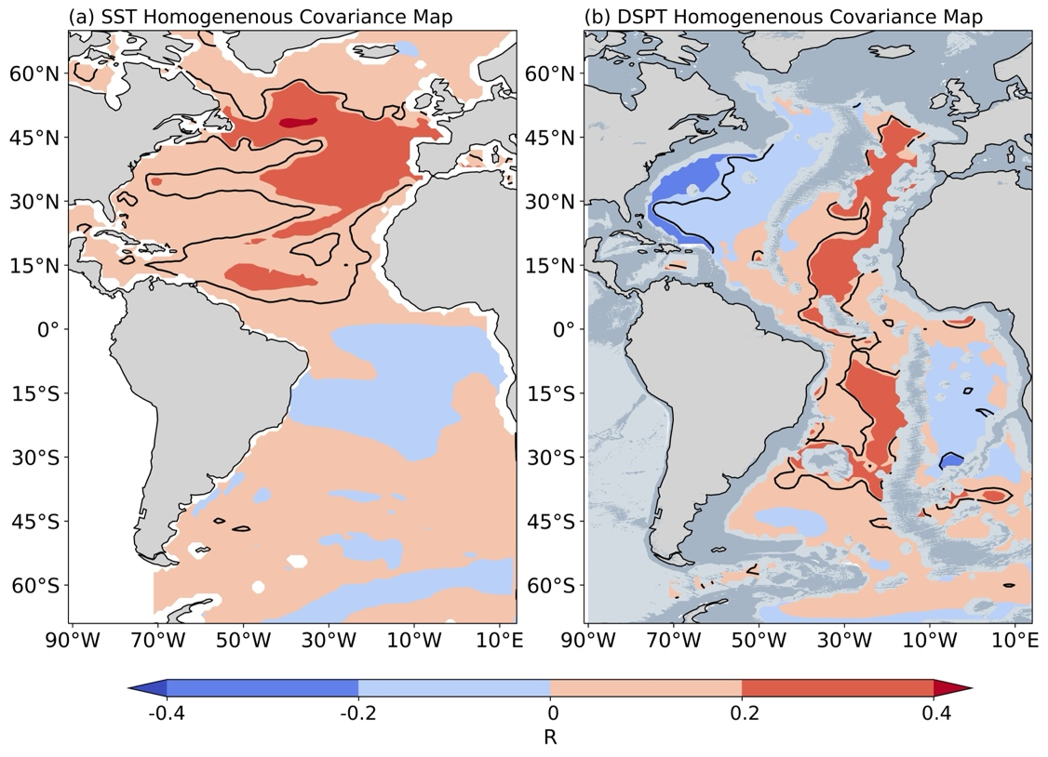
Figure S5. The leading SVD1 mode between the SST and DSPT in the Atlantic Ocean in the AMV sub-ensemble from the CMIP 6 historical runs. (a) The homogeneous covariance maps for SST. (b) The homogeneous covariance maps for DSPT. And the black solid line denotes the areas are significant at the 95% confidence level. Continents are masked in taupe, submarine topography shallower than 3,000 m is shaded in gray, and that deeper than 3,000 m deep is shaded in dark gray.

Table S3. The lead‐lag correlation results between the DAMV and AMV among observation, reanalysis, and multi-model simulations. Asterisk (*) and double asterisk (**) represent the correlation coefficients are significant at the 85% and 90% respectively, confidence level based on the effective number of degrees of freedom.
Datasets | Leading years | $$R_{max}$$ | Leading year of Maximum | Lagging years | $$R_{min}$$ | Lagging year of Minimum
Observation | 26-0 | 0.75** | 7 | 28-32 | -0.91** | 30
Reanalysis | 22-0 | 0.87** | 7 | 26-35 | -0.71** | 30
GFDL-ESM4 |  | 0.25 | 7 | 15-28 | -0.46** | 22
GFDL-CM4 | 8-0 | 0.34* | 2 | 18-22 | -0.27* | 21
MRI-ESM2-0 | 15-0 | 0.38* | 4 | 7-22 | -0.30* | 13

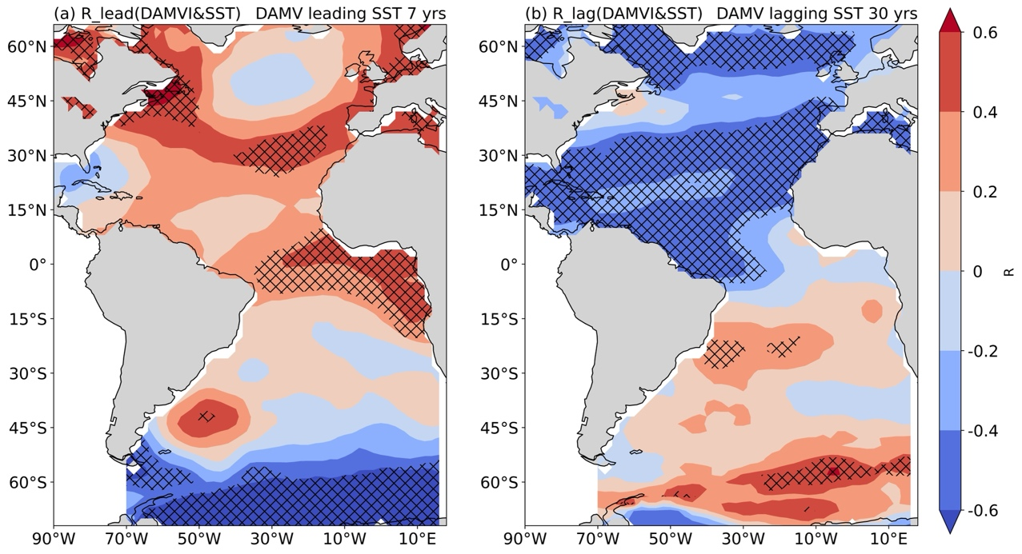
Figure S6. Lead-lag correlation maps between the DAMV and SST field. (a) The lead correlation map about the DAMV index leading the SST anomaly 7 years. (b) The lag correlation map about the DAMV index lagging the SST anomaly 30 years. The areas marked by crosses are significant at the 95% confidence level.

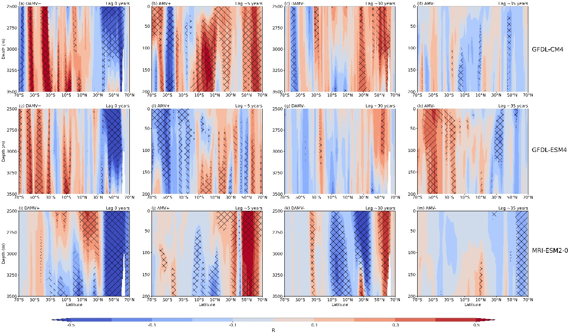

Figure S7. AMV-DAMV delayed coupling signal in Atlantic zonal mean sea potential temperature profile across multi-model simulations. (a) The correlation maps of the Atlantic zonal mean sea potential temperature with the DAMV index in the GFDL-CM4 simulation as a function of depth and latitude. (b-d) The same as (a), but for lagged correlations. (e-h) and (i-m) are as in (a-d), but for the GFDL-ESM4 (the second row) and MRI-ESM2-0 (the last row) respectively. In (a-m), a 9-99 years band-pass filtering is applied to the data prior to the correlation, and the areas marked by crosses are significant at the 90% confidence level based on the effective number of degrees of freedom.
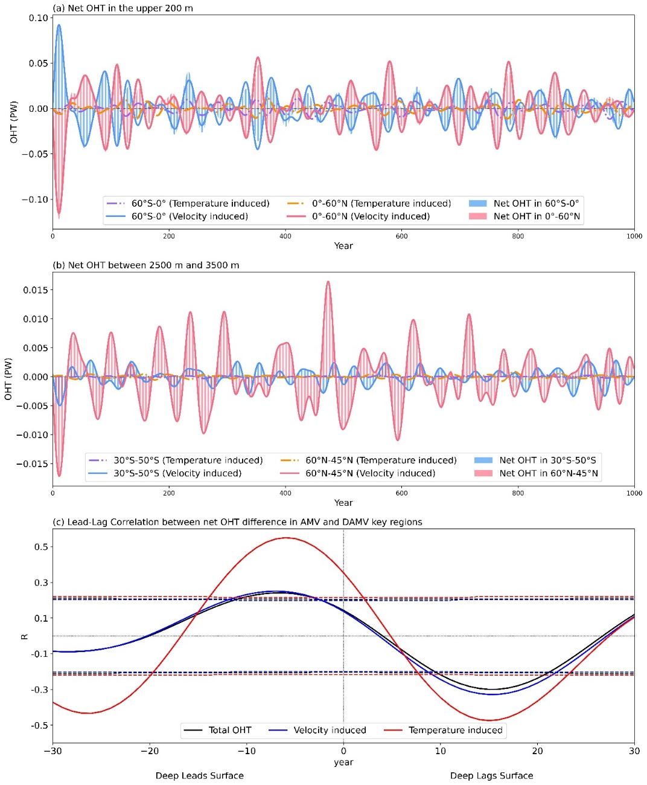

Figure S8. Temporal features of net meridional ocean heat transport among AMV and DAMV key regions for MRI‐ESM2-0. Net meridional ocean heat transport (units: PW) in (a) two key regions of AMV in the upper 200 m (north: 0°–60°N, south: 60°S–0°), and (b) two key regions of DAMV between 2500 m and 3500 m (north: 45°–60°N, south: 30°–50°S). In (a–b), red bars represent the total part of south key regions decomposed into temperature-induced component in orange solid line and velocity-induced component in red dash‐dotted line, while blue bars stand for the total part in north key regions, and purple solid line (blue dash‐dotted line) represents temperature-induced component (velocity-induced component). (c) Lead-lag correlation of net meridional ocean heat transport between the AMV North Atlantic key region and the difference between two DAMV key regions for total part in black, velocity-induced component in blue, and temperature-induced component in red. And the dashed lines denote the 90% confidence levels using the effective number of degrees of freedom. In (a–c), a 29–99 years bandpass filtering is applied to focus on the multidecadal variability.

