Online Resource for:
European Child & Adolescent Psychiatry

Adolescents at the crossroads: genetic associations between psychotic symptoms and antisocial traits

Authors:
Natalia Tesli^{1,2}, Piotr Jaholkowski², Jaroslav Rokicki^{3,4}, Andreas Jangmo⁵, Laoura Ziaka³, Viktoria Birkenæs², Alexey Shadrin², Martin Tesli^{6,7,8}, Ole A. Andreassen², Unn K Haukvik^{3,6}

Affiliations:
¹ Division of Mental Health Services, Akershus University Hospital, Lorenskog, Norway
²Centre for Precision Psychiatry, Division of Mental Health and Addiction, University of Oslo and Oslo University Hospital, Oslo, Norway
³Centre of Research and Education in Forensic Psychiatry, Oslo University Hospital, Oslo, Norway
⁴Department of Electronic Systems, Vilnius Gediminas Technical University, Vilnius, Lithuania
⁵Department of Chronic Diseases, Norwegian Institute of Public Health, Oslo, Norway
⁶Department of Mental Health and Addiction, Institute of Clinical Medicine, University of Oslo, Norway
⁷Division of Mental Health and Substance Abuse, Diakonhjemmet Hospital, Oslo, Norway
⁸Department of Mental Health, Norwegian Institute of Public Health, Oslo, Norway

Corresponding author:
Natalia Tesli, PhD
Email: natalia.tesli@ahus.no
Phone: +47 95520629
Division of Mental Health Services, Akershus University Hospital, Lorenskog, Norway
ORCID: 0000-0002-9263-3993
Table of Contents
Figure 1. 3
Note 1 3
Note 2 4
Genetic association analyses: results without transformations (raw sum scores on MoBa-questionnaires) 6
Figure 2. 6
Table 1. 6
Figure 3. 8
Table 2. 8
Genetic associations: item-level logistic models 10
Figure 4. Psychotic-like experiences. 11
Table 3. Psychotic-like experiences. 12
Figure 5. Psychopathy traits. 14
Table 4. Psychopathy traits. 15
Figure 6. Conduct disorder traits. 17
Table 5. Conduct disorder traits. 18
Figure 7. Oppositional-defiant disorder traits. 20
Table 6. Oppositional-defiant disorder traits. 21
References: 23

Figure 1.

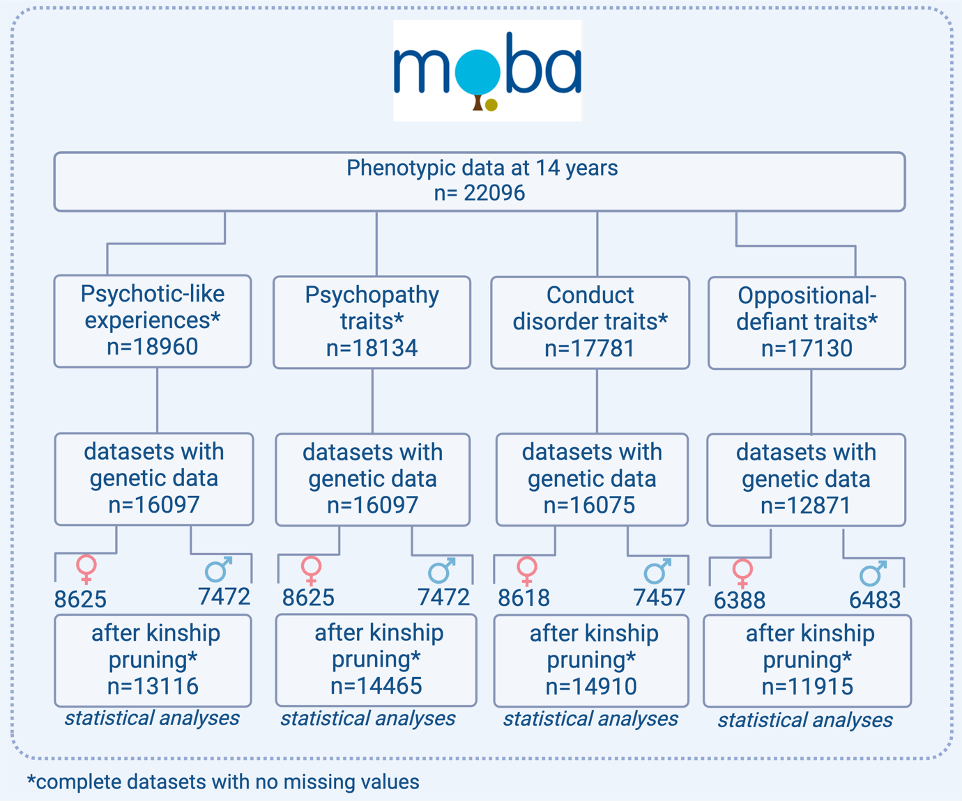

Figure 1. Participation flowchart for the genetic analyses with psychotic-like experiences (CAPE-16, frequency scale), psychopathy traits (Youth Psychopathic Traits Inventory-Short child version), conduct disorder and oppositional-defiant disorder traits (Parent/Teacher Rating Scale for Disruptive Behavior Disorders) from MoBa-questionnaires at 14 years

Note 1

Blood samples obtained from umbilical cord were sent to the Norwegian Institute of Public Health for DNA extraction and storage (https://www.fhi.no/en/publ/2012/protocols-for-moba/). The genotyping of MoBa-cohort was conducted by several research projects (https://github.com/folkehelseinstituttet/mobagen). A novel family-based pipeline was implemented to account for the complex relatedness structure of MoBa cohort, with a concurrent control of the differences resulting from the array and batch effects (MoBaPsychGen genotype quality control pipeline[1]).
The MoBaPsychGen pipeline (https://github.com/psychgen/MoBaPsychGen-QC-pipeline) includes preimputation quality control (QC), phasing, imputation, and post-imputation QC and prioritizes retaining individuals over SNPs. The analysis was restricted to the individuals of European ancestry selected based on the visual comparison of the first seven genetic principal components (PC) with PCs from 1000 Genomes phase 1 unrelated samples, as described previously. Further, to control for population stratification with selected sample, we included top 10 PCs as covariates in all regression analyses. We controlled for genetic relatedness by excluding individuals with a first or second-degree relatives in the given sample (with i.e., kinship coefficient ≥0.125 as described by Pillinger et al. [2].

Note 2

Positive psychotic-like symptoms from the MoBa-questionnaire were defined by self-report responses at 14 years. The questions were based on previously validated CAPE-15 measure (Community Assessment of Psychic Experiences) [3]. The present questionnaire contains 16 questions in total, 15 from CAPE-15 measure and 1 from CAPE-9 [4] measure. It has recently been validated in the MoBA data by our research group [5]. The selected items consist of questions related to 3 factors on positive psychotic symptom scale: persecutory ideation, bizarre experiences, and perceptual abnormalities. Each item is endorsed on two 4-point scales: the first scale is related to the frequency of a given experience (never, sometimes, often, nearly always) and the second scale is related to the degree of distress. As there were many missing values on the second scale, the analyses were confined to the first scale, i.e., frequency of a given symptom/experience. The scale included the following questions: [UB252] Do you ever feel as if things in magazines or on TV were written especially for you?; [UB254] Do you ever feel as if you are being persecuted in any way?; [UB256] Do you ever feel as if there is a conspiracy against you?; [UB258] Do you ever feel as if electrical devices can influence the way you think?; [UB260] Do you ever feel as if the thoughts in your head are not your own?; [UB262] Have your thoughts ever been so vivid that you were worried other people would hear them?; [UB264] Do you ever feel as if you are under the control of some force or power other than yourself?; [UB266] Do you ever hear voices when you are alone (not radio or TV)?; [UB268] Do you ever see objects, people or animals that other people cannot see?; [UB270] Have you ever had the feeling as if people drop hint about you, or say things with a double meaning?; [UB272] Do you ever feel as if some people are not what they seem to be?; [UB274] Do you ever feel that people look at you oddly because of your appearance?; [UB276] Have you ever felt as if the thoughts in your head are being taken away from you?; [UB278] Do you ever feel as if your own thoughts were being echoed back to you?; [UB280] Do you ever hear voices talking to each other when you are alone?; [UB282] Have you ever felt as if a double has taken the place of a family member, a friend or an acquaintance?
Psychopathy traits were measured with Youth psychopathic traits questionnaire consisting of selective items from the Youth Psychopathic Traits Inventory-Child version [6]. The questionnaire used in the present study included the following questions: [UB155] It’s easy for me to make other people do things that suit me well; [UB156] I can fool others by acting extra nice and sweet; [UB157] I am good at getting people to believe in what I make up; [UB158] It’s weak to feel guilty when you have hurt others; [UB159] It’s weak to feel nervous or worried; [UB160] Feelings are less important to me than they are for others; [UB161] It often happens that I do things without thinking ahead; [UB162] It often happens that I talk first and think later; [UB163] I think of myself as someone who does things suddenly; [UB164] I get angry at myself when I make mistakes; [UB165] I get upset when there is a single mistake in my work.
Conduct disorder traits were defined by self-report based on 8 selected items from Parent/Teacher Rating Scale for Disruptive Behaviour Disorders (RS-DBD) [7]. Each item was rated on a 6-point Likert scale from 1(never/rarely), 2 (1 time), 3 (2-4 times), 4 (5-10 times), 5 (11-20) times, to 6 (more than 20 times). The choice of 6-point scale in comparison with 4-point scale in the original RS-DBD instrument was motivated by obtaining a large variance of responses. The present study included the following questions: [UB127] Bullied, threatened or intimidated others; [UB128] Initiated physical fights; [UB129] Been physically cruel to others; [UB130] Harassed or injured animals physically; [UB131] Stolen items of nontrivial value without confronting a victim (e.g. shoplifting); [UB132] Deliberately destroyed other’s property; [UB133] Been truant from school; [UB134] Used an object that can cause serious physical harm to others (e.g. a bat, stone, knife, heavy toy). Questions from the original RS-DBD scale which were not age-appropriate, such as has forced someoen into sexual activity were removed from the current scale.
Oppositional-defiant disorder traits were defined by mothers’ responses based on 8 selected items from Parent/Teacher Rating Scale for Disruptive Behaviour Disorders (RS-DBD)[7]. Each item was rated on a 4-point Likert scale from 1(never/rarely), 2 (sometimes), 3 (often), to 4 (very often). The present study included the following questions: [UM170] Loses temper (tantrums); [UM171] Argues with adults; [UM172] Actively defies or refuses to comply with adults’ requests or rules; [UM173] Deliberately annoys people; [UM174] Blames others for his/her mistakes or misbehavior; [UM175] Is touchy or easily annoyed by others [UM176] Is angry and resentful; [UM177] Is spiteful or vindictive.
The complete documentation for study protocol at 14-years can be found here: https://www.fhi.no/globalassets/dokumenterfiler/studier/den-norske-mor-far-og-barn--undersokelsenmoba/instrumentdokumentasjon/instrument-documentation-q14_barn.pdf (instrument documentation for youth) and here: https://www.fhi.no/globalassets/dokumenterfiler/studier/den-norske-mor-far-og-barn--undersokelsenmoba/instrumentdokumentasjon/instrument-documentation-q14_mor.pdf (instrument documentation for mothers).

Genetic association analyses: results without transformations (raw sum scores on MoBa-questionnaires)

Figure 2.
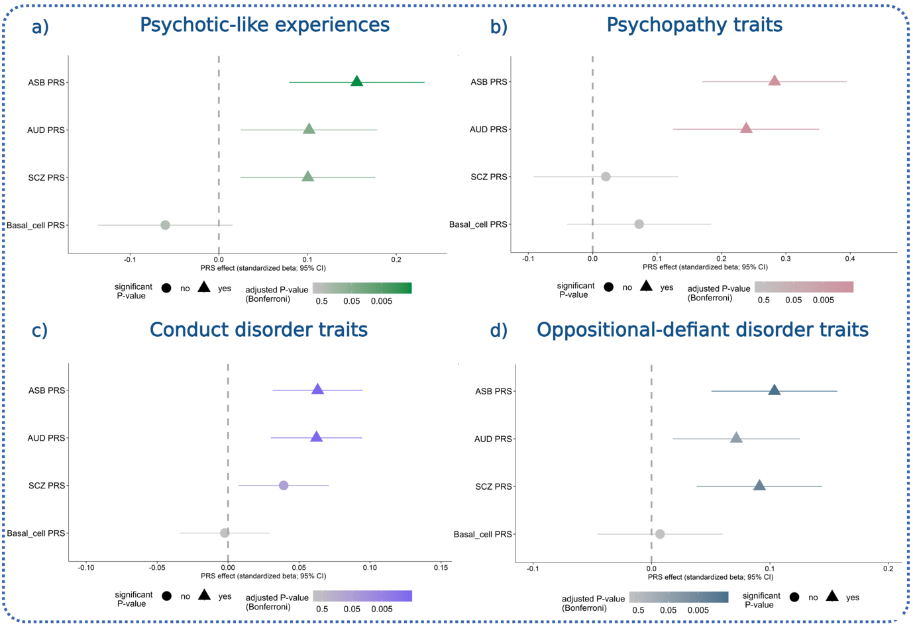
Figure 2. Associations between polygenic risk scores for schizophrenia (SCZ), antisocial behaviour (ASB), alcohol use disorder (AUD), basal cell carcinoma and psychotic-like symptoms (a), psychopathy traits (b), conduct disorder traits (c), and oppositional-definat traits (d). PRS polygenic risk score. Error bars represent the 95% confidence intervals for the estimate value. The vertical line represents an effect estimate equal to zero. All p-values corrected with Bonferroni for multiple testing for each outcome separately

Table 1.

Psychotic-like experiences (CAPE-16)
Polygenic score | PRS effect (β-value) | 95% Confidence interval | p-value
PRS SCZ | 0.10 | 0.02-0.17 | 0.038
PRS ASB | 0.15 | 0.07-0.23 | 0.0002
PRS AUD | 0.10 | 0.02-0.17 | 0.03
PRS basal cell | -0.06 | -0.13-0.15 | 0.47
Psychopathy traits (YPI-CV)
Polygenic score | PRS effect (β-value) | 95% Confidence interval | p-value
PRS SCZ | 0.02 | -0.09-0.13 | 0.99
PRS ASB | 0.28 | 0.17-0.39 | 3.15 × 10⁻⁶
PRS AUD | 0.23 | 0.12-0.35 | 1.5 × 10⁻⁴
PRS basal cell | 0.07 | -0.03-018 | 0.82
Conduct disorder traits (RS-DBD)
Polygenic score | PRS effect (β-value) | 95% Confidence interval | p-value
PRS SCZ | 0.03 | 0.007- 0.07 | 0.06
PRS ASB | 0.06 | 0.03-0.09 | 0.0003
PRS AUD | 0.06 | 0.03-0.09 | 0.0006
PRS basal cell | -0.002 | -0.03-0.02 | 1
Oppositional-defiant disorder traits (RS-DBD)
Polygenic score | PRS effect (β-value) | 95% Confidence interval | p-value
PRS SCZ | 0.09 | 0.03-0.14 | 0.003
PRS ASB | 0.10 | 0.05-0.15 | 0.0005
PRS AUD | 0.07 | 0.01-0.12 | 0.03
PRS basal cell | 0.007 | -0.04-0.06 | 1

Table 1. Associations between polygenic risk scores for schizophrenia (SCZ), antisocial behaviour (ASB), alcohol use disorder (AUD), basal cell carcinoma and psychotic-like symptoms, psychopathy traits, conduct disorder traits, and oppositional-definat traits. PRS polygenic risk score. All p-values corrected with Bonferroni for multiple testing for each outcome separately.

Figure 3.
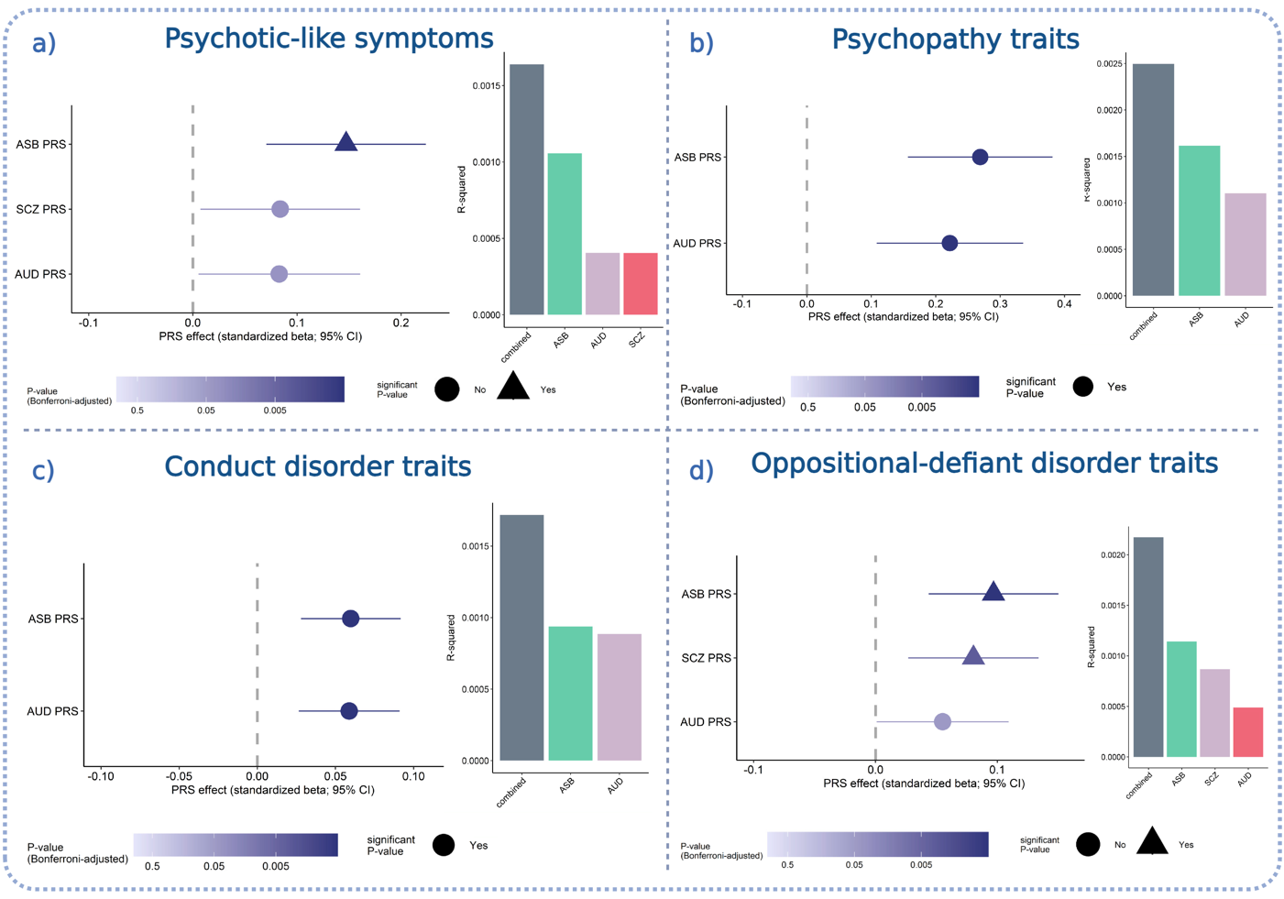
Figure 3. Multivariable linear regression models for the associations between psychotic-like symptoms (a); psychopathy traits (b); conduct disorder traits (c), oppositional-defiant disorder traits (d) and polygenic risk scores. ASB antisocial behaviour; SCZ schizophrenia; AUD alcohol use disorder; PRS polygenic score. Error bars represent the 95% confidence intervals of the estimate value. The vertical line represents an effect estimate equal to zero. R-squared is calcuated from linear regression models for the associations between the phenotypes and PRSs. All p-values corrected with Bonferroni for multiple testing for each outcome separately.

Table 2.
Psychotic-like experiences (CAPE-16)
Polygenic score | PRS effect (β-value) | 95% Confidence interval | p-value | R²
PRS SCZ | 0.08 | 0.007-0.16 | 0.09 | 0.0004
PRS ASB | 0.14 | 0.07-0.22 | 0.0003 | 0.001
PRS AUD | 0.08 | 0.005-0.16 | 0.09 | 0.0004
PRS-combined |  |  |  | 0.0016
Psychopathy traits (YPI-CV)
Polygenic score | PRS effect (β-value) | 95% Confidence interval | p-value | R²
PRS ASB | 0.26 | 0.15-0.38 | 2.64 × 10⁻⁶ | 0.0016
PRS AUD | 0.22 | 0.10-0.33 | 0.0002 | 0.0011
PRS-combined |  |  |  | 0.0024
Conduct disorder traits (RS-DBD)
Polygenic score | PRS effect (β-value) | 95% Confidence interval | p-value | R²
PRS ASB | 0.059 | 0.027-0.091 | 0.0004 | 0.0009
PRS AUD | 0.058 | 0.026-0.091 | 0.0006 | 0.0008
PRS-combined |  |  |  | 0.0017
Oppositional-defiant disorder traits (RS-DBD)
Polygenic score | PRS effect (β-value) | 95% Confidence interval | p-value | R²
PRS SCZ | 0.08 | 0.02-0.13 | 0.009 | 0.0008
PRS ASB | 0.09 | 0.04-0.15 | 0.0009 | 0.0011
PRS AUD | 0.05 | 0.001-0.10 | 0.12 | 0.0004
PRS-combined |  |  |  | 0.0021

Table 2. Multivariable linear regression models for the associations between psychotic-like symptoms; psychopathy traits; conduct disorder traits, oppositional-defiant disorder traits and polygenic risk scores. ASB antisocial behaviour; SCZ schizophrenia; AUD alcohol use disorder; PRS polygenic score. R-squared is calcuated from linear regression models for the associations between the phenotypes and PRSs.

Genetic associations: item-level logistic models

Figure 4. Psychotic-like experiences.
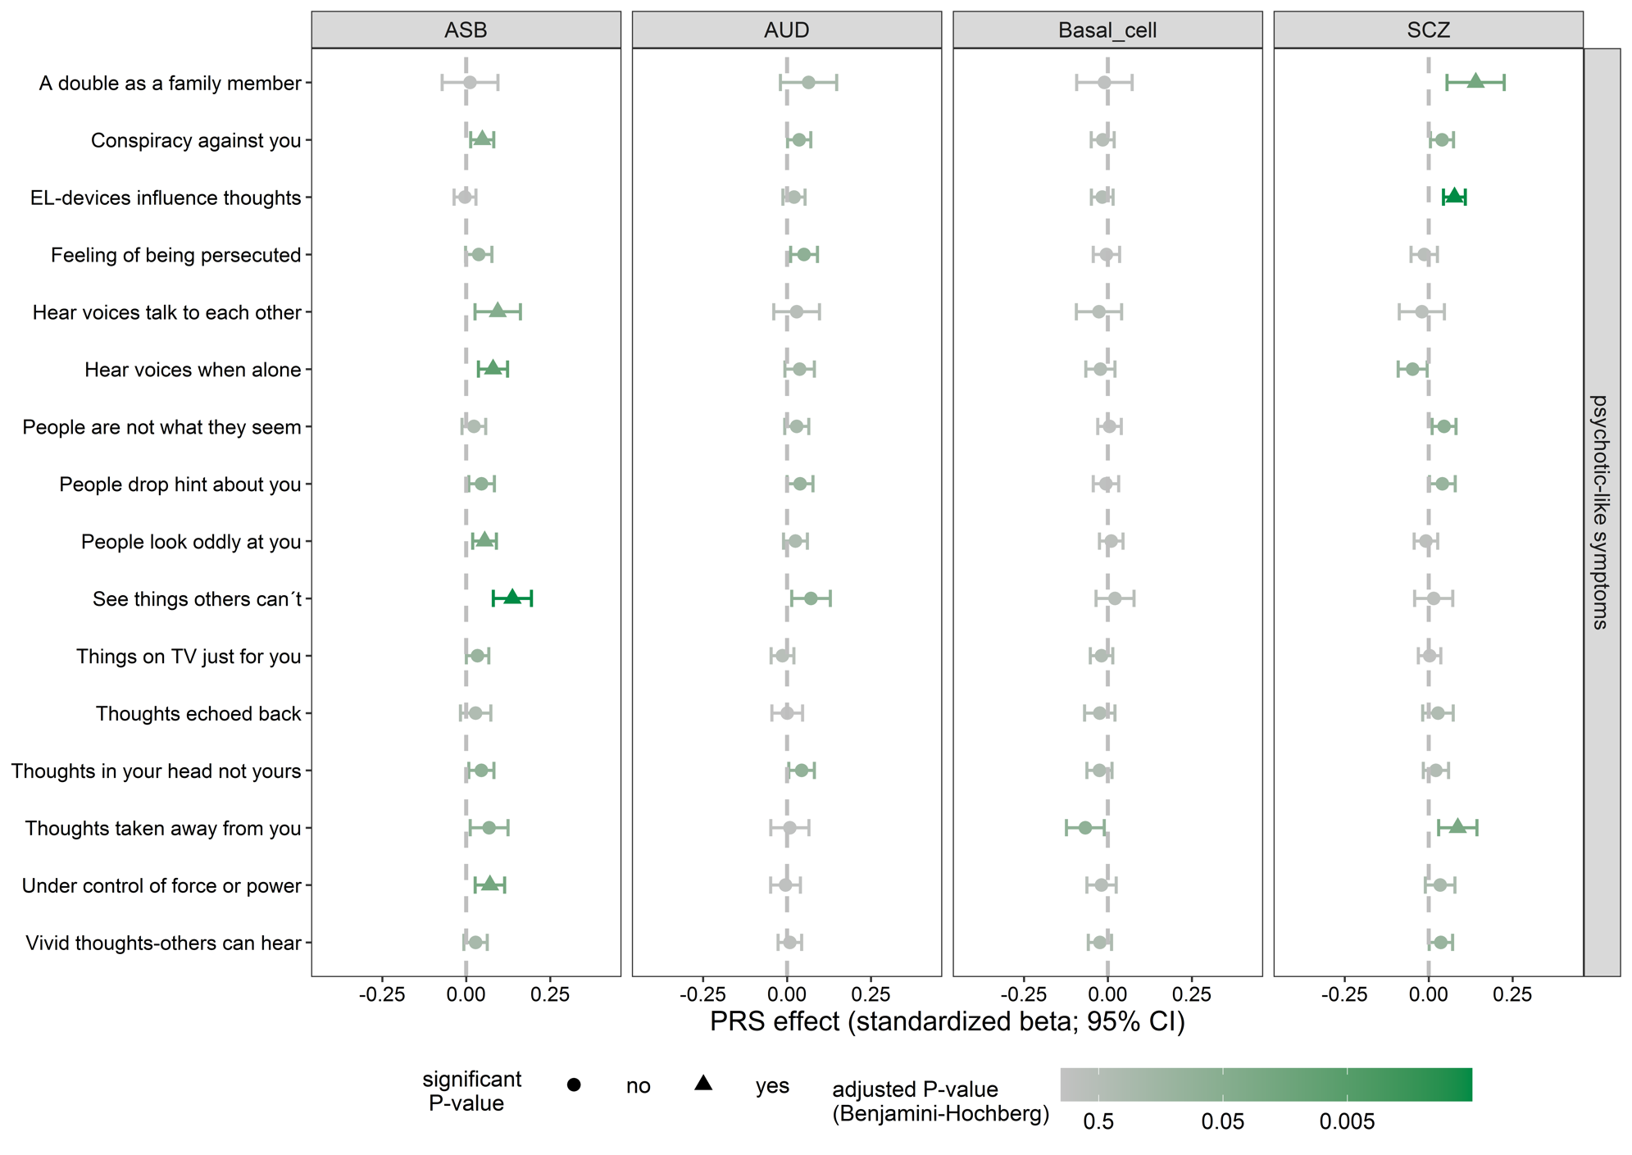
Figure 4. Logistic regression models for the associations between psychotic-like experiences (CAPE-16); and polygenic risk scores. ASB antisocial behaviour; SCZ schizophrenia; AUD alcohol use disorder; PRS polygenic risk score. Error bars represent the 95% CI of the estimate value. The vertical line represents an effect estimate equal to zero. The models included sex and the 10 first PCs as covariates. All p-values corrected with FDR for multiple testing.

Table 3. Psychotic-like experiences.

Item | Question | PRS | β-value | CI lower | CI upper | p-value
UB252 | Things on TV just for you | SCZ | 0.003 | -0.031 | 0.036 | 0.8911
UB254 | Feeling of being persecuted | SCZ | -0.013 | -0.052 | 0.026 | 0.6639
UB256 | Conspiracy against you | SCZ | 0.040 | 0.005 | 0.074 | 0.0893
UB258 | EL-devices influence thoughts | SCZ | 0.077 | 0.044 | 0.109 | 0.0001
UB260 | Thoughts in your head not yours | SCZ | 0.021 | -0.016 | 0.059 | 0.4361
UB262 | Vivid thoughts-others can hear | SCZ | 0.036 | 0.001 | 0.071 | 0.1233
UB264 | Under control of force or power | SCZ | 0.034 | -0.010 | 0.078 | 0.2843
UB266 | Hear voices when alone | SCZ | -0.048 | -0.091 | -0.005 | 0.1008
UB268 | See things others can’t | SCZ | 0.015 | -0.042 | 0.071 | 0.7533
UB270 | People drop hint about you | SCZ | 0.041 | 0.002 | 0.079 | 0.1194
UB272 | People are not what they seem | SCZ | 0.046 | 0.010 | 0.081 | 0.0727
UB274 | People look oddly at you | SCZ | -0.008 | -0.043 | 0.027 | 0.7648
UB276 | Thoughts taken away from you | SCZ | 0.086 | 0.029 | 0.144 | 0.0273
UB278 | Thoughts echoed back | SCZ | 0.028 | -0.018 | 0.073 | 0.4027
UB280 | Hear voices talk to each other | SCZ | -0.020 | -0.087 | 0.047 | 0.7093
UB282 | A double as a family member | SCZ | 0.140 | 0.055 | 0.225 | 0.0201
Item | Question | PRS | β-value | CI lower | CI upper | p-value
UB252 | Things on TV just for you | ASB | 0.034 | 0.000 | 0.067 | 0.1293
UB254 | Feeling of being persecuted | ASB | 0.037 | -0.002 | 0.076 | 0.1589
UB256 | Conspiracy against you | ASB | 0.048 | 0.014 | 0.082 | 0.0460
UB258 | EL-devices influence thoughts | ASB | -0.004 | -0.036 | 0.029 | 0.8669
UB260 | Thoughts in your head not yours | ASB | 0.045 | 0.008 | 0.083 | 0.0796
UB262 | Vivid thoughts-others can hear | ASB | 0.028 | -0.007 | 0.063 | 0.2644
UB264 | Under control of force or power | ASB | 0.071 | 0.027 | 0.114 | 0.0201
UB266 | Hear voices when alone | ASB | 0.080 | 0.036 | 0.123 | 0.0070
UB268 | See things others can’t | ASB | 0.138 | 0.081 | 0.194 | 0.0001
UB270 | People drop hint about you | ASB | 0.046 | 0.008 | 0.084 | 0.0796
UB272 | People are not what they seem | ASB | 0.023 | -0.013 | 0.058 | 0.3865
UB274 | People look oddly at you | ASB | 0.055 | 0.019 | 0.090 | 0.0247
UB276 | Thoughts taken away from you | ASB | 0.068 | 0.012 | 0.125 | 0.0796
UB278 | Thoughts echoed back | ASB | 0.028 | -0.017 | 0.073 | 0.3964
UB280 | Hear voices talk to each other | ASB | 0.094 | 0.026 | 0.161 | 0.0460
UB282 | A double as a family member | ASB | 0.011 | -0.072 | 0.094 | 0.8669
Item | Question | PRS | β-value | CI lower | CI upper | p-value
UB252 | Things on TV just for you | AUD | -0.014 | -0.047 | 0.020 | 0.5990
UB254 | Feeling of being persecuted | AUD | 0.051 | 0.011 | 0.090 | 0.0745
UB256 | Conspiracy against you | AUD | 0.036 | 0.001 | 0.071 | 0.1233
UB258 | EL-devices influence thoughts | AUD | 0.021 | -0.012 | 0.054 | 0.3960
UB260 | Thoughts in your head not yours | AUD | 0.043 | 0.005 | 0.081 | 0.0904
UB262 | Vivid thoughts-others can hear | AUD | 0.008 | -0.027 | 0.044 | 0.7648
UB264 | Under control of force or power | AUD | -0.004 | -0.049 | 0.040 | 0.8734
UB266 | Hear voices when alone | AUD | 0.038 | -0.006 | 0.082 | 0.2334
UB268 | See things others can’t | AUD | 0.071 | 0.014 | 0.129 | 0.0777
UB270 | People drop hint about you | AUD | 0.039 | 0.000 | 0.077 | 0.1293
UB272 | People are not what they seem | AUD | 0.029 | -0.007 | 0.065 | 0.2644
UB274 | People look oddly at you | AUD | 0.025 | -0.010 | 0.060 | 0.3403
UB276 | Thoughts taken away from you | AUD | 0.008 | -0.049 | 0.065 | 0.8669
UB278 | Thoughts echoed back | AUD | 0.001 | -0.045 | 0.046 | 0.9774
UB280 | Hear voices talk to each other | AUD | 0.029 | -0.039 | 0.097 | 0.5835
UB282 | A double as a family member | AUD | 0.064 | -0.020 | 0.148 | 0.2843
Item | Question | PRS | β-value | CI lower | CI upper | p-value
UB252 | Things on TV just for you | Bcell | -0.019 | -0.052 | 0.014 | 0.4361
UB254 | Feeling of being persecuted | Bcell | -0.004 | -0.044 | 0.035 | 0.8669
UB256 | Conspiracy against you | Bcell | -0.016 | -0.050 | 0.019 | 0.5554
UB258 | EL-devices influence thoughts | Bcell | -0.017 | -0.049 | 0.016 | 0.4828
UB260 | Thoughts in your head not yours | Bcell | -0.025 | -0.063 | 0.012 | 0.3641
UB262 | Vivid thoughts-others can hear | Bcell | -0.024 | -0.059 | 0.011 | 0.3582
UB264 | Under control of force or power | Bcell | -0.019 | -0.063 | 0.025 | 0.5750
UB266 | Hear voices when alone | Bcell | -0.022 | -0.066 | 0.021 | 0.4828
UB268 | See things others can’t | Bcell | 0.021 | -0.035 | 0.078 | 0.6135
UB270 | People drop hint about you | Bcell | -0.006 | -0.044 | 0.032 | 0.8669
UB272 | People are not what they seem | Bcell | 0.005 | -0.030 | 0.040 | 0.8669
UB274 | People look oddly at you | Bcell | 0.010 | -0.025 | 0.045 | 0.7218
UB276 | Thoughts taken away from you | Bcell | -0.067 | -0.123 | -0.011 | 0.0796
UB278 | Thoughts echoed back | Bcell | -0.024 | -0.069 | 0.021 | 0.4729
UB280 | Hear voices talk to each other | Bcell | -0.026 | -0.094 | 0.041 | 0.5990
UB282 | A double as a family member | Bcell | -0.010 | -0.093 | 0.072 | 0.8669

Table 3. Logistic regression models for the associations between psychotic-like experiences (CAPE-16); and polygenic risk scores. ASB antisocial behaviour; SCZ schizophrenia; AUD alcohol use disorder; PRS polygenic risk score. The models included sex and the 10 first PCs as covariates. All p-values corrected with FDR for multiple testing.

Figure 5. Psychopathy traits.
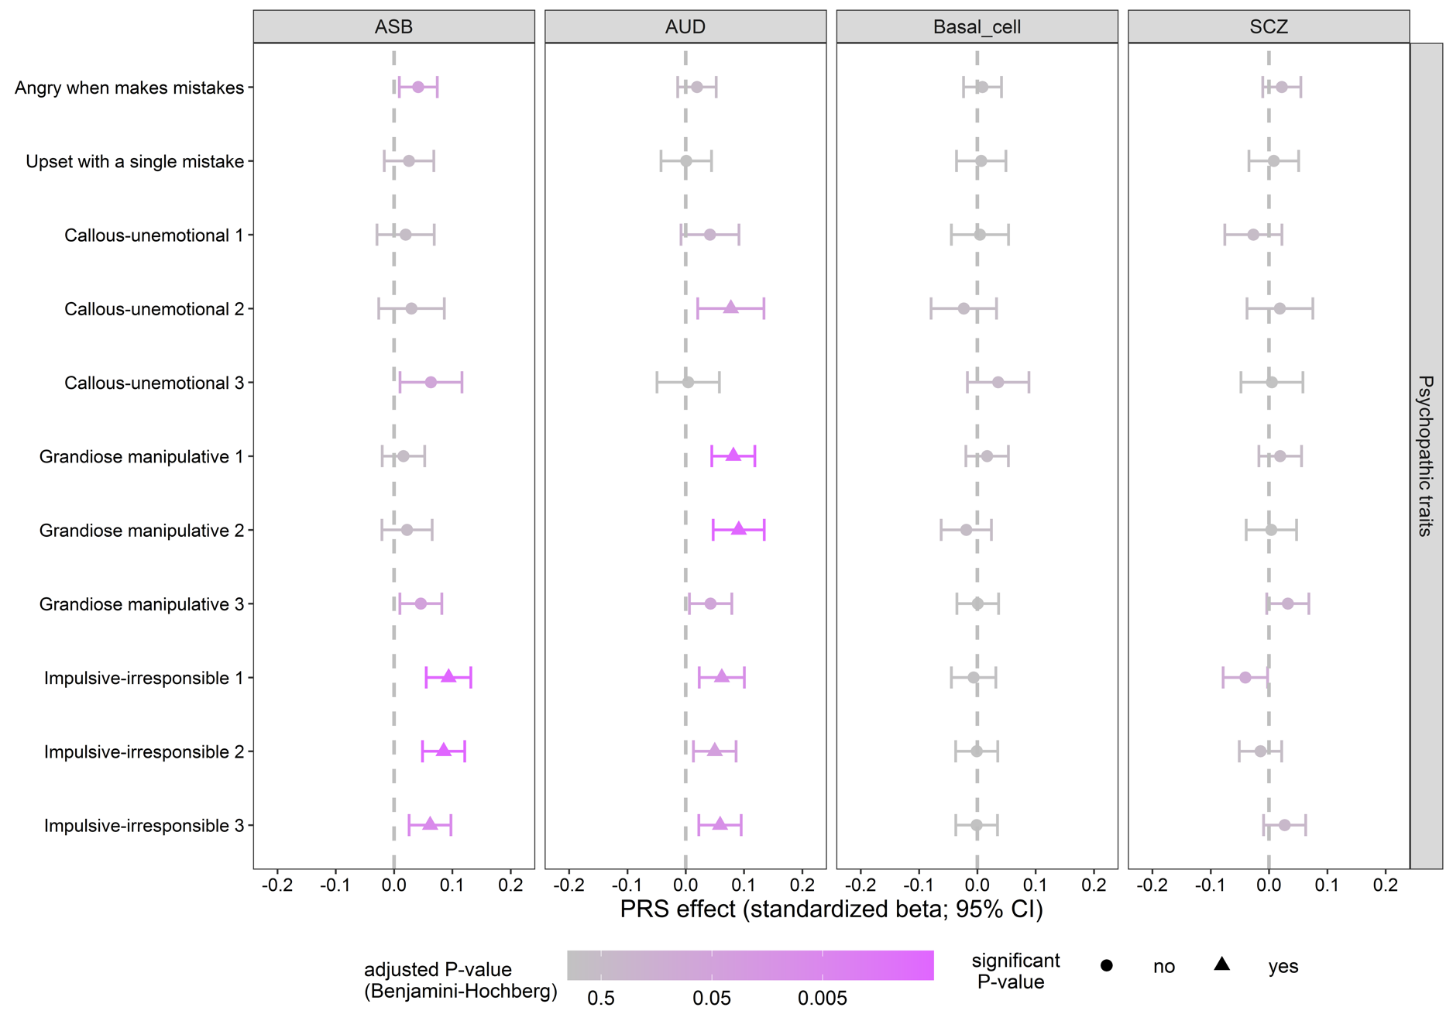
Figure 5. Logistic regression models for the associations between psychopathy traits (YPI-CV) and polygenic risk scores. Each 3 items correspond to the 3 dimensions of psychopathy (callous-unemotional, grandiose-manipulative, impulsive-irresponsible) with additional 2 items from Child and Adolescent perfection scale. ASB antisocial behaviour; SCZ schizophrenia; AUD alcohol use disorder; PRS polygenic risk score. Error bars represent the 95% CI of the estimate value. The vertical line represents an effect estimate equal to zero. The models included sex and the 10 first PCs as covariates. All p-values corrected with FDR for multiple testing.

Table 4. Psychopathy traits.
Item | Question | PRS | β-value | CI lower | CI upper | p-value
UB155 | Grandiose manipulative 1 | SCZ | 0.019 | -0.017 | 0.056 | 0.5485
UB156 | Grandiose manipulative 2 | SCZ | 0.004 | -0.039 | 0.047 | 0.9607
UB157 | Grandiose manipulative 3 | SCZ | 0.032 | -0.004 | 0.068 | 0.2316
UB158 | Callous-unemotional 1 | SCZ | -0.027 | -0.076 | 0.022 | 0.5485
UB159 | Callous-unemotional 2 | SCZ | 0.019 | -0.038 | 0.075 | 0.7084
UB160 | Callous-unemotional 3 | SCZ | 0.005 | -0.048 | 0.058 | 0.9607
UB161 | Impulsive-irresponsible 1 | SCZ | -0.041 | -0.079 | -0.002 | 0.1178
UB162 | Impulsive-irresponsible 2 | SCZ | -0.015 | -0.051 | 0.022 | 0.6117
UB163 | Impulsive-irresponsible 3 | SCZ | 0.027 | -0.009 | 0.063 | 0.3725
UB164 | Angry when makes mistakes | SCZ | 0.022 | -0.011 | 0.055 | 0.4358
UB165 | Upset with a single mistake | SCZ | 0.008 | -0.034 | 0.051 | 0.9132
Item | Question | PRS | β-value | CI lower | CI upper | p-value
UB155 | Grandiose manipulative 1 | ASB | 0.016 | -0.020 | 0.053 | 0.6080
UB156 | Grandiose manipulative 2 | ASB | 0.022 | -0.021 | 0.065 | 0.5485
UB157 | Grandiose manipulative 3 | ASB | 0.046 | 0.010 | 0.082 | 0.0504
UB158 | Callous-unemotional 1 | ASB | 0.020 | -0.029 | 0.069 | 0.6117
UB159 | Callous-unemotional 2 | ASB | 0.030 | -0.026 | 0.086 | 0.5485
UB160 | Callous-unemotional 3 | ASB | 0.063 | 0.010 | 0.116 | 0.0711
UB161 | Impulsive-irresponsible 1 | ASB | 0.093 | 0.055 | 0.132 | 7.6×10⁻⁵
UB162 | Impulsive-irresponsible 2 | ASB | 0.085 | 0.049 | 0.121 | 9.4×10⁻⁵
UB163 | Impulsive-irresponsible 3 | ASB | 0.062 | 0.026 | 0.098 | 0.0065
UB164 | Angry when makes mistakes | ASB | 0.042 | 0.009 | 0.074 | 0.0504
UB165 | Upset with a single mistake | ASB | 0.026 | -0.017 | 0.068 | 0.5227
Item | Question-item | PRS | β-value | CI lower | CI upper | p-value
UB155 | Grandiose manipulative 1 | AUD | 0.082 | 0.045 | 0.119 | 0.0002
UB156 | Grandiose manipulative 2 | AUD | 0.091 | 0.047 | 0.135 | 0.0005
UB157 | Grandiose manipulative 3 | AUD | 0.043 | 0.006 | 0.079 | 0.0721
UB158 | Callous-unemotional 1 | AUD | 0.042 | -0.008 | 0.091 | 0.2747
UB159 | Callous-unemotional 2 | AUD | 0.077 | 0.021 | 0.134 | 0.0377
UB160 | Callous-unemotional 3 | AUD | 0.004 | -0.049 | 0.058 | 0.9607
UB161 | Impulsive-irresponsible 1 | AUD | 0.062 | 0.023 | 0.101 | 0.0108
UB162 | Impulsive-irresponsible 2 | AUD | 0.050 | 0.013 | 0.086 | 0.0377
UB163 | Impulsive-irresponsible 3 | AUD | 0.059 | 0.023 | 0.095 | 0.0108
UB164 | Angry when makes mistakes | AUD | 0.019 | -0.014 | 0.052 | 0.5274
UB165 | Upset with a single mistake | AUD | 0.001 | -0.042 | 0.044 | 0.9701
Item | Question-item | PRS | β-value | CI lower | CI upper | p-value
UB155 | Grandiose manipulative 1 | Bcell | 0.017 | -0.020 | 0.053 | 0.6080
UB156 | Grandiose manipulative 2 | Bcell | -0.019 | -0.062 | 0.024 | 0.6080
UB157 | Grandiose manipulative 3 | Bcell | 0.001 | -0.035 | 0.036 | 0.9701
UB158 | Callous-unemotional 1 | Bcell | 0.004 | -0.044 | 0.053 | 0.9607
UB159 | Callous-unemotional 2 | Bcell | -0.023 | -0.079 | 0.033 | 0.6117
UB160 | Callous-unemotional 3 | Bcell | 0.036 | -0.017 | 0.088 | 0.4358
UB161 | Impulsive-irresponsible 1 | Bcell | -0.006 | -0.045 | 0.032 | 0.9288
UB162 | Impulsive-irresponsible 2 | Bcell | -0.001 | -0.037 | 0.035 | 0.9701
UB163 | Impulsive-irresponsible 3 | Bcell | -0.001 | -0.037 | 0.035 | 0.9701
UB164 | Angry when makes mistakes | Bcell | 0.009 | -0.024 | 0.041 | 0.7935
UB165 | Upset with a single mistake | Bcell | 0.007 | -0.036 | 0.049 | 0.9288

Table 4. Logistic regression models for the associations between psychopathy traits (YPI-CV) and polygenic risk scores. Each 3 items correspond to the 3 dimensions of psychopathy (callous-unemotional, grandiose-manipulative, impulsive-irresponsible) with additional 2 items from Child and Adolescent perfection scale. ASB antisocial behaviour; SCZ schizophrenia; AUD alcohol use disorder; PRS polygenic risk score. The models included sex and the 10 first PCs as covariates. All p-values corrected with FDR for multiple testing.

Figure 6. Conduct disorder traits.
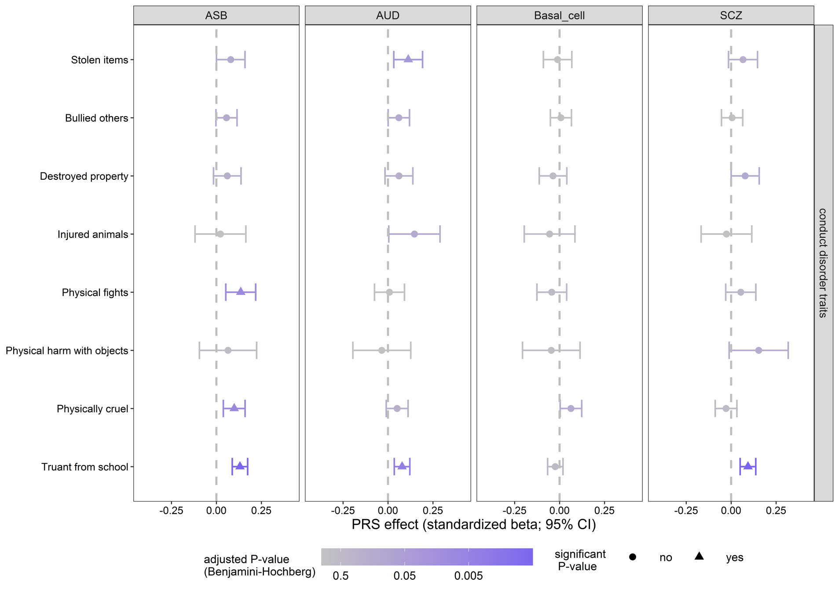
Figure 6. Logistic regression models for the associations between conduct disorder traits (RS-DBD); and polygenic risk scores. ASB antisocial behaviour; SCZ schizophrenia; AUD alcohol use disorder; PRS polygenic risk score. Error bars represent the 95% CI of the estimate value. The vertical line represents an effect estimate equal to zero. The models included sex and the 10 first PCs as covariates. All p-values corrected with FDR for multiple testing.

Table 5. Conduct disorder traits.

Item | Question | PRS | β-value | CI lower | CI upper | p-value
UB127 | Bullied others | SCZ | 0.005 | -0.054 | 0.064 | 0.8573
UB128 | Physical fights | SCZ | 0.054 | -0.030 | 0.137 | 0.3715
UB129 | Physically cruel | SCZ | -0.029 | -0.089 | 0.032 | 0.5146
UB130 | Injured animals | SCZ | -0.026 | -0.167 | 0.115 | 0.8498
UB131 | Stolen items | SCZ | 0.066 | -0.015 | 0.147 | 0.2288
UB132 | Destroyed property | SCZ | 0.078 | 0.000 | 0.156 | 0.1451
UB133 | Truant from school | SCZ | 0.093 | 0.050 | 0.137 | 0.0004
UB134 | Physical harm with objects | SCZ | 0.153 | -0.011 | 0.318 | 0.1673
Item | Question | PRS | β-value | CI lower | CI upper | p-value
UB127 | Bullied others | ASB | 0.056 | -0.002 | 0.115 | 0.1605
UB128 | Physical fights | ASB | 0.135 | 0.052 | 0.218 | 0.0089
UB129 | Physically cruel | ASB | 0.099 | 0.039 | 0.160 | 0.0089
UB130 | Injured animals | ASB | 0.023 | -0.119 | 0.164 | 0.8558
UB131 | Stolen items | ASB | 0.080 | 0.001 | 0.159 | 0.1451
UB132 | Destroyed property | ASB | 0.061 | -0.016 | 0.137 | 0.2288
UB133 | Truant from school | ASB | 0.131 | 0.088 | 0.174 | 6 ×10⁻⁸
UB134 | Physical harm with objects | ASB | 0.065 | -0.094 | 0.224 | 0.5877
Item | Question | PRS | β-value | CI lower | CI upper | p-value
UB127 | Bullied others | AUD | 0.060 | 0.001 | 0.119 | 0.1451
UB128 | Physical fights | AUD | 0.008 | -0.075 | 0.092 | 0.8573
UB129 | Physically cruel | AUD | 0.051 | -0.010 | 0.112 | 0.2288
UB130 | Injured animals | AUD | 0.147 | 0.005 | 0.290 | 0.1451
UB131 | Stolen items | AUD | 0.112 | 0.032 | 0.192 | 0.0312
UB132 | Destroyed property | AUD | 0.061 | -0.016 | 0.138 | 0.2288
UB133 | Truant from school | AUD | 0.078 | 0.035 | 0.121 | 0.0040
UB134 | Physical harm with objects | AUD | -0.034 | -0.195 | 0.127 | 0.8310
Item | Question | PRS | β-value | CI lower | CI upper | p-value
UB127 | Bullied others | Bcell | 0.007 | -0.051 | 0.066 | 0.8558
UB128 | Physical fights | Bcell | -0.043 | -0.126 | 0.039 | 0.4864
UB129 | Physically cruel | Bcell | 0.063 | 0.003 | 0.123 | 0.1451
UB130 | Injured animals | Bcell | -0.055 | -0.197 | 0.086 | 0.5877
UB131 | Stolen items | Bcell | -0.011 | -0.090 | 0.068 | 0.8558
UB132 | Destroyed property | Bcell | -0.036 | -0.113 | 0.040 | 0.5146
UB133 | Truant from school | Bcell | -0.024 | -0.066 | 0.019 | 0.4616
UB134 | Physical harm with objects | Bcell | -0.046 | -0.206 | 0.114 | 0.7307

Table 5. Logistic regression models for the associations between conduct disorder traits (RS-DBD); and polygenic risk scores. ASB antisocial behaviour; SCZ schizophrenia; AUD alcohol use disorder; PRS polygenic risk score. The models included sex and the 10 first PCs as covariates. All p-values corrected with FDR for multiple testing.

Figure 7. Oppositional-defiant disorder traits.
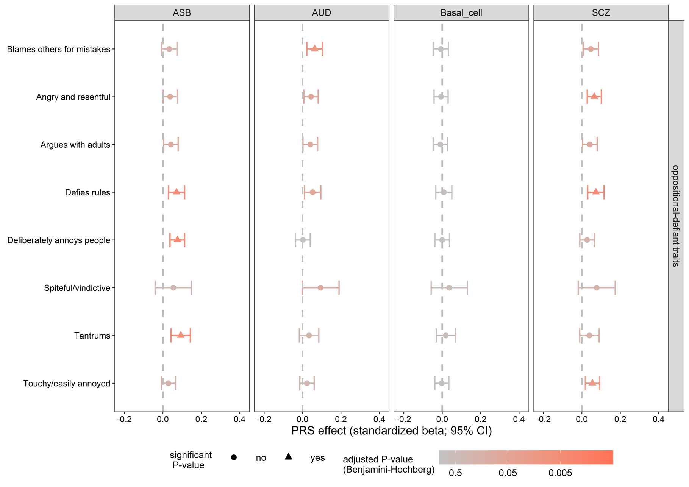
Figure 7. Logistic regression models for the associations between oppositional-defiant disorder traits (RS-DBD); and polygenic risk scores. ASB antisocial behaviour; SCZ schizophrenia; AUD alcohol use disorder; PRS polygenic risk score. Error bars represent the 95% CI of the estimate value. The vertical line represents an effect estimate equal to zero. The models included sex and the 10 first PCs as covariates. All p-values corrected with FDR for multiple testing.

Table 6. Oppositional-defiant disorder traits.

Item | Question | PRS | β-value | CI lower | CI upper | p-value
UM170 | Tantrums | SCZ | 0.039 | -0.011 | 0.090 | 0.2123
UM171 | Argues with adults | SCZ | 0.042 | 0.003 | 0.080 | 0.0867
UM172 | Defies rules | SCZ | 0.073 | 0.031 | 0.115 | 0.0056
UM173 | Deliberately annoys people | SCZ | 0.027 | -0.011 | 0.065 | 0.2540
UM174 | Blames others for mistakes | SCZ | 0.047 | 0.006 | 0.087 | 0.0749
UM175 | Touchy/easily annoyed | SCZ | 0.055 | 0.018 | 0.092 | 0.0162
UM176 | Angry and resentful | SCZ | 0.064 | 0.028 | 0.101 | 0.0056
UM177 | Spiteful/vindictive | SCZ | 0.077 | -0.019 | 0.174 | 0.2123
Item | Question | PRS | β-value | CI lower | CI upper | p-value
UM170 | Tantrums | ASB | 0.093 | 0.043 | 0.143 | 0.0048
UM171 | Argues with adults | ASB | 0.042 | 0.004 | 0.080 | 0.0867
UM172 | Defies rules | ASB | 0.071 | 0.029 | 0.113 | 0.0056
UM173 | Deliberately annoys people | ASB | 0.075 | 0.037 | 0.113 | 0.0034
UM174 | Blames others for mistakes | ASB | 0.033 | -0.007 | 0.074 | 0.2034
UM175 | Touchy/easily annoyed | ASB | 0.029 | -0.008 | 0.066 | 0.2123
UM176 | Angry and resentful | ASB | 0.038 | 0.001 | 0.075 | 0.0961
UM177 | Spiteful/vindictive | ASB | 0.054 | -0.040 | 0.149 | 0.3611
Item | Question | PRS | β-value | CI lower | CI upper | p-value
UM170 | Tantrums | AUD | 0.034 | -0.017 | 0.085 | 0.2848
UM171 | Argues with adults | AUD | 0.041 | 0.002 | 0.079 | 0.0929
UM172 | Defies rules | AUD | 0.053 | 0.011 | 0.095 | 0.0574
UM173 | Deliberately annoys people | AUD | 0.002 | -0.036 | 0.040 | 0.9472
UM174 | Blames others for mistakes | AUD | 0.063 | 0.023 | 0.104 | 0.0114
UM175 | Touchy/easily annoyed | AUD | 0.023 | -0.014 | 0.061 | 0.3195
UM176 | Angry and resentful | AUD | 0.044 | 0.007 | 0.081 | 0.0687
UM177 | Spiteful/vindictive | AUD | 0.094 | -0.001 | 0.190 | 0.1127
Item | Question | PRS | β-value | CI lower | CI upper | p-value
UM170 | Tantrums | Bcell | 0.019 | -0.031 | 0.069 | 0.5845
UM171 | Argues with adults | Bcell | -0.009 | -0.047 | 0.029 | 0.7849
UM172 | Defies rules | Bcell | 0.009 | -0.033 | 0.050 | 0.8144
UM173 | Deliberately annoys people | Bcell | 0.000 | -0.038 | 0.038 | 0.9956
UM174 | Blames others for mistakes | Bcell | -0.007 | -0.047 | 0.033 | 0.8339
UM175 | Touchy/easily annoyed | Bcell | -0.002 | -0.039 | 0.035 | 0.9472
UM176 | Angry and resentful | Bcell | -0.006 | -0.042 | 0.031 | 0.8339
UM177 | Spiteful/vindictive | Bcell | 0.037 | -0.058 | 0.131 | 0.5845

Table 6. Logistic regression models for the associations between oppositional-defiant disorder traits (RS-DBD); and polygenic risk scores. ASB antisocial behaviour; SCZ schizophrenia; AUD alcohol use disorder; PRS polygenic risk score. The models included sex and the 10 first PCs as covariates. All p-values corrected with FDR for multiple testing.

References:

1. Corfield EC, Frei O, Shadrin AA, Rahman Z, Lin A, Athanasiu L, et al. The Norwegian Mother, Father, and Child cohort study (MoBa) genotyping data resource: MoBaPsychGen pipeline v.1. bioRxiv. 2022:2022.06.23.496289.
2. Pillinger T, Osimo EF, de Marvao A, Shah M, Francis C, Huang J, et al. Effect of polygenic risk for schizophrenia on cardiac structure and function: a UK Biobank observational study. Lancet Psychiatry. 2023;10(2):98-107.
3. Capra C, Kavanagh DJ, Hides L, Scott J. Brief screening for psychosis-like experiences. Schizophr Res. 2013;149(1-3):104-7.
4. Birkenæs V, Refsum Bakken N, Frei E, Jaholkowski P, Smeland OB, Tesfaye M, et al. Psychometric Properties and Diagnostic Associations of the Short-Form Community Assessment of Psychic Experiences in a Population-Based Sample of 29 021 Adult Men. Schizophrenia Bulletin. 2023;49(5):1229-38.
5. Birkenaes V, Parekh P, Hegemann L, Bakken NR, Frei E, Jaholkowski P, et al. Youth psychotic experiences: psychometric evaluation and diagnostic associations of the CAPE-16 in adolescents from the Norwegian Mother, Mather and Child Cohort. J Child Psychol Psychiatry. 2025.
6. van Baardewijk Y, Stegge H, Andershed H, Thomaes S, Scholte E, Vermeiren R. Measuring psychopathic traits in children through self-report. The development of the Youth Psychopathic Traits Inventory-Child Version. Int J Law Psychiatry. 2008;31(3):199-209.
7. Silva RR, Alpert M, Pouget E, Silva V, Trosper S, Reyes K, et al. A rating scale for disruptive behavior disorders, based on the DSM-IV item pool. Psychiatr Q. 2005;76(4):327-39.

