nature climate change

Brief Communication

Carbon Neutrality by 2060 Is Critical for Survival of Tibetan Plateau’s Largest Glacier

Contents:
Supplementary Figure 1: Flowchart of methodology.
Supplementary Figure 2: Observed global, TP and PIF temperature rising since 1940.
Supplementary Figure 3: Observed global, TP and PIF temperature rising with 11-year centered rolling mean since 1940.
Supplementary Figure 4: PIF temperature and precipitation variation relative to baseline (2000–2014) under different SSPs.
Supplementary Figure 5: Annual variation of PIF from 2000 to 2300 under different SSPs.
Supplementary Figure 6: Annual variation of PIF from the carbon neutrality to 2300 under different CNs.
Supplementary Figure 7: Spatial distribution variation of PIF under SSP2-4.5 (top) and SSP5-8.5 (bottom).
Supplementary Figure 8: Model performance validation with remote sensing DEM difference.

Supplementary Table 1: Ice velocity validation of multi-period.

Supplementary Table 2: Bias correction assessment of CMIP6 temperature (2000–2014)

Supplementary Table 3: Bias correction assessment of CMIP6 precipitation (2000–2014).

Supplementary Table 4:Bias correction assessment of CMIP6 wind (2000–2014).

Supplementary Table 5: Bias correction assessment of CMIP6 relative humidity (2000–2014).

Fig. S1

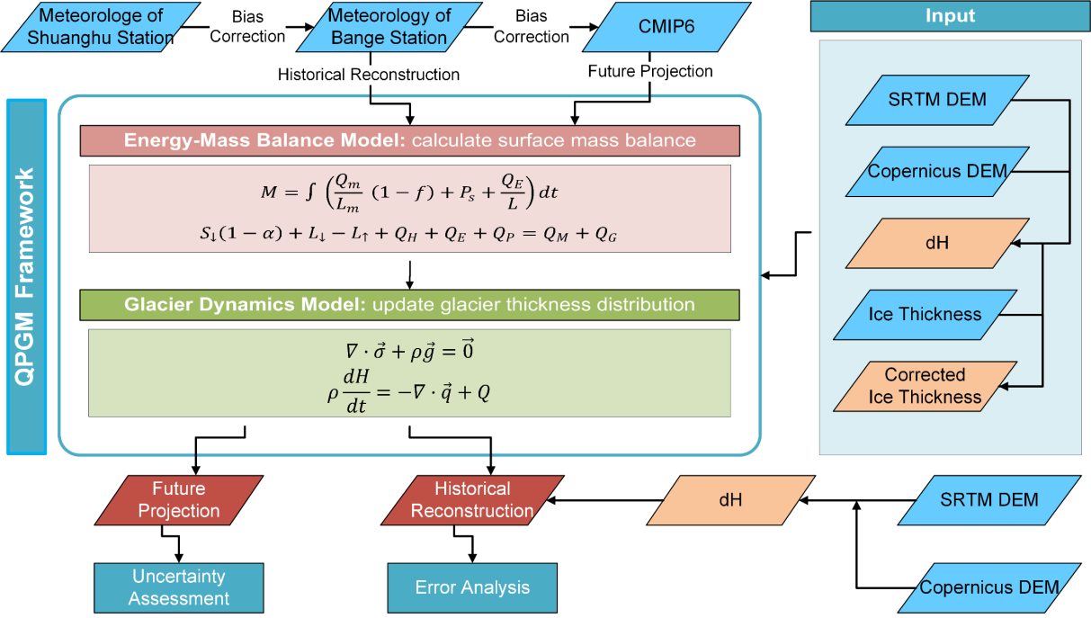
Supplementary Figure 1. Flowchart of methodology.

Fig. S2
(A) Global and TP
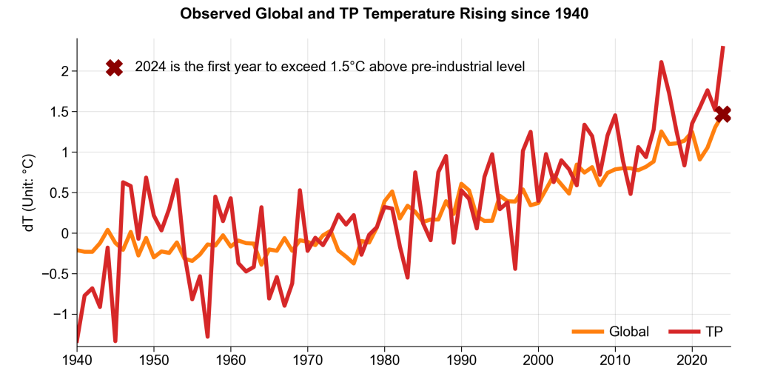
(B) Global and PIF
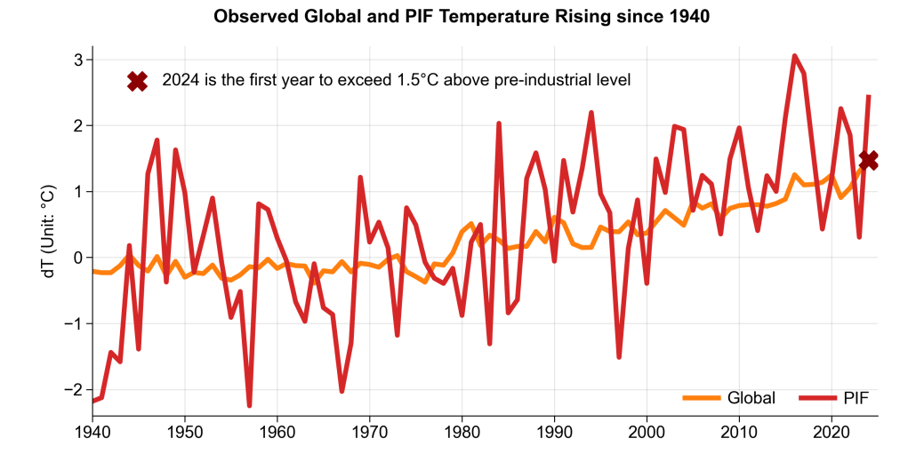
(C) Global and TP with 21-year centered rolling mean
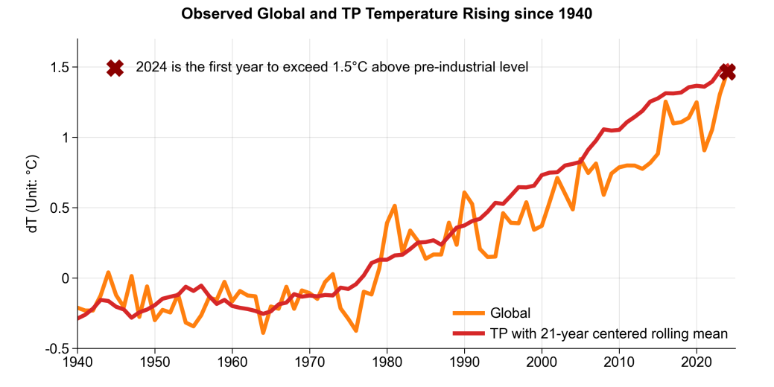
(D) Global and PIF with 21-year centered rolling mean
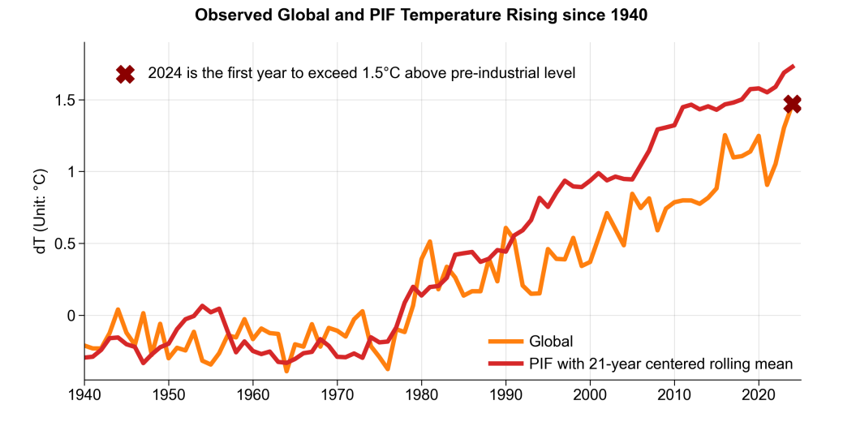
Supplementary Figure 2. Observed global, TP and PIF temperature rising since 1940.

Fig. S3
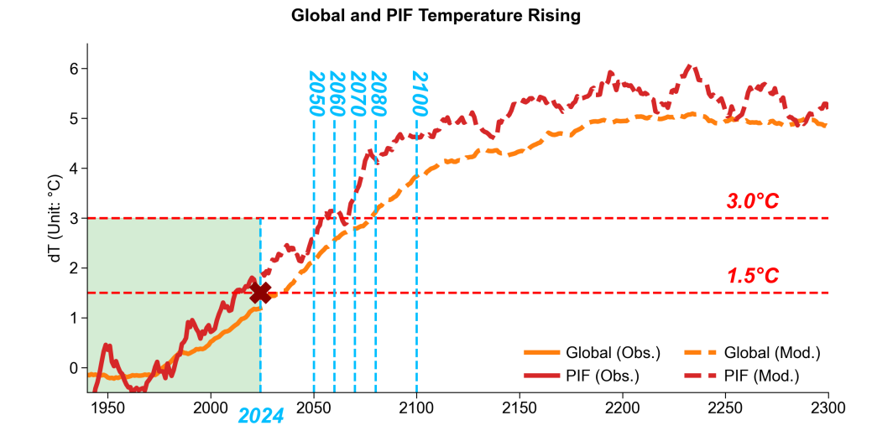
Supplementary Figure 3. Observed global, TP and PIF temperature rising with 11-year centered rolling mean since 1940 under SSP2-4.5.

Fig. S4
(A) Delta temperature relative to baseline (2000–2014)
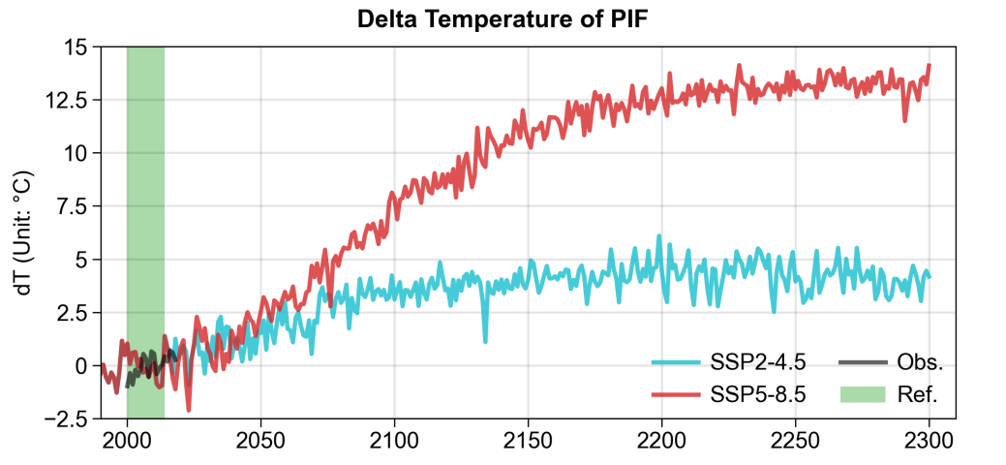

(B) Delta precipitation relative to baseline (2000–2014)
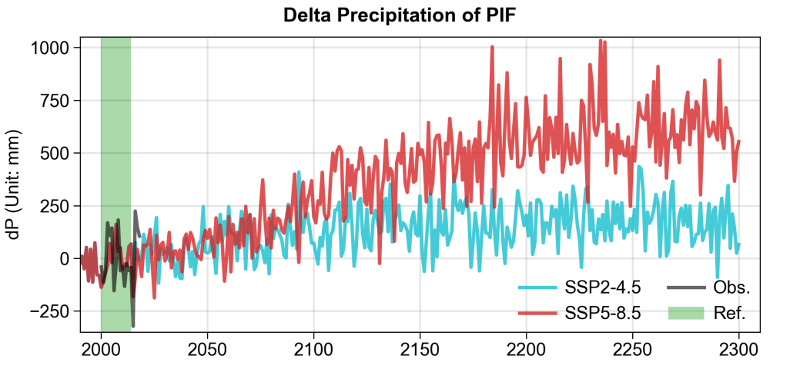
Supplementary Figure 4. PIF temperature and precipitation variation relative to baseline (2000–2014) under different SSPs.

Fig. S5
(A) Annual mass loss of PIF during 2000–2300
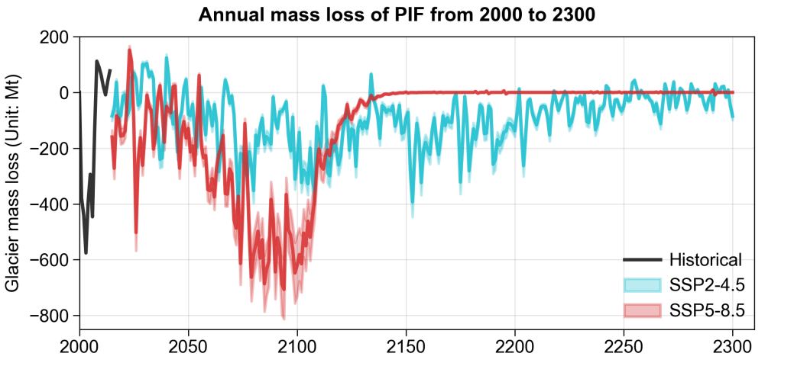
(A) Annual area loss of PIF during 2000–2300
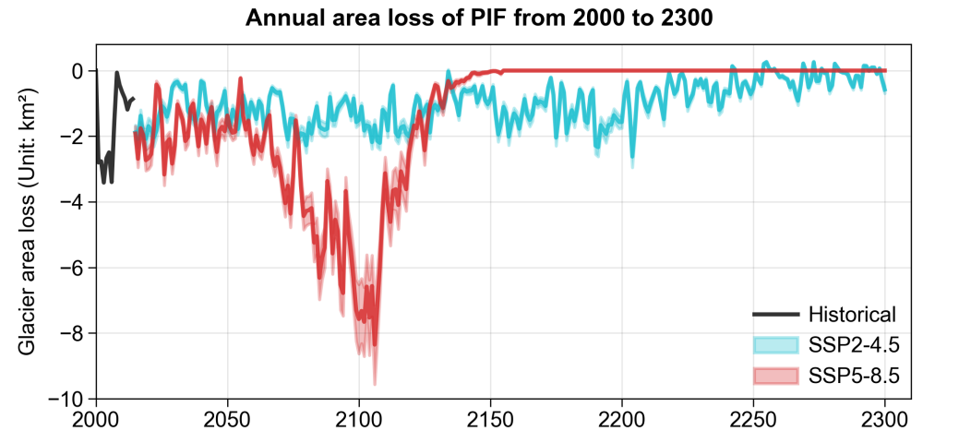
Supplementary Figure 5. Annual variation of PIF from 2000 to 2300 under different SSPs.

Fig. S6
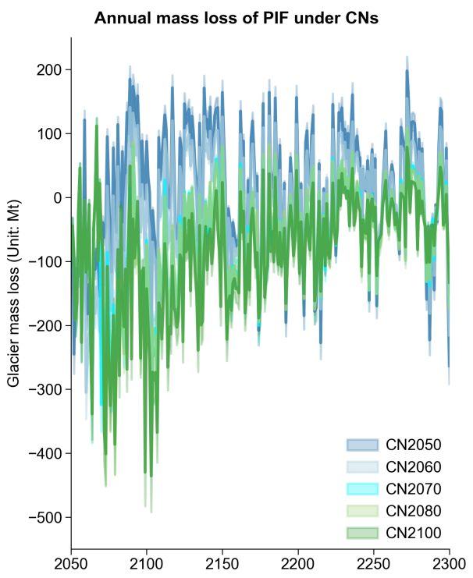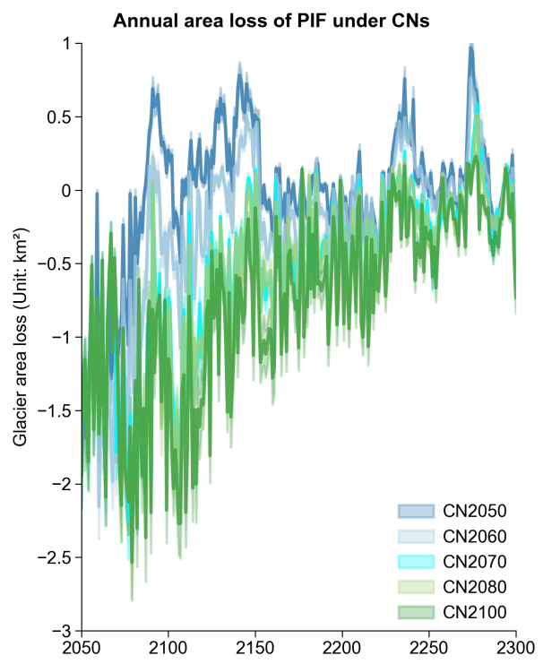
Supplementary Figure 6. Annual variation of PIF from the carbon neutrality to 2300 under different CNs.

Fig. S7
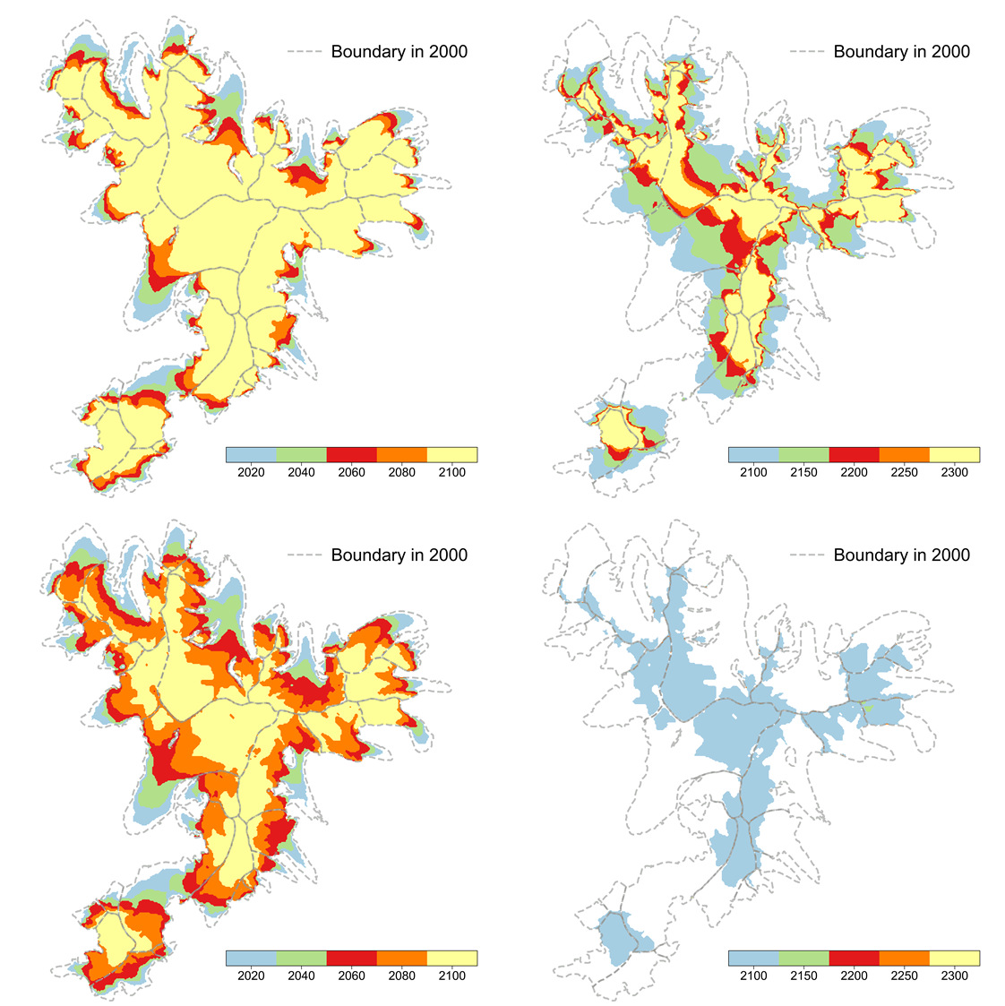
Supplementary Figure 7. Spatial distribution variation of PIF under SSP2-4.5 (top) and SSP5-8.5 (bottom).

Fig. S8
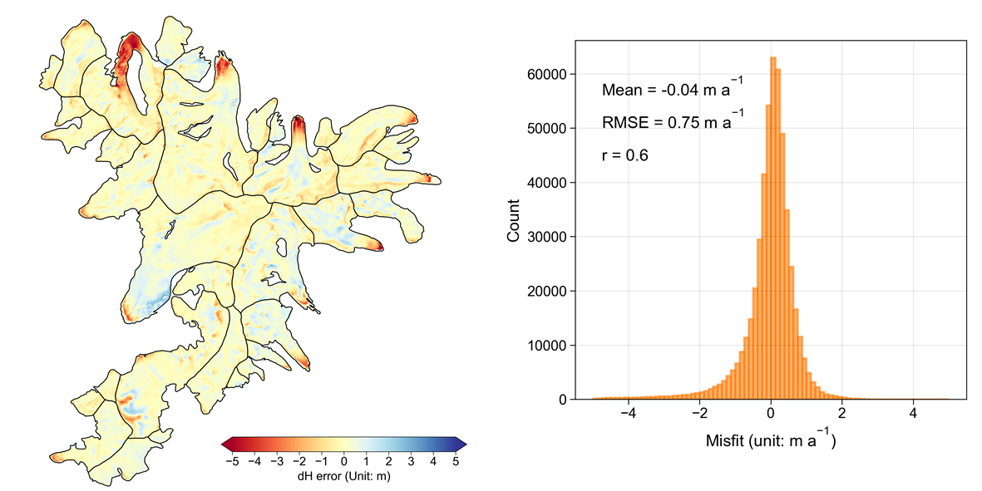
Supplementary Figure 8. Model performance validation with remote sensing DEM difference.

Table. S1
Table. S1. Ice velocity validation of multi-period.
Period | Mean velocity (m a⁻¹) | Max velocity (m a⁻¹)
2009.1–2009.3 | 1.81 | 15.01
2009 | 1.82 | 15.01
2000–2009 | 1.85 | 18.45
2000–2018 | 1.80 | 15.86

Table. S2
Table. S2. Bias correction assessment of CMIP6 temperature (2000–2014).
Index | Observation/K | Origin/K | Corrected/K
Mean | -8.5 | -1.8 | -1.8
Std | 8.5 | 6.8 | 6.9
Min | -25.1 | -14.9 | -15.1
25% | -16.0 | -8.1 | -7.8
50% | -9.7 | -2.0 | -2.2
75% | -0.6 | 4.8 | 5.0
Max | 5.0 | 8.9 | 8.9

Table. S3
Table. S3. Bias correction assessment of CMIP6 precipitation (2000–2014).
Index | Observation/mm | Origin/mm | Corrected/mm
Mean | 40.5 | 46.1 | 46.1
Std | 37.9 | 62.7 | 56.7
Min | 0.7 | 0 | 0
25% | 7.9 | 2.1 | 2.0
50% | 22.3 | 9.5 | 14.6
75% | 69.4 | 77.2 | 80.9
Max | 132.0 | 270.3 | 206.0

Table. S4
Table. S4. Bias correction assessment of CMIP6 wind (2000–2014).
Index | Observation/ms⁻¹ | Origin/ms⁻¹ | Corrected/ms⁻¹
Mean | 3.6 | 3.9 | 3.9
Std | 1.4 | 0.9 | 1.0
Min | 1.6 | 1.5 | 1.9
25% | 2.4 | 3.2 | 3.1
50% | 3.3 | 3.8 | 3.7
75% | 4.6 | 4.5 | 4.6
Max | 7.3 | 7.8 | 7.0

Table. S5
Table. S5. Bias correction assessment of CMIP6 relative humidity (2000–2014).
Index | Observation/% | Origin/% | Corrected/%
Mean | 48.9 | 43.2 | 43.2
Std | 18.1 | 17.0 | 16.4
Min | 18.2 | 14.4 | 15.9
25% | 33.0 | 28.6 | 27.8
50% | 49.0 | 42.0 | 43.5
75% | 66.5 | 59.1 | 59.0
Max | 88.5 | 74.5 | 70.0

