Supplementary Information

Amplified Ground Shaking Induced by Subterranean Gas Expansion (Time-lagged Seismic Champagne effect): Unveiling a New Geohazard Following the 2024 Noto Peninsula Earthquake

Yuji Enomoto, Shinshu University

A Aftershocks with Epicenter in Wajima City at Depth 0 km (JMA Intensity ≧3): Seismic Waveforms and amplitude spectral densities
As illustrated in Figs. 4g and 4h of the main text, in addition to the M3.6 aftershock that occurred at 17:55 JST on Jan. 1, 2024, four further aftershocks with hypocentral depths reported as 0 km and epicenters located within Wajima City were recorded, each registering a JMA seismic intensity of 3. The seismic data for these events are compiled in Table SI-1, while their waveforms, amplitude spectral density, and JMA intensity distribution maps are presented in Figs. SI-1 a-h.
These aftershocks were characterized by abrupt waveform onsets, and their acceleration spectra consistently exhibited a dominant frequency band around 10–15 Hz. Moreover, as summarized in Table 1 in the main text, the ratio of the maximum horizontal acceleration amplitude (A_{H} = √(NS² + EW²)) to the maximum vertical acceleration amplitude, A_{H}/A_{V} ratios, demonstrate that horizontal motion overwhelmingly exceeded vertical motion, a feature consistent with localized amplification processes in the shallow subsurface. Taken together, these characteristics—namely, the spectral dominance in the 10–15 Hz band and the elevated A_{H}/A_{V} ratios—strongly suggest that the subsurface instability in Wajima City, initially triggered by the aftershock at 17:21:30 through the so-called “seismic champagne phenomenon,” persisted throughout the subsequent sequence of shallow earthquakes.

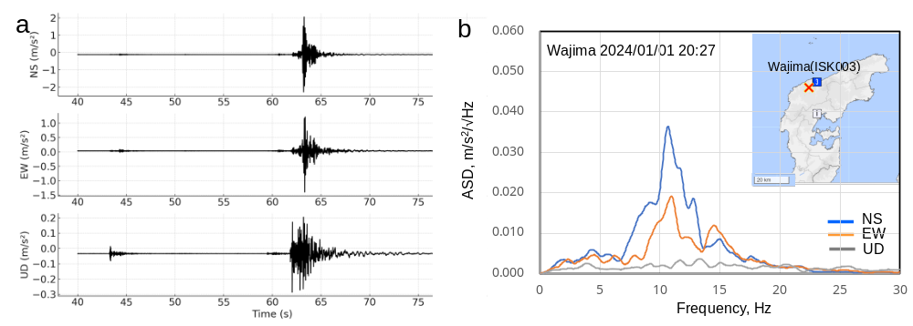

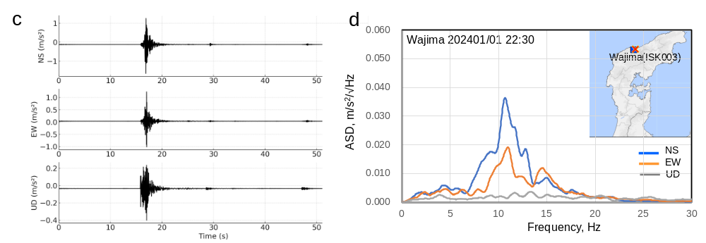

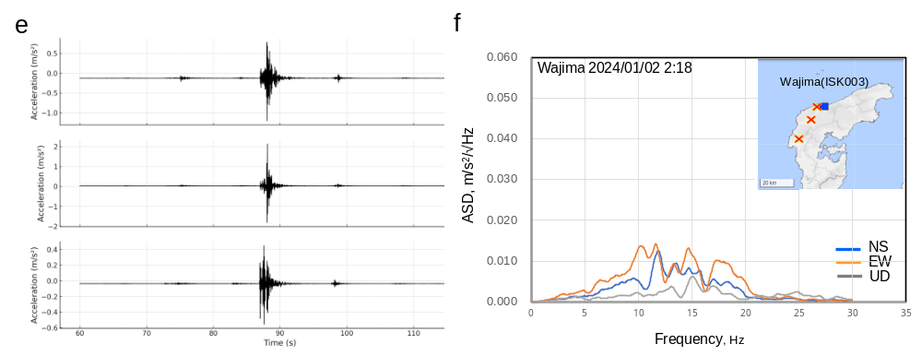

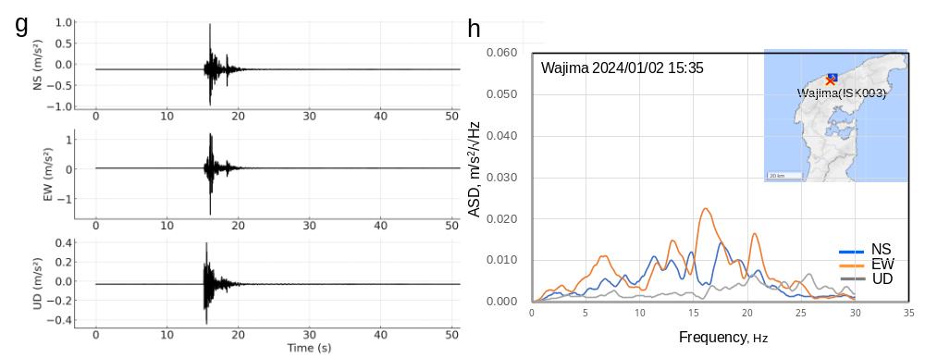

Fig. SI-1 Seismic waveforms and corresponding amplitude spectral densities (ASD) of the principal motion for representative aftershocks. a, b) M4.0 event at 20:27 JST on Jan. 1, 2024; c, d) M3.2 event at 22:30 JST on Jan. 1, 2024; e, f) M3.3 event at 02:18 JST on Jan. 2, 2024; g, h) M3.2 event at 15:36 JST on Jan. 2, 2024.

B Manhole Uplift Phenomena
To examine the hypothesis that internal pressurization by high-pressure gas accumulated within sealed manholes played a crucial role in their uplift, the conditions under which gas pressure could have induced the observed manhole displacement are estimated from a mechanical perspective. Based on specifications were determined based on data from the Japan Sewerage Works Association Standard (JSWAS A-11：chrome-extension://efaidnbmnnnibpcajpcglclefindmkaj/https://unihole.jp/files/pdf/catalog.pdf)
for precast reinforced concrete manholes used in sewer systems, the manhole structure is assumed to have the following specifications: an effective height of 1.8 m, an outer diameter of 0.95 m, a cast iron cover with a diameter of 0.6 m, and a total weight of 1,000 kg. The manhole is connected to two sewage pipes, each with a diameter of 300 mm and a connection length of 0.3m. The shear failure strength at the pipe joints is assumed to be 51.1 kN/m² ²³. The static friction coefficient between the surrounding soil and the concrete wall is taken to be 0.4. The surface area of the manhole cover subjected to internal pressure is calculated as A=π×(0.62)/4=0.283 m².
Under these conditions, the resistive forces against uplift are estimated as follows:
- Gravitational Resistance (F₁): F₁=1,000 kg×9.8 m/s²=9,800 N
- Sidewall Frictional Resistance (F₂): The sidewall contact area is π×0.95×1.8=5.37 m². The vertical earth pressure acting on the sidewalls is approximated by the average vertical stress exerted by the structure’s self-weight over the base area (π×0.952/4=0.708 m². Thus, the average vertical stress is 9,800 N/0.708 m²=13,830 Pa, and the corresponding frictional resistance is:
F₂=0.4×13,830×5.37=29,700 N.
- Shear Resistance at Pipe Connections (F₃): The combined shear area for two pipes is 0.942×0.3×2=0.565 m², yielding a shear resistance of:
F₃=51,100×0.565=28,900 N
- Total Resistance Force (F): F=F₁+F₂+F₃=9,800+29,700+28,900=68,400 N
To overcome this resistance via internal gas pressure acting on the manhole cover, the required pressure is: P=68,400/0.283=241,690 Pa. Adding atmospheric pressure (101,325 Pa), the total gas pressure required to lift the manhole becomes: P_{gas}=241,690+101,325=343,015 Pa.

