Supporting Information
Synergistic Catalysis: Sodium Perborate-Mediated Advanced Oxidation Processes Coupled with MIL-88B(Fe) for Photocatalytic Degradation of Methylene Blue
Dongjie He, Xin Li, Nuo Xu, Yimeng Gu, Jiabo Wang, Peng He, Qun Liu*, Yu Zhang*
School of Petrochemical Technology, Jilin University of Chemical Technology, Jilin 132022, China;
Corresponding author E-mail addresses: qunliu@jlict.edu.cn (Q. Liu), zhang99yu@jlict.edu.cn (Y. Zhang)
Text S1. Material
Ferric chloride hexahydrate (FeCl₃·6H₂O), 1,4-benzenedicarboxylic acid (H₂BDC), N, N-dimethylformamide (DMF), sodium hydroxide (NaOH), ethanol (C₂H₆O), Sodium perborate tetrahydrate (NaH₄B₂O₈) and methylene blue (MB) were purchased from Sinopharm Chemical Reagent Co., Ltd. (Beijing, China). Sodium hydroxide (NaOH) was purchased from Aladdin Reagent Co., Ltd. (Shanghai, China), and methanol (CH₃OH) was obtained from Macklin Biochemical Technology Co., Ltd. (Shanghai, China). Hydrochloric acid (HCl), tert butanol (TBA), benzoquinone (BQ), sodium azide (NaN3) disodium ethylenediaminete traacetic acid (EDTA-2Na), Sodium dihydrogen phosphate (NaH₂PO₄), anhydrous sodium sulfate (NaSO₄), copper nitrate (Cu(NO₃)₂) and potassium chloride (KCl) were purchased from Shanghai Titan Technology Co., Ltd and Merck (Germany).
Text S2. Preparation of MIL-88B(Fe)
Typically, ferric chloride hexahydrate (FeCl₃·6H₂O, 2.70 g) and terephthalic acid (H₂BDC, 1.16 g) were dispersed in N, N-dimethylformamide (DMF, 50 mL) under continuous magnetic stirring. Subsequently, NaOH solution (4 mL, 2.0 mol·L⁻¹) was added dropwise, and the mixture was stirred vigorously for 30 minutes. The resulting homogeneous solution was then transferred into a Teflon-lined stainles steel autoclave and heated at 100 °C for 12 hours in a convection oven. After naturally cooling to room temperature, the product was collected by centrifugation to remove the solvent. The obtained solid powder was thoroughly washed with deionized water under continuous stirring for 12 hours to eliminate residual DMF. The product was further purified by repeated washing cycles (three times each) with ultrapure water and ethanol, followed by centrifugation. Finally, the precipitate was vacuum-dried at 80°C overnight, yielding a reddish-brown MIL-88B(Fe) powder.
Text S3. Characterization
The X-ray diffraction spectrum can be measured on the Empyrean Razor (Netherlands) diffractometer in the range of 5°-55°. The infrared spectrum can be tested on the Alpha Centaurt FT-IR spectrophotometer, spectroscopic analysis was conducted with a wave number range of 4000-500 cm⁻¹. N₂ adsorption measurements were conducted on the automatic volumetric adsorption equipment (BELSORP-mini II). Prior to analysis, all samples were vacuum-degassed for 4 hours at 393K. The morphology of the material was observed using a scanning electron microscope (JSM-7610F Plus, Japan). The surface electronic states were analyzed by X-ray photoelectron spectroscopy (XPS, Al Kα, Thermo Fisher Scientific, USA). UV-Visible diffuse reflectance spectroscopy (UV-Vis DRS) was performed using BaSO₄ as a reflectance standard to determine the optical absorption properties of the material. Photoluminescence (PL) spectra were recorded on a fluorescence spectrophotometer (F-7000) with an excitation wavelength of 345 nm. The electron paramagnetic resonance (EPR) spectra were recorded on a Bruker ELEXSYS E500 spectrometer operating at X-band under ambient conditions. Electrochemical measurements, including electrochemical impedance spectroscopy (EIS), photocurrent response (I-t), Mott-Schottky analysis and Linear sweep cyclic voltammetry test (LSV) were conducted using a standard three-electrode system connected to a CHI electrochemical workstation. For the preparation of the photoanode, the photocatalyst was dispersed in a Nafion solution (10 mg·mL⁻¹) and ultrasonicated for 1 h to ensure homogeneity. Subsequently, 0.2 mL of the colloidal suspension was drop-cast onto a glass substrate and dried under ambient conditions. The photoelectrochemical tests were carried out in an aqueous Na₂SO₄ electrolyte under simulated solar irradiation using a 300 W Xe lamp equipped with a 420 nm UV-cutoff filter.
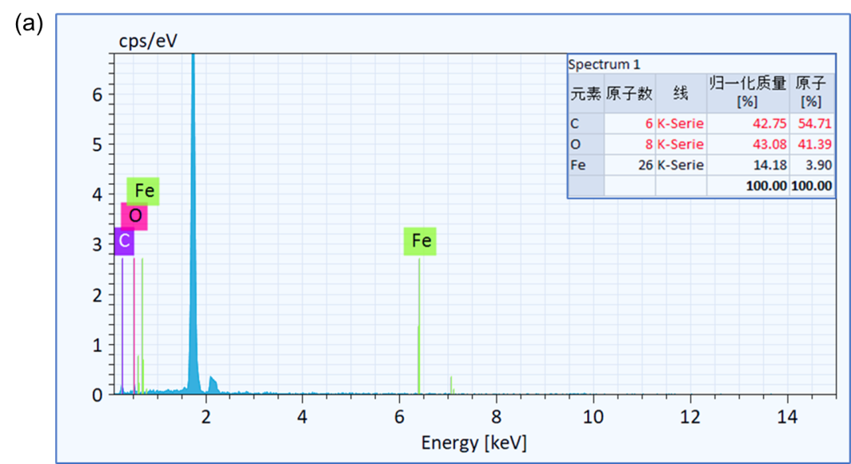
Fig. S1. EDS images of MIL-88B(Fe).
Table S1. Comparison of the hotocatalytic degradation performance of MIL-88B (Fe).
Photocatalysts  MOF | Pollutant concentration | Volume mg·L⁻¹ | Oxidant addition | Degradation effect Time (min) | Ref.
MIL-53(Fe) | RhB | 10 | H₂O₂ | 100% 50min | ¹
MIL-53(Fe) | AO7 | 10 | PS | 99% 90min | ²
Fe⁰@C700 | CIP | 20 | PMS | 75% 60min | ³
MIL-88B | IBP | 60 | PS | 94% 180min | ⁴
FeNi-MOF | MB | 6.4 | PMS | 99% 30min | ⁵
FeNi-MOF | MB | 6.4 | PDS | 98% 30min | ⁵
MOF1 | TC | 20 | H₂O₂ | 97% 60min | ⁶
MOF2 | TC | 20 | H₂O₂ | 86% 60min | ⁶
Fe²⁺-MOF | IMD | 180 | SPC | 99% 120min | ⁷
FeCo-PB | MB | 6.4 | PMS | 72% 30min | ⁸
MIL-88B(Fe) | MB | 10 | SPB | 97% 30min | This work

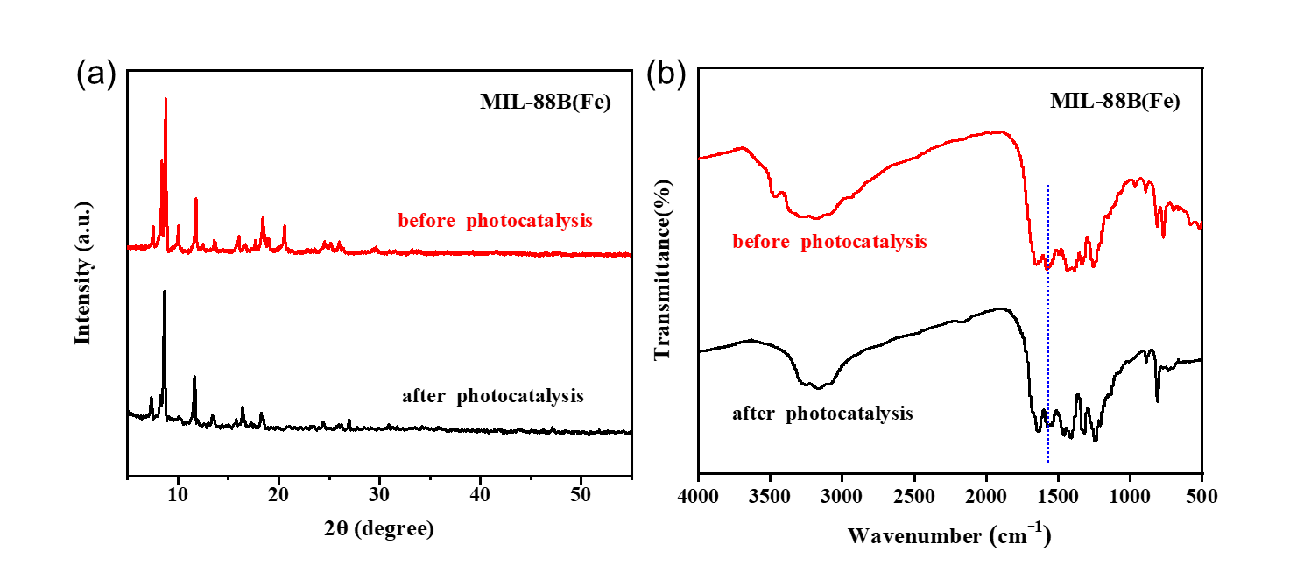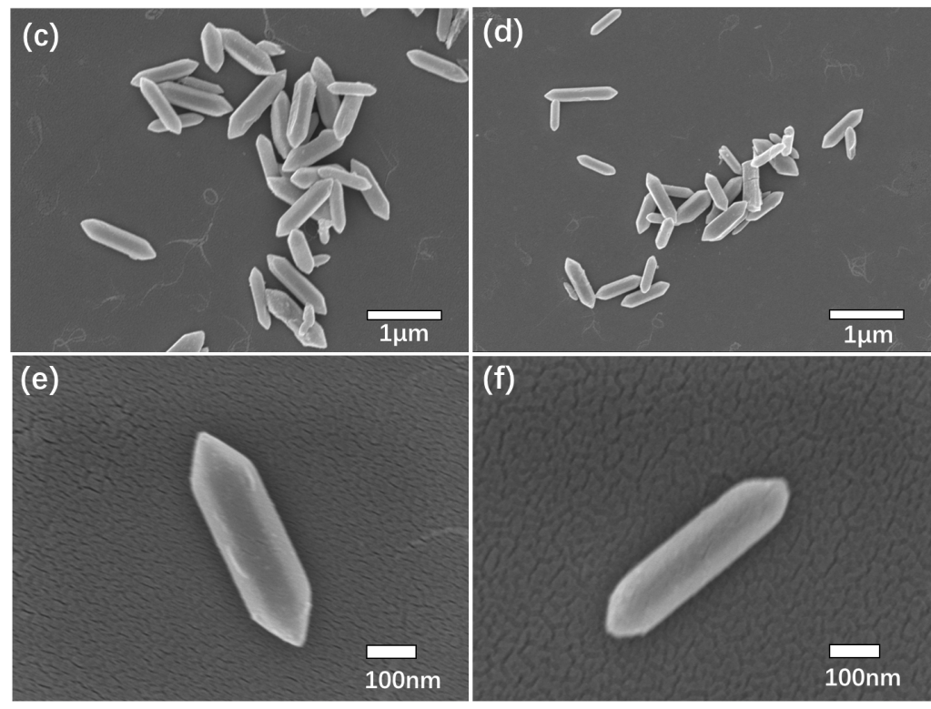

Fig. S2. (a) XRD and (b) FT-IR spectra of MIL-88B (Fe) before and after photocatalysis, (e)-(f) SEM of MIL-88B(Fe) after photocatalysis.
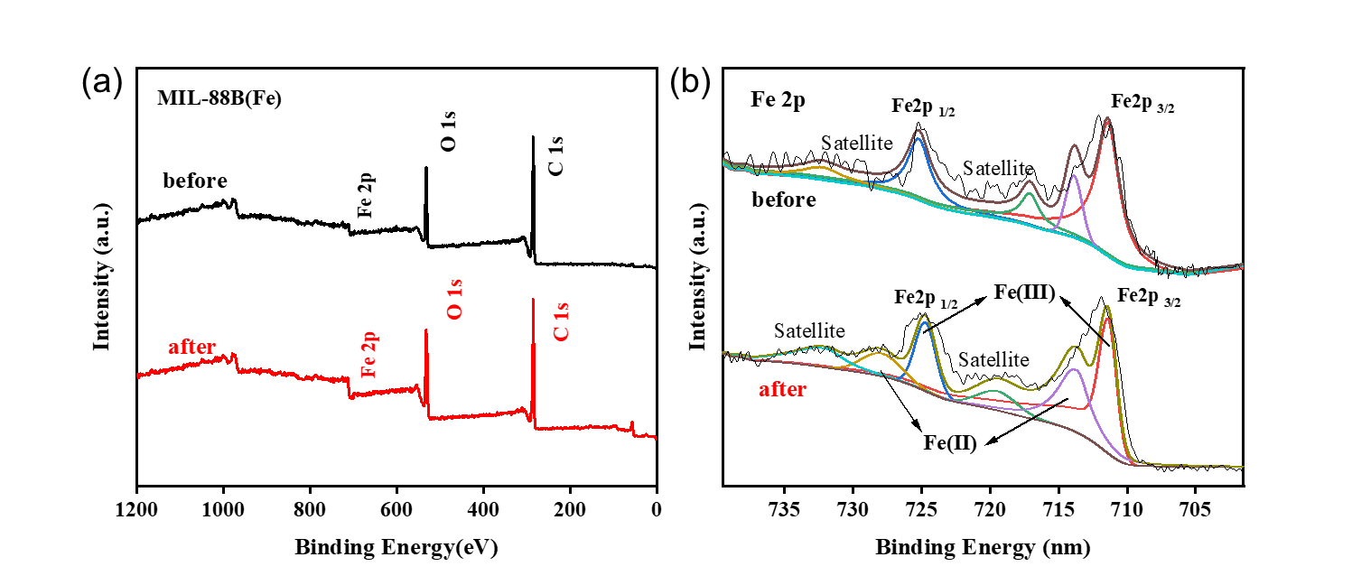
Fig. S3. (a) XPS spectra before and after photocatalysis MIL-88B (Fe) and (b) high resolution spectra of Fe 2p.

References
1. L. Ai, C. Zhang, L. Li and J. Jiang, Applied Catalysis B: Environmental, 2014, 148-149, 191-200.
2. Y. Gao, S. Li, Y. Li, L. Yao and H. Zhang, Applied Catalysis B: Environmental, 2017, 202, 165-174.
3. J.-Q. Zhou, H.-Y. Xu, B. Li, B.-Y. Wang, Y. Liu, Z.-h. Zhao and Y.-L. Zhuang, Environmental Research, 2025, 268, 120790.
4. N. Liu, J. Wu, F. Fei, J. Lei, W. Shi, G. Quan, S. Zeng, X. Zhang and L. Tang, Journal of Colloid and Interface Science, 2022, 612, 1-12.
5. D. Wang, M. Suo, S. Lai, L. Deng, J. Liu, J. Yang, S. Chen, M.-F. Wu and J.-P. Zou, Applied Catalysis B: Environmental, 2023, 321, 122054.
6. T.-C. Yue, L.-L. Wang, W. Li, J. Zhang, D.-Z. Wang and X.-H. Bu, Separation and Purification Technology, 2025, 363, 132127.
7. M. M. Sablas, M. D. G. de Luna, S. Garcia-Segura, C.-W. Chen, C.-F. Chen and C.-D. Dong, Separation and Purification Technology, 2020, 250, 117269.
8. H. Li, J. Zhang, Y. Yao, X. Miao, J. Chen and J. Tang, Environmental Pollution, 2019, 255, 113337.

