Supplementary File 1
Construction of Overexpression Rice Lines
4.1.1 Experimental Materials
Plant materials: Nipponbare rice (Oryza sativa Japonica group) and transgenic Nipponbare rice overexpressing the target gene. T0 generation transgenic rice was cultivated in a greenhouse, and T1 seeds were harvested. Generation advancement was conducted at the Hainan planting base to obtain T2 seeds, which were then planted in the greenhouse to harvest T3 seeds.

Strains: Overexpression plasmid vector pBWA(V)HS (Wuhan Biorun Biological Technology Co., Ltd.), EHA105 Agrobacterium tumefaciens competent cells (Wuhan Biorun Biological Technology Co., Ltd.), and Escherichia coli competent cells (Biorun).

Experimental reagents: Total RNA extraction kit (RNAiso Plus, TaKaRa), reverse transcription kit (PrimeScript™ FAST RT reagent Kit, TaKaRa), agarose gel recovery kit (Axygen), Magic Ruler DNA marker (RBA00, Biorun), restriction enzymes: BsmBI (#RCA01, Biorun), BsaI (#RCA02, Biorun), BbsI (#RCA03, Biorun), EcoRV (NEB), Yeast Extract (Sigma), Tryptone (Sigma), BioRun Seamless Cloning Kit (#RDA01, Biorun), 2×Biorun Pfu PCR Mix (#RBC00, Biorun), 2×BioRun Magic PCR Mix (#RAA00, Biorun), hygromycin (#RJA00-10g, Biorun Selected), cefotaxime (#RJB00-100g, Biorun Selected), KOD Fx (#RAD00, Biorun Selected), G418 (#RJC00, Biorun Selected), carbenicillin (#RJD00, Biorun Selected), rifampicin (#RJF00, Biorun Selected), glufosinate (#RJK00, Biorun Selected), kanamycin (#RJG00, Biorun Selected), quantitative fluorescence reagent (TB Green® Premix Ex Taq™ II, TaKaRa). Other reagents are listed in Section 3.1.2.1.

Experimental instruments: Hand-held UV analyzer (A48141, Thermo Fisher), constant temperature incubator shaker (NRY-2102C, Thermo Scientific), ultra-micro UV-Vis spectrophotometer (Q6000, NanoDrop), clean bench (BCM-1300-A, Suzhou Antai Air Technology Co., Ltd.), through-flow growth chamber (#EAA06, Wuhan Biorun Biological Technology Co., Ltd.). Other equipment is listed in Section 3.1.2.2.

4.1.2 Total RNA Extraction
Total RNA was extracted using the TaKaRa total RNA extraction kit (RNAiso Plus, TaKaRa) according to the kit instructions. Approximately 0.6 g of leaf tissue was ground into powder in liquid nitrogen and transferred to a centrifuge tube. Then, 600 μL of RNAiso Plus was added, and the mixture was homogenized and incubated at room temperature for 5 minutes. After centrifugation at 12,000 × g and 4°C for 5 minutes, the supernatant was transferred to a new 1.5 mL centrifuge tube. Chloroform (1/5 the volume of RNAiso Plus) was added to the new tube, followed by vigorous mixing and incubation at room temperature for 5 minutes. After centrifugation at 12,000 × g and 4°C for 15 minutes, the supernatant was transferred to another new tube. Isopropanol (0.5–1 times the volume of RNAiso Plus) was added to the tube, and the mixture was incubated at room temperature for 10 minutes. After centrifugation at 12,000 × g and 4°C for 10 minutes, the precipitate was washed with an equal volume of 75% ethanol and centrifuged at 7,500 × g and 4°C for 5 minutes. The supernatant was discarded, and the precipitate was air-dried and dissolved in an appropriate amount of RNase-free water. Finally, the RNA concentration was measured using a Drop 2000 spectrophotometer.

4.1.3 Reverse Transcription and PCR Amplification
cDNA was synthesized using the reverse transcription kit (PrimeScript™ FAST RT reagent Kit, TaKaRa) according to the kit instructions. Genomic DNA removal: Appropriately diluted RNA was added to the amplification plate wells, followed by 2 μL of 8X gDNA Eraser Premix and RNase-free H2O to a total volume of 16 μL. The mixture was incubated in a PCR amplifier at 42°C for 2 minutes. Reverse transcription reaction: 5X RT Premix was added to the mixture from the previous step to bring the total volume to 20 μL. The reaction was then incubated in a PCR amplifier at 37°C for 10 minutes, 85°C for 5 seconds, and finally held at 4°C. The following primers were designed for amplifying the target gene:
D2225_0S1(+): AACACGGGGGACTTTGCAACatggctgcccagaacaacaaggag
D2225_0S1(-): TGAAGACAGAGCTAGTTACAtcaaaaggccacttcggcgttgg
The PCR reaction system was as follows: 9.0 μL of 2X EasyTaqR PCR SuperMix, 2.0 μL of cDNA template, 0.5 μL each of forward and reverse primers (10 μM), and 7.0 μL of ddH2O, making a total volume of 20 μL. The PCR program was as follows: 94°C for 3 minutes for pre-denaturation; 30 cycles of 94°C for 30 seconds, 60°C for 30 seconds, and 72°C for 30 seconds; followed by a final extension at 72°C for 10 minutes. The amplified cDNA template was separated on a 1.5%–2.0% agarose gel, and the gel slice was stored at -20°C.

4.1.4 Recovery and Purification of PCR Products
The DNA band was recovered and purified using a DNA gel recovery kit (Axygen). Under UV light, the agarose gel slice containing the target DNA was excised, and surface liquid was absorbed with a tissue paper. The gel was then cut into small pieces. The weight of the gel was measured (the weight of a 1.5 mL centrifuge tube was pre-recorded), and this weight was considered as one gel volume. Three volumes of Buffer DE-A were added, and the mixture was thoroughly mixed and heated at 75°C with intermittent mixing for 3 minutes until the gel was completely melted (approximately 7 minutes). Then, 0.5 volume of Buffer DE-B was added and mixed well. The mixture was transferred to a DNA preparation tube (placed in a 2 mL centrifuge tube) and centrifuged at 12,000 × g for 1 minute. The filtrate was discarded. The preparation tube was placed back into the 2 mL centrifuge tube, and 500 μL of Buffer W1 was added. After centrifugation at 12,000 × g for 30 seconds, the filtrate was discarded. This step was repeated with 700 μL of Buffer W2, followed by centrifugation at 12,000 × g for 30 seconds. The filtrate was discarded, and the washing step with 700 μL of Buffer W2 was repeated once more, followed by centrifugation at 12,000 × g for 1 minute. The preparation tube was placed back into the 2 mL centrifuge tube and centrifuged at 12,000 × g for 1 minute. Finally, the preparation tube was transferred to a clean 1.5 mL centrifuge tube, and 25–30 μL of Eluent or deionized water was added to the center of the preparation membrane. After incubation at room temperature for 1 minute, the tube was centrifuged at 12,000 × g for 1 minute to elute the DNA, which was then stored at -20°C.

4.1.5 Enzyme Digestion and Purification of Vectors
The Golden Gate vector construction system based on Type IIs restriction enzymes features recognition sites that are distinct from their cleavage sites. Due to this characteristic, the four-base sequences at the cleavage sites of Type IIs restriction enzymes can be any combination of nucleotides, offering 4^4 = 256 possibilities. This allows for clever base design to connect fragments to the vector or other fragments, whether for single or multiple fragments, without leaving any enzyme recognition sites, achieving truly "seamless" ligation.

The pBWA(V)HS overexpression empty vector was digested using the following system:

Reagent Component | Volume
Nuclease-free Water | 13uL
10*Buffer | 2uL
Bsal/Eco31l | 1uL
pBWA(V)HS-ccdB | 4uL
Total | 20uL

Digestion Reaction Setup
Temperature | Time
37℃ | 1 hours

The digested vector was purified using a PCR purification kit (the purified product was labeled as pBWA(V)HS-ccdB(D)) for use in the next recombinant reaction.

4.1.6 Recombinant Reaction of Target CDS Sequence and Vector
The target gene fragment was recombined with the product of the pBWA(V)HS overexpression vector digested with BsaI/Eco31I. This approach ensures that the constructed vector does not contain restriction sites at either end of the target fragment. The purified DNA recovery solution and the purified digestion product were used in the following recombinant reaction system:

Reagent Component | Volume
Biorun 2*EasyClone Mix | 10uL
pBWA(V)HS-ccdB(D) | 5uL
rDNAG1 | 5uL
Total | 20uL

Digestion Reaction Setup
Temperature | Time
37℃ | 30 hours

4.1.7 Transformation of Competent Cells
The ligation product was added to 50 μL of freshly thawed *E. coli* competent cells. After gentle mixing, the reaction system was incubated on ice for 30 minutes. Subsequently, the mixture was heat-shocked in a 42°C water bath for 70 seconds and then rapidly transferred to an ice box for an additional 5-minute ice bath. Then, 500 μL of LB liquid medium, equilibrated to room temperature, was added to the centrifuge tube. The tube was incubated at 37°C with shaking at 200 rpm for 45 minutes to allow cell recovery. Next, 40 μL of 50 mg/mL kanamycin was evenly spread on a pre-prepared LB solid medium plate, which was then inverted and incubated in a 37°C incubator for 30 minutes. After the kanamycin was completely absorbed, 200 μL of the bacterial culture was evenly spread onto the plate and incubated overnight in a 37°C incubator.

4.1.8 Colony PCR Identification
Ten individual colonies were picked for simultaneous inoculation into 1.5 mL EP tubes and PCR identification. The bacterial solutions from these ten colonies were subjected to PCR amplification. For colonies yielding 1-3 positive bands, 100 μL of the corresponding bacterial culture was sent for sequencing using the sequencing primer: gccaacaagtgcggccag. The remaining 400 μL of bacterial culture was inoculated into a medium containing kanamycin and cultured in a test tube with shaking. After the sequencing results were obtained, one tube of the correctly sequenced strain was selected for plasmid extraction, while the remaining bacterial strains were stored at low temperature.
Reagent Component | Volume
Nuclease-free Water | 9.5uL
Biorun Magic PCR Mix | 12.5uL
primer：35seq 100μM | 1uL
primer：D2225 100μM | 1uL
Template | 1uL
Total volum | 25uL

Setup | Cycles
94℃ for 5 min | 1
94℃ for 30 sec | 30
50℃ for 45 sec | 30
72℃ for 60 sec | 30
72℃ for 10min | 1
16℃ for 30min | 1

4.1.9 Plasmid Transformation
Add 1 µL of the sequencing-verified plasmid to 50 µL of EHA105 *Agrobacterium tumefaciens* competent cells. Mix thoroughly and transfer the mixture to an electroporation cuvette. After electroporation, add 1 mL of LB liquid medium to the cuvette for recovery. Mix thoroughly and transfer the solution to a 1.5 mL centrifuge tube. Incubate the tube in a shaker at 30°C and 180 rpm for 30 minutes. Then, inoculate 50 µL of the activated *Agrobacterium* culture onto an LB solid medium plate and incubate at 30°C in the dark for 48 hours.

4.1.10 Detection of *Agrobacterium*
Pick individual *Agrobacterium* colonies and perform PCR amplification using the primers designed in the experimental steps described above. Check the PCR amplification results. If the electrophoretic bands of the positive control and the samples are clear and of the correct size, and no bands are observed in the negative control, the product can be used for subsequent experiments.

The reaction system is as follows:
Reagent Component | Volume
Forward Primer（10µM） | 1μl
Reverse Primer（10µM） | 1μl
2×Taq PCR Mix | 10μl
ddH2O | 7μl
Template | 1μl
Total | 20μl

4.2 Genetic Transformation of Rice
4.2.1 Callus Induction
Select rice grains without mold spots and with normal embryos. Surface sterilize the grains with 75% ethanol for 1 min, followed by rinsing with sterile water (1 min per rinse). Then sterilize with 15% sodium hypochlorite for 20 min, and rinse three times with sterile water (1 min per rinse). Inoculate the sterilized grains on callus induction medium and culture under light at 26°C for 20 days.

4.2.2 Agrobacterium Infection
Pick a single Agrobacterium colony and suspend it in infection medium to prepare a bacterial suspension with OD600 = 0.2. Transfer the calli to a conical flask, add the Agrobacterium suspension, and incubate for 10-15 min. After infection, discard the bacterial suspension and transfer the calli to co-culture medium. Co-culture at 20°C for 48-72 hours.

4.2.3 Callus Selection
Prepare LB medium supplemented with 8 μL of 500 mM rifampicin, 40 μL of 60 mg/mL kanamycin, and 50 μg/mL hygromycin. Transfer the calli from step 4.2.2 to the selection medium and culture in the dark at 26°C for 20-30 days. Subsequently, transfer the positive calli to a secondary selection medium. During subculturing, be sure to pick monoclonal calli. Culture in the dark at 26°C for 7-10 days.

4.2.4 Differentiation and Rooting
Transfer the positive calli to differentiation medium and culture under light at 25-27°C for 15-20 days. Once shoots of 2-5 cm in length have differentiated, transfer them to rooting medium and culture under light at 30°C for 7-10 days.

4.2.5 Detection of Positive Rice Seedlings
Extract genomic DNA from rice seedlings using the CTAB method. Perform PCR detection using the same method as for Agrobacterium detection (as described in section 4.1.10), with the primers used in section 4.1.10.

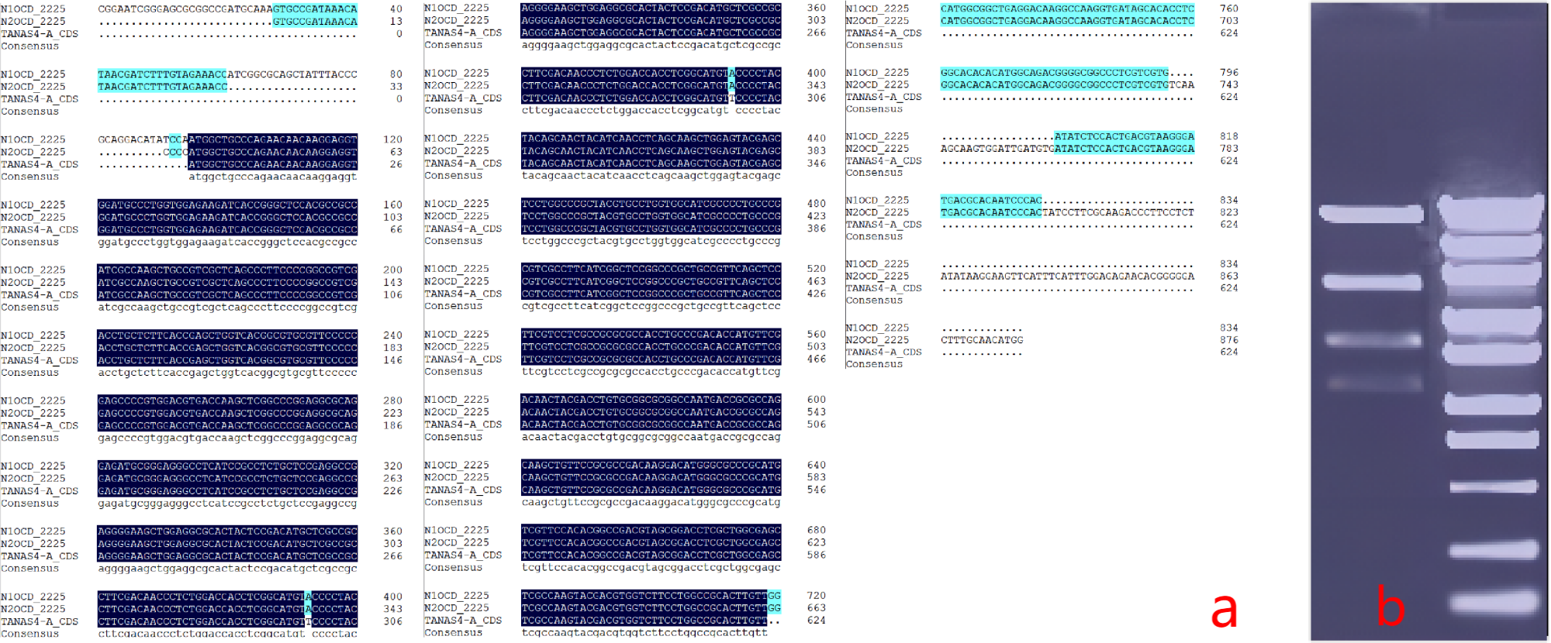
SFig.1-1 a) Sequencing of the TaNAS Fragment, b) Quality Control Verification Diagram of the Recombinant Plasmid Digested with EcoRV Endonuclease
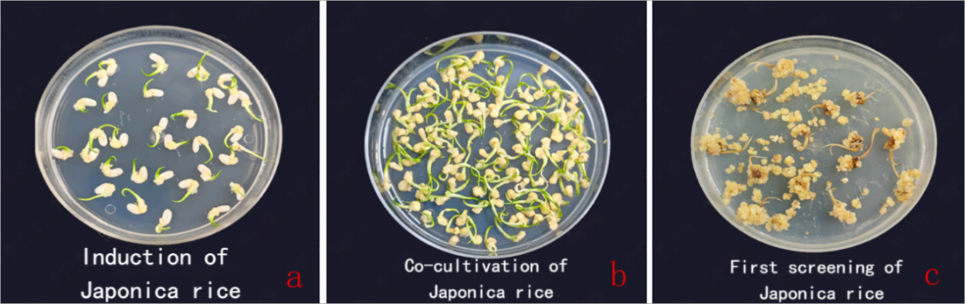
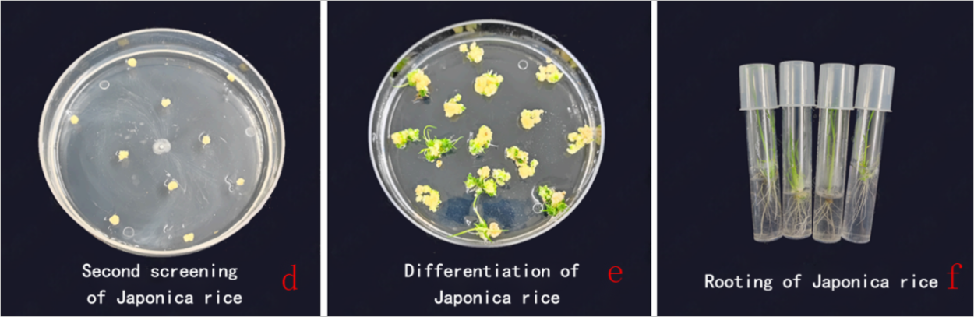
SFig.1-2 Genetic Transformation of Rice Tissues

