Supplementary File 2
Construction of the BSMV-VIGS System
5.2.1 Experimental Materials
Biological Materials: NC2 spring wheat (AABBDD, *Triticum aestivum* L.), *Nicotiana benthamiana* L., plant transformation vectors BSMV-α, BSMV-β, and BSMV-γb (Shangang Zhishuo Biological Technology Co., Ltd., Shanghai). *E. coli* competent cells and *Agrobacterium tumefaciens* were the same as described in section 4.1.1.

Experimental Reagents: Medium-scale plasmid extraction kit (DP106) (Tiangen, Beijing); T4 DNA Ligase (M1801) (Promega (Beijing) Biotechnology Co., Ltd.); rifampicin (Rifampici, Rif) and kanamycin sulfate (Kanamycin, Kan) (Solarbio, Beijing); restriction enzyme ApaI (TaKaRa, Dalian); universal reverse transcription kit (HiScript II 1st Strand cDNA Synthesis Kit, Vazyme, Nanjing); dipotassium hydrogen phosphate, potassium dihydrogen phosphate.

Preparation of 0.1 M potassium phosphate buffer (pH = 7.2):
At room temperature, weigh 27.22 g of potassium dihydrogen phosphate and 45.64 g of dipotassium hydrogen phosphate, and dissolve each in 200 mL of deionized water to prepare 1 M potassium dihydrogen phosphate and 1 M dipotassium hydrogen phosphate solutions, respectively. Then, measure 28.37 mL of the 1 M potassium dihydrogen phosphate solution and 71.7 mL of the 1 M dipotassium hydrogen phosphate solution, mix thoroughly, and adjust the volume to 1 L with deionized water. Store the final solution at room temperature.
5.2.2 Cloning of the Target Gene
The target gene fragment was cloned using the Ligation Independent Cloning (LIC) technique (Yuan et al., 2011). Cloning primer sequences (lowercase sequences in Table 5-1) were added to the 5' end of the designed primers. Total RNA was extracted from NC2 leaves and reverse transcribed into cDNA using a universal reverse transcription kit. The primers were synthesized by Sangon Biotech (Shanghai). The RT-PCR products were separated on a 1% agarose gel, and the target bands were excised and purified using an agarose gel DNA recovery kit for subsequent ligation into the BSMV-γb vector.
Primer Name | Primer Sequence (5'-3') Lowercase letters indicate flanking recombination sequences | Purpose
BSMV-NAS1-F | tccgtttctaaggaagggcccgtttaaAGGAGGTGGATGCCCTGGTG | Cloning Primers
BSMV-NAS1-R | ttaaccaccaccaccgggcccGGTTGATGTAGTTGCTGTAGT | Cloning Primers
BSMV-F | CTAAGCTTGAAAGTGAGGTTAAC | Sequencing Primers

5.2.3 Ligation of BSMV-γb Vector
Place the PCR product in a reaction system containing T4 DNA polymerase, 1× reaction buffer, and 5 mM dATP, and incubate at room temperature (25°C) for 30 minutes to generate sticky ends. After the reaction, heat the mixture at 75°C for 10 minutes to inactivate the T4 DNA polymerase. Subsequently, perform single-enzyme digestion on the BSMV-γb vector using the restriction endonuclease Apal, then recover and purify the linearized vector. Next, mix the linearized BSMV-γb vector with T4 DNA polymerase, 1× reaction buffer, and 5 mM dTTP to generate sticky ends complementary to those of the PCR product. Finally, mix the treated PCR product (200 ng) with the linearized vector (20 ng), incubate at 66°C for 2 minutes, and then slowly cool to room temperature. The recombinant plasmid is named: BSMV-γ-TaNAS4-A.

5.2.4 Transformation of E. coli Competent Cells
Take 10 μL of the recombinant vector solution, transfer the recombinant vector into E. coli competent cells using the heat shock method, culture the competent cells, pick single-colony clones for colony PCR, and send a small amount of the bacterial solution from the screened positive colonies to BGI (Beijing Genomics Institute) for sequencing. Dissolve the remaining bacterial solution in 60% glycerol, subject it to liquid nitrogen shock, and store it in a -20°C refrigerator. Later, extract the plasmid from the bacterial solution with consistent sequencing results using a plasmid extraction kit for subsequent experiments.

5.2.5 Transformation of Agrobacterium tumefaciens Competent Cells
Take out the stored EHA105 Agrobacterium competent cells from the ultra-low temperature refrigerator, inoculate them onto solid LB medium containing 50 mg/L Rifampicin (Rif), and perform streaking. Then seal the plate with parafilm, invert it, and incubate in a 28°C constant-temperature incubator for 48 hours to revive the bacterial strain. Pick a single colony, inoculate it into liquid LB medium containing 50 mg/L Rif, and incubate with shaking at 28°C and 200 rpm for 24 hours (the culture can be temporarily stored at 4°C after incubation). Transfer 1 mL of the bacterial culture to 50 mL of liquid LB medium, and continue culturing until the OD₆₀₀ value reaches 0.4–0.6 (approximately 15–20 hours). Then transfer all the bacterial culture to a 50 mL centrifuge tube, centrifuge at 4000 rpm for 10 minutes, and discard the supernatant. Next, wash the bacterial cells three times with sterile water, resuspend them in 10% glycerol, aliquot them, subject to liquid nitrogen freezing, and finally store at -80°C.
Transform Agrobacterium via electroporation: Aspirate 100 μL of ice-bath thawed EHA105 Agrobacterium competent cells and 2 μL of the recombinant plasmid, mix gently, add to an electroporation cuvette, and perform electroporation once. First, thoroughly clean the electroporation cuvette with distilled water 3–4 times. Turn on the electroporator and set the voltage to 18 kV. Next, aspirate 800 μL of liquid LB medium into the electroporation cuvette, transfer it to a 1.5 mL centrifuge tube, and incubate with shaking at 28°C and 200 rpm for 2–3 hours. After that, aspirate 100–200 μL of the bacterial solution, evenly spread it on the surface of solid LB medium containing 25 mg/L Rif and 100 mg/L Kanamycin (Kan), and incubate in a 28°C constant-temperature incubator for 24–36 hours. Then, pick a single colony, inoculate it into liquid LB medium containing the same antibiotics, and incubate again with shaking at 28°C and 200 rpm for 24–36 hours. After confirming the colony via PCR detection, use a portion of the bacterial solution to prepare the engineered bacteria infection suspension, and add 10% glycerol to the remaining bacterial solution, subject to liquid nitrogen freezing, then store at -80°C. The Agrobacterium transformation of vectors BSMV-α, BSMV-β, BSMV-γb, and BSMV-γ-TaPDS is also performed following this procedure.

5.2.6 Suspension Culture of Agrobacterium
Inoculate 0.5 mL of bacterial solution into 50 mL of liquid LB medium containing 25 mg/L Rif and 100 mg/L Kan, and incubate with shaking at 28°C and 200 rpm until the OD₆₀₀ value reaches 0.7 (approximately 10–12 hours). After incubation, centrifuge the bacterial culture at 2200 rpm for 10 minutes at room temperature, collect the precipitate, resuspend it in 10 mM MgCl₂ solution, and adjust the OD₆₀₀ value to 0.7. Then, add 10 mM MES (pH 5.2) and 0.1 mM Acetosyringone (AS), and let it stand at room temperature for more than 3 hours.

5.2.7 Infiltration of Tobacco
Wheat has a certain degree of natural resistance to Agrobacterium tumefaciens, so first divide the suspension into three groups:Empty vector group (abbreviated as γ below): Three Agrobacterium solutions containing BSMV-α, BSMV-β, and BSMV-γb plasmids;Target gene silencing group (abbreviated as VIGS below): Three Agrobacterium solutions containing BSMV-α, BSMV-β, and BSMV-γ-TaNAS4-A plasmids;Control group (abbreviated as PDS below): Three Agrobacterium solutions containing BSMV-α, BSMV-β, and BSMV-γ-TaPDS plasmids.In each group, the concentrations of the three plasmid vectors are mixed as evenly as possible at a ratio of 1:1:1. Inoculate tobacco leaves according to these three groups. Use a syringe to aspirate 1 mL of bacterial solution per group, select one-month-old healthy tobacco plants, and infiltrate 4–8 leaves. Place the infiltrated tobacco in a greenhouse (day: 25°C, 14 h; night: 20°C, 10 h) for cultivation. After 7–14 days of cultivation in the greenhouse, select tobacco leaves with tumor-like lesions and cut off leaves infected with different viruses. Put the crushed leaves into a grinder, add 20 mM potassium phosphate solution (pH = 7.2) containing 1% diatomaceous earth, grind thoroughly, and store in a -20°C refrigerator for later use.

5.2.8 Inoculation of Wheat Leaves
Select soil-cultured potted wheat leaves at the three-leaf stage in the aforementioned greenhouse for rub inoculation, and inoculate them with the ground tobacco leaf solutions of the γ, VIGS, and PDS groups respectively. The specific operation is as follows: Select healthy wheat plants with uniform growth, put on latex gloves, then hold the leaf with the index finger of the right hand, and gently rub the ground solution back and forth several times from the middle to the tip of the leaf. When the wax is scraped off the leaf, a slight squeaking sound should be heard. Allow the plants to absorb the virus for 5–10 minutes, then spray the leaves with sterile water using a fine-mist spray bottle. Additionally, rub healthy leaves with 20 mM potassium phosphate solution (pH = 7.2) containing 1% diatomaceous earth to observe the impact of mechanical damage caused by rubbing, and record this as the Mock control. After inoculation, spray all plants with sterile water, then cover the inoculated wheat plants with plastic wrap. Cultivate under the conditions of a photoperiod of 16 hours, temperature of 20–23°C (night–day), and relative humidity of 50–60%. After 24 hours, if no obvious mechanical damage is found on the leaves, the plastic wrap can be removed. Observe the inoculation status daily; when the leaves of the PDS group start to turn chlorotic and albino, it indicates that the gene silencing system is functioning, and the inoculation is successful.

5.2.9 Secondary Inoculation
When the wheat cultured in the greenhouse enters the grain-filling stage, use the above method to rub the lower stem of the wheat ear on a large scale. Then, slightly scratch the stem 4–5 cm below the wheat ear with a syringe needle, spray the spikelets with the virus solution, and spray sterile water after inoculation.
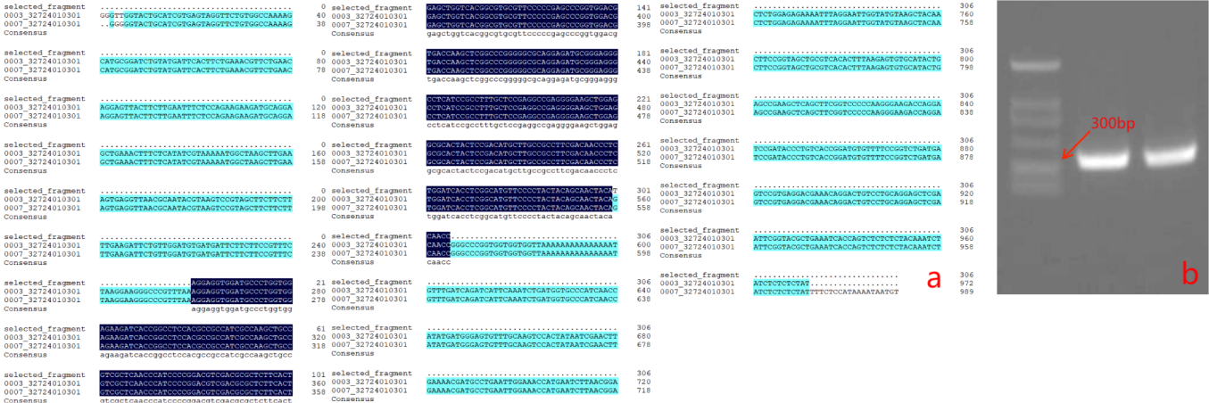
SFig.2-1 PCR of Bacterial Culture and Sequencing of Cloned Fragments

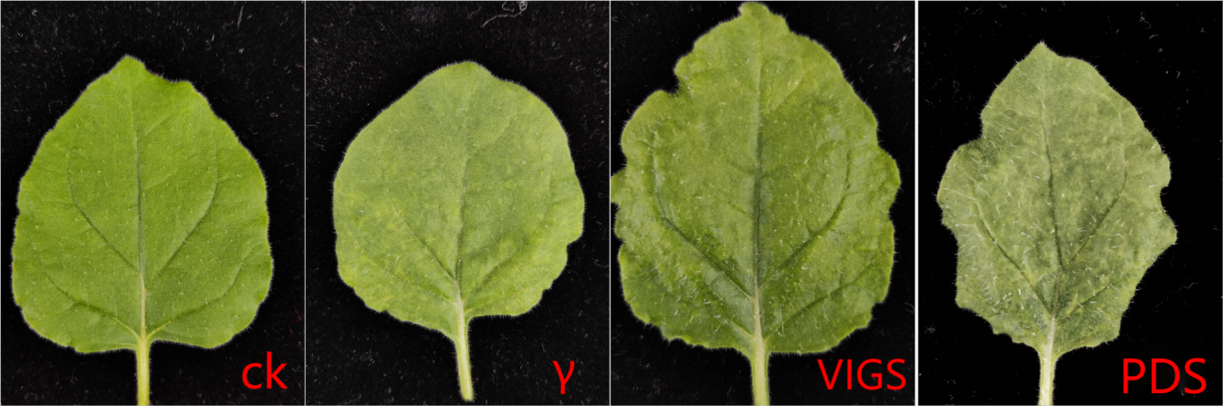
SFig.2-2 Symptoms Observed in Naturally Grown Tobacco Leaves (CK) and Tobacco Leaves Inoculated with Three Other Viruses

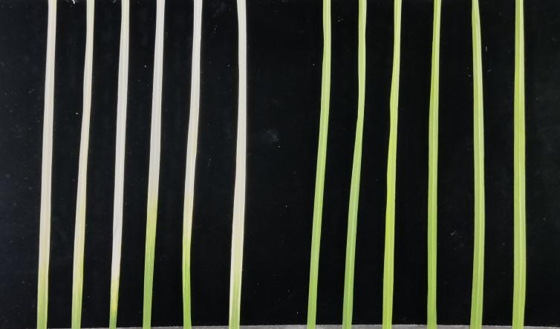
SFig.2-3 Wheat seedling PDS albino leaf (left) and control leaf (CK)

