Attach
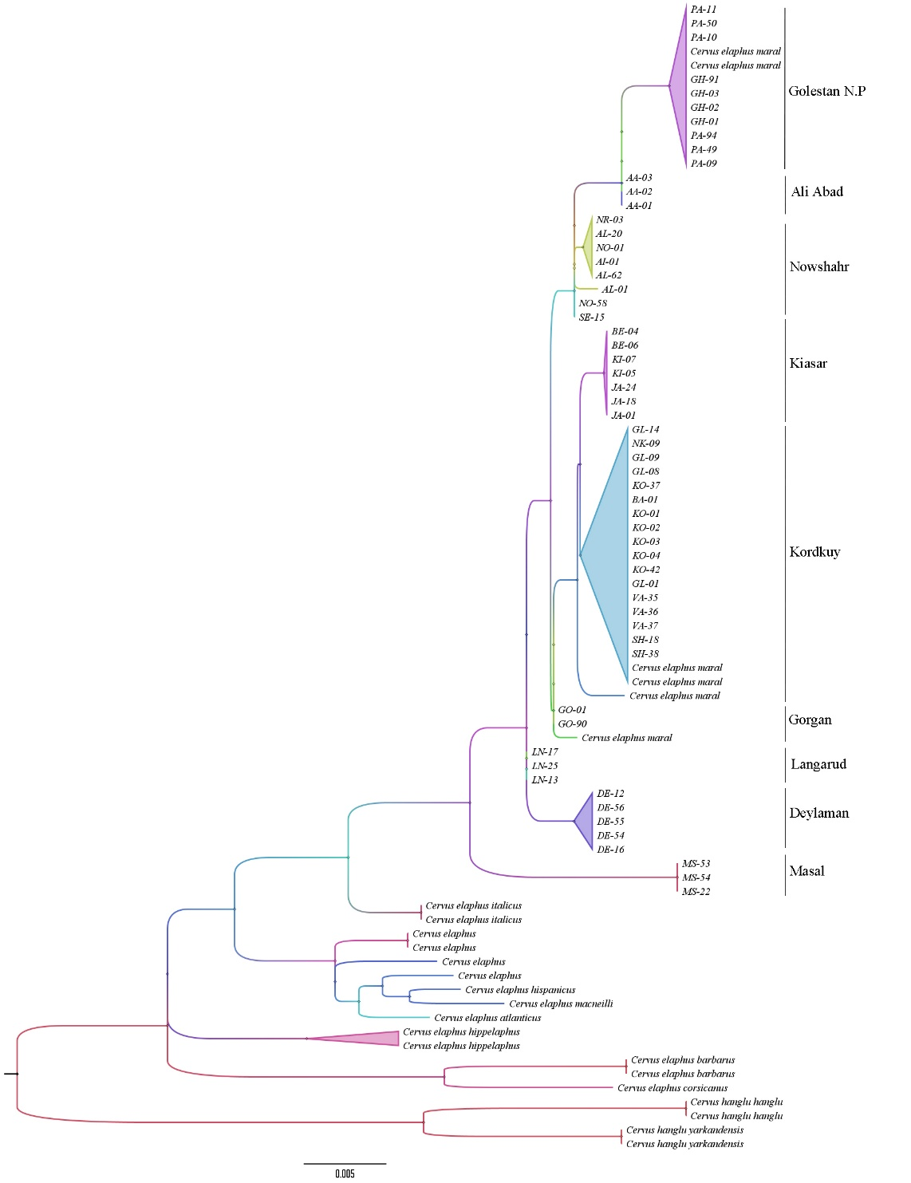
Figure S1: Maximum Likelihood tree based on the D-loop region (all major clades are separated with a posterior probability of one)

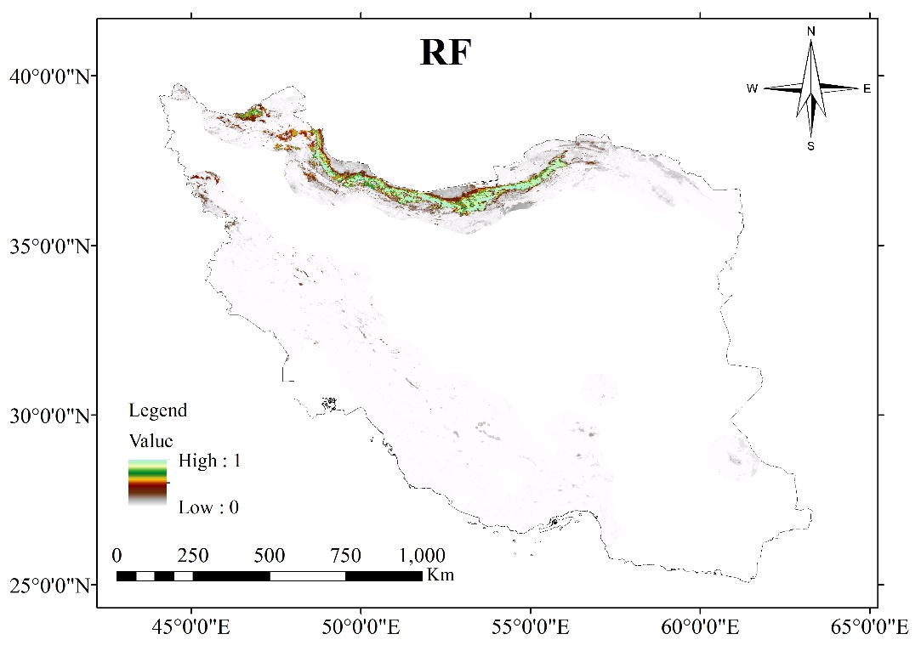
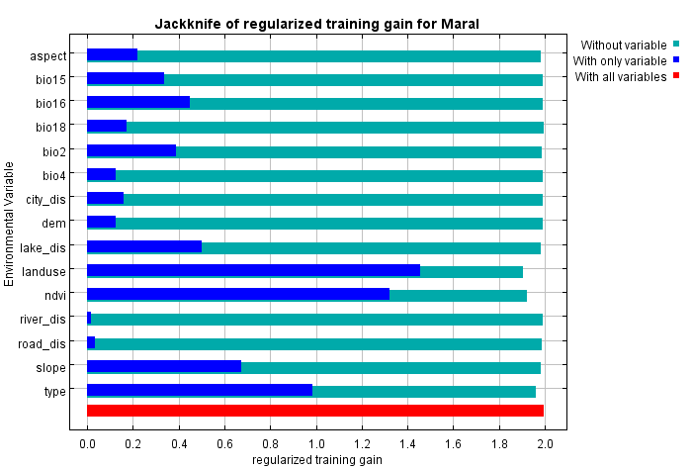
Figure S2: Most Important Variables in the Distribution of Caspian Red Deer in the Maxent Model
Figure S3: RF Model for Habitat Suitability Assessment in Iran

Table S1: Genetic Accession Numbers for Caspian Red Deer Samples in the Present Study
Accession number | Code | Sampling place | Accession number | Code | Sampling place | Accession number |  | Code | Sampling place
PV008916 | SE-15 | Sari | PV008897 | KO-37 | Kordkuy | PV008877 | PA-09 |  | Golestan N.P
PV008917 | NO-01 | Nowshahr | PV008898 | KO-42 | Kordkuy | PV008878 | PA-10 |  | Golestan N.P
PV008918 | NO-58 | Nowshahr | PV008899 | JA-01 | Jahan-Nama | PV008879 | PA-11 |  | Golestan N.P
PV008919 | NR-03 | Noor | PV008900 | JA-18 | Jahan-Nama | PV008880 | PA-49 |  | Golestan N.P
PV008920 | AL-01 | Golestanak | PV008901 | JA-24 | Jahan-Nama | PV008881 | PA-50 |  | Golestan N.P
PV008921 | AL-20 | Golestanak | PV008902 | GL-01 | Galugah | PV008882 | PA-94 |  | Golestan N.P
PV008922 | AL-62 | Golestanak | PV008903 | GL-08 | Galugah | PV008883 | GH-01 |  | Ghorogh
PV008923 | LN-13 | Langarud | PV008904 | GL-09 | Galugah | PV008884 | GH-02 |  | Ghorogh
PV008924 | LN-17 | Langarud | PV008905 | GL-14 | Galugah | PV008885 | GH-03 |  | Ghorogh
PV008925 | LN-25 | Langarud | PV008906 | BE-04 | Behshahr | PV008886 | GH-91 |  | Ghorogh
PV008926 | DE-12 | Deylaman | PV008907 | BE-06 | Behshahr | PV008887 | AA-01 |  | Ali Abad
PV008927 | DE-16 | Deylaman | PV008908 | NK-09 | Neka | PV008888 | AA-02 |  | Ali Abad
PV008928 | DE-54 | Deylaman | PV008909 | VA-35 | Neka | PV008889 | AA-03 |  | Ali Abad
PV008929 | DE-55 | Deylaman | PV008910 | VA-36 | Neka | PV008890 | GO-01 |  | Gorgan
PV008930 | DE-56 | Deylaman | PV008911 | VA-37 | Neka | PV008891 | GO-90 |  | Gorgan
PV008931 | MS-22 | Masal | PV008912 | SH-18 | Neka | PV008892 | BA-01 |  | Badli
PV008932 | MS-53 | Masal | PV008913 | SH-38 | Neka | PV008893 | KO-01 |  | Kordkuy
PV008933 | MS-54 | Masal | PV008914 | KI-05 | Kiasar | PV008894 | KO-02 |  | Kordkuy
PV008934 | AI-01 | Aynaloo | PV008915 | KI-07 | Kiasar | PV008905 | KO-03 |  | Kordkuy
 |  |  |  |  |  | PV008896 | KO-04 |  | Kordkuy

