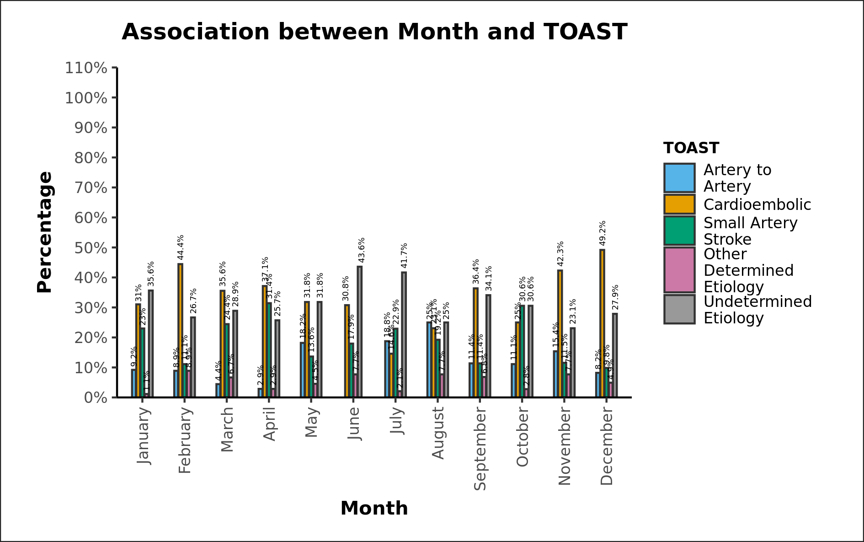

Supp 1: Distribution of ischemic stroke subtypes (as per TOAST schema) in different months

