Supplementary information for
Leveraging Machine Learning to Reveal Transparency in Integrated Assessment Models Ensembles

This supplementary file includes:
Supplementary notes:1-8
Supplementary tables: 1-13
Supplementary figures: 1-8
Supplementary references
Supplementary Note 1. The specific procedure of Morris analysis
The specific procedure is as follows. First, 1000 sets of samples with a time step of 5 years are randomly selected from the normalized training dataset. The data in each set of samples are integrated into a time series and input into the pretrained LSTM model for prediction. Second, the Morris analysis tool from the SALib library is used to perform sensitivity analysis on the sample data, calculating the Morris index ($μ$) and the standard deviation (sigma) of the response for each feature. Third, to enhance the reliability of the results, 1000 resampling iterations are conducted, and the bootstrap method is employed to calculate the confidence intervals for the Morris indices. The 2.5th and 97.5th percentiles are then used as the lower and upper limits of the confidence intervals, respectively.

Supplementary Note 2. Errors across model variables on energy supply
The error situations for segmented technologies within the energy supply are shown in Figure S1. The input error for solar power generation is the most prominent and consistent across models. Despite the standardized RMSE indicating that its relative error is generally within an acceptable range, this largely explains the more significant errors observed in renewable energy across the models presented in Figure 1. Additionally, historical nuclear power exhibits relatively large errors in various model scenarios, exceeding the acceptable range, especially for the POLES and GEM-E3 models. This implies that calibration issues exist for nuclear variables in almost all models. In comparison, the model errors for natural gas, hydropower, and biomass energy are more minor. Except for WITCH, the errors in other IAMs are also within an acceptable range for wind power.

Supplementary Note 3. Analysis on the acceptability of the errors across model variables
Owing to the limitations of the RMSE in measuring the relative bias of model inputs and its inability to exclude the influence of data time trend components, we further assess the acceptability of the errors in each model variable by comparing the normal RMSE and normal-centered RMSE, in addition to analyzing the absolute errors of the models. As shown in the scatter plot portion of Figure 2, the variables can be broadly divided into three categories: First category: This group is characterized by both normal RMSE and centered RMSE being below the dashed line, specifically including primary energy supply (ES1), fossil fuel-based electricity generation (ES2), renewable electricity generation (ES3), and population (SE2). This indicates that the input errors of most of the energy supply variables and population variables in the model group are within an acceptable range, validating the previous analysis results regarding absolute errors. Second category: This category encompasses variables with a normal RMSE greater than one and a normal centered RMSE less than one, which involve energy demand in the industrial sector (ED2), energy demand in the residential and commercial sectors (ED3), and carbon dioxide emissions (CE). This suggests that the model group errors for these variables exceed the acceptable range. The model errors primarily arise from the quantitative discrepancies between the input and valid values rather than from variability biases in the data (i.e., deviations in calibration trends). The biases in these variables can be quickly addressed through adjustments to the input data. Third category: This group features variables that exhibit calibration errors over the historical period, where the normal RMSE and normal-centered RMSE are greater than 1. Examples include the SE1 variable for WITCH, the ED1 variable for GCAM and GEM-E3, and the ED2 variable for GEM-E3 in Figure 2. These error issues need to be corrected through model recalibration.

Supplementary Note 4. Robustness test of model errors with changed historical data sources
In the first section of the main text, we compared the errors in key variables of mainstream IA models based on historical data. Since different data sources may have varying historical statistical methodologies, this can influence the error assessment results. Therefore, we supplemented historical error estimates from other commonly used authoritative data sources, such as IEA, as detailed in Supplementary Table 13. The historical variables data for robustness. However, it is important to clarify that we are not trying to select an error-free historical dataset as a benchmark here, since no statistical dataset is without error. Instead, we aim to evaluate the relative errors and their long-term impacts based on a reasonable historical benchmark, highlighting the importance of calibrating model inputs.
Supplementary Figure 7 presents the error results from replacing economic, energy supply, and emission-related variables (energy demand data from other sources was not found). We observe that the errors in SE1, SE2, ES1, ES2, and ES3 show almost no difference from those in Figure 2, both in terms of relative error range and other error dimensions. This indicates that although there are quantity differences between data sources, their impact on the model error assessment results is minimal. For total primary energy (ES1), the MESSAGE and POLES models, under the new historical benchmark, shifted from being above the historical values to being below them, though the relative error levels remained low. The MESSAGE, GCAM, and TIAM-ECN models, under the new benchmark, shifted from being below the historical values to being above them, but still remained within an acceptable range.
Supplementary Figure 8 shows the error results from replacing the variables for coal, oil, natural gas, hydropower, nuclear, solar, wind, and biomass in primary energy. We find that errors for coal, oil, natural gas, wind, and biomass show almost no difference in relative error range or other error dimensions compared to Figure 3, indicating that the error assessment results are robust. However, for hydropower (PH), nuclear (PN), and solar (PS), all models exhibit significant differences in relative errors compared to Figure 3, suggesting that the data from the BP Statistical Review of World Energy and International Renewable Energy Agency may differ substantially from the benchmarks used by the model group for these indicators. In the error assessment for solar energy, changing the data source amplified the differences between models. For example, the relative error in the MESSAGE model exceeded 100% under the new benchmark, highlighting the large discrepancy between the model’s initial values and the statistical data. Nonetheless, we wish to remind that no statistical data is without error, so the differences caused by changing data sources are objective and do not affect other analysis results.

Supplementary Note 5. The sensitivity to other variables initial values for emission predictions
The initial input sensitivity of final energy with respect to emissions follows a trend that contrasts with the emissions trajectory itself. In the case of coal-fired power generation, the effect of stringent emission reduction constraints under different climate targets emerges relatively early. Even in short-term forecasts (1-year and 3-year horizons), the sensitivity of coal input is negative—implying that a higher quantity of coal input today leads to a lower projected coal consumption in the near future (Supplementary Fig. 3; Supplementary Note 3). In the long run, however, this stringent constraint effect becomes less evident, especially compared to the sensitivity of emissions to their own initial input levels. This suggests that short-term carbon emissions respond inversely to long-term trends due to strict emission constraints in the net-zero scenario. By contrast, in the BAU scenario—where emission reduction constraints are absent—short-term emissions exhibit positive sensitivity to initial input values (Supplementary Fig. 4).
The initial values of coal and solar energy in primary energy exhibit a trend similar to the sensitivity of initial CO₂ values (Fig. 3). However, the effect of reduced coercive emissions under climate targets occurs earlier. The sensitivity of coal's initial value to emissions in 2040 is -0.73. This means that a higher initial value for coal will lead to decreased coal production in 2040. Solar energy exhibits a sensitivity trend opposite to that of coal. An increase in the initial value of solar energy will result in a slight increase in emissions from 2040 to 2050 (with sensitivity coefficients between 0 and 0.5). The reason is probably that the initial input level of renewable energy is relatively low. Increasing its initial value alleviates the long-term pressure of renewable energy substitution. Meanwhile, the typical constraints on energy technology penetration rates in optimization-based IAMs prevent a sharp increase in renewable energy, which, to some extent, leads to the early onset of the coercive emission reduction effect for energy-related variables.
Exceedance of 1.5°C of global warming directly results from insufficient near-term mitigation strategies (Rogelj, J., et al., 2019). Indeed, IAM scenarios show a significant linear relationship between short-term emissions (in 2030) and long-term temperature responses (van Vuuren and Riahi, 2010). Therefore, the global carbon emission level in 2030 provides an indication of the degree of global warming projected for end-of-century. Regression analysis suggests that each additional 1 Gt of CO₂ emissions in 2030 is associated with an approximate increase of 0.006°C in projected temperature overshoot by 2100. In particular, to limit the overshoot to below 0.05 °C, we need to keep global carbon emissions in 2030 within 16.7 Gt. If we aim to keep the overshoot below 0.1 °C, this limit will increase to 25 Gt. Furthermore, ridge regression analysis (Supplementary Fig. 5) identifies electricity consumption, initial carbon prices, and starting emission levels as key predictors of 2030 emissions. These findings highlight the importance of initial model parameterization in shaping long-term temperature projections, including the magnitude of potential overshoot.

Supplementary Note 6. Additional statements of mitigation attribution of industry sector
In the industrial sector, GCAM and REMIND models exhibit the highest emission reductions under the 1.5°C climate target, while also demonstrating the largest uncertainty ranges across scenarios (Fig. 5a, model fingerprint). Although both models show strong emissions reduction in the industrial sector, the underlying drivers differ. Zero-carbon electricity, including hydrogen utilization, is the main driver of industrial emissions reductions in the GCAM model (Fig. 5b, model attribution), with electricity deployment being the most relied-upon mitigation solution in GCAM. Furthermore, green hydrogen is expected to be a key solution for achieving carbon neutrality in the industrial sector in the GCAM model. This is because GCAM’s underlying preference suggests that future hydrogen costs will be economically viable, and the deployment of clean hydrogen will help lower the cost of mitigating climate change (Wolfram et al., 2024). Similarly, it offers insight into the reduction in carbon intensity within the industrial sector as modeled by MESSAGE.
The REMIND model, on the other hand, places greater emphasis on using CCS technology to assist the industrial sector in achieving deep decarbonization. The highest mean value and the most extensive uncertainty range characterize the scale of carbon capture from industrial processes in this model. This aligns with its technology selection logic, which suggests that carbon capture technologies will have the dual advantages of large-scale emission reduction and cost savings by transitioning to a zero-carbon future (Schreyer et al., 2020).
Similarly, the AIM/CGE and IMAGE models rely on CCS technology to curb emissions. The difference is that the former focuses on negative emission technologies, whereas the latter relies more on using CCS for fossil fuels.

Supplementary Note 7. Additional statements of mitigation attribution of transport sector
According to the GCAM model's research on the zero-carbon transition of the global transportation sector, by 2050, the sector will be fully electrified, except for international shipping and long-distance aviation, which will rely on hydrogen fuel (Speizer et al., 2024). While the AIM/CGE model has a smaller uncertainty range, its emission reduction effort is relatively low among the model ensembles. Its emission reduction effect relies synchronously on transforming the power system and the synergy with the transportation system.
Notably, the upper quartile of carbon intensity reduction in the WITCH model is less than 0. This implies that the model's carbon intensity in the transportation sector will still be on an upward trend in 2050, indicating a lagging process of emission reduction in this sector.

Supplementary Note 8. Additional statements of mitigation attribution of residential and commercial sector
The emission reduction efforts in the residential and commercial sectors by 2050 are lower than those in the industrial and transport sectors (-5 to 25 Mt/EJ). The AIM/CGE and IMAGE models show relatively low carbon intensity reductions in the scenario ensemble, with average reductions less than 5 Mt/EJ. This is because natural gas usage remains high in these models, with the average natural gas consumption in the residential and commercial sectors in 2050 around 35 EJ, ranking among the top two in all models. The GCAM, GEM-E3, MESSAGE, POLES, and REMIND models display higher carbon intensity reductions, with REMIND showing the largest uncertainty range (-5 to 23 Mt/EJ). In these models, natural gas usage is the dominant factor for emission reductions in all models except GEM-E3, where hydrogen use plays a more prominent role. GEM-E3, due to its higher hydrogen utilization and differentiated scenario distribution, emerges as the model with the strongest explanatory power for emission reductions in the sector and is the primary source of uncertainty in the carbon intensity reduction in the residential and commercial sectors.

Supplementary Table 1. Scenario-based model statistics
Model name | Model version | Number of situations
AIM/CGE | AIM/CGE 2.1 | 7
 | AIM/CGE 2.2 | 33
 | AIM/Hub-Global 2.0 | 4
GCAM | GCAM-PR 5.3 | 2
GEM-E3 | GEM-E3_V2021 | 41
IMAGE | IMAGE 3.0 | 30
 | IMAGE 3.0.1 | 8
 | IMAGE 3.0.2 | 16
 | IMAGE 3.2 | 40
MESSAGE | MESSAGE-GLOBIOM 1.0 | 17
 | MESSAGEix-GLOBIOM 1.0 | 8
 | MESSAGEix-GLOBIOM_1.1 | 164
 | MESSAGEix-GLOBIOM_1.2 | 19
 | MESSAGEix-GLOBIOM_GEI 1.0 | 20
POLES | POLES CD-LINKS | 1
 | POLES EMF33 | 14
 | POLES ENGAGE | 70
 | POLES GECO2019 | 10
REMIND | REMIND 1.7 | 6
 | REMIND 2.1 | 60
 | REMIND-MAgPIE 1.7-3.0 | 28
 | REMIND-MAgPIE 2.1-4.2 | 16
 | REMIND-MAgPIE 2.1-4.3 | 8
 | REMIND-Transport 2.1 | 8
WITCH | WITCH 4.6 | 4
 | WITCH 5.0 | 86
 | WITCH-GLOBIOM 4.4 | 8
COFFEE | COFFEE 1.1 | 77
TIAM | TIAM-ECN 1.1 | 45
 | Total number of situations | 850

Supplementary Table 1. The effectiveness of Random Forest in the electric power sector
RF | Cross-validation score | Training set R² | MSE
AIM/CGE | 0.892 | 0.999 | 3.227
GEM-E3 | 0.999 | 0.999 | 0.292
GCAM | 0.995 | 0.999 | 1.837
IMAGE | 0.986 | 0.998 | 4.728
MESSAGE | 0.996 | 0.999 | 1.303
POLES | 0.984 | 0.999 | 4.112
REMIND | 0.995 | 0.999 | 1.108
WITCH | 0.992 | 0.999 | 1.097

Supplementary Table 2 The effectiveness of XGBoost in power sector
XGBoost | Cross-validation score | Training set R² | MSE
AIM/CGE | 0.900 | 0.999 | 0.001
GEM-E3 | 0.998 | 0.999 | 0.001
GCAM | 0.995 | 0.999 | 0.004
IMAGE | 0.987 | 0.998 | 0.047
MESSAGE | 0.997 | 0.999 | 0.0001
POLES | 0.982 | 0.999 | 0.021
REMIND | 0.995 | 0.999 | 0.010
WITCH | 0.989 | 0.999 | 0.006

Supplementary Table 3. The effectiveness of the Random Forest in the industrial sector
 | Cross-validation score | Training set R² | MSE
AIM/CGE | 0.972 | 0.999 | 0.097
GCAM | 0.948 | 0.997 | 0.750
IMAGE | 0.929 | 0.997 | 0.426
MESSAGE | 0.944 | 0.998 | 0.245
POLES | 0.987 | 0.999 | 0.075
REMIND | 0.972 | 0.999 | 0.262
WITCH | 0.975 | 0.999 | 0.074

Supplementary Table 4. The effectiveness of the XGBoost in the industrial sector
 | Cross-validation score | Training set R² | MSE
AIM/CGE | 0.968 | 0.999 | 0.0005
GCAM | 0.952 | 0.999 | 0.017
IMAGE | 0.938 | 0.999 | 0.00001
MESSAGE | 0.932 | 0.999 | 0.092
POLES | 0.988 | 0.999 | 0.005
REMIND | 0.967 | 0.999 | 0.037
WITCH | 0.980 | 0.999 | 0.006

Supplementary Table 5. The effectiveness of the Random Forest in the transportation sector
 | Cross-validation score | Training set R² | MSE
AIM/CGE | 0.947 | 0.999 | 0.088
GEM-E3 | 0.994 | 0.999 | 0.035
GCAM | 0.856 | 0.997 | 0.605
IMAGE | 0.929 | 0.996 | 2.089
MESSAGE | 0.971 | 0.999 | 0.409
POLES | 0.944 | 0.999 | 0.552
REMIND | 0.957 | 0.998 | 0.572
WITCH | 0.931 | 0.998 | 0.877

Supplementary Table 6. The effectiveness of the XGBoost in the transportation sector
 | Cross-validation score | Training set R² | MSE
AIM/CGE | 0.952 | 0.999 | 0.001
GEM-E3 | 0.991 | 0.999 | 0.001
GCAM | 0.878 | 0.997 | 0.060
IMAGE | 0.932 | 0.999 | 0.518
MESSAGE | 0.965 | 0.999 | 0.132
POLES | 0.942 | 0.999 | 0.076
REMIND | 0.964 | 0.998 | 0.376
WITCH | 0.918 | 0.998 | 0.077

Supplementary Table 7. The effectiveness of the Random Forest in the residential sector.
 | Cross-validation score | Training set R² | MSE
AIM/CGE | 0.743 | 0.986 | 0.967
GEM-E3 | 0.983 | 0.999 | 0.016
GCAM | 0.985 | 0.999 | 0.039
IMAGE | 0.961 | 0.998 | 0.079
MESSAGE | 0.984 | 0.999 | 0.036
POLES | 0.968 | 0.999 | 0.043
REMIND | 0.990 | 0.999 | 0.032
WITCH | 0.976 | 0.998 | 0.078

Supplementary Table 8. The effectiveness of the XGBoost in the residential sector.
 | Cross-validation score | Training set R² | MSE
AIM/CGE | 0.686 | 0.997 | 0.151
GEM-E3 | 0.968 | 0.999 | 0.001
GCAM | 0.979 | 0.999 | 0.002
IMAGE | 0.919 | 0.998 | 0.009
MESSAGE | 0.985 | 0.999 | 0.024
POLES | 0.972 | 0.999 | 0.004
REMIND | 0.989 | 0.999 | 0.022
WITCH | 0.976 | 0.999 | 0.021

Supplementary Table 9. The effectiveness of the Random Forest for economic losses.
 | Cross-validation score | Training set R² | MSE
WITCH | 0.896 | 0.998 | 0.074
GEM-E3 | 0.995 | 0.999 | 0.006
MESSAGE | 0.969 | 0.998 | 0.038
AIM | 0.954 | 0.999 | 0.012

Supplementary Table 10. The effectiveness of the Random Forest for economic losses.
 | Cross-validation score | Training set R² | MSE
WITCH | 0.896 | 0.999 | 0.0002
GEM-E3 | 0.994 | 0.999 | 0.000004
MESSAGE | 0.967 | 0.999 | 0.0012
AIM | 0.965 | 0.999 | 0.00001

Supplementary Table 11. The classification of model input errors
 | Socio-economy |  | Energy Supply |  |  | Energy Demand |  |  | Climate
 | GDP | Population | Primary Energy | Electricity  Fossil | Electricity Renewables | Transport | Industry | R & C | CO₂
 | S1 | S2 | Es1 | Es2 | Es3 | Ed1 | Ed2 | Ed3 | C1
AIM/CGE | Low | Low | Medium | High | Low | Low | High | High | Low
AIM/CGE | (-7.9%) | (-1.7%) | (-0.7%) | (2.2%) | (-9.7%) | (-6.2%) | (29.8%) | (18.2%) | (-6.4%)
COFFEE |  |  | Low | Low | Medium | Low | High | Medium | Low
COFFEE |  |  | (-3.0%) | (-4.0%) | (-0.6%) | (-6.0%) | (20.9%) | (-0.7%) | (-11.8%)
GCAM | High | Low | High | Medium | Low | Medium | High | Medium | Low
GCAM | (10.7%) | (-1.0%) | (0.5%) | (5.8%) | (-7.7%) | (2.3%) | (46.4%) | (3.8%) | (-12.1%)
GEM-E3 | High | Low | Medium | Low | High | High | High | High | Low
GEM-E3 | (13.3%) | (-0.3%) | (0.4%) | (-7.8%) | (5.8%) | (15.3%) | (19.1%) | (7.1%) | (-5.1%)
IMAGE | Medium | Low | Medium | High | Medium | Low | High | High | Low
IMAGE | (-4.5%) | (-0.9%) | (0.2%) | (2.6%) | (-3.0%) | (-8.5%) | (10.7%) | (8.2%) | (-8.2%)
MESSAGE-GLOBIOM | Medium | Low | High | Medium | Medium | Medium | High | High | Medium
MESSAGE-GLOBIOM | (-3.6%) | (-1.8%) | (1.6%) | (-0.5%) | (-2.8%) | (-3.2%) | (28.4%) | (18.0%) | (-0.7%)
POLES | Medium | Medium | High | High | High | High | High | High | Low
POLES | (-2.8%) | (-0.7%) | (2.1%) | (3.1%) | (2.8%) | (5.6%) | (44.3%) | (6.5%) | (-11.0%)
REMIND | Medium | Low | Medium | Medium | High | Medium | High | High | Low
REMIND | (-1.3%) | (-1.2%) | (-0.7%) | (-0.3%) | (6.5%) | (0.0%) | (40.9%) | (7.4%) | (-6.2%)
TIAM-ECN |  |  | High | High | Low | Medium | Medium | High | Low
TIAM-ECN |  |  | (3.7%) | (4.1%) | (-5.8%) | (2.9%) | (0.6%) | (4.6%) | (-5.0%)
WITCH | High | Low | Medium | Medium | High | Low | Medium | Low | Low
WITCH | (3.2%) | (-2.2%) | (-1.1%) | (-0.1%) | (8.7%) | (-23.4%) | (-8.7%) | (-5.5%) | (-13.8%)

Supplementary Table 12. The historical variables data
Variable | Unit | 2005 | 2010 | 2015 | 2020 | Data source
GDP|MER | billion US$2010/yr | 52610.82 | 66691.88 | 69154.64 | 72093.46 | World Bank (WB)
Population | million | 6552.70 | 6969.99 | 7403.85 | 7820.21 | World Bank (WB)
Primary Energy | EJ/yr | 460.08 | 508.77 | 547.39 | 566.49 | EI Statistical Review of World Energy, Energy Institute (EI)
Primary Energy|Biomass | EJ/yr | 44.80 | 49.20 | 52.60 | 57.50 | International Energy Agency (IEA)
Primary Energy|Coal | EJ/yr | 126.17 | 150.97 | 157.21 | 152.04 | EI Statistical Review of World Energy
Primary Energy|Fossil | EJ/yr | 415.28 | 459.57 | 494.79 | 508.99 | EI Statistical Review of World Energy
Primary Energy|Gas | EJ/yr | 99.28 | 113.74 | 125.24 | 138.97 | EI Statistical Review of World Energy
Primary Energy|Hydro | EJ/yr | 30.01 | 34.27 | 37.61 | 41.21 | EI Statistical Review of World Energy
Primary Energy|Nuclear | EJ/yr | 27.39 | 26.54 | 23.96 | 24.40 | EI Statistical Review of World Energy
Primary Energy|Oil | EJ/yr | 164.61 | 166.56 | 182.75 | 174.83 | EI Statistical Review of World Energy
Primary Energy|Renewable | EJ/yr | 234.63 | 244.06 | 264.95 | 275.48 | EI Statistical Review of World Energy
Primary Energy|Solar | EJ/yr | 0.04 | 0.34 | 2.48 | 8.08 | EI Statistical Review of World Energy
Primary Energy|Wind | EJ/yr | 1.08 | 3.46 | 8.06 | 15.07 | EI Statistical Review of World Energy
Secondary Energy|Electricity|Fossil | EJ/yr | 44.26 | 52.16 | 57.85 | 59.57 | EI Statistical Review of World Energy
Secondary Energy|Electricity|Renewables (incl. Biomass) | EJ/yr | 3.97 | 8.03 | 16.62 | 31.01 | EI Statistical Review of World Energy
Final Energy|Industry | EJ/yr | 93.70 | 110.64 | 116.80 | 120.97 | International Energy Agency (IEA)
Final Energy|Residential and Commercial | EJ/yr | 105.25 | 111.76 | 114.16 | 120.38 | International Energy Agency (IEA)
Final Energy|Transportation | EJ/yr | 92.98 | 101.74 | 112.76 | 104.56 | International Energy Agency (IEA)
Emissions|CO2 | Mt CO2/yr | 35364.36 | 39518.04 | 42634.40 | 44516.41 | AR6 history database

Supplementary Table 13. The historical variables data for robustness
Variable | Unit | 2005 | 2010 | 2015 | 2020 | Data source
GDP|MER | billion US$2010/yr | 52694.89 | 66681.95 | 69379.23 | 72747.23 | International Monetary Fund (IMF)
Primary Energy | EJ/yr | 125.57 | 153.63 | 162.11 | 160.33 | International Energy Agency (IEA)
Primary Energy|Coal | EJ/yr | 99.05 | 113.47 | 124.53 | 140.38 | International Energy Agency (IEA)
Primary Energy|Gas | EJ/yr | 27.72 | 32.25 | 35.38 | 38.16 | International Energy Agency (IEA)
Primary Energy|Hydro | EJ/yr | 26.24 | 25.99 | 23.46 | 23.98 | BP Statistical Review of World Energy
Primary Energy|Nuclear | EJ/yr | 169.95 | 171.83 | 185.59 | 177.18 | BP Statistical Review of World Energy
Primary Energy|Oil | EJ/yr | 0.02 | 0.12 | 0.91 | 3.01 | International Energy Agency (IEA)
Primary Energy|Solar | EJ/yr | 0.37 | 1.23 | 2.98 | 5.72 | International Renewable Energy Agency (IRENA)
Primary Energy|Wind | EJ/yr | 43.75 | 52.17 | 58.03 | 59.33 | International Renewable Energy Agency (IRENA)
Secondary Energy|Electricity|Fossil | EJ/yr | 11.86 | 15.12 | 19.84 | 26.97 | International Energy Agency (IEA)
Secondary Energy|Electricity|Renewables (incl. Biomass) | EJ/yr | 34505.38 | 38843.82 | 40936.48 | 38565.52 | International Energy Agency (IEA)
Emissions|CO2 | Mt CO2/yr | 52694.89 | 66681.95 | 69379.23 | 72747.23 | Global Carbon Project (GCP)

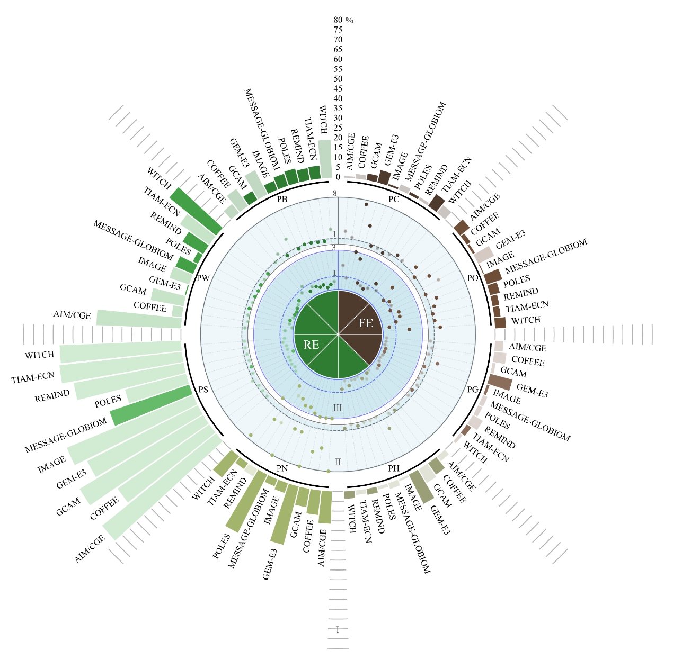
Supplementary Figure 1. Historical errors of specific energy supply technologies.
Note: The power generation capacity in the figure includes eight specific indicators: Primary Energy|Coal (PC), Primary Energy|Oil (PO), Primary Energy|Gas (PG), Primary Energy|Hydro (PH), Primary Energy|Nuclear (PN), Primary Energy|Solar (PS), Primary Energy| Wind (PW), and Primary Energy|Biomass (PB). Zone I, II, and III represent the three different metrics to quantify errors. I. Relative Bias, II. Normal Root Mean Square Error (Normal RMSE), and III. Normal Centered Root Mean Square Error (Normal Centered RMSE) are represented in the figure by the outermost bar chart, the middle scatter plot, and the inner scatter plot, respectively. In the scatter plots, a coordinate value of 1 on the axes represents the boundary where both Normal RMSE = 1 and Normal Centered RMSE = 1. An RMSE value greater than 1 indicates that the error is unacceptable, while a Normal Centered RMSE value less than 1 suggests the presence of excessive data input error in the model.

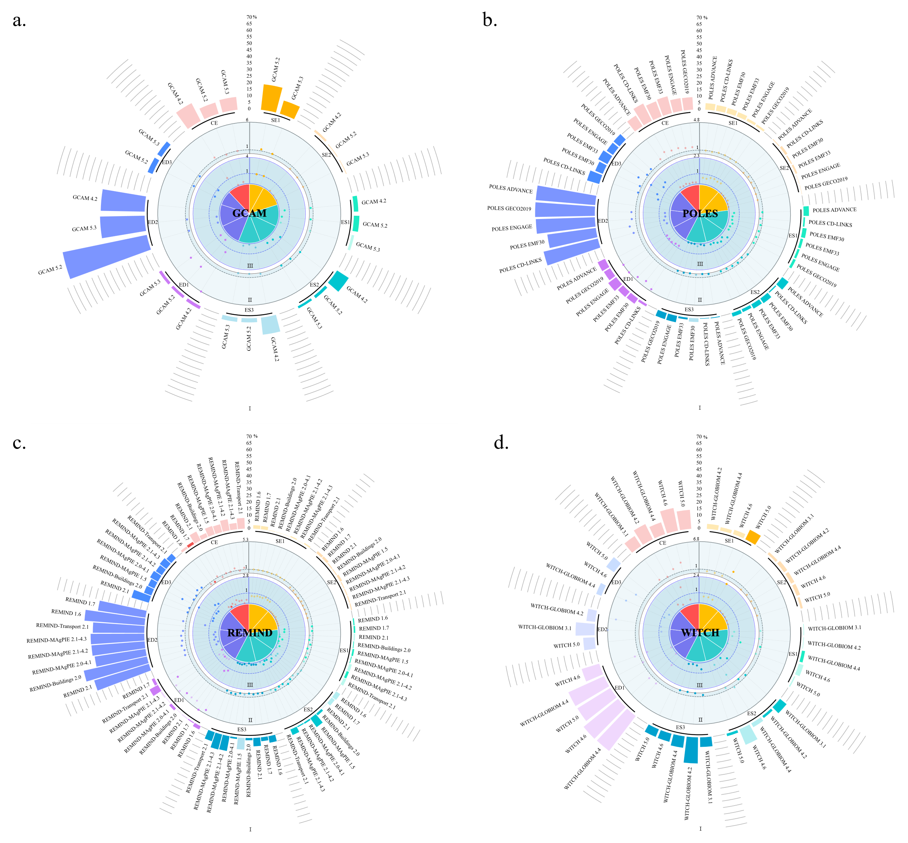
Supplementary Figure 2. Comparison of historical errors across different model versions
Note: All model inputs in the figure can be divided into four categories, namely Socio-Economic (SE), Energy Supply (ES), Energy Demand (ED), and Climate (CE). Specific variable indicators include GDP|MER (SE1), Population (SE2), Primary Energy (ES1), Secondary Energy|Electricity|Fossil (ES2), Secondary Energy|Electricity|Renewables (ES3), Final Energy|Industry (ED1), Final Energy|Transportation (ED2), Final Energy|Residential and Commercial (ED3), Emissions|CO2 (CE). The figure shows three levels of model historical error: I. Relative Bias (Bias), II. Normal Root Mean Square Error (Normal RMSE), and III.Normal Centered Root Mean Square Error (Normal Centered RMSE), which are represented in the figure as the outermost bar chart, the middle layer scatter plot, and the inner layer scatter plot, respectively.

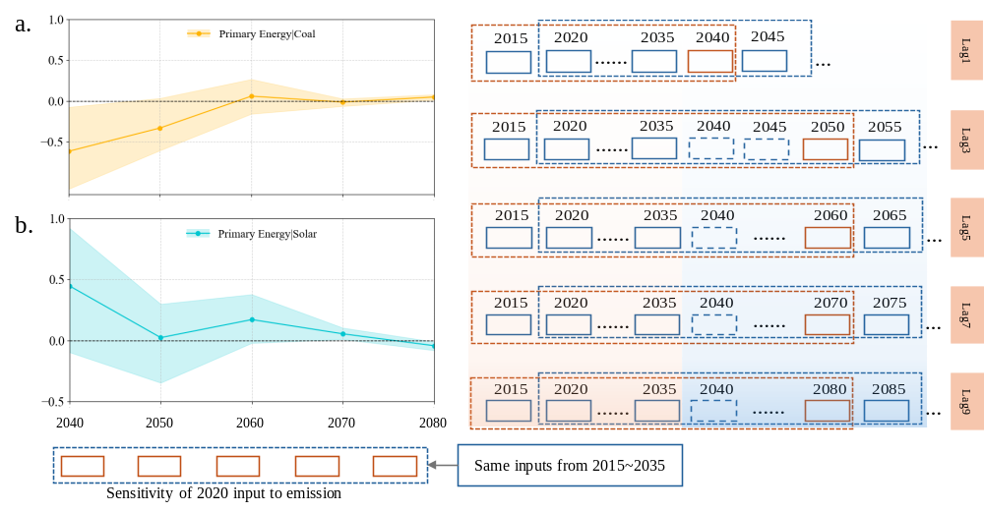
Supplementary Figure 3. LSTM-ZERO model long-term prediction and sensitivity to initial values
Note: In Figure 3a-b on the left shows the sensitivity to coal and solar initial values for long-term emission predictions, with the shaded area inside the dashed lines representing the sensitivity range results from 5% to 95% after 1000 samples.

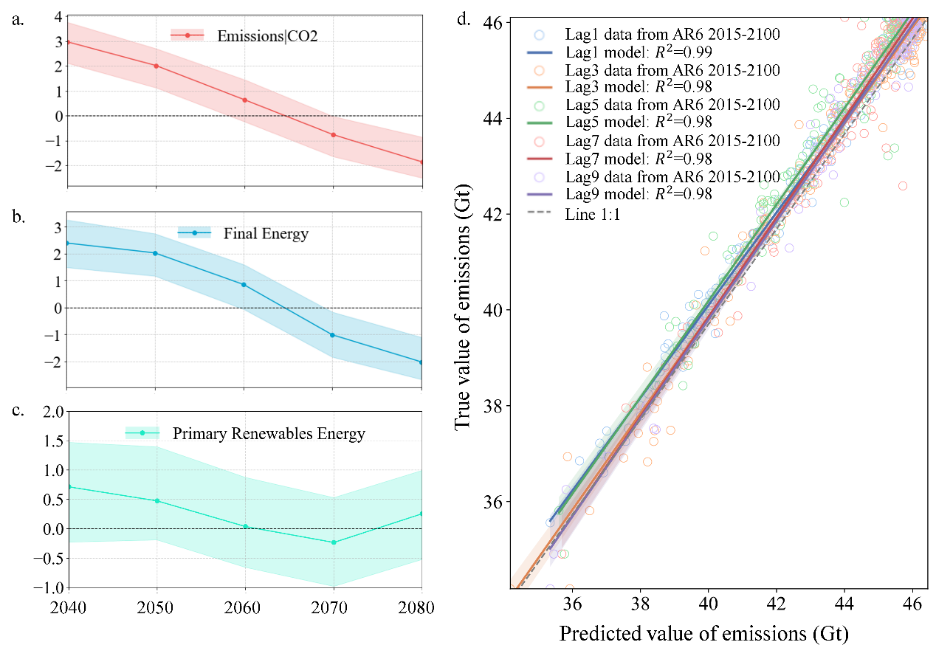
Supplementary Figure 4. LSTM-BAU model long-term prediction and sensitivity to initial values
Note: a-c, The initial value of emissions, final energy and non-biomass renewable primary energy sensitivity of long-term emission predictions, with the shaded area inside the dashed lines indicating the sensitivity range results from the 5% to 95% sensitivity coefficients after 1000 samples. Subfigure d portrays the model performance of test database for LSTM-BAU model. The period from 2015 to 2035 serves as model input, while the period from 2040 to 2080 represents the predicted carbon dioxide emission levels by the LSTM model.

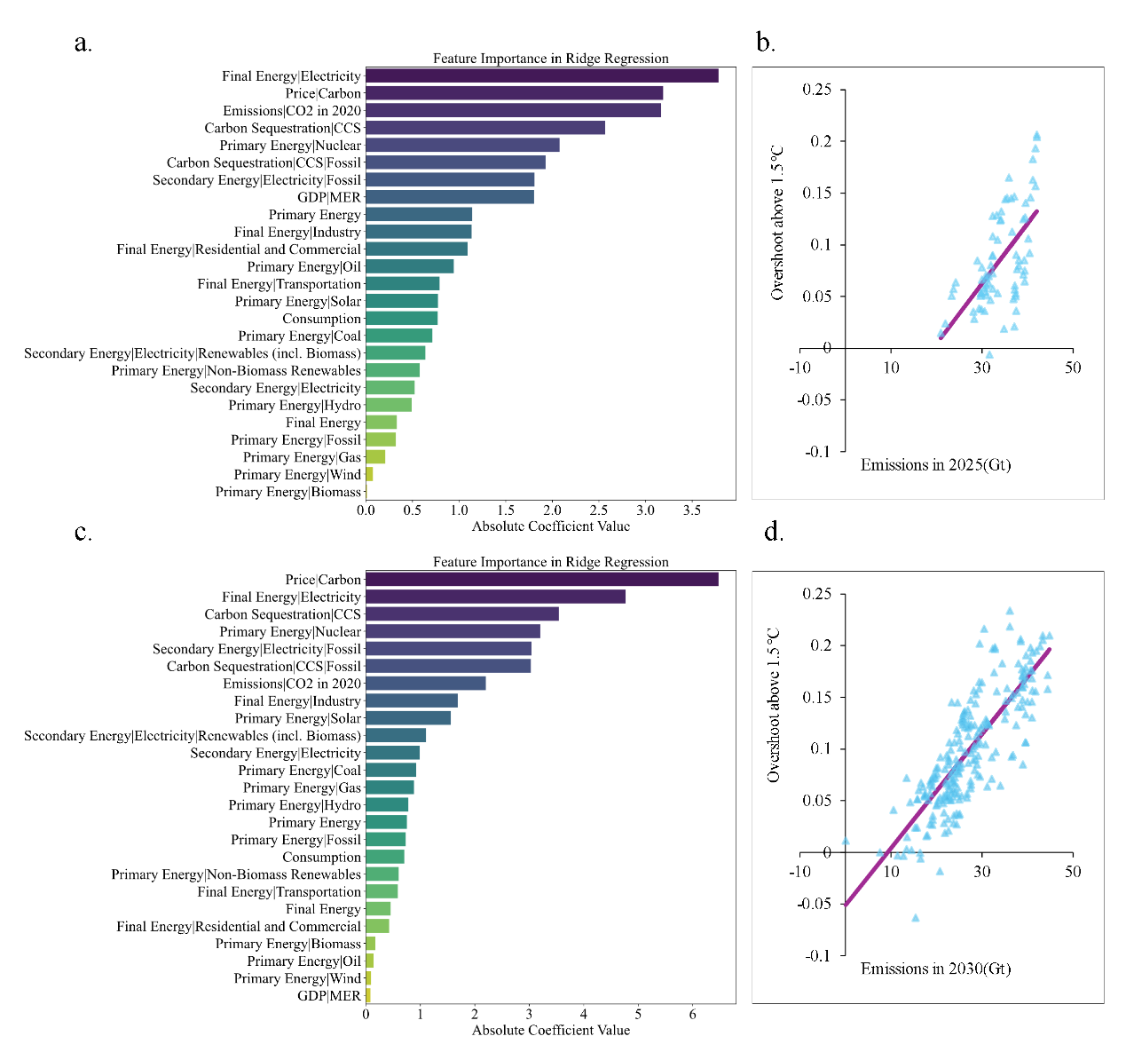
Supplementary Figure 5. Climate overshoot prediction
Note: The bar chart shows the feature importance ranking for the 2020 model initial values' impact on carbon dioxide emissions in 2030 and 2025, as given by Ridge regression. The dot-line graph displays the linear regression results of carbon emission levels in 2025 and 2030 on the overshoot range exceeding 1.5°C.
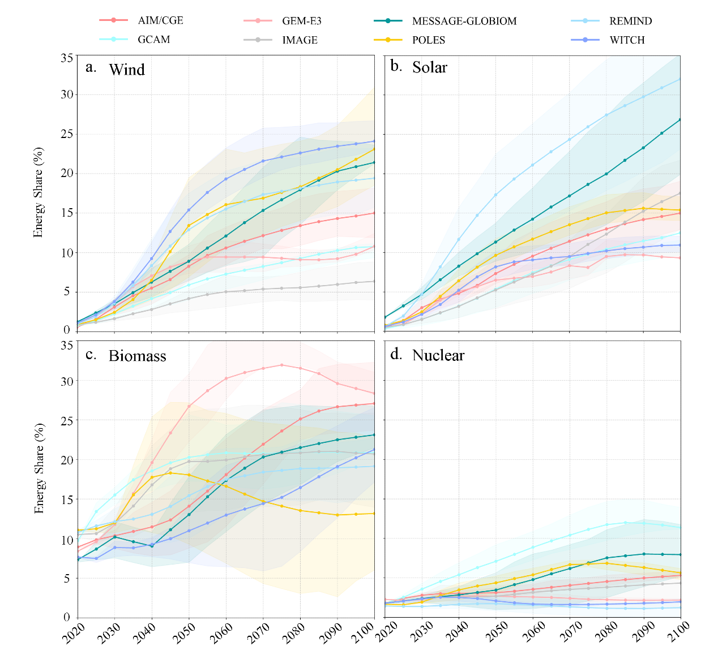
Supplementary Figure 6. Technological development path supporting decarbonization
Note: Subfigures a, b, c, and d show the time-varying trajectories of the proportion of primary energy from wind, solar, biomass, and nuclear energy in the model scenario dataset, respectively. Different colours correspond to different IAMs, and the shading represents the scenario uncertainty range.
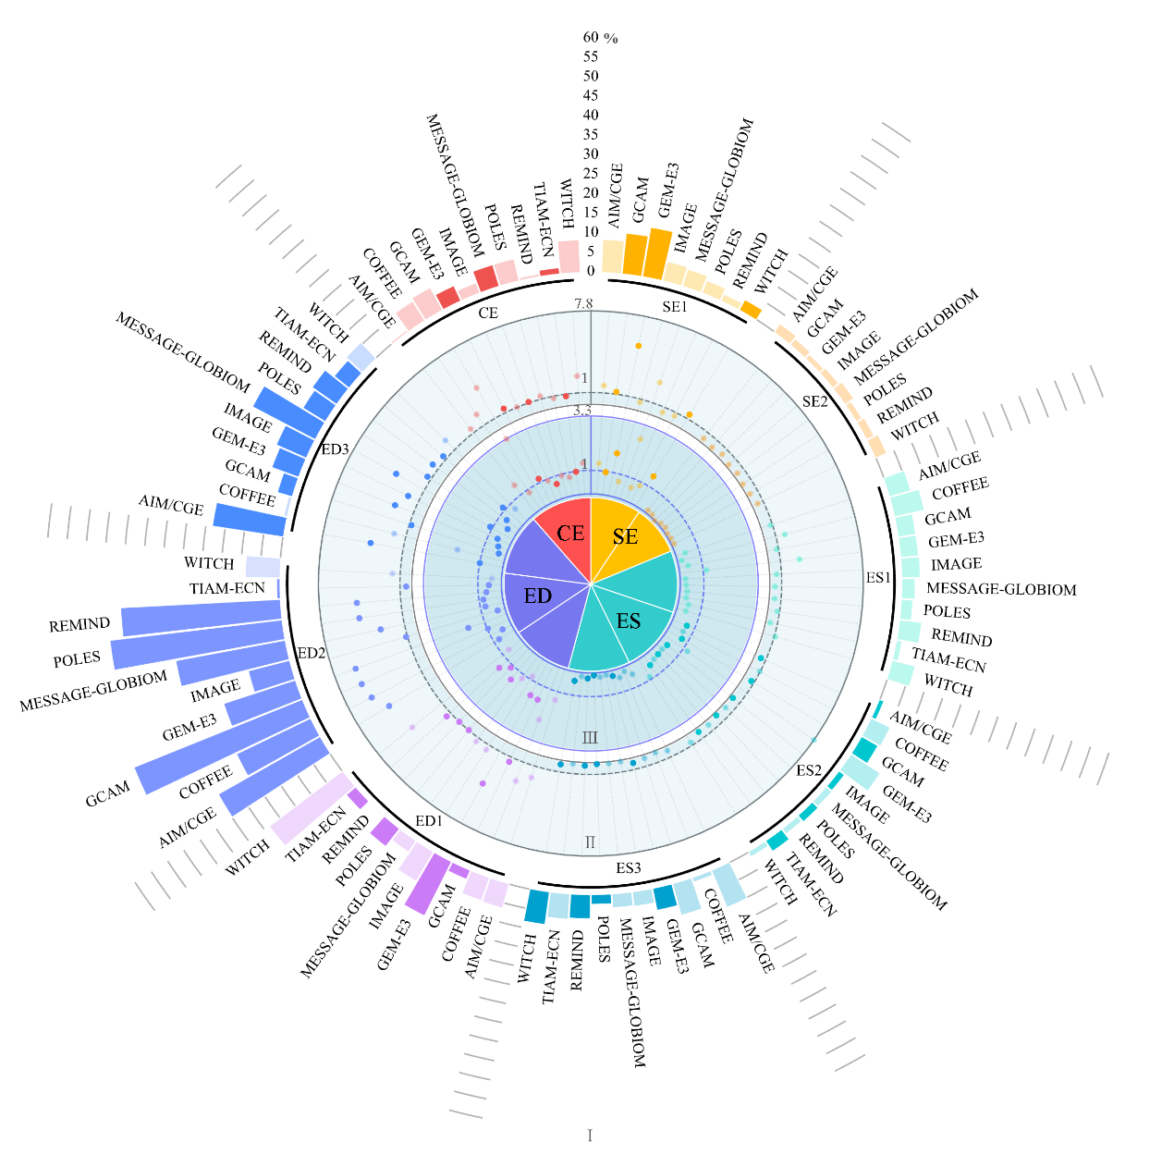

Supplementary Figure 7. Cross-model comparison of historical variable errors
with different data sources
Note: All model inputs can be categorized into four groups, namely Socio-Economic (SE), Energy Supply (ES), Energy Demand (ED), and Climate (CE). The specific variable indicators include GDP|MER (SE1), Population (SE2), Primary Energy (ES1), Secondary Energy|Electricity|Fossil (ES2), Secondary Energy|Electricity|Renewables (ES3), Final Energy|Industry (ED1), Final Energy|Transportation (ED2), Final Energy|Residential and Commercial (ED3), and Emissions|CO2 (CE). The figure displays three levels of historical error for the models, which are I Relative Bias (Bias), II Normalized Root Mean Square Error (Normal RMSE), and III Normal Centered Root Mean Square Error (Normal Centered RMSE), corresponding to the outermost bar chart, the middle scatter plot, and the inner scatter plot in the figure, respectively. In the scatter plots, the coordinate value 1 on the axes denotes the boundary line where Normal RMSE=1 and Normal Centered RMSE=1. Each scatter point corresponds to a variable of a model. More analysis on the acceptability of the errors across model variables is reported in Supplementary Note 1.

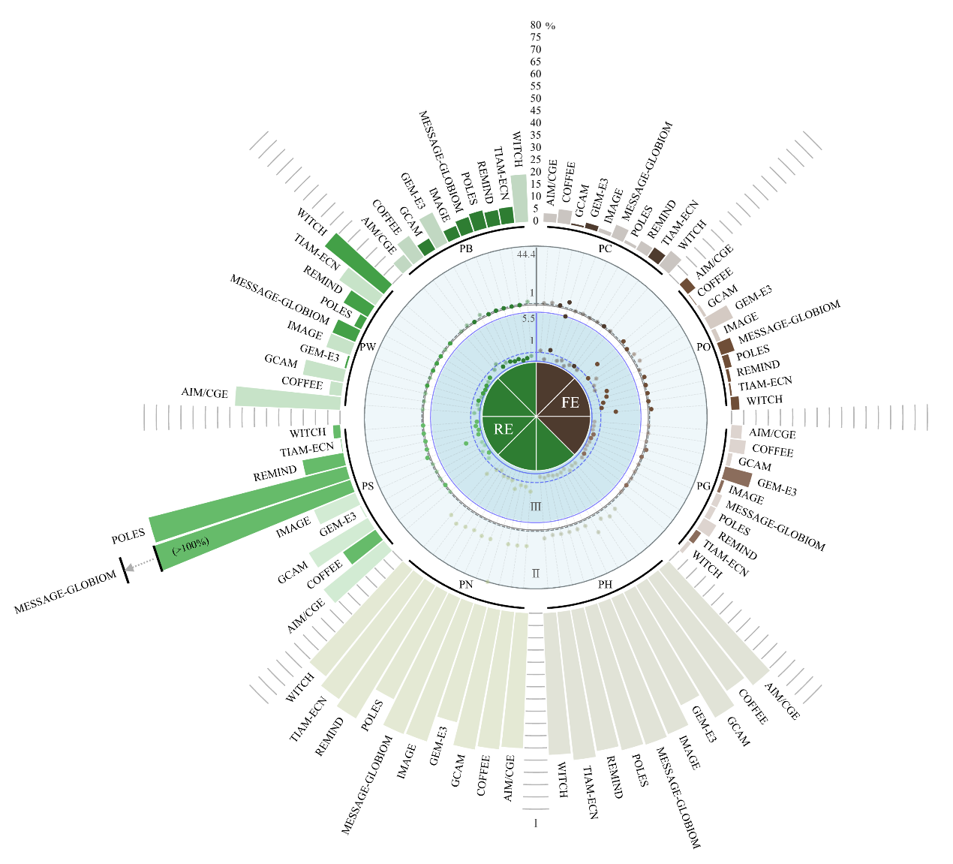
Supplementary Figure 8. Historical errors of specific energy supply technologies
with different data sources
Note: The power generation capacity in the figure includes eight specific indicators: Primary Energy|Coal (PC), Primary Energy|Oil (PO), Primary Energy|Gas (PG), Primary Energy|Hydro (PH), Primary Energy|Nuclear (PN), Primary Energy|Solar (PS), Primary Energy| Wind (PW), and Primary Energy|Biomass (PB). Zone I, II, and III represent the three different metrics to quantify errors. I. Relative Bias, II. Normal Root Mean Square Error (Normal RMSE), and III. Normal Centered Root Mean Square Error (Normal Centered RMSE) are represented in the figure by the outermost bar chart, the middle scatter plot, and the inner scatter plot, respectively. In the scatter plots, a coordinate value of 1 on the axes represents the boundary where both Normal RMSE = 1 and Normal Centered RMSE = 1. An RMSE value greater than 1 indicates that the error is unacceptable, while a Normal Centered RMSE value less than 1 suggests the presence of excessive data input error in the model.

Supplementary References
Schreyer, F., Luderer, G., Rodrigues, R., Pietzcker, R. C., Baumstark, L., Sugiyama, M., Brecha, R. J., & Ueckerdt, F. (2020). Common but differentiated leadership: strategies and challenges for carbon neutrality by 2050 across industrialized economies. Environmental Research Letters, 15(11), 114016. https://doi.org/10.1088/1748-9326/abb852
Speizer, S., Fuhrman, J., Aldrete Lopez, L., George, M., Kyle, P., Monteith, S., & McJeon, H. (2024). Integrated assessment modeling of a zero-emissions global transportation sector. Nature Communications, 15(1), 4439. https://doi.org/10.1038/s41467-024-48424-9
Wolfram, P., Kyle, P., Fuhrman, J., O’Rourke, P., & McJeon, H. (2024). The hydrogen economy can reduce costs of climate change mitigation by up to 22%. One Earth, 7(5), 885–895. https://doi.org/https://doi.org/10.1016/j.oneear.2024.04.012

