Deep dehydrated layered membrane for selective and fast ion separation
Zhaoyu Ma¹, Jilong Fan¹, Chenguang Zhu¹, Hongfei Gao^{1,2}, Jun Gao^{1,2,3}*
¹Key Laboratory of Photoelectric Conversion and Utilization of Solar Energy, Qingdao Institute of Bioenergy and Bioprocess Technology, Chinese Academy of Sciences, Qingdao 266101, China
²Shandong Energy Institute, Qingdao 266101, China
³Qingdao New Energy Shandong Laboratory, Qingdao, 266101, China
*Corresponding author
Email: jun.gao@qibebt.ac.cn

This file includes:
Figures S1 to S34
Tables S1 to S7
References

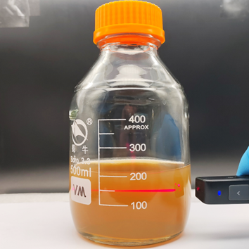
Fig. S1 The vermiculite nanosheet dispersion with Tyndall effect.

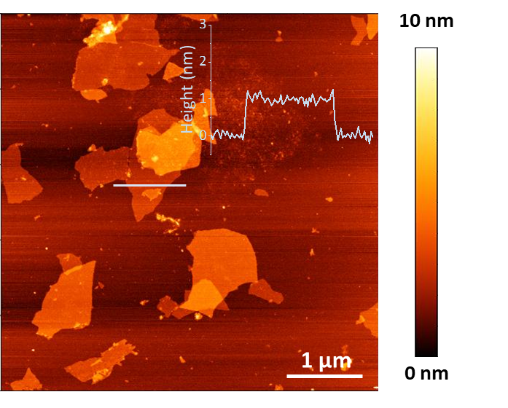
Fig. S2 AFM image of the exfoliated vermiculite nanosheets. Inset is the height profile across the solid line.

Fig. S3 Zeta potential of the vermiculite nanosheets in aqueous dispersions.

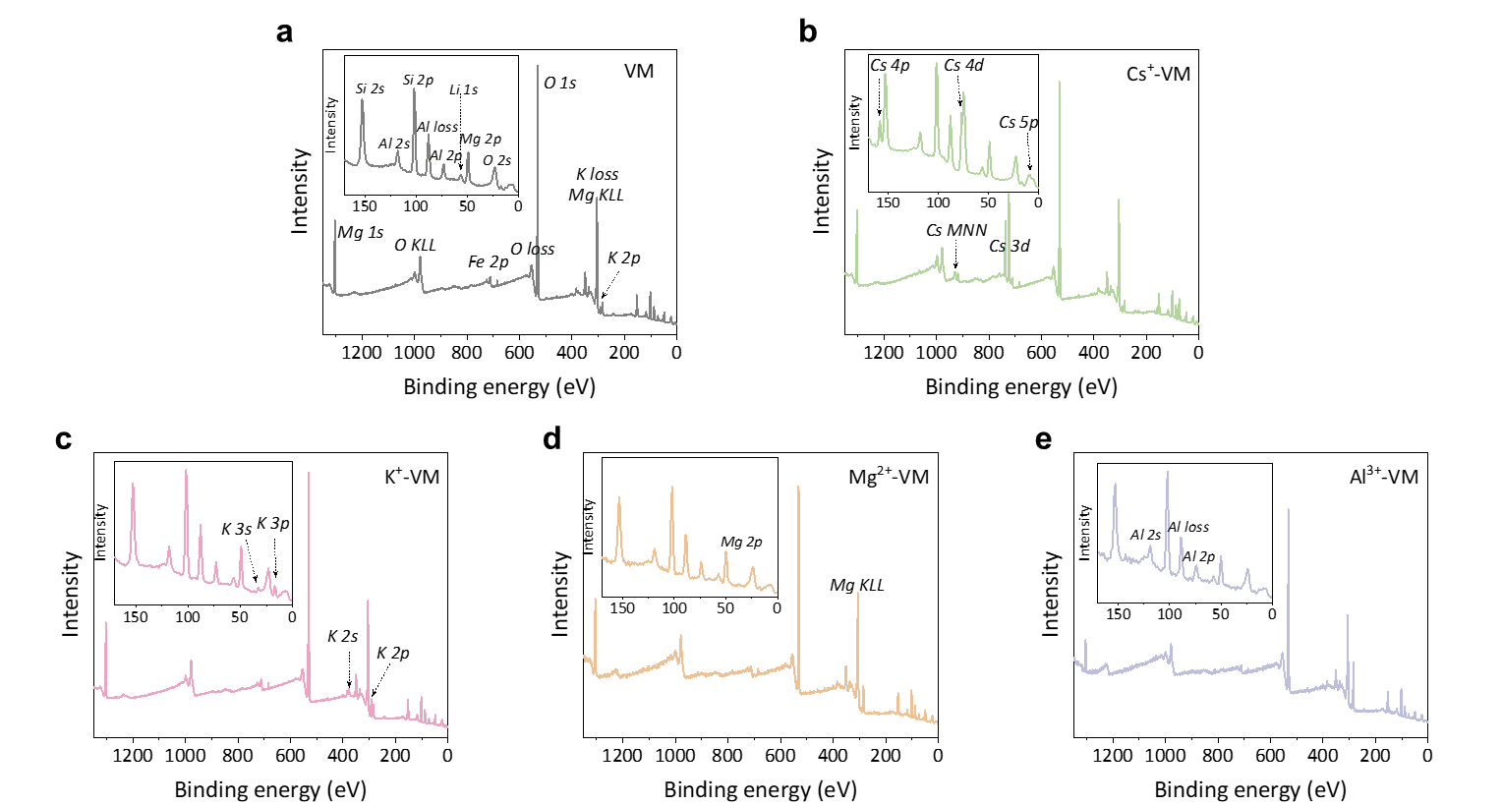
Fig. S4 XPS spectra of (a) neat VM and the (b) Cs⁺ ion, (c) K⁺ ion, (d) Mg²⁺ and (e) Al³⁺ ion intercalated VM membranes. Insets are the enlargements ranging 0-150 eV.

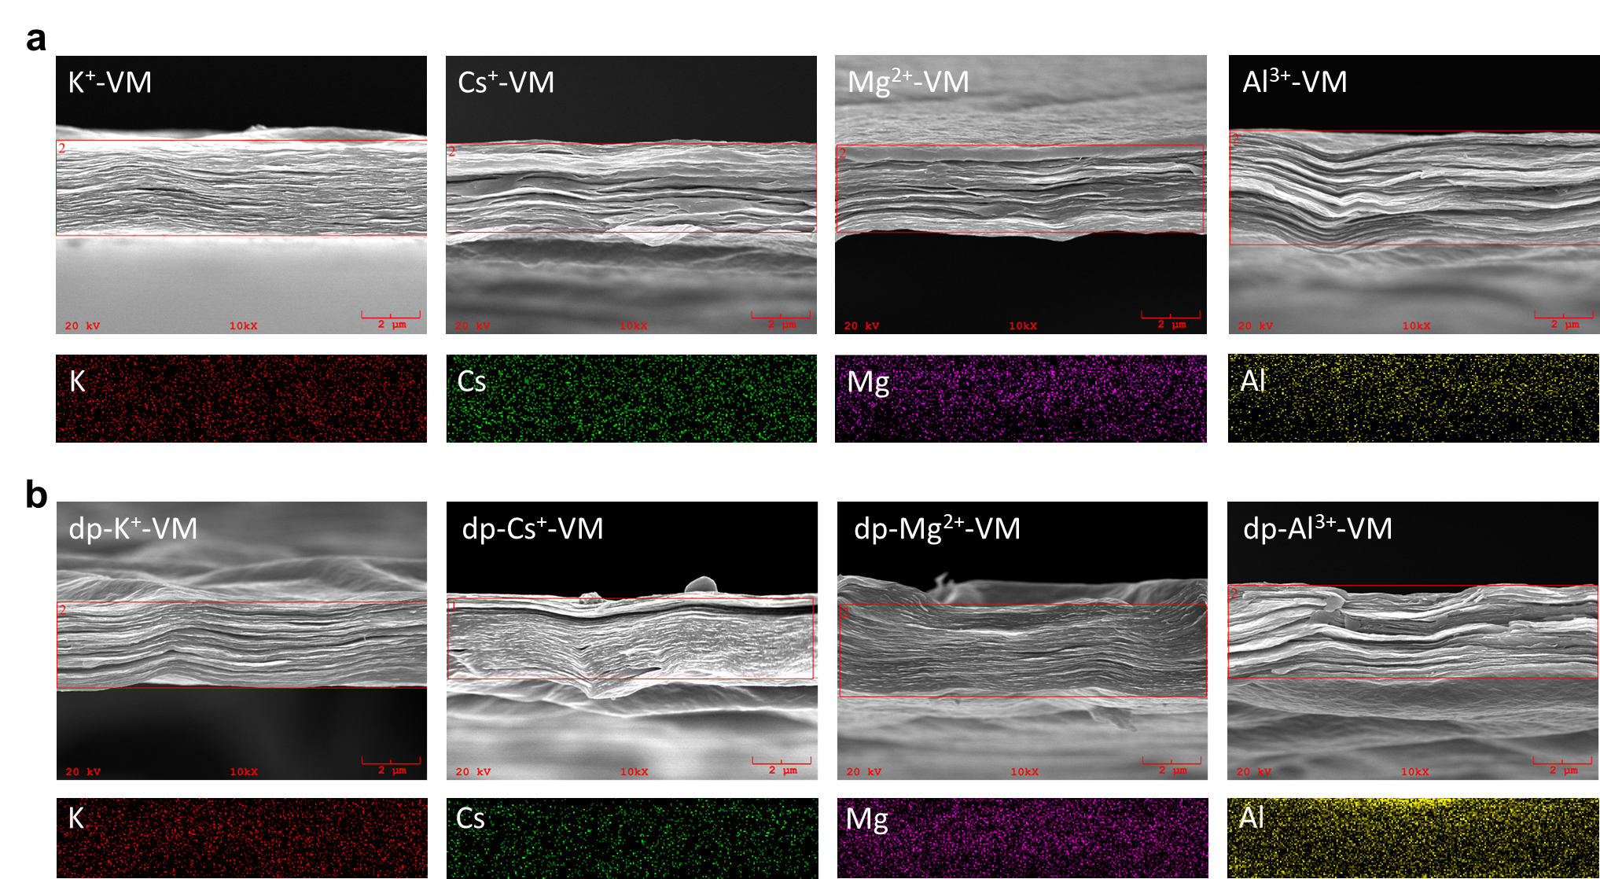
Fig. S5 SEM images of (a) X-VM and (b) dp-X-VM membranes. The corresponding EDS mappings show uniformly distribution of the intercalated ions before and after deep dehydration.

Fig. S6 TG curves of the neat VM and X-VM membranes. The heating rate is 10 °C/min.

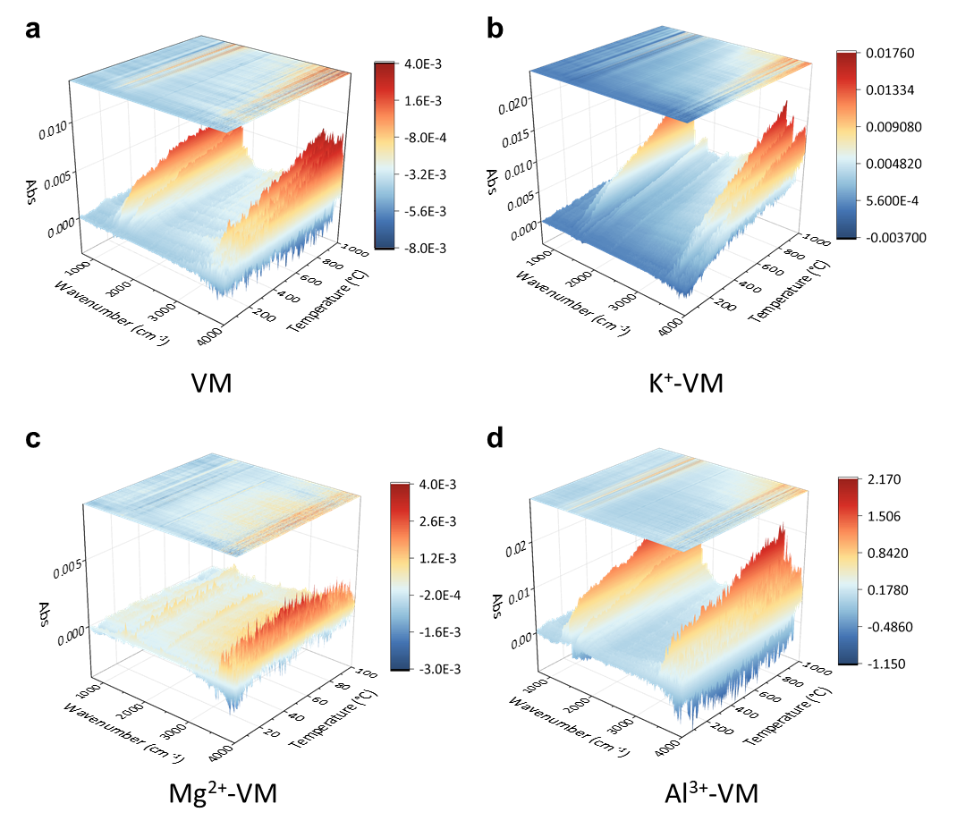
Fig. S7 TG-FTIR coupled analysis of (a) the pure VM and (b-d) different ion-intercalated X-VM membranes. The heating rate is 10 °C/min.

Fig. S8 FT-IR spectra of pristine VM, Cs⁺-VM and dp-Cs⁺-VM membranes. The peaks of –OH and Si(Al)–O–Si were labeled by ν (stretching vibration) and β (bending vibration).

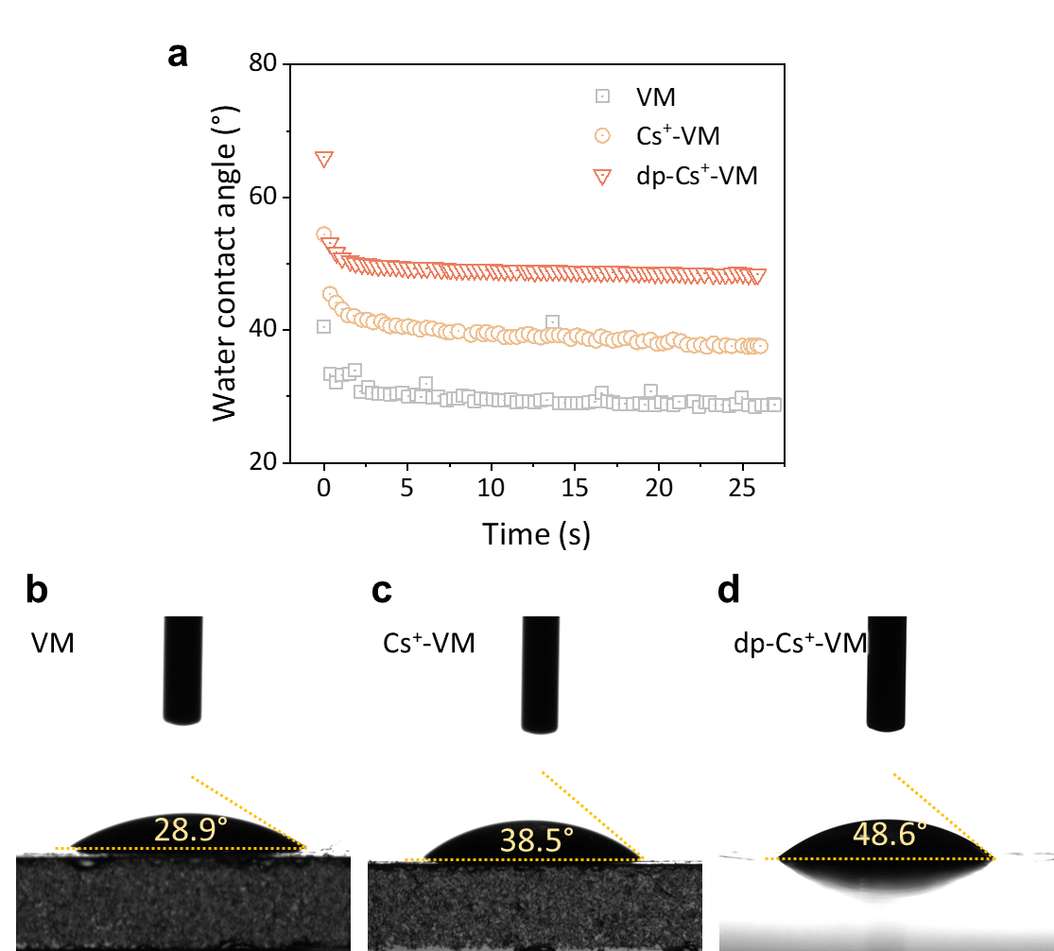
Fig. S9 (a) Dynamic water contact angles of pristine VM, Cs⁺-VM and dp-Cs⁺-VM membranes. (b-d) The snapshots of the equilibrium states.

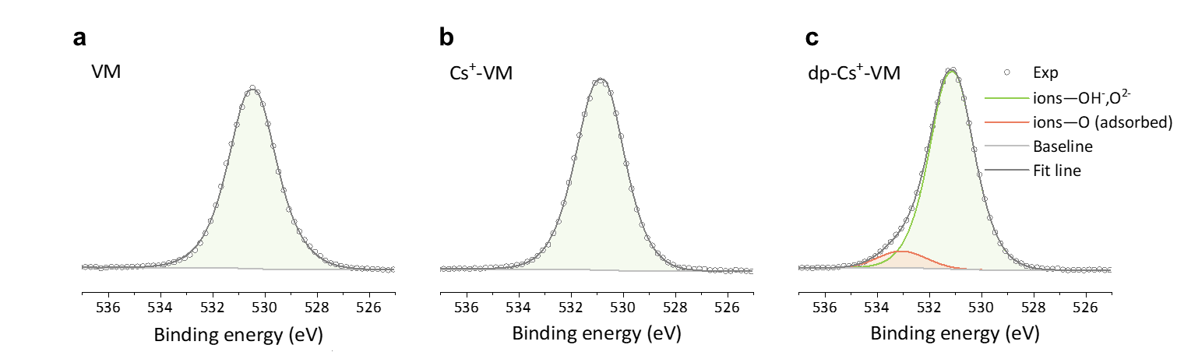
Fig. S10 XPS fine scan spectra of O1s in (a) neat VM, (b) Cs⁺-VM and (c) dp-Cs⁺-VM membranes. The observed new split peak over 532 eV is attributed to the enhanced adsorbed Cs⁺ ions with O atoms under dehydrated state.

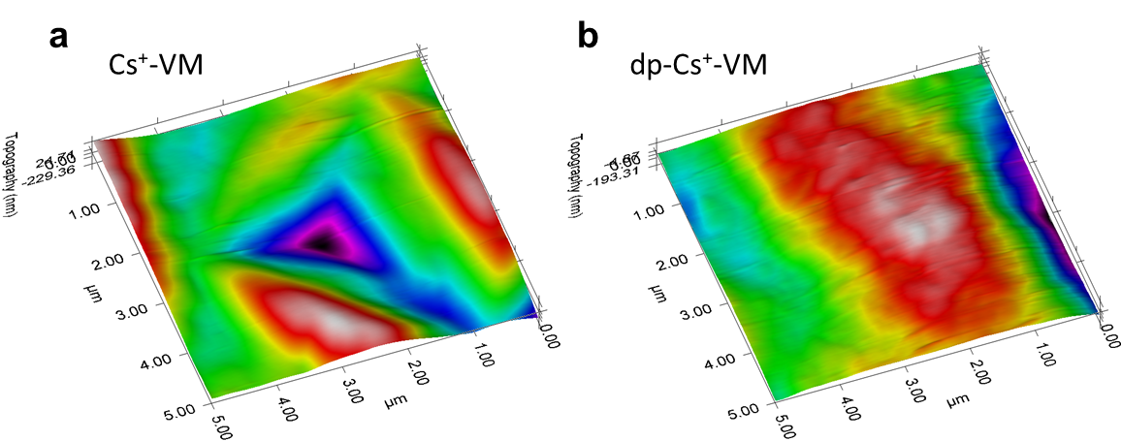
Fig. S11 Testing areas of (a) Cs⁺-VM, and (b) dp-Cs⁺-VM membranes for nanoindentation.

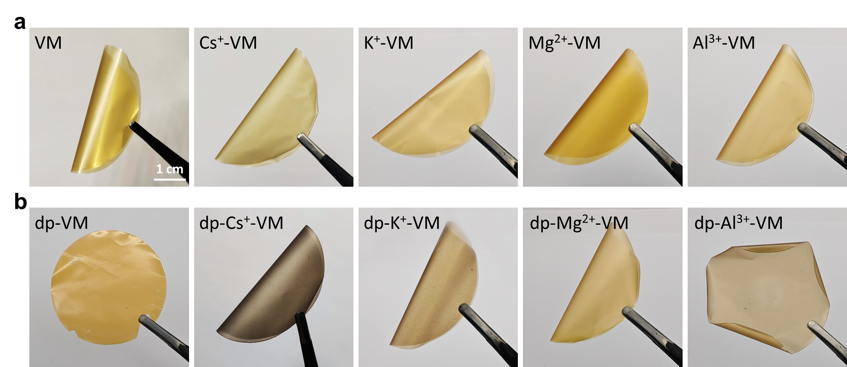
Fig. S12 Digital photos of (a) X-VM and (b) dp-X-VM membranes, showing a distinct color change. All the samples were bendable with toughness except for the dp-VM and dp-Al³⁺-VM.

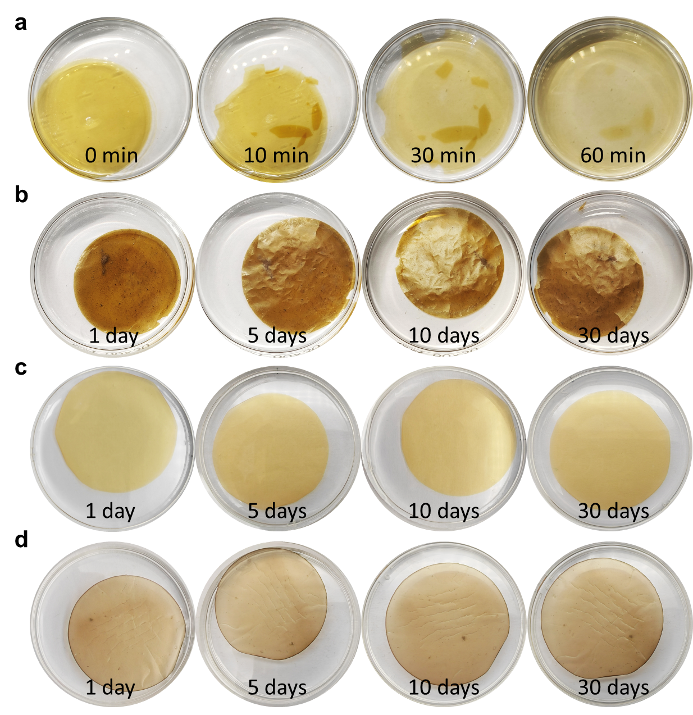
Fig. S13 Comparison of the aqueous stability of (a) neat VM, (b) dp-VM, (c) Cs⁺-VM, and (d) dp-Cs⁺-VM membranes.

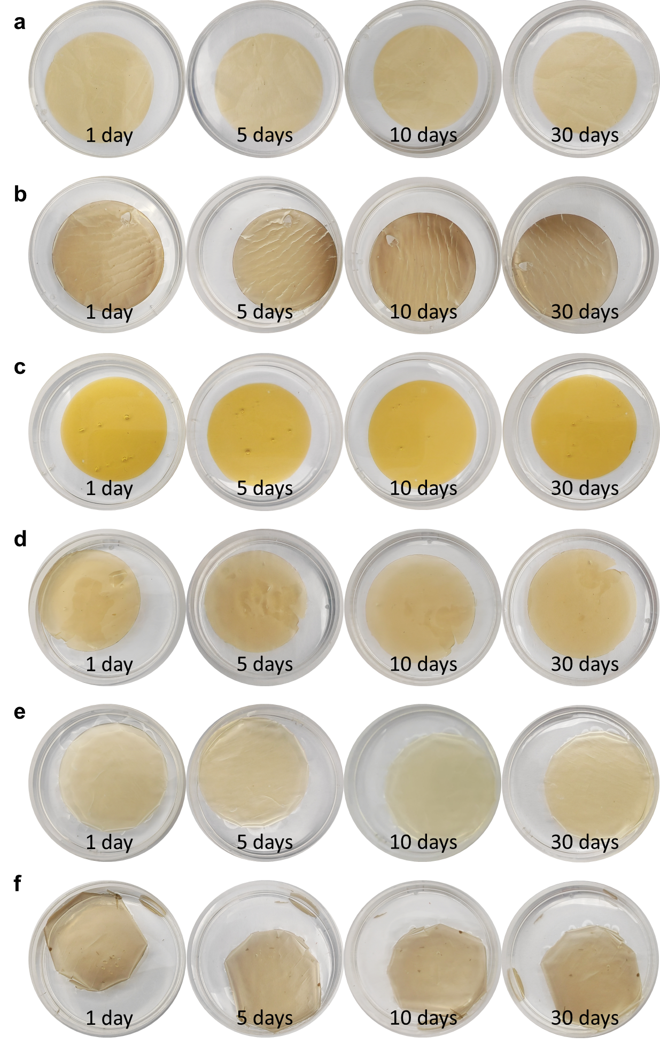
Fig. S14 The aqueous stability of (a) K⁺-VM, (b) dp-K⁺-VM, (c) Mg²⁺-VM, (d) dp-Mg²⁺-VM, (e) Al³⁺-VM, and (f) dp-Al³⁺-VM membranes.

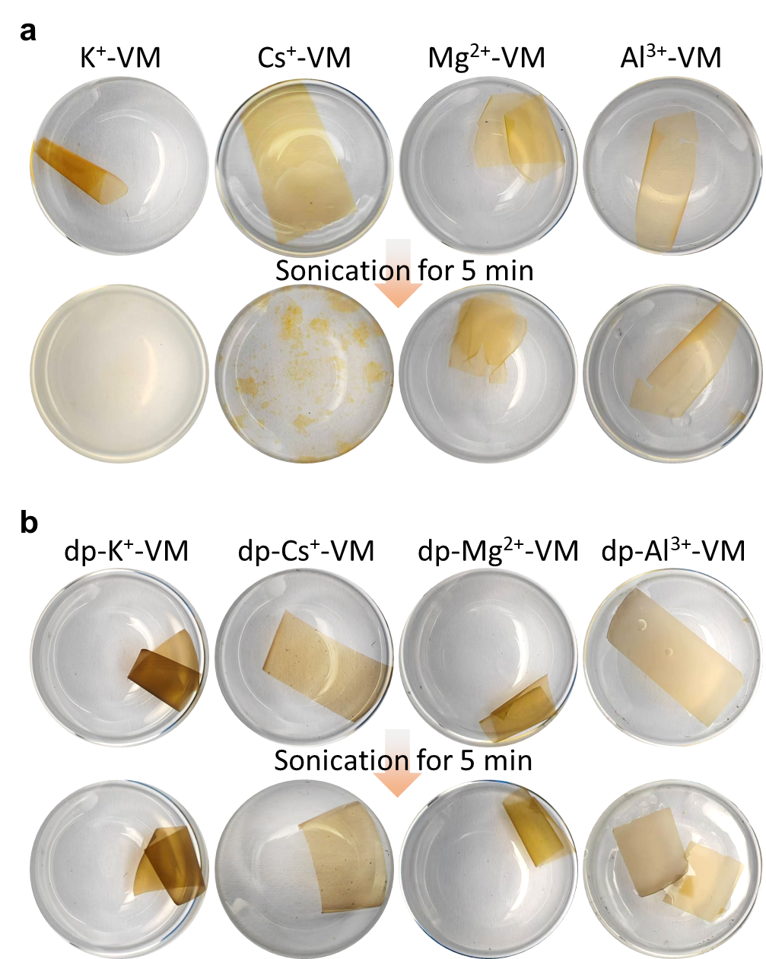
Fig. S15 The stability of (a) X-VM and (b) dp-X-VM membranes under ultrasonication.

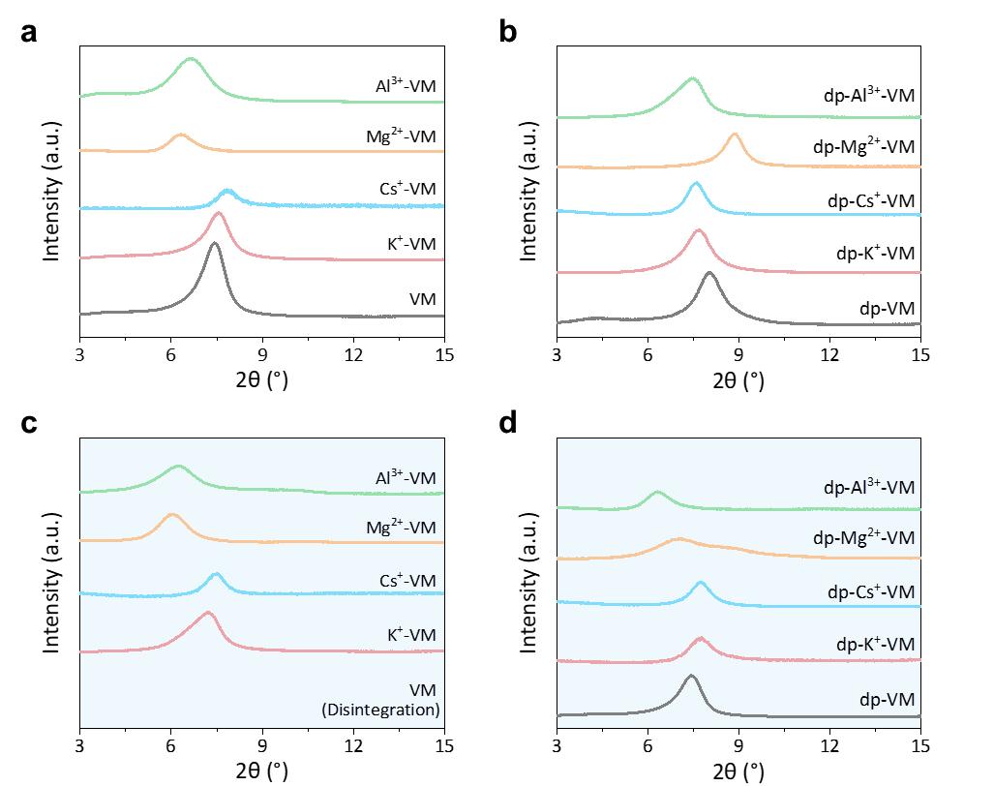
Fig. S16 XRD spectra of X-VMs and dp-X-VMs (a-b) before and (c-d) after immersion treatment for 30 days.

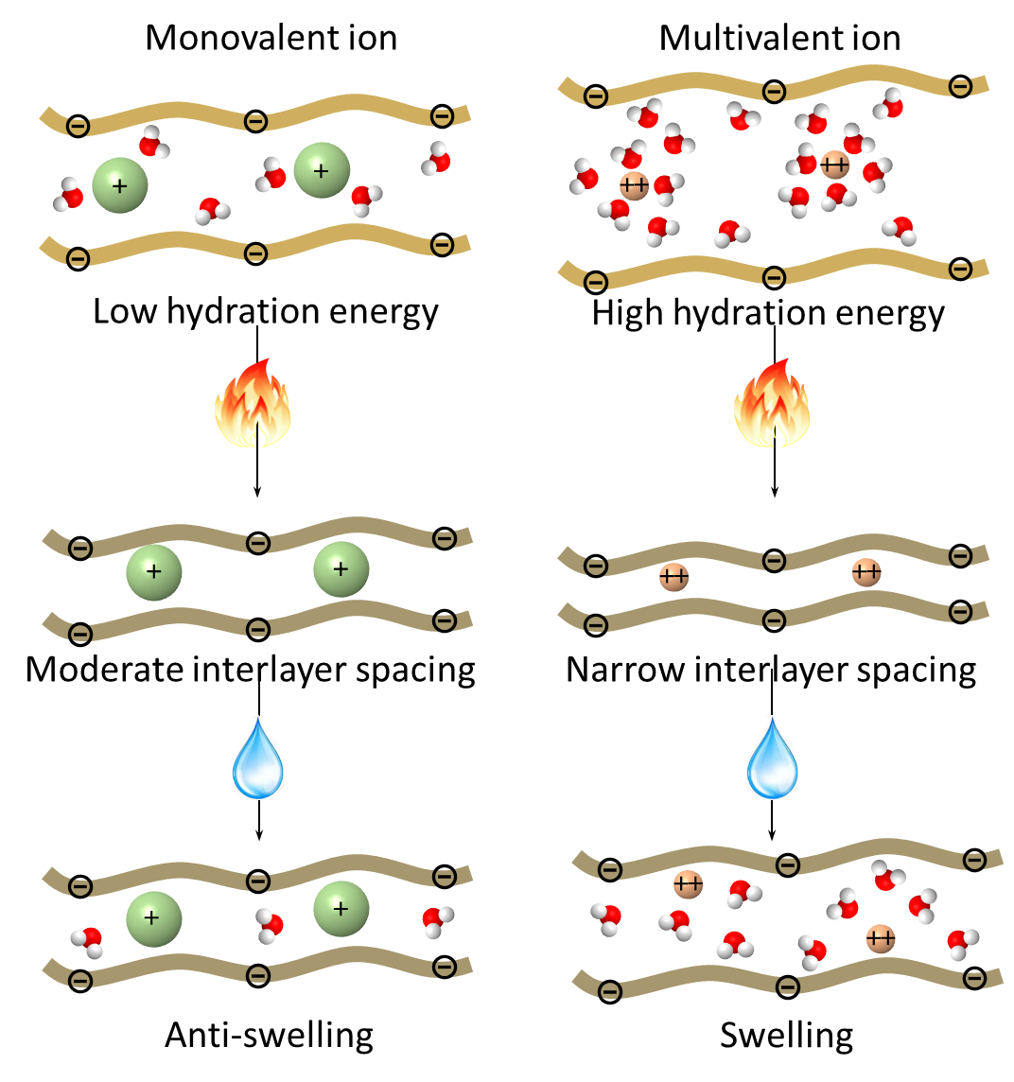
Fig. S17 Schematic illustration of the ion intercalation effect. Monovalent ions like Cs⁺ with lower hydration energy could form stable moderate interlayer channel after deep dehydration.

Table S1 The corrected energy used to calculate the binding energies of the cations and vermiculite nanosheet. Lists are total energy of the whole system and the contributions from the vermiculite layer ($E_{VM}$) and bare/hydrated ions ($E_{M^{n+}}$). The energy unit is Hartree.
Ion | $$E_{M^{n+}@VM}$$ | $$E_{VM}$$ | $$E_{M^{n+}}$$
K⁺ | -3297.64924 | -3200.29288 | -97.05312
Cs⁺ | -3220.41024 | -3200.19839 | -19.99806
Mg²⁺ | -3332.63476 | -3200.18871 | -131.76444
Al³⁺ | -3201.95282 | -3200.00343 | -0.27845
Cs⁺ (5 Å)** | -6440.0961 | -6399.6861 | -39.91793
Cs⁺ (4 Å)** | -6440.2952 | -6399.81439 | -39.91717
Cs⁺ (3 Å)** | -6440.39065 | -6399.86465 | -39.91698
Li(H₂O)₄⁺ | -3277.42297 | -3200.87922 | -76.27979
Mg(H₂O)₆²⁺ | -3367.74441 | -3200.86207 | -166.32901
*All binding energy calculations take the BSSE into consideration.
**Double layers of the nanosheets with two Cs⁺ ions.

Table S2 The calculated electron energy of the dp-Cs⁺-VM with different interlayer spacings and the corresponding escaping water molecules. The energy unit is Hartree.
Energy  Interlayer  spacing | dp-Cs⁺-VM | Water | $$Total$$
5 Å | -6676.759 | / | -6676.759
4 Å | -6556.331 | -120.635* | -6676.966
3 Å | -6470.226 | -206.790** | -6677.016
*7 water molecules per unit structure. The calculation method and level are exactly the same as dp-Cs⁺-VM.
**12 water molecules per unit structure. The calculation method and level are exactly the same as dp-Cs⁺-VM.

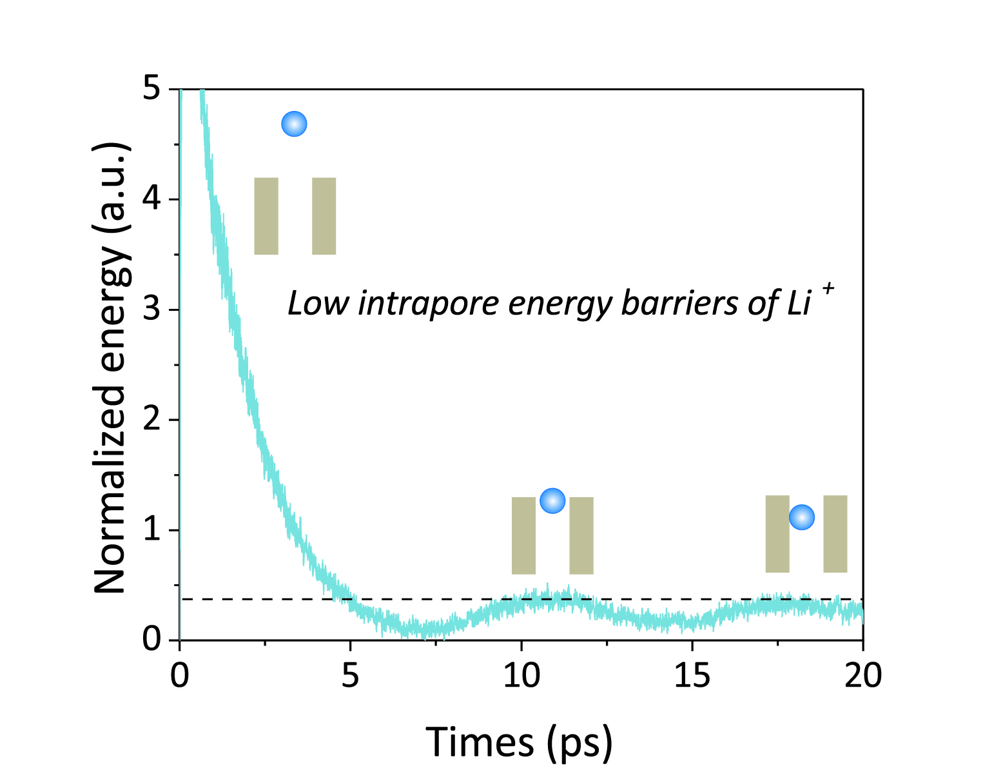
Fig. S18 Change of relative energy showing low intrapore energy barrier of Li⁺ ion.

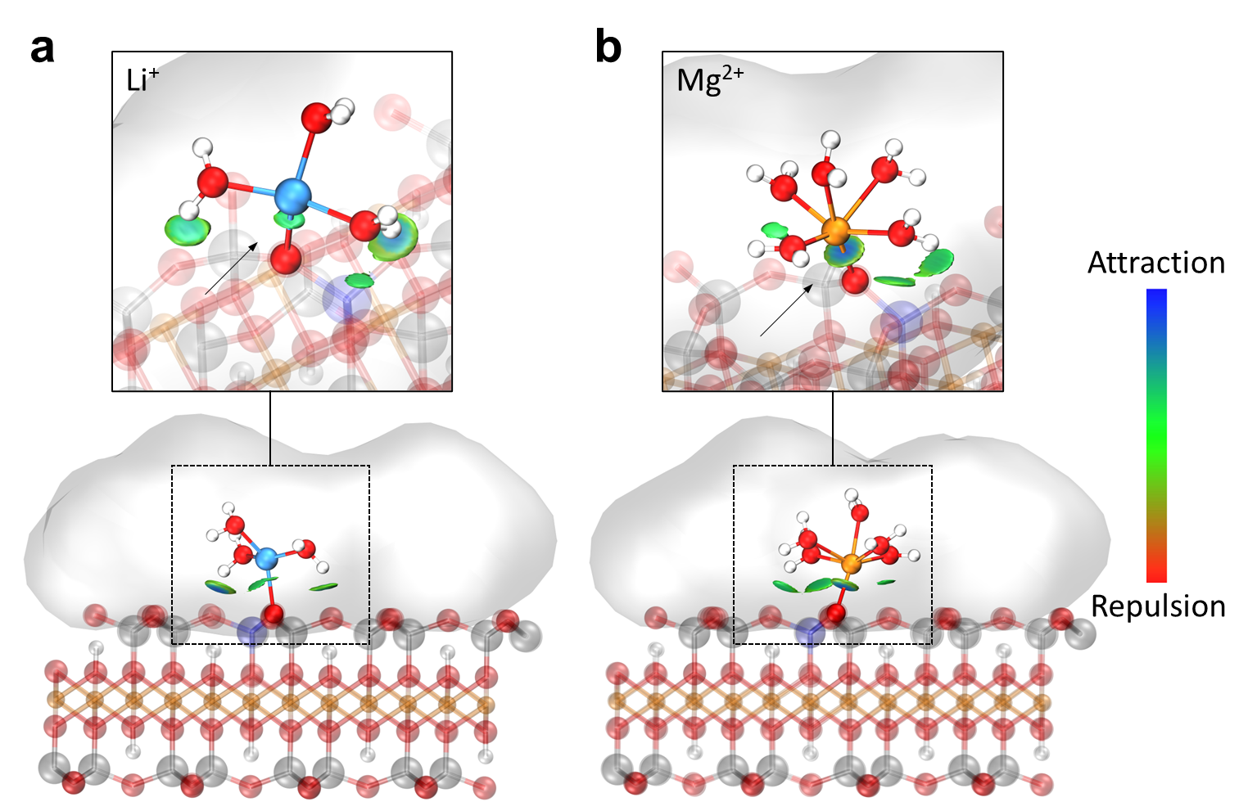
Fig. S19 Non-covalent interaction regions (green isosurfaces, isovalue = 0.01) between vermiculite and hydrated Li⁺, Mg²⁺, respectively. The black arrow in the enlarged image indicates the direct coordination of the cation with the oxygen atom on the vermiculite surface. A stronger interaction area can be found between Mg²⁺ and vermiculite. Water molecules other than in the first hydration shell are represented by grey shadows.

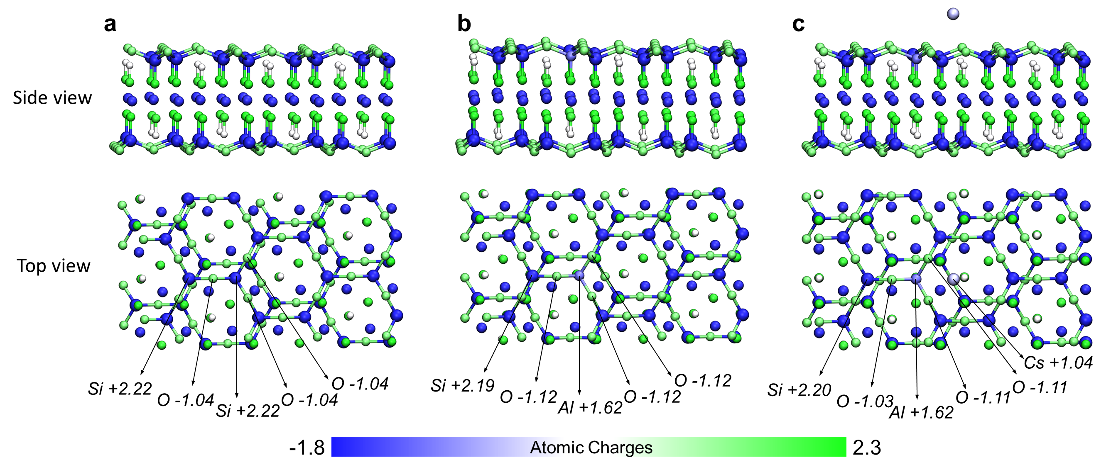
Fig. S20 Hirshfeld-I atomic charge map of the vermiculite surface. The main structural units include (a) Pure Si-O site, (b) Al-doped Al-O site, and (c) Cs⁺ adsorbed Al-O site. The energy barrier for cation transport within the vermiculite channels primarily arises from traversing regions with positive atomic charges, such as Si and Al.

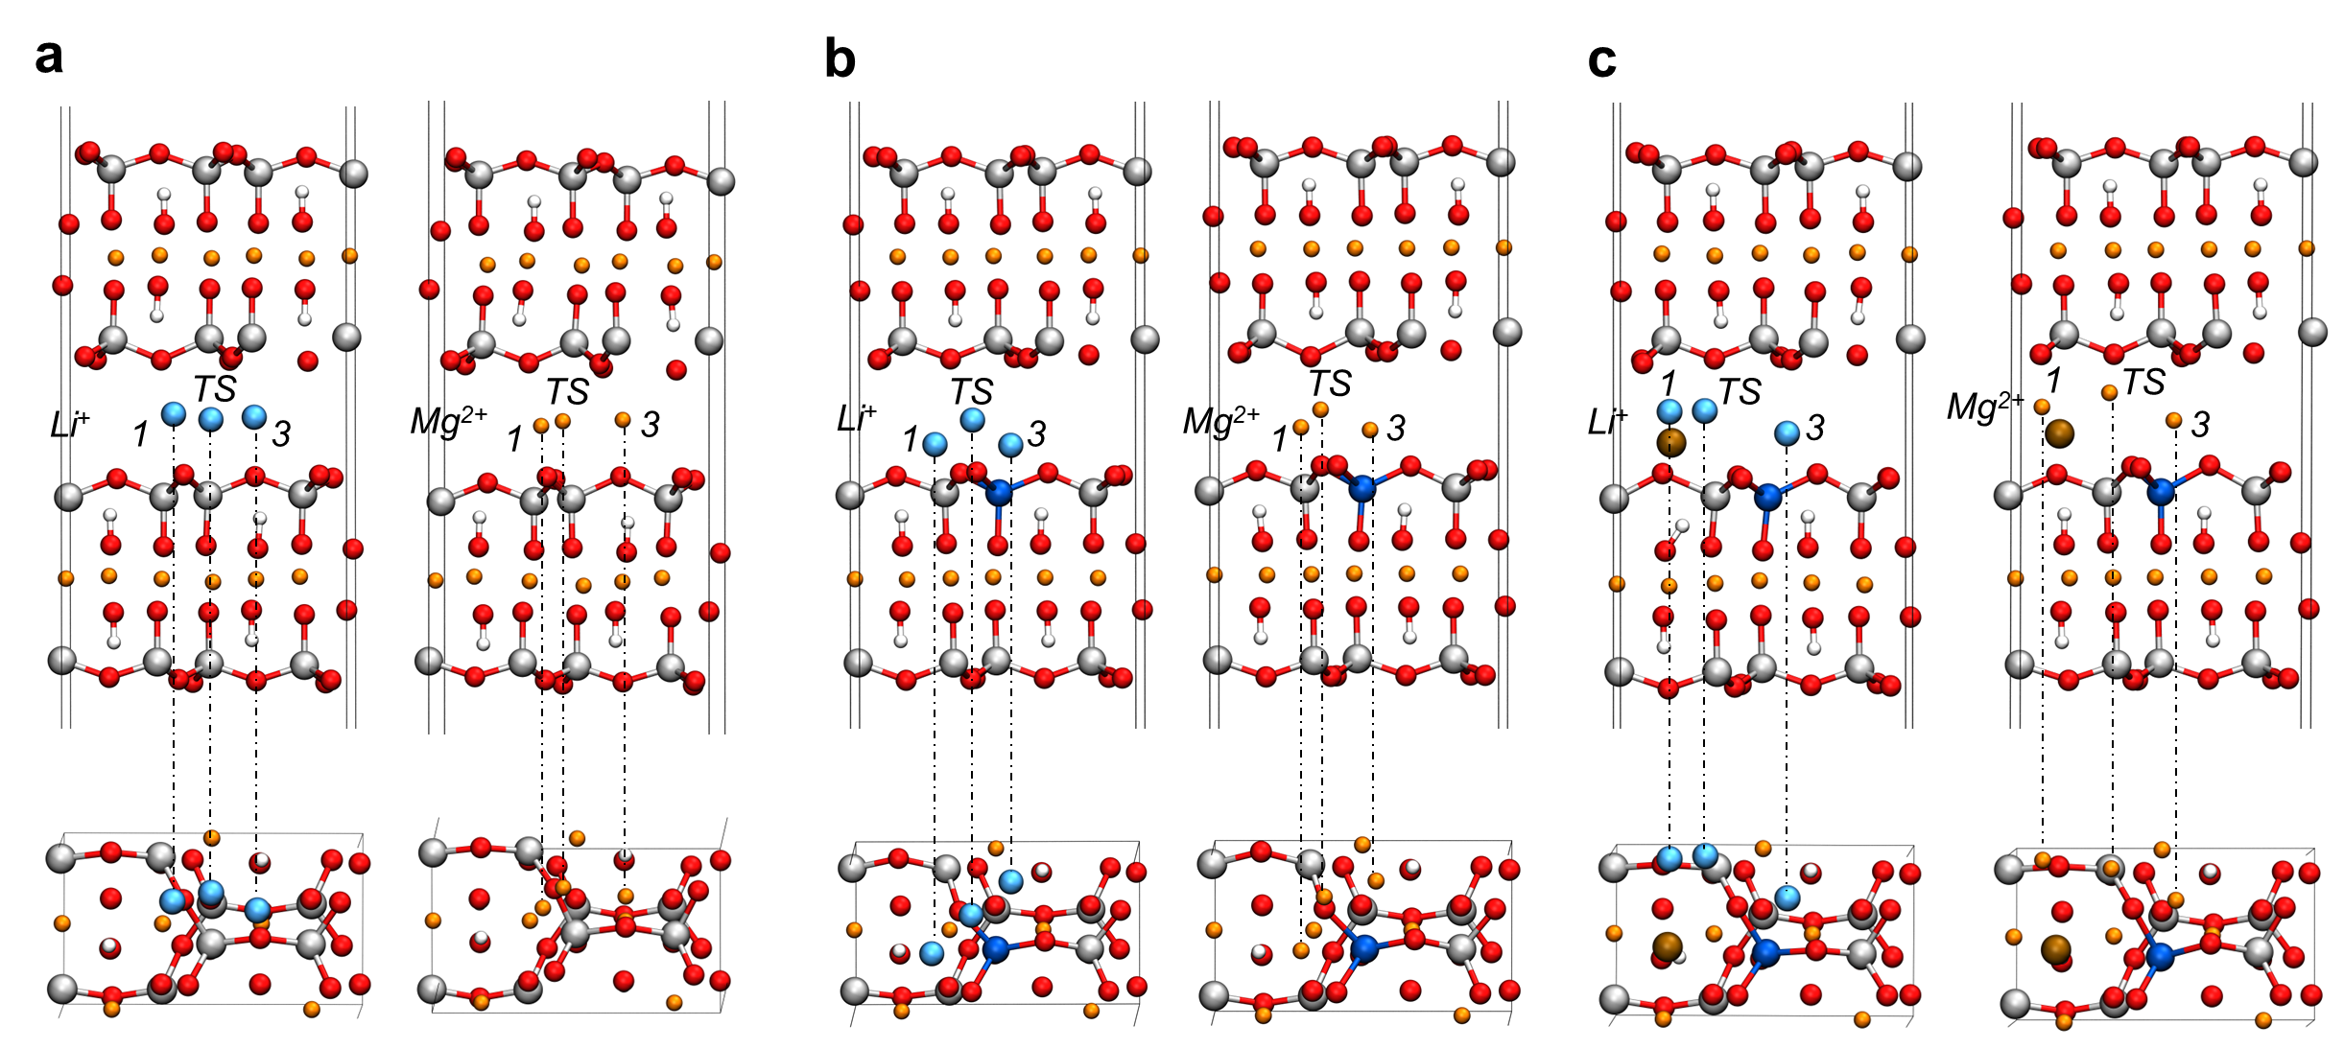
Fig. S21 Side and top view of the calculated cation diffusion path using CI-NEB methods. Possible transport pathways include (a) O-Si-O, (b) O-Al-O, and (c) O-Al-O/Cs⁺. The diffusion path is 1→TS→3.

Table S3 Calculated total energies of the initial (E₁), transition (E_{ts}) and final (E₃) states using CI-NEB method. The energy unit is Hartree.
Site | Ion | E₁ | E_{ts} | E₃
O-Si-O | Li⁺ | -1608.9697 | -1608.9666 | -1608.9746
O-Si-O | Mg²⁺ | -1664.6981 | -1664.6891 | -1664.7090
O-Al-O | Li⁺ | -1607.0974 | -1607.0804 | -1607.1116
O-Al-O | Mg²⁺ | -1662.9039 | -1662.8754 | -1662.9249
O-Al-O/Cs⁺ | Li⁺ | -1627.2832 | -1627.2733 | -1627.3619
O-Al-O/Cs⁺ | Mg²⁺ | -1682.9891 | -1682.9620 | -1683.0902

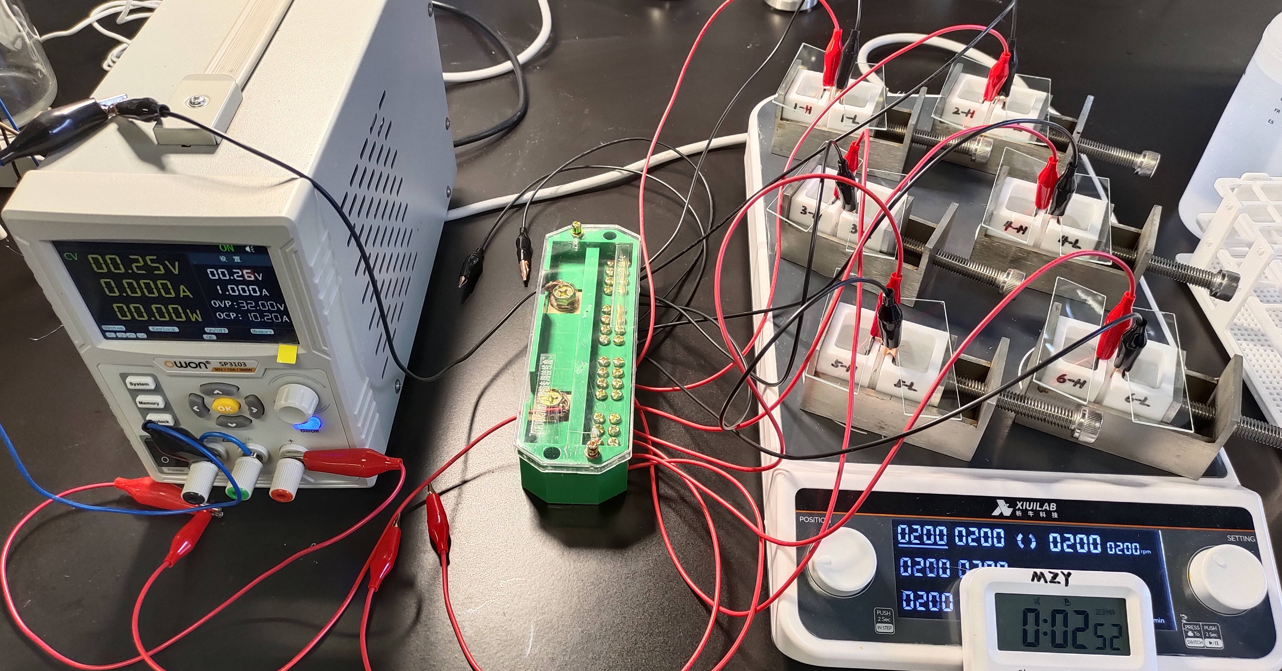
Fig. S22 Homemade external electric field driven ion permeation evaluation devices.

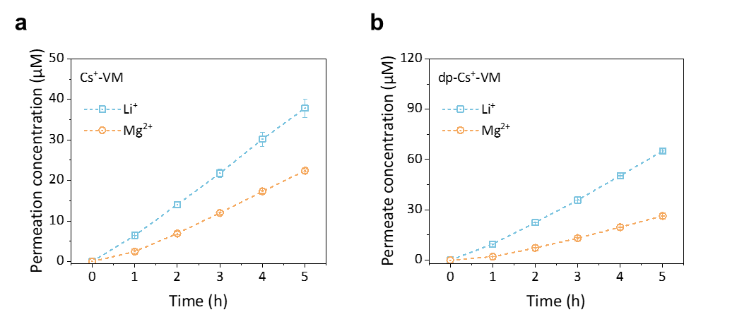
Fig. S23 Permeation concentrations of Li⁺ and Mg²⁺ through the Cs⁺-VM and dp-Cs⁺-VM membrane as a function of testing time. The thicknesses of all membranes were 3 μm. The feed solution was 0.1 M LiCl + 0.1 M MgCl₂. Error bars in all cases represent standard deviation of the data from at least three individual experiments.

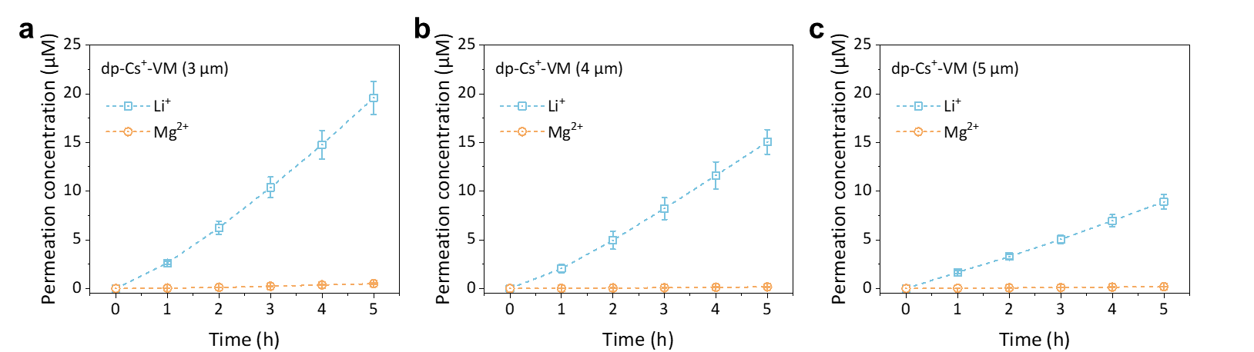
Fig. S24 Permeation concentrations of Li⁺ and Mg²⁺ through the dp-Cs⁺-VM with membrane thickness of (a) 3 μm, (b) 4 μm, and (c) 5 μm as a function of testing time. The feed solution was 0.1 M LiCl + 0.1 M MgCl₂ mixed solution. Error bars in all cases represent standard deviation of the data from at least three individual experiments.

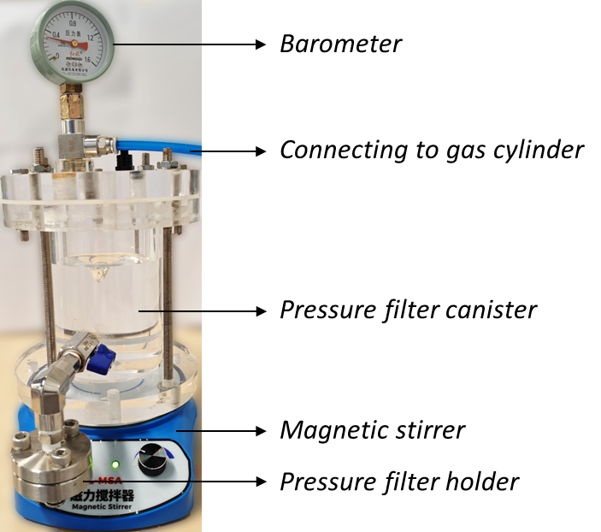
Fig. S25 Homemade setups used for dead-end filtration testing. The effective area of the membrane cell is 4.9 cm².

Table S4 Dead-end filtration testing results*.
Sample | Water permeance  (L m⁻² h⁻¹ bar⁻¹) | Salt rejection (%)*
VM | broken | /
Cs⁺-VM | 0.104±0.008 | 21%
dp-VM | 0.032±0.010 | 37%
dp-Cs⁺-VM | 0.084±0.015 | 48%
*Dead-end filtration test conditions—The testing samples were mounted into the Millipore filter holder with 25 mm diameter and pre-pressurized for 2 h at 3.5 bar for equilibrium. The filtrate was collected in a precision cylinder after 5 h of permeation under 3 bar.
**The rejection to salts were calculated from the conductivity of feed (0.1 M LiCl and MgCl₂) and permeation solution.

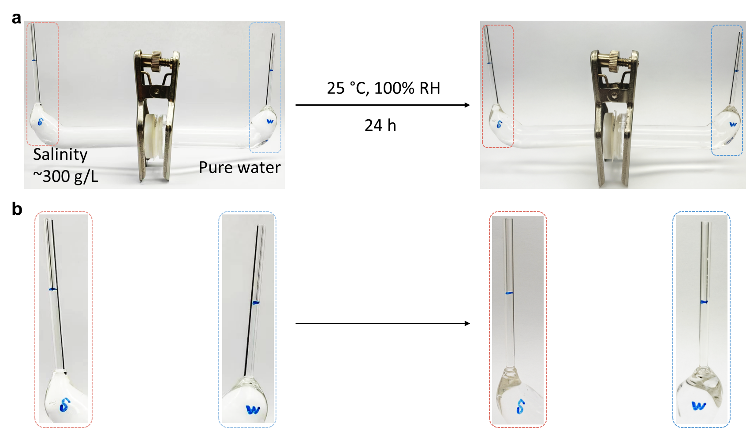
Fig. S26 (a) Evaluation of water osmosis in U-shaped cells. (b) Magnified view of the capillary regions. The diameter of the capillary tube is 1 mm. There is no apparent water migration process during the testing.

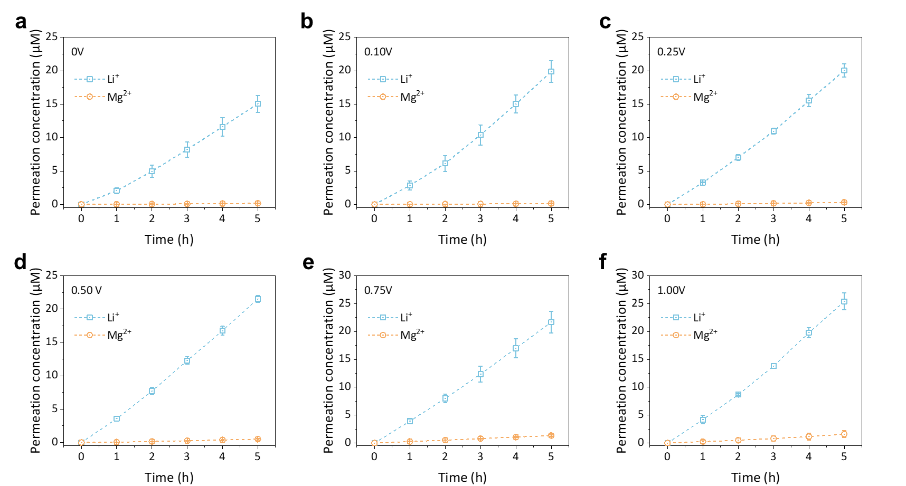
Fig. S27 Effect of the external electric field strength on ion selective permeation. Applied bias voltage is (a) 0V, (b) 0.10 V, (c) 0.25 V, (d) 0.50 V, (e) 0.75 V and (f) 1.00 V. Error bars in all cases represent standard deviation of the data from at least three individual experiments.

Table S5 Comparison of the Li⁺/Mg²⁺ permselectivity performance of this work with recent reports in the literature.
Membranbe | Li⁺ permeability (mmol m⁻² h⁻¹) | Li⁺/Mg²⁺ selectivity | C_{Feed} (M)* | External driving force | Ref.
Lumirror® membrane | 14 | 21 | 1.0 | 10 V | 1
COF-EB1BD1/PAN | 45 | 443 | 0.2 | 0.5 mA/cm² | 2
COF-4EO-PAN | 34 | 64 | 0.2 | / | 3
COF-TpBDMe2 | 50 | 217 | 0.1 (single) | / | 4
COF-TpEBr | 50 | 48 | 0.4 | / | 5
Zr-BTB+PSS | 830 | 37.8 | 0.1 (single) | 0 | 6
GO+PSS | 2580 | 20 | 1.2 | 38 V | 7
VM+PSS-1 | 1300 | 23.8 | 0.8 | 0.1 V | 8
VM+PSS-2 | 410 | 9.2 | 0.8 | / | 8
Mxene+PSS | 80 | 28 | 0.4 | / | 9
GO+PEI | 67 | 16.8 | 0.5 | / | 10
LDH | 7 | 4.78 | 0.2 | / | 11
GO+PEI-SO₃H | 92 | 10.7 | 0.4 | 0.1 V | 12
AAO/PTI/PCN | 41 | 681 | 2.0 | / | 13
Al³⁺-MXene | 2 | 3.1 | 0.2 | / | 14
rGO | 15 | 12 | 0.1 | / | 15
Al₁₃-MXene | 10 | 2.5 | 0.5 | / | 16
CC3 | 77 | 104 | 0.2 | 5 mA/cm² | 17
UiO-66 | 74 | 19 | 0.2 | 5 mA/cm² | 18
UiO-66-SO₃H | 100 | 1.88 | 0.2 | 5 mA/cm² | 18
UiO-66-NH₂-1 | 45 | 25 | 0.2 | 5 mA/cm² | 19
UiO-66-NH₂-2 | 69 | 39 | 0.2 | 5 mA/cm² | 19
DB15C5@UiO-66 | 280 | 10 | 0.2 | / | 20
DB18C6@UiO-66 | 300 | 13 | 0.2 | / | 20
dp-Cs⁺-VM(0.1V) | 645 | 148.25 | 0.2 | 0.1 V | This work
dp-Cs⁺-VM | 489 | 91.77 | 0.2 | / | This work
*Total concentration of the mixture solution except noted.
**The background color corresponds to the categories in Figure 4d of the article.

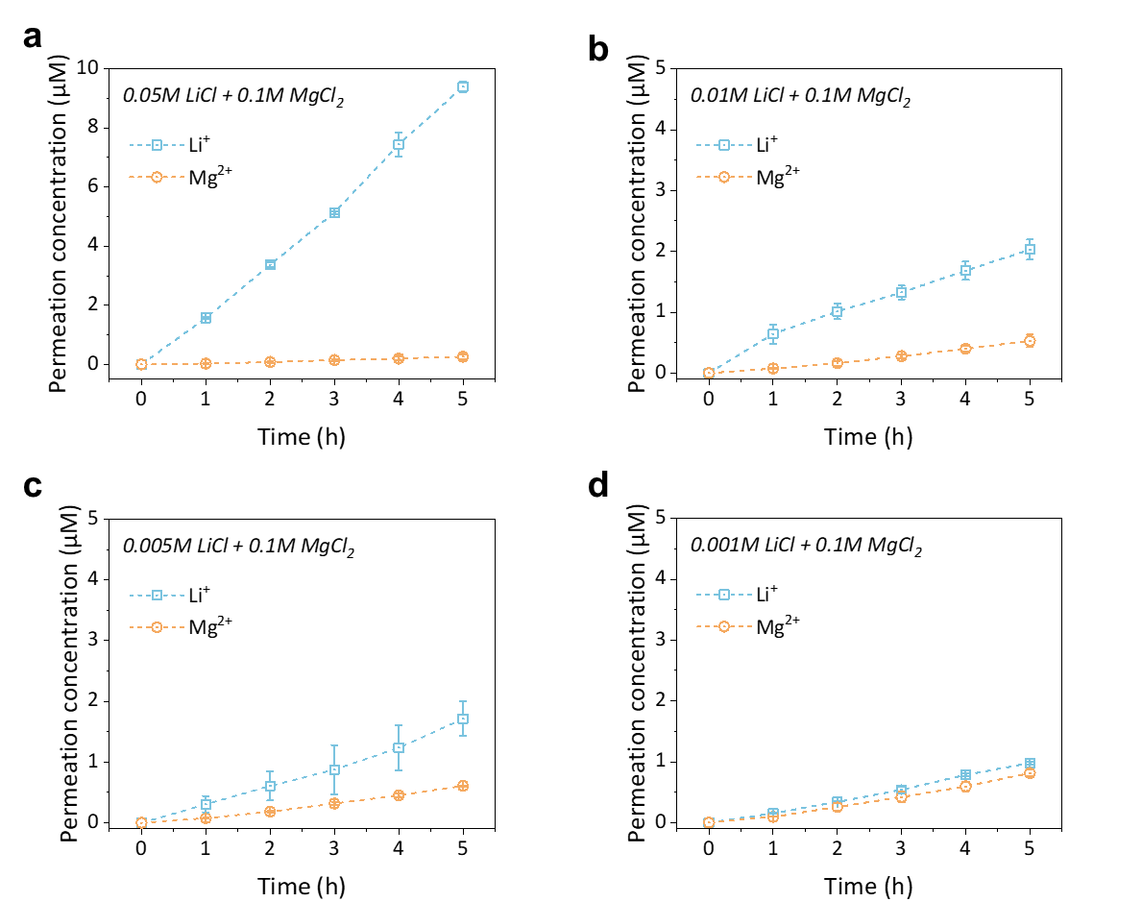
Fig. S28 Permeation concentrations of Li⁺ and Mg²⁺ through the dp-Cs⁺-VM membranes with different Mg²⁺/Li⁺ ratio of (a) 2:1, (b) 10:1, (c) 50:1, and (d) 100:1 as a function of testing time. Error bars in all cases represent standard deviation of the data from at least three individual experiments.

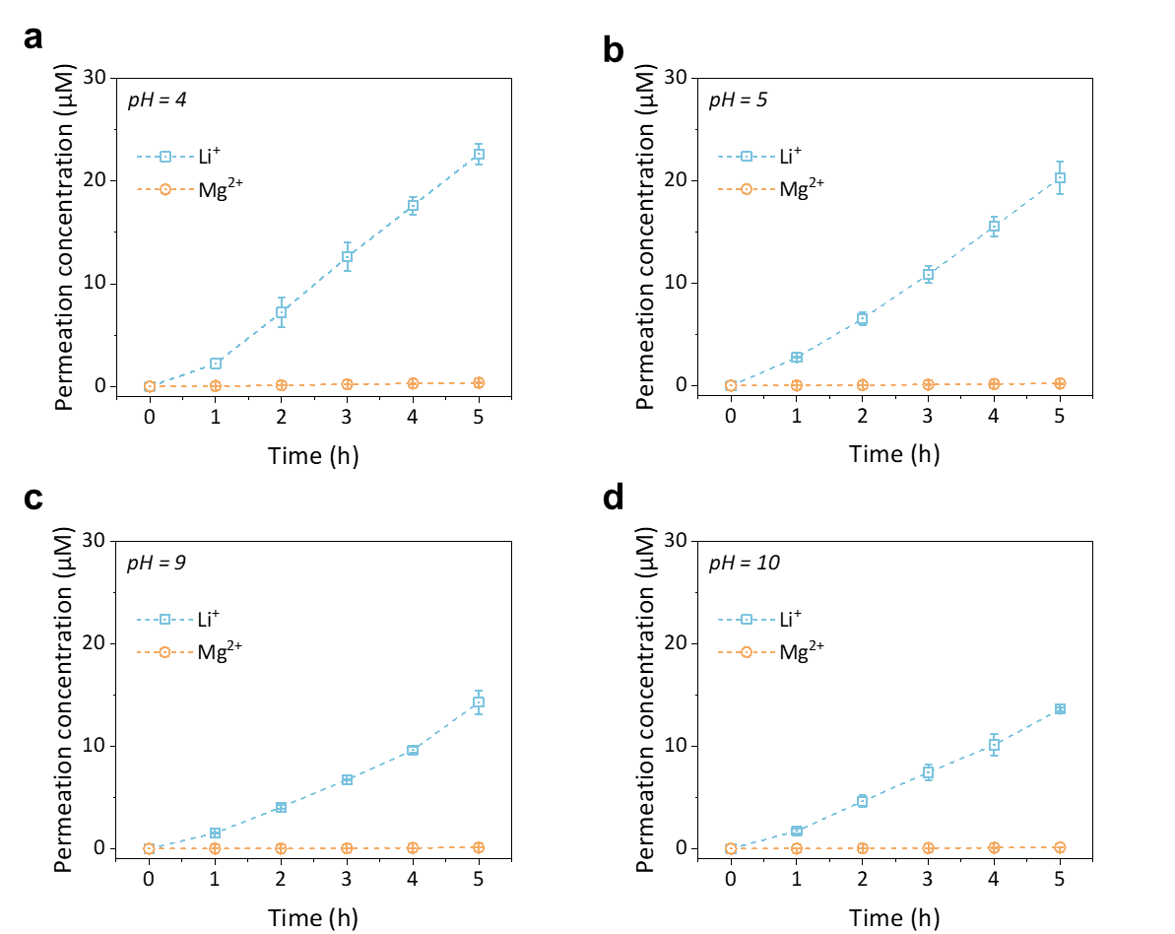
Fig. S29 Stability of dp-Cs⁺-VM membranes in acid and alkali environments. The tested pH ranges from (a) pH=4, (b) pH=5, (c) pH=9, and (d) pH=10, adjusting by dilute hydrochloric acid or dilute sodium hydroxide solution. The feed solution is 0.1 M LiCl and MgCl₂. Error bars in all cases represent standard deviation of the data from at least three individual experiments.

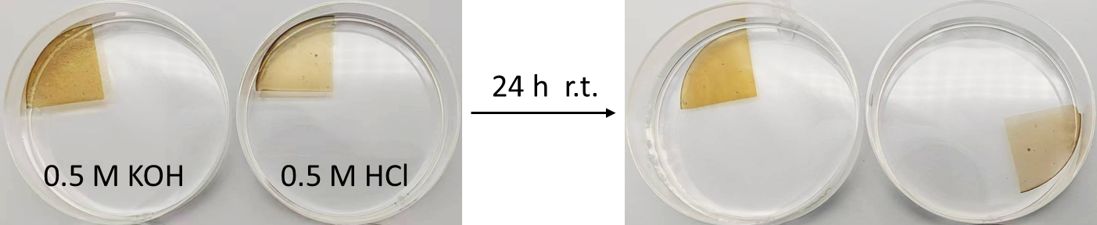
Fig. S30 dp-Cs⁺-VM membranes in strong acid and alkali impact tests.

Fig. S31 XRD spectra of dp-Cs⁺-VM membranes before and after immersed in acid and alkali environments showing better alkali resistance.

Table S6 Content of five main cations of the related solutions for lithium extraction using the bittern of Qinghai Lake, China.
Cation (mol/L)*  Sample | Li⁺ | Na⁺ | K⁺ | Mg²⁺ | Ca²⁺
Bittern | 1.524 | 0.122 | 0.0270 | 6.731 | 0.001
Bittern after electrodialysis | 1.441 | 0.113 | 0.022 | 6.718 | 0.001
Li-rich dialysate | 0.081 | 0.012 | 0.003 | 0.012 | <0.001
Li depleted solution | 0.004 | 0.239 | 0.005 | 0.002 | <0.001
*Average value measured by ICP-OES at least three times.

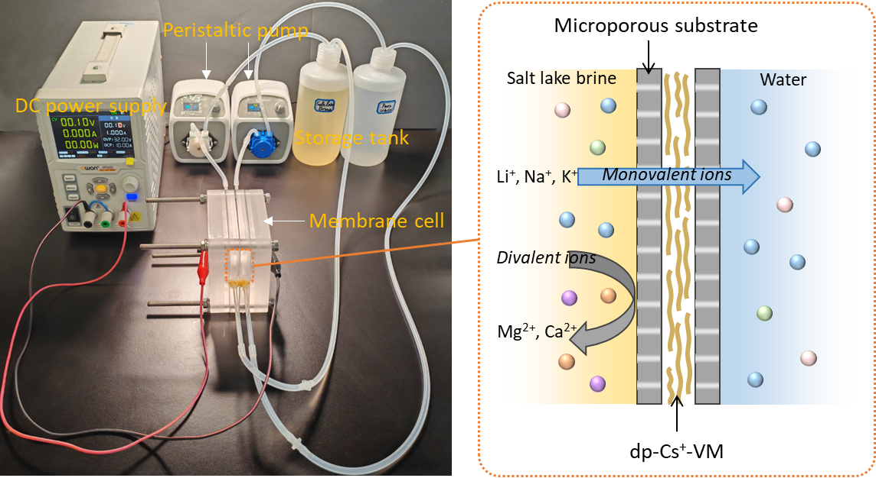
Fig. S32 Homemade setups and the scheme for the salt lake bittern electrodialysis process. The flow rates of both sides were set to 50 mL/min. The effective area of the membrane cell is 3.14 cm². The applied voltage was 0.1 V. The cycling time was 30 h.

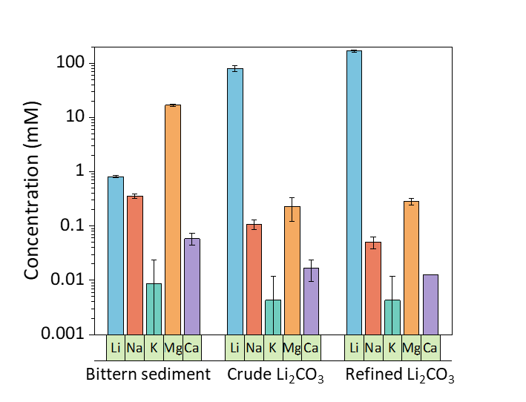
Fig. S33 Composition of the sediments directly precipitated from the bittern, the dialysate (crude Li₂CO₃), and further refined (refined Li₂CO₃). 40 mg of each sediment was dissolved using 0.5 M HCl solution and diluted to 50 mL. Error bars in all cases represent standard deviation of the data from at least three individual experiments (K⁺ ion concentration is near detection limit of ICP-OES).

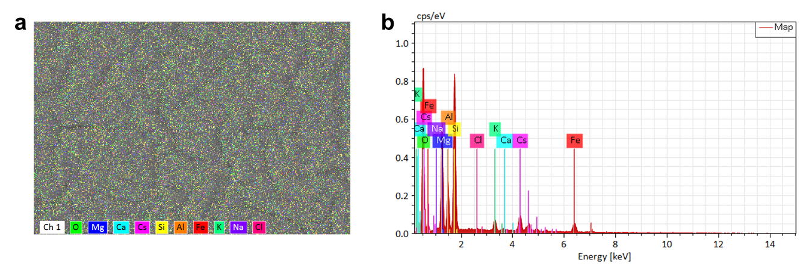
Fig. S34 (a) EDS mapping image and (b) energy spectra of all elements in dp-Cs⁺-VM.

Table S7 Mass ratio of each element in the dp-Cs⁺-VM membrane from the EDS results.
Element | Atomic number | Mass ratio (%)
Element | Atomic number | Sample 1 | Sample 2 | Sample 3
O | 8 | 48.06 | 47.86 | 47.80
Na* | 11 | 0.07 | 0.04 | 0.05
Mg | 12 | 12.12 | 11.81 | 11.83
Al | 13 | 4.77 | 4.87 | 4.64
Si | 14 | 17.34 | 17.16 | 17.14
Cl* | 17 | 0.20 | 0.02 | 0.08
K | 19 | 1.86 | 1.81 | 1.73
Ca* | 20 | 0.04 | 0.00 | 0.08
Fe | 26 | 5.27 | 6.64 | 6.30
Cs | 55 | 10.26 | 9.81 | 10.34
* Elements present at levels close to the detection limit.

Reference
1. Wang, P. et al. Ultrafast ion sieving using nanoporous polymeric membranes. Nat. Commun. 9, 569 (2018).
2. Hou, L. et al. Understanding the Ion Transport Behavior across Nanofluidic Membranes in Response to the Charge Variations. Adv. Funct. Mater. 31, 2009970 (2021).
3. Bing, S. et al. Bio-inspired construction of ion conductive pathway in covalent organic framework membranes for efficient lithium extraction. Matter 4, 2027–2038 (2021).
4. Sheng, F. et al. Efficient Ion Sieving in Covalent Organic Framework Membranes with Sub‐2‐Nanometer Channels. Adv. Mater. 33, 2104404 (2021).
5. Wang, R. et al. Engineering of Covalent Organic Framework Nanosheet Membranes for Fast and Efficient Ion Sieving: Charge‐Induced Cation Confined Transport. Small Methods 2401111 (2024) doi:10.1002/smtd.202401111.
6. Lv, Y. et al. Two-Dimensional Sulfonate-Functionalized Metal–Organic Framework Membranes for Efficient Lithium-Ion Sieving. Nano Lett. 24, 2782–2788 (2024).
7. Ran, J. et al. A novel mixed matrix membrane framework for ultrafast cation sieving. Chem. Commun. 56, 6543–6546 (2020).
8. Pang, S. et al. 2D nanofluidic vermiculite membranes with self-confinement channels and recognition sites for ultrafast lithium ion-selective transport. J. Membr. Sci. 687, 122054 (2023).
9. Lu, Z., Wu, Y., Ding, L., Wei, Y. & Wang, H. A lamellar MXene (Ti₃C₂T_{x})/PSS composite membrane for fast and selective lithium‐ion separation. Angew. Chem. Int. Ed. 60, 22265–22269 (2021).
10. Zhang, W. et al. Graphene oxide membrane regulated by surface charges and interlayer channels for selective transport of monovalent ions over divalent ions. Sep. Purif. Technol. 291, 120938 (2022).
11. Li, B. et al. Facile synthesis and exfoliation of micro‐sized LDH to fabricate 2D membranes towards Mg/Li separation. AIChE J. 69, e18212 (2023).
12. Dai, L. et al. Freestanding two-dimensional nanofluidic membranes modulated by zwitterionic polyelectrolyte for mono-/di-valent ions selectivity transport. J. Membr. Sci. 677, 121621 (2023).
13. Zhang, Y. et al. Congener-welded crystalline carbon nitride membrane for robust and highly selective Li/Mg separation. Sci. Adv. 10, eadm9620 (2024).
14. Ding, L. et al. Effective ion sieving with Ti3C2Tx MXene membranes for production of drinking water from seawater. Nat. Sustain. 3, 296–302 (2020).
15. Xi, Y.-H. et al. Graphene-based membranes with uniform 2D nanochannels for precise sieving of mono-/multi-valent metal ions. J. Membr. Sci. 550, 208–218 (2018).
16. Zhu, J. et al. Precisely Tunable Ion Sieving with an Al13–Ti3C2Tx Lamellar Membrane by Controlling Interlayer Spacing. ACS Nano 14, 15306–15316 (2020).
17. Xu, T. et al. Highly Ion-Permselective Porous Organic Cage Membranes with Hierarchical Channels. J. Am. Chem. Soc. 144, 10220–10229 (2022).
18. Xu, T. et al. Engineering Leaf-Like UiO-66-SO3H Membranes for Selective Transport of Cations. Nano-Micro Lett. 12, 51 (2020).
19. Xu, T. et al. Highly Cation Permselective Metal–Organic Framework Membranes with Leaf‐Like Morphology. ChemSusChem 12, 2593–2597 (2019).
20. Xu, T. et al. Perfect confinement of crown ethers in MOF membrane for complete dehydration and fast transport of monovalent ions. Sci. Adv. 10, eadn0944 (2024).

