Supplementary Materials:
Spatial-Immune Multi-omics Refines Prognostication in Early-Stage Estrogen Receptor-Positive Breast Cancer

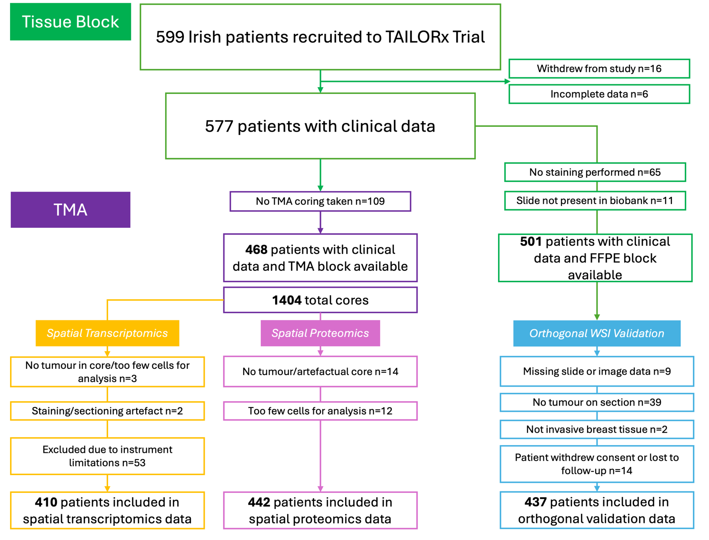
- Supplementary Figures -
Figure S1. CONSORT diagram of Irish patients previously enrolled on the TAILORx clinical trial, split for spatial transcriptomics, spatial proteomics, and orthogonal WSI validation analyses. N.B. Spatial transcriptomics instrument limitations allude to the restricted aspiration area of the Nanostring GeoMx DSP, as this was too small to accommodate all 8 rows of 12 TMA cores.

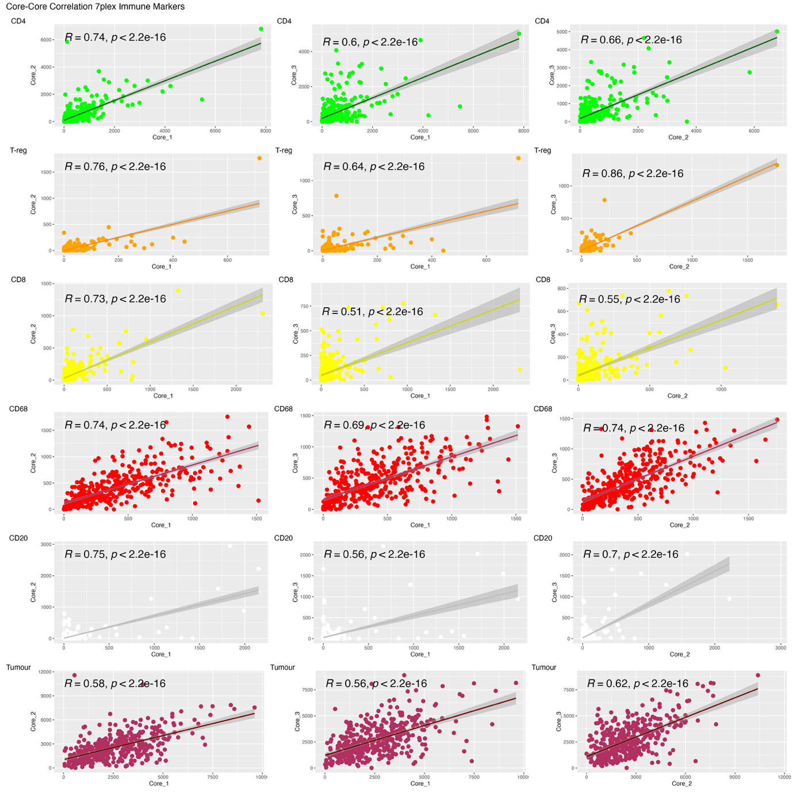
Figure S2. Core-core correlation for objects detected by spatial proteomics workflow. R = Pearsons correlation coefficient.

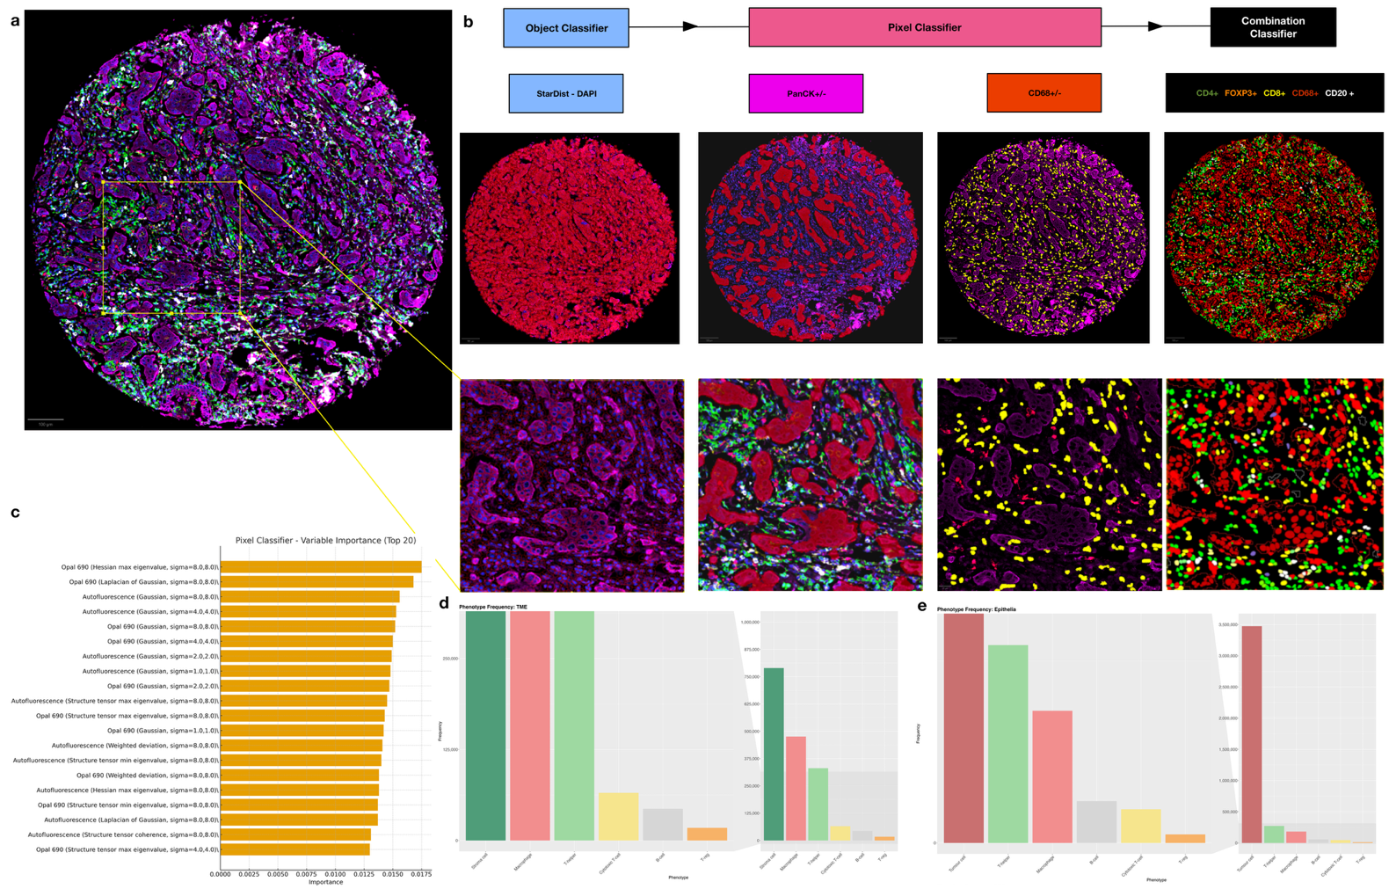
Figure S3. Digital pathology workflow for multiplexed immunofluorescence data. A. Illustrative example of a representative TMA core and region of interest (ROI: yellow). B. Classifier generation workflow, with example outputs at the core level (middle row) and ROI level (bottom row). C. Variable importance for the pixel classifier. D.-E. Barcharts of detected phenotype frequencies within all cores. Left plot shows a zoom in to the y-axis. For D. Tumour Microenvironment (i.e. Stroma). E. Tumour epithelia (i.e. tumour).

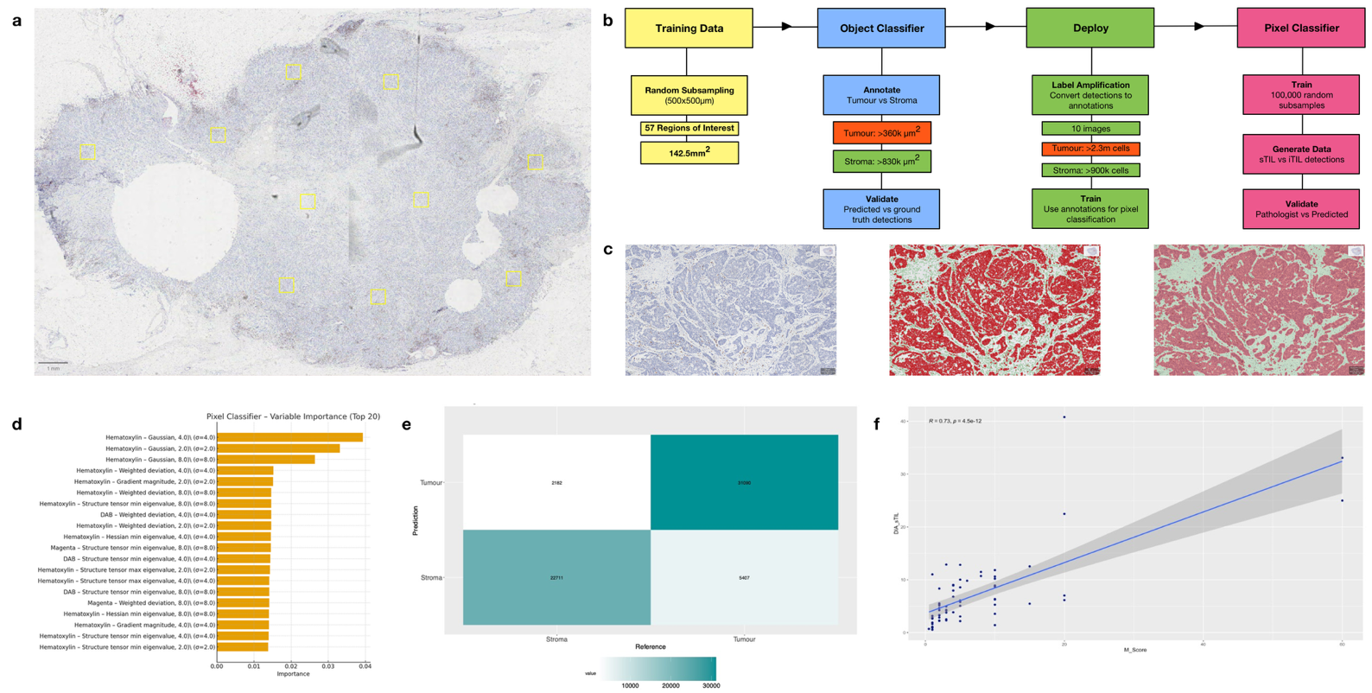
Figure S4. Digital pathology workflow for orthogonal CD8 Immunohistochemistry. A. Illustrative example of a representative whole slide image (WSI) and regions of interest (ROI: yellow). B. Classifier generation workflow. Briefly, an object detection classifier was trained to generate tumour vs stroma detections. These were then used as annotations for generation of a pixel classifier for the same classes. C. Illustrative examples of object detection and pixel classification in an ROI. D. Variable importance for the pixel classifier. E. Confusion matrix for the generated object detection classifier. F. Correlation plot of stromal CD8 percentage versus pathologist ground truth in a hold-out validation set of n=68 WSIs.

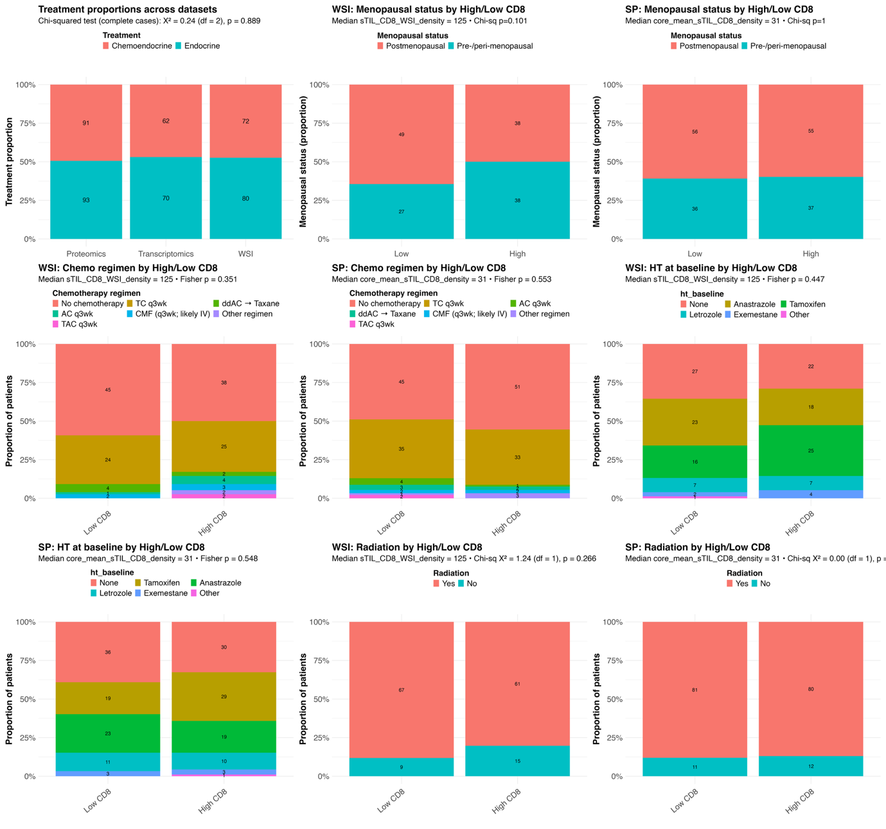
Figure S5. Drop-out and missing comparison using Chi-squared and Fishers-exact tests (categorical, two-sided) or Wilcoxon rank-sum (continuous, two-sided), across datasets for the Intermediate Oncotype Dx RS (RS16-25). A. Received adjuvant treatment across spatial omics datasets. B.-C. Groups of menopausal status across high vs low CD8 density, for B. WSIs, C. Spatial proteomics. D.-E. Groups of received adjuvant chemotherapy regimen across high vs low CD8 density, for D. WSIs, E. Spatial proteomics. F.-G. Groups of received adjuvant hormone therapy regimen across high vs low CD8 density, for F. WSIs, G. Spatial proteomics. H.-I. Groups of received radiotherapy across high vs low CD8 density, for H. WSIs. I. Spatial proteomics.

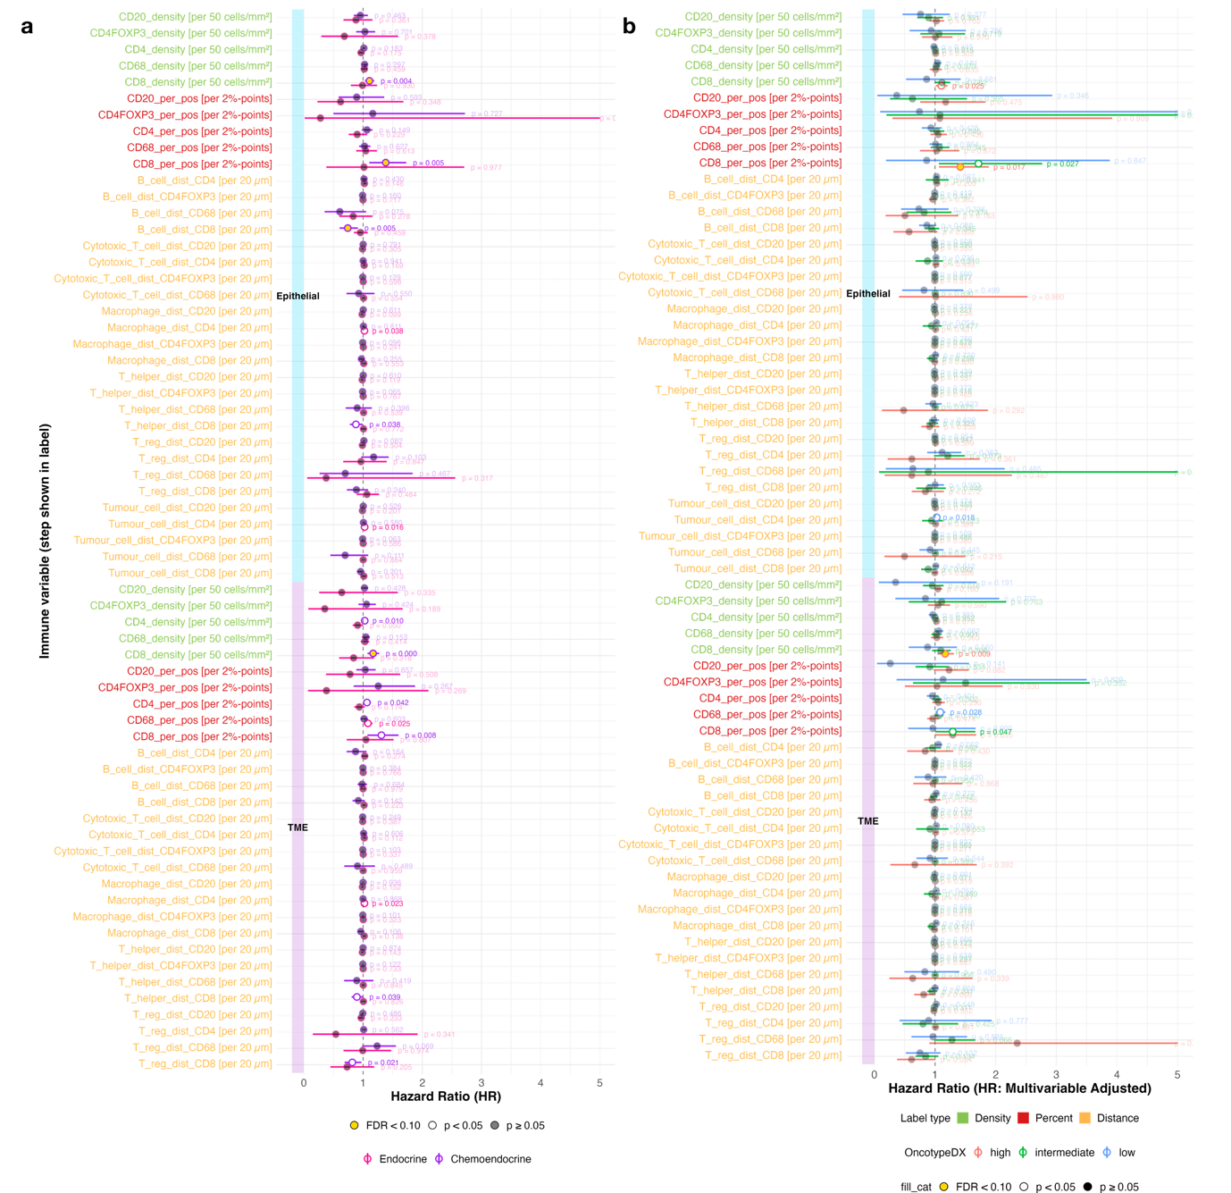
Figure S6. Multivariable Cox regression forest plots for a predictor density (green), percent (red), or distance/proximity (yellow) immune variable, adjusted for all clinical covariates (menopausal status, patient age, histological grade, primary tumour size, luminal subtype). A. Whole cohort split by received adjuvant treatment. B. Individual Oncotype Dx RS categories. p-values show significance, point fill shows FDR-adjusted significance.

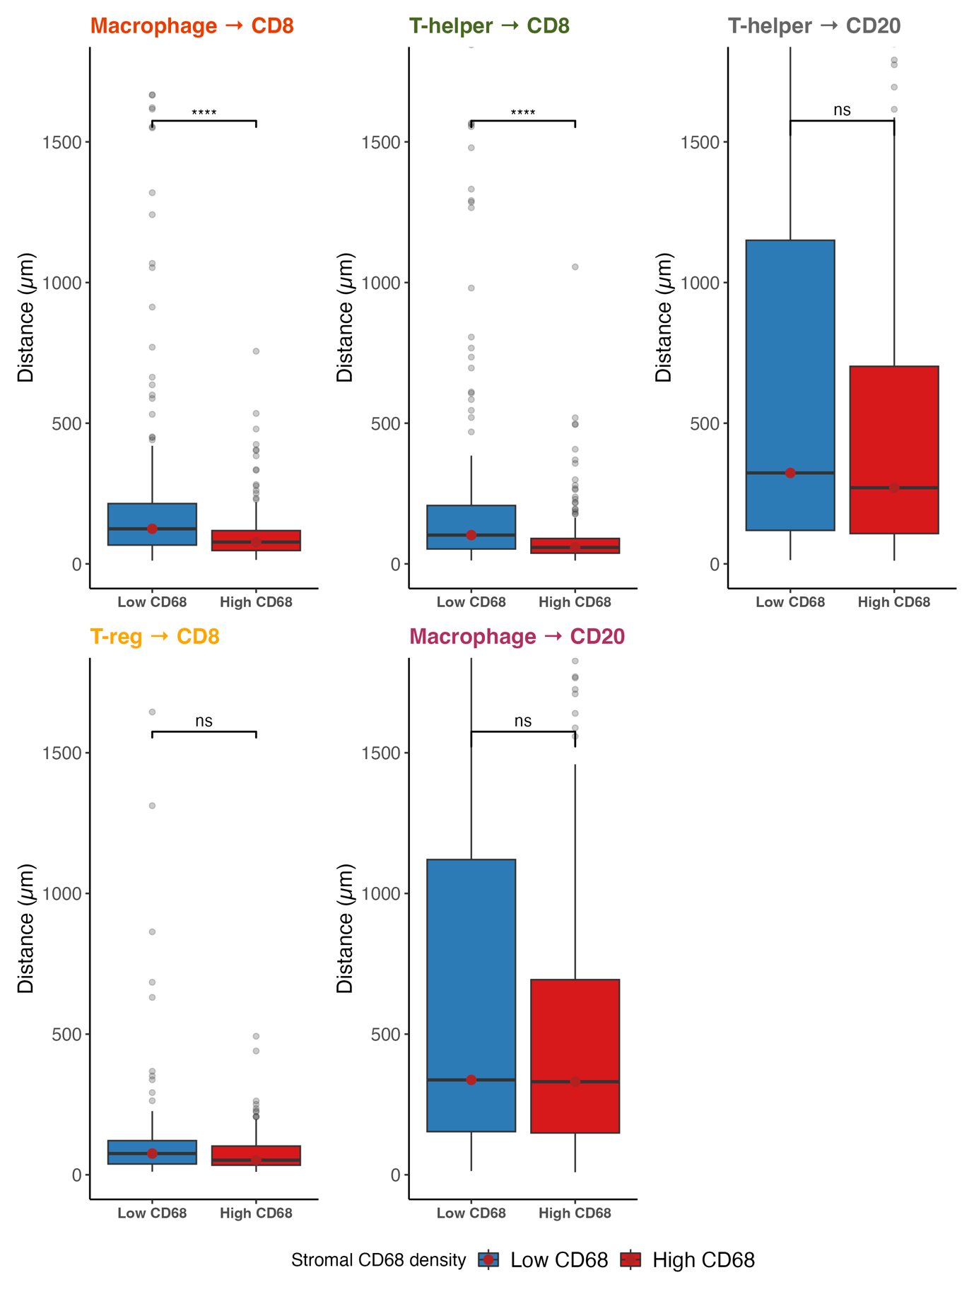
Figure S7. Boxplots of key proximity variables across categories of high vs low stromal CD68 (macrophage) density. Asterisks show the p-value significance (see methods). Comparison of medians was performed using a two-sided Wilcoxon test.

- Supplementary Tables -

Table S1. Antibodies and Dyes used in 6-plex mIF Spatial Proteomics, Spatial Transcriptomics, and Orthogonal Validation Assessment of Cohort Tissue Microarray and Whole-Resection Samples
Antibody | Clonality, Species | Clone | Antigen Retrieval | Antibody Conc. | Fluorophore | Fluorophore Conc. | Linker Usage
CD4 | Monoclonal Rabbit | EP204 | pH9 | 1:140 | Opal 520 | 1:200 | Yes
CD8 | Monoclonal Mouse | C8/144B | pH9 | 1:450 | Opal 570 | 1:500 | Yes
FOXP3 | Monoclonal Rabbit | D608R | pH6 | 1:285 | Opal 620 | 1:75 | Yes
CD68 | Monoclonal Mouse | PG-M1 | pH6 | 1:100 | Opal 650 | 1:150 | No
Pan-Cytokeratin | Monoclonal Mouse | AE1/AE3 | pH6 | 1:500 | Opal 690 | 1:150 | No
CD20 | Monoclonal Mouse | L26 | pH6 | 1:280 | Opal 780 | 1:25 | No*
Pan-Cytokeratin¹ | Monoclonal Mouse | AE1+AE3 | pH9 | - | AF 532 | - | No
CD45¹ | Monoclonal Mouse | 2B11+PD7/26 | pH9 | - | AF 594 | - | No
SYTO13¹ | - | - | pH9 | - | AF 647 | - | No
CD8! | Monoclonal Mouse | C8/144B | pH9 | Proprietary | - | - | -
* Opal TSA-DIG:
1 Antibodies-dyes used for morphology marking, Nanostring GeoMx.
! Antibody used for orthogonal validation on whole-resection specimens.

Table S2. Marker score derived from spatial proteomics data (TMA and WSI), across patient samples overall, and within epithelial (iTIL) and TME (sTIL) segments.
Median percentage (%)
Marker | Overall | Overall  IQR  (Q1-Q3) | Stroma | Stroma IQR  (Q1-Q3) | Epithelia | Epithelia IQR  (Q1-Q3)
CD4⁺ | 3.59 | 1.1 – 8.5 | 6.67 | 2.2 – 13.3 | 1.40 | 0.4 – 4.4
CD4⁺FOXP3⁺ | 0.05 | 0 – 0.3 | 0.10 | 0 – 0.5 | 0.009 | 0 – 0.08
CD8⁺ | 0.71 | 0.3 – 1.6 | 1.48 | 0.5 – 2.9 | 0.25 | 0 – 0.7
CD68⁺ | 6.93 | 3.2 – 10.5 | 12.70 | 5.9 – 19.5 | 3.36 | 1.2 – 6.3
CD20⁺ | 0.10 | 0 – 0.4 | 0.10 | 0 – 0.5 | 0.06 | 0 – 0.3
CD8^{WSI} | 2.78 | 1.4-4.4 | 4.24 | 2.2-7.6 | 0.84 | 0.4-1.8
Median density (cells/mm²)
CD4⁺ | 130.2 | 41.1 – 368.3 | 122.7 | 37.8 - 310 | 126.4 | 33.2 – 379.2
CD4⁺FOXP3⁺ | 1.9 | 0 – 11.3 | 1.6 | 0 – 11.6 | 0.8 | 0 – 7.2
CD8⁺ | 28.2 | 10.1 – 68.8 | 27.0 | 9.3 – 75.8 | 22.3 | 7.5 – 62.1
CD68⁺ | 301.4 | 130.4 – 469.4 | 272.6 | 115.6 – 439.9 | 295.5 | 108.6 – 556.7
CD20⁺ | 3.7 | 0.8 – 17.0 | 1.8 | 0 – 10.9 | 4.8 | 0 – 22.8
CD8^{WSI} | 226.0 | 117-423.0 | 125.0 | 65-246.0 | 74.3 | 35.4-163.9

Table S4. Cell detection parameters used for StarDist plugin for detection of DAPI+ cells in multiplexed immunofluorescence images in QuPath.
Cell detection parameters - mIF
Parameter | Value
Model | dsb2018_heavy_augment.pb
Channels | DAPI
Normalise Percentiles | 10, 99
Threshold | 0.45
Pixel Size | 0.499
Cell Expansion | 5.0μm
Measure Shape | TRUE
Measure Intensity | TRUE
Include Probability | TRUE
Contrain to Parent | FALSE

Table S5. Cell detection parameters used for orthogonal validation of CD8 immunohistochemistry on whole-slide images in QuPath.
Cell detection parameters - WSI
Parameter | Value
Detection Image | Optical density sum
Requested pixel size | 0.15μm
Background Radius | 4μm  (opening by reconstruction TRUE)
Median Filter Radius | 1μm
Sigma | 1μm
Minimum Area | 10μm²
Maximum Area | 400μm²
Threshold | 0.07
Max Background Density | 4  (split by shape TRUE; Exclude DAB FALSE)
Cell Expansion | 1.3μm  (include cell nucleus FALSE; sooth boundaries TRUE; make measurements TRUE)

Table S6. TME immune variable (sTIL) Proportional Hazard (PH) checks across strata of received adjuvant therapy.
Covariate | rho | Chi-square | df | p | Global Chi-square | Global p
Chemoendocrine
B_cell_dist_CD4 [per 20 µm] | −0.043 | 0.170 | 1 | 0.680 | 8.240 | 0.221
B_cell_dist_CD4FOXP3 [per 20 µm] | 0.009 | 0.070 | 1 | 0.791 | 8.989 | 0.174
B_cell_dist_CD68 [per 20 µm] | 0.167 | 0.108 | 1 | 0.742 | 9.175 | 0.164
B_cell_dist_CD8 [per 20 µm] | −0.144 | 1.644 | 1 | 0.200 | 9.341 | 0.155
CD20_density [per 50 cells/mm²] | 0.017 | 0.172 | 1 | 0.679 | 8.188 | 0.225
CD20_per_pos [per 2%-points] | −0.066 | 0.003 | 1 | 0.959 | 8.324 | 0.215
CD4FOXP3_density [per 50 cells/mm²] | −0.023 | 0.041 | 1 | 0.839 | 8.266 | 0.219
CD4FOXP3_per_pos [per 2%-points] | 0.057 | 0.008 | 1 | 0.929 | 8.272 | 0.219
CD4_density [per 50 cells/mm²] | −0.009 | 0.009 | 1 | 0.926 | 8.523 | 0.202
CD4_per_pos [per 2%-points] | 0.077 | 0.531 | 1 | 0.466 | 9.067 | 0.170
CD68_density [per 50 cells/mm²] | −0.134 | 1.461 | 1 | 0.227 | 8.682 | 0.192
CD68_per_pos [per 2%-points] | −0.141 | 1.076 | 1 | 0.299 | 8.767 | 0.187
CD8_density [per 50 cells/mm²] | 0.056 | 0.749 | 1 | 0.387 | 8.882 | 0.180
CD8_per_pos [per 2%-points] | −0.040 | 0.043 | 1 | 0.835 | 8.266 | 0.219
Cytotoxic_T_cell_dist_CD20 [per 20 µm] | 0.036 | 0.087 | 1 | 0.768 | 7.623 | 0.267
Cytotoxic_T_cell_dist_CD4 [per 20 µm] | −0.043 | 0.334 | 1 | 0.563 | 7.638 | 0.266
Cytotoxic_T_cell_dist_CD4FOXP3 [per 20 µm] | −0.042 | 0.036 | 1 | 0.850 | 7.200 | 0.303
Cytotoxic_T_cell_dist_CD68 [per 20 µm] | 0.234 | 2.206 | 1 | 0.137 | 9.565 | 0.144
Macrophage_dist_CD20 [per 20 µm] | 0.084 | 0.477 | 1 | 0.490 | 9.199 | 0.163
Macrophage_dist_CD4 [per 20 µm] | −0.184 | 1.968 | 1 | 0.161 | 10.351 | 0.111
Macrophage_dist_CD4FOXP3 [per 20 µm] | −0.025 | 0.008 | 1 | 0.928 | 8.406 | 0.210
Macrophage_dist_CD8 [per 20 µm] | −0.161 | 2.365 | 1 | 0.124 | 10.268 | 0.114
T_helper_dist_CD20 [per 20 µm] | 0.123 | 1.087 | 1 | 0.297 | 7.657 | 0.264
T_helper_dist_CD4FOXP3 [per 20 µm] | 0.005 | 0.031 | 1 | 0.861 | 6.491 | 0.370
T_helper_dist_CD68 [per 20 µm] | 0.214 | 2.515 | 1 | 0.113 | 8.917 | 0.178
T_helper_dist_CD8 [per 20 µm] | 0.161 | 0.421 | 1 | 0.516 | 7.210 | 0.302
T_reg_dist_CD20 [per 20 µm] | 0.149 | 1.371 | 1 | 0.242 | 7.583 | 0.270
T_reg_dist_CD4 [per 20 µm] | −0.026 | 0.215 | 1 | 0.643 | 6.691 | 0.350
T_reg_dist_CD68 [per 20 µm] | 0.282 | 1.905 | 1 | 0.168 | 7.793 | 0.254
T_reg_dist_CD8 [per 20 µm] | 0.114 | 0.059 | 1 | 0.808 | 6.650 | 0.354
Endocrine
B_cell_dist_CD4 [per 20 µm] | −0.120 | 0.125 | 1 | 0.723 | 3.044 | 0.803
B_cell_dist_CD68 [per 20 µm] | 0.149 | 0.034 | 1 | 0.853 | 2.879 | 0.824
CD20_density [per 50 cells/mm²] | −0.318 | 3.196 | 1 | 0.074 | 7.232 | 0.300
CD20_per_pos [per 2%-points] | −0.314 | 4.411 | 1 | 0.036 | 8.314 | 0.216
CD4FOXP3_density [per 50 cells/mm²] | −0.346 | 4.824 | 1 | 0.028 | 9.295 | 0.158
CD4FOXP3_per_pos [per 2%-points] | −0.367 | 5.559 | 1 | 0.018 | 9.710 | 0.137
CD4_density [per 50 cells/mm²] | −0.040 | 0.014 | 1 | 0.906 | 4.498 | 0.610
CD4_per_pos [per 2%-points] | 0.120 | 0.474 | 1 | 0.491 | 5.061 | 0.536
CD68_density [per 50 cells/mm²] | −0.288 | 1.687 | 1 | 0.194 | 6.599 | 0.360
CD68_per_pos [per 2%-points] | −0.117 | 0.445 | 1 | 0.505 | 5.169 | 0.522
CD8_density [per 50 cells/mm²] | −0.351 | 3.766 | 1 | 0.052 | 9.142 | 0.166
CD8_per_pos [per 2%-points] | −0.271 | 3.361 | 1 | 0.067 | 8.484 | 0.205
T_helper_dist_CD8 [per 20 µm] | 0.060 | 0.006 | 1 | 0.936 | 3.043 | 0.803
T_reg_dist_CD20 [per 20 µm] | −0.111 | 0.007 | 1 | 0.932 | 3.926 | 0.687
T_reg_dist_CD4 [per 20 µm] | −0.608 | 0.355 | 1 | 0.552 | 4.535 | 0.605
T_reg_dist_CD68 [per 20 µm] | 0.471 | 0.328 | 1 | 0.567 | 3.880 | 0.693
T_reg_dist_CD8 [per 20 µm] | 0.143 | 0.037 | 1 | 0.848 | 4.089 | 0.665

Table S7. Epithelial immune variable (iTIL) Proportional Hazard (PH) checks across strata of received adjuvant therapy.
Covariate | rho | Chi-square | df | p | Global Chi-square | Global p
Chemoendocrine
B_cell_dist_CD68 [per 20 µm] | 0.108 | 0.021 | 1 | 0.885 | 3.377 | 0.760
B_cell_dist_CD8 [per 20 µm] | 0.189 | 0.187 | 1 | 0.665 | 3.136 | 0.792
CD20_density [per 50 cells/mm²] | −0.011 | 0.039 | 1 | 0.844 | 8.024 | 0.236
CD20_per_pos [per 2%-points] | 0.004 | 0.066 | 1 | 0.797 | 8.042 | 0.235
CD4FOXP3_density [per 50 cells/mm²] | −0.007 | 0.000 | 1 | 0.997 | 8.235 | 0.221
CD4FOXP3_per_pos [per 2%-points] | −0.018 | 0.012 | 1 | 0.912 | 8.221 | 0.222
CD4_density [per 50 cells/mm²] | 0.060 | 0.121 | 1 | 0.728 | 8.649 | 0.194
CD4_per_pos [per 2%-points] | 0.111 | 0.454 | 1 | 0.501 | 9.231 | 0.161
CD68_density [per 50 cells/mm²] | −0.091 | 0.269 | 1 | 0.604 | 8.216 | 0.223
CD68_per_pos [per 2%-points] | −0.034 | 0.030 | 1 | 0.863 | 8.151 | 0.227
CD8_density [per 50 cells/mm²] | 0.005 | 0.098 | 1 | 0.754 | 8.457 | 0.207
CD8_per_pos [per 2%-points] | 0.002 | 0.105 | 1 | 0.746 | 8.363 | 0.213
Cytotoxic_T_cell_dist_CD20 [per 20 µm] | 0.131 | 0.631 | 1 | 0.427 | 6.877 | 0.332
Cytotoxic_T_cell_dist_CD4 [per 20 µm] | −0.153 | 0.565 | 1 | 0.452 | 6.624 | 0.357
Cytotoxic_T_cell_dist_CD4FOXP3 [per 20 µm] | 0.089 | 0.481 | 1 | 0.488 | 5.813 | 0.444
Cytotoxic_T_cell_dist_CD68 [per 20 µm] | 0.283 | 1.711 | 1 | 0.191 | 7.399 | 0.286
Macrophage_dist_CD20 [per 20 µm] | 0.080 | 0.456 | 1 | 0.500 | 7.937 | 0.243
Macrophage_dist_CD4 [per 20 µm] | −0.238 | 1.390 | 1 | 0.238 | 9.137 | 0.166
Macrophage_dist_CD4FOXP3 [per 20 µm] | 0.061 | 0.261 | 1 | 0.609 | 7.031 | 0.318
Macrophage_dist_CD8 [per 20 µm] | −0.125 | 1.375 | 1 | 0.241 | 8.184 | 0.225
T_helper_dist_CD20 [per 20 µm] | 0.144 | 0.988 | 1 | 0.320 | 6.473 | 0.372
T_helper_dist_CD4FOXP3 [per 20 µm] | 0.066 | 0.326 | 1 | 0.568 | 4.985 | 0.546
T_helper_dist_CD68 [per 20 µm] | 0.327 | 2.155 | 1 | 0.142 | 7.555 | 0.273
T_helper_dist_CD8 [per 20 µm] | 0.076 | 0.056 | 1 | 0.812 | 5.291 | 0.507
T_reg_dist_CD20 [per 20 µm] | 0.093 | 1.520 | 1 | 0.218 | 7.136 | 0.308
T_reg_dist_CD4 [per 20 µm] | 0.023 | 0.007 | 1 | 0.932 | 6.025 | 0.420
T_reg_dist_CD68 [per 20 µm] | 0.124 | 0.010 | 1 | 0.921 | 7.522 | 0.275
T_reg_dist_CD8 [per 20 µm] | −0.066 | 0.023 | 1 | 0.881 | 7.423 | 0.283
Tumour_cell_dist_CD20 [per 20 µm] | 0.081 | 0.312 | 1 | 0.576 | 7.683 | 0.262
Tumour_cell_dist_CD4 [per 20 µm] | −0.212 | 1.242 | 1 | 0.265 | 8.663 | 0.193
Tumour_cell_dist_CD4FOXP3 [per 20 µm] | 0.039 | 0.182 | 1 | 0.669 | 6.715 | 0.348
Tumour_cell_dist_CD68 [per 20 µm] | 0.279 | 1.996 | 1 | 0.158 | 8.779 | 0.186
Tumour_cell_dist_CD8 [per 20 µm] | −0.143 | 2.879 | 1 | 0.090 | 8.752 | 0.188
Endocrine
B_cell_dist_CD68 [per 20 µm] | 0.244 | 0.340 | 1 | 0.560 | 1.488 | 0.960
B_cell_dist_CD8 [per 20 µm] | −0.339 | 0.827 | 1 | 0.363 | 3.437 | 0.752
CD20_density [per 50 cells/mm²] | −0.315 | 1.015 | 1 | 0.314 | 5.177 | 0.521
CD20_per_pos [per 2%-points] | −0.350 | 1.646 | 1 | 0.199 | 5.683 | 0.460
CD4FOXP3_density [per 50 cells/mm²] | −0.258 | 2.223 | 1 | 0.136 | 6.580 | 0.361
CD4FOXP3_per_pos [per 2%-points] | −0.246 | 2.383 | 1 | 0.123 | 6.696 | 0.350
CD4_density [per 50 cells/mm²] | 0.095 | 0.248 | 1 | 0.618 | 4.667 | 0.587
CD4_per_pos [per 2%-points] | 0.075 | 0.159 | 1 | 0.690 | 4.614 | 0.594
CD68_density [per 50 cells/mm²] | −0.276 | 2.291 | 1 | 0.130 | 7.662 | 0.264
CD68_per_pos [per 2%-points] | −0.214 | 1.208 | 1 | 0.272 | 5.909 | 0.433
CD8_density [per 50 cells/mm²] | −0.117 | 0.441 | 1 | 0.507 | 4.970 | 0.548
CD8_per_pos [per 2%-points] | −0.099 | 0.286 | 1 | 0.593 | 4.767 | 0.574
Cytotoxic_T_cell_dist_CD68 [per 20 µm] | 0.014 | 0.017 | 1 | 0.898 | 3.295 | 0.771
Macrophage_dist_CD8 [per 20 µm] | −0.189 | 0.056 | 1 | 0.812 | 4.132 | 0.659
T_helper_dist_CD8 [per 20 µm] | −0.159 | 0.123 | 1 | 0.726 | 3.783 | 0.706
T_reg_dist_CD20 [per 20 µm] | −0.087 | 0.001 | 1 | 0.978 | 5.049 | 0.537
T_reg_dist_CD4 [per 20 µm] | −0.255 | 0.272 | 1 | 0.602 | 4.976 | 0.547
T_reg_dist_CD68 [per 20 µm] | 0.601 | 1.775 | 1 | 0.183 | 6.199 | 0.401
T_reg_dist_CD8 [per 20 µm] | 0.194 | 0.569 | 1 | 0.450 | 4.486 | 0.611
Tumour_cell_dist_CD8 [per 20 µm] | −0.082 | 0.001 | 1 | 0.973 | 3.758 | 0.709

Table S8. TME immune variable (sTIL) Proportional Hazard (PH) checks across strata of Oncotype Dx RS categories.
Covariate | rho | Chi-square | df | p | Global Chi-square | Global p
High RS
B_cell_dist_CD4 [per 20 µm] | −0.512 | 2.184 | 1 | 0.139 | 5.639 | 0.465
B_cell_dist_CD4 [per 20 µm] | −0.512 | 2.184 | 1 | 0.139 | 5.639 | 0.465
B_cell_dist_CD4 [per 20 µm] | −0.512 | 2.184 | 1 | 0.139 | 5.639 | 0.465
B_cell_dist_CD68 [per 20 µm] | −0.365 | 3.844 | 1 | 0.050 | 5.531 | 0.478
B_cell_dist_CD68 [per 20 µm] | −0.365 | 3.844 | 1 | 0.050 | 5.531 | 0.478
B_cell_dist_CD68 [per 20 µm] | −0.365 | 3.844 | 1 | 0.050 | 5.531 | 0.478
CD20_per_pos [per 2%-points] | −0.070 | 0.096 | 1 | 0.757 | 8.156 | 0.227
CD20_per_pos [per 2%-points] | −0.070 | 0.096 | 1 | 0.757 | 8.156 | 0.227
CD20_per_pos [per 2%-points] | −0.070 | 0.096 | 1 | 0.757 | 8.156 | 0.227
CD4FOXP3_per_pos [per 2%-points] | −0.205 | 0.129 | 1 | 0.720 | 9.093 | 0.168
CD4FOXP3_per_pos [per 2%-points] | −0.205 | 0.129 | 1 | 0.720 | 9.093 | 0.168
CD4FOXP3_per_pos [per 2%-points] | −0.205 | 0.129 | 1 | 0.720 | 9.093 | 0.168
CD4_per_pos [per 2%-points] | −0.204 | 0.234 | 1 | 0.629 | 10.064 | 0.122
CD4_per_pos [per 2%-points] | −0.204 | 0.234 | 1 | 0.629 | 10.064 | 0.122
CD4_per_pos [per 2%-points] | −0.204 | 0.234 | 1 | 0.629 | 10.064 | 0.122
CD68_per_pos [per 2%-points] | −0.322 | 0.211 | 1 | 0.646 | 8.853 | 0.182
CD68_per_pos [per 2%-points] | −0.322 | 0.211 | 1 | 0.646 | 8.853 | 0.182
CD68_per_pos [per 2%-points] | −0.322 | 0.211 | 1 | 0.646 | 8.853 | 0.182
CD8_per_pos [per 2%-points] | 0.059 | 1.111 | 1 | 0.292 | 7.840 | 0.250
CD8_per_pos [per 2%-points] | 0.059 | 1.111 | 1 | 0.292 | 7.840 | 0.250
CD8_per_pos [per 2%-points] | 0.059 | 1.111 | 1 | 0.292 | 7.840 | 0.250
Cytotoxic_T_cell_dist_CD68 [per 20 µm] | −0.210 | 1.629 | 1 | 0.202 | 10.097 | 0.121
Cytotoxic_T_cell_dist_CD68 [per 20 µm] | −0.210 | 1.629 | 1 | 0.202 | 10.097 | 0.121
Cytotoxic_T_cell_dist_CD68 [per 20 µm] | −0.210 | 1.629 | 1 | 0.202 | 10.097 | 0.121
T_helper_dist_CD68 [per 20 µm] | −0.355 | 2.198 | 1 | 0.138 | 10.990 | 0.089
T_helper_dist_CD68 [per 20 µm] | −0.355 | 2.198 | 1 | 0.138 | 10.990 | 0.089
T_helper_dist_CD68 [per 20 µm] | −0.355 | 2.198 | 1 | 0.138 | 10.990 | 0.089
T_reg_dist_CD68 [per 20 µm] | 0.029 | 1.831 | 1 | 0.176 | 7.886 | 0.247
T_reg_dist_CD68 [per 20 µm] | 0.029 | 1.831 | 1 | 0.176 | 7.886 | 0.247
T_reg_dist_CD68 [per 20 µm] | 0.029 | 1.831 | 1 | 0.176 | 7.886 | 0.247
T_reg_dist_CD8 [per 20 µm] | 0.030 | 0.016 | 1 | 0.899 | 5.979 | 0.426
T_reg_dist_CD8 [per 20 µm] | 0.030 | 0.016 | 1 | 0.899 | 5.979 | 0.426
T_reg_dist_CD8 [per 20 µm] | 0.030 | 0.016 | 1 | 0.899 | 5.979 | 0.426
Intermediate RS
B_cell_dist_CD4 [per 20 µm] | −0.152 | 0.219 | 1 | 0.640 | 1.135 | 0.980
B_cell_dist_CD4 [per 20 µm] | −0.152 | 0.219 | 1 | 0.640 | 1.135 | 0.980
B_cell_dist_CD4 [per 20 µm] | −0.152 | 0.219 | 1 | 0.640 | 1.135 | 0.980
B_cell_dist_CD4FOXP3 [per 20 µm] | 0.032 | 0.062 | 1 | 0.803 | 1.082 | 0.982
B_cell_dist_CD4FOXP3 [per 20 µm] | 0.032 | 0.062 | 1 | 0.803 | 1.082 | 0.982
B_cell_dist_CD4FOXP3 [per 20 µm] | 0.032 | 0.062 | 1 | 0.803 | 1.082 | 0.982
B_cell_dist_CD68 [per 20 µm] | 0.101 | 0.055 | 1 | 0.815 | 1.054 | 0.983
B_cell_dist_CD68 [per 20 µm] | 0.101 | 0.055 | 1 | 0.815 | 1.054 | 0.983
B_cell_dist_CD68 [per 20 µm] | 0.101 | 0.055 | 1 | 0.815 | 1.054 | 0.983
B_cell_dist_CD8 [per 20 µm] | 0.299 | 0.158 | 1 | 0.691 | 1.256 | 0.974
B_cell_dist_CD8 [per 20 µm] | 0.299 | 0.158 | 1 | 0.691 | 1.256 | 0.974
B_cell_dist_CD8 [per 20 µm] | 0.299 | 0.158 | 1 | 0.691 | 1.256 | 0.974
CD20_density [per 50 cells/mm²] | −0.257 | 0.291 | 1 | 0.589 | 3.489 | 0.745
CD20_density [per 50 cells/mm²] | −0.257 | 0.291 | 1 | 0.589 | 3.489 | 0.745
CD20_density [per 50 cells/mm²] | −0.257 | 0.291 | 1 | 0.589 | 3.489 | 0.745
CD20_per_pos [per 2%-points] | −0.375 | 0.962 | 1 | 0.327 | 4.325 | 0.633
CD20_per_pos [per 2%-points] | −0.375 | 0.962 | 1 | 0.327 | 4.325 | 0.633
CD20_per_pos [per 2%-points] | −0.375 | 0.962 | 1 | 0.327 | 4.325 | 0.633
CD4FOXP3_density [per 50 cells/mm²] | −0.032 | 0.094 | 1 | 0.759 | 3.192 | 0.784
CD4FOXP3_density [per 50 cells/mm²] | −0.032 | 0.094 | 1 | 0.759 | 3.192 | 0.784
CD4FOXP3_density [per 50 cells/mm²] | −0.032 | 0.094 | 1 | 0.759 | 3.192 | 0.784
CD4FOXP3_per_pos [per 2%-points] | −0.029 | 0.142 | 1 | 0.706 | 3.187 | 0.785
CD4FOXP3_per_pos [per 2%-points] | −0.029 | 0.142 | 1 | 0.706 | 3.187 | 0.785
CD4FOXP3_per_pos [per 2%-points] | −0.029 | 0.142 | 1 | 0.706 | 3.187 | 0.785
CD4_density [per 50 cells/mm²] | 0.005 | 0.005 | 1 | 0.941 | 3.064 | 0.801
CD4_density [per 50 cells/mm²] | 0.005 | 0.005 | 1 | 0.941 | 3.064 | 0.801
CD4_density [per 50 cells/mm²] | 0.005 | 0.005 | 1 | 0.941 | 3.064 | 0.801
CD4_per_pos [per 2%-points] | 0.148 | 0.860 | 1 | 0.354 | 3.788 | 0.705
CD4_per_pos [per 2%-points] | 0.148 | 0.860 | 1 | 0.354 | 3.788 | 0.705
CD4_per_pos [per 2%-points] | 0.148 | 0.860 | 1 | 0.354 | 3.788 | 0.705
CD68_density [per 50 cells/mm²] | −0.359 | 2.490 | 1 | 0.115 | 6.135 | 0.408
CD68_density [per 50 cells/mm²] | −0.359 | 2.490 | 1 | 0.115 | 6.135 | 0.408
CD68_density [per 50 cells/mm²] | −0.359 | 2.490 | 1 | 0.115 | 6.135 | 0.408
CD68_per_pos [per 2%-points] | −0.222 | 1.090 | 1 | 0.297 | 4.098 | 0.663
CD68_per_pos [per 2%-points] | −0.222 | 1.090 | 1 | 0.297 | 4.098 | 0.663
CD68_per_pos [per 2%-points] | −0.222 | 1.090 | 1 | 0.297 | 4.098 | 0.663
CD8_density [per 50 cells/mm²] | −0.139 | 1.029 | 1 | 0.310 | 4.109 | 0.662
CD8_density [per 50 cells/mm²] | −0.139 | 1.029 | 1 | 0.310 | 4.109 | 0.662
CD8_density [per 50 cells/mm²] | −0.139 | 1.029 | 1 | 0.310 | 4.109 | 0.662
CD8_per_pos [per 2%-points] | −0.200 | 1.396 | 1 | 0.237 | 4.860 | 0.562
CD8_per_pos [per 2%-points] | −0.200 | 1.396 | 1 | 0.237 | 4.860 | 0.562
CD8_per_pos [per 2%-points] | −0.200 | 1.396 | 1 | 0.237 | 4.860 | 0.562
Cytotoxic_T_cell_dist_CD20 [per 20 µm] | −0.086 | 0.150 | 1 | 0.699 | 1.617 | 0.951
Cytotoxic_T_cell_dist_CD20 [per 20 µm] | −0.086 | 0.150 | 1 | 0.699 | 1.617 | 0.951
Cytotoxic_T_cell_dist_CD20 [per 20 µm] | −0.086 | 0.150 | 1 | 0.699 | 1.617 | 0.951
Cytotoxic_T_cell_dist_CD4 [per 20 µm] | −0.094 | 0.181 | 1 | 0.671 | 1.738 | 0.942
Cytotoxic_T_cell_dist_CD4 [per 20 µm] | −0.094 | 0.181 | 1 | 0.671 | 1.738 | 0.942
Cytotoxic_T_cell_dist_CD4 [per 20 µm] | −0.094 | 0.181 | 1 | 0.671 | 1.738 | 0.942
Cytotoxic_T_cell_dist_CD4FOXP3 [per 20 µm] | 0.066 | 0.153 | 1 | 0.695 | 1.585 | 0.954
Cytotoxic_T_cell_dist_CD4FOXP3 [per 20 µm] | 0.066 | 0.153 | 1 | 0.695 | 1.585 | 0.954
Cytotoxic_T_cell_dist_CD4FOXP3 [per 20 µm] | 0.066 | 0.153 | 1 | 0.695 | 1.585 | 0.954
Cytotoxic_T_cell_dist_CD68 [per 20 µm] | 0.033 | 0.036 | 1 | 0.849 | 1.501 | 0.959
Cytotoxic_T_cell_dist_CD68 [per 20 µm] | 0.033 | 0.036 | 1 | 0.849 | 1.501 | 0.959
Cytotoxic_T_cell_dist_CD68 [per 20 µm] | 0.033 | 0.036 | 1 | 0.849 | 1.501 | 0.959
Macrophage_dist_CD20 [per 20 µm] | −0.103 | 0.270 | 1 | 0.603 | 1.870 | 0.931
Macrophage_dist_CD20 [per 20 µm] | −0.103 | 0.270 | 1 | 0.603 | 1.870 | 0.931
Macrophage_dist_CD20 [per 20 µm] | −0.103 | 0.270 | 1 | 0.603 | 1.870 | 0.931
Macrophage_dist_CD4 [per 20 µm] | −0.338 | 1.211 | 1 | 0.271 | 2.632 | 0.853
Macrophage_dist_CD4 [per 20 µm] | −0.338 | 1.211 | 1 | 0.271 | 2.632 | 0.853
Macrophage_dist_CD4 [per 20 µm] | −0.338 | 1.211 | 1 | 0.271 | 2.632 | 0.853
Macrophage_dist_CD4FOXP3 [per 20 µm] | 0.083 | 0.137 | 1 | 0.711 | 1.772 | 0.939
Macrophage_dist_CD4FOXP3 [per 20 µm] | 0.083 | 0.137 | 1 | 0.711 | 1.772 | 0.939
Macrophage_dist_CD4FOXP3 [per 20 µm] | 0.083 | 0.137 | 1 | 0.711 | 1.772 | 0.939
Macrophage_dist_CD8 [per 20 µm] | −0.155 | 0.487 | 1 | 0.485 | 1.875 | 0.931
Macrophage_dist_CD8 [per 20 µm] | −0.155 | 0.487 | 1 | 0.485 | 1.875 | 0.931
Macrophage_dist_CD8 [per 20 µm] | −0.155 | 0.487 | 1 | 0.485 | 1.875 | 0.931
T_helper_dist_CD20 [per 20 µm] | −0.098 | 0.209 | 1 | 0.648 | 1.889 | 0.930
T_helper_dist_CD20 [per 20 µm] | −0.098 | 0.209 | 1 | 0.648 | 1.889 | 0.930
T_helper_dist_CD20 [per 20 µm] | −0.098 | 0.209 | 1 | 0.648 | 1.889 | 0.930
T_helper_dist_CD4FOXP3 [per 20 µm] | 0.096 | 0.197 | 1 | 0.658 | 1.861 | 0.932
T_helper_dist_CD4FOXP3 [per 20 µm] | 0.096 | 0.197 | 1 | 0.658 | 1.861 | 0.932
T_helper_dist_CD4FOXP3 [per 20 µm] | 0.096 | 0.197 | 1 | 0.658 | 1.861 | 0.932
T_helper_dist_CD68 [per 20 µm] | 0.029 | 0.036 | 1 | 0.850 | 1.685 | 0.946
T_helper_dist_CD68 [per 20 µm] | 0.029 | 0.036 | 1 | 0.850 | 1.685 | 0.946
T_helper_dist_CD68 [per 20 µm] | 0.029 | 0.036 | 1 | 0.850 | 1.685 | 0.946
T_helper_dist_CD8 [per 20 µm] | 0.110 | 0.061 | 1 | 0.805 | 1.735 | 0.942
T_helper_dist_CD8 [per 20 µm] | 0.110 | 0.061 | 1 | 0.805 | 1.735 | 0.942
T_helper_dist_CD8 [per 20 µm] | 0.110 | 0.061 | 1 | 0.805 | 1.735 | 0.942
T_reg_dist_CD20 [per 20 µm] | −0.119 | 0.335 | 1 | 0.563 | 5.130 | 0.527
T_reg_dist_CD20 [per 20 µm] | −0.119 | 0.335 | 1 | 0.563 | 5.130 | 0.527
T_reg_dist_CD20 [per 20 µm] | −0.119 | 0.335 | 1 | 0.563 | 5.130 | 0.527
T_reg_dist_CD4 [per 20 µm] | −0.330 | 1.280 | 1 | 0.258 | 5.823 | 0.443
T_reg_dist_CD4 [per 20 µm] | −0.330 | 1.280 | 1 | 0.258 | 5.823 | 0.443
T_reg_dist_CD4 [per 20 µm] | −0.330 | 1.280 | 1 | 0.258 | 5.823 | 0.443
T_reg_dist_CD68 [per 20 µm] | 0.367 | 1.640 | 1 | 0.200 | 6.045 | 0.418
T_reg_dist_CD68 [per 20 µm] | 0.367 | 1.640 | 1 | 0.200 | 6.045 | 0.418
T_reg_dist_CD68 [per 20 µm] | 0.367 | 1.640 | 1 | 0.200 | 6.045 | 0.418
T_reg_dist_CD8 [per 20 µm] | 0.121 | 0.254 | 1 | 0.614 | 4.795 | 0.570
T_reg_dist_CD8 [per 20 µm] | 0.121 | 0.254 | 1 | 0.614 | 4.795 | 0.570
T_reg_dist_CD8 [per 20 µm] | 0.121 | 0.254 | 1 | 0.614 | 4.795 | 0.570
Low RS
B_cell_dist_CD4 [per 20 µm] | −0.150 | 0.025 | 1 | 0.875 | 6.045 | 0.418
B_cell_dist_CD4 [per 20 µm] | −0.150 | 0.025 | 1 | 0.875 | 6.045 | 0.418
B_cell_dist_CD4 [per 20 µm] | −0.150 | 0.025 | 1 | 0.875 | 6.045 | 0.418
B_cell_dist_CD4FOXP3 [per 20 µm] | 0.512 | 0.633 | 1 | 0.426 | 8.294 | 0.217
B_cell_dist_CD4FOXP3 [per 20 µm] | 0.512 | 0.633 | 1 | 0.426 | 8.294 | 0.217
B_cell_dist_CD4FOXP3 [per 20 µm] | 0.512 | 0.633 | 1 | 0.426 | 8.294 | 0.217
B_cell_dist_CD68 [per 20 µm] | 0.340 | 0.752 | 1 | 0.386 | 6.971 | 0.323
B_cell_dist_CD68 [per 20 µm] | 0.340 | 0.752 | 1 | 0.386 | 6.971 | 0.323
B_cell_dist_CD68 [per 20 µm] | 0.340 | 0.752 | 1 | 0.386 | 6.971 | 0.323
B_cell_dist_CD8 [per 20 µm] | 0.196 | 0.444 | 1 | 0.505 | 5.989 | 0.424
B_cell_dist_CD8 [per 20 µm] | 0.196 | 0.444 | 1 | 0.505 | 5.989 | 0.424
B_cell_dist_CD8 [per 20 µm] | 0.196 | 0.444 | 1 | 0.505 | 5.989 | 0.424
CD20_density [per 50 cells/mm²] | −0.229 | 0.819 | 1 | 0.366 | 4.976 | 0.547
CD20_density [per 50 cells/mm²] | −0.229 | 0.819 | 1 | 0.366 | 4.976 | 0.547
CD20_density [per 50 cells/mm²] | −0.229 | 0.819 | 1 | 0.366 | 4.976 | 0.547
CD20_per_pos [per 2%-points] | −0.266 | 0.831 | 1 | 0.362 | 5.000 | 0.544
CD20_per_pos [per 2%-points] | −0.266 | 0.831 | 1 | 0.362 | 5.000 | 0.544
CD20_per_pos [per 2%-points] | −0.266 | 0.831 | 1 | 0.362 | 5.000 | 0.544
CD4FOXP3_density [per 50 cells/mm²] | −0.101 | 0.114 | 1 | 0.735 | 4.353 | 0.629
CD4FOXP3_density [per 50 cells/mm²] | −0.101 | 0.114 | 1 | 0.735 | 4.353 | 0.629
CD4FOXP3_density [per 50 cells/mm²] | −0.101 | 0.114 | 1 | 0.735 | 4.353 | 0.629
CD4FOXP3_per_pos [per 2%-points] | −0.099 | 0.188 | 1 | 0.665 | 4.280 | 0.639
CD4FOXP3_per_pos [per 2%-points] | −0.099 | 0.188 | 1 | 0.665 | 4.280 | 0.639
CD4FOXP3_per_pos [per 2%-points] | −0.099 | 0.188 | 1 | 0.665 | 4.280 | 0.639
CD4_density [per 50 cells/mm²] | 0.225 | 1.998 | 1 | 0.158 | 5.897 | 0.435
CD4_density [per 50 cells/mm²] | 0.225 | 1.998 | 1 | 0.158 | 5.897 | 0.435
CD4_density [per 50 cells/mm²] | 0.225 | 1.998 | 1 | 0.158 | 5.897 | 0.435
CD4_per_pos [per 2%-points] | 0.274 | 2.886 | 1 | 0.089 | 6.989 | 0.322
CD4_per_pos [per 2%-points] | 0.274 | 2.886 | 1 | 0.089 | 6.989 | 0.322
CD4_per_pos [per 2%-points] | 0.274 | 2.886 | 1 | 0.089 | 6.989 | 0.322
CD68_density [per 50 cells/mm²] | −0.247 | 0.520 | 1 | 0.471 | 5.322 | 0.503
CD68_density [per 50 cells/mm²] | −0.247 | 0.520 | 1 | 0.471 | 5.322 | 0.503
CD68_density [per 50 cells/mm²] | −0.247 | 0.520 | 1 | 0.471 | 5.322 | 0.503
CD68_per_pos [per 2%-points] | −0.165 | 0.533 | 1 | 0.465 | 4.590 | 0.597
CD68_per_pos [per 2%-points] | −0.165 | 0.533 | 1 | 0.465 | 4.590 | 0.597
CD68_per_pos [per 2%-points] | −0.165 | 0.533 | 1 | 0.465 | 4.590 | 0.597
CD8_density [per 50 cells/mm²] | −0.171 | 0.796 | 1 | 0.372 | 5.010 | 0.543
CD8_density [per 50 cells/mm²] | −0.171 | 0.796 | 1 | 0.372 | 5.010 | 0.543
CD8_density [per 50 cells/mm²] | −0.171 | 0.796 | 1 | 0.372 | 5.010 | 0.543
CD8_per_pos [per 2%-points] | −0.157 | 0.832 | 1 | 0.362 | 5.000 | 0.544
CD8_per_pos [per 2%-points] | −0.157 | 0.832 | 1 | 0.362 | 5.000 | 0.544
CD8_per_pos [per 2%-points] | −0.157 | 0.832 | 1 | 0.362 | 5.000 | 0.544
Cytotoxic_T_cell_dist_CD20 [per 20 µm] | 0.223 | 1.062 | 1 | 0.303 | 3.028 | 0.805
Cytotoxic_T_cell_dist_CD20 [per 20 µm] | 0.223 | 1.062 | 1 | 0.303 | 3.028 | 0.805
Cytotoxic_T_cell_dist_CD20 [per 20 µm] | 0.223 | 1.062 | 1 | 0.303 | 3.028 | 0.805
Cytotoxic_T_cell_dist_CD4 [per 20 µm] | 0.482 | 2.169 | 1 | 0.141 | 6.229 | 0.398
Cytotoxic_T_cell_dist_CD4 [per 20 µm] | 0.482 | 2.169 | 1 | 0.141 | 6.229 | 0.398
Cytotoxic_T_cell_dist_CD4 [per 20 µm] | 0.482 | 2.169 | 1 | 0.141 | 6.229 | 0.398
Cytotoxic_T_cell_dist_CD4FOXP3 [per 20 µm] | 0.214 | 0.065 | 1 | 0.799 | 3.754 | 0.710
Cytotoxic_T_cell_dist_CD4FOXP3 [per 20 µm] | 0.214 | 0.065 | 1 | 0.799 | 3.754 | 0.710
Cytotoxic_T_cell_dist_CD4FOXP3 [per 20 µm] | 0.214 | 0.065 | 1 | 0.799 | 3.754 | 0.710
Cytotoxic_T_cell_dist_CD68 [per 20 µm] | 0.211 | 0.160 | 1 | 0.689 | 2.896 | 0.822
Cytotoxic_T_cell_dist_CD68 [per 20 µm] | 0.211 | 0.160 | 1 | 0.689 | 2.896 | 0.822
Cytotoxic_T_cell_dist_CD68 [per 20 µm] | 0.211 | 0.160 | 1 | 0.689 | 2.896 | 0.822
Macrophage_dist_CD20 [per 20 µm] | 0.371 | 1.920 | 1 | 0.166 | 3.115 | 0.794
Macrophage_dist_CD20 [per 20 µm] | 0.371 | 1.920 | 1 | 0.166 | 3.115 | 0.794
Macrophage_dist_CD20 [per 20 µm] | 0.371 | 1.920 | 1 | 0.166 | 3.115 | 0.794
Macrophage_dist_CD4 [per 20 µm] | 0.346 | 0.685 | 1 | 0.408 | 3.168 | 0.788
Macrophage_dist_CD4 [per 20 µm] | 0.346 | 0.685 | 1 | 0.408 | 3.168 | 0.788
Macrophage_dist_CD4 [per 20 µm] | 0.346 | 0.685 | 1 | 0.408 | 3.168 | 0.788
Macrophage_dist_CD4FOXP3 [per 20 µm] | 0.070 | 0.012 | 1 | 0.913 | 1.584 | 0.954
Macrophage_dist_CD4FOXP3 [per 20 µm] | 0.070 | 0.012 | 1 | 0.913 | 1.584 | 0.954
Macrophage_dist_CD4FOXP3 [per 20 µm] | 0.070 | 0.012 | 1 | 0.913 | 1.584 | 0.954
Macrophage_dist_CD8 [per 20 µm] | 0.043 | 0.004 | 1 | 0.950 | 1.639 | 0.950
Macrophage_dist_CD8 [per 20 µm] | 0.043 | 0.004 | 1 | 0.950 | 1.639 | 0.950
Macrophage_dist_CD8 [per 20 µm] | 0.043 | 0.004 | 1 | 0.950 | 1.639 | 0.950
T_helper_dist_CD20 [per 20 µm] | 0.398 | 2.723 | 1 | 0.099 | 4.643 | 0.590
T_helper_dist_CD20 [per 20 µm] | 0.398 | 2.723 | 1 | 0.099 | 4.643 | 0.590
T_helper_dist_CD20 [per 20 µm] | 0.398 | 2.723 | 1 | 0.099 | 4.643 | 0.590
T_helper_dist_CD4FOXP3 [per 20 µm] | 0.097 | 0.025 | 1 | 0.875 | 2.905 | 0.821
T_helper_dist_CD4FOXP3 [per 20 µm] | 0.097 | 0.025 | 1 | 0.875 | 2.905 | 0.821
T_helper_dist_CD4FOXP3 [per 20 µm] | 0.097 | 0.025 | 1 | 0.875 | 2.905 | 0.821
T_helper_dist_CD68 [per 20 µm] | 0.221 | 0.464 | 1 | 0.496 | 3.759 | 0.709
T_helper_dist_CD68 [per 20 µm] | 0.221 | 0.464 | 1 | 0.496 | 3.759 | 0.709
T_helper_dist_CD68 [per 20 µm] | 0.221 | 0.464 | 1 | 0.496 | 3.759 | 0.709
T_helper_dist_CD8 [per 20 µm] | 0.126 | 0.144 | 1 | 0.704 | 3.194 | 0.784
T_helper_dist_CD8 [per 20 µm] | 0.126 | 0.144 | 1 | 0.704 | 3.194 | 0.784
T_helper_dist_CD8 [per 20 µm] | 0.126 | 0.144 | 1 | 0.704 | 3.194 | 0.784
T_reg_dist_CD20 [per 20 µm] | 0.327 | 0.940 | 1 | 0.332 | 3.573 | 0.734
T_reg_dist_CD20 [per 20 µm] | 0.327 | 0.940 | 1 | 0.332 | 3.573 | 0.734
T_reg_dist_CD20 [per 20 µm] | 0.327 | 0.940 | 1 | 0.332 | 3.573 | 0.734
T_reg_dist_CD4 [per 20 µm] | −0.265 | 0.018 | 1 | 0.895 | 3.940 | 0.685
T_reg_dist_CD4 [per 20 µm] | −0.265 | 0.018 | 1 | 0.895 | 3.940 | 0.685
T_reg_dist_CD4 [per 20 µm] | −0.265 | 0.018 | 1 | 0.895 | 3.940 | 0.685
T_reg_dist_CD68 [per 20 µm] | −0.150 | 0.013 | 1 | 0.910 | 3.814 | 0.702
T_reg_dist_CD68 [per 20 µm] | −0.150 | 0.013 | 1 | 0.910 | 3.814 | 0.702
T_reg_dist_CD68 [per 20 µm] | −0.150 | 0.013 | 1 | 0.910 | 3.814 | 0.702
T_reg_dist_CD8 [per 20 µm] | 0.201 | 0.002 | 1 | 0.966 | 3.811 | 0.702
T_reg_dist_CD8 [per 20 µm] | 0.201 | 0.002 | 1 | 0.966 | 3.811 | 0.702
T_reg_dist_CD8 [per 20 µm] | 0.201 | 0.002 | 1 | 0.966 | 3.811 | 0.702

Table S9. Epithelial immune variable (iTIL) Proportional Hazard (PH) checks across strata of Oncotype Dx RS categories.
Covariate | rho | Chi-square | df | p | Global Chi-square | Global p
High RS
B_cell_dist_CD68 [per 20 µm] | 0.378 | 0.035 | 1 | 0.851 | 3.656 | 0.723
B_cell_dist_CD68 [per 20 µm] | 0.378 | 0.035 | 1 | 0.851 | 3.656 | 0.723
B_cell_dist_CD68 [per 20 µm] | 0.378 | 0.035 | 1 | 0.851 | 3.656 | 0.723
B_cell_dist_CD8 [per 20 µm] | 0.106 | 0.003 | 1 | 0.955 | 2.188 | 0.902
B_cell_dist_CD8 [per 20 µm] | 0.106 | 0.003 | 1 | 0.955 | 2.188 | 0.902
B_cell_dist_CD8 [per 20 µm] | 0.106 | 0.003 | 1 | 0.955 | 2.188 | 0.902
CD20_per_pos [per 2%-points] | −0.087 | 0.052 | 1 | 0.819 | 8.456 | 0.207
CD20_per_pos [per 2%-points] | −0.087 | 0.052 | 1 | 0.819 | 8.456 | 0.207
CD20_per_pos [per 2%-points] | −0.087 | 0.052 | 1 | 0.819 | 8.456 | 0.207
CD4FOXP3_per_pos [per 2%-points] | −0.224 | 0.184 | 1 | 0.668 | 8.830 | 0.183
CD4FOXP3_per_pos [per 2%-points] | −0.224 | 0.184 | 1 | 0.668 | 8.830 | 0.183
CD4FOXP3_per_pos [per 2%-points] | −0.224 | 0.184 | 1 | 0.668 | 8.830 | 0.183
CD4_per_pos [per 2%-points] | −0.082 | 0.080 | 1 | 0.778 | 8.472 | 0.206
CD4_per_pos [per 2%-points] | −0.082 | 0.080 | 1 | 0.778 | 8.472 | 0.206
CD4_per_pos [per 2%-points] | −0.082 | 0.080 | 1 | 0.778 | 8.472 | 0.206
CD68_per_pos [per 2%-points] | −0.321 | 0.169 | 1 | 0.681 | 9.942 | 0.127
CD68_per_pos [per 2%-points] | −0.321 | 0.169 | 1 | 0.681 | 9.942 | 0.127
CD68_per_pos [per 2%-points] | −0.321 | 0.169 | 1 | 0.681 | 9.942 | 0.127
CD8_per_pos [per 2%-points] | 0.066 | 0.994 | 1 | 0.319 | 7.932 | 0.243
CD8_per_pos [per 2%-points] | 0.066 | 0.994 | 1 | 0.319 | 7.932 | 0.243
CD8_per_pos [per 2%-points] | 0.066 | 0.994 | 1 | 0.319 | 7.932 | 0.243
Cytotoxic_T_cell_dist_CD68 [per 20 µm] | −0.021 | 0.005 | 1 | 0.942 | 6.293 | 0.391
Cytotoxic_T_cell_dist_CD68 [per 20 µm] | −0.021 | 0.005 | 1 | 0.942 | 6.293 | 0.391
Cytotoxic_T_cell_dist_CD68 [per 20 µm] | −0.021 | 0.005 | 1 | 0.942 | 6.293 | 0.391
T_helper_dist_CD68 [per 20 µm] | 0.310 | 0.024 | 1 | 0.877 | 5.219 | 0.516
T_helper_dist_CD68 [per 20 µm] | 0.310 | 0.024 | 1 | 0.877 | 5.219 | 0.516
T_helper_dist_CD68 [per 20 µm] | 0.310 | 0.024 | 1 | 0.877 | 5.219 | 0.516
T_reg_dist_CD4 [per 20 µm] | −0.075 | 0.137 | 1 | 0.711 | 7.388 | 0.286
T_reg_dist_CD4 [per 20 µm] | −0.075 | 0.137 | 1 | 0.711 | 7.388 | 0.286
T_reg_dist_CD4 [per 20 µm] | −0.075 | 0.137 | 1 | 0.711 | 7.388 | 0.286
T_reg_dist_CD68 [per 20 µm] | 0.374 | 0.084 | 1 | 0.772 | 10.101 | 0.120
T_reg_dist_CD68 [per 20 µm] | 0.374 | 0.084 | 1 | 0.772 | 10.101 | 0.120
T_reg_dist_CD68 [per 20 µm] | 0.374 | 0.084 | 1 | 0.772 | 10.101 | 0.120
Tumour_cell_dist_CD68 [per 20 µm] | 0.232 | 0.061 | 1 | 0.805 | 8.507 | 0.203
Tumour_cell_dist_CD68 [per 20 µm] | 0.232 | 0.061 | 1 | 0.805 | 8.507 | 0.203
Tumour_cell_dist_CD68 [per 20 µm] | 0.232 | 0.061 | 1 | 0.805 | 8.507 | 0.203
Intermediate RS
B_cell_dist_CD4 [per 20 µm] | −0.225 | 0.012 | 1 | 0.913 | 0.747 | 0.993
B_cell_dist_CD4 [per 20 µm] | −0.225 | 0.012 | 1 | 0.913 | 0.747 | 0.993
B_cell_dist_CD4 [per 20 µm] | −0.225 | 0.012 | 1 | 0.913 | 0.747 | 0.993
B_cell_dist_CD68 [per 20 µm] | 0.217 | 0.356 | 1 | 0.551 | 1.005 | 0.985
B_cell_dist_CD68 [per 20 µm] | 0.217 | 0.356 | 1 | 0.551 | 1.005 | 0.985
B_cell_dist_CD68 [per 20 µm] | 0.217 | 0.356 | 1 | 0.551 | 1.005 | 0.985
B_cell_dist_CD8 [per 20 µm] | −0.360 | 1.133 | 1 | 0.287 | 2.101 | 0.910
B_cell_dist_CD8 [per 20 µm] | −0.360 | 1.133 | 1 | 0.287 | 2.101 | 0.910
B_cell_dist_CD8 [per 20 µm] | −0.360 | 1.133 | 1 | 0.287 | 2.101 | 0.910
CD20_density [per 50 cells/mm²] | −0.259 | 0.863 | 1 | 0.353 | 3.924 | 0.687
CD20_density [per 50 cells/mm²] | −0.259 | 0.863 | 1 | 0.353 | 3.924 | 0.687
CD20_density [per 50 cells/mm²] | −0.259 | 0.863 | 1 | 0.353 | 3.924 | 0.687
CD20_per_pos [per 2%-points] | −0.253 | 0.996 | 1 | 0.318 | 4.100 | 0.663
CD20_per_pos [per 2%-points] | −0.253 | 0.996 | 1 | 0.318 | 4.100 | 0.663
CD20_per_pos [per 2%-points] | −0.253 | 0.996 | 1 | 0.318 | 4.100 | 0.663
CD4FOXP3_density [per 50 cells/mm²] | −0.001 | 0.015 | 1 | 0.901 | 3.070 | 0.800
CD4FOXP3_density [per 50 cells/mm²] | −0.001 | 0.015 | 1 | 0.901 | 3.070 | 0.800
CD4FOXP3_density [per 50 cells/mm²] | −0.001 | 0.015 | 1 | 0.901 | 3.070 | 0.800
CD4FOXP3_per_pos [per 2%-points] | −0.005 | 0.011 | 1 | 0.916 | 3.061 | 0.801
CD4FOXP3_per_pos [per 2%-points] | −0.005 | 0.011 | 1 | 0.916 | 3.061 | 0.801
CD4FOXP3_per_pos [per 2%-points] | −0.005 | 0.011 | 1 | 0.916 | 3.061 | 0.801
CD4_density [per 50 cells/mm²] | 0.030 | 0.035 | 1 | 0.851 | 3.099 | 0.796
CD4_density [per 50 cells/mm²] | 0.030 | 0.035 | 1 | 0.851 | 3.099 | 0.796
CD4_density [per 50 cells/mm²] | 0.030 | 0.035 | 1 | 0.851 | 3.099 | 0.796
CD4_per_pos [per 2%-points] | 0.091 | 0.328 | 1 | 0.567 | 3.325 | 0.767
CD4_per_pos [per 2%-points] | 0.091 | 0.328 | 1 | 0.567 | 3.325 | 0.767
CD4_per_pos [per 2%-points] | 0.091 | 0.328 | 1 | 0.567 | 3.325 | 0.767
CD68_density [per 50 cells/mm²] | −0.181 | 0.428 | 1 | 0.513 | 3.600 | 0.731
CD68_density [per 50 cells/mm²] | −0.181 | 0.428 | 1 | 0.513 | 3.600 | 0.731
CD68_density [per 50 cells/mm²] | −0.181 | 0.428 | 1 | 0.513 | 3.600 | 0.731
CD68_per_pos [per 2%-points] | −0.091 | 0.057 | 1 | 0.811 | 3.160 | 0.788
CD68_per_pos [per 2%-points] | −0.091 | 0.057 | 1 | 0.811 | 3.160 | 0.788
CD68_per_pos [per 2%-points] | −0.091 | 0.057 | 1 | 0.811 | 3.160 | 0.788
CD8_density [per 50 cells/mm²] | −0.119 | 0.368 | 1 | 0.544 | 3.491 | 0.745
CD8_density [per 50 cells/mm²] | −0.119 | 0.368 | 1 | 0.544 | 3.491 | 0.745
CD8_density [per 50 cells/mm²] | −0.119 | 0.368 | 1 | 0.544 | 3.491 | 0.745
CD8_per_pos [per 2%-points] | −0.014 | 0.070 | 1 | 0.792 | 2.830 | 0.830
CD8_per_pos [per 2%-points] | −0.014 | 0.070 | 1 | 0.792 | 2.830 | 0.830
CD8_per_pos [per 2%-points] | −0.014 | 0.070 | 1 | 0.792 | 2.830 | 0.830
Cytotoxic_T_cell_dist_CD20 [per 20 µm] | −0.166 | 0.542 | 1 | 0.461 | 4.147 | 0.657
Cytotoxic_T_cell_dist_CD20 [per 20 µm] | −0.166 | 0.542 | 1 | 0.461 | 4.147 | 0.657
Cytotoxic_T_cell_dist_CD20 [per 20 µm] | −0.166 | 0.542 | 1 | 0.461 | 4.147 | 0.657
Cytotoxic_T_cell_dist_CD4 [per 20 µm] | −0.225 | 0.241 | 1 | 0.623 | 3.949 | 0.684
Cytotoxic_T_cell_dist_CD4 [per 20 µm] | −0.225 | 0.241 | 1 | 0.623 | 3.949 | 0.684
Cytotoxic_T_cell_dist_CD4 [per 20 µm] | −0.225 | 0.241 | 1 | 0.623 | 3.949 | 0.684
Cytotoxic_T_cell_dist_CD4FOXP3 [per 20 µm] | −0.065 | 0.035 | 1 | 0.851 | 3.649 | 0.724
Cytotoxic_T_cell_dist_CD4FOXP3 [per 20 µm] | −0.065 | 0.035 | 1 | 0.851 | 3.649 | 0.724
Cytotoxic_T_cell_dist_CD4FOXP3 [per 20 µm] | −0.065 | 0.035 | 1 | 0.851 | 3.649 | 0.724
Cytotoxic_T_cell_dist_CD68 [per 20 µm] | −0.059 | 0.000 | 1 | 0.985 | 3.619 | 0.728
Cytotoxic_T_cell_dist_CD68 [per 20 µm] | −0.059 | 0.000 | 1 | 0.985 | 3.619 | 0.728
Cytotoxic_T_cell_dist_CD68 [per 20 µm] | −0.059 | 0.000 | 1 | 0.985 | 3.619 | 0.728
Macrophage_dist_CD20 [per 20 µm] | −0.089 | 0.265 | 1 | 0.607 | 4.017 | 0.674
Macrophage_dist_CD20 [per 20 µm] | −0.089 | 0.265 | 1 | 0.607 | 4.017 | 0.674
Macrophage_dist_CD20 [per 20 µm] | −0.089 | 0.265 | 1 | 0.607 | 4.017 | 0.674
Macrophage_dist_CD4 [per 20 µm] | −0.271 | 0.433 | 1 | 0.511 | 4.010 | 0.675
Macrophage_dist_CD4 [per 20 µm] | −0.271 | 0.433 | 1 | 0.511 | 4.010 | 0.675
Macrophage_dist_CD4 [per 20 µm] | −0.271 | 0.433 | 1 | 0.511 | 4.010 | 0.675
Macrophage_dist_CD4FOXP3 [per 20 µm] | −0.004 | 0.002 | 1 | 0.966 | 3.659 | 0.723
Macrophage_dist_CD4FOXP3 [per 20 µm] | −0.004 | 0.002 | 1 | 0.966 | 3.659 | 0.723
Macrophage_dist_CD4FOXP3 [per 20 µm] | −0.004 | 0.002 | 1 | 0.966 | 3.659 | 0.723
Macrophage_dist_CD8 [per 20 µm] | −0.195 | 0.594 | 1 | 0.441 | 4.178 | 0.653
Macrophage_dist_CD8 [per 20 µm] | −0.195 | 0.594 | 1 | 0.441 | 4.178 | 0.653
Macrophage_dist_CD8 [per 20 µm] | −0.195 | 0.594 | 1 | 0.441 | 4.178 | 0.653
T_helper_dist_CD20 [per 20 µm] | −0.104 | 0.290 | 1 | 0.590 | 3.986 | 0.679
T_helper_dist_CD20 [per 20 µm] | −0.104 | 0.290 | 1 | 0.590 | 3.986 | 0.679
T_helper_dist_CD20 [per 20 µm] | −0.104 | 0.290 | 1 | 0.590 | 3.986 | 0.679
T_helper_dist_CD4FOXP3 [per 20 µm] | −0.104 | 0.118 | 1 | 0.731 | 3.774 | 0.707
T_helper_dist_CD4FOXP3 [per 20 µm] | −0.104 | 0.118 | 1 | 0.731 | 3.774 | 0.707
T_helper_dist_CD4FOXP3 [per 20 µm] | −0.104 | 0.118 | 1 | 0.731 | 3.774 | 0.707
T_helper_dist_CD68 [per 20 µm] | −0.039 | 0.002 | 1 | 0.963 | 3.697 | 0.718
T_helper_dist_CD68 [per 20 µm] | −0.039 | 0.002 | 1 | 0.963 | 3.697 | 0.718
T_helper_dist_CD68 [per 20 µm] | −0.039 | 0.002 | 1 | 0.963 | 3.697 | 0.718
T_helper_dist_CD8 [per 20 µm] | −0.444 | 3.591 | 1 | 0.058 | 6.618 | 0.358
T_helper_dist_CD8 [per 20 µm] | −0.444 | 3.591 | 1 | 0.058 | 6.618 | 0.358
T_helper_dist_CD8 [per 20 µm] | −0.444 | 3.591 | 1 | 0.058 | 6.618 | 0.358
T_reg_dist_CD20 [per 20 µm] | −0.498 | 2.411 | 1 | 0.121 | 7.904 | 0.245
T_reg_dist_CD20 [per 20 µm] | −0.498 | 2.411 | 1 | 0.121 | 7.904 | 0.245
T_reg_dist_CD20 [per 20 µm] | −0.498 | 2.411 | 1 | 0.121 | 7.904 | 0.245
T_reg_dist_CD4 [per 20 µm] | −0.107 | 0.026 | 1 | 0.873 | 6.715 | 0.348
T_reg_dist_CD4 [per 20 µm] | −0.107 | 0.026 | 1 | 0.873 | 6.715 | 0.348
T_reg_dist_CD4 [per 20 µm] | −0.107 | 0.026 | 1 | 0.873 | 6.715 | 0.348
T_reg_dist_CD68 [per 20 µm] | −0.456 | 0.952 | 1 | 0.329 | 9.333 | 0.156
T_reg_dist_CD68 [per 20 µm] | −0.456 | 0.952 | 1 | 0.329 | 9.333 | 0.156
T_reg_dist_CD68 [per 20 µm] | −0.456 | 0.952 | 1 | 0.329 | 9.333 | 0.156
T_reg_dist_CD8 [per 20 µm] | −0.075 | 0.375 | 1 | 0.540 | 7.149 | 0.307
T_reg_dist_CD8 [per 20 µm] | −0.075 | 0.375 | 1 | 0.540 | 7.149 | 0.307
T_reg_dist_CD8 [per 20 µm] | −0.075 | 0.375 | 1 | 0.540 | 7.149 | 0.307
Tumour_cell_dist_CD20 [per 20 µm] | −0.071 | 0.162 | 1 | 0.688 | 3.860 | 0.696
Tumour_cell_dist_CD20 [per 20 µm] | −0.071 | 0.162 | 1 | 0.688 | 3.860 | 0.696
Tumour_cell_dist_CD20 [per 20 µm] | −0.071 | 0.162 | 1 | 0.688 | 3.860 | 0.696
Tumour_cell_dist_CD4 [per 20 µm] | −0.236 | 0.466 | 1 | 0.495 | 4.095 | 0.664
Tumour_cell_dist_CD4 [per 20 µm] | −0.236 | 0.466 | 1 | 0.495 | 4.095 | 0.664
Tumour_cell_dist_CD4 [per 20 µm] | −0.236 | 0.466 | 1 | 0.495 | 4.095 | 0.664
Tumour_cell_dist_CD4FOXP3 [per 20 µm] | −0.054 | 0.027 | 1 | 0.868 | 3.708 | 0.716
Tumour_cell_dist_CD4FOXP3 [per 20 µm] | −0.054 | 0.027 | 1 | 0.868 | 3.708 | 0.716
Tumour_cell_dist_CD4FOXP3 [per 20 µm] | −0.054 | 0.027 | 1 | 0.868 | 3.708 | 0.716
Tumour_cell_dist_CD68 [per 20 µm] | −0.040 | 0.001 | 1 | 0.975 | 3.708 | 0.716
Tumour_cell_dist_CD68 [per 20 µm] | −0.040 | 0.001 | 1 | 0.975 | 3.708 | 0.716
Tumour_cell_dist_CD68 [per 20 µm] | −0.040 | 0.001 | 1 | 0.975 | 3.708 | 0.716
Tumour_cell_dist_CD8 [per 20 µm] | −0.063 | 0.087 | 1 | 0.768 | 3.776 | 0.707
Tumour_cell_dist_CD8 [per 20 µm] | −0.063 | 0.087 | 1 | 0.768 | 3.776 | 0.707
Tumour_cell_dist_CD8 [per 20 µm] | −0.063 | 0.087 | 1 | 0.768 | 3.776 | 0.707
Low RS
B_cell_dist_CD68 [per 20 µm] | −0.213 | 0.276 | 1 | 0.600 | 0.792 | 0.992
B_cell_dist_CD68 [per 20 µm] | −0.213 | 0.276 | 1 | 0.600 | 0.792 | 0.992
B_cell_dist_CD68 [per 20 µm] | −0.213 | 0.276 | 1 | 0.600 | 0.792 | 0.992
B_cell_dist_CD8 [per 20 µm] | 0.068 | 0.178 | 1 | 0.673 | 0.662 | 0.995
B_cell_dist_CD8 [per 20 µm] | 0.068 | 0.178 | 1 | 0.673 | 0.662 | 0.995
B_cell_dist_CD8 [per 20 µm] | 0.068 | 0.178 | 1 | 0.673 | 0.662 | 0.995
CD20_density [per 50 cells/mm²] | −0.206 | 0.647 | 1 | 0.421 | 5.004 | 0.543
CD20_density [per 50 cells/mm²] | −0.206 | 0.647 | 1 | 0.421 | 5.004 | 0.543
CD20_density [per 50 cells/mm²] | −0.206 | 0.647 | 1 | 0.421 | 5.004 | 0.543
CD20_per_pos [per 2%-points] | −0.269 | 2.122 | 1 | 0.145 | 6.585 | 0.361
CD20_per_pos [per 2%-points] | −0.269 | 2.122 | 1 | 0.145 | 6.585 | 0.361
CD20_per_pos [per 2%-points] | −0.269 | 2.122 | 1 | 0.145 | 6.585 | 0.361
CD4FOXP3_density [per 50 cells/mm²] | 0.002 | 0.015 | 1 | 0.902 | 4.065 | 0.668
CD4FOXP3_density [per 50 cells/mm²] | 0.002 | 0.015 | 1 | 0.902 | 4.065 | 0.668
CD4FOXP3_density [per 50 cells/mm²] | 0.002 | 0.015 | 1 | 0.902 | 4.065 | 0.668
CD4FOXP3_per_pos [per 2%-points] | −0.130 | 0.211 | 1 | 0.646 | 4.442 | 0.617
CD4FOXP3_per_pos [per 2%-points] | −0.130 | 0.211 | 1 | 0.646 | 4.442 | 0.617
CD4FOXP3_per_pos [per 2%-points] | −0.130 | 0.211 | 1 | 0.646 | 4.442 | 0.617
CD4_density [per 50 cells/mm²] | 0.267 | 2.025 | 1 | 0.155 | 6.111 | 0.411
CD4_density [per 50 cells/mm²] | 0.267 | 2.025 | 1 | 0.155 | 6.111 | 0.411
CD4_density [per 50 cells/mm²] | 0.267 | 2.025 | 1 | 0.155 | 6.111 | 0.411
CD4_per_pos [per 2%-points] | 0.167 | 0.903 | 1 | 0.342 | 4.888 | 0.558
CD4_per_pos [per 2%-points] | 0.167 | 0.903 | 1 | 0.342 | 4.888 | 0.558
CD4_per_pos [per 2%-points] | 0.167 | 0.903 | 1 | 0.342 | 4.888 | 0.558
CD68_density [per 50 cells/mm²] | −0.205 | 1.155 | 1 | 0.282 | 5.128 | 0.528
CD68_density [per 50 cells/mm²] | −0.205 | 1.155 | 1 | 0.282 | 5.128 | 0.528
CD68_density [per 50 cells/mm²] | −0.205 | 1.155 | 1 | 0.282 | 5.128 | 0.528
CD68_per_pos [per 2%-points] | −0.156 | 0.329 | 1 | 0.566 | 4.219 | 0.647
CD68_per_pos [per 2%-points] | −0.156 | 0.329 | 1 | 0.566 | 4.219 | 0.647
CD68_per_pos [per 2%-points] | −0.156 | 0.329 | 1 | 0.566 | 4.219 | 0.647
CD8_density [per 50 cells/mm²] | 0.067 | 0.097 | 1 | 0.755 | 4.232 | 0.645
CD8_density [per 50 cells/mm²] | 0.067 | 0.097 | 1 | 0.755 | 4.232 | 0.645
CD8_density [per 50 cells/mm²] | 0.067 | 0.097 | 1 | 0.755 | 4.232 | 0.645
CD8_per_pos [per 2%-points] | 0.022 | 0.005 | 1 | 0.944 | 4.110 | 0.662
CD8_per_pos [per 2%-points] | 0.022 | 0.005 | 1 | 0.944 | 4.110 | 0.662
CD8_per_pos [per 2%-points] | 0.022 | 0.005 | 1 | 0.944 | 4.110 | 0.662
Cytotoxic_T_cell_dist_CD20 [per 20 µm] | 0.449 | 2.541 | 1 | 0.111 | 2.751 | 0.839
Cytotoxic_T_cell_dist_CD20 [per 20 µm] | 0.449 | 2.541 | 1 | 0.111 | 2.751 | 0.839
Cytotoxic_T_cell_dist_CD20 [per 20 µm] | 0.449 | 2.541 | 1 | 0.111 | 2.751 | 0.839
Cytotoxic_T_cell_dist_CD4 [per 20 µm] | 0.417 | 2.005 | 1 | 0.157 | 3.386 | 0.759
Cytotoxic_T_cell_dist_CD4 [per 20 µm] | 0.417 | 2.005 | 1 | 0.157 | 3.386 | 0.759
Cytotoxic_T_cell_dist_CD4 [per 20 µm] | 0.417 | 2.005 | 1 | 0.157 | 3.386 | 0.759
Cytotoxic_T_cell_dist_CD4FOXP3 [per 20 µm] | −0.227 | 1.000 | 1 | 0.317 | 1.484 | 0.961
Cytotoxic_T_cell_dist_CD4FOXP3 [per 20 µm] | −0.227 | 1.000 | 1 | 0.317 | 1.484 | 0.961
Cytotoxic_T_cell_dist_CD4FOXP3 [per 20 µm] | −0.227 | 1.000 | 1 | 0.317 | 1.484 | 0.961
Cytotoxic_T_cell_dist_CD68 [per 20 µm] | 0.269 | 0.924 | 1 | 0.336 | 1.548 | 0.956
Cytotoxic_T_cell_dist_CD68 [per 20 µm] | 0.269 | 0.924 | 1 | 0.336 | 1.548 | 0.956
Cytotoxic_T_cell_dist_CD68 [per 20 µm] | 0.269 | 0.924 | 1 | 0.336 | 1.548 | 0.956
Macrophage_dist_CD20 [per 20 µm] | 0.405 | 1.778 | 1 | 0.182 | 2.078 | 0.912
Macrophage_dist_CD20 [per 20 µm] | 0.405 | 1.778 | 1 | 0.182 | 2.078 | 0.912
Macrophage_dist_CD20 [per 20 µm] | 0.405 | 1.778 | 1 | 0.182 | 2.078 | 0.912
Macrophage_dist_CD4 [per 20 µm] | 0.374 | 1.481 | 1 | 0.224 | 2.986 | 0.811
Macrophage_dist_CD4 [per 20 µm] | 0.374 | 1.481 | 1 | 0.224 | 2.986 | 0.811
Macrophage_dist_CD4 [per 20 µm] | 0.374 | 1.481 | 1 | 0.224 | 2.986 | 0.811
Macrophage_dist_CD4FOXP3 [per 20 µm] | −0.097 | 0.229 | 1 | 0.632 | 0.757 | 0.993
Macrophage_dist_CD4FOXP3 [per 20 µm] | −0.097 | 0.229 | 1 | 0.632 | 0.757 | 0.993
Macrophage_dist_CD4FOXP3 [per 20 µm] | −0.097 | 0.229 | 1 | 0.632 | 0.757 | 0.993
Macrophage_dist_CD8 [per 20 µm] | 0.034 | 0.024 | 1 | 0.878 | 0.599 | 0.996
Macrophage_dist_CD8 [per 20 µm] | 0.034 | 0.024 | 1 | 0.878 | 0.599 | 0.996
Macrophage_dist_CD8 [per 20 µm] | 0.034 | 0.024 | 1 | 0.878 | 0.599 | 0.996
T_helper_dist_CD20 [per 20 µm] | 0.518 | 3.791 | 1 | 0.052 | 4.539 | 0.604
T_helper_dist_CD20 [per 20 µm] | 0.518 | 3.791 | 1 | 0.052 | 4.539 | 0.604
T_helper_dist_CD20 [per 20 µm] | 0.518 | 3.791 | 1 | 0.052 | 4.539 | 0.604
T_helper_dist_CD4FOXP3 [per 20 µm] | −0.117 | 0.626 | 1 | 0.429 | 1.688 | 0.946
T_helper_dist_CD4FOXP3 [per 20 µm] | −0.117 | 0.626 | 1 | 0.429 | 1.688 | 0.946
T_helper_dist_CD4FOXP3 [per 20 µm] | −0.117 | 0.626 | 1 | 0.429 | 1.688 | 0.946
T_helper_dist_CD68 [per 20 µm] | 0.158 | 0.024 | 1 | 0.877 | 1.724 | 0.943
T_helper_dist_CD68 [per 20 µm] | 0.158 | 0.024 | 1 | 0.877 | 1.724 | 0.943
T_helper_dist_CD68 [per 20 µm] | 0.158 | 0.024 | 1 | 0.877 | 1.724 | 0.943
T_helper_dist_CD8 [per 20 µm] | 0.119 | 0.131 | 1 | 0.718 | 1.972 | 0.922
T_helper_dist_CD8 [per 20 µm] | 0.119 | 0.131 | 1 | 0.718 | 1.972 | 0.922
T_helper_dist_CD8 [per 20 µm] | 0.119 | 0.131 | 1 | 0.718 | 1.972 | 0.922
T_reg_dist_CD20 [per 20 µm] | 0.566 | 3.907 | 1 | 0.048 | 9.159 | 0.165
T_reg_dist_CD20 [per 20 µm] | 0.566 | 3.907 | 1 | 0.048 | 9.159 | 0.165
T_reg_dist_CD20 [per 20 µm] | 0.566 | 3.907 | 1 | 0.048 | 9.159 | 0.165
T_reg_dist_CD4 [per 20 µm] | −0.353 | 0.193 | 1 | 0.660 | 6.015 | 0.422
T_reg_dist_CD4 [per 20 µm] | −0.353 | 0.193 | 1 | 0.660 | 6.015 | 0.422
T_reg_dist_CD4 [per 20 µm] | −0.353 | 0.193 | 1 | 0.660 | 6.015 | 0.422
T_reg_dist_CD68 [per 20 µm] | 0.691 | 2.141 | 1 | 0.143 | 8.354 | 0.213
T_reg_dist_CD68 [per 20 µm] | 0.691 | 2.141 | 1 | 0.143 | 8.354 | 0.213
T_reg_dist_CD68 [per 20 µm] | 0.691 | 2.141 | 1 | 0.143 | 8.354 | 0.213
T_reg_dist_CD8 [per 20 µm] | −0.175 | 0.019 | 1 | 0.890 | 4.860 | 0.562
T_reg_dist_CD8 [per 20 µm] | −0.175 | 0.019 | 1 | 0.890 | 4.860 | 0.562
T_reg_dist_CD8 [per 20 µm] | −0.175 | 0.019 | 1 | 0.890 | 4.860 | 0.562
Tumour_cell_dist_CD20 [per 20 µm] | 0.371 | 1.497 | 1 | 0.221 | 1.897 | 0.929
Tumour_cell_dist_CD20 [per 20 µm] | 0.371 | 1.497 | 1 | 0.221 | 1.897 | 0.929
Tumour_cell_dist_CD20 [per 20 µm] | 0.371 | 1.497 | 1 | 0.221 | 1.897 | 0.929
Tumour_cell_dist_CD4 [per 20 µm] | 0.344 | 1.500 | 1 | 0.221 | 3.015 | 0.807
Tumour_cell_dist_CD4 [per 20 µm] | 0.344 | 1.500 | 1 | 0.221 | 3.015 | 0.807
Tumour_cell_dist_CD4 [per 20 µm] | 0.344 | 1.500 | 1 | 0.221 | 3.015 | 0.807
Tumour_cell_dist_CD4FOXP3 [per 20 µm] | −0.061 | 0.168 | 1 | 0.682 | 0.661 | 0.995
Tumour_cell_dist_CD4FOXP3 [per 20 µm] | −0.061 | 0.168 | 1 | 0.682 | 0.661 | 0.995
Tumour_cell_dist_CD4FOXP3 [per 20 µm] | −0.061 | 0.168 | 1 | 0.682 | 0.661 | 0.995
Tumour_cell_dist_CD68 [per 20 µm] | 0.048 | 0.009 | 1 | 0.923 | 0.599 | 0.996
Tumour_cell_dist_CD68 [per 20 µm] | 0.048 | 0.009 | 1 | 0.923 | 0.599 | 0.996
Tumour_cell_dist_CD68 [per 20 µm] | 0.048 | 0.009 | 1 | 0.923 | 0.599 | 0.996
Tumour_cell_dist_CD8 [per 20 µm] | 0.016 | 0.004 | 1 | 0.947 | 0.670 | 0.995
Tumour_cell_dist_CD8 [per 20 µm] | 0.016 | 0.004 | 1 | 0.947 | 0.670 | 0.995
Tumour_cell_dist_CD8 [per 20 µm] | 0.016 | 0.004 | 1 | 0.947 | 0.670 | 0.995

