Supplementary Materials for
Distinct composition and assembly processes of bacterial communities in a river from the arid area: Ecotypes or habitat types?
Ran Qi^{a,b} , Nana Xue^{c}, Xiaobin Zhou^{d,e}, Li Zhao^{d}, Wenjuan Song^{d,e*} , Yuyi Yang^{e,f}
ª Institute of Geological Survey, China University of Geosciences, Wuhan, 430074, China
^{b} Command Center of Integrated Survey of Natural Resources, China Geological Survey, Beijing,100055, China
d College of Grassland and Environment Sciences, Xinjiang Agricultural University, Urumqi, 830052, China
^{d} Xinjiang Institute of Ecology and Geography, Chinese Academy of Sciences, Urumqi, 830011, China
^{e} University of Chinese Academy of Science, Beijing, 100049, China
^{f} Key Laboratory of Aquatic Botany and Watershed Ecology, Wuhan Botanical Garden, Chinese Academy of Sciences, Wuhan, 430074, China
*Corresponding author
Wenjuan Song, Xinjiang Institute of Ecology and Geography, Chinese Academy of Sciences, Urumqi, 830011, China, Email: songwj@ms.xjb.ac.cn

Fig.S1 The sampling sites in the major tributaries and mainstream of the Ili River
Fig. S2 Difference in the relative abundance of top 12 phyla across the three habitats (W: water; S: sediment; B: biofilm).
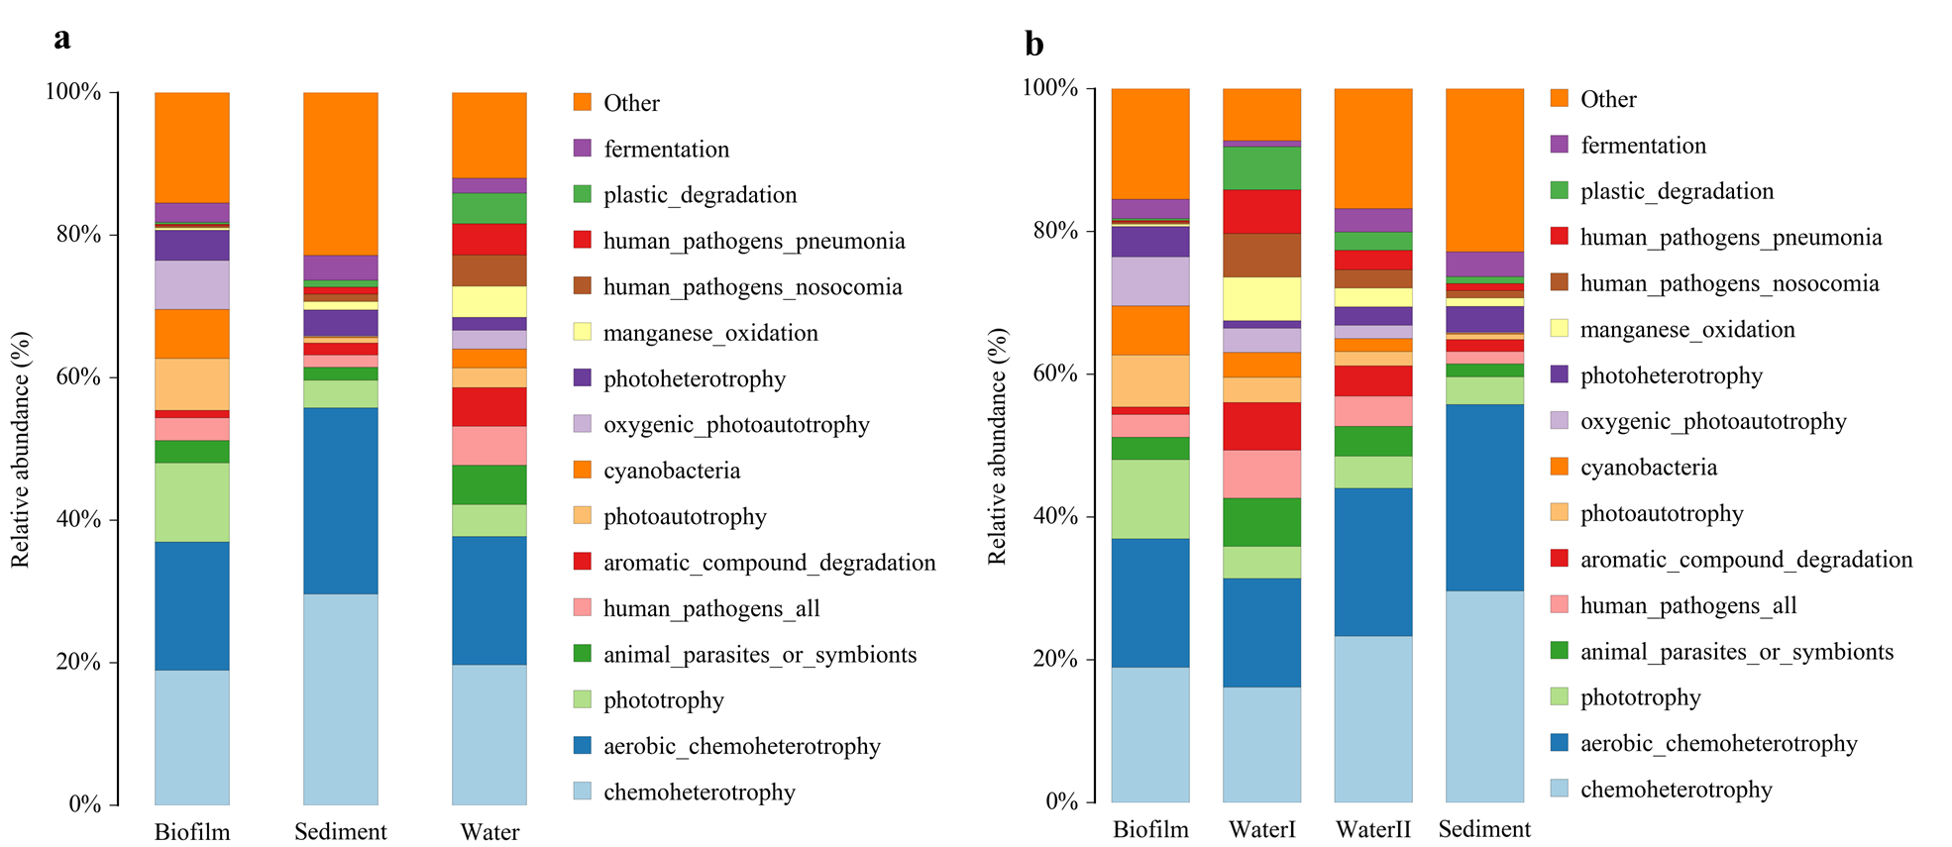
Fig. S3 The relative abundance of function predicated by FAPROTAX across different habitats or ecotypes.

