Supplementary material to ‘Drilling rocks with laser: Sci-Fi or reality?’
Characterization of rocks selected for laser experiments
Granite selected for the test is light-colored and it shows holocrystalline, phaneritic, granular structure. Grain-size ranges from fine (200µm) to medium (2mm) with macroscopically visible feldspars, quartz and biotite. The mineral composition consists in quartz (32%), plagioclase (30%), K-feldspar (28%), chlorite (3%), biotite (3%), and some accessory minerals such as calcite, apatite, and magnetite (Tab S1.). The granite has density of 2.64 g/cm³, open porosity 0.5% resulting from intragranular fractures existing in the rock. The thermal conductivity is low 3.17 W/m·K, while uniaxial compressive strength (UCS) is high ~ 102MPa (see Tab. S2)
The sandstone shows a sedimentary layering given by two portions of the rock that differ in color; reddish (sandstone R) and yellowish (sandstone Y). Both portions are indistinguishable under the optical microscope, but differs slightly in chemical composition (Tab. S1). The sandstone is well sorted, exhibiting a fine-grained texture, with an average grain size of approximately 100 µm. The grains range in shape from angular to rounded and have low sphericity. The contact between grains varies from concavo-convex to sutured, suggesting matured diagenesis. The reddish portion of sandstone consists of quartz (83%), K-feldspar (7%), chlorite (4%), and white mica (6%), while yellowish portion contains quartz (87%), K-feldspar (6%), white mica (5%), and chlorite (2%). In both types of sandstone accessory minerals such as magnetite, apatite and Fe-oxides can be found. The sandstone has density ranging from 2.60 to 266g/cm³ and open porosity 1.01 – 1.18%. The thermal conductivity is relatively high 5.11 – 5.16 W/m·K, and UCS of 62.4 – 67.8 MPa (see Tab. S2).
The Limestone sample is composed exclusively of calcite, which is present in the rock as very fine-grained matrix forming micrite (1 - 5 µm), or sparry crystals within fossils (> 100 µm). The limestone has density of 2.64 g/cm³, open porosity 0.6%. The thermal conductivity is low 3.32 W/m·K, while UCS is high 94 MPa (see Tab. S2)

Table S1. Modal mineral composition determined by XRD and whole rock chemical composition of selected lithologies. Whole rock chemical composition was normalized on anhydrous basis. Mineral abbreviations according to (Whitney and Evans, 2010).
% | granite | Sandstone R | Sandstone Y | limestone
Qz | 32 | 83 | 87 | -
Cri | 1 | - | - | -
Pl | 30 | - | - | -
Kfs | 28 | 7 | 6 | -
Chl | 3 | 4 | 2 | -
Bt | 3 | - | - | -
Wm | - | 6 | 5 | -
Sdl | 2 | - | - | -
Cal | 1 | - | - | 100
wt%
SiO₂ | 73.86 | 93.57 | 91.24 | 0.69
TiO₂ | 0.14 | 0.31 | 0.23 | 0.02
Al₂O₃ | 14.49 | 3.41 | 4.14 | 0.31
Fe₂O₃ | 1.29 | 1.26 | 2.61 | 0.07
MnO | 0.03 | 0.01 | 0.12 | <0.01
MgO | <0.01 | <0.01 | <0.01 | 0.52
CaO | 1.15 | 0.04 | 0.07 | 98.37
Na₂O | 4.32 | 0.03 | 0.03 | 0.02
K₂O | 4.66 | 1.33 | 1.53 | <0.01
P₂O₅ | 0.05 | 0.03 | 0.03 | <0.01
Tot | 100 | 100 | 100 | 100
LOI | 0.60 | 0.79 | 1.30 | 42.96
LOI – loss on ignition, wt% - weight percent, Wm – white mica (Ms, Ph),
Table S2. Physical and thermal properties of the selected lithologies.
 | granite | sandstone reddish | sandstone yellowish | limestone
ρ (g/cm³) | 2.64 | 2.60 | 2.66 | 2.63
Ab (%) | 0.50 | 1.04 | 1.18 | 0.59
V_{p} (km/s) | 3.94 | 4.78 | 5.03 | 6.82
V_{s} (km/s) | 2.26 | 2.85 | 2.98 | 3.14
ν (-) | 0.25 | 0.22 | 0.23 | 0.37
G (GPa) | 13.68 | 21.07 | 23.63 | 25.60
M (GPa) | 40.83 | 59.22 | 67.36 | 122.51
K (GPa) | 22.59 | 31.13 | 35.86 | 88.39
E (GPa) | 34.14 | 51.56 | 58.12 | 70.03
UCS* (MPa) | 102.14 | 62.36 | 67.79 | 93.80
λ (W/m·K) | 3.17 | 5.16 | 5.11 | 3.32
C_{p} (J/kg·K) | 875.49 | 882.71 | 859.46 | 766.73
α (m²/s) | 1.59 ·10⁻⁶ | 2.24 ·10⁻⁶ | 2.23 · 10⁻⁶ | 1.65 · 10⁻⁶
solidus (°C)** | 700 | 700 | 700 | 860***
liquidus (°C)** | 1020 | 1480 | 1480 | 2570***
* calculated from elastic properties according to (Rahman and Sarkar, 2023), ** solidus (first melts) and liquidus (complete melting) temperature were estimated for chemical composition of selected lithologies at equilibrium conditions by MELTS and FactSage software, *** CaCO₃ decomposes to CaO at 860°C, therefore the CaO complete melting point temperature is reported.

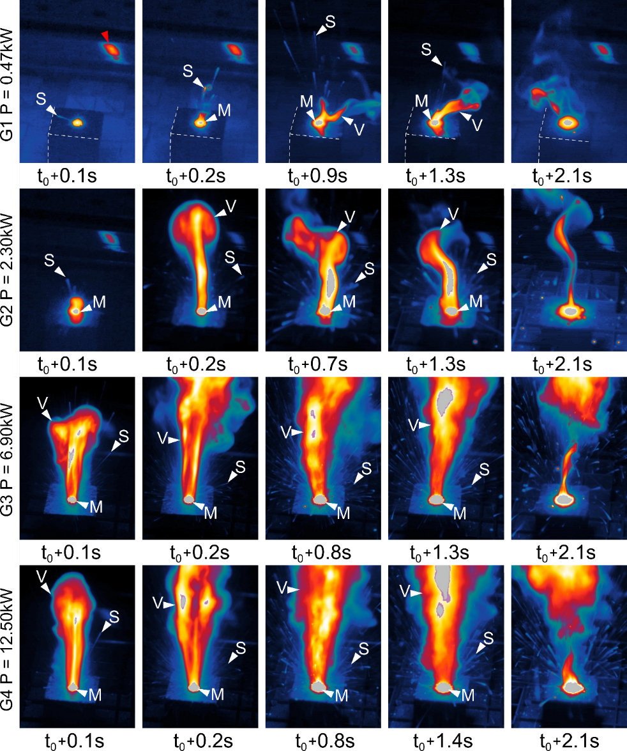
Figure S1. IR images of granite during the single spot tests (ST) at representative timestamps showing evolution of laser drilling process at different power levels. S – spallation, M – melting, V – vaporization.
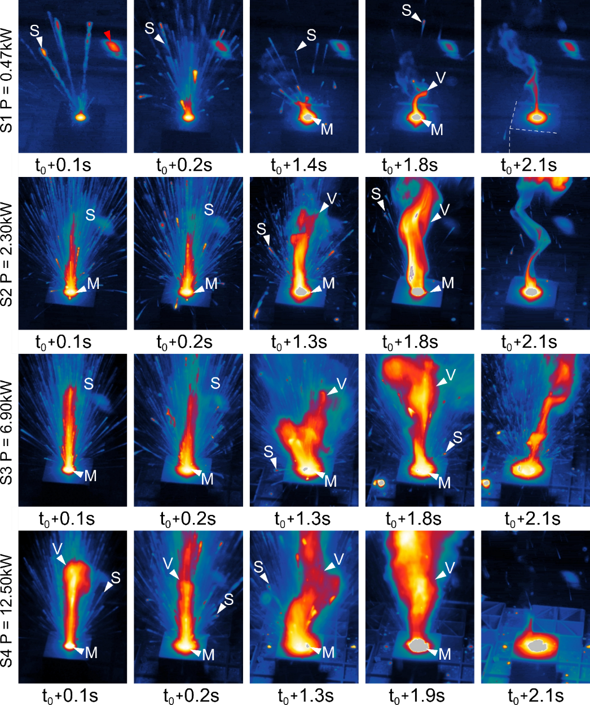
Figure S2. IR images of sandstone during the single spot tests (ST) at representative timestamps showing evolution of laser drilling process at different power levels. S – spallation, M – melting, V – vaporization.
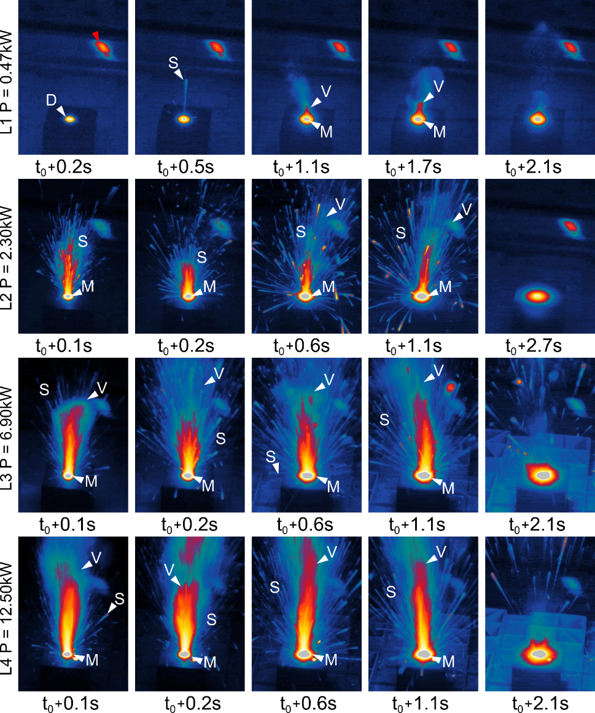
Figure S3. IR images of limestone during the single spot tests (ST) at representative timestamps showing evolution of laser drilling process at different power levels. S – spallation, M – melting, V – vaporization.

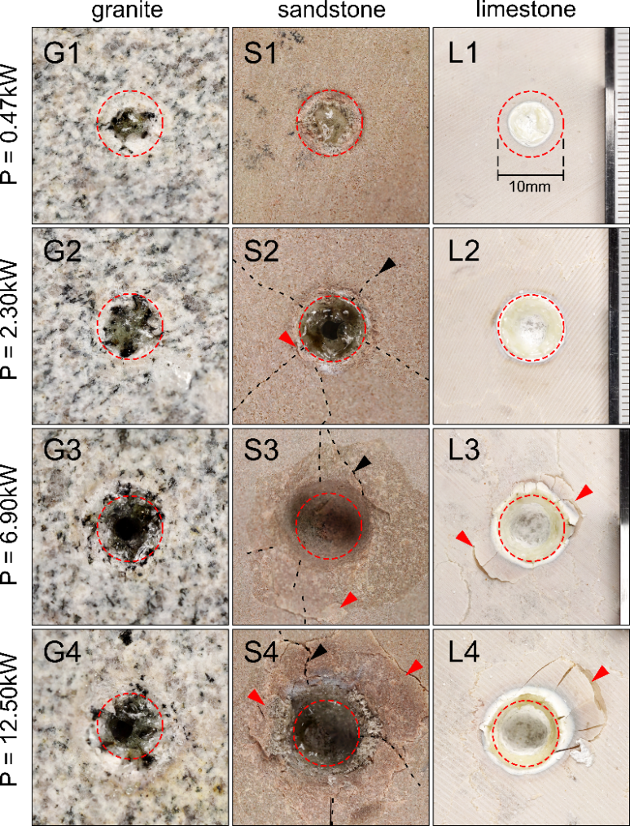
Figure S4. Images of craters after the single spot laser tests (ST). The red dashed circle defines fixed beam spot size (10ᴓmm), black arrows and black dashed line indicate tensile fractures, while red arrows indicate partially detached spalls (shearing fractures).

