Supplementary Information
For
Miniaturized Electromechanical Biosensor for Preclinical Cardiac Drug Screening
Haolan Sun¹, Longlong Li¹, Arunkumar Shanmugasundaram^{1, 3}, Eung-Sam Kim², Bong-Kee Lee¹ and Dong-Weon Lee^{1, 3, 4} *

¹School of Mechanical Engineering, Chonnam National University, Gwangju 61186, Republic of Korea
²School of Biological Sciences and Biotechnology, Chonnam National University, Gwangju 61186, Republic of Korea
³Advanced Medical Device Research Center for Cardiovascular Disease, Chonnam National University, Gwangju 61186, Republic of Korea
⁴Center for Next-Generation Sensor Research and Development, Chonnam National University, Gwangju 61186, Republic of Korea

*Corresponding author. E-mail: mems@jnu.ac.kr

Supplementary Figures

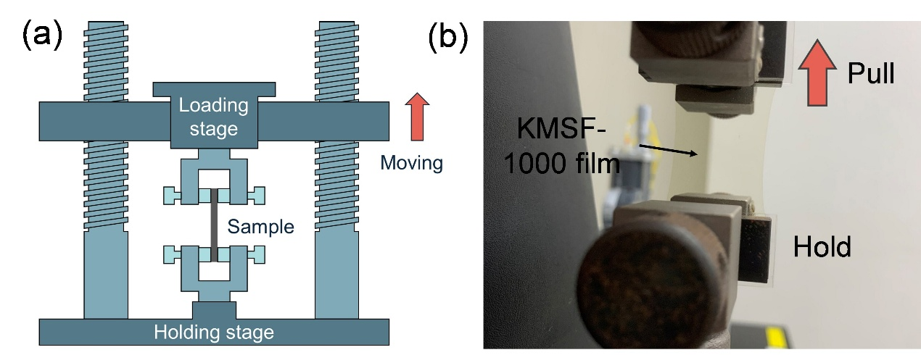
Fig. S1. Tensile testing setup for evaluating the mechanical properties of SU-8 and KMSF-1000 films. a Schematic illustration of the uniaxial tensile testing system, showing the loading and holding stages used to apply controlled displacement to the polymer sample. b Optical image of the experimental setup, where a KMSF-1000 film is clamped between the grips and subjected to uniaxial tension.

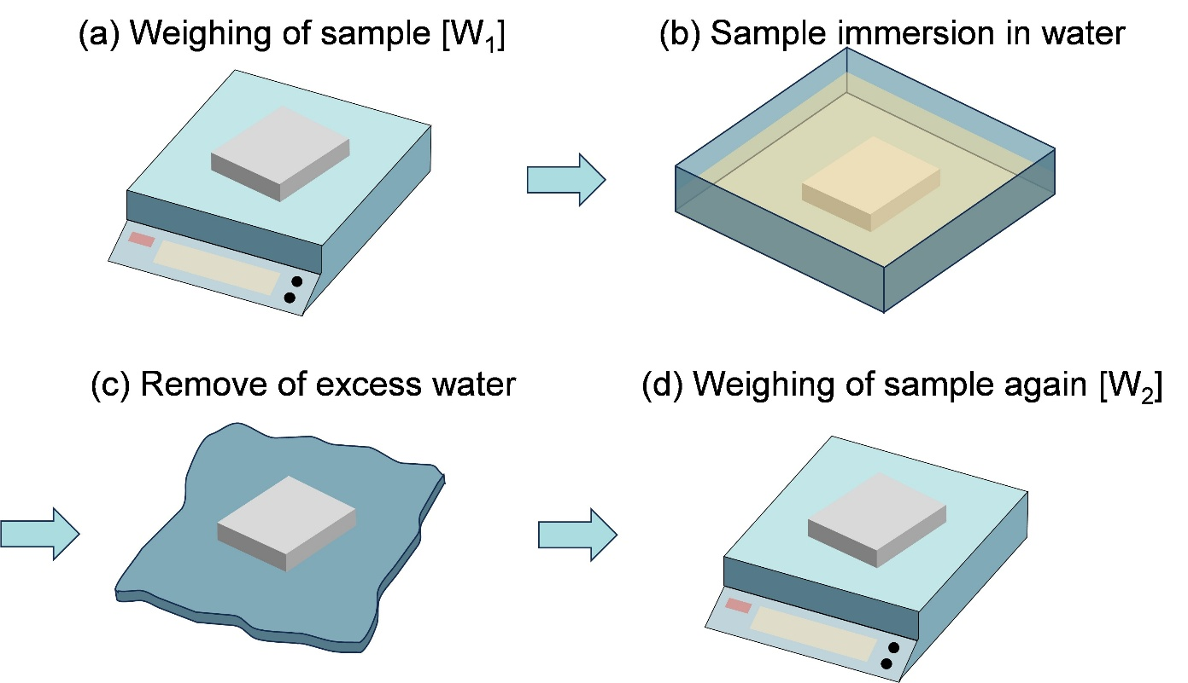
Fig. S2. Schematic of the water absorption testing procedure for polymer films. a Measure the weight of the sample before treatment. b immersing the sample in DI water for 24 hours. c Remove residual DI water. d Measure the weight of the sample after processing.

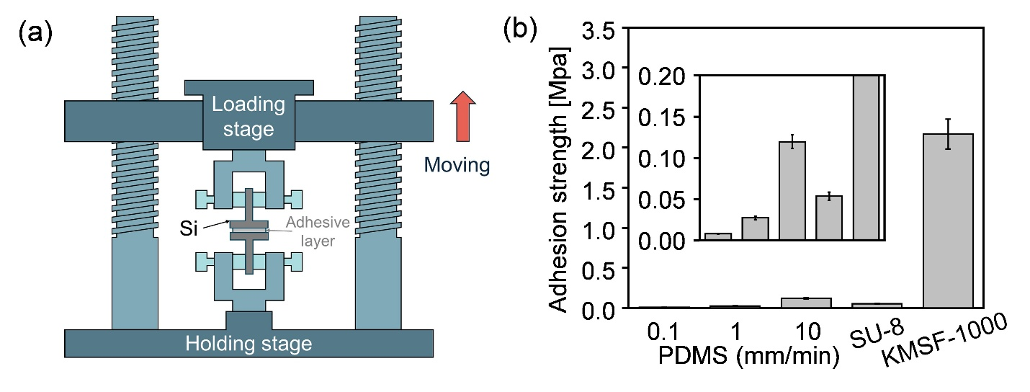
Fig. S3. Adhesion strength measurement of polymer films on silicon substrates. a Schematic illustration of the pull-off test setup, in which the polymer film is bonded to a silicon substrate and subjected to vertical loading to evaluate interfacial adhesion. b Measured adhesion strength of SU-8 and KMSF-1000 films under different treatment conditions. KMSF-1000 exhibited significantly higher adhesion to silicon, which was maintained after UV exposure and post-cure annealing, without the need for additional adhesion promoters.

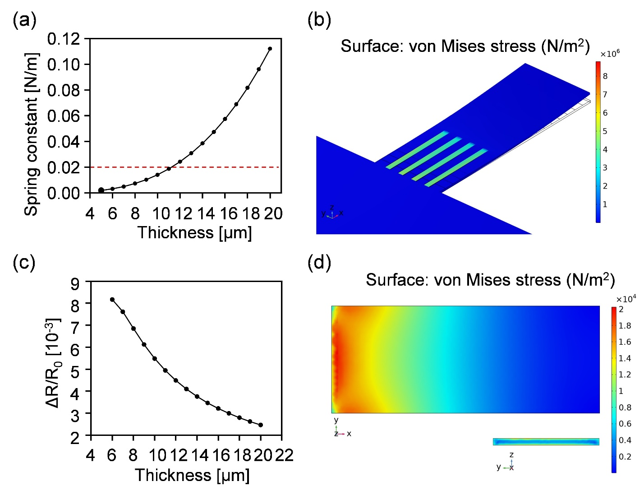
Fig. S4. Simulation analysis of cantilever thickness design. a Relationship between the spring constant and the cantilever thickness (with a cantilever length and width of 1000 μm and 400 μm, respectively), showing increased stiffness with thickness. b Stress distribution on the microcantilever and the nano silicon strain sensor under a 1 μN load applied at the cantilever free end. c Relationship between the resistance change rate of the nano silicon sensor and the cantilever thickness under a 1 μN upward load, indicating decreased sensitivity with increasing thickness. d Stress distribution analysis of the microcantilever using COMSOL finite element analysis, showing stress concentration near the fixed end and close to the cantilever surface.

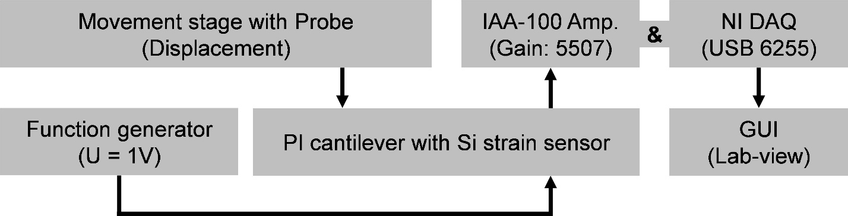
Fig. S5. Experimental setup for characterizing the cantilever with an embedded silicon strain sensor. Block diagram of the measurement system, consisting of a movement stage with probe for applying calibrated displacements, a function generator for driving inputs, a cantilever integrated with a silicon strain sensor, an IAA-100 amplifier for signal conditioning, and a National Instruments DAQ (USB-6255) for real-time acquisition. A LabVIEW-based GUI was used for visualization and data recording.

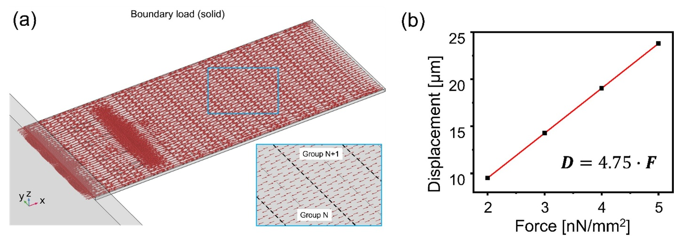
Fig. S6. Simulating the deformation of a cantilever during cardiomyocyte contraction. a Simulation of cardiomyocyte contraction by applying alternating stress to the microcantilever surface using COMSOL finite element analysis. b Linear relationship between the upward displacement of the cantilever free end and the surface-applied stress.

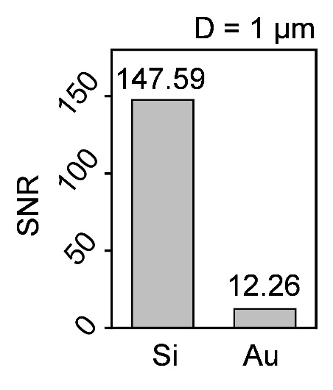
Fig. S7. Signal-to-noise ratio comparison between silicon and gold strain sensors integrated into identical microcantilevers under a fixed 1 µm displacement at the cantilever free end.

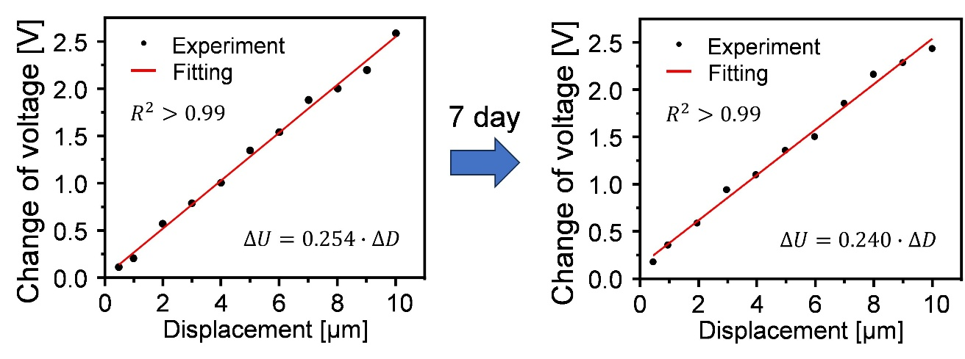
Fig. S8. Sensitivity comparison of the microcantilever with an integrated nanosilicon strain sensor before and after one week in a cell culture environment, showing no significant change.

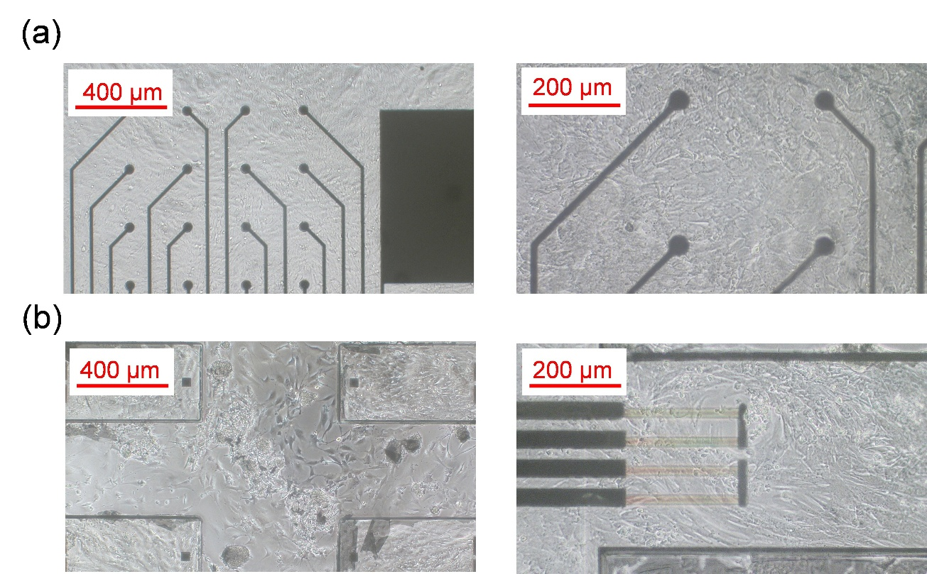
Fig. S9. Microscopic images of cardiomyocytes cultured on the bio-platform seven days after seeding. a Optical images of cardiomyocytes adhered to the MEA region at different magnifications. b Optical images of cardiomyocytes cultured on the microcantilever integrated with the nanosilicon strain sensor, showing uniform attachment and spreading across the cantilever structures.

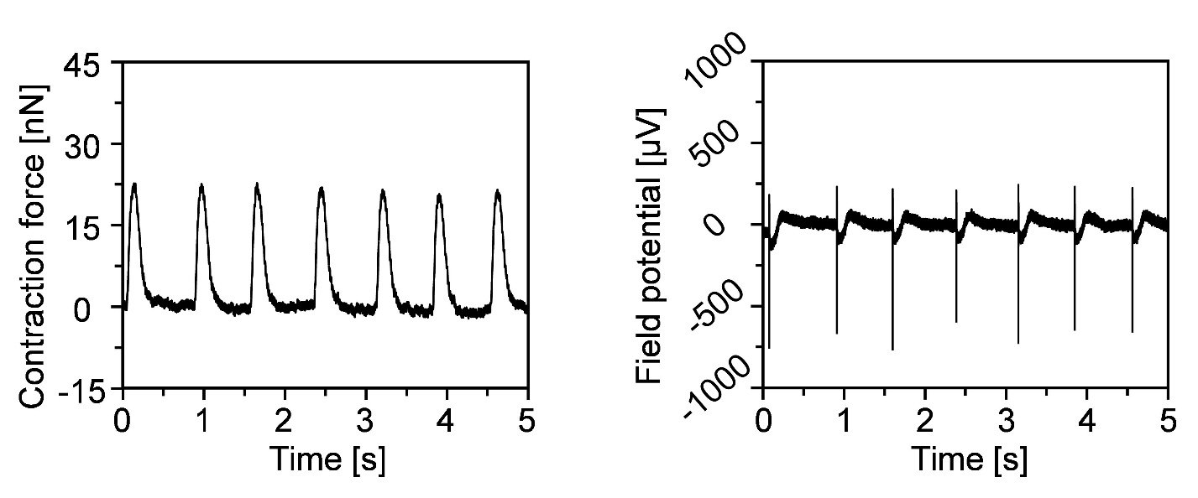
Fig. S10. Representative recordings of NRVMs on day 3 after seeding. Both contractile force signals from the nanosilicon strain sensor and field potential signals from the MEA were detected for the first time, showing clear temporal synchronization between electrical and mechanical activity.

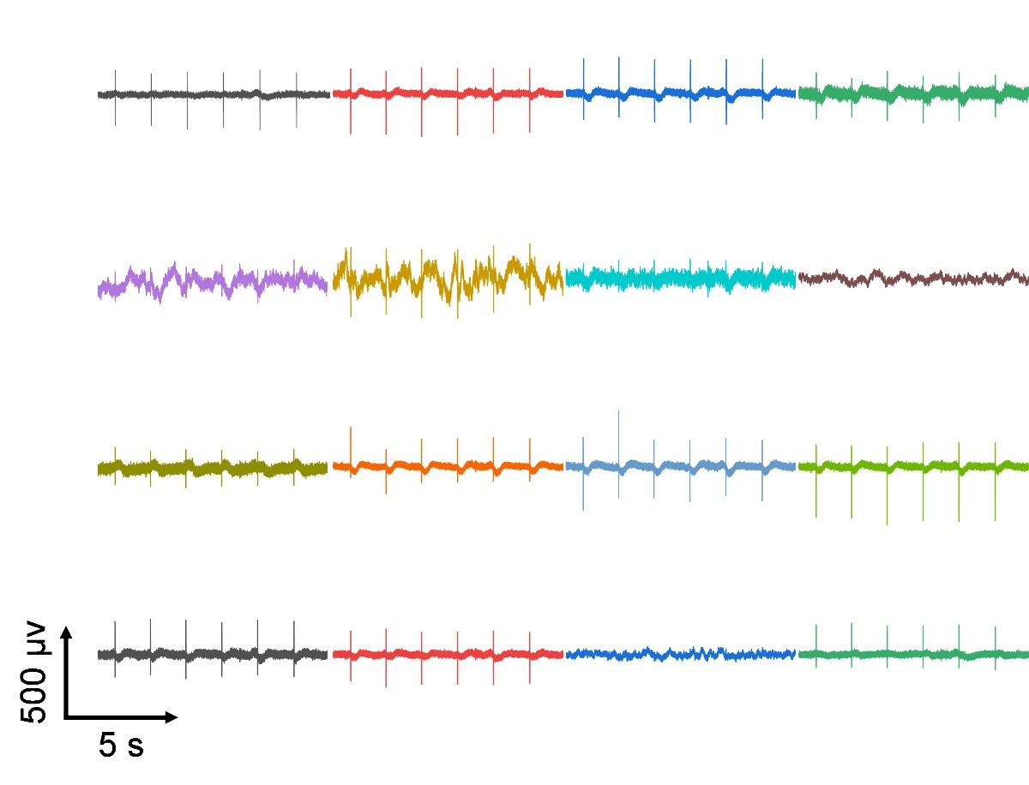
Fig. S11. Representative field potential recordings from hiPSC-CMs at different time points after seeding. Spontaneous extracellular field potentials became detectable within 24 h, demonstrating the onset of rhythmic electrical activity.

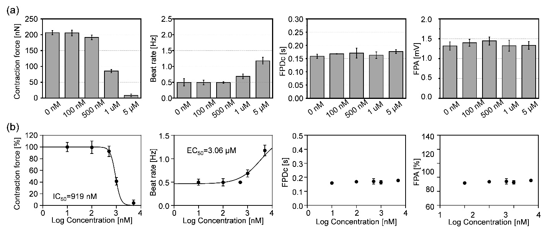
Fig. S12. Dose-dependent effects of Blebbistatin on cardiomyocyte function. a NRVMs were treated with increasing concentrations of Blebbistatin (0, 100, 500 nM, 1 μM, and 5 μM), and contractile force, spontaneous beat rate, correct field potential duration (FPDc), and field potential amplitude (FPA) were quantified. b The corresponding dose–response relationship for contractility inhibition was derived, confirming concentration-dependent suppression of mechanical output with preserved electrophysiological activity at lower doses.

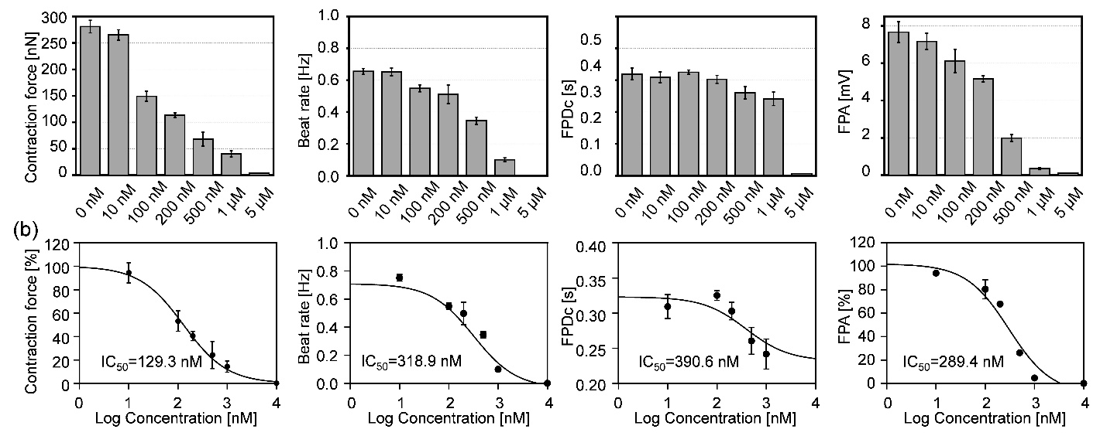
Fig. S13. Dose–response analysis of Verapamil in NRVMs. a Bar graphs showing the effects of increasing concentrations of Verapamil (0 nM, 100 nM, 500 nM, 1 µM, and 5 µM) on contraction force, spontaneous beat rate, correct field potential duration (FPDc), and field potential amplitude (FPA). b Verapamil produced a concentration-dependent suppression of contraction force and beat rate, accompanied by a reduction in FPA and shortening of FPD, consistent with blockade of L-type Ca²⁺ channels and impaired calcium-dependent excitation–contraction coupling.

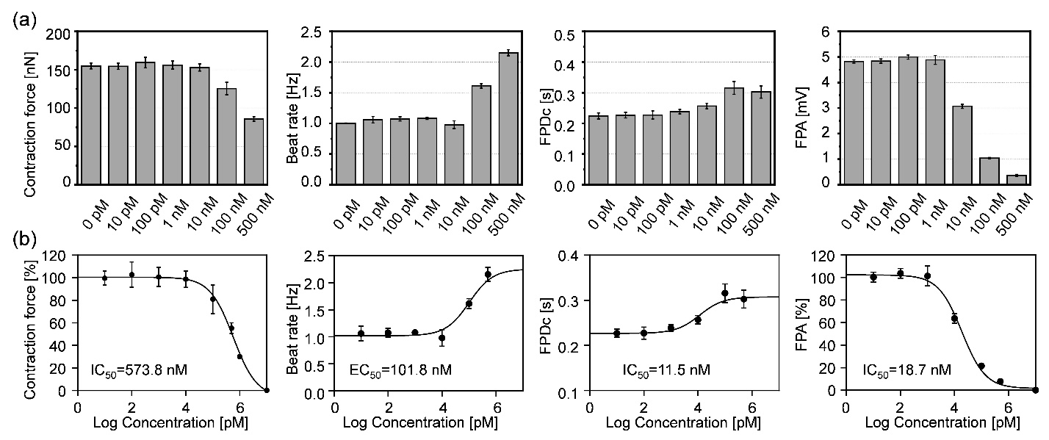
Fig. S14. Dose-dependent effects of astemizole on cardiomyocyte contractile and electrophysiological properties. a Bar graphs show quantitative changes in contractile force, spontaneous beat rate, correct field potential duration (FPDc), and field potential amplitude (FPA) following treatment with increasing concentrations of astemizole (10 nM to 5 µM). b Astemizole induced progressive FPD prolongation at low doses, consistent with hERG channel blockade, while higher concentrations additionally reduced contractile force and FPA, reflecting downstream disruption of depolarization and calcium handling. Beat rate showed modest but variable changes across concentrations.

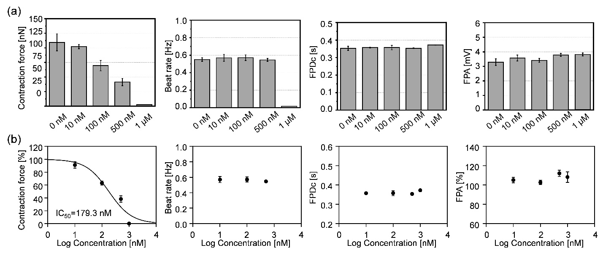
Fig. S15. Dose-dependent effects of Blebbistatin on cardiomyocyte function. a hiPSC-CMs were treated with increasing concentrations of Blebbistatin (0, 100, 500 nM, 1 μM, and 5 μM), and contractile force, spontaneous beat rate, correct field potential duration (FPDc), and field potential amplitude (FPA) were quantified. b The corresponding dose–response relationship for contractility inhibition was derived, confirming concentration-dependent suppression of mechanical output with preserved electrophysiological activity at lower doses.

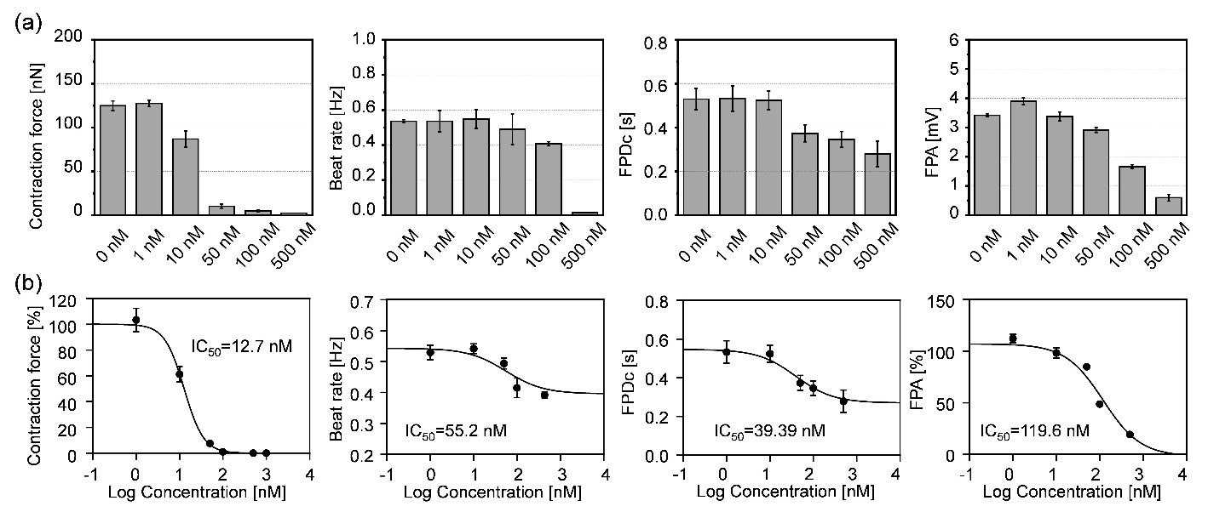
Fig. S16. Dose–response analysis of Verapamil in hiPSC-CMs. a Bar graphs showing the effects of increasing concentrations of Verapamil (0 nM, 100 nM, 500 nM, 1 µM, and 5 µM) on contraction force, spontaneous beat rate, correct field potential duration (FPDc), and field potential amplitude (FPA). b Verapamil produced a concentration-dependent suppression of contraction force and beat rate, accompanied by a reduction in FPA and shortening of FPD, consistent with blockade of L-type Ca²⁺ channels and impaired calcium-dependent excitation–contraction coupling.

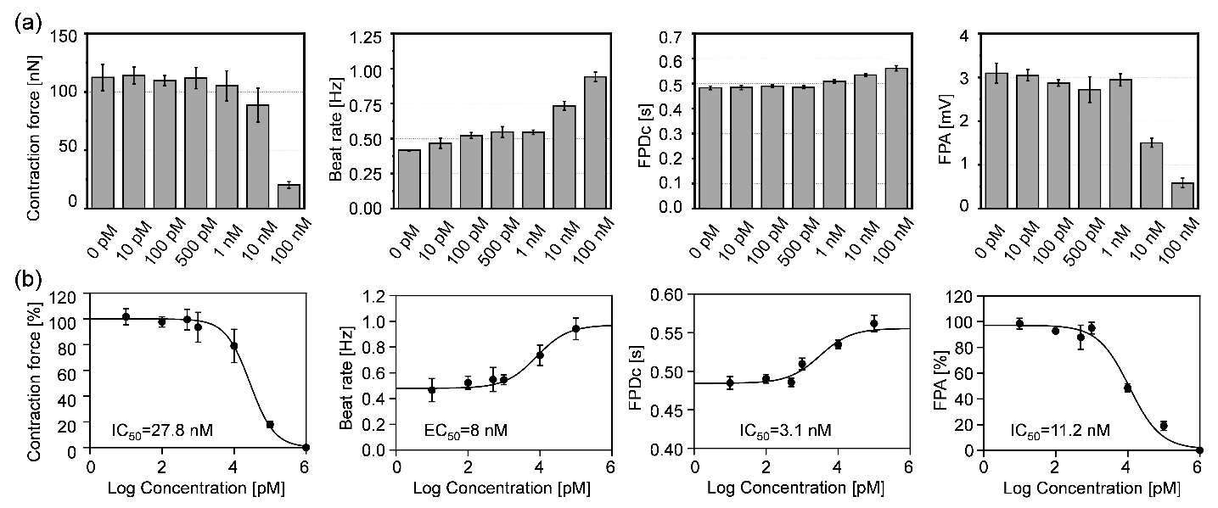
Fig. S17. Dose-dependent effects of astemizole on hiPSC-CMs contractile and electrophysiological properties. a Bar graphs show quantitative changes in contractile force, (b) spontaneous beat rate, correct field potential duration (FPDc), and field potential amplitude (FPA) following treatment with increasing concentrations of astemizole (10 nM to 5 µM). b Astemizole induced progressive FPD prolongation at low doses, consistent with hERG channel blockade, while higher concentrations additionally reduced contractile force and FPA, reflecting downstream disruption of depolarization and calcium handling. Beat rate showed modest but variable changes across concentrations.

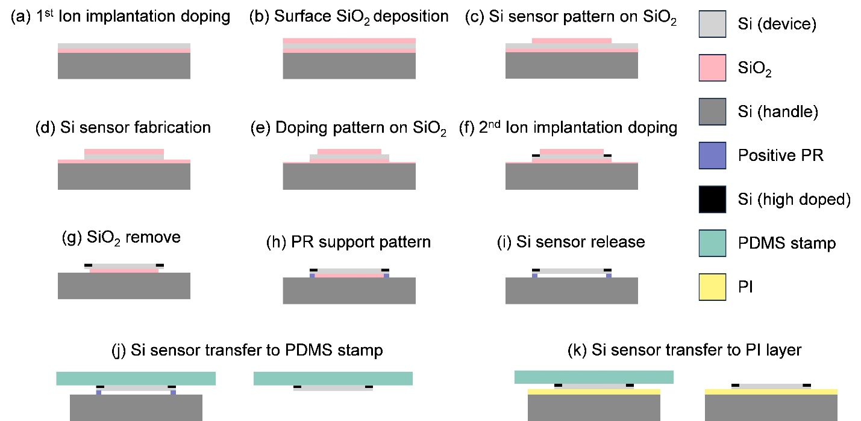
Fig. S18. Schematic illustration of the fabrication and transfer process of the nanosilicon strain sensor. a Prepare the SOI wafer and ion implantation for boron doping, b Depositing a SiO₂ layer, c, d photolithography and wet etching steps to define the sensor region, e, f second ion implantation for boron doping to define the contact pad, g-i preparation of a temporary support structure and oxide removal, j release of the nanosilicon sensor using a PDMS stamp, and k transfer and integration of the sensor onto the flexible KMSF-1000 substrate. This stepwise process enables seamless integration of the nanosilicon strain sensor with the polymer-based microcantilever platform for electromechanical biosensing.

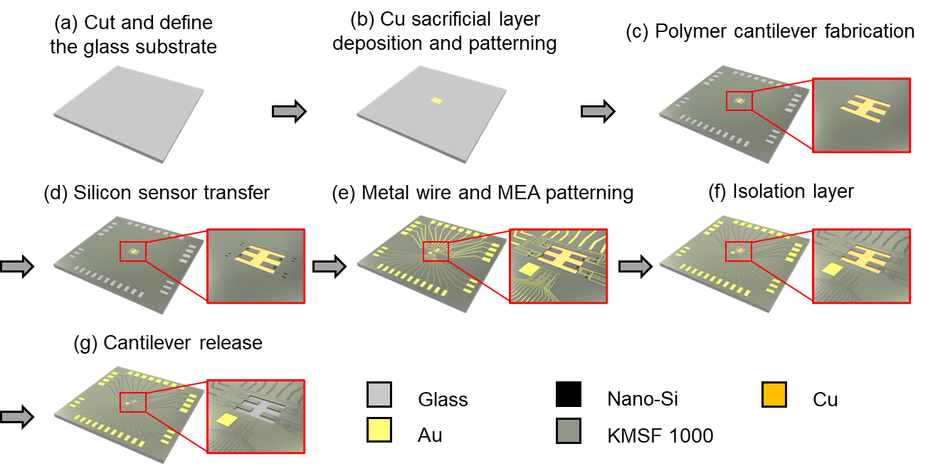
Fig. S19. Schematic illustration of the fabrication process flow for the bio-platform combining a polymer microcantilever integrated with a nano silicon strain sensor and an MEA. a Cut and define the glass substrate. b Define the copper sacrificial area. c Making the polymer cantilever on the sacrificial layer. d Transfer the nano-silicon strain sensor on the polymer cantilever. e A gold layer is deposited and patterned into metal electrodes and conductive lines. f Cover the sensor and MEA by polymer isolating layer. g Release the polymer cantilever by remove the copper sacrificial layer.

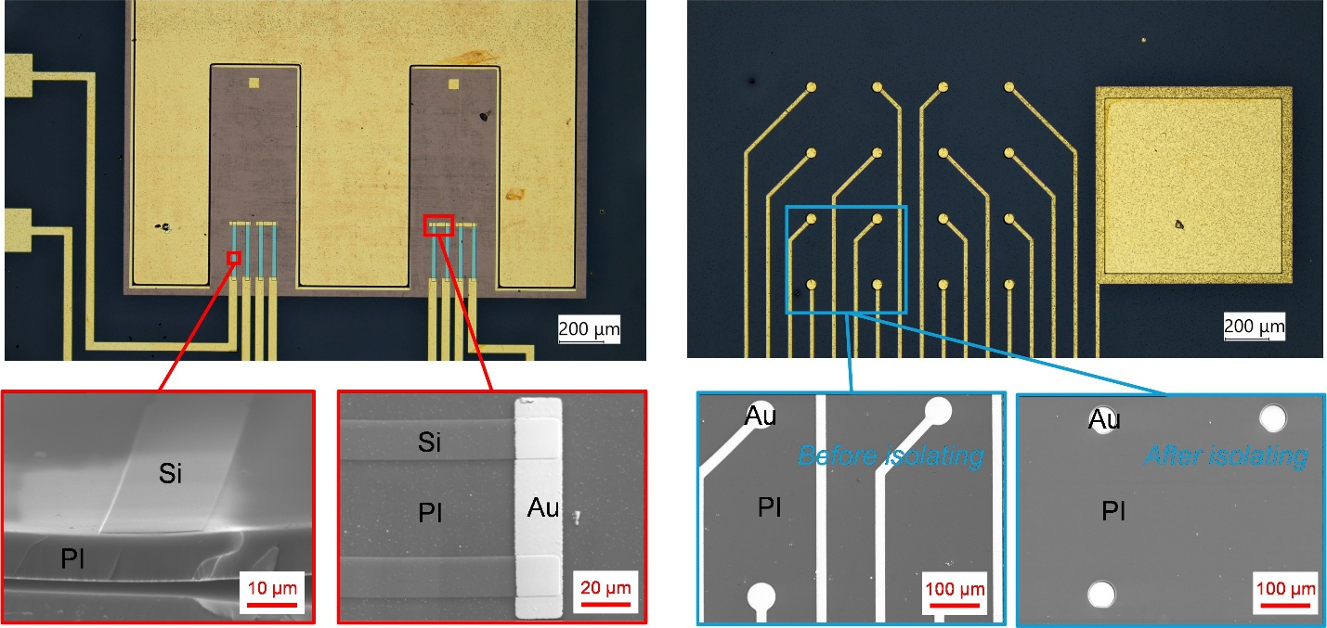
Fig. S20. Microscopic images of the microcantilever integrated with the nano silicon strain sensor and the MEA, along with detailed SEM images.

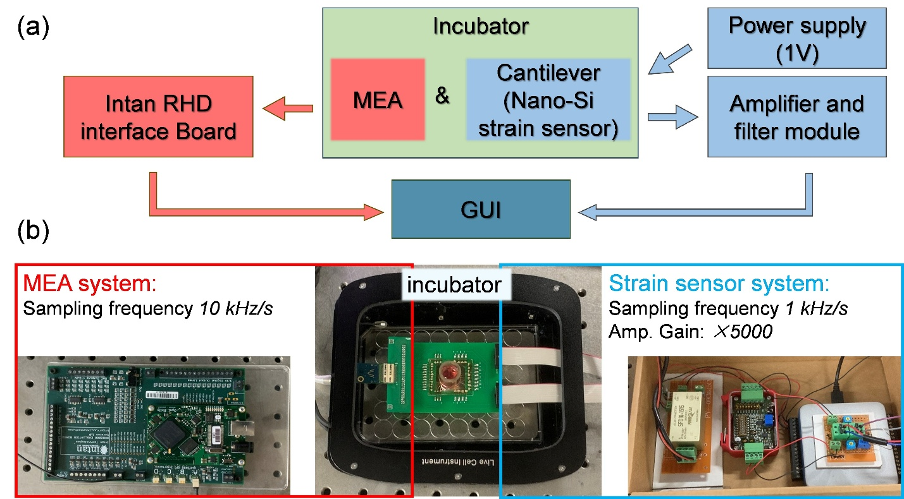
Fig. S21. Experimental setup for simultaneous mechanical and electrical recordings using the cantilever–MEA platform. a Block diagram showing the integration of the microcantilever with an embedded nanosilicon strain sensor and the MEA inside the incubator. The strain sensor system was powered by a 1 V supply and connected to an amplifier and filter module, while MEA signals were acquired through an Intan RHD interface board. Both systems were linked to a GUI for synchronized data acquisition. b Photographs illustrate the individual hardware components, including the MEA system, incubator setup, and strain sensor system.

Supplementary Notes
Supplementary Note 1
10-µm-thick SU-8 and KMSF-1000 films were fabricated by spin coating and UV curing, after which their mechanical properties were evaluated using uniaxial tensile testing. Both ends of the film were clamped and stretched at a constant rate of 0.1 mm/s, while a force sensor recorded the applied load and displacement, yielding a force–displacement curve (Fig. S5). The Young’s modulus (E) was calculated using
$$E=\frac{F}{A}∙\frac{l_{0}}{l_{1}}$$
where F is the applied longitudinal force, A is the cross-sectional area of the sample, l₀​ is the initial gauge length and l₁​ is the total displacement. The elongation at break was determined as
$$Elongation=\frac{∆l}{l_{0}}×100\%$$
where Δl is the increase in length at fracture relative to the initial gauge length.

Supplementary Note 2
SU-8 and KMSF-1000 films were coated onto separate silicon wafers and cured by baking and UV exposure. The samples were then immersed in deionized water at 25°C for 24 h to evaluate water uptake. The water absorption ratio (M) was calculated using
$$M=\frac{W_{t}-W_{0}}{W_{0}-W_{s}}×100\%$$
where W₀ is the initial weight of the sample, Wₜ is its weight after 24 h immersion, and Wₛ is the weight of the bare silicon wafer. Although KMSF-1000 exhibited measurable water absorption, its uptake was markedly lower than that of SU-8, confirming its superior dimensional stability for long-term applications.

Supplementary Note 3
Since single-crystalline silicon cannot be directly deposited onto polymer substrates, transfer printing is commonly employed to integrate silicon devices onto flexible platforms. SU-8 has traditionally been used as an adhesive layer; however, when PDMS is used as the transfer stamp, precise control of peeling speed is required to prevent delamination or sensor damage. To address this limitation, we compared the adhesion strength of SU-8 and KMSF-1000 films to silicon wafers using a pull-off test (Fig. S7a). The results show that the adhesion force of the PDMS stamp to silicon increases with peeling speed and at 10 mm/min exceeds the adhesion strength of SU-8, leading to a high probability of transfer failure (Fig. S7b). In contrast, KMSF-1000 demonstrated robust adhesion to silicon, reaching 2.17 MPa, which is substantially higher than both SU-8 and the PDMS stamp. This strong and stable adhesion minimizes operational challenges during transfer printing and significantly improves the reliability of silicon sensor integration on polymer substrates.

Supplementary Note 4: Optimization of the dimensional design of the microcantilever
The cantilever’s dimensions and structure were meticulously designed to optimize its functionality. Initially, we aimed to reduce the cantilever’s area to enhance device efficiency. However, given the application requirements, the cantilever was designed to support a monolayer of cardiomyocyte tissue, accommodating at least 100 cells. According to previous research, the area of a mature cardiomyocyte exceeds 1000 µm². Thus, the cantilever’s area was required to exceed 1×10⁵ µm². Considering the aspect ratio and design requirements, the cantilever’s length and width were determined to be 1000 µm and 400 µm, respectively.
To achieve the highest possible sensor sensitivity, the cantilever’s thickness was identified as a critical parameter. Excluding the influence of the integrated silicon sensor, the cantilever’s thickness is the primary determinant of its stiffness. The theoretical spring constant (𝑘), used as the design basis, was calculated using the formula:
$$k=\frac{EWt^{3}}{4L^{3}}$$
where 𝐸 represents Young’s modulus, 𝑊 is the width, 𝐿 is the length, and 𝑡 is the thickness. As shown in Fig. S8a, a thinner cantilever demonstrates a lower spring constant, resulting in higher force sensitivity. However, excessively low stiffness complicates fabrication, processing, and operational stability. Based on prior studies and empirical observations, the stiffness was determined not to fall below 0.02 N/m.
Furthermore, we performed simulations using COMSOL Multiphysics finite element analysis software to evaluate the variation in resistance of the integrated silicon sensor under different cantilever thicknesses. In the simulation model Fig. S8b), one end of the cantilever was fixed, and a uniformly distributed upward load of 1 µN/mm² was applied to its surface. Fig. S8c illustrates that as the cantilever thickness decreases (from 20 µm to 5 µm), the resistance variation rate of the silicon sensor increases. However, excessive reductions in thickness intensify the influence of the silicon sensor on stiffness, and further reductions do not improve device performance. Taking all factors into account, an ideal cantilever thickness of 12 µm was identified to balance optimal performance and structural stability. Fig. S8d shows the stress distribution analysis of the microcantilever using COMSOL finite element analysis, showing stress concentration near the fixed end and close to the cantilever surface.
Supplementary Note 5. Relationship between cantilever displacement and loading force
The correlation between applied load on the microcantilever and the resulting output voltage was derived from the bending equation of a rectangular cantilever. The displacement of the free end (δ) under an applied load (F) is given by
$$δ=\frac{4FL^{3}}{Ebh^{3}}$$
where E is the Young’s modulus of the cantilever, L, b, and h are the length, width, and thickness, respectively, and F is the upward force applied to the free end.
Although the cantilever body is composed primarily of KMSF-1000 (>90%), the contribution of the embedded nanoscale silicon strain sensor to the effective stiffness must be considered, as silicon is significantly stiffer than KMSF-1000. To quantify this effect, finite element simulations (COMSOL Multiphysics) were used to estimate the equivalent Young’s modulus of the hybrid structure. The resulting value (0.202 GPa) was close to the intrinsic modulus of KMSF-1000 (0.14 GPa), confirming that the nanoscale silicon element has minimal influence on overall flexibility and does not compromise the low-stiffness properties of the cantilever.
From this calibration, a linear relationship between free-end displacement and applied load was established, expressed as:
$$F=3.49×{10}^{-2}∙δ$$
where F is in micronewtons (µN) and δ is the displacement in micrometers (µm).

Supplementary Note 6: Relationship between Cantilever Displacement and Loading force
To determine the relationship between the applied load on the microcantilever and the change in output voltage, we used the bending equation for a rectangular cantilever to calculate the correlation between the displacement of the free end and the applied load:
$$δ=\frac{4FL^{3}}{Ebh^{3}}$$
Here, δ represents the displacement of the free end of the cantilever, E denotes the Young's modulus of the cantilever, L, b, and h are the length, width, and height of the cantilever, respectively, and F signifies the upward load applied to its free end. Although the cantilever consists of over 90% KMSF-1000, the influence of the nano-silicon sensor on its overall Young's modulus cannot be overlooked, given the significantly higher hardness of silicon relative to KMSF-1000. To evaluate this impact, we developed a theoretical model using COMSOL to calculate the cantilever's equivalent Young’s modulus. The simulation results revealed an equivalent Young’s modulus of 0.202 GPa, which is closely aligned with the Young's modulus of KMSF-1000 (0.14 GPa). These findings confirm that the nano-silicon sensors exert minimal influence on the cantilever's flexibility and do not compromise its low-stiffness properties. Overall, the cantilever exhibited a linear relationship between the displacement at its free end and the applied load.
$$F=3.49×{10}^{-2}∙δ$$

Supplementary Note 7
Neonatal rats’ ventricular myocytes (NRVM) were used in this study. The primary ventricular cells were isolated from Sprague-Dawley rats (Damool Science, Daejeon, South Korea), three days after their birth, following the protocol approved by the Animal Ethics Committee of Chonnam National University in accordance with the Principles of Laboratory Animal Care and specific national laws (license number: CNU IACUC-YB-2025-48). To obtain the discrete cardiomyocytes, the ventricular tissue was minced and placed in an enzyme solution obtained by mixing 0.4 mg∙mL-1 collagenase and 0.6 mg∙mL-1 pancreatin solution. Under the influence of the digestive enzyme solution, the ventricular tissue was divided into independent cardiomyocytes. To extract the required cardiomyocytes from the digestive solution, the solution with the cardiomyocytes was placed in percoll, and the percoll solution is centrifuged to separate the cardiomyocyte layer and the fibroblast layer. The highly pure cardiomyocytes were obtained by pre-plating the separated cardiomyocyte layer. Conversely, after sterilizing the well plate that contains the cantilever device, the cell culture solution consisting of 67% Dulbecco’s modified Eagle medium (DMEM, LONZA, Gyeongsan-si, Korea), 17% Heparin sodium salt from the porcine intestinal mucosa (M199, Sigma-Aldrich, Gyeongsan-si, Korea), 10% Horse serum (HS, Sigma-Aldrich, Gyeongsan-si, Korea), 5% fetal bovine serum (FBS, Sigma-Aldrich, Gyeongsan-si, Korea), and 1% penicillin streptomycin (P/S, Sigma-Aldrich, Gyeongsan-si, Korea) is added to the well plate, and the purified cardiomyocytes are then seeded onto the surface of the cantilever device at a density of 1000 cardiomyocytes per mm². The cantilever device with the cardiomyocytes is then transferred to the incubator and the culture at 37°C under 5% CO2 and the cell culture medium is changed once every two days.

Supplementary Note 8
hiPSC-cardiomyocyte culture. hiPSC-CMs and their corresponding culture medium were commercially sourced from NEXEL and shipped in vials containing 2.5 million viable hiPSC-CMs, stored in liquid nitrogen upon arrival. Prior to thawing the cells, the device was sterilized and coated with 50 μg/mL fibronectin (Corning) for 1 hour. A vial containing 1 mL of hiPSC-CMs was rapidly thawed in a 37°C water bath for 3 minutes and subsequently placed in a biosafety cabinet to complete the process. The hiPSC-CMs were resuspended in 9 mL of manufacturer-provided plating medium and centrifuged to remove the supernatant. Finally, the hiPSC-CMs were resuspended in 1 mL of plating medium. Before seeding, fibronectin was removed from the device, ensuring it remained partially moist. The hiPSC-CMs were seeded at a density of 1000 cells mm-². After seeding, the device was incubated at 37°C with 5% CO₂ for 24 hours, after which the plating medium was replaced with maintenance medium. The culture medium was then replaced every 48 hours during the cultivation process.

Supplementary Note 9
Immunocytochemical staining analysis. Immunocytochemical staining was performed using the antibodies described in this section. In a typical process, the cardiomyocytes were placed in a 3.7% formalin solution for 10 min at 25 ºC and rinsed three times with phosphate-buffered saline (PBS Takara). Permeabilization was performed with 0.1% Triton-X (Sigma Aldrich) in PBS for 10 min at 25 ºC. To prevent nonspecific binding, the antibodies were incubated at 25 ºC for 30 min in 3% bovine albumin serum (3% BSA, Sigma Aldrich). Primary antibodies were used to detect α-actin (1:100, Sigma) and vinculin (1:100, Abcam) in the cardiac sarcomere, and Integrin β1 immunostaining (1:100, Sigma) was performed to measure receptor localization. The primary antibodies were diluted in a 1% blocking solution and incubated for 1.5 h at 25 ºC. The secondary antibodies (Alexa-Flour 488 goat anti-mouse IgG conjugate and Alexa-Flour 568 rabbit (1:200, Abcam)) were diluted in the same blocking solution and incubated for 2 h at 25 ºC. The cardiomyocytes were then incubated at 25 ºC for 1.5 h before being DAPI stained (Sigma). Finally, the cardiomyocytes were analyzed by an inverted confocal laser microscope (Leica TCS SP5 XCLSM, Germany). ImageJ software was used to measure the α-sarcomere length of the cardiomyocytes.

Supplementary Note 10
Nano-silicon strain sensor preparation:
Surface cleaning of SOI wafer using piranha solution (H₂SO₄:H₂O₂ = 2:1) for 15 min.
Dope the entire area with boron by ion implantation (power of 20 keV, dose of 5 × 10¹⁴ cm⁻²)
Rapid thermal annealing at 900°C for 60 s.
Dry oxidation, using PECVD to produces an SiO₂ layer of about 300 nm on the surface of the SOI wafer.
Spin coat AZ GXR 601 (3000 rpm for 30 s), then soft baking at 90°C for 90s.
UV light expose (80 mJ/cm²) to define the silicon sensor pattern and post exposure baking at 110°C for 90s, then develope (AZ 300 mif) for 50s.
Wet etch of SiO₂ layer by BOE (6:1) solution for 30 s.
SOI wafer cleaning using acetone, IPA, and DI water.
Wet etch of Si device layer by TMAH solution at 80°C for 1 min.
UV-lithography to define wire contact area using photoresist (AZ GXR 601) and developer (AZ 300 mif).
Wet etch of SiO₂ layer by BOE (6:1) solution for 3 min.
Dope SOI wafer with boron by ion implantation (power of 20 keV, dose of 1 × 10¹⁶ cm⁻²)
Rapid thermal annealing at 900°C for 60 s.
HF (49%) solution wet etch BOX layer of SOI wafer for 90 s. Removal of exposed BOX layer and 1μm side etch sensor supported BOX layer.
UV-lithography to define support structure using photoresist (AZ GXR 601) and developer (AZ 300 mif).
Microcantilever preparation:
Define the glass wafer using laser cuter.
Piranha (2:1) cleaning of a glass wafer for 15 min.
Deposit Cu (500 nm) using PVD process (sputter).
UV-lithography to define microcantilever sacrificial mask using photoresist (AZ GXR 601) and developer (AZ 300 mif).
Spin coat KMSF-1000 (1100 rpm for 30 s) and soft baking at 110°C for 10 min.
UV light exposes (400 mJ/cm²) with microcantilever mask and develop (KMSF developer) for 1 min.
Nano-silicon transfer:
Spin coating liquid PDMS on a PET film (700 rpm, 40 s), and bake at 80°C for 2 h, then cut it to 30 mm length and 30mm width as PDMS stamp.
HF (49%) solution wet etch BOX layer of SOI wafer for 20 min.
Soak the SOI wafer with DI water, then dry it.
Transfer of the nano-silicon from the SOI wafer onto the PDMS stamp and cleaning it with acetone, IPA, and DI water.
Align and attach the PDMS stamp onto the microcantilever.
Bake at 110°C for 10 s.
Lift off PDMS stamp.
Metallization:
BOE (6:1) solution cleaning for 5 s to remove native oxide on silicon.
Deposit Cr/Au, 10 nm/200 nm by E-beam evaporation.
UV-lithography to define strain sensor and MEA mask using photoresist (AZ GXR 601) and developer (AZ 300 mif).
Wet etch using Au etchant for 30 s, Cr etchant for 10 s.
PR removal using acetone, IPA, and DI water.
Encapsulation:
Spin coat KMSF-1000 (4000 rpm for 50 s) and soft baking at 110°C for 3 min.
UV light exposes (400 mJ/cm²) with isolation mask and develop (KMSF developer) for 30 s.
Cantilever release:
Release the microcantilever in Cu etchant for 2 hrs.
Roughening the surface of glass substrate by placing in BOE (6:1) solution for 1 min.
Soak the SOI wafer with DI water and dry it.

