Supplementary Figure

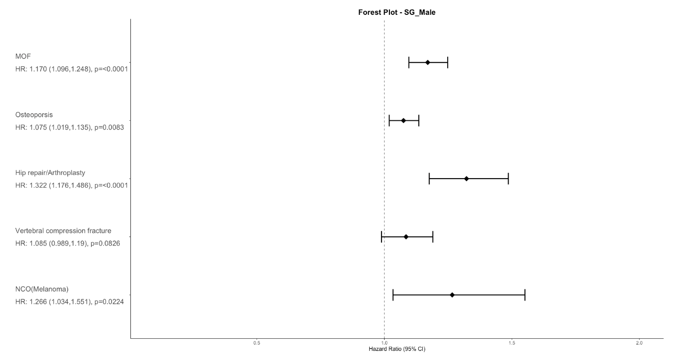
Supplementary figure 1. Forest plot of the subgroup analysis over male

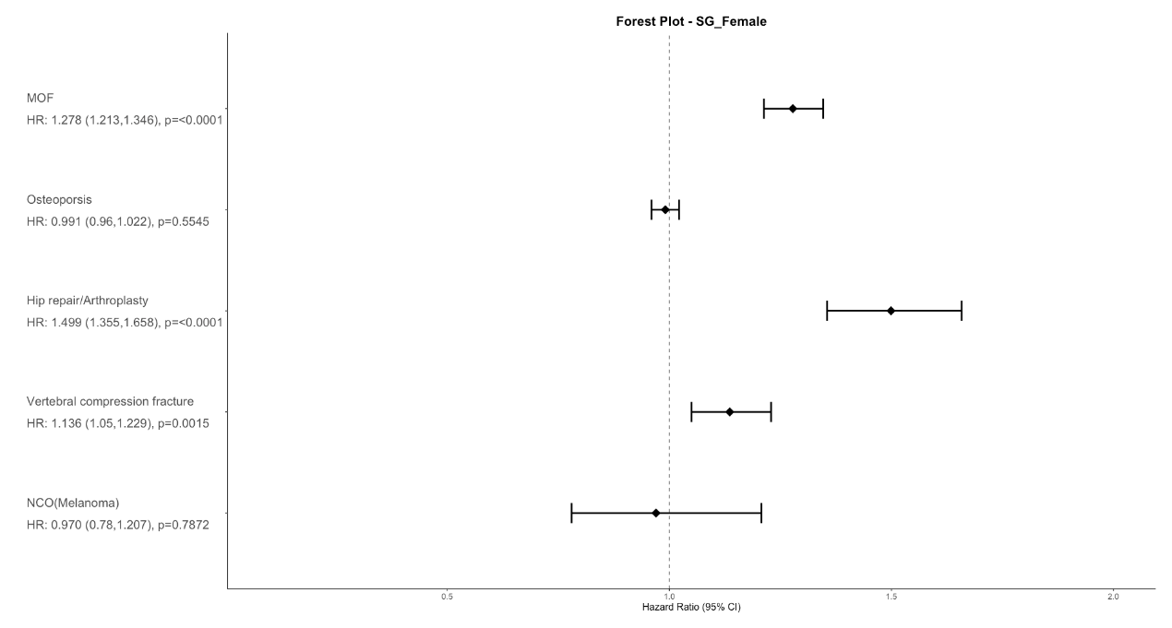
Supplementary figure 2. Forest plot of the subgroup analysis over female

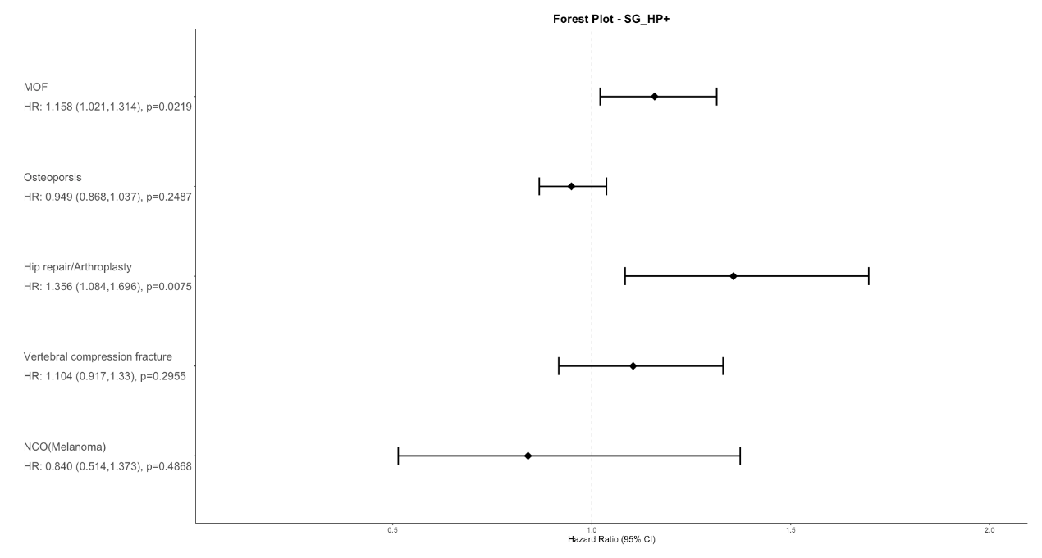
Supplementary figure 3. Forest plot of the subgroup analysis over patient with positive Helicobacter pylori test

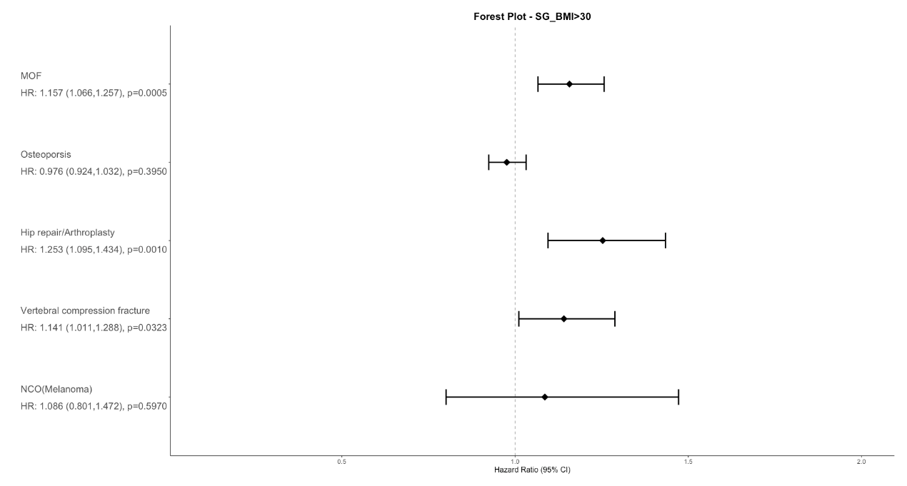
Supplementary figure 4. Forest plot of the subgroup analysis over patient with high body-mass index (BMI >30)

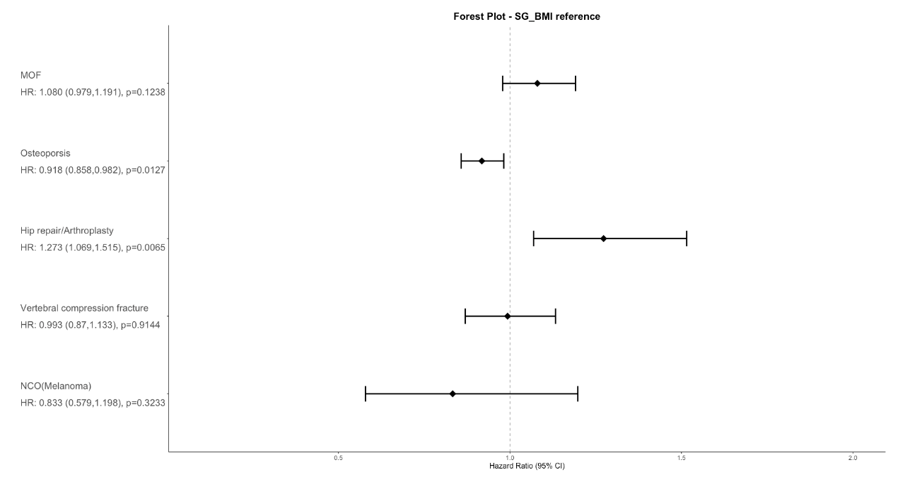
Supplementary figure 5. Forest plot of the subgroup analysis over patient with body-mass index in reference level (BMI 20-29)

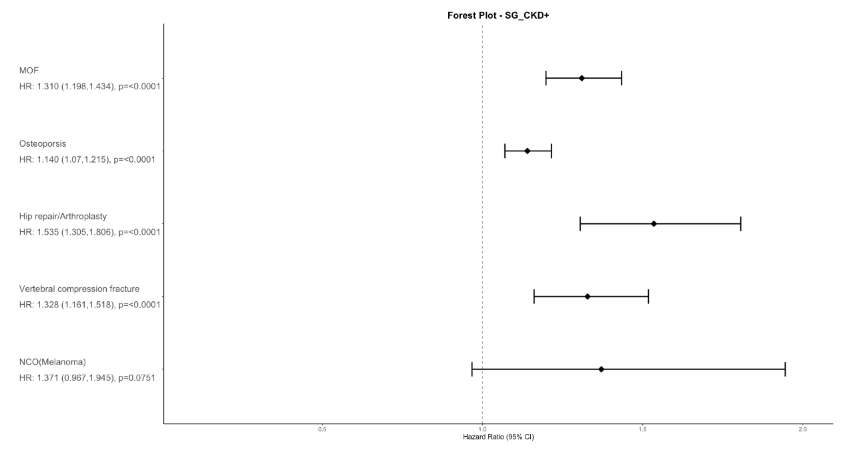
Supplementary figure 6. Forest plot of the subgroup analysis over CKD patients

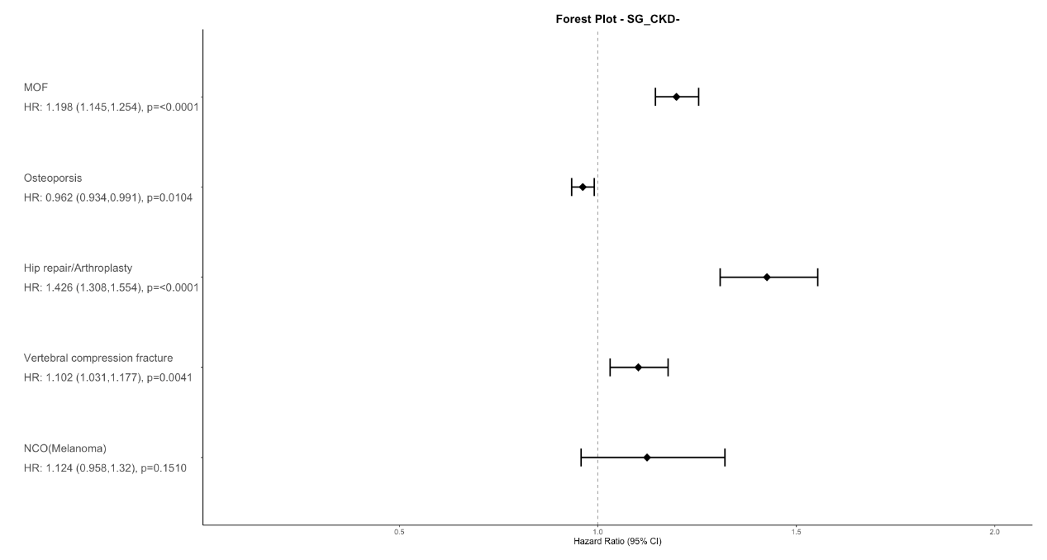
Supplementary figure 7. Forest plot of the subgroup analysis over non-CKD patients

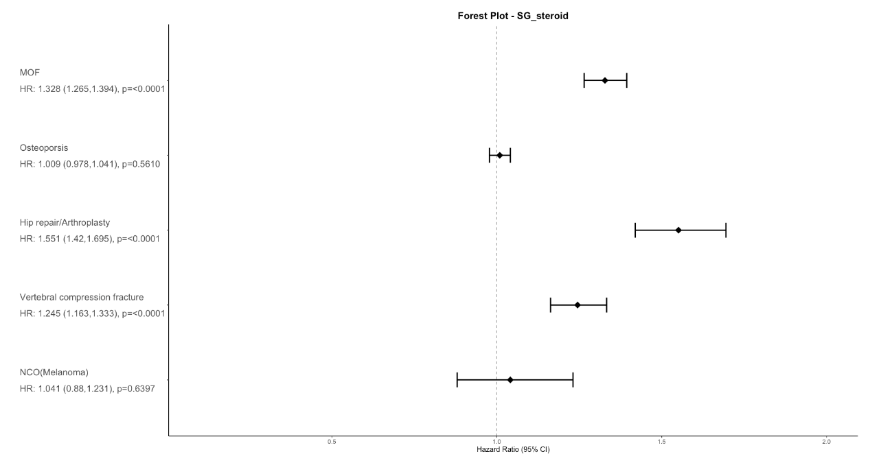
Supplementary figure 8. Forest plot of the subgroup analysis over patient with steroid usage

