SUPPLEMENTARY DATA
Table S1. Pairwise population differentiation using the fixation index (F_{ST}) per basin. Confidence intervals within parentheses
 | CHA | PTZ | CTZ | BAL
PTZ | 0.2676  (0.1771-0.3235)
CTZ | 0.2606  (0.1505-0.3201) | 0.1639  (0.1398-0.1836)
BAL | 0.3328  (0.2397-0.4797) | 0.0465  (0.0436-0.0494) | 0.2659  (0.3141-0.3635)
MEX | 0.4053  (0.3435-0.5720) | 0.3498  (0.2991-0.4501) | 0.3285  (0.2724-0.3576) | 0.3646  (0.3413-0.4445)

Table S2. Migration rates between the five hydrological basins in Bursera cuneta. Numbers in parenthesis denote 95% confidence intervals.

 | Donor group
Recipient group | CHA | PTZ | CTZ | BAL | MEX
CHA | 0.6842 (0.0167) | 0.1115 (0.0687) | 0.1486 (0.0698) | 0.0345 (0.0296) | 0.0212 (0.0201)
PTZ | 0.0977 (0.0209) | 0.8277 (0.0245) | 0.0323 (0.0192) | 0.0207 (0.0122) | 0.0215 (0.0146)
CTZ | 0.0592 (0.0205) | 0.0680 (0.0495) | 0.8008 (0.0478) | 0.0353 (0.0166) | 0.0367 (0.0161)
BAL | 0.0875 (0.0334) | 0.0680 (0.0408) | 0.0447 (0.0343) | 0.7530 (0.0301) | 0.0468 (0.0319)
MEX | 0.0461 (0.0405) | 0.0918 (0.0623) | 0.1374 (0.0673) | 0.0347 (0.0318) | 0.6900 (0.0218)

Table S3. Cohen’s D values, 95% of confidence intervals, p values, and effect size direction of the three combined gravity models: comb1) Geo + TDF + Niche; comb2) Geo + TDF + TF; and comb3) Geo + TDF + TF + Niche + Rough. * P < 0.05, ** P < 0.005
Scale (m) | 1000 |  |  |  | 2000 |  |  |  |  | 3000 |  |  |  |  | 4000 |  |  |  |  | 5000
Combined Models | Cohen's D | Lower CI | Upper CI | P-value | Cohen's D | Lower CI | Upper CI | P value | Cohen's D |  | Lower CI | Upper CI | P value | Cohen's D |  | Lower CI | Upper CI | P value | Cohen's D |  | Lower CI | Upper CI | P value | Effect size direction
Comb1:
TDF | 0.293 | 0.206 | 0.380 | 0.000** | 0.260 | 0.173 | 0.347 | 0.000** | 0.410 |  | 0.322 | 0.497 | 0.000** | 0.454 |  | 0.366 | 0.542 | 0.000** | 0.528 |  | 0.440 | 0.617 | 0.000** | (+)
Niche | 0.100 | 0.013 | 0.187 | 0.110 | 0.136 | 0.049 | 0.223 | 0.03* | 0.161 |  | 0.074 | 0.248 | 0.010** | 0.089 |  | 0.002 | 0.175 | 0.157 | 0.104 |  | 0.017 | 0.191 | 0.097 | (+)
Comb2:
TDF | 0.261 | 0.174 | 0.348 | 0.000** | 0.240 | 0.152 | 0.327 | 0.001** | 0.386 |  | 0.298 | 0.473 | 0.000** | 0.448 |  | 0.360 | 0.535 | 0.000** | 0.541 |  | 0.453 | 0.630 | 0.000** | (+)
TF | -0.262 | -0.349 | -0.175 | 0.000 | -0.287 | -0.374 | -0.199 | 0.000** | -0.294 |  | -0.381 | -0.207 | 0.000** | -0.318 |  | -0.405 | -0.230 | 0.000** | -0.329 |  | -0.417 | -0.242 | 0.000** | (-)
Comb3:
TDF | 0.257 | 0.169 | 0.344 | 0.000** | 0.226 | 0.139 | 0.314 | 0.000** | 0.377 |  | 0.289 | 0.464 | 0.000** | 0.403 |  | 0.315 | 0.491 | 0.000** | 0.479 |  | 0.391 | 0.567 | 0.000** | (+)
TF | -0.159 | -0.246 | -0.072 | 0.012* | -0.159 | -0.246 | -0.072 | 0.011* | -0.141 |  | -0.228 | -0.054 | 0.024* | -0.206 |  | -0.293 | -0.119 | 0.001** | -0.226 |  | -0.313 | -0.139 | 0.000** | (-)
Niche | 0.093 | 0.006 | 0.180 | 0.137 | 0.091 | 0.004 | 0.178 | 0.146 | 0.111 |  | 0.023 | 0.197 | 0.079 | 0.029 |  | -0.057 | 0.116 | 0.637 | 0.036 |  | -0.051 | 0.123 | 0.565 | (+)
Rough | 0.472 | 0.383 | 0.560 | 0.000** | 0.453 | 0.365 | 0.542 | 0.000* | 0.443 |  | 0.355 | 0.531 | 0.000* | 0.371 |  | 0.284 | 0.459 | 0.000** | 0.272 |  | 0.184 | 0.360 | 0.000** | (+)

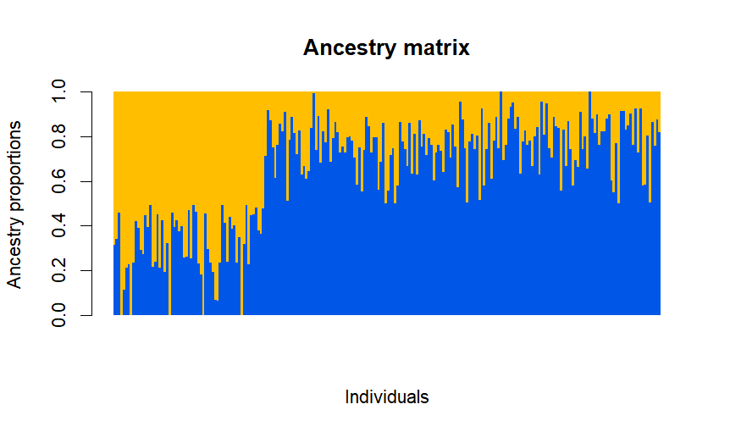
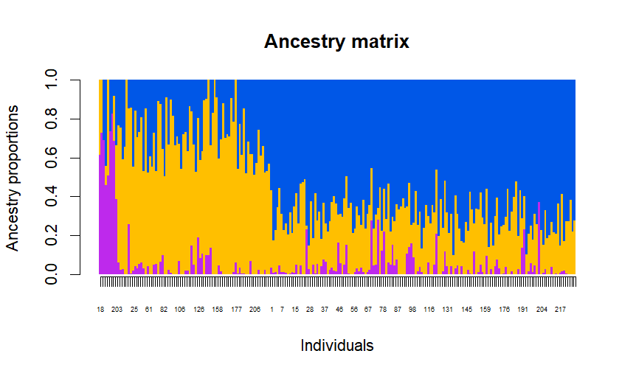
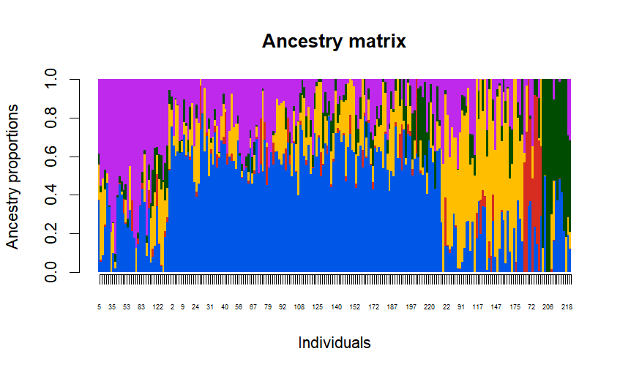
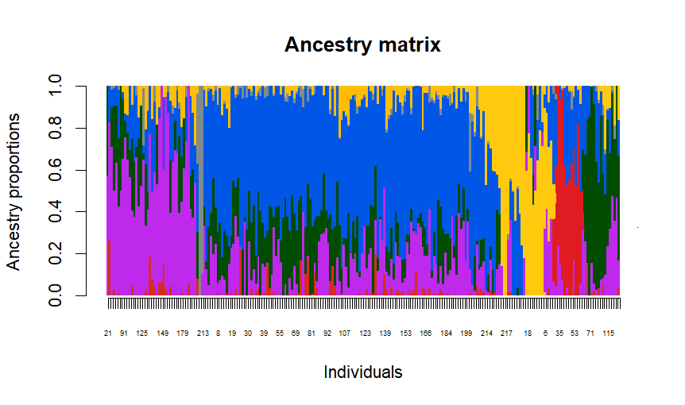
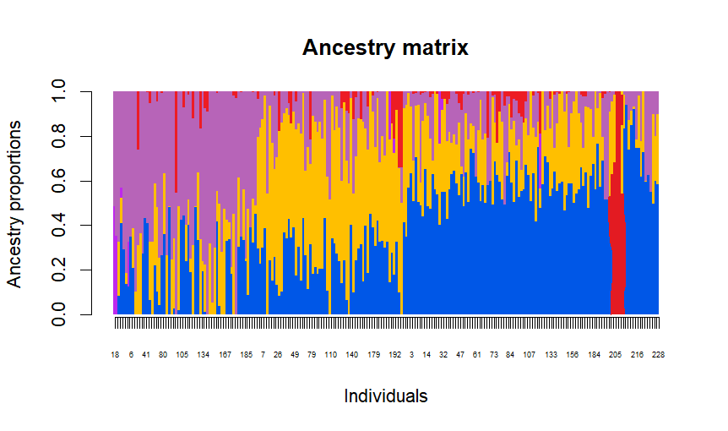
Figure S4
CHA
PTZ
CTZ
BAL
MEX
K = 3
K = 4
K = 5
K = 6
K = 2

Figure S5
