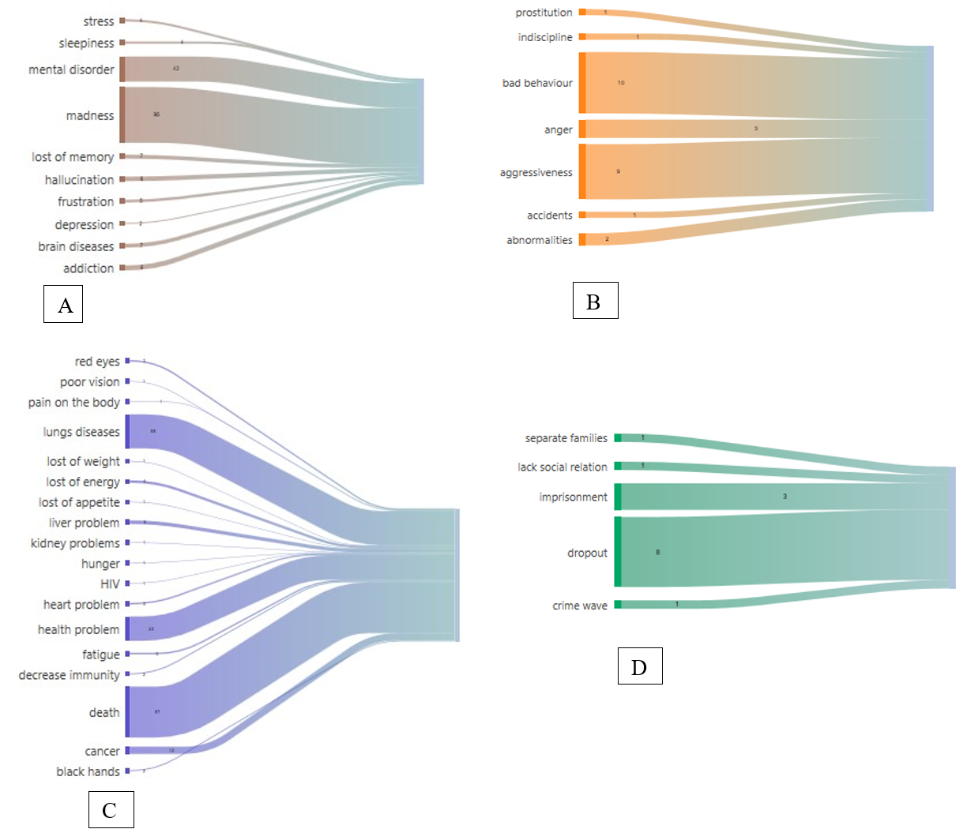
Figure 4 (A–D). Categorization of Perceived Negative Effects of Drug Use Among Adolescents, Based on Word Cloud Content Analysis
Figure 4A. Neuropsychological disorders perceived as consequences of drug use
As shown in Figure 4A, madness (n = 96) and mental disorder (n = 43) were the most dominant neuropsychological consequences reported by adolescents. Other effects included addiction (n=9), hallucination (n=8), loss of memory (7), brain diseases (n=7), frustration, stress, sleepiness and depression. These responses suggest that adolescents strongly associate drug use with cognitive impairment and psychological destabilization.
Figure 4B. Abnormal behaviours perceived as consequences of drug use
In terms of behavioural disturbances (Figure 4B), adolescents most frequently cited bad behaviour (n = 10), aggressiveness (n = 9), and anger (n = 3). Less frequent responses included indiscipline, accidents, abnormalities, and prostitution. These mentions reflect the perceived disruption of self-control and social norms associated with drug use.
Figure 4C. Somatic consequences attributed to drug use
Among the somatic consequences reported by adolescents (Figure 4C), the most frequently cited were death (n = 87), lung diseases (n = 58), and Health problem (n = 42). Other responses included cancer, heart problems, fatigue, pain, and loss of appetite. Less common were mentions of kidney problems, liver disease, decreased immunity, and specific signs like black hands or red eyes. These responses highlight the perception of drug use as a serious threat to physical health and life expectancy.
Figure 4D. Social problems associated with drug use
Figure 4D presents the social consequences reported by participants, with school dropout (n = 8) and imprisonment (n = 3) being the most cited. Other responses included crime wave, family separation, and loss of social relations. These elements illustrate the adolescents’ awareness of how drug use can contribute to social marginalization and institutional consequences.

