Phase II proof-of-concept study of durvalumab and cediranib with and without olaparib in recurrent ovarian cancer

Junya Tabata¹⁺, Tzu-Ting Huang^{1+*}, Elena Giudice^{1,2}, Kristen R. Ibanez^{1,3}, Jayakumar R. Nair¹, Aanika Balaji Warner¹, Britanny B. Solarz¹, Valentina Bolanos¹, Bernadette Redd⁴, Nahoko Sato⁵, Shraddha Rastogi⁵, Sunmin Lee⁵, Roshan L. Shrestha⁵, Alexander Y. Mitrophanov⁶, Stanley Lipkowitz¹, Kevin Conlon¹, Chien Chu Huang¹, and Jung-Min Lee^{1, *}

Methods
Samples collection for WES and RNAseq
Paired tissue samples (pre- and on-treatment biopsies) were available for 11 and 9 patients in the D+O+C and D+C arms, respectively. Biopsies were not obtained from five patients in the D+O+C arm for the following reasons: three patients were unable to undergo biopsy due to the restriction on research biopsy during COVID-19, one had tissue of insufficient quality for DNA/RNA extraction, and one withdrew consent prior to the scheduled procedure. In the D+C arm, biopsies were not obtained from four patients: one was unable to undergo biopsy due to elevated partial thromboplastin time, two were unable to undergo biopsy due to the restriction on research biopsy during COVID-19 and one had the procedure cancelled with no safely accessible target lesions on imaging.

WES analysis
WES was performed on DNA extracted from tumor biopsy specimens. Samples were pooled and sequenced on NovaSeq Xplus 10B run using Agilent SureSelect XT-Low Human All Exon V8 and paired-end sequencing mode. The samples have 66M to 487M pass filter reads, with Q30 above 87%. The samples were mapped and variants were called using Dragen with Agilent SureSelect target file S33266340_hg38_v8.bed. Percent total mapping against reference genome hg38 is about 98% and uniquely mapped reads are above 35%. Library complexity (i.e., percentage of non-duplicate reads) was determined by measuring the percentage of unique fragments in the mapped reads using MarkDuplicate utility. Percent duplicate reads are between 11% to 62%. There are 63% to 89% of reads mapped on target. Coverage statistics were also measured using Dragen. The mapped sequencing depth coverage over target (after alignment and marking duplicates) was between 95x to 599x. The mean insert size for these samples was between 118 and 282 bases. More than 90% of the target region have the coverage above 20x.
Dragen was run for 75 cases (including 75 pairs of case vs normal) using the mode of somatic variant calling. There are about 233 to 71,802 variants per sample, including 195 to 69,216 SNPs and 32 to 2,586 INDELs. The Ti/Tv ratio is between 0.85 and 2.78. Dragen was run for 55 non-cases or normal samples using the mode of germline joint genotyping. There are about 33,173 to 40,863 variants per sample, including 31,220 to 38,532 SNPs and 1,923 to 2,421 INDELs. The Ti/Tv ratio is between 2.65 and 2.74.
RNAseq analysis
RNAseq was performed on tumor biopsies to characterize gene expression profiles. RNA samples were pooled and sequenced on NovaSeq Xplus 1.5B using Illumina® Stranded Total RNA Prep, Ligation with Ribo-Zero Plus and paired-end sequencing. The samples have 122 to 190 million pass filter reads with more than 92% of bases above the quality score of Q30. Reads of the samples were trimmed for adapters and low-quality bases using Cutadapt before alignment with the reference genome (hg38) and the annotated transcripts using STAR. The average mapping rate of all samples is 93%. Unique alignment is above 47%. There are 3.55 to 49.58% unmapped reads. The mapping statistics are calculated using Picard software. The samples have 4.29% ribosomal bases. Percent coding bases are between 8-50%. Percent UTR bases are 13-31%, and mRNA bases are between 21-77% for all the samples. Library complexity is measured in terms of unique fragments in the mapped reads using Picard’s MarkDuplicate utility. The samples have 7-76% non-duplicate reads. In addition, the gene expression quantification analysis was performed for all samples using STAR/RSEM tools. Quartile normalization and log transformation prior to analysis were performed on datasets. GSEA analysis using phenotype-based premutation mode with 1000 permutations was done by GSEA software using NIH Integrated Data Analysis Platform (NIDAP). Differential expression analysis between exceptional responders and NCB tumors was performed using DESeq2 with thresholds of p < 0.05 and |log₂ fold-change| > 1. Functional enrichment of these gene lists was performed using STRING v12.0 (https://string-db.org/).

CTCs analysis
Peripheral blood samples (10 mL EDTA tubes) were collected at baseline, C1D15, C3D1, and progression. After RBC lysis, blood cells were incubated with nuclear dye (#H3570, Hoechst 33342, Life Technologies, DC, USA), viability dye (#L34966, LIVE/DEAD Fixable Aqua, Life Technologies) and antibodies including PE-conjugated anti-human epithelial cell adhesion molecule (EpCAM) Ab (#130-091-253, clone HEA-125, Miltenyi Biotec, CA, USA). The anti-PE magnetic beads (#130-048-801, Miltenyi Biotec) were then used to enrich EpCAM-positive cells. Cell quantification was calculated by multiparameter flow cytometry. Viable, nucleated, EpCAM-positive, CD45 (#304014, clone HI30, Bio-Legend, CA, USA) negative cells were finally considered CTCs.

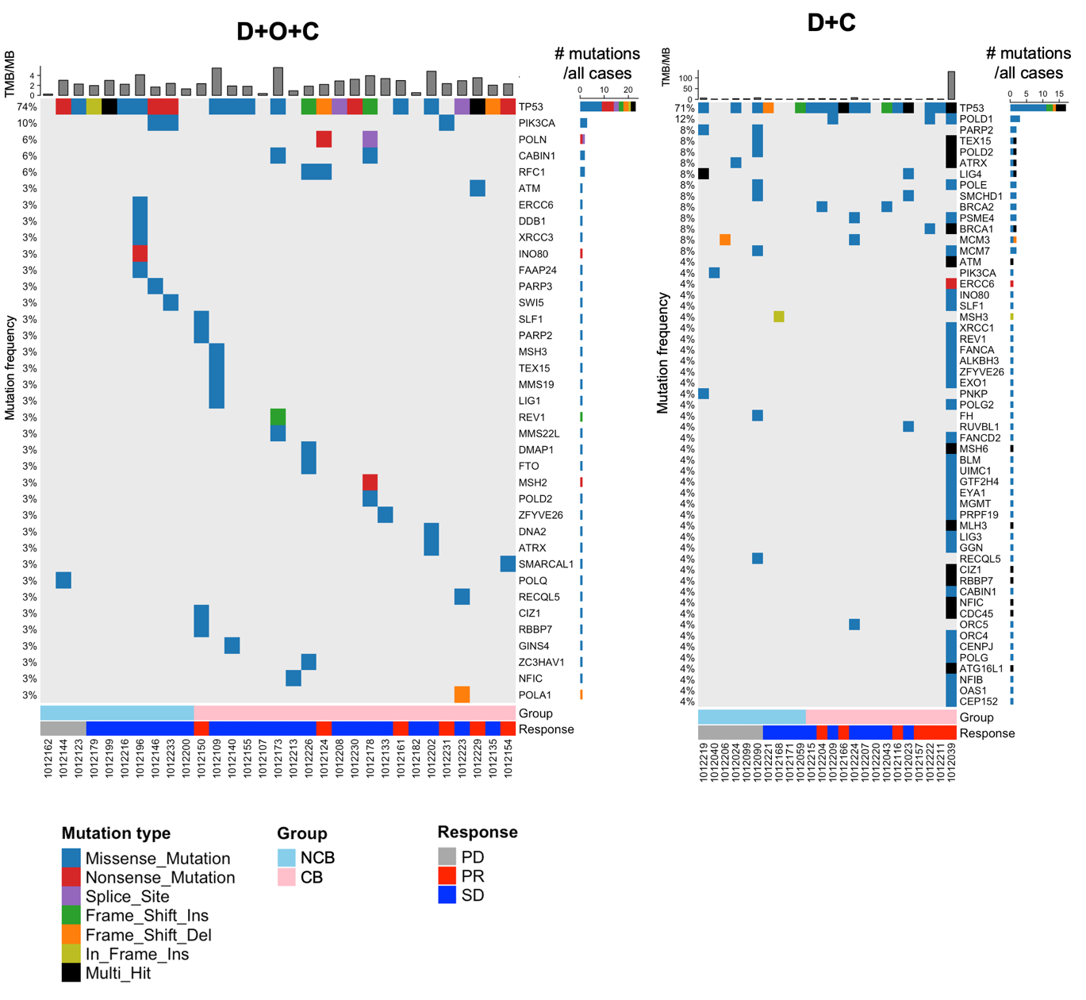

Extended Data Fig. 1: Somatic mutations in DNA repair- and survival-associated genes. Whole-exome sequencing data analysis revealed the genetic alterations of genes related to DNA repair or survival in D+O+C and D+C arms.

Abbreviations: CB, clinical benefit; D+O+C, durvalumab, cediranib, and olaparib; D+C, durvalumab plus cediranib; NCB, no clinical benefit; PD, progression disease; PR, partial response; SD, stable disease; TMB/MB, tumor mutation burden/megabase.

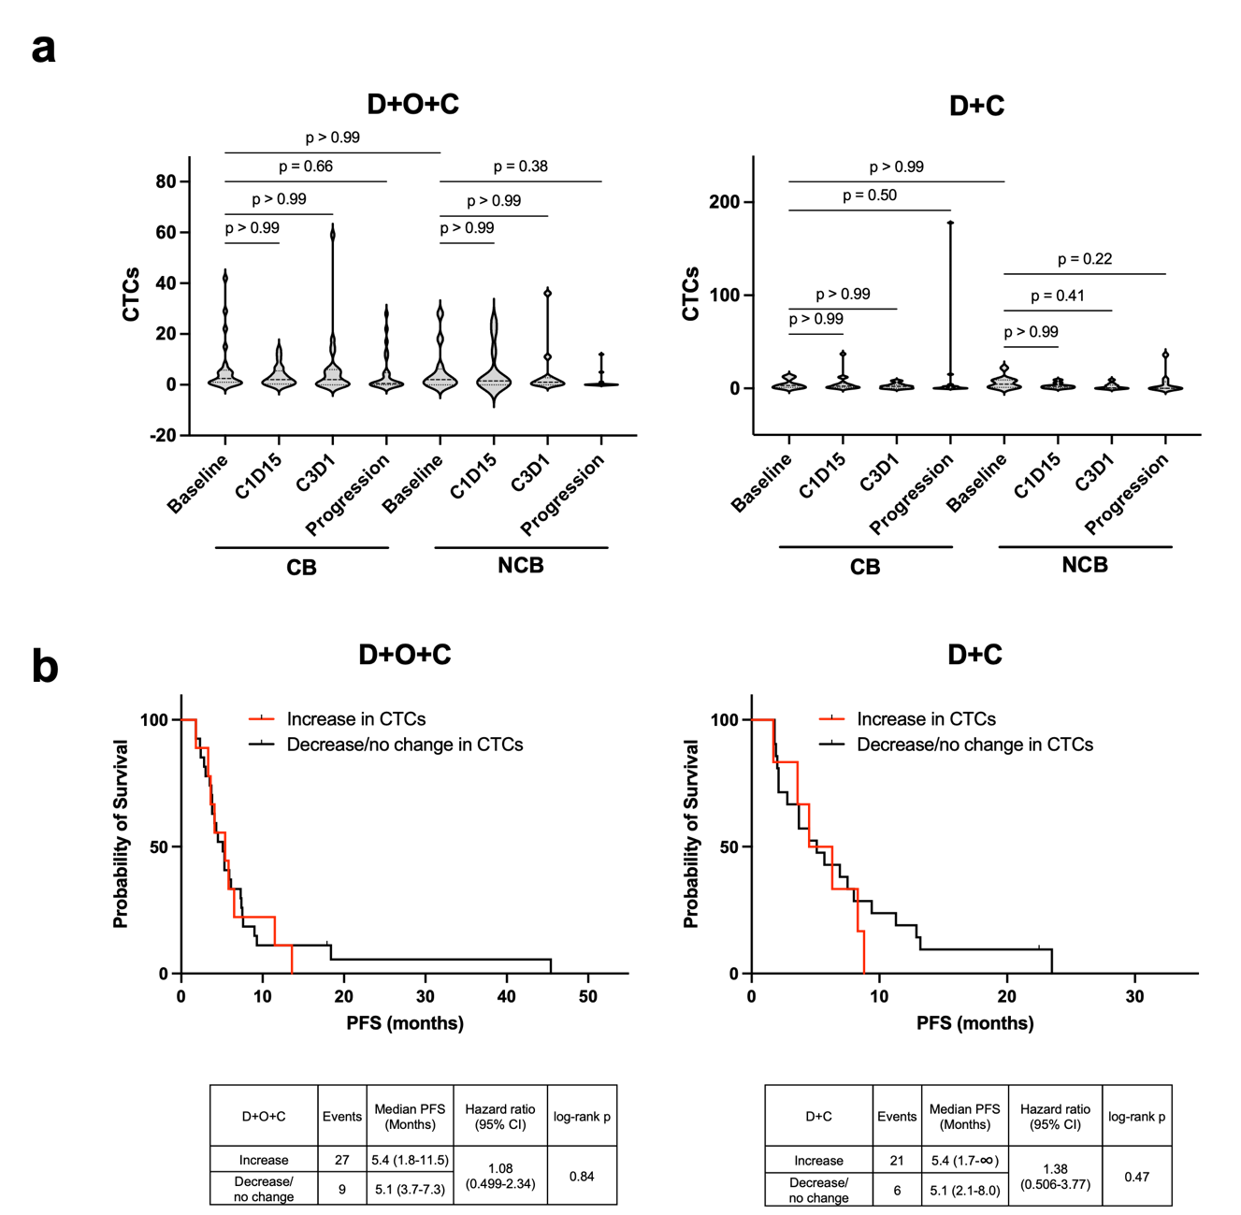
Extended Data Fig. 2: CTCs analyses.
a. Dynamic changes of CTCs between baseline and C1D15. No changes were observed in the count per tube of EpCAM+ CTCs in patients with CB or NCB.
b. Kaplan–Meier estimates of PFS in patients with EpCAM+ MUC1+ CTCs versus no change or increase in EpCAM+ MUC1+ CTCs.

Abbreviations: C1D15, cycle 1 day 15; C3D1, cycle 3 day 1; CB, clinical benefit; CTCs, circulating tumor cells; CI, confidence interval; D+O+C, durvalumab, cediranib, and olaparib; D+C, durvalumab plus cediranib; EpCAM, epithelial cell adhesion molecules; NCB, no clinical benefit; PFS, progression-free survival.

