Supplementary Material
Impact of polyethylene glycol molecular weight on C-phycocyanin structural stability
Mélissa Justinª, Adrien Lerbretª, Camille Loupiacª
ªL’Institut Agro, Univ. Bourgogne Europe, INRAE, UMR PAM 1517, F-21000 Dijon, France

*Corresponding author: camille.loupiac@agrosupdijon.fr

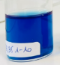
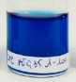
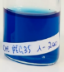
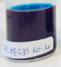
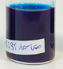
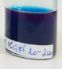
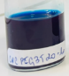
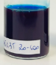
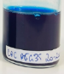
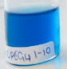
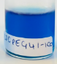
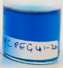
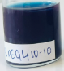
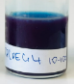
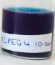
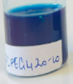
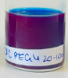
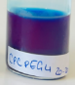
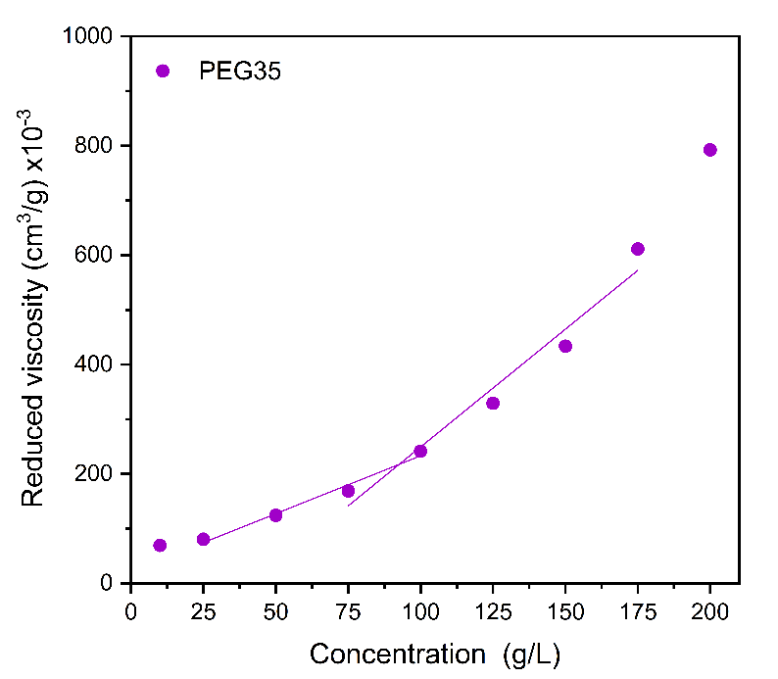
Fig. S1. Phase diagram of CPC-PEG mixtures at increasing concentrations
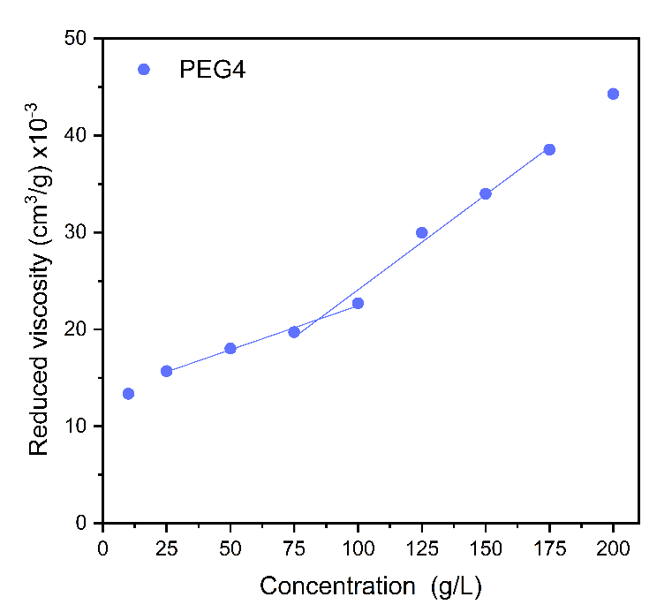
C* = 92 g/L
C* = 83 g/L
FigS2. Viscosity profile of PEG4 and PEG35 solutions across the dilute and semi-dilute transition (n=3)

FigS3. Thermogram deconvolution

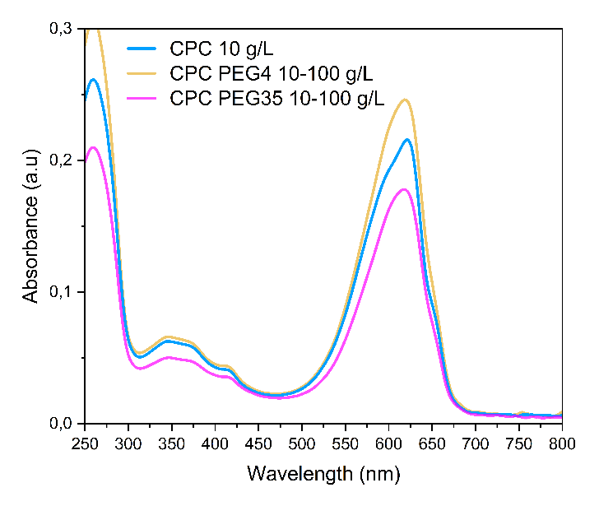
B
A
FigS4. UV-Visible spectra of C-phycocyanin (0.45 µM), CPC PEG4 and CPC PEG35 (A) filtered and (B) unfiltered in 0.1 NaPi buffer at pH 7.2 buffer

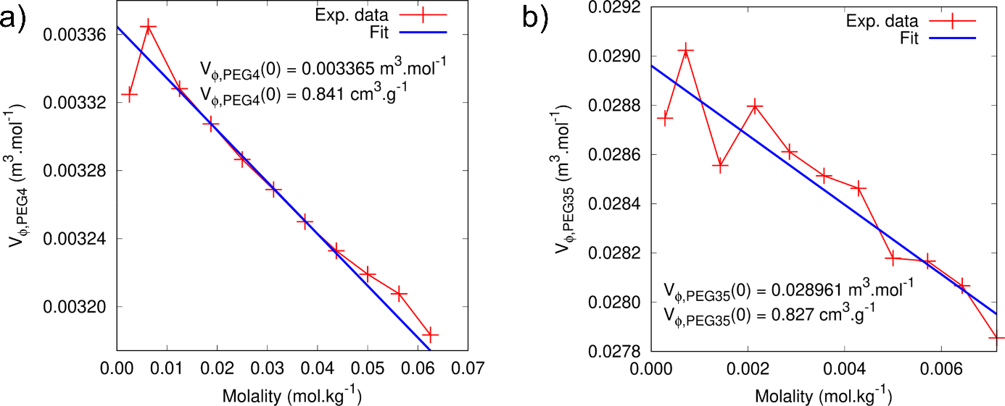
Fig. S5. Apparent specific volume of PEG4 (a) and PEG35 (b) as a function of their molality. The specific volumes at infinite dilution determined by linear regression were found to be of 0.841 and 0.827 cm³.g⁻¹ for PEG4 and PEG35, respectively.

