SUPPLEMENTARY INFORMATION

Self-similar Sequences Yield Higher Protein Expression in a Squid Ring Teeth Protein Library

Khushank Singhal¹, Benjamin D. Allen², Thomas M. Baer³, Melik C. Demirel^{1,4,*}

¹ Department of Engineering Science and Mechanics, The Pennsylvania State University, University Park, Pennsylvania 16802, USA.
² Tandem Repeat Technologies, Inc., 3401 Grays Ferry Avenue, Bldg. 450, Philadelphia, PA 19146, USA.
³ Stanford Photonics Research Center, Stanford University, Stanford, California, USA.
⁴ Huck Institutes of Life Sciences and Materials Research Institute, The Pennsylvania State University, University Park, Pennsylvania 16802, USA.

*Corresponding author, email: melik@psu.edu

Keywords: SRT protein, combinatorial library, sequence self-similarity, microcapillary arrays, FACS, recombinant proteins, high-throughput screening

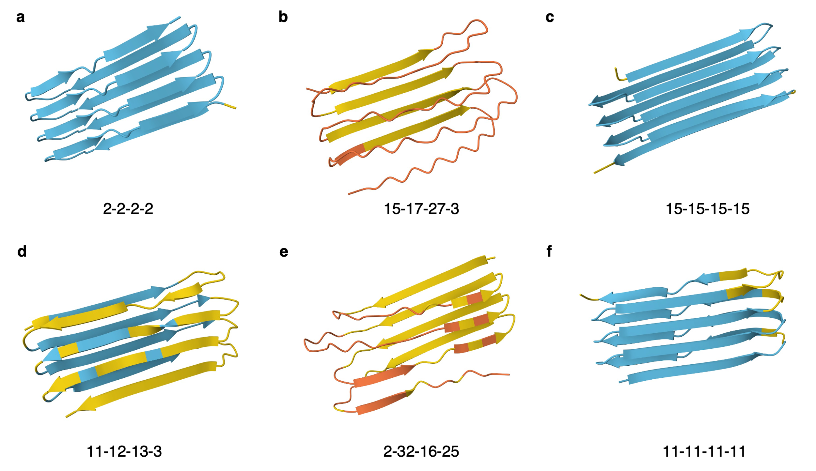
Figure S1. SRT protein structure predictions. AlphaFold 3 predictions of several homogenous (a, c, f) and heterogenous (b, d, e) SRT protein variants in the library. Homogenous (or self-similar) variants show high-confidence, perfect β-sheet conformations. Color-code represent standard AlphFold 3 pIDDT levels. The serial numbers of the amorphous fragments are mentioned in Figure S2a. Naming convention: a protein formed of fragments with serial numbers w, x, y, and z is named “w-x-y-z”. The crystalline regions are kept constant across all fragments as mentioned in Fig. 1. These simulation results suggest that proteins with self-similar amorphous fragments assemble into β-sheets, similar to native SRT proteins. Heterogenous amorphous regions are prone to disordered folding.

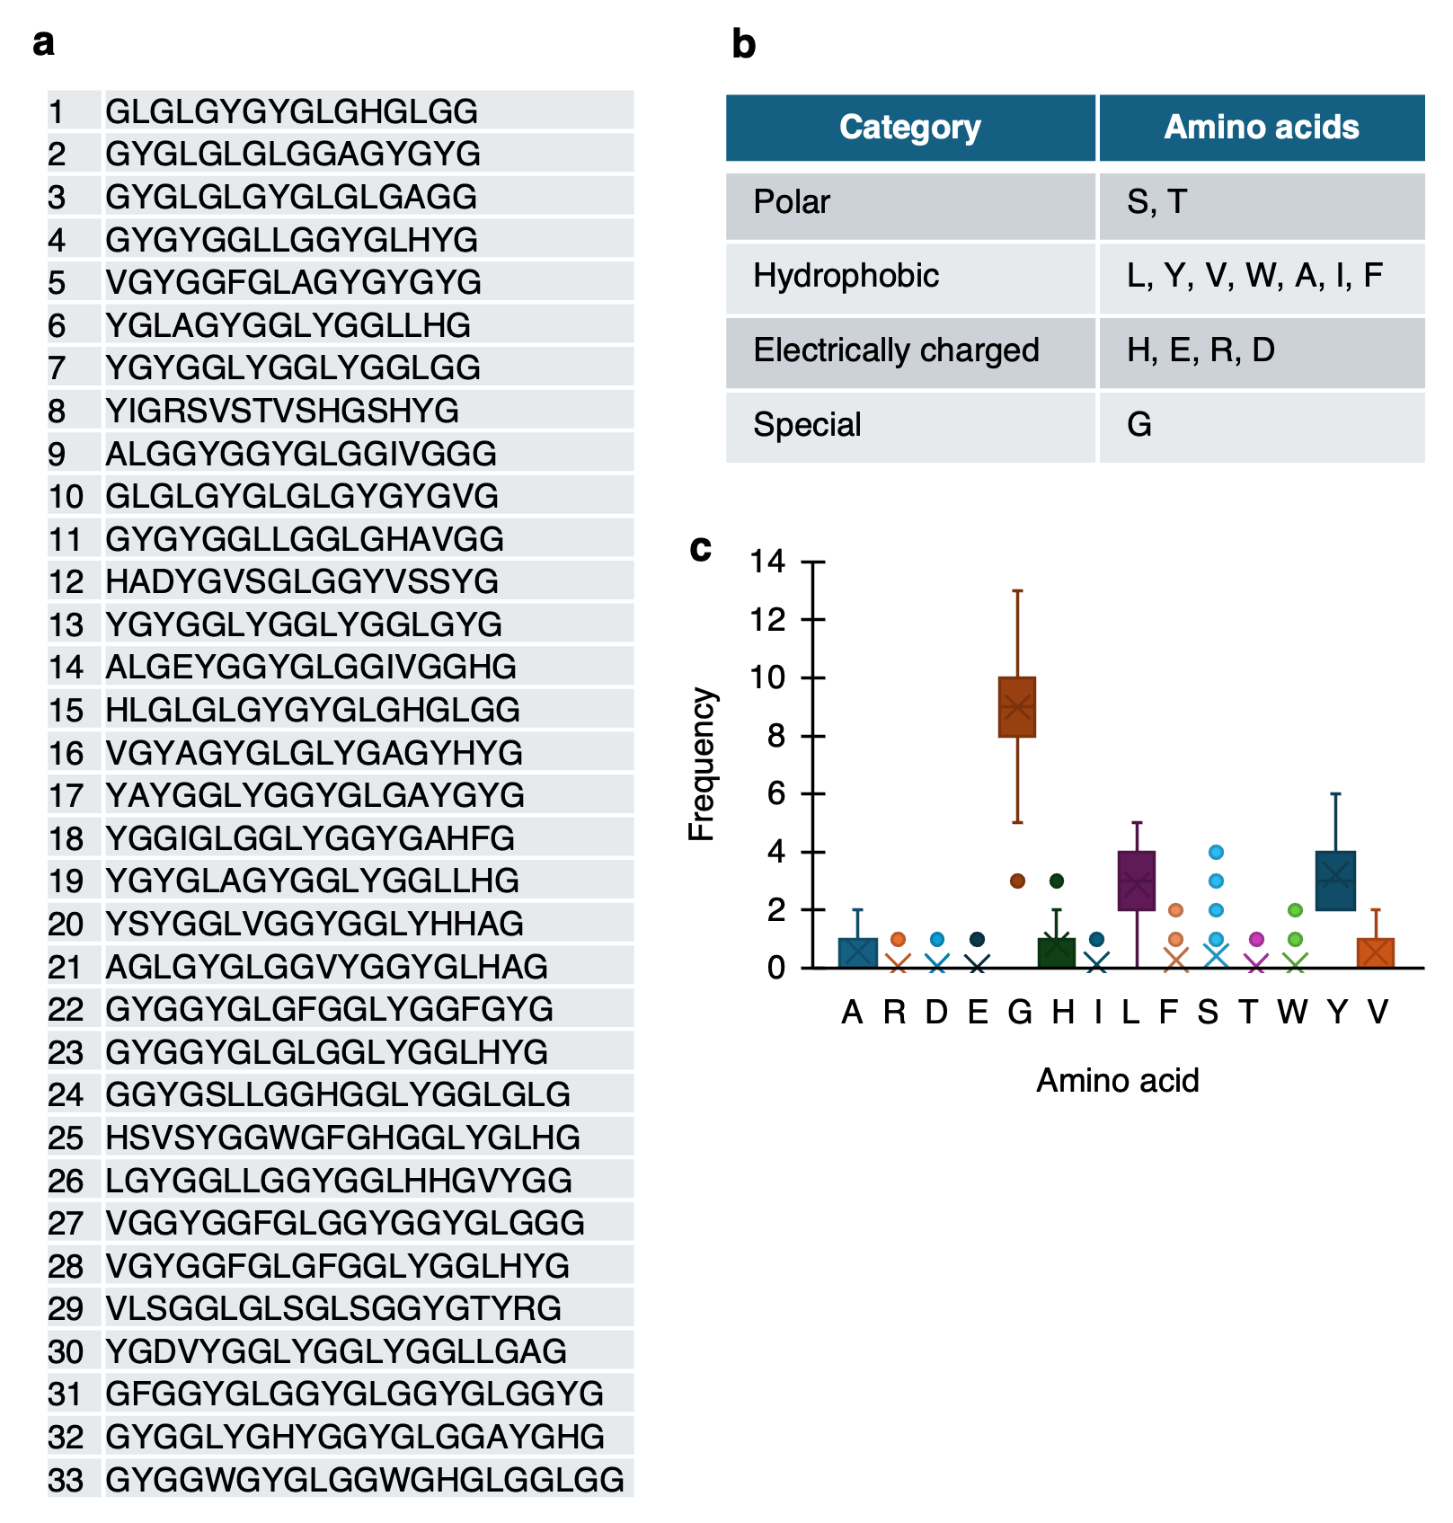
Figure S2. SRT library fragments and amino acids a. List of amorphous region fragments designed to synthesize the SRT library. b. List of amino acids utilized in the fragment pool and their classification. c. Frequency chart of amino acids in the fragment pool.

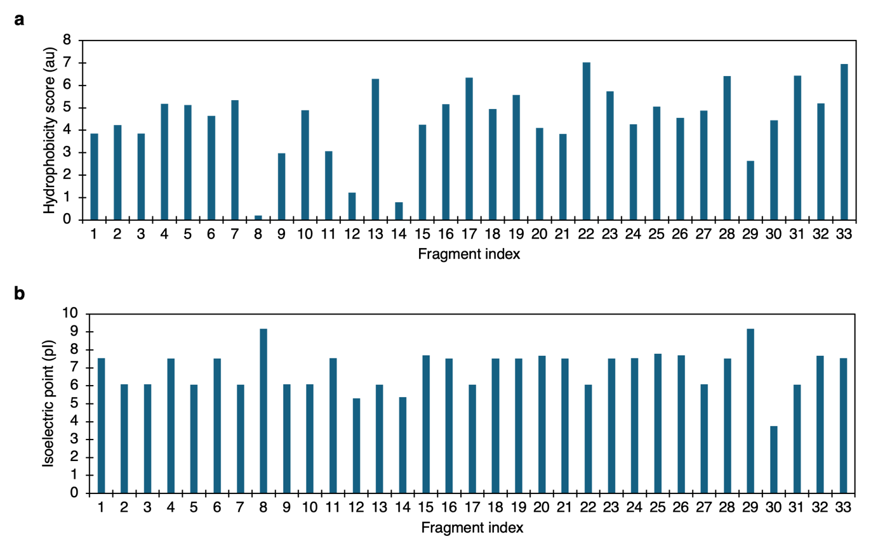
Figure S3. Hydrophobicity and isoelectric point. Plots depicting hydrophobicity scores (a) according to the Wimley-White scale, and isoelectric points (b) of the designed fragments.

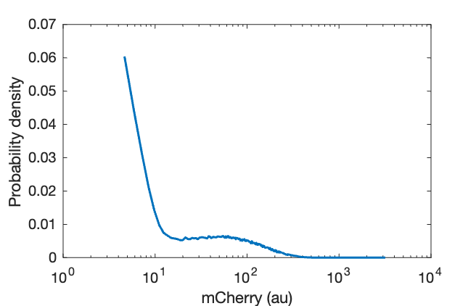
Figure S4. Flow-cytometry frequency chart. Distribution of single cell clones in the SRT library with respect to mCherry fluorescence.
This distribution can be thought of as a composite distribution of individual clonal distributions. Since the sequences identified in the medium and high bin are non-overlapping and similar in frequency (Figure 4d), the distributions of clones of these bins must be largely separated. Therefore, the net frequency of clones in each bin should be independent of other bins. Figure S4 shows a far greater composite frequency at the medium bin location compared to that at high bin, hence, a greater replication tendency of clones in the medium bin compared to that in the high bin.

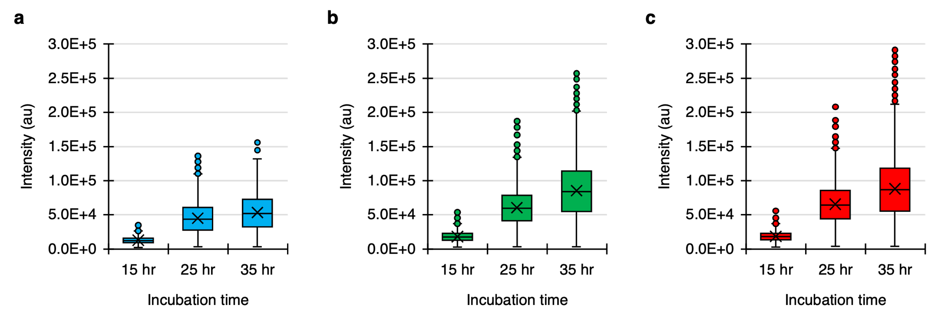
Figure S5. Time-series protein production charts. Distribution of fluorescence intensities of capillaries containing clones from the low (a), medium (b), and high (c) bins.

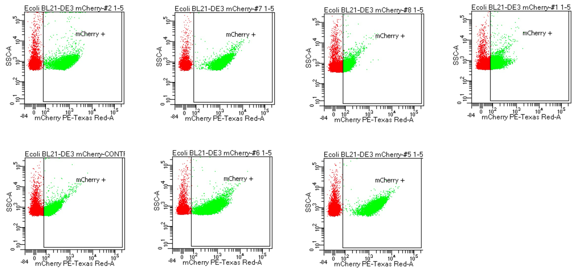
Figure S6. Flow cytometry charts of individual clones. Flow cytometry plots illustrating single cell mCherry fluorescence levels of several clones from the SRT library.

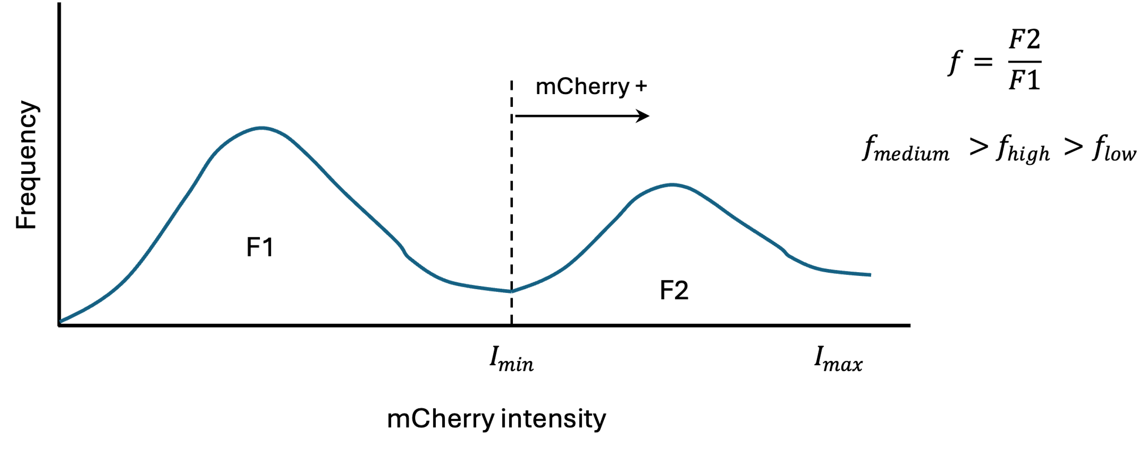
Figure S7. Distribution of single-cell fluorescence. The schematic describes the postulated distribution of cells in the library, where only a fraction of cells per variant express mCherry. This fraction is greater for the medium bin, enabling it to offset the loss in protein titer due to lower single cell expression.

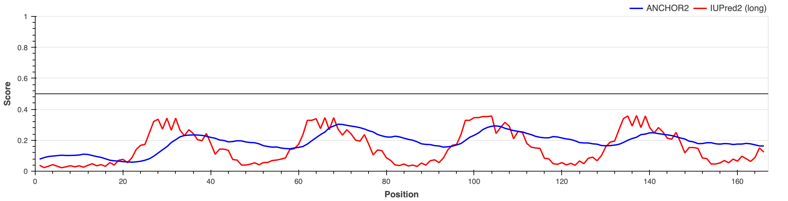
Figure S8. Disorder measurements. Periodic disorder profile with four distinct peaks measured by protein disorder levels (https://iupred2a.elte.hu)

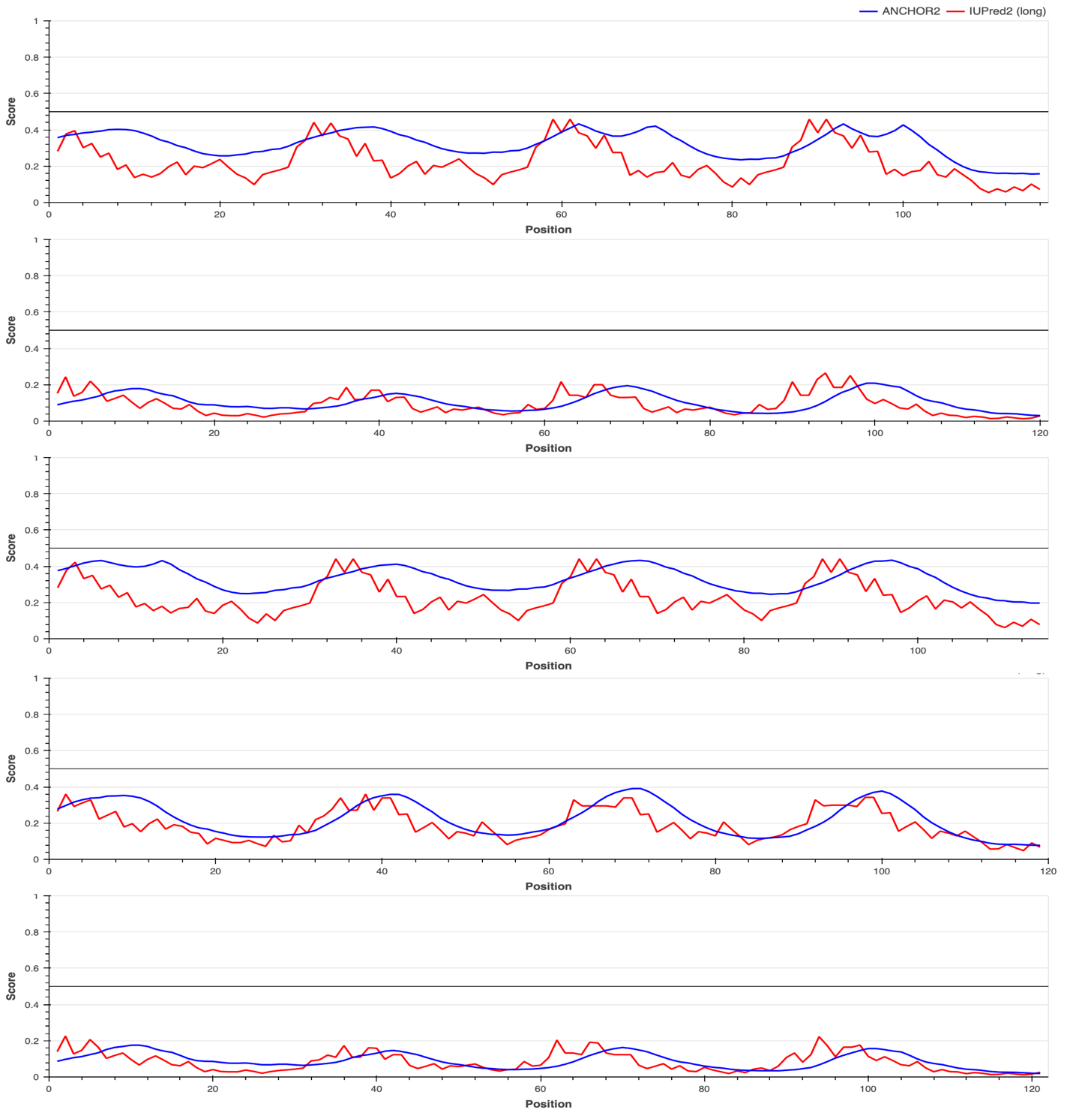
Figure S9. Disorder measurements in homogenous protein sequences. Comparison of high self-similarity (cumulative self-similarity score: 560 – 600). Highly self-similar clones show periodic disorder patterns with four evenly spaced peaks, closely resembling the TR-n4 profile. Protein disorder levels are measured using a web server. https://iupred2a.elte.hu

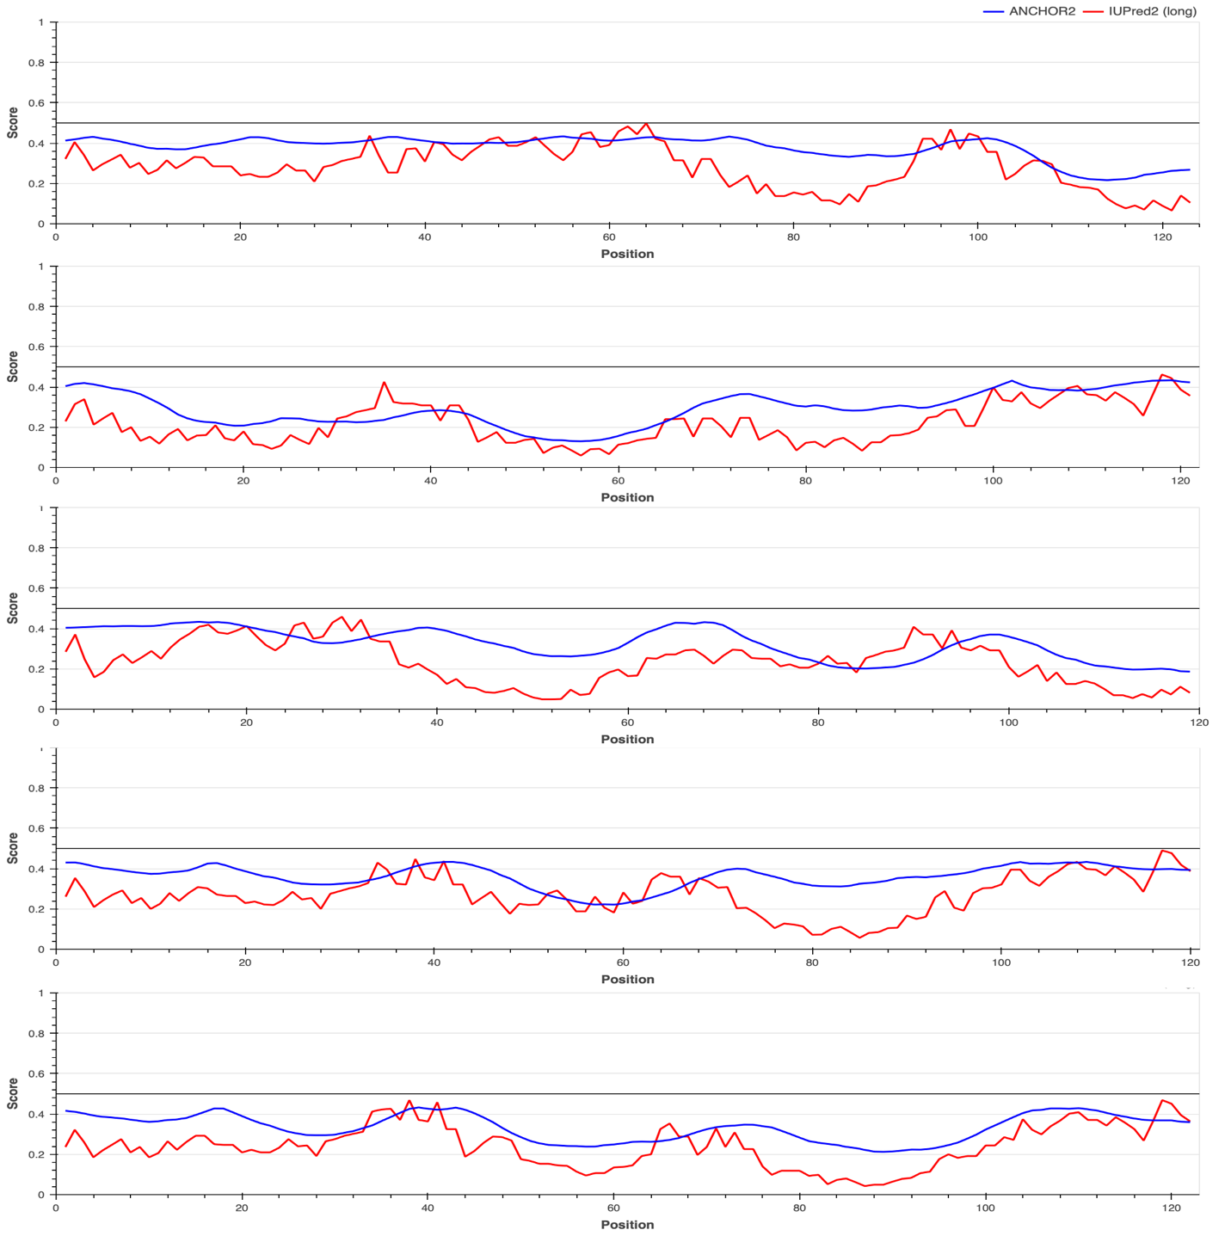
Figure S10. Disorder measurements in heterogenous protein sequences. Comparison of low self-similarity (cumulative self-similarity score: 266 – 273). Protein disorder levels are measured using a web server. https://iupred2a.elte.hu.

