SUPPLEMENTARY INFORMATION

Local expertise anchors biodiversity documentation, but geopolitical power drives parachute discovery

Mario R. Moura^{1*}, Raquel L. Carvalho², Karoline Ceron³, Jhonny J. M. Guedes⁴, Matheus de T. Moroti⁴, Gabriel Nakamura⁵

Correspondence to: mariormoura@gmail.com

This PDF file includes
Supplementary Tables
Supplementary Figures

SUPPLEMENTARY TABLES

Supplementary Table 1.
Variation Inflation Factor (VIF) for socioeconomic variables per country. Analyses of holotype retention and outflow centrality used the 52-nation dataset, while analyses of holotype appropriation and inflow centrality used the 32-nation dataset.
Variable | 52-nations dataset | 32-nations dataset
Biodiversity and Habitat Issue | 1.059 | 2.043
Colonial Origin | 1.356 | 2.244
Global Peace Index | 1.140 | 1.475
Human Capital Index | 1.488 | 3.270
Research Spending (% of GDP) | 1.771 | -
Number of collected specimens | 1.301 | 1.366
Number of research institutions | - | 2.080

Supplementary Table 2.
Results of the beta-binomial generalized linear model (GLM) examining factors associated with holotype retention. The table presents coefficient estimates (log-odds scale), standard errors, and significance values. Significant predictors at the p < 0.05 level are indicated in bold face. Total number of observations = 52. Model R² = 50.8%.
Coefficients | Estimates | CI | P-value
Intercept | -1.34 | -1.84 – -0.85 | <0.001
Research Spending (% of GDP) | 0.11 | -0.53 – 0.76 | 0.731
Biodiversity and Habitat Issue | 0.32 | -0.18 – 0.82 | 0.208
Global Peace Index | -0.38 | -0.85 – 0.09 | 0.110
Human Capital Index | -0.13 | -0.58 – 0.33 | 0.581
Colonial Origin | 1.15 | 0.43 – 1.88 | 0.002
Number of collected specimens | -0.16 | -0.68 – 0.35 | 0.534

Supplementary Table 3.
Results of the beta-binomial generalized linear model (GLM) examining factors associated with holotype appropriation. The table presents coefficient estimates (log-odds scale), standard errors, and significance values. Significant predictors at the p < 0.05 level are indicated in bold face. Total number of observations = 32. Model R² = 75.5%.
Coefficients | Estimates | CI | P-value
Intercept | -0.55 | -1.27 – 0.18 | 0.138
Number of institution | -0.20 | -1.00 – 0.60 | 0.621
Number of collected specimens | 0.32 | -0.42 – 1.05 | 0.400
Biodiversity and Habitat Issue | 0.99 | 0.19 – 1.79 | 0.015
Global Peace Index | 0.13 | -0.49 – 0.76 | 0.673
Human Capital Index | 0.98 | -0.63 – 2.60 | 0.233
Colonial Origin | -1.32 | -2.27 – -0.38 | 0.006

Supplementary Table 4.
Results of the Gamma generalized linear model (GLM) examining factors associated with holotype outflow centrality. The table presents coefficient estimates (log-scale), standard errors, and significance values. Significant predictors at the p < 0.05 level are indicated in bold face. Total number of observations = 52. R² Nagelkerke = 46.7%.
Coefficients | Estimates | CI | P-value
Intercept | 1.37 | 1.27 – 1.47 | <0.001
Research Spending (% of GDP) | 0.04 | -0.10 – 0.18 | 0.568
Number of collected specimens | 0.18 | 0.05 – 0.31 | 0.007
Biodiversity and Habitat Issue | -0.17 | -0.27 – -0.06 | 0.002
Global Peace Index | -0.03 | -0.13 – 0.08 | 0.638
Human Capital Index | -0.20 | -0.32 – -0.08 | 0.001
Colonial Origin | 0.25 | 0.13 – 0.37 | <0.001

Supplementary Table 5.
Results of the Gamma generalized linear model (GLM) examining factors associated with holotype inflow centrality. The table presents coefficient estimates (log-scale), standard errors, and significance values. Significant predictors at the p < 0.05 level are indicated in bold face. Total number of observations = 32. R² Nagelkerke = 82.4%.
Coefficients | Estimates | CI | P-value
Intercept | 0.50 | 0.43 – 0.57 | <0.001
Number of research institutions | 0.13 | 0.03 – 0.24 | 0.012
Number of collected specimens | 0.09 | 0.01 – 0.17 | 0.024
Biodiversity and Habitat Issue | 0.16 | 0.05 – 0.26 | 0.003
Global Peace Index | -0.01 | -0.10 – 0.07 | 0.756
Human Capital Index | -0.04 | -0.17 – 0.09 | 0.525
Colonial Origin | -0.26 | -0.37 – -0.15 | <0.001

SUPPLEMENTARY FIGURES

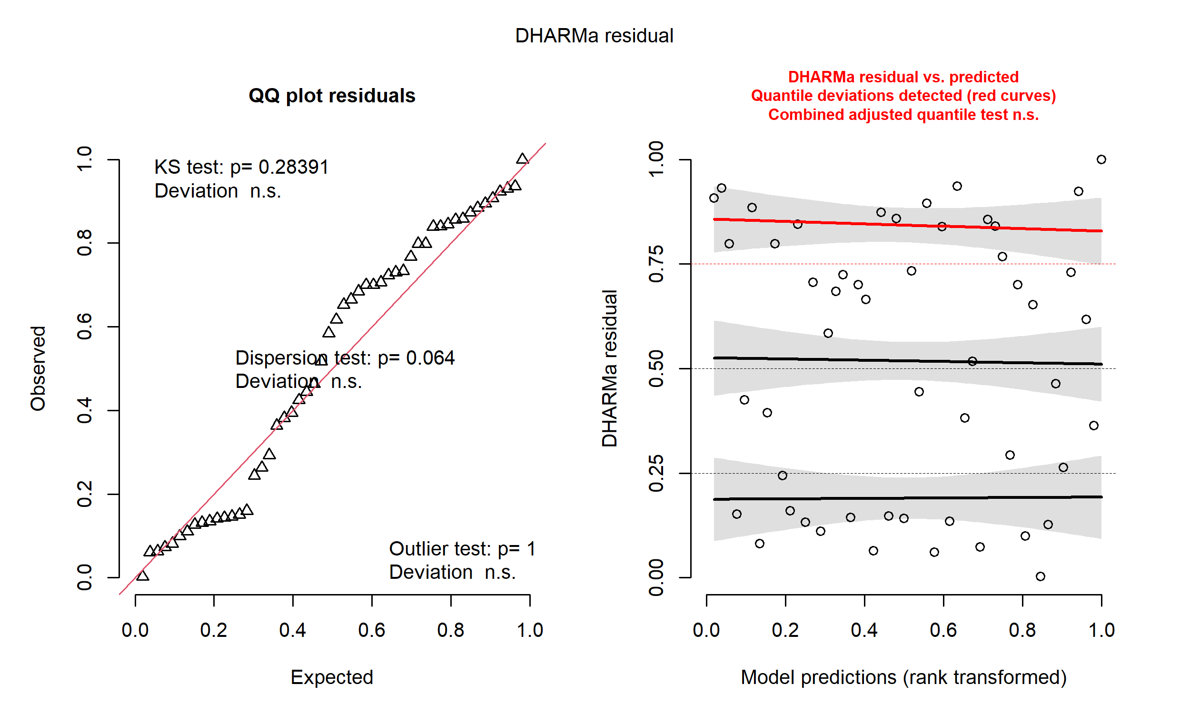
Supplementary Figure 1.
DHARMa residual diagnostics for the model of holotype retention. (a) Q-Q plot of scaled residuals against uniform distribution. (b) Residuals plotted against model predictions. A significant deviation in one diagnostic test does not necessarily invalidate our results when considered alongside others. The QQ plots indicated a generally good fit, and residual plots showed only minor deviations in one or two quantiles. This is not a major concern, particularly given our reasonably sample size.
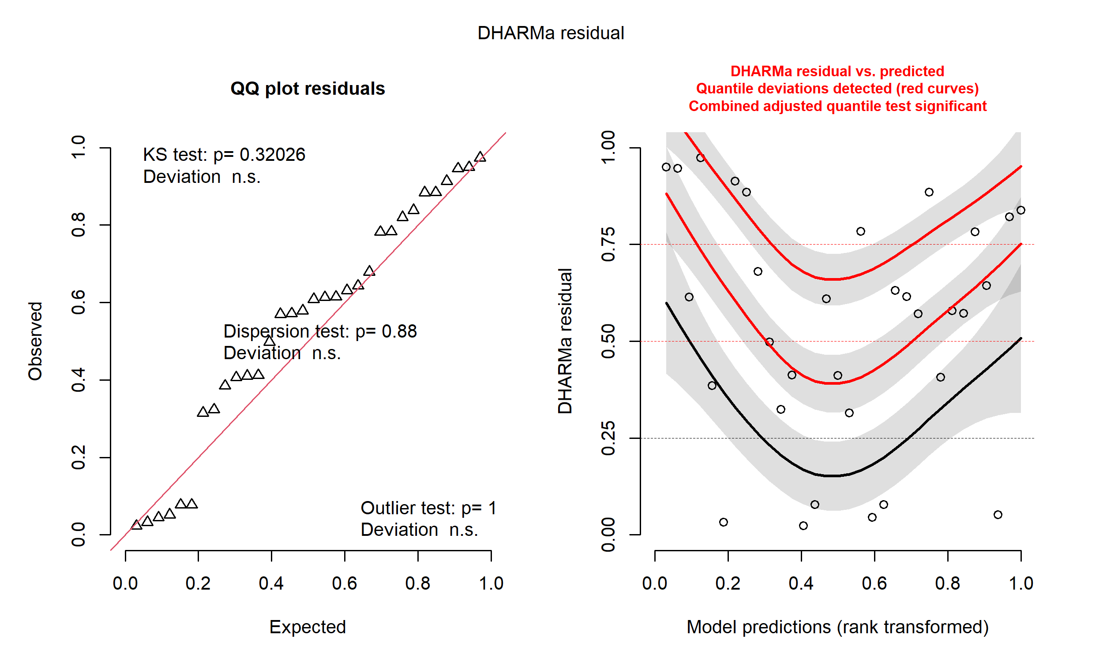
Supplementary Figure 2.
DHARMa residual diagnostics for the model of holotype appropriation. (a) Q-Q plot of scaled residuals against uniform distribution. (b) Residuals plotted against model predictions. A significant deviation in one diagnostic test does not necessarily invalidate our results when considered alongside others. The QQ plots indicated a generally good fit, and residual plots showed only minor deviations in one or two quantiles. This is not a major concern, particularly given our reasonably sample size.
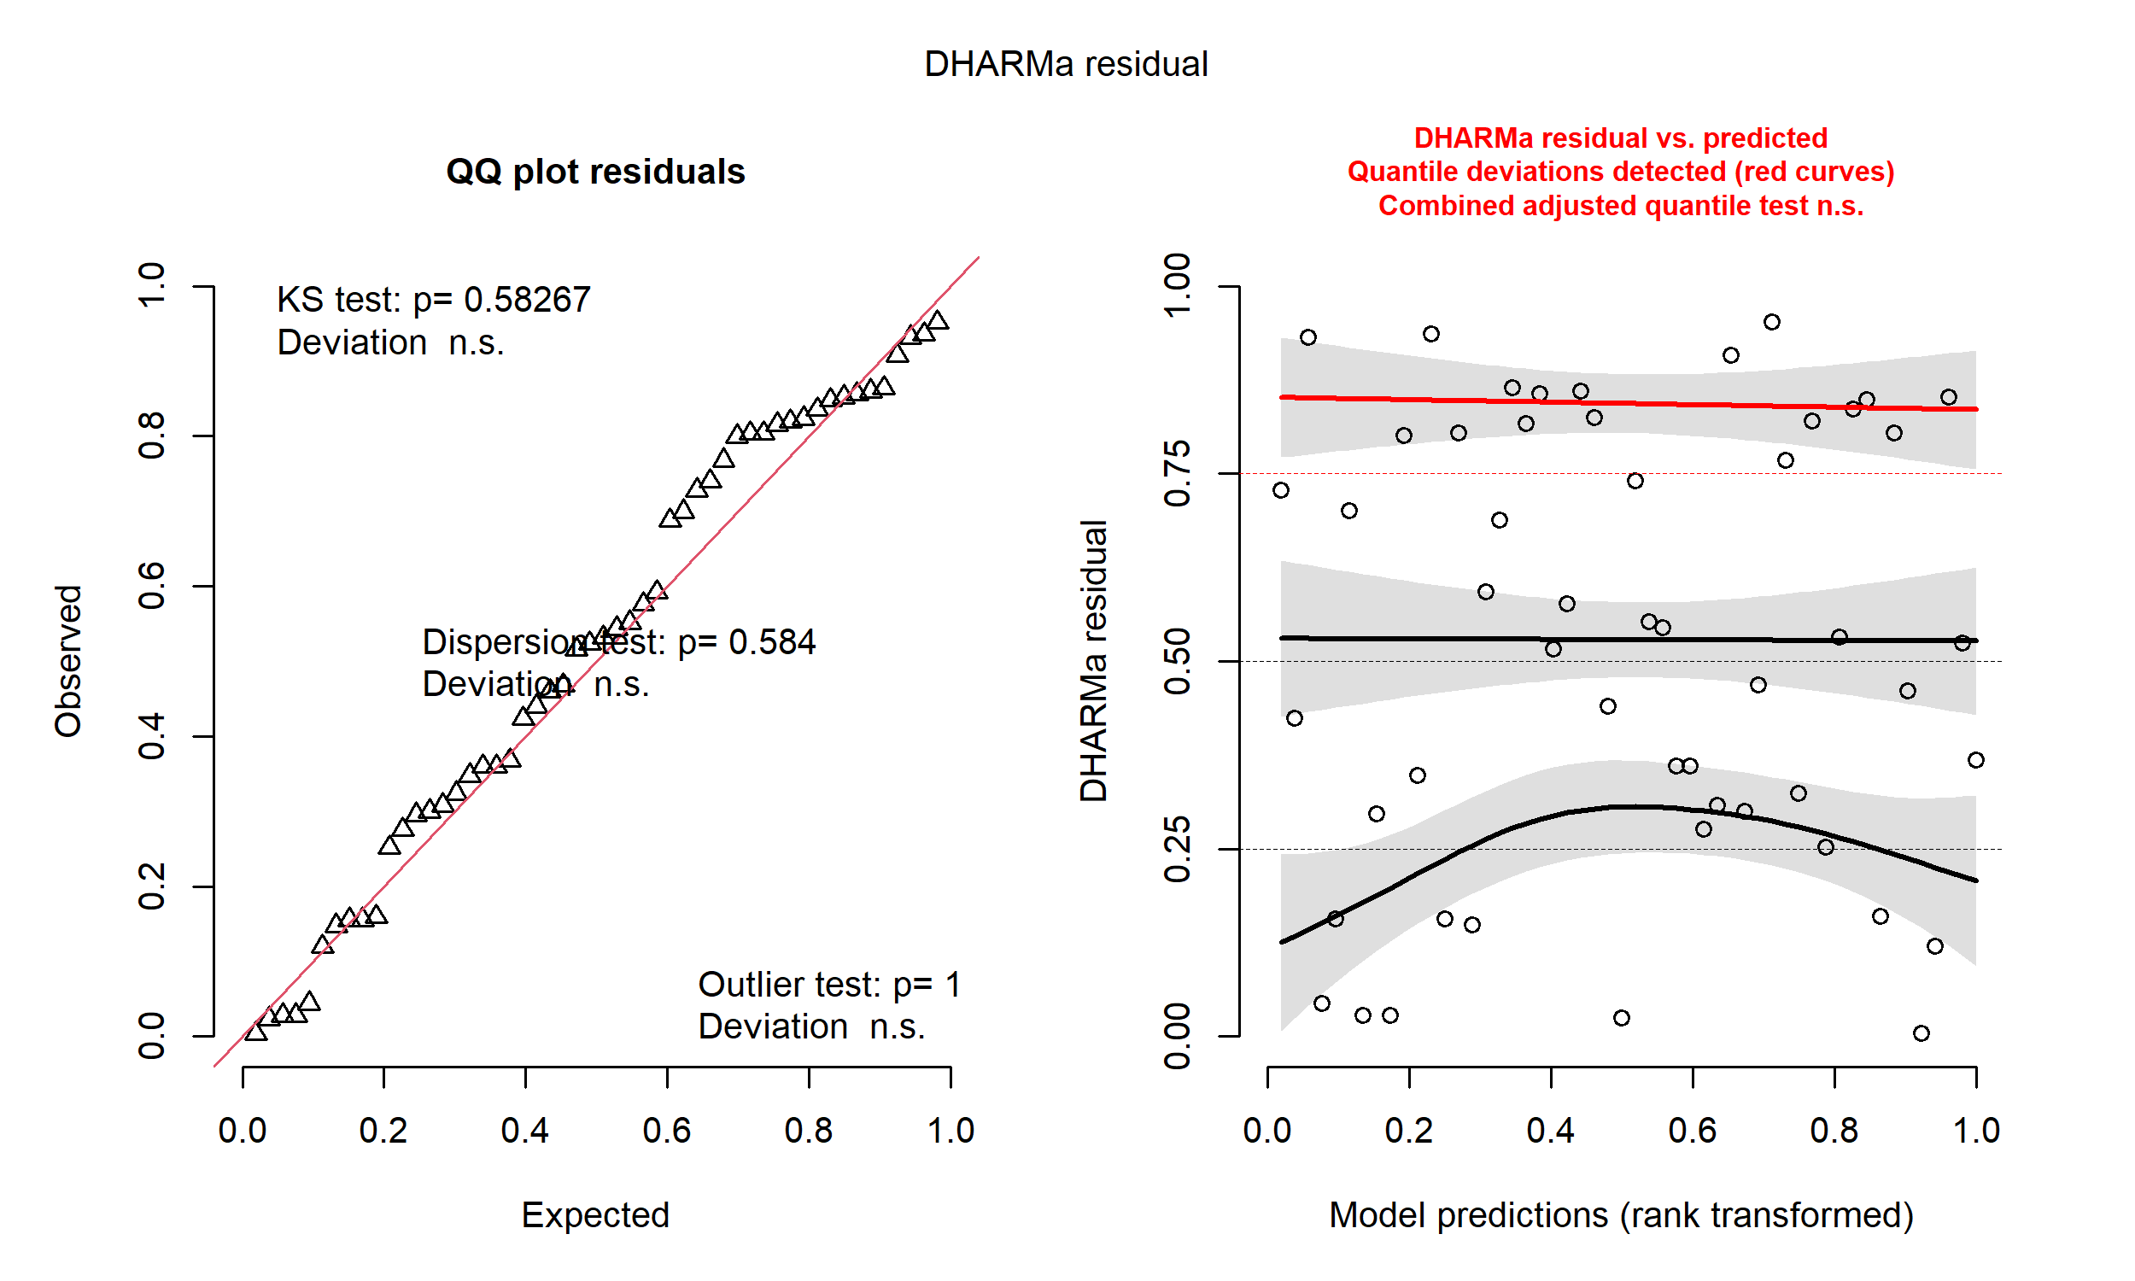
Supplementary Figure 3.
DHARMa residual diagnostics for the model of holotype outflow centrality. (a) Q-Q plot of scaled residuals against uniform distribution. (b) Residuals plotted against model predictions. A significant deviation in one diagnostic test does not necessarily invalidate our results when considered alongside others. The QQ plots indicated a generally good fit, and residual plots showed only minor deviations in one or two quantiles. This is not a major concern, particularly given our reasonably sample size.
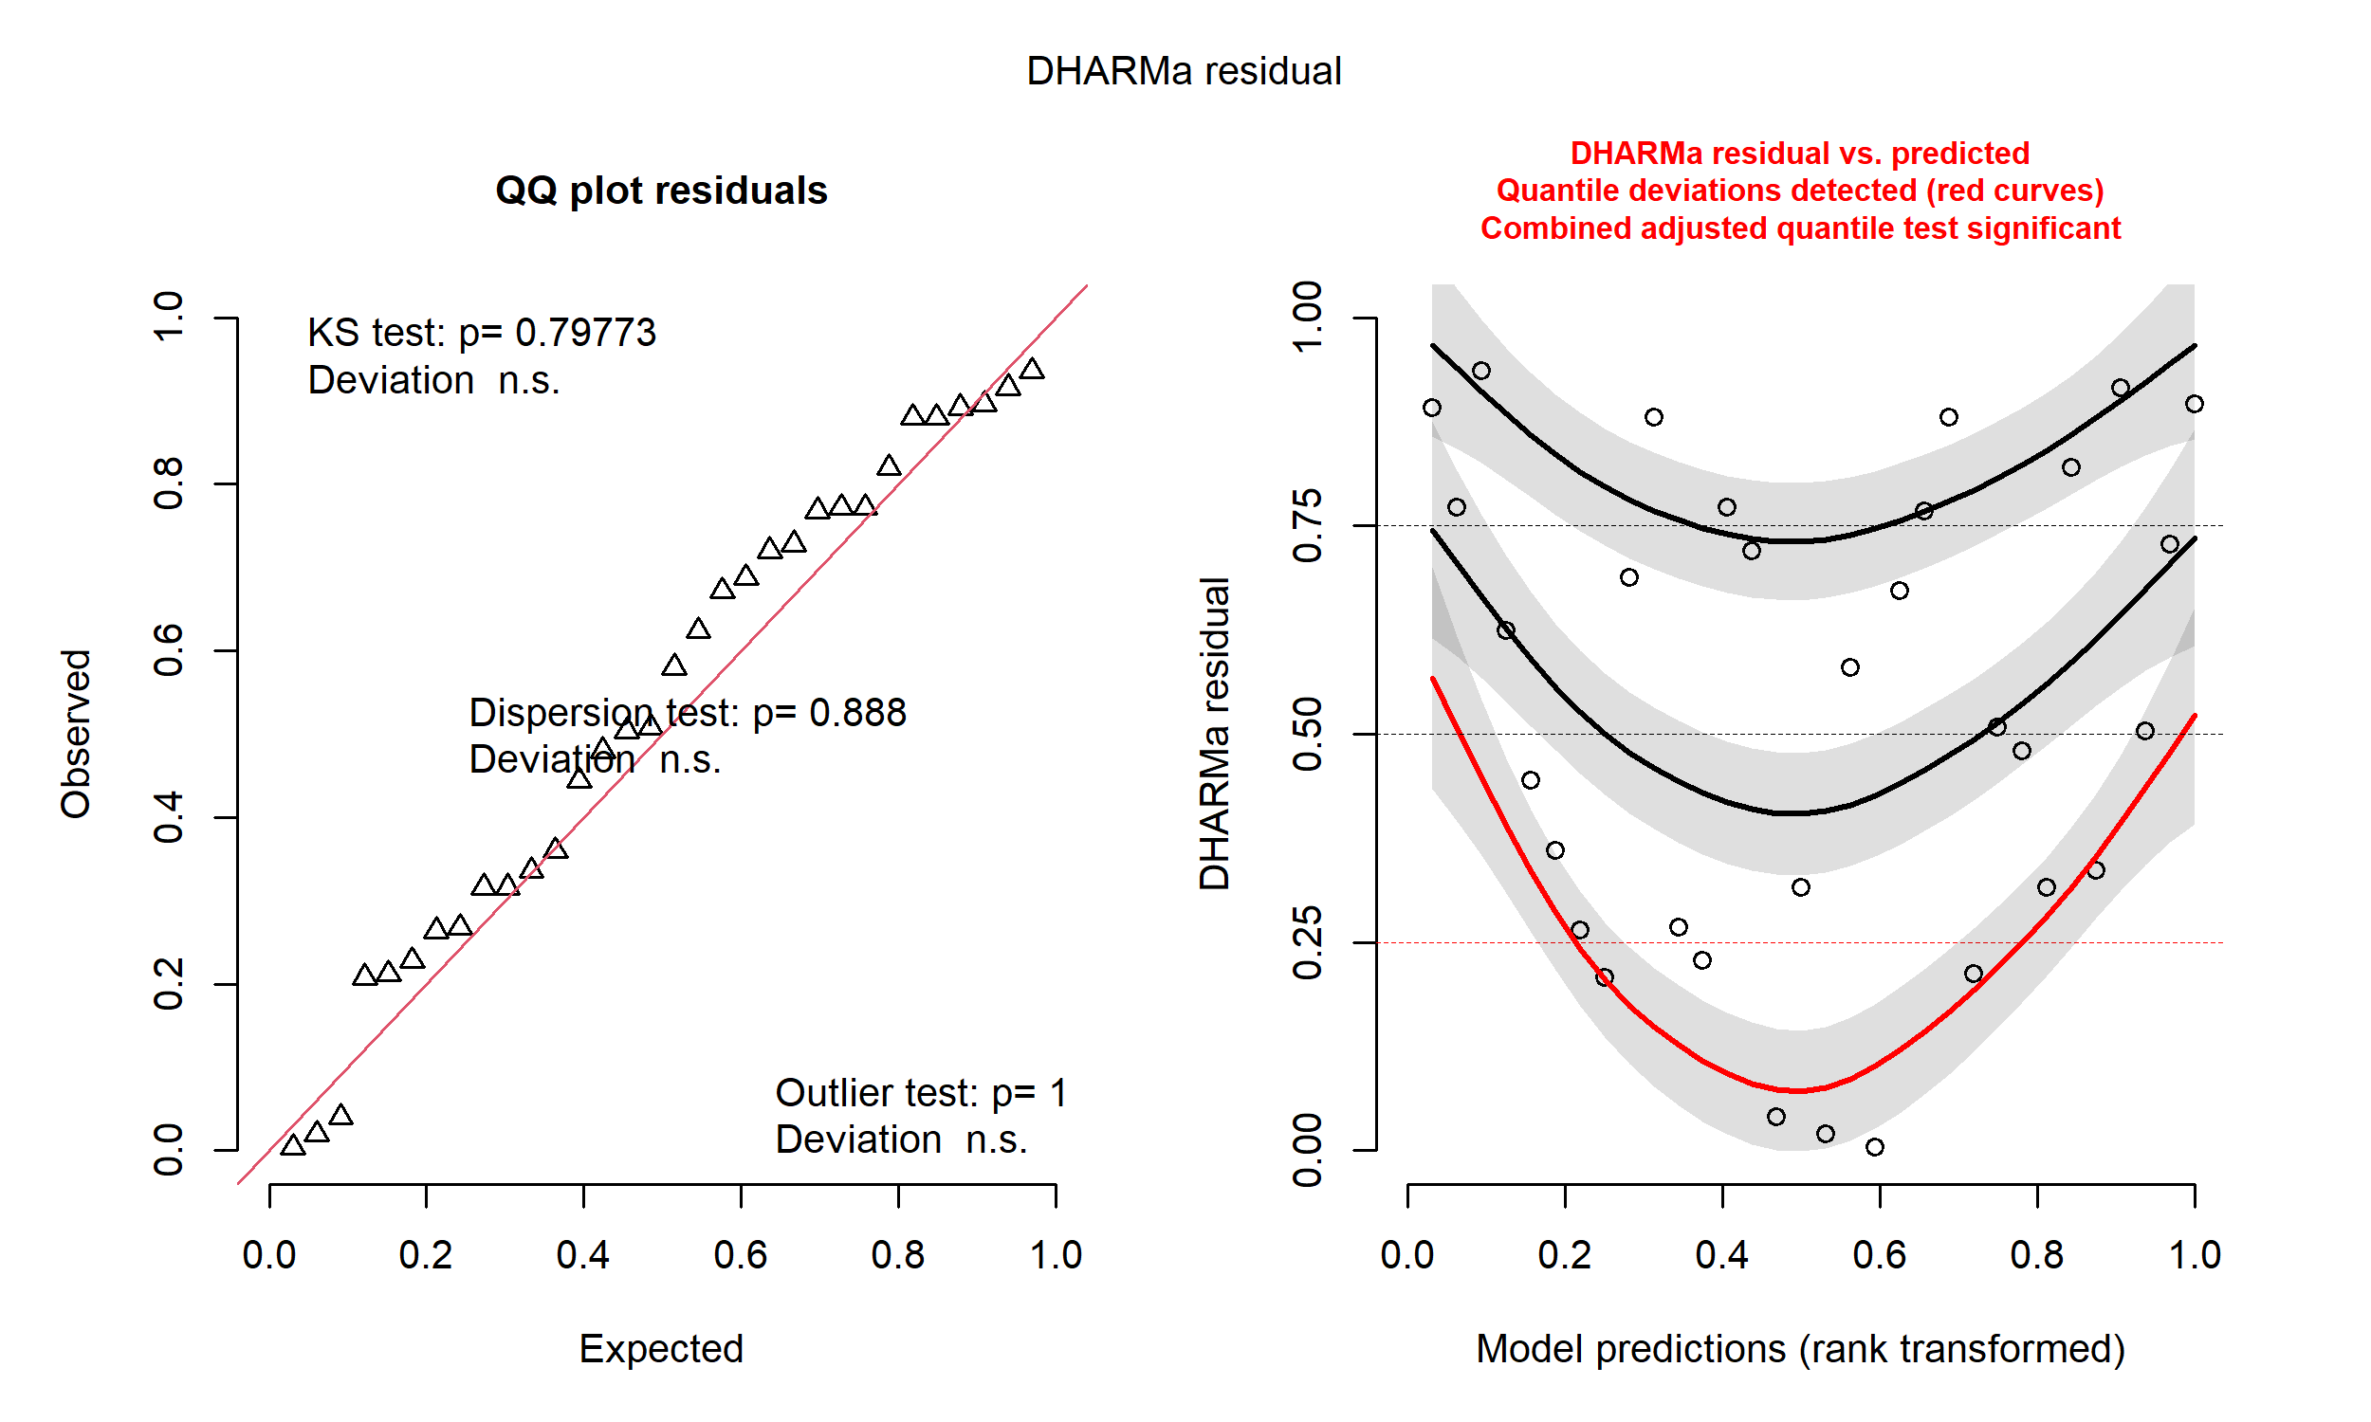
Supplementary Figure 4.
DHARMa residual diagnostics for the model of holotype inflow centrality. (a) Q-Q plot of scaled residuals against uniform distribution. (b) Residuals plotted against model predictions. A significant deviation in one diagnostic test does not necessarily invalidate our results when considered alongside others. The QQ plots indicated a generally good fit, and residual plots showed only minor deviations in one or two quantiles. This is not a major concern, particularly given our reasonably sample size.

