Supplementary Figures
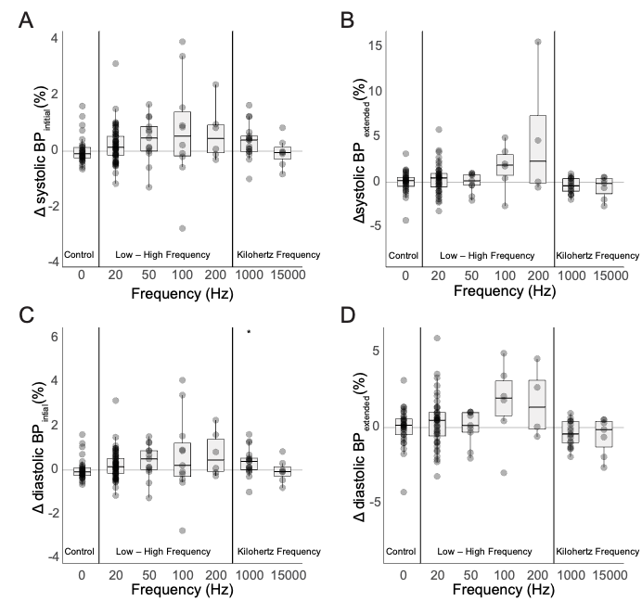
Figure S1. Changes in Blood Pressure during Renal Nerve Stimulation. Shown are collective data across subjects for changes in systolic blood pressure during the (A) initial and (B) extended response periods as well as diastolic blood pressure during the (C) initial and (D) extended response periods.

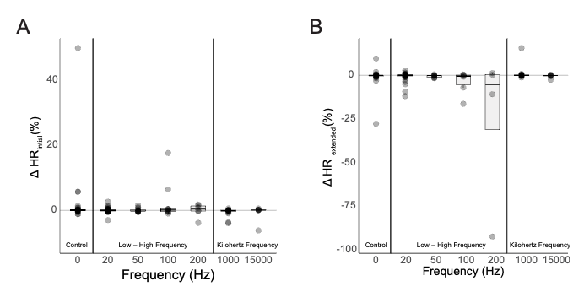
Figure S2. Changes in Heart Rate during Renal Nerve Stimulation. Shown are collective data across subjects for changes heart rate during the (A) initial and (B) extended response periods.

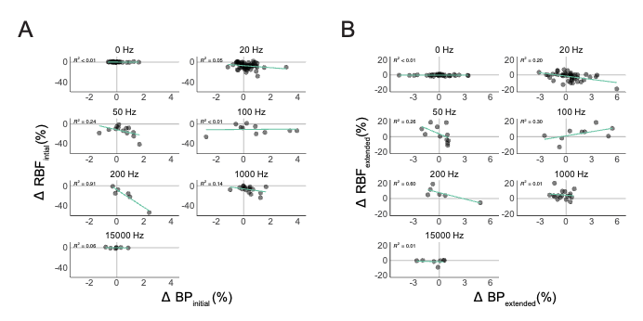
Figure S3. Relationships between Systemic Blood Pressure and Renal Blood Flow Changes. Shown are collective data across subjects for (A) initial and (B) extended response periods.

